E-Item-Order-Service

Git Hub URL:

Order-item:

<https://github.com/kittulal/order-server-cloud-config/tree/master/order-item/order-item>

Order-Service

<https://github.com/kittulal/order-server-cloud-config/tree/master/orderservice>

Order-Cloud-Config-Server

<https://github.com/kittulal/order-server-cloud-config/tree/master/orderservice>

Swagger-UI

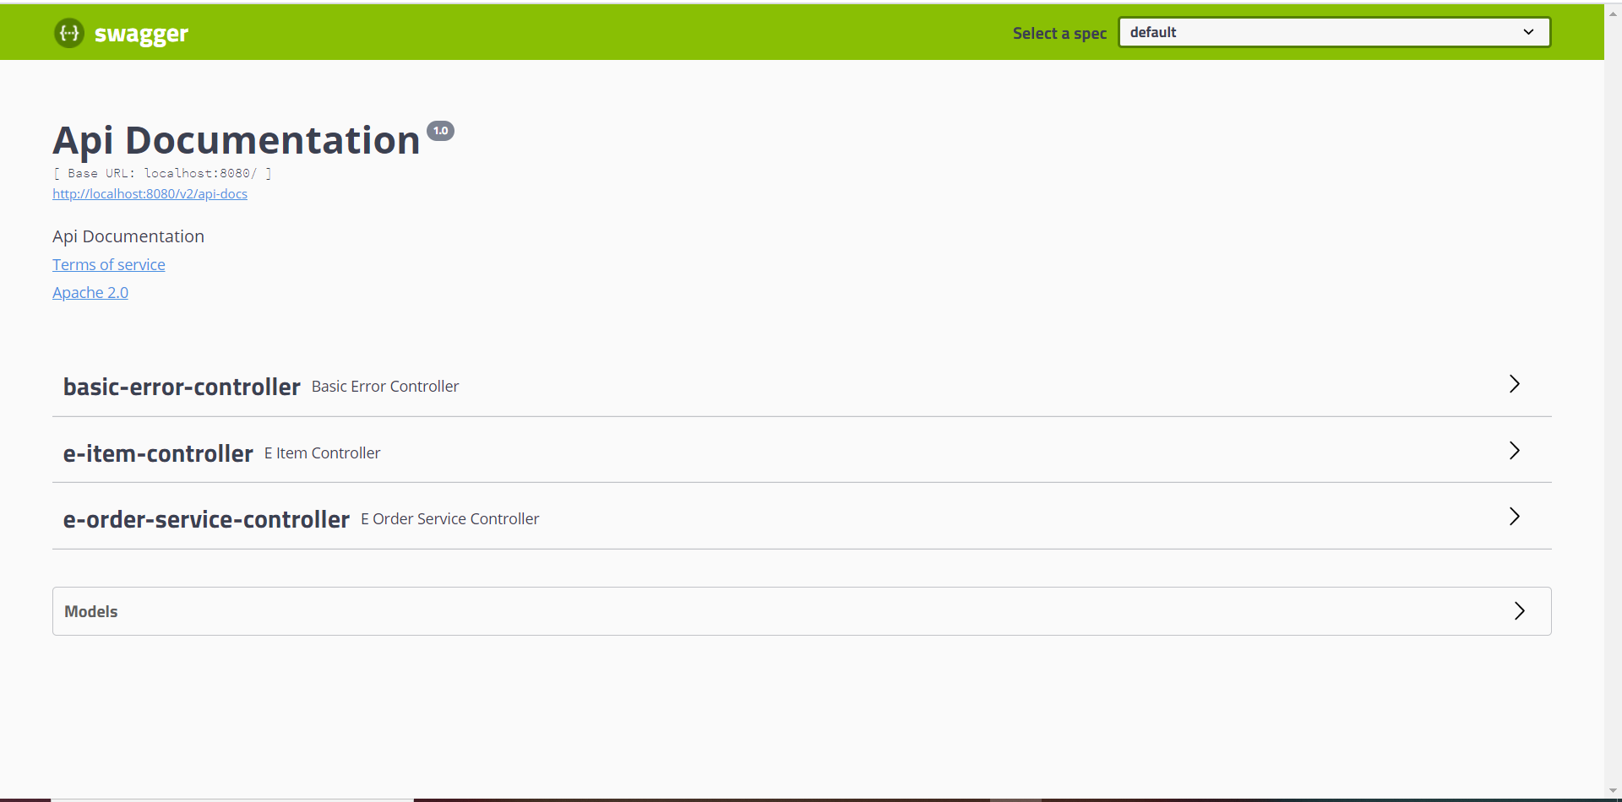

e-item-controller:

Only has Item view service

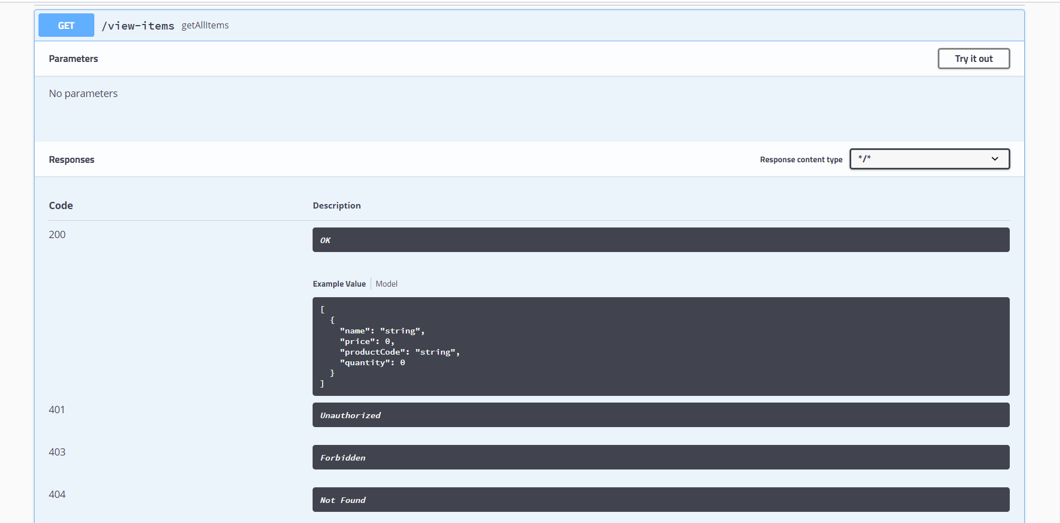

Now let’s try to view the available products/items in e-item-controller.

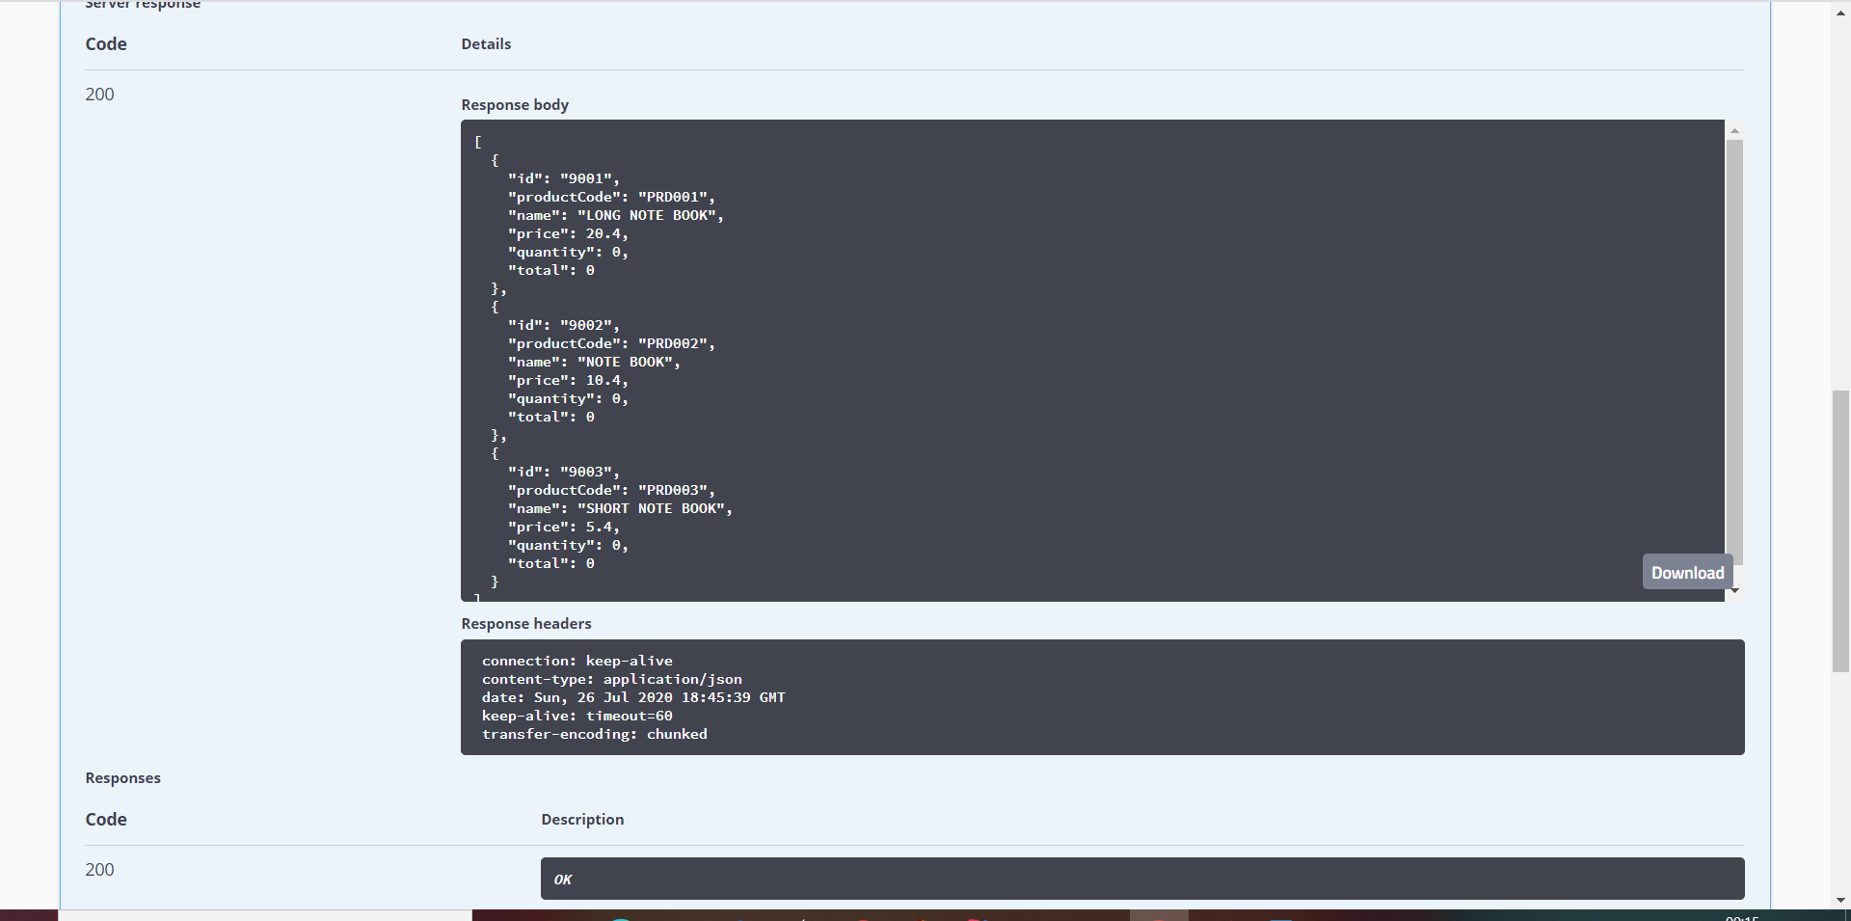

For posting Item order the following services are there.

[e-order-service-controller](http://localhost:8080/swagger-ui.html#/e-order-service-controller)

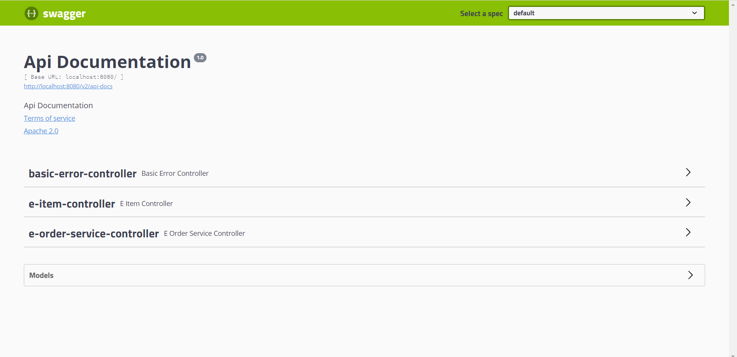

1st – Posting Item Order:

Input-request

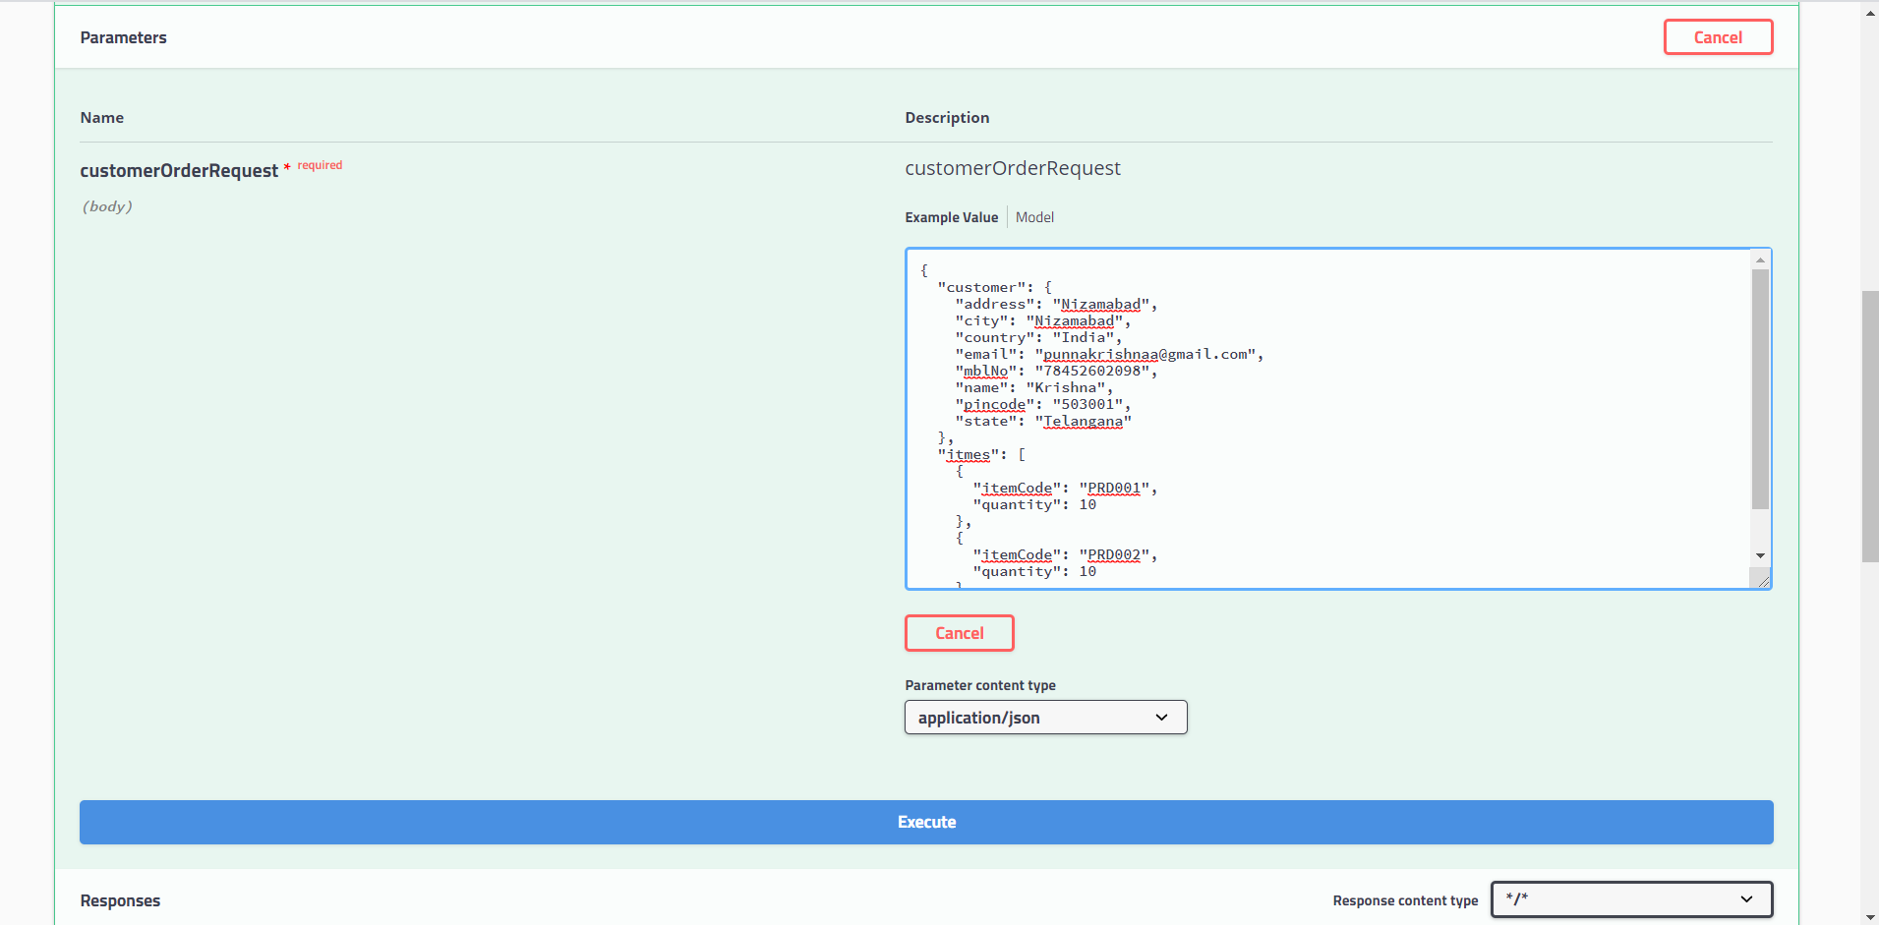

Output

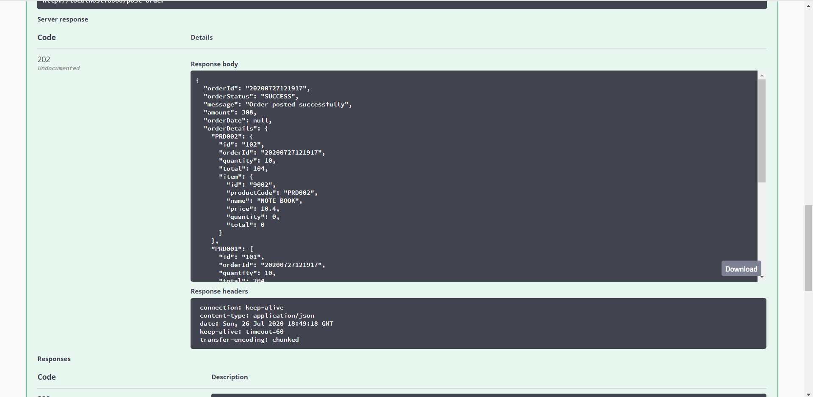

View The Order-Item-Info

I/P:

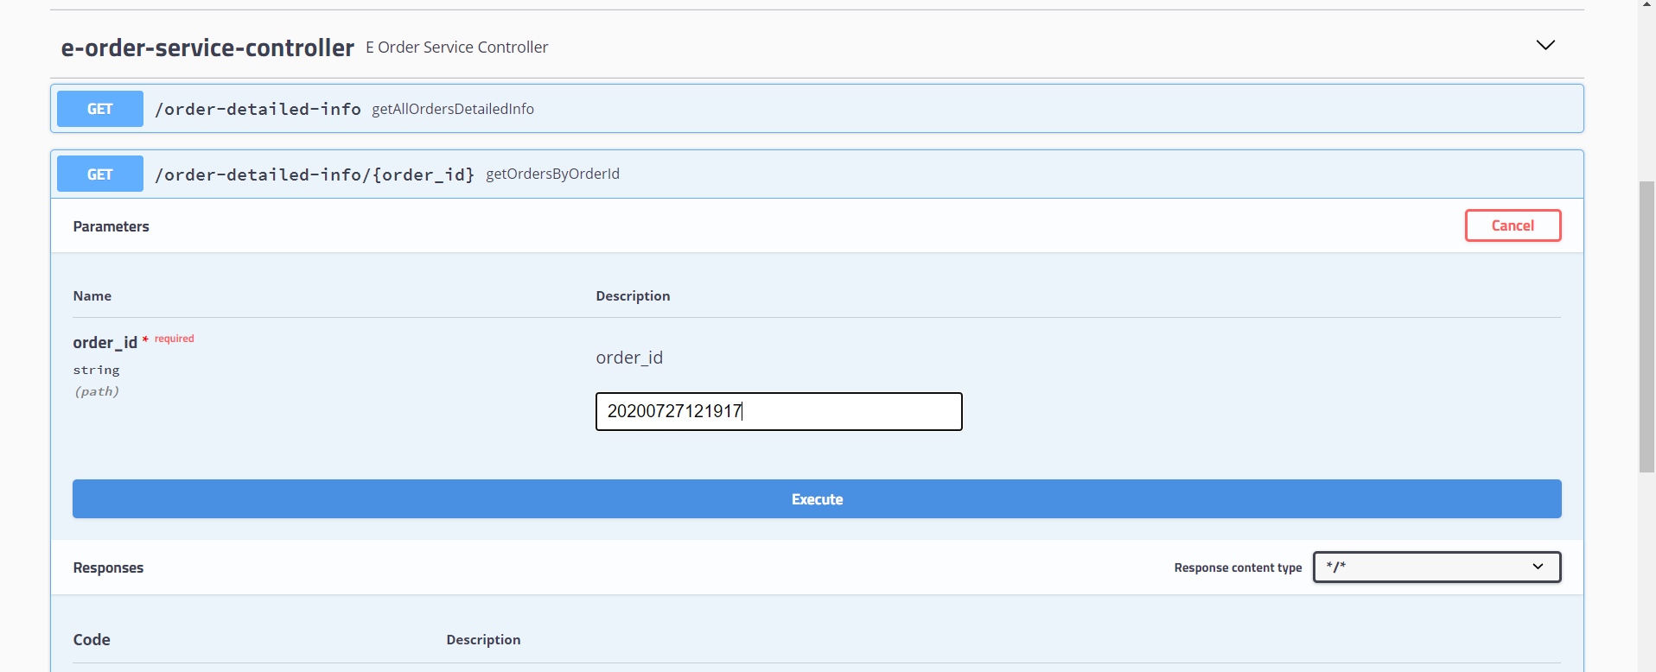

O/P

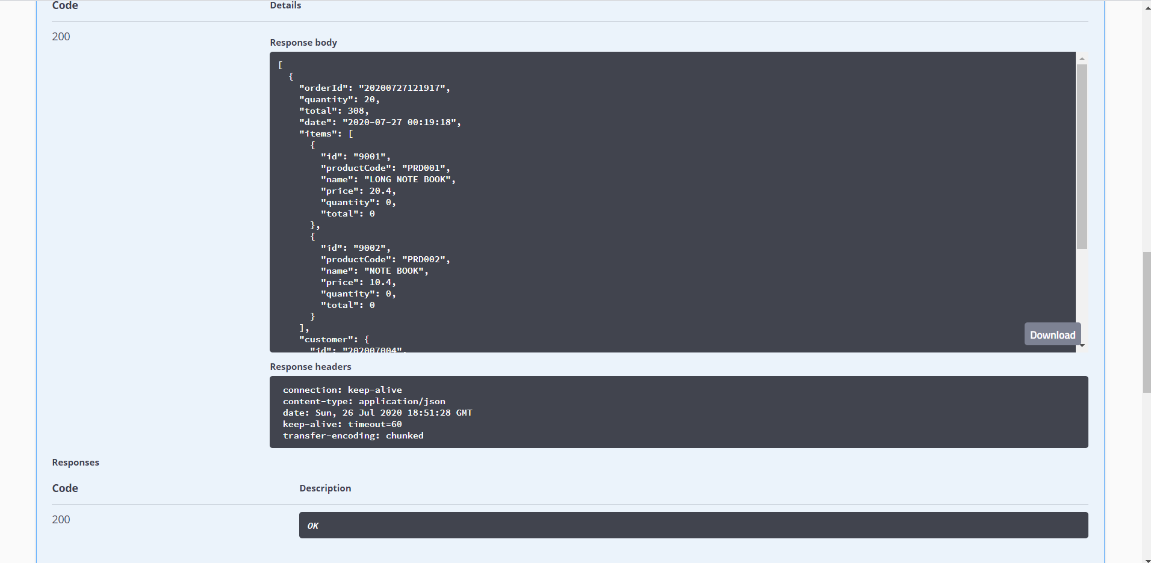

View All Orders Info:

I/P:

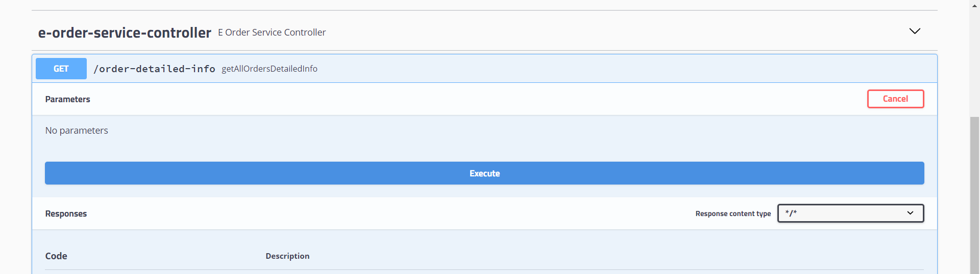

O/P:

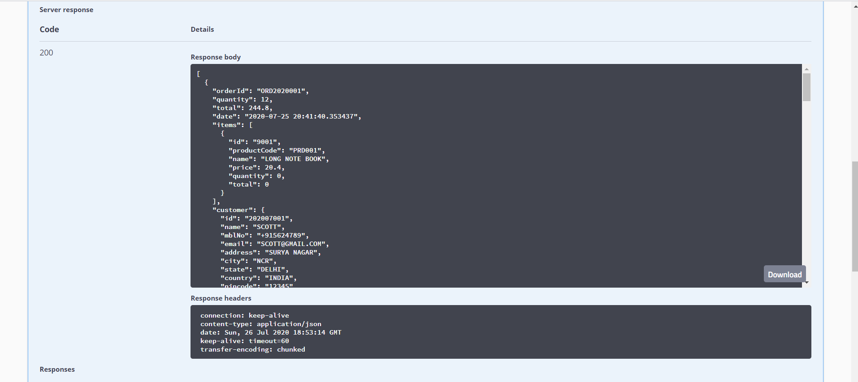

Customer Order View:

I/P

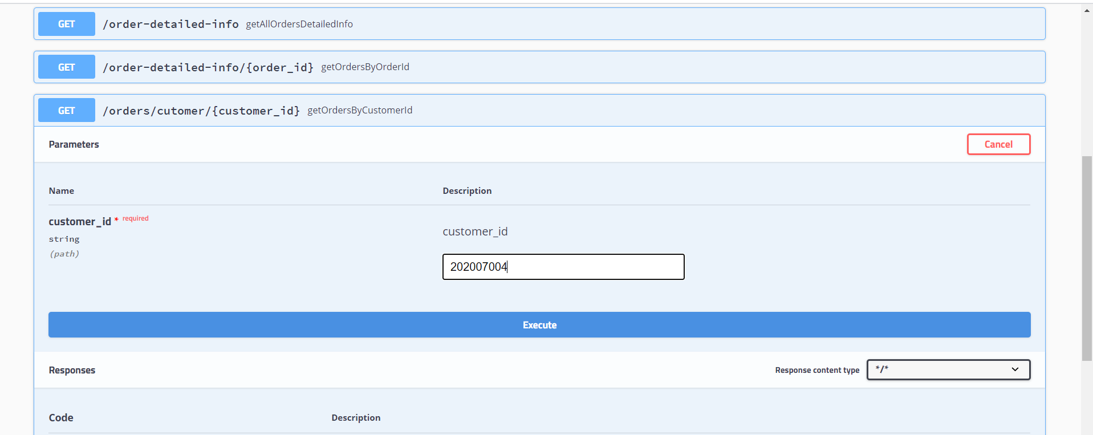

O/P

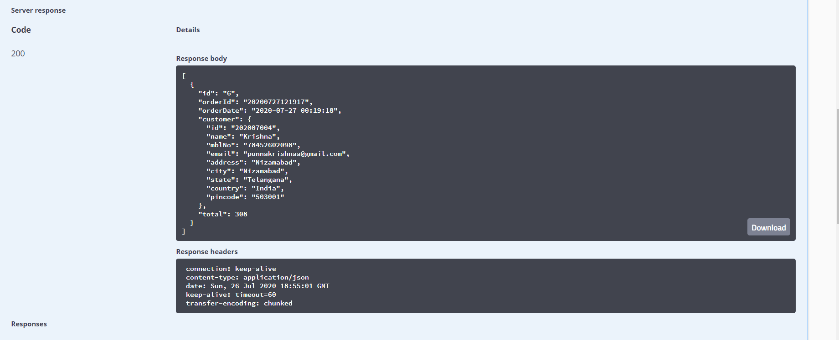

Global Exceptions Handler:

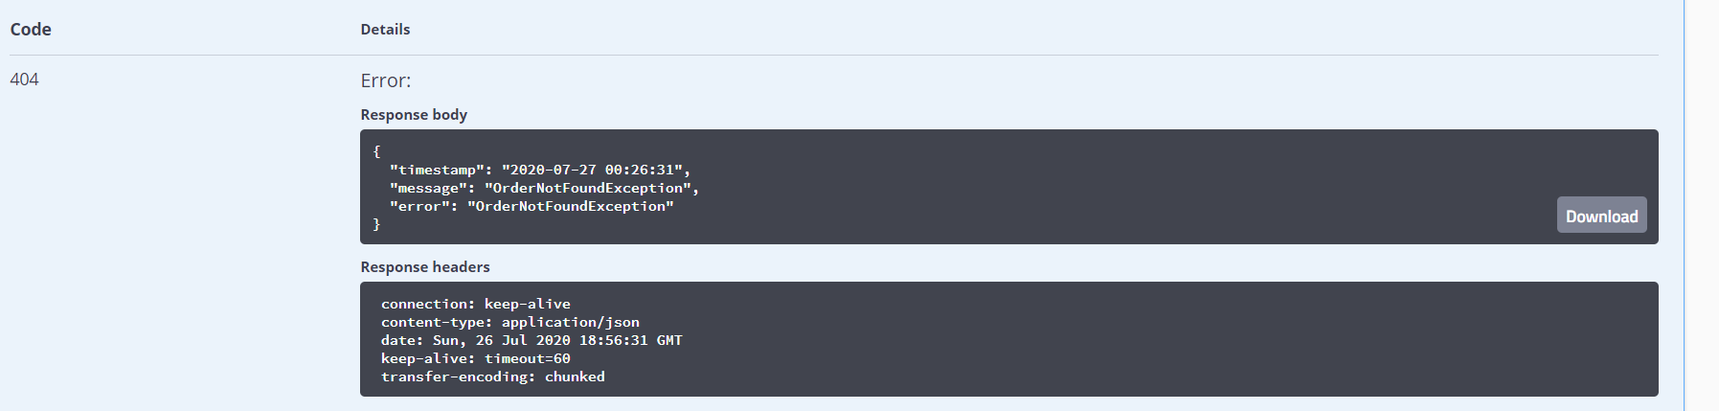

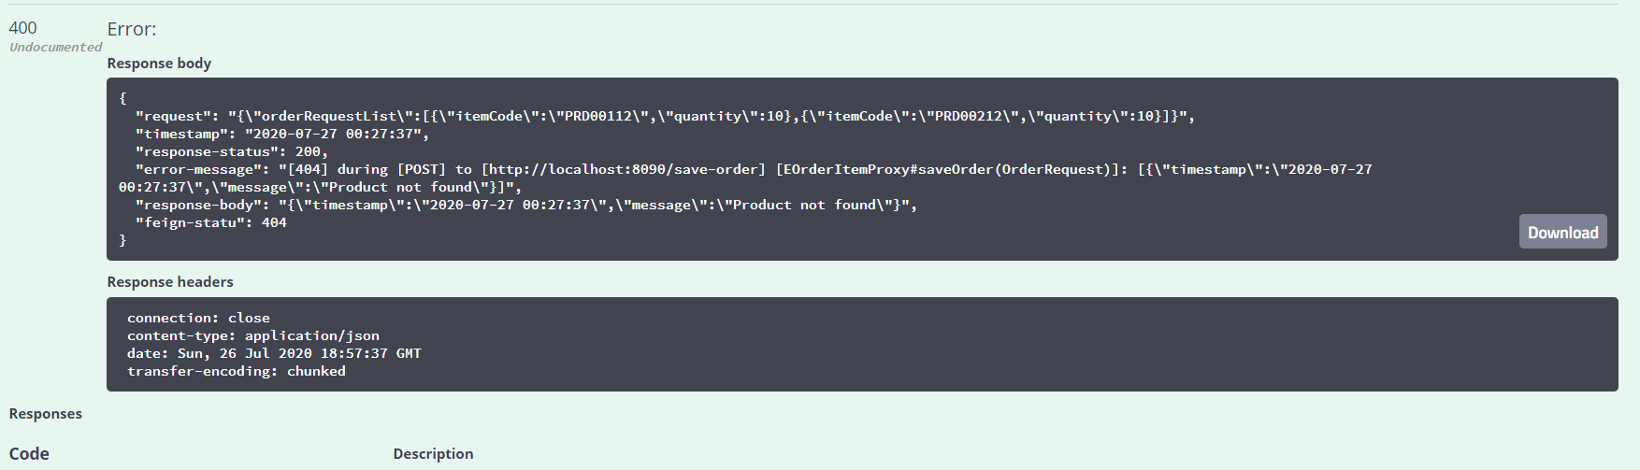

DB

