Order-Item

Git Hub URL:

Order-item:

<https://github.com/kittulal/order-server-cloud-config/tree/master/order-item/order-item>

Order-Service

<https://github.com/kittulal/order-server-cloud-config/tree/master/orderservice>

Order-Cloud-Config-Server

<https://github.com/kittulal/order-server-cloud-config/tree/master/orderservice>

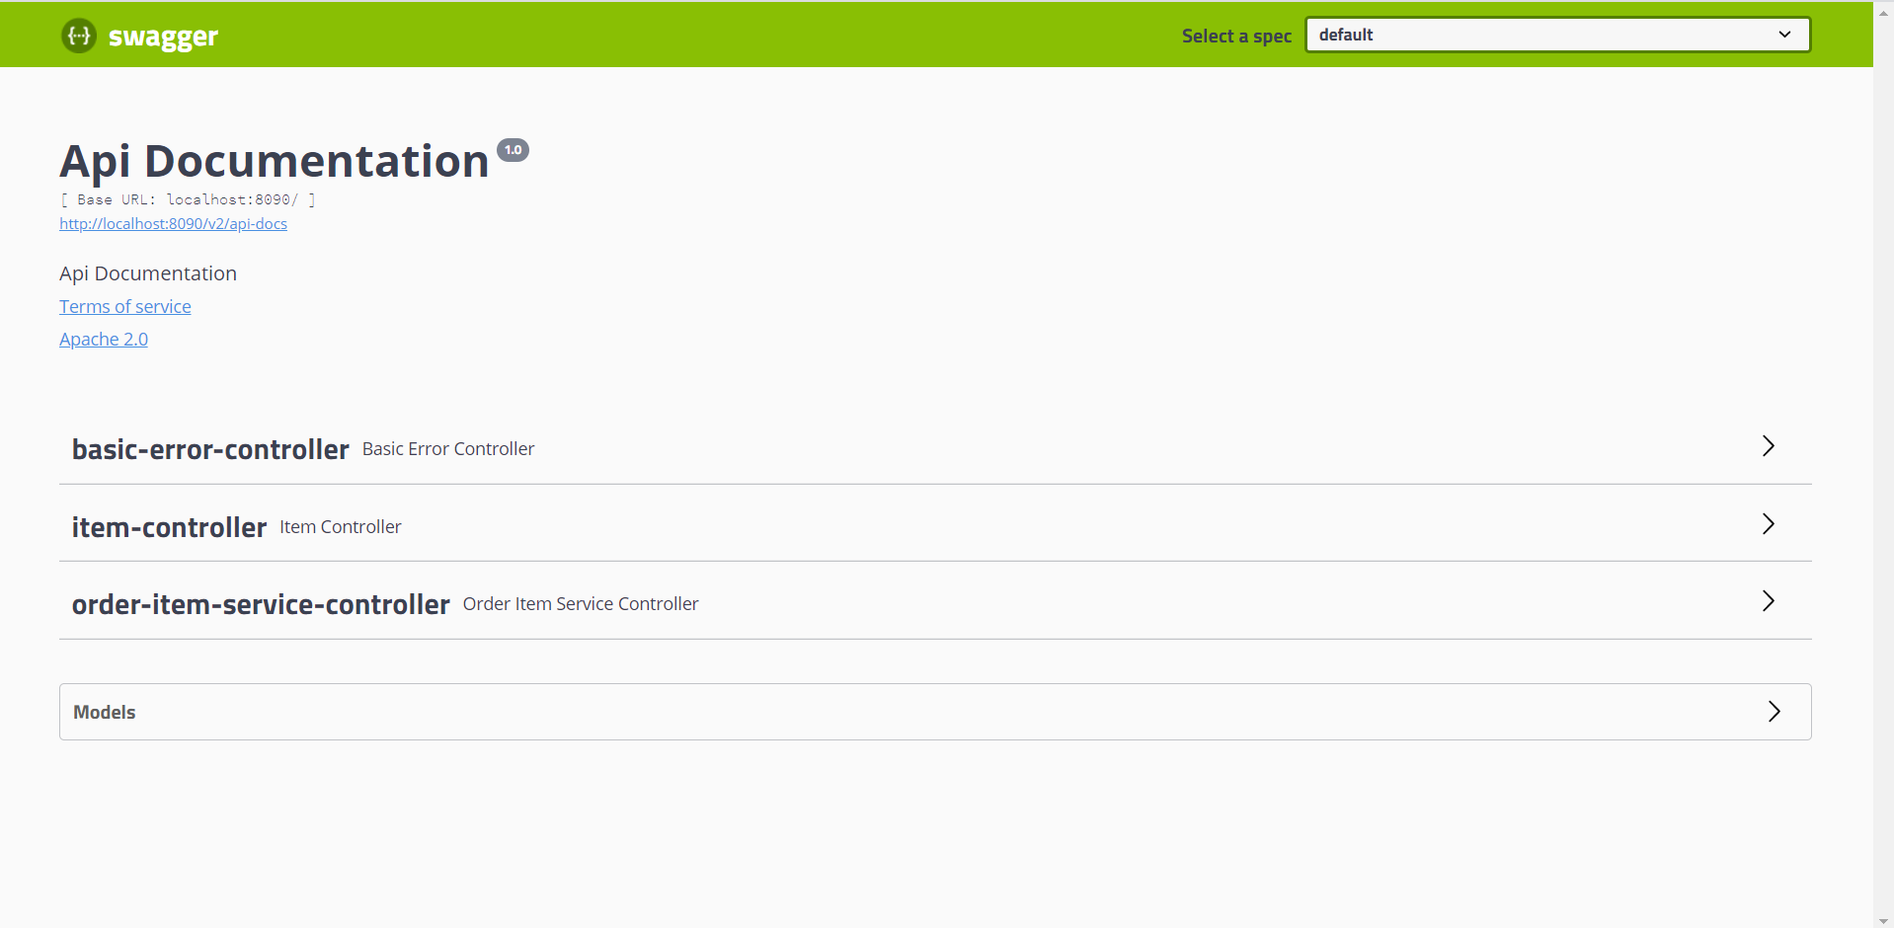

Item-Controller

I/P

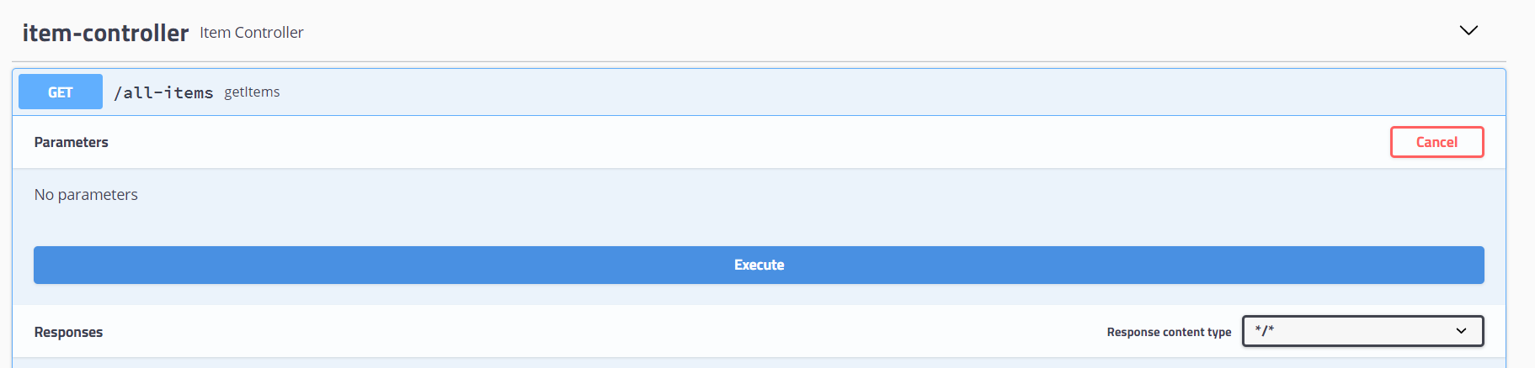

O/P

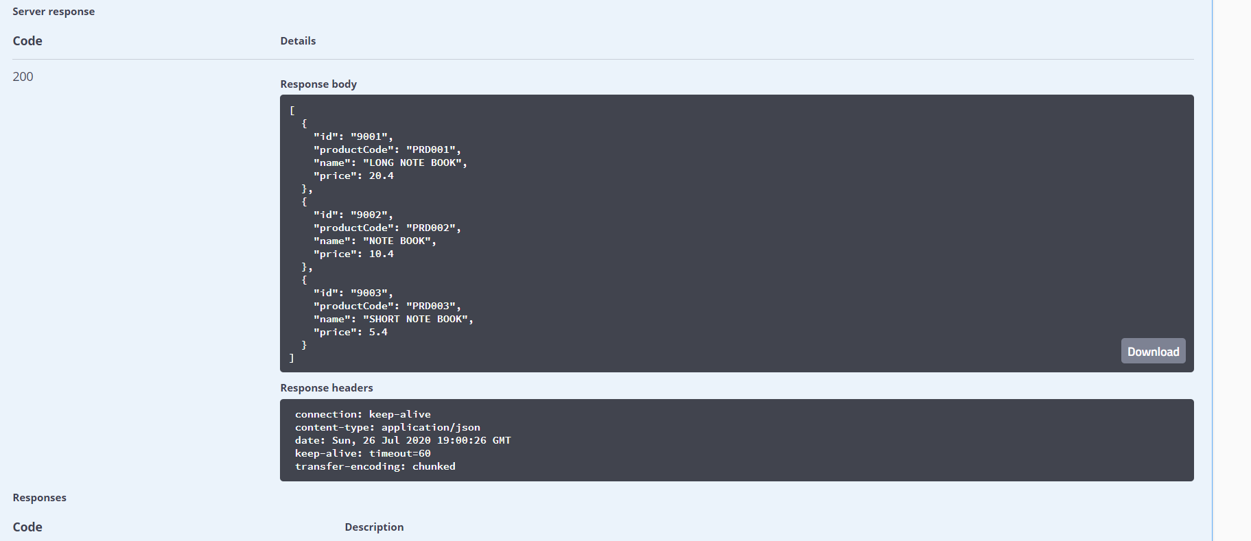

Order-Item-Service-Controller

i/p

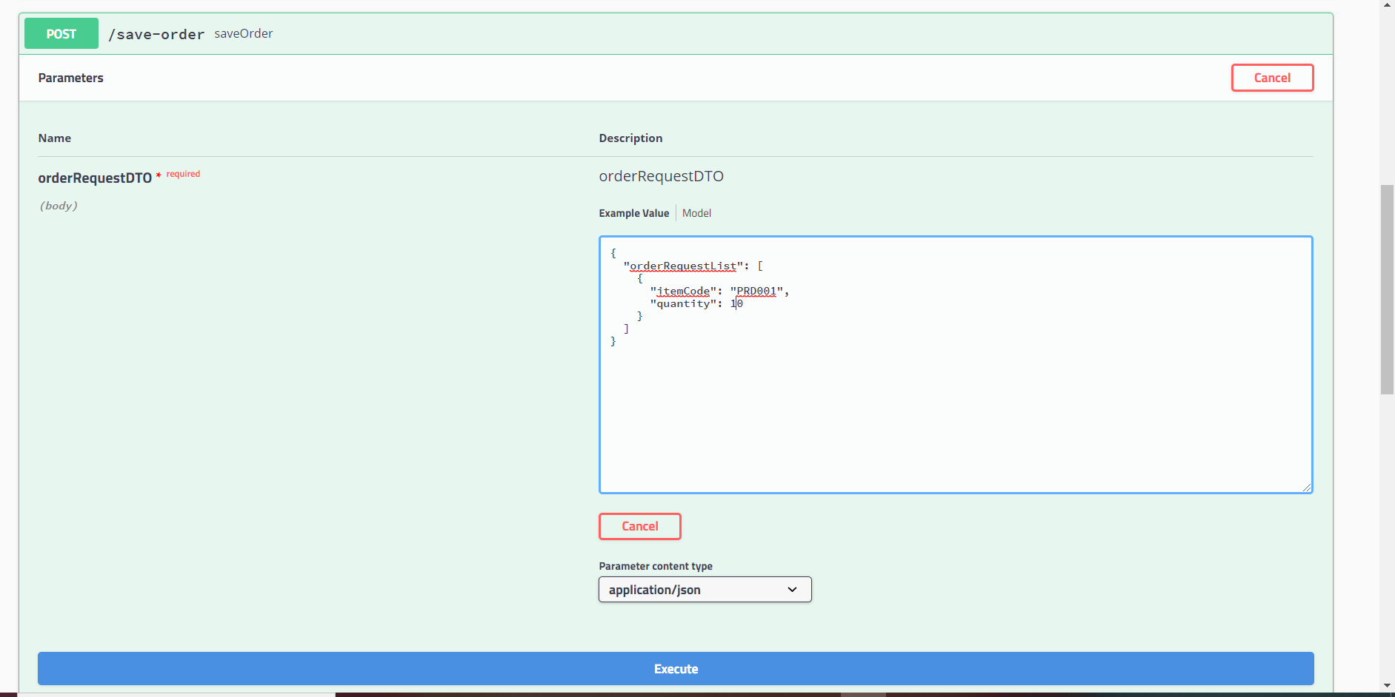

o/p

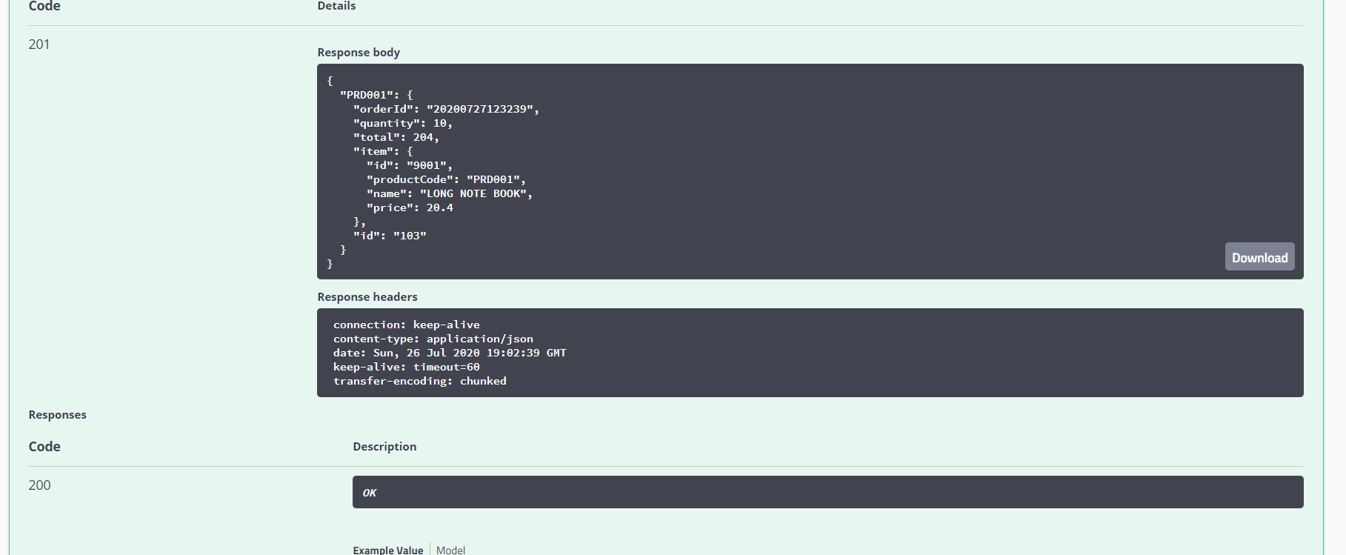

View-Order

i/p

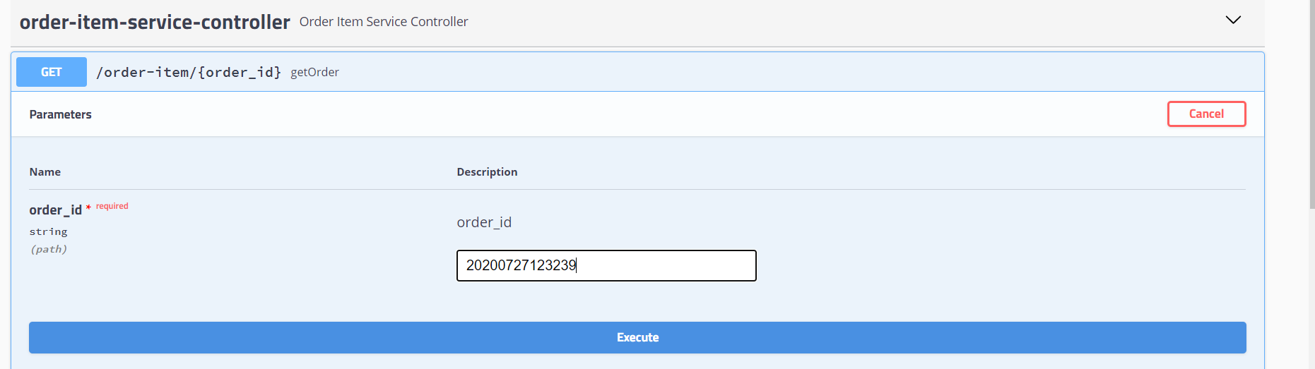

o/p

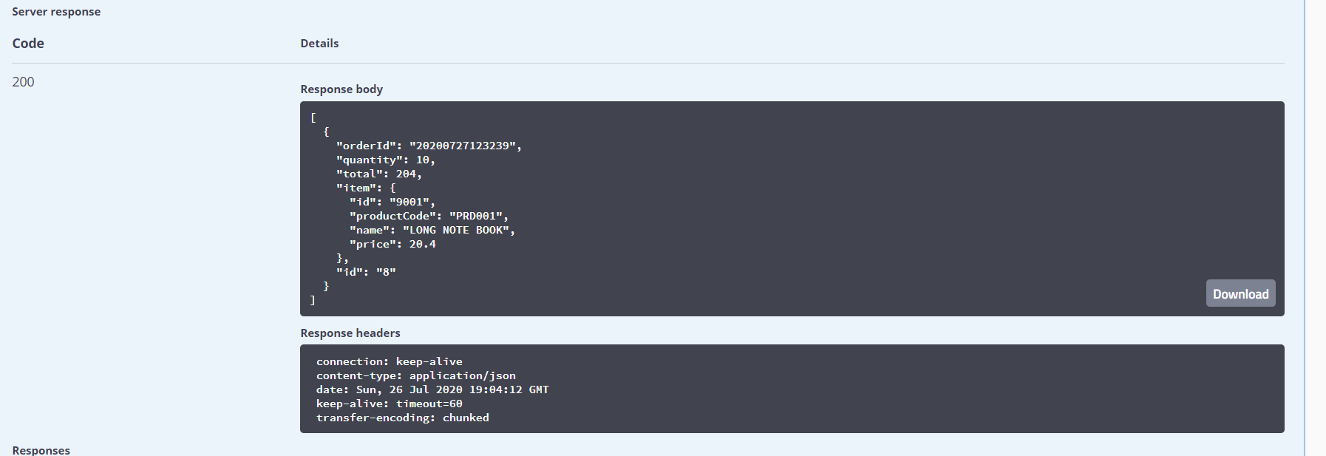

Global Exceptional Handler

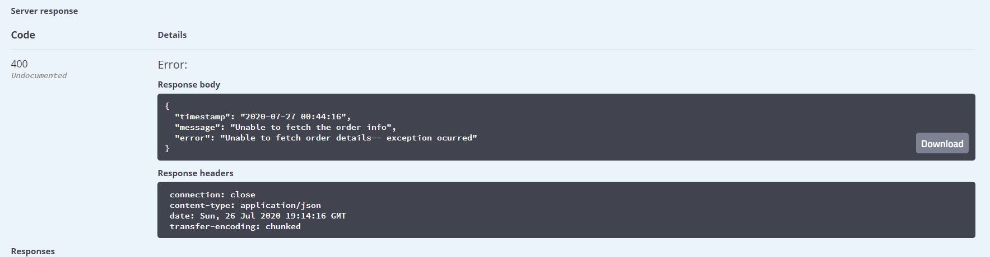

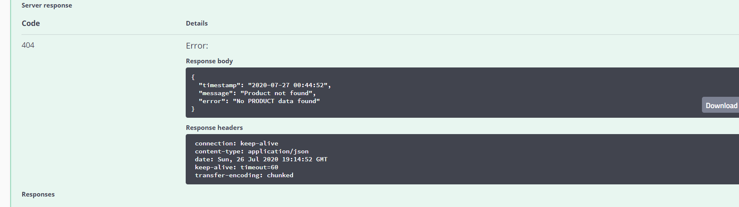

DB

