Figure 1

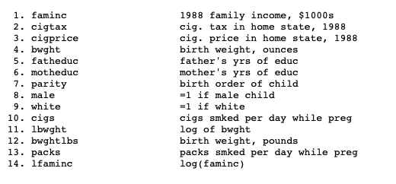

Figure 2

Figure 3

Figure 4

Figure 5

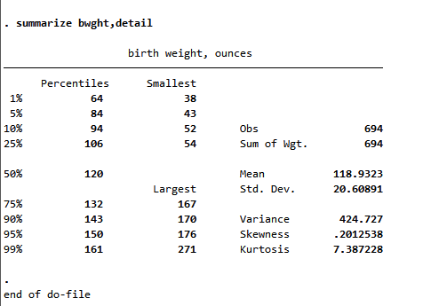

Figure 6

Figure 7

Figure 8

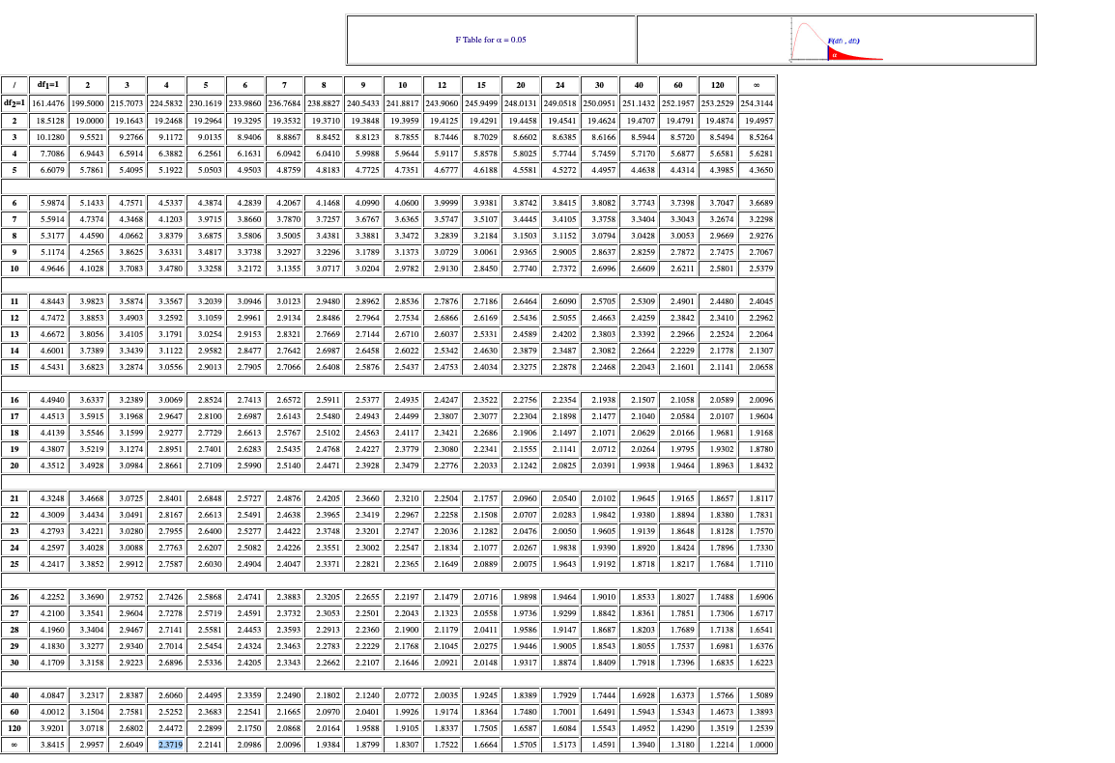

Figure 9

Figure 10

Figure 11

Figure 12

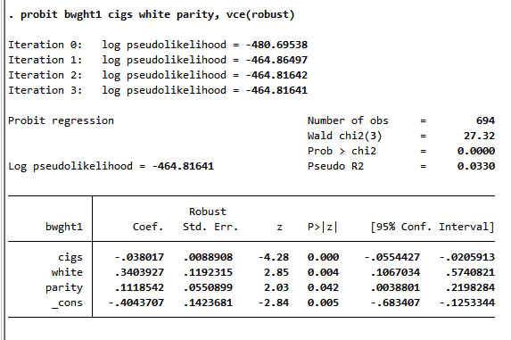

Figure 13

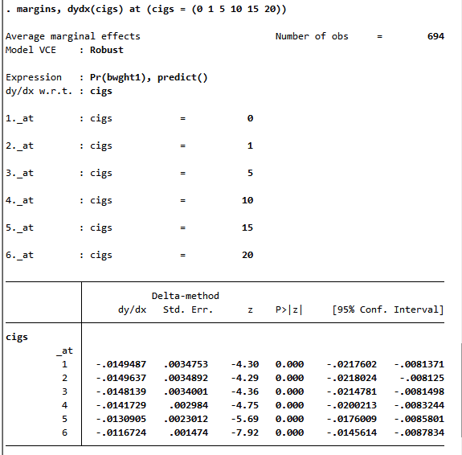

Figure 14

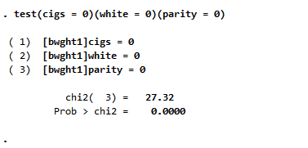

Figure 15

