Kittens

kittens are the cutest thing in the world! some of the cutest kitens are listed below.

## trivia question

What meows and purrs?

dog

cat

cow

mouse

* Siamese
* 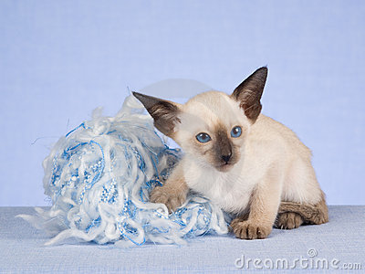Maine Coon
* 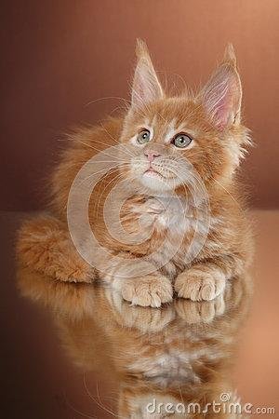Persian

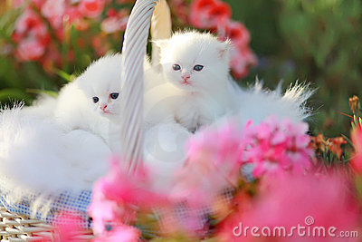[More about cats](http://w3schools.com)