Project Title: Inquiry System for Wisdom Book Shop

Unit No: 18

Module: Procedural Programming

Student Name: MOHAMED FAROOK MOHAMED FAZRIN

ICBT ID No: KD/HNDCOM/39/16

## Table of Contents

## Introduction and Problem Background

Wisdom is a famous book seller in the city. They sell enormous range of books under different categories such as IT, English, fiction, music, etc... Customers can make an inquiry about different books over the phone and by walking to their help desk. Company has manual system to maintain the details of the books (Book ID, category, book name, description about book, price, available quantity, publisher and author).

Day by day their customer base is growing up. Therefore it has become very hard for the staffs to handle day to day inquiries. Management needs a proper solution to reduce the work load of employees, to get better performance from them and enhance customer satisfaction through better service. So they decide to go for automated inquiry system.

Wisdom book shop management requested to program an automated inquiry system with different privileges for each staff member so that they can keep track of who’s accessing the account. The software team, who is going to develop and design an inquiry system planned to include the following features to enhance user friendly and security of the system;

1. Proper authentication to the system (login).
2. List of special offers.
3. List of available book categories.
4. Search specific book information.
5. Exit.

This report includes the strength and weakness of the developed program with very strong justifications for language selection and modularization for clear understanding and future enhancements.

# LO 1.1

## Computer Programming Languages

Computer Programming Language is any of various languages for expressing setoff detailed instruction for a digital computer. Such instruction can be executed directly when they are in the computer manufacturer-specific numerical form known as machine language, after a simple substitution process when expressed in a corresponding assembly language, or after translation form some higher-level language (Hemmendinger, 2015).

## Types Programming Languages

1. Machine Languages

A machine language consists of the numeric codes for the operations that a particular computer can execute directly. Codes are strings of 0s and1s, or binary digits.

1. Assembly Languages

Assembly language is one level above machine language. It uses short mnemonic codes for instructions and allows the programmer to introduce names for blocks of memory that hold data.

1. Algorithmic Languages

Algorithmic languages are designed to express mathematical or symbolic computations. They can express algebraic operations in notation similar to mathematics and allow the use of subprograms that package commonly used operations for reuse.

They were the first high level languages. (Ex: FORTRAN, ALGOL, LISP, C).

1. Business-Oriented Languages

(Ex: COBOL, SQL).

1. Education-Oriented Languages

(Ex: BASIC, PASCAL, LOGO, HYPERTALK).

1. Object-Oriented Languages

Object-oriented languages helps to manage complexity in large programs. Objects package data and the operations on them so that only the operations are publicly accessible and internal details of the data structures are hidden this information hiding made large-scale programming easier by allowing a programmer to think about each part of the program in isolation.

(Ex: C++, ADA, JAVA, VISUAL BASIC)

1. Declarative Languages

Declarative languages, also called non procedural or very high level, are programming languages in which (ideally) a program specifies what is to be done rather than how to do it (Ex: Logic Programming Language :- PROLOG, Functional Languages :- LISP, ML, Haskell)

1. Scripting Languages

Scripting languages are sometimes called little languages they are intended to solve relatively small programming problems that do not require the overhead of data declarations and other features needed to make large programs manageable.(Ex: PERL)

1. Document Formatting Languages

Document formatting languages specify the organization of printed text and graphics. (Ex: TEX, POSTSCRIPT, SGML)

1. Display Languages

(Ex: HTML, XML) (Hemmendinger, 2015).

Procedural Programming

Procedural programming is the standard approach used in traditional computer language such as C, Pascal, and FORTRAN. The basic idea is to have a program specify the sequence of steps that implements a particular algorithm. Procedural programming is a term used to denote the way in which a computer programmer writes a program. This method of developing software, which also is called an application, revolves around keeping code as concise as possible. It also focuses on a very specific end result to be achieved (Slideshare, 2016).

Following Benefits are there for using a Procedural Programming

* Excellent for general purpose programming
* Many books and references available on well-tried and tested coding algorithms - no need to re-invent the wheel.
* Good level of control without having to know precise target CPU details - unlike low level languages.
* Portable source code - use a different compiler to target a different CPU (Teach IT, 2016).

Structured Programming

C++ is a structured programming language which is based on three main steps or sections of its procedural section;

**1. Sequence**   Execute a list of statements in order.

**2. Repetition**   Repeat a block of statements while a condition is true.

**3. Selection**   Choose at most one action from several alternative conditions.

(Depaul University, 2016)

*Wisdom Bookshop database management is required such system of Sequence, Repetition and Selection. To understand structured programming, think in terms of a section of program code that has only one entry point and one exit point.  It is very important that**there cannot be multiple entry points or multiple exit points. There must be only one way into the section of code and one way out of the section of code, even though C++ is object oriented programming language it is a highly compatible with procedural programming as well, so it is used to create the Database system for Wisdom Bookshop in this particular scenario* (Baldwin, 2007)*.*

# LO 2.1

Following units of functions are designed for Wisdom book shop data base

Main Function

Wisdom Book Shop Welcome Message.

Required output 🡺 Welcome message.

Login function for Wisdom Book Shop database

Display main functions to select

Required Inputs 🡺 Select an option from main menu

If Admin Login Selected

Required Inputs 🡺 Username & password.

Required file 🡺 A file contains username and password

Required output 🡺 If username & password matching.

If matching following functions will be displayed.

01: ADD NEW BOOKS

02: DISPLAY ALL BOOKS

03: SEARCH BOOKS BY ID NUMBER

04: SEARCH BOOKS BY CATEGORY

05: SEARCH BY BOOK NAME

06: DELETE & UPDATE BY DISPLAY LIST

07: SEARCH & DELETE BY BOOK NAME

08: SEARCH & DELETE BY BOOK CATEGORY

09: SEARCH & UPDATE BY BOOK NAME

10: SEARCH & UPDATE BY BOOK ID

11: VIEW SPECIAL OFFERS

12: HELP

13: EXIT

Required Input 🡺 A selection from the list by indicating number.

If not matching 🡺 Try again to enter username & password.

## 01: ADD NEW BOOKS

Required Input 🡺 Add those details to the Database file.

Required Output 🡺 Details of the book to be added.

Required File 🡺 A file contains data of books.

## 02: DISPLAY ALL BOOKS

Required Output 🡺 Book list of all books.

Required File 🡺 A file contains data of books.

## 03: SEARCH BOOKS BY ID NUMBER

Required input 🡺 Book ID

Required file 🡺 A file contains data of books.

Required Output 🡺 Search Results.

## 04: SEARCH BOOKS BY CATEGORY

Required input 🡺 Book Category.

Required file 🡺 A file contains data of books.

Required Output 🡺 Search Results.

## 05: SEARCH BY BOOK NAME .

Required input 🡺 Book Name.

Required file 🡺 A file contains data of books

Required Output 🡺 Search Results.

## 06: DELETE & UPDATE BY DISPLAY LIST

Required Output 🡺 All Booklist.

Required file 🡺 A file contains data of books

Required input 🡺 Select Update or Delete.

Book ID which is going to Update or Delete.

Required Output 🡺 Confirmation Message or Feedback.

## 07: SEARCH & DELETE BY BOOK NAME

Required input 🡺 Book Name Which is going to Delete.

Required file 🡺 A file contains data of books

Required Output 🡺 Search Results

Required input 🡺 Confirm again to delete the Searched Book.

Required Output 🡺 Confirmation Message or Feedback.

## 08: SEARCH & DELETE BY BOOK CATEGORY

Required input 🡺 Book category which is going to delete.

Required file 🡺 A file contains data of books

Required Output 🡺 Search Results

Required input 🡺 Confirm again to delete the searched book.

Required Output 🡺 Confirmation message or feedback.

## 09: SEARCH & UPDATE BY BOOK NAME

Required input 🡺 Book Category which is going to update.

Required file 🡺 A file contains data of books

Required Output 🡺 Search results

Required input 🡺 Confirm to update the searched book and updated Data.

Required Output 🡺 Confirmation Message or Feedback.

## 10: SEARCH & UPDATE BY BOOK ID

Required input 🡺 Book ID which is going to update.

Required file 🡺 A file contains data of books

Required Output 🡺 Search Results

Required input 🡺 Confirm to update the searched book and updated Data.

Required Output 🡺 Confirmation Message or Feedback.

## 11: VIEW SPECIAL OFFERS

Required Output 🡺 Book list of all Special Offers books.

Required File 🡺 A file contains data of books.

## 12: HELP

Required Output 🡺 Help Information.

If staff functions selected

Then Go to Staff or Guest Login Options

Required Inputs 🡺 Username & Password.

Required file 🡺 A file contains username and password

Required output 🡺 If username & Password matching.

If matching following functions will be displayed.

**.** **01: DISPLAY ALL BOOKS**

**. 02: SEARCH BOOKS BY ID NUMBER**

**. 03: SEARCH BOOKS BY CATEGORY**

**. 04: SEARCH BY BOOK NAME**

**. 05: SEARCH BY BOOK AUTHOR**

**. 06: SEARCH BY BOOK PRICE**

**. 07: VIEW SPECIAL OFFERS**

**. 08: HELP**

**. 09: EXIT**

Required Input 🡺 A selection from the list by indicating number.

If not matching 🡺 Try again to enter username & password.

## 01: DISPLAY ALL BOOKS

Required Output 🡺 Book list of all books.

Required File 🡺 A file contains data of books.

## 02: SEARCH BOOKS BY ID NUMBER

Required input 🡺 Book ID

Required file 🡺 A file contains data of books.

Required Output 🡺 Search Results.

## 03: SEARCH BOOKS BY CATEGORY

Required input 🡺 Book Category.

Required file 🡺 A file contains data of books.

Required Output 🡺 Search Results.

## 04: SEARCH BY BOOK NAME

Required input 🡺 Book Name.

Required file 🡺 A file contains data of books

Required Output 🡺 Search Results.

## 05: SEARCH BY BOOK AUTHOR

Required input 🡺 Book author.

Required file 🡺 A file contains data of books

Required Output 🡺 Search Results.

## 06: SEARCH BY BOOK PRICE

Required input 🡺 Book price.

Required file 🡺 A file contains data of books

Required Output 🡺 Search Results.

## 07: VIEW SPECIAL OFFERS

Required Output 🡺 Book list of all Special Offers books.

Required File 🡺 A file contains data of books.

## 08: HELP

Required Output 🡺 Help Information.

# LO 4.4

## User Manual for Wisdom Book Shop’s Enquiry System

Under any particular book shop, there are various number and types of books available and it is sometimes even difficult for the book shop owner to remember the details of any particular book. With this new book shop Enquiry system, book shopkeeper will find easier to perform all the operations which are needed for their daily business transactions. As there will be a common system and screen for all types of users but to perform operations related to admin part, that person should have a valid login id and password. Comprehensive user manual is provided below use this particular Enquiry system.

Login to the Wisdom Enquiry System

Once you open the program welcome message and login instructions will be displayed, If you want to login as an admin then you input ‘1’ to enter your admin username & password as shown in below screenshot.

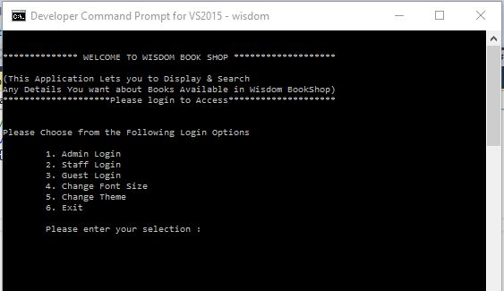

Figure 1 Initial welcome message and main menu

## If Admin Login successful

If Admin Username & password matched with existing admin login details in the system, following Message has to Display (Shown in Figure 2)

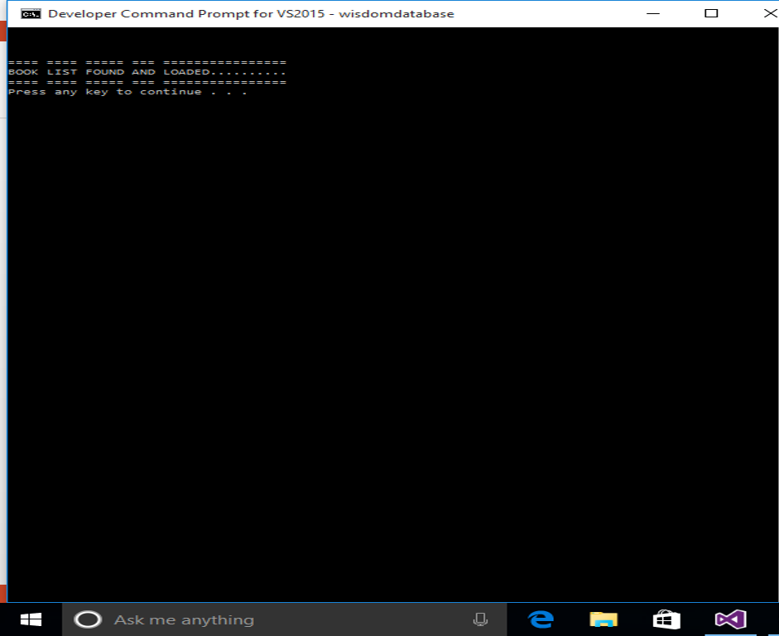

Figure 2 Book List Found and Loaded

This means that database contains all the details of the books is available and ready to display, search, edit, etc…

In case you might see the following error message (As shown in figure 4)

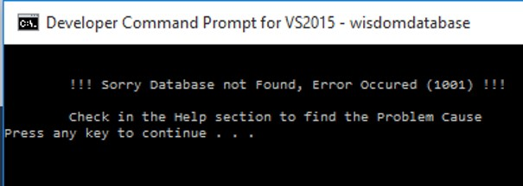

Figure 3 Database Not Found

This means the file contains all the book data might be deleted or moved to some other location, you must contact the IT management to fix this issue.

If you see the display as in the Figure 3 it is normal & you’re ready to get into the administrator functions to display, just press enter or any other key one more time to get the admin function menu, in admin functions you will see the following options.

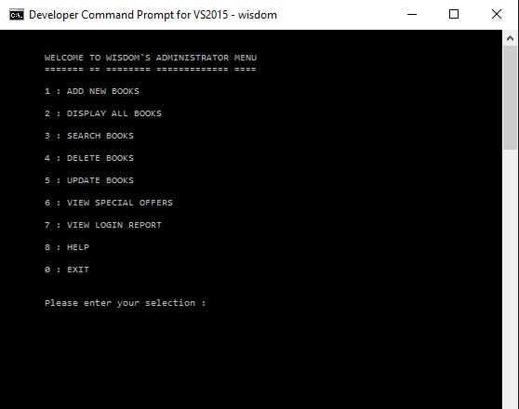

Figure 4 Administrator Menu

Above mentioned functions will be displayed in admin menu. To select from the menu need to input the appropriate number in the list, all functions are described below in numbered order in the menu;

1. ADD NEW BOOKS

For Input No: 1 following Display will appear.

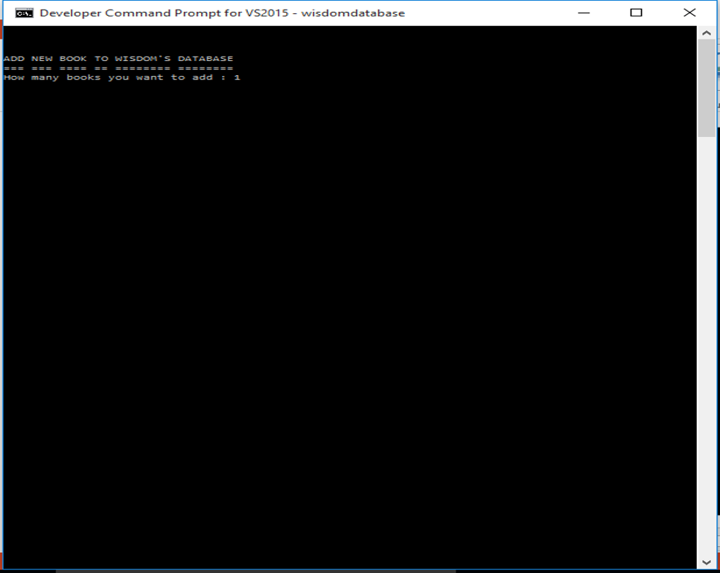

Figure 5 How Many Books want to add?

Here you should enter how many books you want to enter? Then following display will appear.

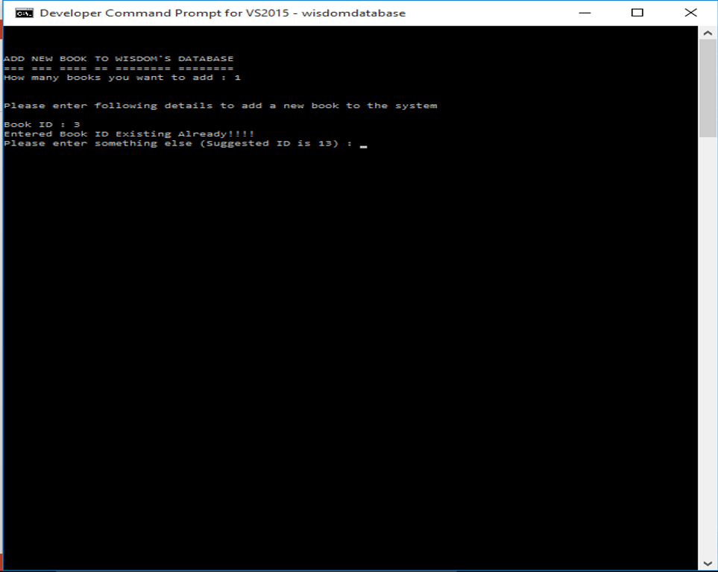

Figure 6 Add Book ID

Adding book ID will be appear in the beginning of book adding Section. If entered book ID is exist already it will notify you as “Entered Book ID existing already” and system will suggest a suitable ID for you, you cannot enter same ID for more than one books, it is prime key for book entries. Then enter following details of the books as per required;

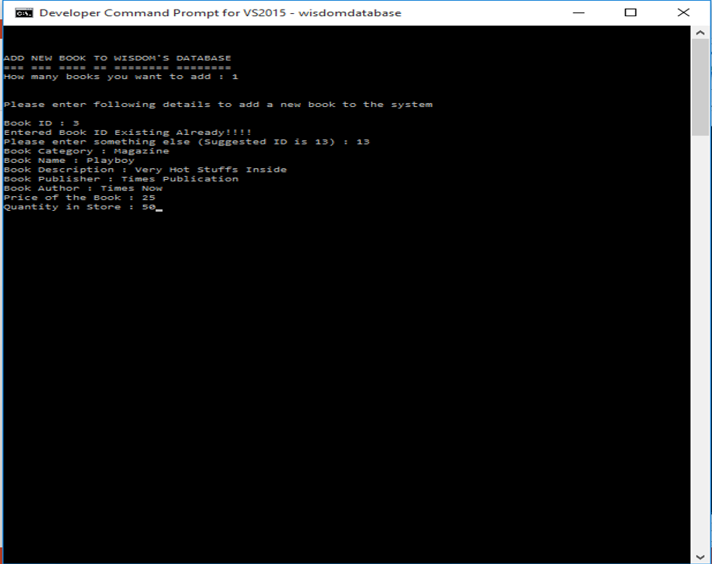

Figure 7 Adding Book Details...

Sample Book details are given above in figure 8. While entering book details in book description if enter book description followed by ‘Sp.’ then this book will be listed as special offer.

1. DISPLAY ALL BOOKS

For Input No: 2 Display All books function will be Appear, in this function all the books details will be displayed whatever available in the Wisdom database. A Sample of this function is given below (Figure 8).

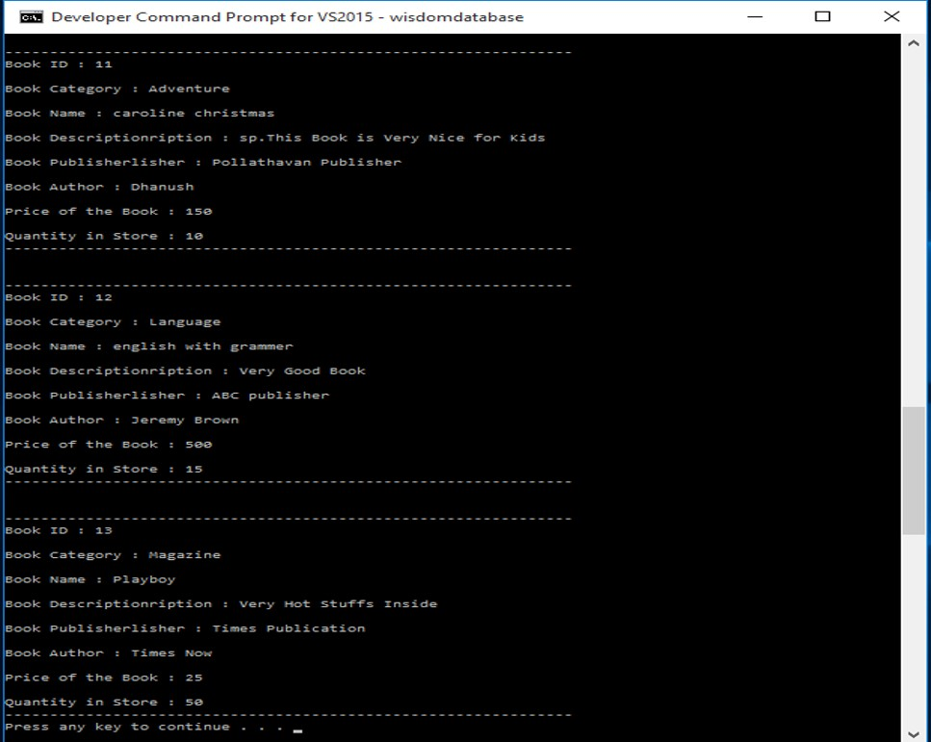

Figure 8 Display All Books

By scrolling scroll bar at right side all book details can be see through. Just by pressing any key able to return to the main menu.

1. SEARCH BOOKS

For input No: 3 search function will appear. In this function books can be searched by many criteria. Search menu is given below (Figure 9).

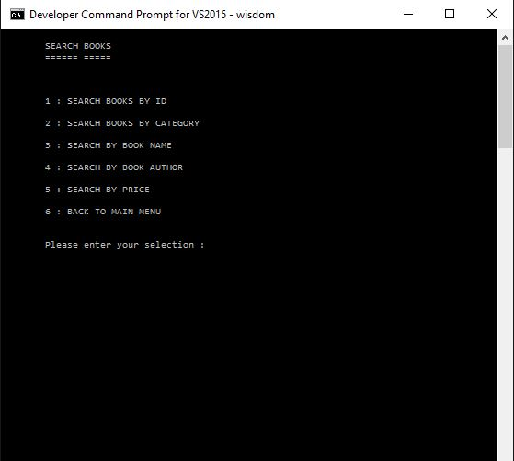

Figure 9 Search Menu

1. SEARCH BOOKS BY ID

For input No: 1 Search books by ID function will appear. In this function books can be searched by ID number of the particular book. A sample search is given below (Figure 10).

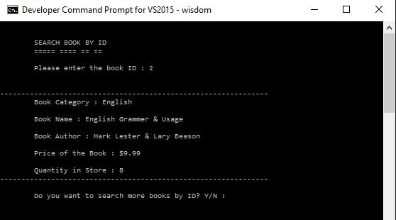

Figure 10 Search by ID

After getting the results there is an indication will be shown to select search more Y/N. by entering ‘y’ search function can be continued or input ‘n’ will take back to search menu. Incase if ID not found in the first time search or need to search more then, search function can be repeated by input ‘y’ as much as required attempts. These inputs are not case sensitive.

1. SEARCH BOOKS BY CATEGORY

For input no: 2 this function will appear. In this function books can be searched by the category of the book. A sample search process is given below (Figure 11).

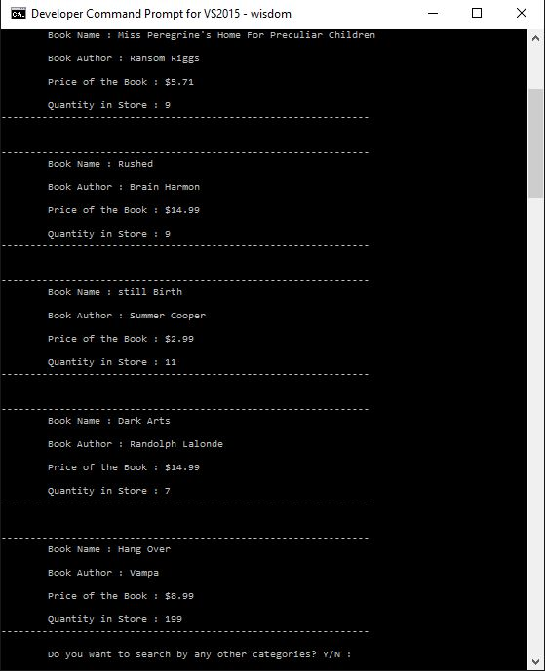

Figure 11 Search by Category

Just by entering first three letters of category will find the proper result, moreover search key letters are not case sensitive. These rules are applicable for all kind of searching options. After getting results you can input ‘y’ to continue the search and ‘n’ to get back to search menu.

1. SEARCH BY BOOK NAME

For input no: 3 this function will appear. In this function books can be searched by name of the book. A sample search process is given below (Figure 12).

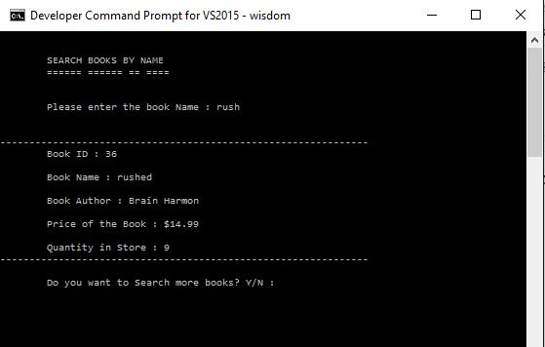

Figure 12 Search by Book Name

After getting results by entering ‘n’ will get back to main menu or input ‘y’ will continue the search function.

1. SEARCH BY BOOK AUTHOR

For input no: 4 this function will appear. In this function books can be searched by author of the book. A sample search process is given below (Figure 13).

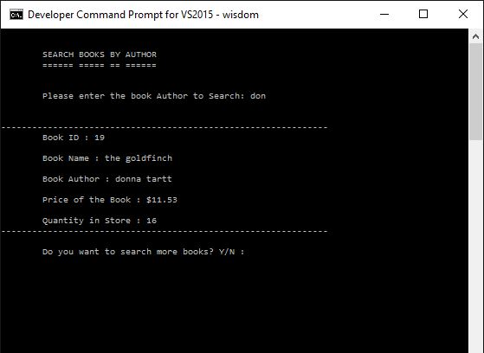

Figure 13 Search Books by Author

After getting results by entering ‘n’ will get back to main menu or input ‘y’ will continue the search function.

1. SEARCH BY PRICE

For input No: 5 will appear this function, once you enter the amount of book price you will be asked to choose one from the following four options

1. Less than $xx
2. Greater than $xx
3. Exact to $xx
4. Return to main menu

Sample process given below (Figure 14).

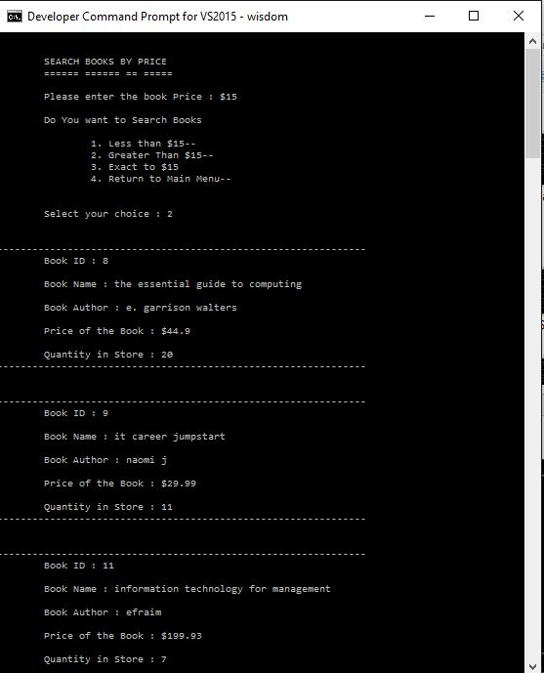

Figure 14 Search by price

After selecting an input from the options it will it will generate the results as per the request and then input ‘y’ will repeat the function and ‘n’ will take back to search menu. From the search menu input ‘6’ will navigate to admin menu.

1. DELETE BOOKS

For Input No: 4 this function will appear, search function will process same as function 3, but additionally delete function added. After searching by book ID, book name or book author, results of the search can be deleted by input ‘y’ for delete notification. But for search by category & display list & delete functions need to input the book ID after display the search results or display list, sample process is given below in following screenshot (Figure 15).

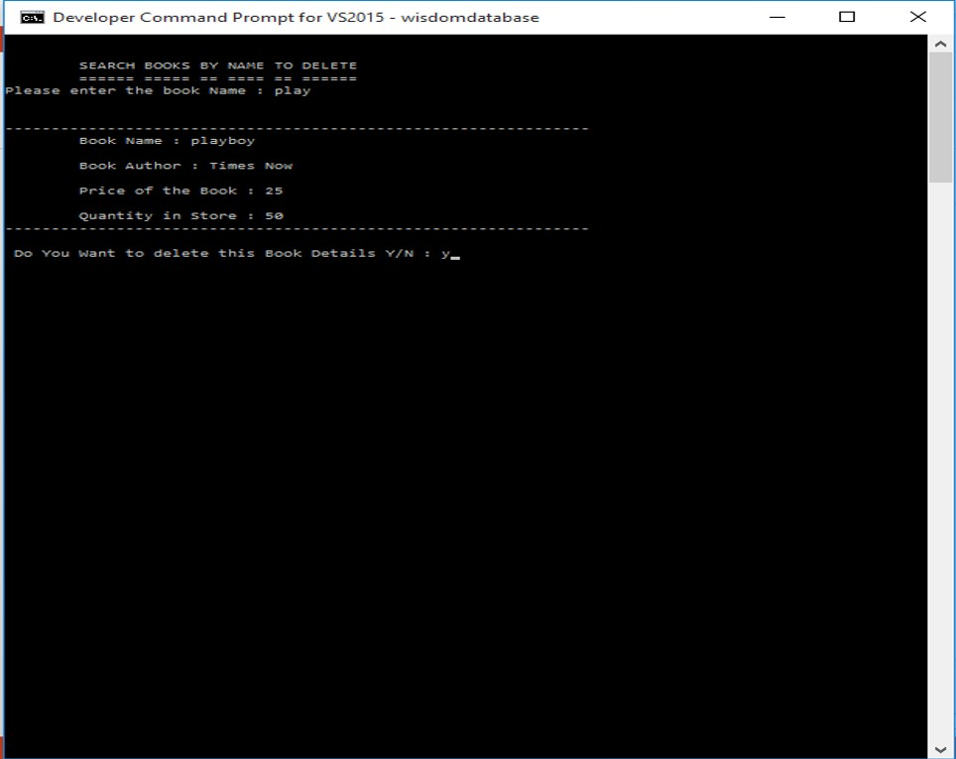

Figure 15 Search by Name to Delete

If multiple results are available it can be selected to delete one by one, by inputting ‘y’ or ‘n’ as per required in other search functions. Input ‘6’ will navigate back to admin menu.

1. UPDATE

For Input No: 5 this function will appear, search function will process same as function 3, but additionally update function added. After searching by book ID, book name or book author, results of the search can be updated by input ‘y’ for update notification. But for search by category & display list & update functions need to input the book ID after display the search results or display list, sample process is given below in following screenshot (Figure 16).

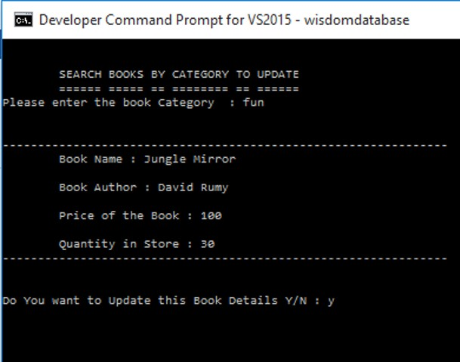

Figure 16 Search and Update by Category

If multiple results are available it can be selected to update one by one, by inputting ‘y’ or ‘n’ as per required. After input ‘y’ updating process will be appear as shown below (Figure 17).

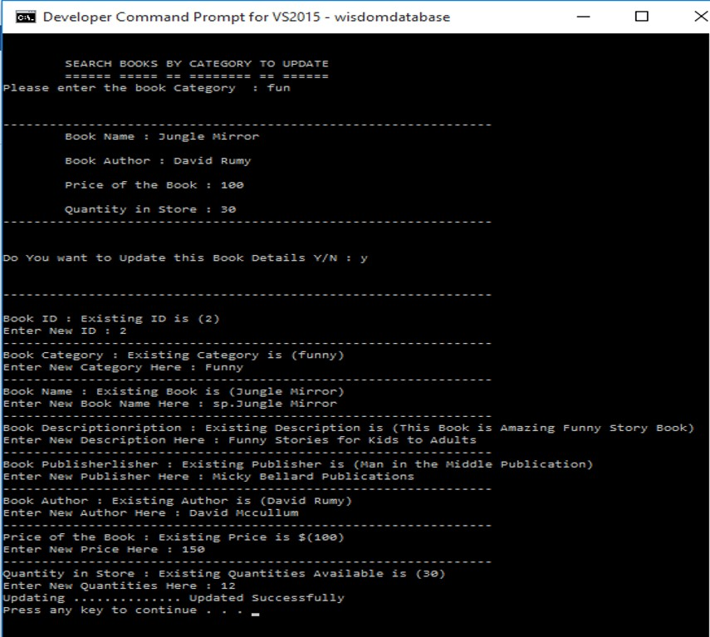

Figure 17 Updating Existing Book details

As shown in Figure 17 While Updating new Book data, existing book details will be displayed. Once complete updating “updating successfully” message will appear and then press any key to back to update menu. From the update menu input ‘6’ will navigate to admin menu as per guided in the list.

1. VIEW SPEACIAL OFFER

For Input No: 6 this function will appear. It will display all the books listed as “special offers”, to add any book to special offer in book description has to be saved by following “Sp.”, to remove any book from special offer list just remove this “Sp.” From the book description and update it. A Sample process is given below (Figure 18).

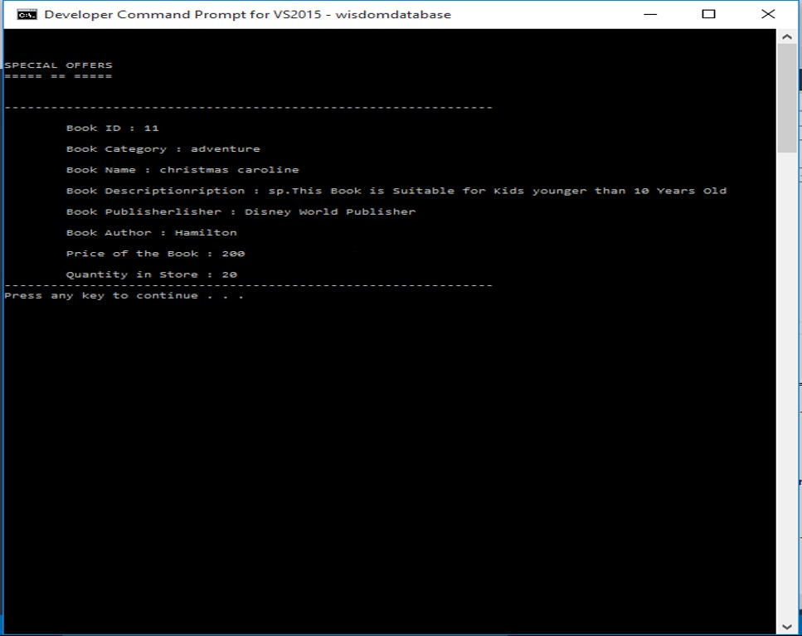

Figure 18 View Special Offer

After the Display View Special Offers Press any key to back to main menu

1. View Login Report

For input No: 13 this function will appear. This Function will show the login time, date & logout time, date of each user. By selecting from the menu login report can be seen.

1. To View Admin login report.
2. To View Staff login report.
3. To View guest login report.
4. Erase all login report.

Sample of each process is given below (Figure 19).

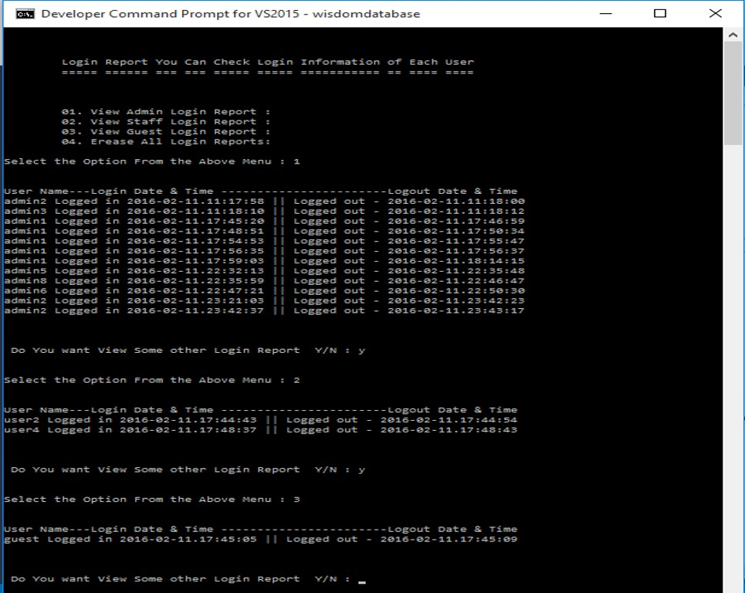

Figure 19 View Login Report

1. Help

For input No: 8 this function will appear. This Function will show Help instructions to operate the Wisdom Database Enquiry system. After view the function press any key to return to back to main menu.

Actual display of help function is given below (Figure 20)

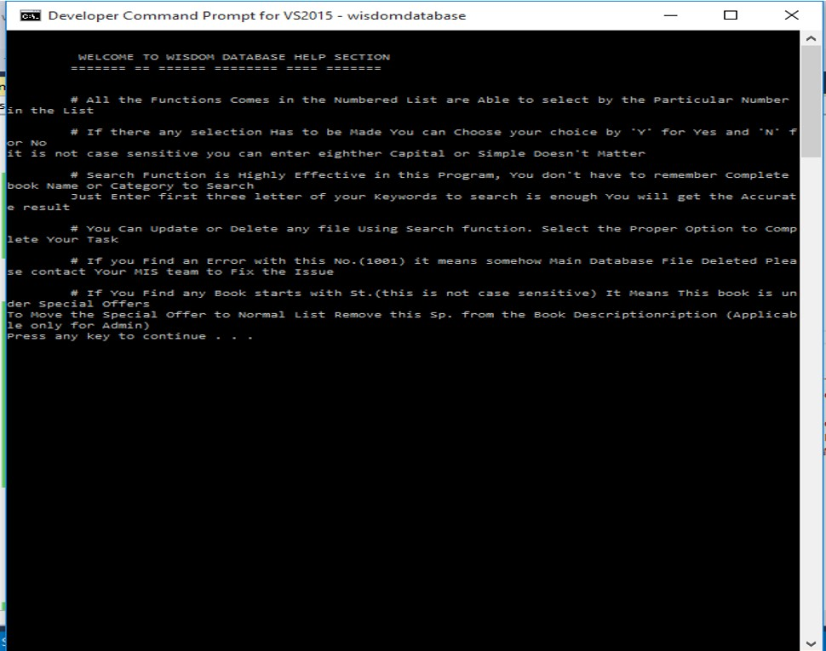

Figure 20 Help Function

# LO 4.1

## Test Plan for Wisdom book Shop’s Enquiry System

Following table will be described the test plan of this particular enquiry system.

|  |  |  |
| --- | --- | --- |
| No | Parameter | Description |
| 01 | Test Plan Identifier | WT-xxx will be unique reference to identify the test cases, xxx represents a variable. |
| 02 | Introduction | Wisdom Book Shop Enquiry System is a tool to manage the Wisdom Book Shop database, It will be used to store, display, search, delete & update the book details of Wisdom Book Shop. |
| 03 | Test Item | Wisdom Book Shop Enquiry System |
| 04 | Features to be tested | Login functions.  Adding, Displaying, Searching, Updating & Deleting Book details.  Proper navigations between the menus.  Accurate flow of data and functions. |
| 05 | Features not to be tested | Common functions between all three of privileged users will not repeat the test for each users. Because same functions are called in different places to execute, in such cases in one executable place only it will be tested. |
| 06 | Testing Techniques | * Black-box testing * White-box testing |
| 07 | Approach | Functional Testing   1. Unit Testing 2. Integration Testing 3. System Testing 4. Acceptance Testing   Non Functional Testing   1. Performance Testing 2. Security Testing 3. Usability Testing 4. Learnability test 5. Efficiency test 6. Satisfaction test 7. Memorability test 8. Error test 9. Compatibility test |
| 08 | Item Pass/Fail Criteria | Documented whether a software item has Pass or failed its test |
| 09 | Test deliverables | Test specifications and Test summary reports |
| 10 | Testing tasks | All tasks for planning and executing the testing |
| 11 | Environmental needs | Hardware & software, OS & tools required. |
| 12 | Staffing and training needs | Staffing requirements and any specific skills and training requirements |

# Test Case W001

|  |  |
| --- | --- |
| Test Case ID | W001 |
| System | WISDOM Enquiry System |
| Sub System | Main Menu Functions |
| Test Method/Technique | White box Technique |
| Designed by | M.F.M Fazrin |
| Executed by | M.F.M Fazrin |
| Execution date | 16/02/2016 |
| Short Description | Testing Change Theme |

Pre-condition

System is still not logged in, this function is accessible to all users

|  |  |  |  |  |
| --- | --- | --- | --- | --- |
| Steps | Action | Expected Response | Pass/ Fail | Comments |
| 01 | Input No 5 to execute | Display “Do you want to change the theme (Y/N)?” | Pass |  |
| 02 | Input ‘Y’ | 1. Black and White theme 2. White and Black theme 3. Return   Enter your Selection here | Pass |  |
| 03 | Input ‘1’ | Background color changed to black and text color changed to white | Pass |  |
| 04 | Input ‘2’ | Background color changed to white and text color changed to black | Pass |  |
| 05 | Input ‘3’ | Back to Main Menu | Pass |  |

Post-conditions & Comments

Color is changed as per selected and Menu Navigations are working properly.

# Test Case W002

|  |  |
| --- | --- |
| Test Case ID | W002 |
| System | WISDOM Enquiry System |
| Sub System | Main Menu Functions |
| Test Method/Technique | Black box Technique |
| Designed by | M.F.M Fazrin |
| Executed by | M.F.M Fazrin |
| Execution date | 16/02/2016 |
| Short Description | Testing Change Theme |

Pre-condition

System is still not logged in, this function is accessible to all users.

|  |  |  |  |  |
| --- | --- | --- | --- | --- |
| Steps | Action | Expected Response | Pass/ Fail | Comments |
| 01 | Input No 5 to execute | Display “Do you want to change the theme (Y/N)?” | Pass |  |
| 02 | Input ‘N’ | Return to Main Menu | Pass |  |
| 03 | Input ‘3’ | Return to Main Menu | Pass |  |
| 04 | Input ‘abcd’ | Display “Please enter a valid Input” | Pass |  |

Post-conditions & Comments

Main Menu functions remains without any navigation errors or any other bugs. No invalid results found.

# Test Case W003

|  |  |
| --- | --- |
| Test Case ID | W003 |
| System | WISDOM Enquiry System |
| Sub System | Main Menu Functions |
| Test Method/Technique | White box Technique |
| Designed by | M.F.M Fazrin |
| Executed by | M.F.M Fazrin |
| Execution date | 16/02/2016 |
| Short Description | Testing Change Font Size |

Pre-condition

System is still not logged in, this function is accessible to all users.

|  |  |  |  |  |
| --- | --- | --- | --- | --- |
| Steps | Action | Expected Response | Pass/ Fail | Comments |
| 01 | Input ‘4’ to execute | Display “Enter font size” | Pass |  |
| 02 | Input 10 | Font size changed to 10 and back to Main Menu | Pass |  |
| 03 | Input 12 | Font size changed to 12 and back to Main Menu | Pass |  |

Post-conditions & Comments

Entire Font Size is changed to entered font size, No bugs or errors found.

# Test Case W004

|  |  |
| --- | --- |
| Test Case ID | W004 |
| System | WISDOM Enquiry System |
| Sub System | Main Menu Functions |
| Test Method/Technique | Black box Technique |
| Designed by | M.F.M Fazrin |
| Executed by | M.F.M Fazrin |
| Execution date | 16/02/2016 |
| Short Description | Testing Change Font Size |

Pre-condition

System is still not logged in, this function is accessible to all users.

|  |  |  |  |  |
| --- | --- | --- | --- | --- |
| Steps | Action | Expected Response | Pass/ Fail | Comments |
| 01 | Input ‘4’ to execute | Display “Enter font size” | Pass |  |
| 02 | Input “Color” | Display “Please Enter a Valid Input “  “Enter for Size “ | Pass |  |
| 03 | Input 1500 | Display “Please enter font size Less than 25...”  “Enter for Size “ | Pass |  |

Post-conditions & Comments

No Errors found while invalid inputs. Font size remains same as it was at the beginning while invalid inputs given.

# Test Case W005

|  |  |
| --- | --- |
| Test Case ID | W005 |
| System | WISDOM Enquiry System |
| Sub System | Main Menu Functions |
| Test Method/Technique | White box Technique |
| Designed by | M.F.M Fazrin |
| Executed by | M.F.M Fazrin |
| Execution date | 16/02/2016 |
| Short Description | Login to Guest Functions |

Pre-condition

System is still not logged in, this function is accessible to all users.

|  |  |  |  |  |
| --- | --- | --- | --- | --- |
| Steps | Action | Expected Response | Pass/ Fail | Comments |
| 01 | Input ‘3’ to execute | Display “BOOK LIST FOUND & LOADED”  “Press any key to continue” | Pass |  |
| 02 | Input ‘Down arrow key’ | Display ”Guest Functions Menu” | Pass |  |
| 03 | Input ‘0’ | Display Main Menu | Pass |  |

Post-conditions & Comments

No Errors found. System is logged into Guest Functions.

# Test Case W006

|  |  |
| --- | --- |
| Test Case ID | W006 |
| System | WISDOM Enquiry System |
| Sub System | Guest Functions |
| Test Method/Technique | White box Technique |
| Designed by | M.F.M Fazrin |
| Executed by | M.F.M Fazrin |
| Execution date | 17/02/2016 |
| Short Description | Display book details |

Pre-condition

System is logged into guest user functions, these functions can be access by all users of this system.

|  |  |  |  |  |
| --- | --- | --- | --- | --- |
| Steps | Action | Expected Response | Pass/ Fail | Comments |
| 01 | Input ‘1’ to execute | Display all existing Book details and then following message  “Press any key to continue” | Pass |  |
| 02 | Input ‘Return Key’ | Return to Display ”Guest Functions Menu” | Pass |  |

Post-conditions & Comments

No Errors found. System is logged into Guest Functions. Displaying book details function is working properly. Menu navigations are working accurately.

# Test Case W007

|  |  |
| --- | --- |
| Test Case ID | W007 |
| System | WISDOM Enquiry System |
| Sub System | Guest Functions |
| Test Method/Technique | Black box Technique |
| Designed by | M.F.M Fazrin |
| Executed by | M.F.M Fazrin |
| Execution date | 17/02/2016 |
| Short Description | Display book details |

Pre-condition

System is logged into guest user functions, these functions can be access by all users of this system.

|  |  |  |  |  |
| --- | --- | --- | --- | --- |
| Steps | Action | Expected Response | Pass/ Fail | Comments |
| 01 | Input ‘a’ | Display “Please enter valid input”  “Please enter your selection” | Pass |  |
| 02 | Input ‘abcd’ | Display “Please enter valid input”  “Please enter your selection” | Pass |  |

Post-conditions & Comments

No errors found. System is logged into guest functions. Menu navigations are working accurately. Invalid inputs displays proper error messages and navigate to try again

# Test Case W008

|  |  |
| --- | --- |
| Test Case ID | W008 |
| System | WISDOM Enquiry System |
| Sub System | Search books by ID number |
| Test Method/Technique | White box Technique |
| Designed by | M.F.M Fazrin |
| Executed by | M.F.M Fazrin |
| Execution date | 17/02/2016 |
| Short Description | Testing Search books by ID number |

Pre-condition

System is logged into guest user functions, these functions can be access by all users of this system.

|  |  |  |  |  |
| --- | --- | --- | --- | --- |
| Steps | Action | Expected Response | Pass/ Fail | Comments |
| 01 | Input ‘2’ to execute | Display “Please enter the book ID” | Pass |  |
| 02 | Input ‘5’ | Display book details with ID number ‘5’  And following message  “Do you want to search more by book ID? Y/N” | Pass |  |
| 03 | Input ‘Y’ | Display “Please enter the book ID” | Pass |  |
| 04 | Input ‘10’ | Display book details with ID number ‘10’  And following message  “Do you want to search more by book ID? Y/N” | Pass |  |
| 05 | Input ‘N’ | Back to Guest Menu | Pass |  |

Post-conditions & Comments

No errors found. Search results are accurate. Menu navigations are working properly.

# Test Case W009

|  |  |
| --- | --- |
| Test Case ID | W009 |
| System | WISDOM Enquiry System |
| Sub System | Search books by ID number |
| Test Method/Technique | Black box Technique |
| Designed by | M.F.M Fazrin |
| Executed by | M.F.M Fazrin |
| Execution date | 17/02/2016 |
| Short Description | Testing Search books by ID number |

Pre-condition

System is logged into guest user functions, these functions can be accessed by all users of this system.

|  |  |  |  |  |
| --- | --- | --- | --- | --- |
| Steps | Action | Expected Response | Pass/ Fail | Comments |
| 01 | Input ‘2’ to execute | Display “Please enter the book ID” | Pass |  |
| 02 | Input ‘0’ | Display “Sorry…Given book ID is not found… Would you like to try again? Y/N“ Do you want to search more by book ID? Y/N” | Pass |  |
| 03 | Input ‘abc’ | Display “Please enter Valid Input”  “Would you like to try again? Y/N” | Fail | Displaying “Please enter Valid input” but returning back to guest functions. |
| 04 | Input ‘2’ | Display “Please enter the book ID” | Pass |  |
| 05 | Input ‘4’ | Display book details with ID number ‘4’  and following message  “Do you want to search more by book ID? Y/N” | Pass |  |
| 06 | Input ‘abc’ | Display ”Please enter a valid input”  “Do you want to search more by book ID? Y/N” | Fail | Displaying “Please enter Valid input” but returning back to guest functions. |

Post-conditions & Comments

Menu navigations has confused while invalid inputs. Invalid inputs turn the function back to guest functions. No other errors found. Function can be repeat from the guest menu again and works properly for valid inputs.

# Test Case W010

|  |  |
| --- | --- |
| Test Case ID | W010 |
| System | WISDOM Enquiry System |
| Sub System | Search books by category |
| Test Method/Technique | White box Technique |
| Designed by | M.F.M Fazrin |
| Executed by | M.F.M Fazrin |
| Execution date | 17/02/2016 |
| Short Description | Testing Search books by category |

Pre-condition

System is logged into guest user functions, these functions can be accessed by all users of this system.

|  |  |  |  |  |
| --- | --- | --- | --- | --- |
| Steps | Action | Expected Response | Pass/ Fail | Comments |
| 01 | Input ‘3’ to execute | Display “Please enter the book category to search” | Pass |  |
| 02 | Input ‘horror’ | Display book details with the category name of ‘horror “Do you want to search by any other categories? Y/N” | Pass |  |
| 03 | Input ‘Y’ | Display “Please enter the book category to search” | Pass |  |
| 04 | Input ‘funny’ | Sorry... The given book category is not found....Would you like to try again? Y/N | Pass |  |
| 05 | Input ‘N’ | Back to Guest Menu | Pass |  |

Post-conditions & Comments

No errors found. Search results are accurate. Menu navigations are working properly.

# Test Case W011

|  |  |
| --- | --- |
| Test Case ID | W011 |
| System | WISDOM Enquiry System |
| Sub System | Search books by category |
| Test Method/Technique | Black box Technique |
| Designed by | M.F.M Fazrin |
| Executed by | M.F.M Fazrin |
| Execution date | 17/02/2016 |
| Short Description | Testing Search books by category |

Pre-condition

System is logged into guest user functions, these functions can be accessed by all users of this system.

|  |  |  |  |  |
| --- | --- | --- | --- | --- |
| Steps | Action | Expected Response | Pass/ Fail | Comments |
| 01 | Input ‘3’ to execute | Display “Please enter the book category to search” | Pass |  |
| 02 | Input ‘123’ | Display  ”Sorry... The given book category is not found....Would you like to try again? Y/N” | Pass |  |
| 03 | Input ‘abc’ | Display “Please enter valid input”  Display”  ”Sorry... The given book category is not found....Would you like to try again? Y/N” | Fail | Display “Please enter valid input”  But returning to guest menu. |

Post-conditions & Comments

Expected error messages showing while invalid inputs but menu navigations are confused while invalid inputs. No other errors found. Search function can be executed again from the guest menu and works properly for valid inputs

# Test Case W012

|  |  |
| --- | --- |
| Test Case ID | W012 |
| System | WISDOM Enquiry System |
| Sub System | Search books by name |
| Test Method/Technique | White box Technique |
| Designed by | M.F.M Fazrin |
| Executed by | M.F.M Fazrin |
| Execution date | 17/02/2016 |
| Short Description | Testing Search books by name |

Pre-condition

System is logged into guest user functions, these functions can be accessed by all users of this system.

|  |  |  |  |  |
| --- | --- | --- | --- | --- |
| Steps | Action | Expected Response | Pass/ Fail | Comments |
| 01 | Input ‘4’ to execute | Display “Please enter the book name” | Pass |  |
| 02 | Input ‘rushed’ | Display book details with the name of “rushed“  “Do you want to search more books? Y/N” | Pass |  |
| 03 | Input ‘Y’ | Display “Please enter the book name to search” | Pass |  |
| 04 | Input ‘science’ | Display “Sorry... The given book name is not found....Retry? Y/N” | Pass |  |
| 05 | Input ‘N’ | Back to Guest Menu | Pass |  |

Post-conditions & Comments

No errors found. Search results are accurate. Menu navigations are working properly.

# Test Case W013

|  |  |
| --- | --- |
| Test Case ID | W013 |
| System | WISDOM Enquiry System |
| Sub System | Search books by name |
| Test Method/Technique | Black box Technique |
| Designed by | M.F.M Fazrin |
| Executed by | M.F.M Fazrin |
| Execution date | 17/02/2016 |
| Short Description | Testing Search books by name |

Pre-condition

System is logged into guest user functions, these functions can be accessed by all users of this system.

|  |  |  |  |  |
| --- | --- | --- | --- | --- |
| Steps | Action | Expected Response | Pass/ Fail | Comments |
| 01 | Input ‘4’ to execute | Display “Please enter the book name” | Pass |  |
| 02 | Input ‘123’ | Display  ”Sorry... The given book name is not found....Retry? Y/N” | Pass |  |
| 03 | Input ‘abc’ | Display “Please enter valid input”  ”Sorry... The given book name is not found....Retry? Y/N” | Fail | Display “Please enter valid input”  But returning to guest menu. |

Post-conditions & Comments

Expected error messages showing while invalid inputs but menu navigations are confused while invalid inputs. No other errors found. Search function can be executed again from the guest menu and works properly for valid inputs

# Test Case W014

|  |  |
| --- | --- |
| Test Case ID | W014 |
| System | WISDOM Enquiry System |
| Sub System | Search books by author |
| Test Method/Technique | White box Technique |
| Designed by | M.F.M Fazrin |
| Executed by | M.F.M Fazrin |
| Execution date | 17/02/2016 |
| Short Description | Testing Search books by author |

Pre-condition

System is logged into guest user functions, these functions can be accessed by all users of this system.

|  |  |  |  |  |
| --- | --- | --- | --- | --- |
| Steps | Action | Expected Response | Pass/ Fail | Comments |
| 01 | Input ‘5’ to execute | Display “Please enter the book author to search” | Pass |  |
| 02 | Input ‘ran’ | Display all the book details with the author name starts with “ran“  “Do you want to search more books? Y/N” | Pass |  |
| 03 | Input ‘Y’ | Display “Please enter the book author to search” | Pass |  |
| 04 | Input ‘ban’ | Display “Sorry... The given book author is not found....Would you like to try again? Y/N” | Pass |  |
| 05 | Input ‘N’ | Back to Guest Menu | Pass |  |

Post-conditions & Comments

No errors found. Search results are accurate. Menu navigations are working properly.

# Test Case W015

|  |  |
| --- | --- |
| Test Case ID | W015 |
| System | WISDOM Enquiry System |
| Sub System | Search books by author |
| Test Method/Technique | Black box Technique |
| Designed by | M.F.M Fazrin |
| Executed by | M.F.M Fazrin |
| Execution date | 17/02/2016 |
| Short Description | Testing Search books by author |

Pre-condition

System is logged into guest user functions, these functions can be accessed by all users of this system.

|  |  |  |  |  |
| --- | --- | --- | --- | --- |
| Steps | Action | Expected Response | Pass/ Fail | Comments |
| 01 | Input ‘5’ to execute | Display “Please enter the book author to search” | Pass |  |
| 02 | Input ‘123’ | Display  ”Sorry... The given book author is not found....Would you like to try again? Y/N” | Pass |  |
| 03 | Input ‘abc’ | Display “Please enter valid input”  ”Sorry... The given book name is not found....Retry? Y/N” | Fail | Display “Please enter valid input”  But returning to guest menu. |

Post-conditions & Comments

Expected error messages showing while invalid inputs but menu navigations are confused while invalid inputs. No other errors found. Search function can be executed again from the guest menu and works properly for valid inputs

# Test Case W016

|  |  |
| --- | --- |
| Test Case ID | W016 |
| System | WISDOM Enquiry System |
| Sub System | Search books by price |
| Test Method/Technique | White box Technique |
| Designed by | M.F.M Fazrin |
| Executed by | M.F.M Fazrin |
| Execution date | 17/02/2016 |
| Short Description | Testing Search books by price |

Pre-condition

System is logged into guest user functions, these functions can be accessed by all users of this system.

|  |  |  |  |  |
| --- | --- | --- | --- | --- |
| Steps | Action | Expected Response | Pass/ Fail | Comments |
| 01 | Input ‘6’ to execute | Display “Please enter the book price” | Pass |  |
| 02 | Input ‘10’ | Display “Do you want to search books   1. Less than $10 2. Greater than $10 3. Exact to $10 4. Return to main menu   Select your choice” | Pass |  |
| 03 | Input ‘1’ | Display all books less than $10  “Do you want to search more books? Y/N” | Pass |  |
| 04 | Input ‘y’ | Display “Please enter the book price” | Pass |  |
| 05 | Input ‘5’ | Display “Do you want to search books   1. Less than $5 2. Greater than $5 3. Exact to $5 4. Return to main menu   Select your choice” | Pass |  |
| 06 | Input ‘2’ | Display all books greater than $5  “Do you want to search more books? Y/N” | Pass |  |
| 07 | Input ‘y’ | Display “Please enter the book price” | Pass |  |
| 08 | Input ‘10’ | Display “Do you want to search books   1. Less than $10 2. Greater than $10 3. Exact to $10 4. Return to main menu   Select your choice” | Pass |  |
| 09 | Input ‘3’ | Display all books exactly $10  “Do you want to search more books? Y/N” | Pass |  |
| 10 | Input ‘y’ | Display “Please enter the book price” | Pass |  |
| 11 | Input ‘1500’ | Display “Do you want to search books   1. Less than $1500 2. Greater than $1500 3. Exact to $1500 4. Return to main menu   Select your choice” | Pass |  |
| 12 | Input ‘2’ | Display “Sorry… No books found greater than $1500 … Retry? Y/N” | Pass |  |
| 13 | Input ‘y’ | Display “Please enter the book price” | Pass |  |
| 14 | Input ‘0’ | Display “Do you want to search books   1. Less than $0 2. Greater than $0 3. Exact to $0 4. Return to main menu   Select your choice” | Pass |  |
| 15 | Input ‘1’ | Display “Sorry… No books found less than $0 … Retry? Y/N” | Pass |  |
| 16 | Input ‘n’ | Back to guest menu | Pass |  |

Post-conditions & Comments

No errors found. Search results are accurate. Menu navigations are working properly.

# Test Case W017

|  |  |
| --- | --- |
| Test Case ID | W017 |
| System | WISDOM Enquiry System |
| Sub System | Search books by price |
| Test Method/Technique | Black box Technique |
| Designed by | M.F.M Fazrin |
| Executed by | M.F.M Fazrin |
| Execution date | 17/02/2016 |
| Short Description | Testing Search books by price |

Pre-condition

System is logged into guest user functions, these functions can be accessed by all users of this system.

|  |  |  |  |  |
| --- | --- | --- | --- | --- |
| Steps | Action | Expected Response | Pass/ Fail | Comments |
| 01 | Input ‘6’ to execute | Display “Please enter the book price” | Pass |  |
| 02 | Input ‘10’ | Display “Do you want to search books   1. Less than $10 2. Greater than $10 3. Exact to $10 4. Return to main menu   Select your choice” | Pass |  |
| 03 | Input ‘abcd’ | Display “Please enter valid input”  ”select your choice” | Pass |  |
| 04 | Input ‘6’ | Return to guest menu | pass |  |

Post-conditions & Comments

Expected error messages showing while invalid inputs. Menu navigations are working properly. No errors found.

# Test Case W018

|  |  |
| --- | --- |
| Test Case ID | W018 |
| System | WISDOM Enquiry System |
| Sub System | View special offers |
| Test Method/Technique | White box Technique |
| Designed by | M.F.M Fazrin |
| Executed by | M.F.M Fazrin |
| Execution date | 17/02/2016 |
| Short Description | Testing view special offers |

Pre-condition

System is logged into guest user functions, these functions can be access by all users of this system.

|  |  |  |  |  |
| --- | --- | --- | --- | --- |
| Steps | Action | Expected Response | Pass/ Fail | Comments |
| 01 | Input ‘7’ to execute | Display all existing special offer book details and then following message  “Press any key to continue” | Pass |  |
| 02 | Input ‘Return Key’ | Return to Display ”Guest Functions Menu” | Pass |  |

Post-conditions & Comments

No Errors found. System is logged into Guest Functions. Displaying special offers function is working properly. Menu navigations are working accurately.

# Test Case W019

|  |  |
| --- | --- |
| Test Case ID | W019 |
| System | WISDOM Enquiry System |
| Sub System | Help function |
| Test Method/Technique | White box Technique |
| Designed by | M.F.M Fazrin |
| Executed by | M.F.M Fazrin |
| Execution date | 17/02/2016 |
| Short Description | Testing help function |

Pre-condition

System is logged into guest user functions, these functions can be access by all users of this system.

|  |  |  |  |  |
| --- | --- | --- | --- | --- |
| Steps | Action | Expected Response | Pass/ Fail | Comments |
| 01 | Input ‘8’ to execute | Display Help function with following message  “Press any key to continue” | Pass |  |
| 02 | Input ‘Return Key’ | Return to Display ”Guest Functions Menu” | Pass |  |

No Errors found. System is logged into Guest Functions. Displaying help function is working properly. Menu navigations are working accurately.

Post-conditions & Comments

# Test Case W020

|  |  |
| --- | --- |
| Test Case ID | W020 |
| System | WISDOM Enquiry System |
| Sub System | Guest Functions |
| Test Method/Technique | White box Technique |
| Designed by | M.F.M Fazrin |
| Executed by | M.F.M Fazrin |
| Execution date | 17/02/2016 |
| Short Description | Navigate back to main menu & exit |

Pre-condition

System is logged into guest user functions, these functions can be access by all users of this system.

|  |  |  |  |  |
| --- | --- | --- | --- | --- |
| Steps | Action | Expected Response | Pass/ Fail | Comments |
| 01 | Input ‘0’ to execute | Display main menu with following message,  “Dear guest of Wisdom!!!.. Thank you for spent your precious ‘xyz’ seconds with us”  “See you soon…”  “Press any key to continue” | Pass |  |
| 02 | Input ‘6’ | Display  “Total time of wisdom enquiry system used ‘xyz’(minutes spent on the enquiry system’ minutes ”  “Welcome again”  “Press any key to continue” | Pass |  |

Post-conditions & Comments

No Errors found. System is logged out form all Functions. Menu navigations works properly and terminate the system when it is navigate to exit.

# Test Case W021

|  |  |
| --- | --- |
| Test Case ID | W021 |
| System | WISDOM Enquiry System |
| Sub System | Staff Functions |
| Test Method/Technique | White box Technique |
| Designed by | M.F.M Fazrin |
| Executed by | M.F.M Fazrin |
| Execution date | 18/02/2016 |
| Short Description | Login & Logout staff functions |

Pre-condition

System is not logged into any functions, executable from the main menu. This function can be accessed by only with staff ID and password of this system.

|  |  |  |  |  |
| --- | --- | --- | --- | --- |
| Steps | Action | Expected Response | Pass/ Fail | Comments |
| 01 | Input ‘2’ to execute | Display  “Please enter the username ” | Pass |  |
| 02 | Input ‘user1’ | Display  “Please enter the password ” | Pass |  |
| 03 | Input ‘pass1’ | Display  “BOOK LIST FOUND AND LOADED”  “Press any key to continue” | Pass |  |
| 04 | Input ’Return’ key | Display Staff Functions.  “All the functions available in the staff menu are same to guest, those functions tested already from W006 to W019. “ | Pass |  |
| 05 | Input ‘0’ to logout | Display  “Dear user1 of Wisdom!!!”  “You have spent ‘xyz’(seconds spent on system) seconds with wisdom enquiry system”  “Press any key to continue” | Pass |  |
| 06 | Input ‘Return’ key | Display Main menu | Pass |  |
| 07 | Input ‘6’ | Display  “Total time of wisdom enquiry system used ‘xyz’(minutes spent on the enquiry system’ minutes ”  “Welcome again”  “Press any key to continue” | Pass |  |
| 08 | Input ‘Return’ key | Terminate the system | Pass |  |

Post-conditions & Comments

No errors found. System is logged out form all functions. Menu navigations works properly and terminate the system when it is navigate to exit.

# Test Case W022

|  |  |
| --- | --- |
| Test Case ID | W022 |
| System | WISDOM Enquiry System |
| Sub System | Staff functions |
| Test Method/Technique | Black box Technique |
| Designed by | M.F.M Fazrin |
| Executed by | M.F.M Fazrin |
| Execution date | 19/02/2016 |
| Short Description | Log in & logout staff functions |

Pre-condition

System not logged into any accounts, this function can be accessed by only with staff username & password.

|  |  |  |  |  |
| --- | --- | --- | --- | --- |
| Steps | Action | Expected Response | Pass/ Fail | Comments |
| 01 | Input ‘2’ to execute | Display “Please enter the username” | Pass |  |
| 02 | Input ‘user0’ | Display ” Please enter the password” | Pass |  |
| 03 | Input ‘pass0’ | Display “Username & password is invalid”  “Press any key to continue” | Pass |  |
| 04 | Input ’Return’ key | Display admin menu | pass |  |

Post-conditions & Comments

No errors found. System is not logged in to staff functions. Menu navigations are working properly.

# Test Case W023

|  |  |
| --- | --- |
| Test Case ID | W023 |
| System | WISDOM Enquiry System |
| Sub System | Admin Functions |
| Test Method/Technique | White box Technique |
| Designed by | M.F.M Fazrin |
| Executed by | M.F.M Fazrin |
| Execution date | 19/02/2016 |
| Short Description | Log in to admin functions |

Pre-condition

System not logged into any accounts, this function can be accessed by only with admin username & password.

|  |  |  |  |  |
| --- | --- | --- | --- | --- |
| Steps | Action | Expected Response | Pass/ Fail | Comments |
| 01 | Input ‘1’ to execute | Display “Please enter the username” | Pass |  |
| 02 | Input ‘admin1’ | Display ” Please enter the password” | Pass |  |
| 03 | Input ‘p1’ | “Book list found & loaded”  “Press any key to continue” | Pass |  |
| 04 | Input ’Return’ key | Display admin menu | pass |  |

Post-conditions & Comments

No errors found. System is logged in to admin functions. Menu navigations are working properly.

# Test Case W024

|  |  |
| --- | --- |
| Test Case ID | W024 |
| System | WISDOM Enquiry System |
| Sub System | Admin functions |
| Test Method/Technique | Black box Technique |
| Designed by | M.F.M Fazrin |
| Executed by | M.F.M Fazrin |
| Execution date | 19/02/2016 |
| Short Description | Log in to admin function |

Pre-condition

System not logged into any accounts, this function can be accessed by only with admin username & password.

|  |  |  |  |  |
| --- | --- | --- | --- | --- |
| Steps | Action | Expected Response | Pass/ Fail | Comments |
| 01 | Input ‘1’ to execute | Display “Please enter the username” | Pass |  |
| 02 | Input ‘admin0’ | Display ” Please enter the password” | Pass |  |
| 03 | Input ‘p0’ | Display “Username & password is invalid”  “Press any key to continue” | Pass |  |
| 04 | Input ‘return’ key | Return to main menu | pass |  |

Post-conditions & Comments

No errors found. System is not login to any function. Menu navigations are working properly and terminate the system when it is navigate to exit.

# Test Case W025

|  |  |
| --- | --- |
| Test Case ID | W025 |
| System | WISDOM Enquiry System |
| Sub System | Admin functions |
| Test Method/Technique | Black box Technique |
| Designed by | M.F.M Fazrin |
| Executed by | M.F.M Fazrin |
| Execution date | 19/02/2016 |
| Short Description | Add new books to system |

Pre-condition

System logged into admin function, this function can be accessed by only admin privilege users.

|  |  |  |  |  |
| --- | --- | --- | --- | --- |
| Steps | Action | Expected Response | Pass/ Fail | Comments |
| 01 | Input ‘1’ to execute | Display “How many books you want to add?” | Pass |  |
| 02 | Input ‘1’ | Display ” (small instruction)”  “Book ID” | Pass |  |
| 03 | Input ‘40’ | Display “Book category” | Pass |  |
| 04 | Input ‘Fiction’ | Display “Book name” | Pass |  |
| 05 | Input ‘Alien vs. predator’ | Display ”Book description” | Pass |  |
| 06 | Input ’sp.This book is fiction story of alien & human fighting in the moon” | Display “Book publisher” | Pass |  |
| 07 | Input ‘RKGB publishers’ | Display “Book author’ | Pass |  |
| 08 | Input ‘Susan Dias’ | Display “Book price $” | Pass |  |
| 09 | Input ‘4.99’ | Display “Quantity in store” | Pass |  |
| 10 | Input ‘20’ | Display “Book details added successfully”  “Press any key to continue” | Pass |  |
| 11 | Input ‘Return’ key | Navigate to admin menu | Pass |  |

Post-conditions & Comments

No errors found. System is login to admin function. Book details added successfully. Menu navigations are working properly. In book description ‘sp.’ is added in front of description to add this book under special offer category. Book details added to special offers category successfully.

# Test Case W026

|  |  |
| --- | --- |
| Test Case ID | W026 |
| System | WISDOM Enquiry System |
| Sub System | Admin functions |
| Test Method/Technique | Black box Technique |
| Designed by | M.F.M Fazrin |
| Executed by | M.F.M Fazrin |
| Execution date | 19/02/2016 |
| Short Description | Log in to admin function |

Pre-condition

System logged into admin function, this function can be accessed by only admin privilege users.

|  |  |  |  |  |
| --- | --- | --- | --- | --- |
| Steps | Action | Expected Response | Pass/ Fail | Comments |
| 01 | Input ‘1’ to execute | Display “How many books you want to add?” | Pass |  |
| 02 | Input ‘abc’ | Display ” Please enter a valid input”  “How many books you want to add” | Pass |  |
| 03 | Input ‘1’ | Display “Book ID” | Pass |  |
| 04 | Input ‘4’ | Display “Entered book ID exist already”  “Please enter a different ID (Suggested ID is xx)” | pass |  |
| 05 | Input ‘abc’ | Display ” Please enter a valid input”  “Book ID” | Pass |  |
| 06 | Input all other details until book price | Display “Book Price” | Pass |  |
| 07 | Input ‘xyz’ | Display ” Please enter a valid input”  “Book price” | Pass |  |
| 08 | Input ‘10’ | Display “Available quantity in store” | Pass |  |
| 09 | Input ‘abcd’ | Display ” Please enter a valid input”  “Available quantity in store” | Pass |  |
| 10 | Input ‘20’ | Display “Book details added successfully”  “Press any key to continue” | Pass |  |

Post-conditions & Comments

System is logged into admin function. Menu navigations are working properly, while invalid inputs occur system displays proper error messages and navigate to retry.

# Test Case W027

|  |  |
| --- | --- |
| Test Case ID | W027 |
| System | WISDOM Enquiry System |
| Sub System | Admin function |
| Test Method/Technique | White box Technique |
| Designed by | M.F.M Fazrin |
| Executed by | M.F.M Fazrin |
| Execution date | 19/02/2016 |
| Short Description | Search & delete by ID |

Pre-condition

System is logged into admin function, this function can be accessed by only admin privilege users.

|  |  |  |  |  |
| --- | --- | --- | --- | --- |
| Steps | Action | Expected Response | Pass/ Fail | Comments |
| 01 | Input ‘4’ to execute | Display delete function menu | Pass |  |
| 02 | Input ‘1’ | Display ” Please enter the book ID” | Pass |  |
| 03 | Input ‘40’ | Display details of book with book ID no 40 and  “Do you want to delete this book? Y/N” | Pass |  |
| 04 | Input ‘Y’ | Display “ Book list found & loaded “  “Selected item deleted successfully…”  “Do you want to search more? Y/N | pass |  |
| 05 | Input ‘y’ | “Please enter the book ID” | Pass |  |
| 06 | Input ‘39’ | Display “Sorry given book ID not found would you like to try again? Y/N” | pass |  |
| 07 | Input ‘N’ | Display “Press any key to continue” | Pass |  |
| 08 | Input ‘Return’ key | Navigate back to delete menu | Pass |  |

Post-conditions & Comments

No errors found. System is logged in to admin functions. Menu navigations are working properly. Specific book details are deleted successfully.

# Test Case W028

|  |  |
| --- | --- |
| Test Case ID | W028 |
| System | WISDOM Enquiry System |
| Sub System | Admin function |
| Test Method/Technique | Black box Technique |
| Designed by | M.F.M Fazrin |
| Executed by | M.F.M Fazrin |
| Execution date | 19/02/2016 |
| Short Description | Search & delete by ID |

Pre-condition

System is logged into admin function, this function can be accessed by only admin privilege users.

|  |  |  |  |  |
| --- | --- | --- | --- | --- |
| Steps | Action | Expected Response | Pass/ Fail | Comments |
| 01 | Input ‘4’ to execute | Display delete function menu | Pass |  |
| 02 | Input ‘1’ | Display ” Please enter the book ID” | Pass |  |
| 03 | Input ‘abcd’ | Display “Please enter a valid input”  ”Please enter the book ID” | Pass |  |
| 04 | Input ‘35’ | Display details of book with book ID no 35 and  “Do you want to delete this book? Y/N” | pass |  |
| 05 | Input ‘abc’ | Display “Please enter valid input”  “Please enter the book ID” | fail | Displaying “entered book ID not found…..” and navigate back to delete menu |
| 06 | Input ‘1’ | Display “Enter book ID” | pass |  |
| 07 | Input ‘40’ | Display “Sorry given book ID not found would you like to try again? Y/N” | Pass |  |
| 08 | Input ‘n’ key | Display “Press any key to continue” | Pass |  |
| 09 | Input ‘return’ key | Navigate back to delete menu | Pass |  |

Post-conditions & Comments

System is logged in to admin functions. Menu navigation is confused while invalid input to Y/N selection. Yet delete function can be repeated from the delete menu again.

# Test Case W029

|  |  |
| --- | --- |
| Test Case ID | W029 |
| System | WISDOM Enquiry System |
| Sub System | Admin function |
| Test Method/Technique | White box Technique |
| Designed by | M.F.M Fazrin |
| Executed by | M.F.M Fazrin |
| Execution date | 19/02/2016 |
| Short Description | Search & delete by book category |

Pre-condition

System is logged into admin function, this function can be accessed by only admin privilege users.

|  |  |  |  |  |
| --- | --- | --- | --- | --- |
| Steps | Action | Expected Response | Pass/ Fail | Comments |
| 01 | Input ‘4’ to execute | Display delete function menu | Pass |  |
| 02 | Input ‘2’ | Display ” Please enter the book category” | Pass |  |
| 03 | Input ‘horror’ | Display details of book with book category name ‘horror’ and  “Do you want to delete any of the books from the results? Y/N” | Pass |  |
| 04 | Input ‘Y’ | Display “Enter the book ID you want to delete” | pass |  |
| 05 | Input ‘y’ | “Please enter the book ID” | Pass |  |
| 06 | Input ‘38’ | Display “Selected book list deleted successfully.. “Do you want to delete any other categories? Y/N” | pass |  |
| 07 | Input ‘N’ | Display “Press any key to continue” | Pass |  |
| 08 | Input ‘Return’ key | Navigate back to delete menu | Pass |  |

Post-conditions & Comments

No errors found. System is logged in to admin functions. Menu navigations are working properly. Specific book details are deleted successfully.

# Test Case W030

|  |  |
| --- | --- |
| Test Case ID | W030 |
| System | WISDOM Enquiry System |
| Sub System | Admin function |
| Test Method/Technique | Black box Technique |
| Designed by | M.F.M Fazrin |
| Executed by | M.F.M Fazrin |
| Execution date | 19/02/2016 |
| Short Description | Search & delete by book category |

Pre-condition

System is logged into admin function, this function can be accessed by only admin privilege users.

|  |  |  |  |  |
| --- | --- | --- | --- | --- |
| Steps | Action | Expected Response | Pass/ Fail | Comments |
| 01 | Input ‘4’ to execute | Display delete function menu | Pass |  |
| 02 | Input ‘2’ | Display ” Please enter the book category” | Pass |  |
| 03 | Input ‘abcd’ | Display “Sorry the given category is not found…”  ”would you like to try again? Y/N” | Pass |  |
| 04 | Input ‘abc’ | Display “Please enter a valid input”  ” Please enter the book category” | Fail | Display “Please enter a valid input”  But navigate back to delete menu |
| 05 | Input ‘2’ | Display ” Please enter the book category” | Pass |  |
| 06 | Input ’cookery’ | Display all details of book with category name ‘cookery’ and  “Do you want to delete any book details from results? Y/N” | Pass |  |
| 07 | Input ‘abcd’ | Display “Please enter a valid input”  ” Please enter the book category” | Fail | Display “Please enter a valid input”  But navigate back to delete menu |

Post-conditions & Comments

System is logged in to admin functions. Menu navigation is confused while invalid input to Y/N selection. Yet delete function can be repeated from the delete menu again.

# Test Case W031

|  |  |
| --- | --- |
| Test Case ID | W031 |
| System | WISDOM Enquiry System |
| Sub System | Admin function |
| Test Method/Technique | White box Technique |
| Designed by | M.F.M Fazrin |
| Executed by | M.F.M Fazrin |
| Execution date | 19/02/2016 |
| Short Description | Search & delete by book name |

Pre-condition

System is logged into admin function, this function can be accessed by only admin privilege users.

|  |  |  |  |  |
| --- | --- | --- | --- | --- |
| Steps | Action | Expected Response | Pass/ Fail | Comments |
| 01 | Input ‘4’ to execute | Display delete function menu | Pass |  |
| 02 | Input ‘3’ | Display ” Please enter the book name” | Pass |  |
| 03 | Input ‘miss’ | Display details of book with book name starts ‘miss’ and  “Do you want to delete this books details? Y/N” | Pass |  |
| 04 | Input ‘Y’ | Display “….Deleted successfully…….”  “Do you want to search more books to delete by name? Y/N” | pass |  |
| 05 | Input ‘y’ | “Please enter the book name” | Pass |  |
| 06 | Input ‘still’ | Display details of book with book name starts ‘still’ and  “Do you want to delete this books details? Y/N” | pass |  |
| 07 | Input ‘N’ | “Do you want to search more books to delete by name? Y/N” | Pass |  |
| 08 | Input ‘n’ key | Display “Press any key to continue” | Pass |  |
| 09 | Input ‘Return’ key | Navigate back to delete menu | Pass |  |

Post-conditions & Comments

No errors found. System is logged in to admin functions. Menu navigations are working properly. Specific book details are deleted successfully. If more than one result available for specific search, it can be deleted one by one selecting y/n for each book result deleting notifications.

# Test Case W032

|  |  |
| --- | --- |
| Test Case ID | W032 |
| System | WISDOM Enquiry System |
| Sub System | Admin function |
| Test Method/Technique | Black box Technique |
| Designed by | M.F.M Fazrin |
| Executed by | M.F.M Fazrin |
| Execution date | 19/02/2016 |
| Short Description | Search & delete by book name |

Pre-condition

System is logged into admin function, this function can be accessed by only admin privilege users.

|  |  |  |  |  |
| --- | --- | --- | --- | --- |
| Steps | Action | Expected Response | Pass/ Fail | Comments |
| 01 | Input ‘4’ to execute | Display delete function menu | Pass |  |
| 02 | Input ‘3’ | Display ” Please enter the book name” | Pass |  |
| 03 | Input ‘abcd’ | Display “Sorry the given name is not found…”  ”would you like to try again? Y/N” | Pass |  |
| 04 | Input ‘abc’ | Display “Please enter a valid input”  ” Please enter the book name” | Fail | Display “Please enter a valid input”  But navigate back to delete menu |
| 05 | Input ‘3’ | Display ” Please enter the book name” | pass |  |
| 06 | Input ‘abcd’ | Display “Sorry the given name is not found…”  ”would you like to try again? Y/N” | Pass |  |
| 07 | Input ‘n’ | Display “press any key to continue” | Pass |  |
| 08 | Input ‘Return’ key | Navigate to delete menu | Pass |  |

Post-conditions & Comments

System is logged in to admin functions. Menu navigation is confused while invalid input to Y/N selection. Yet delete function can be repeated from the delete menu again.

# Test Case W033

|  |  |
| --- | --- |
| Test Case ID | W033 |
| System | WISDOM Enquiry System |
| Sub System | Admin function |
| Test Method/Technique | White box Technique |
| Designed by | M.F.M Fazrin |
| Executed by | M.F.M Fazrin |
| Execution date | 19/02/2016 |
| Short Description | Search & delete by book author |

Pre-condition

System is logged into admin function, this function can be accessed by only admin privilege users.

|  |  |  |  |  |
| --- | --- | --- | --- | --- |
| Steps | Action | Expected Response | Pass/ Fail | Comments |
| 01 | Input ‘4’ to execute | Display delete function menu | Pass |  |
| 02 | Input ‘4’ | Display ” Please enter the Name of book author” | Pass |  |
| 03 | Input ‘summer’ | Display details of book with book name starts ‘summer’ and  “Do you want to delete this books details? Y/N” | Pass |  |
| 04 | Input ‘Y’ | Display “….Deleted successfully…….”  “press any key to continue” | pass |  |
| 05 | Input ‘return’ key | “Do you want to search more books to delete by name? Y/N” | Pass |  |
| 06 | Input ‘y’ | Display “please enter the name book of author” |  |  |
| 07 | Input ‘steve’ | Display details of book with book name starts ‘steve’ and  “Do you want to delete this books details? Y/N” | pass |  |
| 08 | Input ‘N’ | “Do you want to search more books to delete by author? Y/N” | Pass |  |
| 09 | Input ‘n’ key | Display “Press any key to continue” | Pass |  |
| 10 | Input ‘Return’ key | Navigate back to delete menu | Pass |  |

Post-conditions & Comments

No errors found. System is logged in to admin functions. Menu navigations are working properly. Specific book details are deleted successfully. If more than one result available for specific search, it can be deleted one by one selecting y/n for each book result deleting notifications.

# Test Case W034

|  |  |
| --- | --- |
| Test Case ID | W034 |
| System | WISDOM Enquiry System |
| Sub System | Admin function |
| Test Method/Technique | Black box Technique |
| Designed by | M.F.M Fazrin |
| Executed by | M.F.M Fazrin |
| Execution date | 19/02/2016 |
| Short Description | Search & delete by book author |

Pre-condition

System is logged into admin function, this function can be accessed by only admin privilege users.

|  |  |  |  |  |
| --- | --- | --- | --- | --- |
| Steps | Action | Expected Response | Pass/ Fail | Comments |
| 01 | Input ‘4’ to execute | Display delete function menu | Pass |  |
| 02 | Input ‘4’ | Display ” Please enter the book author” | Pass |  |
| 03 | Input ‘abcd’ | Display “Sorry the given author is not found…”  ”would you like to try again? Y/N” | Pass |  |
| 04 | Input ‘abc’ | Display “Please enter a valid input”  ” Please enter the auhtor name” | Fail | Display “Please enter a valid input”  But navigate back to delete menu |
| 05 | Input ‘4’ | Display ” Please enter the name of book author ” | pass |  |
| 06 | Input ‘abcd’ | Display “Sorry the given author is not found…”  ”would you like to try again? Y/N” | Pass |  |
| 07 | Input ‘n’ | Display “press any key to continue” | Pass |  |
| 08 | Input ‘Return’ key | Navigate to delete menu | Pass |  |

Post-conditions & Comments

System is logged in to admin functions. Menu navigation is confused while invalid input to Y/N selection. Yet delete function can be repeated from the delete menu again.

# Test Case W035

|  |  |
| --- | --- |
| Test Case ID | W035 |
| System | WISDOM Enquiry System |
| Sub System | Admin function |
| Test Method/Technique | White box Technique |
| Designed by | M.F.M Fazrin |
| Executed by | M.F.M Fazrin |
| Execution date | 20/02/2016 |
| Short Description | Display & delete by book ID |

Pre-condition

System is logged into admin function, this function can be accessed by only admin privilege users.

|  |  |  |  |  |
| --- | --- | --- | --- | --- |
| Steps | Action | Expected Response | Pass/ Fail | Comments |
| 01 | Input ‘4’ to execute | Display delete function menu | Pass |  |
| 02 | Input ‘5’ | Display all available books in the database and following message “Do you want to delete any existing book details? Y/N” | Pass |  |
| 03 | Input ‘y’ | Display “Enter the book ID you want to delete ” | Pass |  |
| 04 | Input ‘34’ | Display “Selected item deleted successfully…….”  “Would you like to delete more books? Y/N ” | pass |  |
| 05 | Input ‘y’ | Display “Enter the book ID you want to delete ” | Pass |  |
| 06 | Input ‘33’ | Display “Selected item deleted successfully”  “Would you like to delete more books? Y/N ” | Pass |  |
| 08 | Input ‘N’ | Display “Press any key to continue” | Pass |  |
| 09 | Input ‘Return’ key | Navigate back to delete menu | Pass |  |

Post-conditions & Comments

No errors found. System is logged in to admin functions. Menu navigations are working properly. Specific book details are deleted successfully.

# Test Case W036

|  |  |
| --- | --- |
| Test Case ID | W036 |
| System | WISDOM Enquiry System |
| Sub System | Admin function |
| Test Method/Technique | Black box Technique |
| Designed by | M.F.M Fazrin |
| Executed by | M.F.M Fazrin |
| Execution date | 20/02/2016 |
| Short Description | Display & delete by book ID |

Pre-condition

System is logged into admin function, this function can be accessed by only admin privilege users.

|  |  |  |  |  |
| --- | --- | --- | --- | --- |
| Steps | Action | Expected Response | Pass/ Fail | Comments |
| 01 | Input ‘4’ to execute | Display delete function menu | Pass |  |
| 02 | Input ‘5’ | Display all available books in the database and following message “Do you want to delete any existing book details? Y/N” | Pass |  |
| 03 | Input ‘abcd’ | Display “Please enter a valid input”  ”would you like to try again? Y/N” | Fail | Display “Please enter a valid input”  But navigate back to delete menu |
| 04 | Input ‘5’ | Display all available books in the database and following message “Do you want to delete any existing book details? Y/N” | Pass |  |
| 05 | Input ‘473’ | Display ” Entered book ID not found in the list ”  “Would you like to try again? Y/N” | pass |  |
| 06 | Input ‘abcd’ | Display “Please enter a valid input”  ”would you like to try again? Y/N” | Fail | Display “Please enter a valid input”  But navigate back to delete menu |
| 07 | Input ‘n’ | Display “press any key to continue” | Pass |  |
| 08 | Input ‘Return’ key | Navigate to delete menu | Pass |  |
| 09 | Input ‘0’ | Display “press any key to continue” | Pass |  |
| 10 | Input ‘Return’ key | Navigate to admin menu | Pass |  |

Post-conditions & Comments

System is logged in to admin functions. Menu navigation is confused while invalid input to Y/N selection. Yet delete function can be repeated from the delete menu again.

# Test Case W037

|  |  |
| --- | --- |
| Test Case ID | W037 |
| System | WISDOM Enquiry System |
| Sub System | Admin function |
| Test Method/Technique | White box Technique |
| Designed by | M.F.M Fazrin |
| Executed by | M.F.M Fazrin |
| Execution date | 20/02/2016 |
| Short Description | Search & update by book ID |

Pre-condition

System is logged into admin function, this function can be accessed by only admin privilege users.

|  |  |  |  |  |
| --- | --- | --- | --- | --- |
| Steps | Action | Expected Response | Pass/ Fail | Comments |
| 01 | Input ‘5’ to execute | Display update function menu | Pass |  |
| 02 | Input ‘1’ | Display ” Please enter the book ID” | Pass |  |
| 03 | Input ‘2’ | Display details of book with book ID no 2 and  “Do you want to update this book? Y/N” | Pass |  |
| 04 | Input ‘Y’ | Display “ Book ID : Existing book ID is (2) : Enter the new ID : | pass |  |
| 05 | Input ‘2’ | Display “ Book category : Existing book category is (English) : Enter the new category here : | Pass |  |
| 06 | Input ‘new category’ | Display “ Book name : Existing book name is (IT for management) : Enter the new book name here : | pass |  |
| 07 | Input ‘new book name’ | Display “ Book description : Existing book description is (abcd xyz) : Enter the new book description here : | Pass |  |
| 08 | Input ‘new description’ | Display “ Book publisher : Existing book publisher is (Willey) : Enter the new book publisher here : | Pass |  |
| 09 | Input ‘new publisher’ | Display “ Price of the book : Existing book price is ($99.99) : Enter the new price here : | Pass |  |
| 10 | Input ‘new price’ | Display “ Quantities in the store : Existing quantities are (7) : Enter the new quantities here : | Pass |  |
| 11 | Input ‘new quantities’ | Display “Book details updated successfully”  “Press any key to continue” | Pass |  |
| 12 | Input ‘Return’ key | Navigate back to update menu | Pass |  |

Post-conditions & Comments

No errors found. System is logged in to admin functions. Menu navigations are working properly. Specific book details are updated successfully.

# Test Case W038

|  |  |
| --- | --- |
| Test Case ID | W038 |
| System | WISDOM Enquiry System |
| Sub System | Admin function |
| Test Method/Technique | Black box Technique |
| Designed by | M.F.M Fazrin |
| Executed by | M.F.M Fazrin |
| Execution date | 20/02/2016 |
| Short Description | Search & update by book ID |

Pre-condition

System is logged into admin function, this function can be accessed by only admin privilege users.

|  |  |  |  |  |
| --- | --- | --- | --- | --- |
| Steps | Action | Expected Response | Pass/ Fail | Comments |
| 01 | Input ‘5’ to execute | Display delete function menu | Pass |  |
| 02 | Input ‘1’ | Display ” Please enter the book ID” | Pass |  |
| 03 | Input ‘abcd’ | Display “Please enter a valid input”  ”Please enter the book ID” | Pass |  |
| 04 | Input ‘35’ | Display details of book with book ID no 35 and  “Do you want to update this book? Y/N” | pass |  |
| 05 | Input ‘abc’ | Display “Please enter valid input”  “Please enter the book ID” | fail | Displaying “entered book ID not found…..” and navigate back to update menu |
| 06 | Input ‘1’ | Display “Enter book ID” | pass |  |
| 07 | Input ‘40’ | Display “Sorry given book ID not found would you like to try again? Y/N” | Pass |  |
| 08 | Input ‘n’ key | Display “Press any key to continue” | Pass |  |
| 09 | Input ‘return’ key | Navigate back to update menu | Pass |  |

Post-conditions & Comments

System is logged in to admin functions. Menu navigation is confused while invalid input to Y/N selection. Yet update function can be repeated from the update menu again.

# Test Case W039

|  |  |
| --- | --- |
| Test Case ID | W039 |
| System | WISDOM Enquiry System |
| Sub System | Admin function |
| Test Method/Technique | White box Technique |
| Designed by | M.F.M Fazrin |
| Executed by | M.F.M Fazrin |
| Execution date | 20/02/2016 |
| Short Description | Search & update by book category |

Pre-condition

System is logged into admin function, this function can be accessed by only admin privilege users.

|  |  |  |  |  |
| --- | --- | --- | --- | --- |
| Steps | Action | Expected Response | Pass/ Fail | Comments |
| 01 | Input ‘5’ to execute | Display update function menu | Pass |  |
| 02 | Input ‘2’ | Display ” Please enter the book category” | Pass |  |
| 03 | Input ‘cookery’ | Display all details of book with category name ‘cookery’ and  “Do you want to update any book details from results? Y/N” | Pass |  |
| 04 | Input ‘Y’ | Display “Enter the book ID you want update” | pass |  |
| 05 | Input ‘2’ | Display “Book ID : Existing book ID is (2) : Enter the new ID :” |  |  |
| 06 | Input ‘2’ | Display “ Book category : Existing book category is (English) : Enter the new category here : | Pass |  |
| 07 | Input ‘new category’ | Display “ Book name : Existing book name is (IT for management) : Enter the new book name here : | pass |  |
| 08 | Input ‘new book name’ | Display “ Book description : Existing book description is (abcd xyz) : Enter the new book description here : | Pass |  |
| 09 | Input ‘new description’ | Display “ Book publisher : Existing book publisher is (Willey) : Enter the new book publisher here : | Pass |  |
| 10 | Input ‘new publisher’ | Display “ Price of the book : Existing book price is ($99.99) : Enter the new price here : | Pass |  |
| 11 | Input ‘new price’ | Display “ Quantities in the store : Existing quantities are (7) : Enter the new quantities here : | Pass |  |
| 12 | Input ‘new quantities’ | Display “Book details updated successfully”  “Press any key to continue” | Pass |  |
| 13 | Input ‘Return’ key | Navigate back to update menu | Pass |  |

Post-conditions & Comments

No errors found. System is logged in to admin functions. Menu navigations are working properly. Specific book details are updated successfully. If searched category generate only one result then not necessary to select by book ID to update, directly able to navigate to updating process

# Test Case W040

|  |  |
| --- | --- |
| Test Case ID | W040 |
| System | WISDOM Enquiry System |
| Sub System | Admin function |
| Test Method/Technique | Black box Technique |
| Designed by | M.F.M Fazrin |
| Executed by | M.F.M Fazrin |
| Execution date | 20/02/2016 |
| Short Description | Search & update by book category |

Pre-condition

System is logged into admin function, this function can be accessed by only admin privilege users.

|  |  |  |  |  |
| --- | --- | --- | --- | --- |
| Steps | Action | Expected Response | Pass/ Fail | Comments |
| 01 | Input ‘5’ to execute | Display update function menu | Pass |  |
| 02 | Input ‘2’ | Display ” Please enter the book category” | Pass |  |
| 03 | Input ‘abcd’ | Display “Sorry the given category is not found…”  ”would you like to try again? Y/N” | Pass |  |
| 04 | Input ‘abc’ | Display “Please enter a valid input”  ” Please enter the book category” | Fail | Display “Please enter a valid input”  But navigate back to update menu |
| 05 | Input ‘2’ | Display ” Please enter the book category” | Pass |  |
| 06 | Input ’cookery’ | Display all details of book with category name ‘cookery’ and  “Do you want to update any book details from results? Y/N” | Pass |  |
| 07 | Input ‘abcd’ | Display “Please enter a valid input”  ” Please enter the book category” | Fail | Display “Please enter a valid input”  But navigate back to update menu |

Post-conditions & Comments

System is logged in to admin functions. Menu navigation is confused while invalid input to Y/N selection. Yet update function can be repeated from the update menu again.

# Test Case W041

|  |  |
| --- | --- |
| Test Case ID | W041 |
| System | WISDOM Enquiry System |
| Sub System | Admin function |
| Test Method/Technique | White box Technique |
| Designed by | M.F.M Fazrin |
| Executed by | M.F.M Fazrin |
| Execution date | 20/02/2016 |
| Short Description | Search & update by book name |

Pre-condition

System is logged into admin function, this function can be accessed by only admin privilege users.

|  |  |  |  |  |
| --- | --- | --- | --- | --- |
| Steps | Action | Expected Response | Pass/ Fail | Comments |
| 01 | Input ‘5’ to execute | Display update function menu | Pass |  |
| 02 | Input ‘2’ | Display ” Please enter the book name” | Pass |  |
| 03 | Input ‘mug’ | Display details of book with book name ‘mug’ and  “Do you want to update this book details from results? Y/N” | Pass |  |
| 04 | Input ‘y’ | Display “Book ID : Existing book ID is (28) : Enter the new ID :” | Pass |  |
| 05 | Input ‘28’ | Display “ Book category : Existing book category is (English) : Enter the new category here : | Pass |  |
| 07 | Input ‘new category’ | Display “ Book name : Existing book name is (IT for management) : Enter the new book name here : | pass |  |
| 08 | Input ‘new book name’ | Display “ Book description : Existing book description is (abcd xyz) : Enter the new book description here : | Pass |  |
| 09 | Input ‘new description’ | Display “ Book publisher : Existing book publisher is (Willey) : Enter the new book publisher here : | Pass |  |
| 10 | Input ‘new publisher’ | Display “ Price of the book : Existing book price is ($99.99) : Enter the new price here : | Pass |  |
| 11 | Input ‘new price’ | Display “ Quantities in the store : Existing quantities are (7) : Enter the new quantities here : | Pass |  |
| 12 | Input ‘new quantities’ | Display “Book details updated successfully”  “Press any key to continue” | Pass |  |
| 13 | Input ‘Return’ key | Navigate back to update menu | Pass |  |

Post-conditions & Comments

No errors found. System is logged in to admin functions. Menu navigations are working properly. Specific book details are updated successfully. If searched name generate more than one results then it will show one by one to select to update or not, from that it is able to update it or ignore.