Learning to Build Advanced Customized Models

Group 7: Cat Kim, Khanh Nguyen, Sriram Srinivasan
The Jindal School of Management, The University of Texas at Dallas
BUAN 6383/ MIS 6386: Modeling for Business Analytics
Professor Syam Menon, Ph.D.
December 2, 2024
Part I: Replicating Models from Class 4
1. The estimated values of parameters and corresponding log-likelihood values of all models (Poisson, Negative Binomial Distribution, Zero-Inflated NBD and Finite Mixture Models) 4
2. Evaluate the models developed 4
Significant differences among the results from models 5
Reasons for differences 5
Actual vs. Predicted Number 6
AIC & BIC 10
Likelihood Ratio Test (LRT) 11
Direct vs. Classified Predictions: 12
Segment-Specific Accuracy 13
Model Performance Across Segmentation Levels: 13
Part II: Analysis of New Data 13
1. Poisson regression using MLE 14
a) The estimated parameters and the maximum value of the log-likelihood 14
b) Managerial takeaways and important customer characteristics 14
c) Predict the number of candidates publishing 0, …, 20, 20+ articles based on the Poisson regression. 15
d) Calculations explaining how the predicted values are obtained using the case of 5 articles 16
e) Graph the original and predicted number of articles 17
2. NBD regression using MLE 17
a) The estimated parameters and the maximum value of the log-likelihood 17
b) Managerial takeaways and important customer characteristics 17
c) Predict the number of candidates publishing 0, …, 20, 20+ articles based on the NBD regression. 19
d) Calculations explaining how the predicted values are obtained using the case of 5 articles 20
d) Graph the original and predicted number of articles 21
3. Zero-Inflated NBD Regression 21
a) Explain the logic used in developing the model in detail 21
b) The estimated parameters and the maximum value of the log-likelihood. 21
c) Managerial takeaways and important customer characteristics 22
d) Predict the number of candidates publishing 0, …, 20, 20+ articles based on the Zero-Inflated NBD Regression. 23
e) Calculations explaining how the predicted values are obtained using the case of 5 articles 24
f) Graph the original and predicted number of articles. 25
4. Evaluate the models developed 25
Significant differences among the results from models 26
Reasons for differences 26
Actual vs. Predicted Number 27
AIC & BIC 28
LRT 29
Team Discussion of Takeaways & Insights 29

Part I: Replicating Models from Class

The estimated values of parameters and corresponding log-likelihood values of all models (Poisson, Negative Binomial Distribution, Zero-Inflated NBD and Finite Mixture Models)
Table 1: Estimated Parameters and Log-Likelihood values of all models (Poisson, NBD, Zero-Inflated NBD and the Finite Mixture Models
Model | Estimated Parameters | Maximum Log-Likelihood
Poisson | λ ≈ 3.9912 | ≈ -1544.9964
NBD | n ≈ 0.9977  α ≈ 2.50 | ≈ -1140.0237
Zero-Inflated NBD | n ≈ 1.5039  α ≈ 0.3342  π ≈ 0.1131 | ≈ -1136.1656
Finite Mixture Model: 2 segments | θ1 ≈ 0.852  θ2 ≈ 0  π1 ≈ 0.701  π2 ≈ 0.299  λ1 ≈ 1.802  λ2 ≈ 9.121 | ≈ -1188.8328
Finite Mixture Model: 3 segments | θ1 ≈ 0.430  θ2 ≈ 1.105  θ3 ≈ 0  π1 ≈ 0.277  π2 ≈ 0.543  π3 ≈ 0.180  λ1 ≈ 0.291  λ2 ≈ 3.483  λ3 ≈ 11.216 | ≈ -1132.4030
Finite Mixture Model: 4 segments | θ1 ≈ -0.876  θ2 ≈ 0.722  θ3 ≈ -0.478  θ4 ≈ 0  π1 ≈ 0.102  π2 ≈ 0.503  π3 ≈ 0.151  π4 ≈ 0.244  λ1 ≈ 12.873  λ2 ≈ 3.002  λ3 ≈ 7.418  λ4 ≈ 0.205 | ≈ -1130.0706

Evaluate the models developed
Table 2: Ranking of best models based on prediction, interpretability and simplicity in the model
Goal | Best Model | Comments
Prediction | 4-Segment FM | Has the highest log-likelihood and best captures heterogeneity in the data
Interpretability | Zero-Inflated NBD or 3-Segment FM | - Zero-Inflated NBD handles overdispersion and zero inflation while remaining relatively interpretable.  - 3-Segment FM balances capturing heterogeneity and interpretability, offering insight into distinct subpopulations.
Simplicity is the priority | NBD | Fits better than Poisson, while maintaining a straightforward parameter structure

Table 3: Ranking of best models using prediction accuracy, maximum log-likelihood, AIC, BIC, and LRT
Comparison Method | Best Model | 2nd Best
Actual vs. Predicted # | 4-Segments Finite Mixture Model | 3-Segments Finite Mixture Model
Maximum Log-Likelihood | 4-Segments Finite Mixture Model | 3-Segments Finite Mixture Model
AIC | 3-Segments Finite Mixture Model | 4-Segments Finite Mixture Model
BIC | Zero-Inflated NBD Model | NBD Model
LRT | Zero-Inflated NBD Model | NBD Model
LRT | 3-Segments Finite Mixture Model | 4-Segments Finite Mixture Model

Significant differences among the results from models
Simple models consistently underperform for this dataset, and more complex models are better suited for capturing the underlying structure of the data.
Top Performing Models:
- The 3 and 4 Segments Finite Mixture Models (FMMs) show the best performance in terms of: maximum log-likelihoods, AIC, best balance of fit and complexity:
- The Negative Binomial (NBD) and Zero-Inflated NBD (ZI-NBD) models have the lowest BIC values
Lowest Performing Models:
- The 2-Segment FM and Poisson models rank consistently lowest across all metrics, including log-likelihood, AIC, BIC, and accuracy.
- These lower-performing models also have chi-squared p-values near 0 in the LRT, indicating a statistically significant lack of fit compared to better models.

Reasons for differences
Simple models (Poisson, 2-Segment FM) under perform because:
- Assume less flexible distribution or fewer parameters
- Poisson assumes Equi dispersion (λ= mean = variance), so may not capture overdispersion
- Data exhibits zero inflation and heterogeneity in the data
Complex models outperform simple models due to
- Accounting for overdispersion: The NBD dispersion use parameters (n and α)
- Zero inflation or multimodality: The Zero-Inflated NBD model introduces a parameter (π) to account for an excess of zero counts (more zeros than would be expected from a standard distribution)
- Incorporate heterogeneous data: NBD/Zero-Inflated NBD and Finite Mixture Models (2-segment, 3-segment, 4-segment) incorporate the idea of a heterogeneous population by mixing Poisson-Gamma distributions or different Poisson distributions with different mixing proportions.

Actual vs. Predicted Number
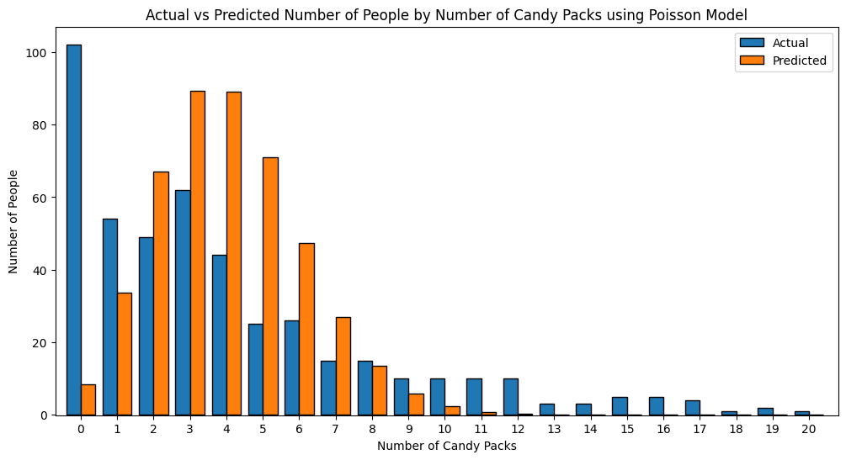
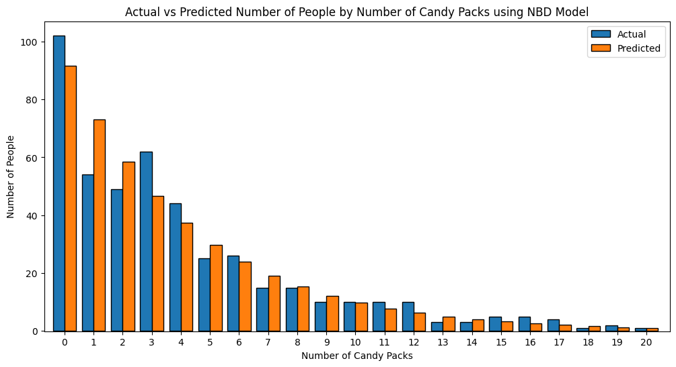
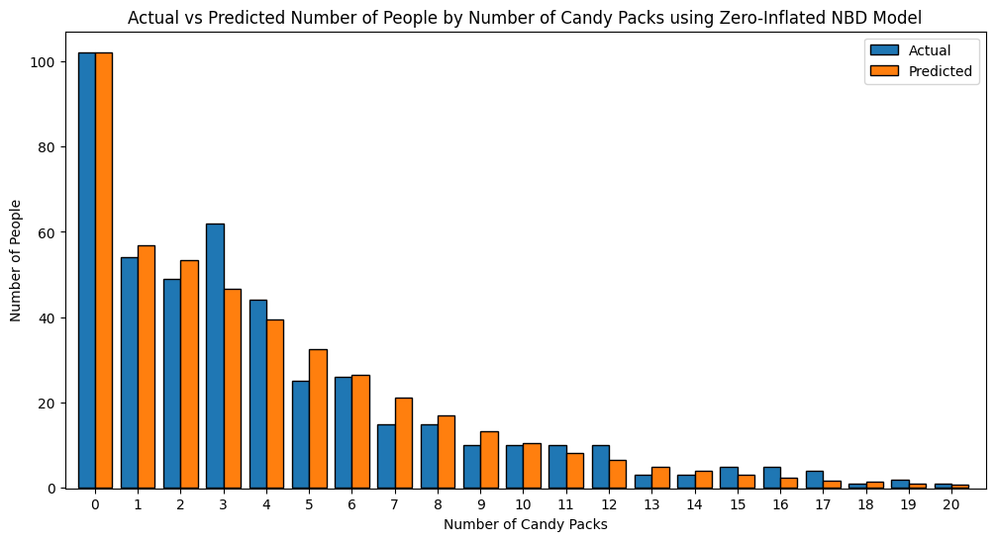
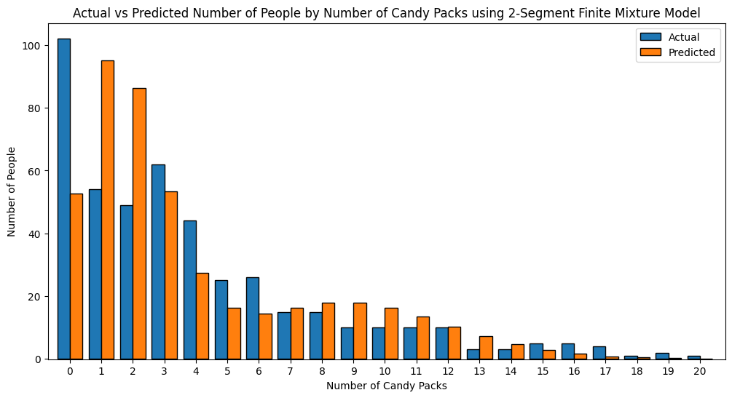
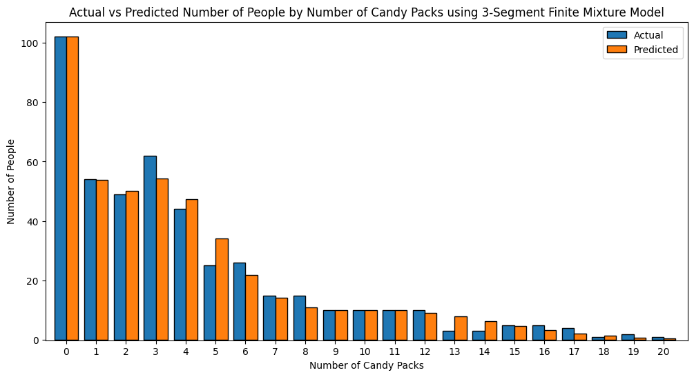
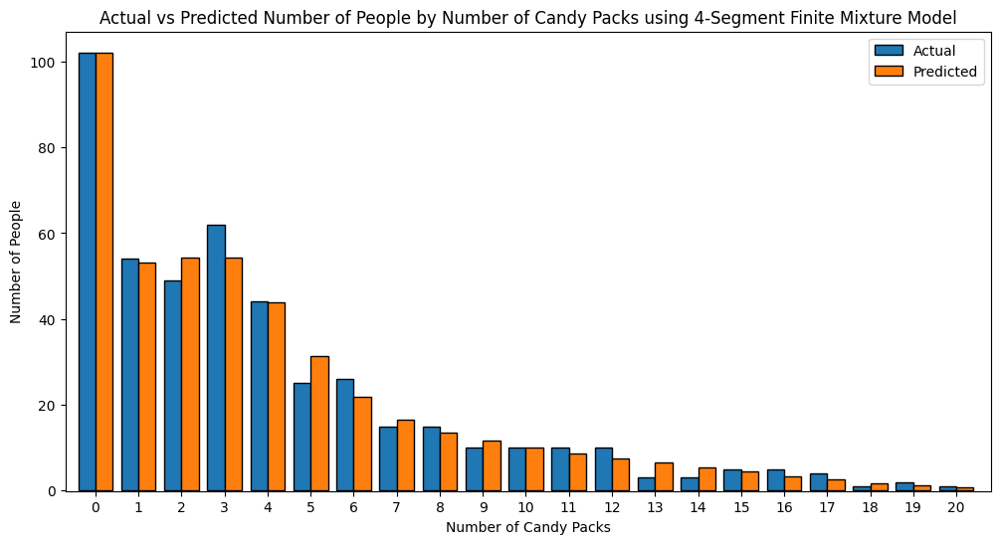
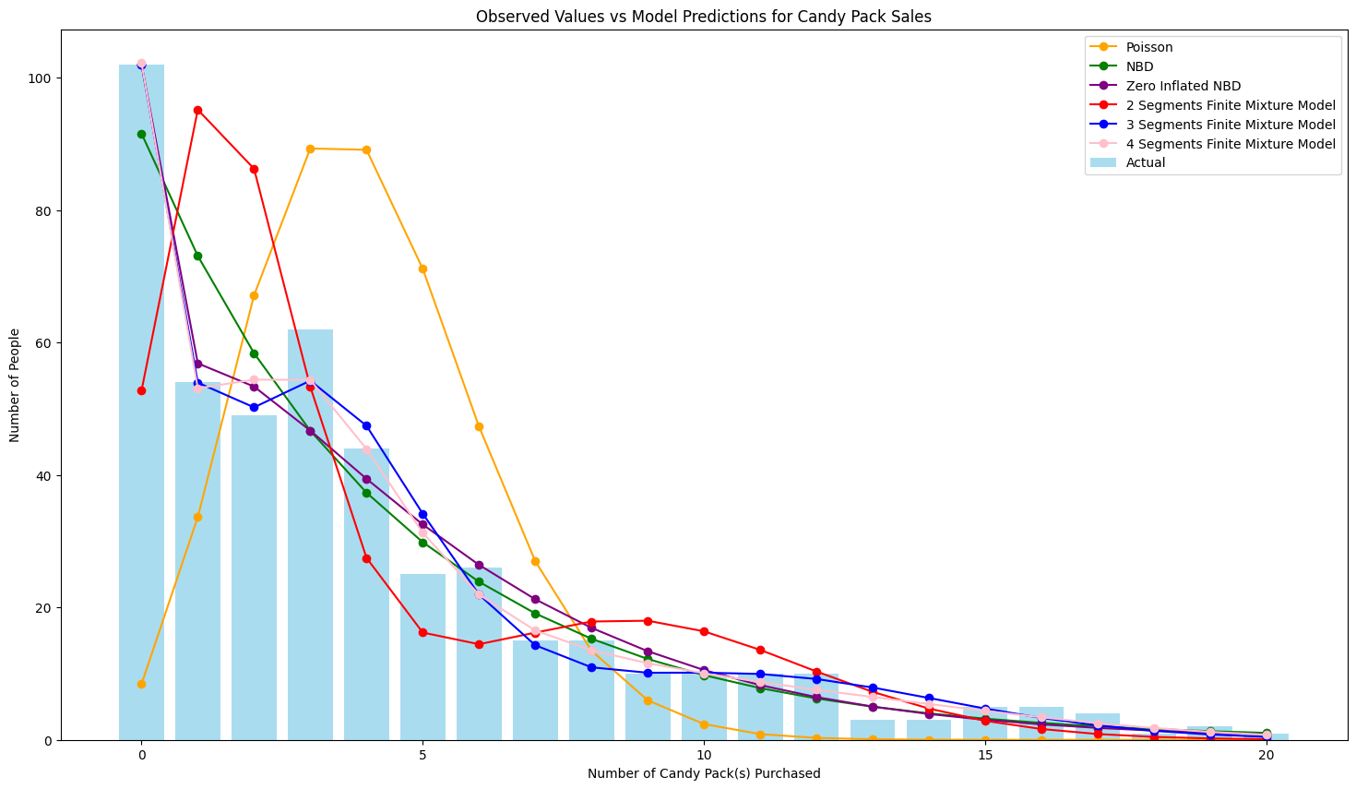
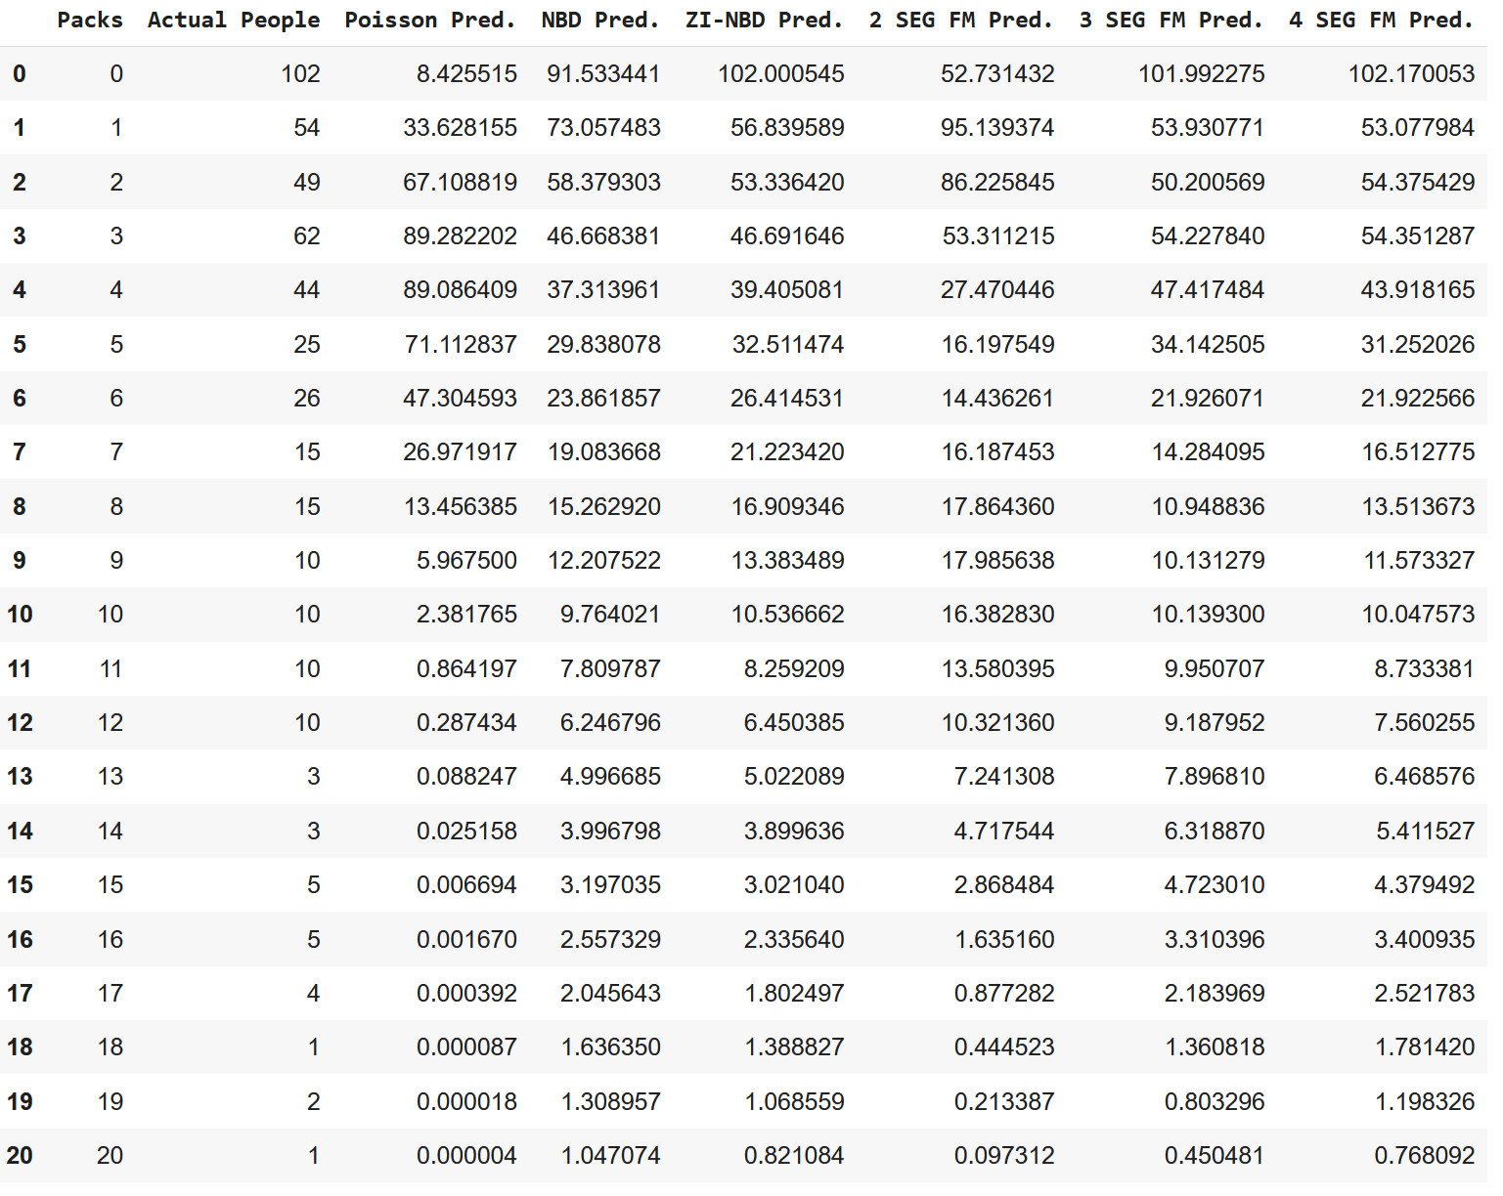
Figure 1: Comparison of actual vs. predictions from all models

AIC & BIC
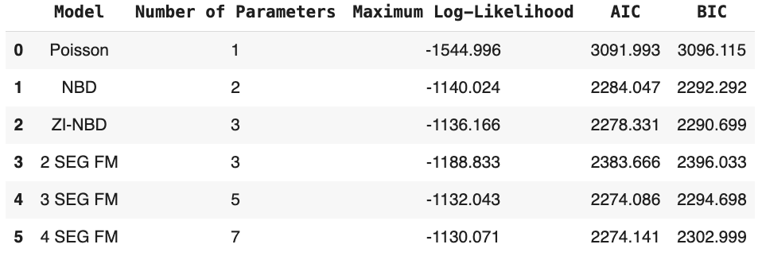
Figure 2: AIC & BIC comparison of all models (Poisson, NBD, ZI-NBD, 2 Segments Fixture Models)
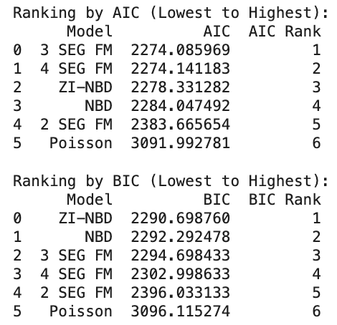

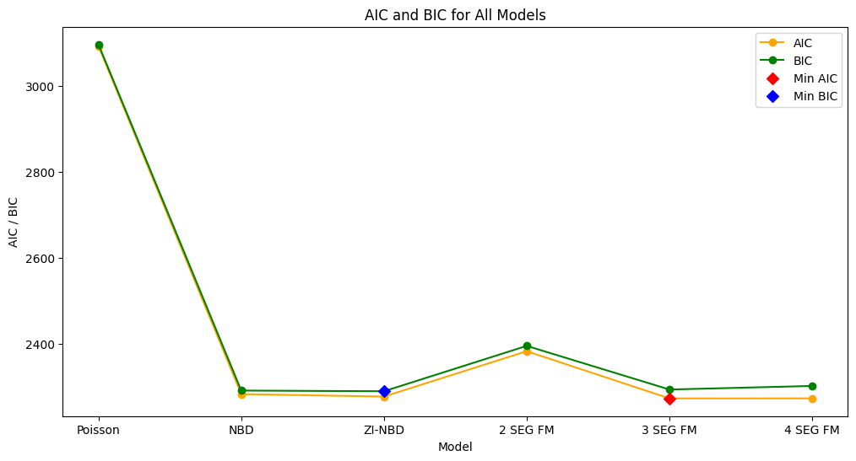

Likelihood Ratio Test (LRT)
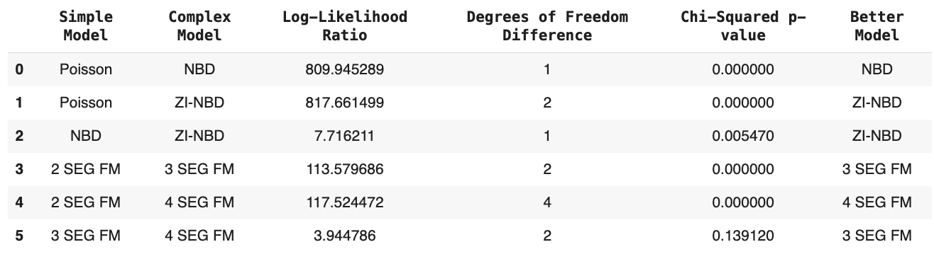
Figure 3: Comparison of models using LRT.
- ZI-NBD outperforms Poisson and NBD due to its ability to handle overdispersion and zero inflation.
- Among finite mixture models, the 3-segment FM strikes the best balance between fit and complexity, as shown by LRT.
- Despite achieving the highest log-likelihood, the 4-segment FM is not favored by LRT because its added complexity does not yield a statistically significant improvement over the 3-segment FM.
Note: LRT does not compare ZI-NBD and 3-segment FM directly because they are not nested models
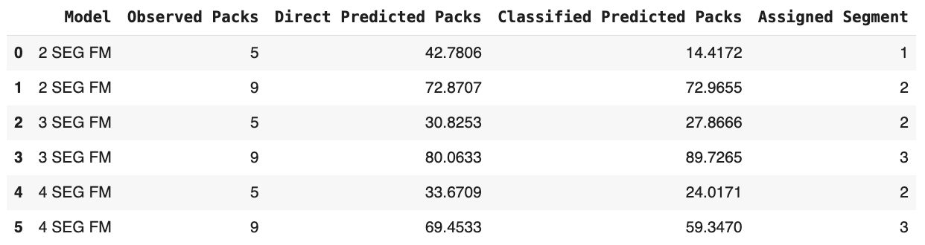
Figure 4: Predictions based on the 2, 3, and 4-Segments Finite Mixture Models over the next 8 weeks of a) a customer who purchased 5 packs in the past week and b) a customer who purchased 9 packs in the past week.
The classified prediction approach consistently outperforms the direct prediction method, especially for customers with higher purchasing volumes. Segmentation helps refine predictions, with the 3-segment model showing a balance between simplicity and accuracy. However, further calibration may be needed for customers with lower purchasing volumes to ensure uniform performance across all segments.
Table 4: Key observations of predictions based on the 2, 3, 4 Segment Finite Mixture Models
Higher Observed Values Yield Better Predictions | For customers with higher observed packs (e.g., 9 packs), the models perform better, especially when classified predictions are used. This is evident in Segments 2 and 3.
Challenges in Lower Observed Packs | The models tend to struggle with customers who purchase fewer packs (e.g., 5 packs). Classified predictions often underestimate or adjust inconsistently (e.g., Segment 1 in row 0).
Impact of Segmentation | Segmentation improves prediction accuracy by tailoring the model to specific customer behaviors within each segment. However, the choice of segmentation level (e.g., 2 vs. 3 vs. 4 segments) plays a crucial role in balancing accuracy and overfitting.

Direct vs. Classified Predictions:
The direct predicted packs are significantly higher than the observed values in most cases, indicating potential overestimation by the general prediction model. For example:
- For a customer who purchased 5 packs (row 0), the direct prediction is 42.78, while the classified prediction is 14.41, much closer to the actual observed packs.
- For a customer who purchased 9 packs (row 1), the direct prediction is 72.87, slightly underestimated by the classified prediction of 72.97, which is very accurate.
This trend demonstrates that classified predictions, which incorporate segmentation, align better with actual customer behavior compared to direct predictions.

Segment-Specific Accuracy
Different segments (e.g., 1, 2, 3) exhibit varying performance based on the models:
- Segment 2 (rows 1, 2, and 4): Classified predictions are very close to observed values, especially for higher observed packs. This shows that the model effectively captures the purchasing behavior of customers in this segment. (Example: In row 4, the observed value is 5 packs, and the classified prediction is 24.01, which is a reasonable adjustment from the direct prediction of 33.67).
- Segment 3 (rows 3 and 5): The model performs well for customers with 9 observed packs. In row 3, classified predictions (89.73) are close to the observed value compared to direct predictions (80.06), reflecting the model’s capability in accurately forecasting high-volume purchases in Segment 3.

Model Performance Across Segmentation Levels:
- 2-Segment Model (rows 0 and 1):
  - The 2-segment model performs well, especially for customers in Segment 2 with higher observed packs (e.g., row 1). The classified prediction aligns closely with actual purchases (72.97 vs. 72.87).
  - However, for Segment 1 (row 0), the classified prediction (14.41) significantly underestimates the observed value of 5 packs, suggesting potential challenges in capturing lower purchasing behavior in this segment.
- 3-Segment Model (rows 2 and 3):
  - The 3-segment model shows marked improvement in predicting high-volume purchases (e.g., row 3). It slightly underestimates lower-volume purchases (e.g., row 2) but provides a closer estimate (27.87 classified vs. 30.82 direct).
- 4-Segment Model (rows 4 and 5):
  - The 4-segment model performs well for customers with higher observed packs (e.g., row 5, observed: 9 packs; classified prediction: 59.35).
  - However, it struggles with lower observed packs (e.g., row 4, observed: 5 packs; classified prediction: 24.01), suggesting that finer segmentation may not always yield better results for all customer types.

Part II: Analysis of New Data
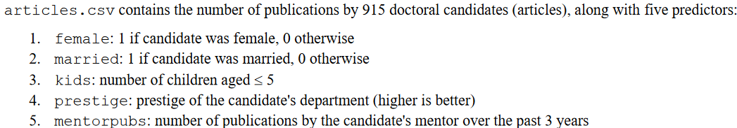

Poisson regression using MLE

The estimated parameters and the maximum value of the log-likelihood
Model | Estimated Parameters | Maximum Log-Likelihood
Poisson Regression | λ₀ ≈ 1.3567  β₁ ≈ -0.2243  β₂ ≈ 0.1559  β₃ ≈ -0.1847  β₄ ≈ 0.0126  β₅ ≈ 0.0255 | ≈ -1651.0565

Managerial takeaways and important customer characteristics
Characteristic | Comments
β₁ (female) | - Largest absolute coefficient (−0.2243)  - Being a female is associated with a lower expected number of publications vs. males  - e^{-0.2243} ≈ 0.799, being female reduces the expected number of articles by ≈ 20.1% vs. Males  - This highlights the need to address gender disparities in academia. Institutions should investigate potential structural or cultural barriers that might contribute to this gap, such as unequal access to resources, mentorship, or biases in the publication process. Implementing targeted support programs, such as mentorship opportunities or flexible work arrangements, could help mitigate this gap.
β₃ (kids) | - 2nd largest absolute coefficient (-0.1847)  - e^{-0.1847} ≈ 0.831, each kid aged ≤ 5 decreases the expected number of articles by ≈ 16.9%.  - Family responsibilities, especially for early-career researchers, can impact productivity. Policies like parental leave, on-campus childcare, or flexible working hours may support researchers balancing work and family. Leadership should also ensure these policies are applied equitably across genders.
β₂ (married) | - 3rd largest absolute coefficient (0.1559)  - e^{0.1559} ≈ 1.169, being married increases the expected number of articles by ≈ 16.9%.  - Marriage might provide emotional or logistical stability, positively influencing productivity. This highlights the importance of fostering a supportive work-life environment for all researchers.
Not as significant factors:
  - Each extra point of the prestige of the university only increases the expected number of articles by only 1.3%.
  - Each extra article by the candidate’s mentor only increases the expected number of articles by only 2.6%.

Predict the number of candidates publishing 0, …, 20, 20+ articles based on the Poisson regression.
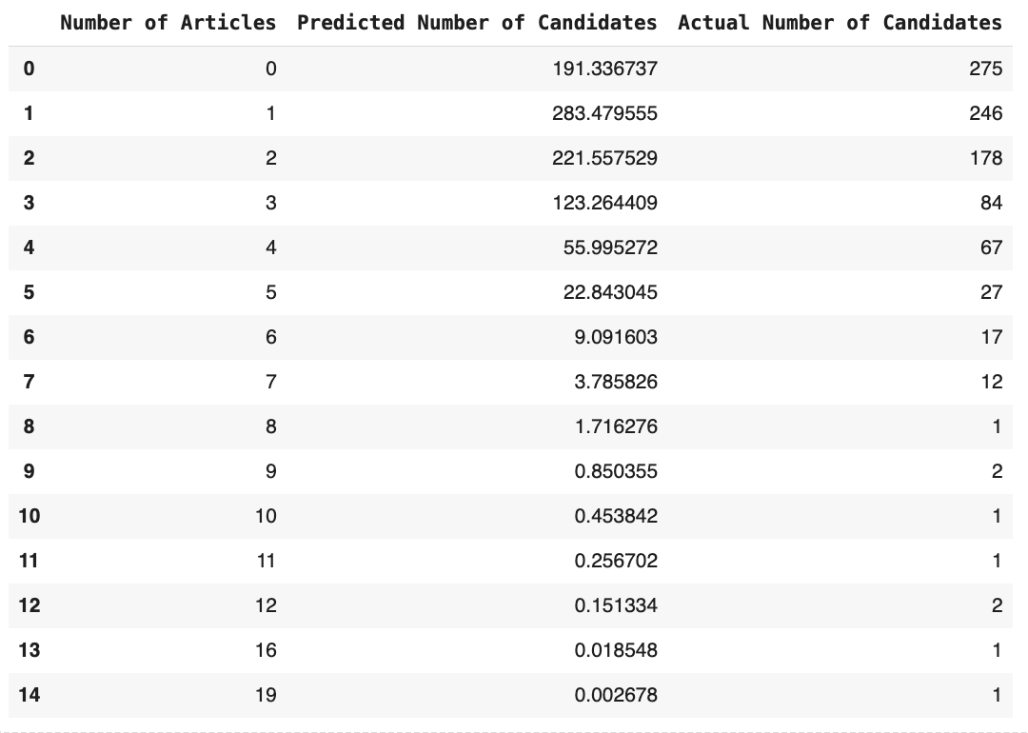

Calculations explaining how the predicted values are obtained using the case of 5 articles
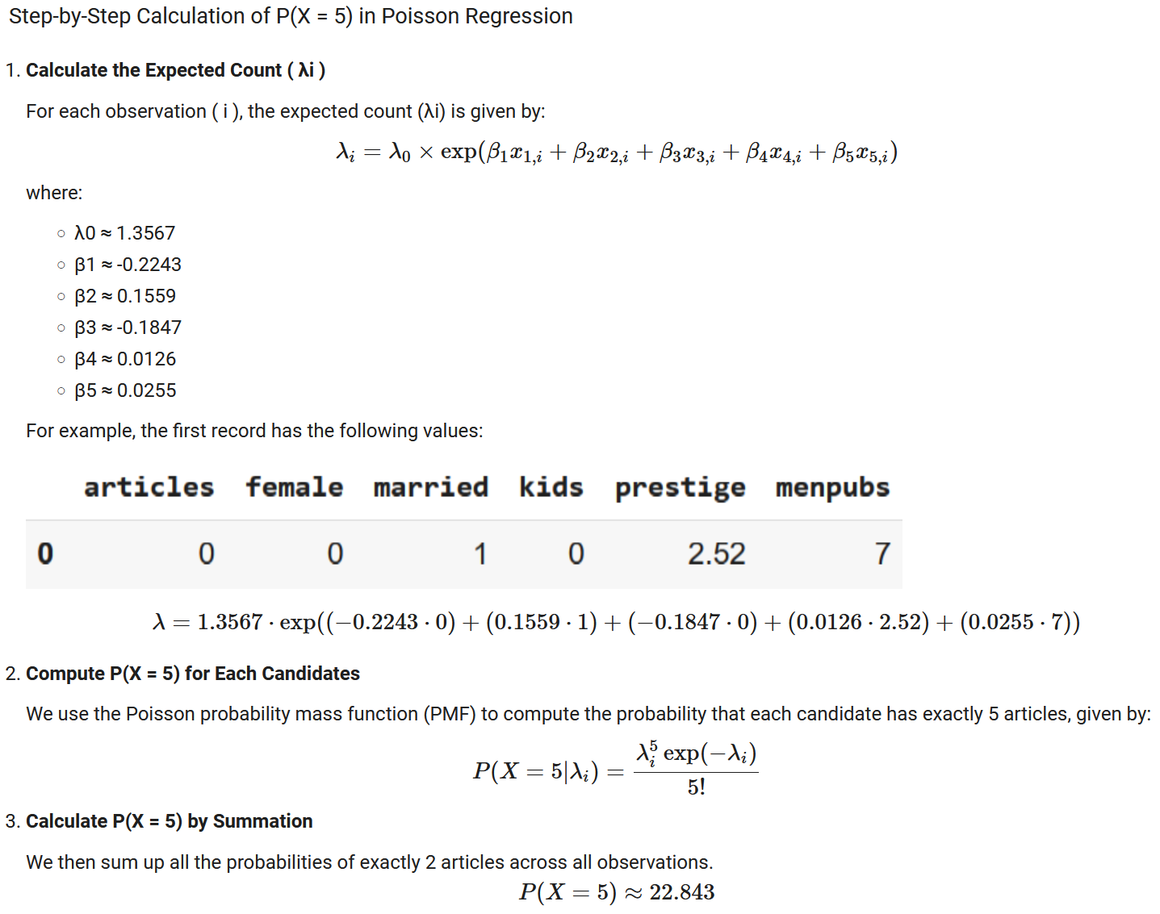

Graph the original and predicted number of articles
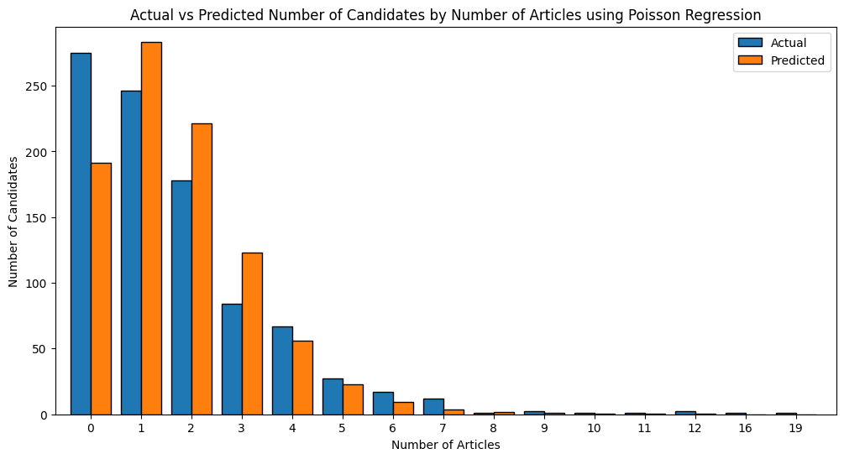

NBD regression using MLE

The estimated parameters and the maximum value of the log-likelihood
Model | Estimated Parameters | Maximum Log-Likelihood
NBD Regression | n ≈ 2.2641  α ≈ 1.7526  β₁ ≈ -0.2163  β₂ ≈ 0.1505  β₃ ≈ -0.1764  β₄ ≈ 0.0153  β₅ ≈ 0.0291 | ≈ -1560.9583

Managerial takeaways and important customer characteristics
Characteristic |  | Comments
β₁ (female) | - Largest absolute coefficient (−0.2163)  - Being a female is associated with a lower expected number of publications vs. males  - e^{-0.2164} ≈ 0.805, being female decreases the expected number of articles by  ≈ 19.5 %  - This highlights the need to address gender disparities in academia. Institutions should investigate potential structural or cultural barriers that might contribute to this gap, such as unequal access to resources, mentorship, or biases in the publication process. Implementing targeted support programs, such as mentorship opportunities or flexible work arrangements, could help mitigate this gap.
β₃ (kids) | - 2nd largest absolute coefficient (-0.1764)  - Having children is associated with a lower expected number of publications  - e^{-0.1764} ≈ 0.838, having kids decreases the expected number of articles by  ≈ 16.2%  - Family responsibilities, especially for early-career researchers, can impact productivity. Policies like parental leave, on-campus childcare, or flexible working hours may support researchers balancing work and family. Leadership should also ensure these policies are applied equitably across genders.
β₂ (married) | - 3rd largest absolute coefficient (0.1505)  - Being married is positively associated with the number of articles published  - e^{0.1505} ≈ 1.162, being married increases the expected number of articles by  ≈ 16.2%  - Marriage might provide emotional or logistical stability, positively influencing productivity. This highlights the importance of fostering a supportive work-life environment for all researchers.
  - Each extra point of the prestige of the university only increases the expected number of articles by only 1.5%.
  - Each extra article by the candidate’s mentor only increases the expected number of articles by only 3.0%.

Predict the number of candidates publishing 0, …, 20, 20+ articles based on the NBD regression.
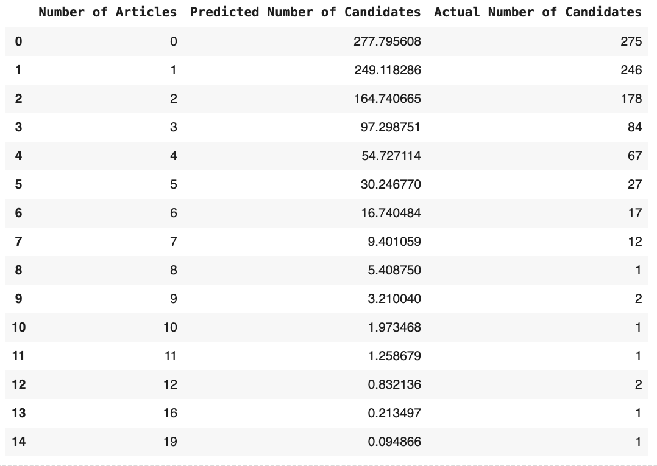

Calculations explaining how the predicted values are obtained using the case of 5 articles
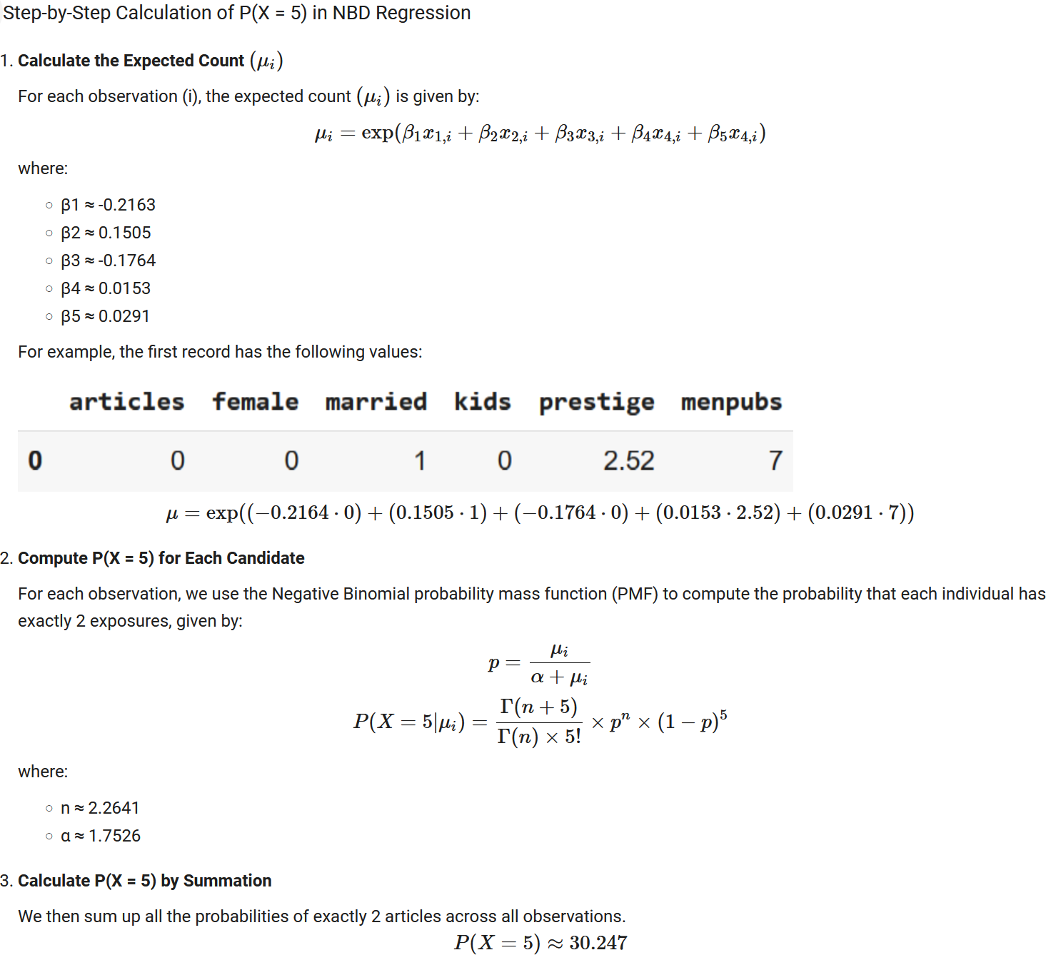

Graph the original and predicted number of articles
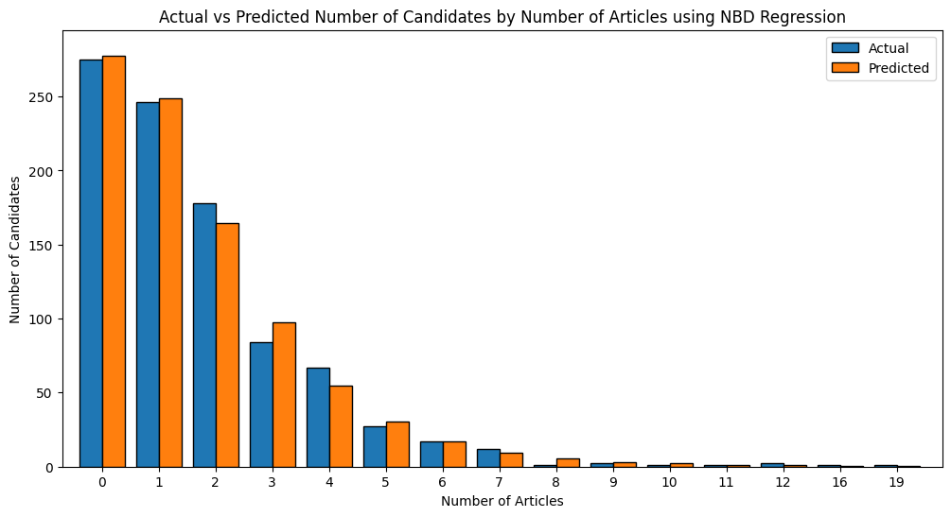

Zero-Inflated NBD Regression

Explain the logic used in developing the model in detail
ZI-NBD Regression is a count model that addresses 2 key characteristics:
- Observed heterogeneity: Link the individual rate of publications with other explanatory variables available in the dataset.
  - The probability in the negative binomial distribution is expressed as $p_{i} = \frac{α}{α+e^{βX_{i}}}$
- Excess zeros: We view 0s as coming from 2 sources - (i) from a fraction π who will never publish and (ii) from the remaining fraction (1 - π) who are likely to publish but have not done so yet. We assume that the number of articles published by the candidates in group (ii) follow a negative binomial distribution (to incorporate heterogeneity among the candidates).
  - For x = 0, $p\left(x = 0; n, α\right) = π + \left(1-π\right) {\left(\frac{α}{α+e^{βX_{i}}}\right)}^{n}$
  - For x > 0, $p\left(x = k; n, α\right) = \left(1-π\right) {\left(\frac{α}{α+e^{βX_{i}}}\right)}^{n}{\left(\frac{e^{βX_{i}}}{α+e^{βX_{i}}}\right)}^{k}$

The estimated parameters and the maximum value of the log-likelihood.
Model | Estimated Parameters | Maximum Log-Likelihood
Zero-Inflated NBD Regression | π ≈ 1e-06  n ≈ 2.2644  α ≈ 1.7519  β₁ ≈ -0.2164  β₂ ≈ 0.1504  β₃ ≈ -0.1768  β₄ ≈ 0.0152  β₅ ≈ 0.0291 | ≈ -1560.9584

Managerial takeaways and important customer characteristics
Characteristic | Comments
β₁ (female) | - Largest absolute coefficient (−0.2164)  - Being a female is associated with a lower expected number of publications vs. males  - e^{-0.2164} ≈ 0.805, being female decreases the expected number of articles by ≈ 19.5 %  - This highlights the need to address gender disparities in academia. Institutions should investigate potential structural or cultural barriers that might contribute to this gap, such as unequal access to resources, mentorship, or biases in the publication process. Implementing targeted support programs, such as mentorship opportunities or flexible work arrangements, could help mitigate this gap.
β₃ (kids) | - 2nd largest absolute coefficient (-0.1768)  - Having children is associated with a lower expected number of publications.  - e^{-0.1768} ≈ 0.838, having kids decreases the expected number of articles by ≈ 16.2%  - Family responsibilities, especially for early-career researchers, can impact productivity. Policies like parental leave, on-campus childcare, or flexible working hours may support researchers balancing work and family. Leadership should also ensure these policies are applied equitably across genders.
β₂ (married) | - 3rd largest absolute coefficient (0.1504)  - Being married is positively associated with the number of articles published.  - e^{0.1504} ≈ 1.162, being married increases the expected number of articles by ≈ 16.2%  - Marriage might provide emotional or logistical stability, positively influencing productivity. This highlights the importance of fostering a supportive work-life environment for all researchers.
- Each extra point of the prestige of the university only increases the expected number of articles by only 1.5%.
- Each extra article by the candidate’s mentor only increases the expected number of articles by only 3.0%.
- In all 3 regression models, males that are married with no kids seem to be associated with higher number of articles published.

Predict the number of candidates publishing 0, …, 20, 20+ articles based on the Zero-Inflated NBD Regression.
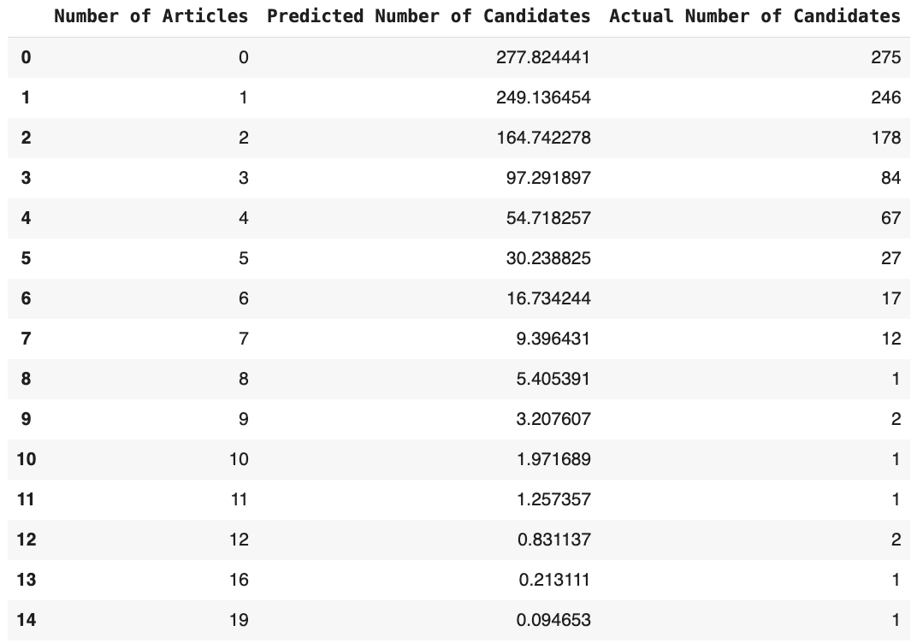

Calculations explaining how the predicted values are obtained using the case of 5 articles
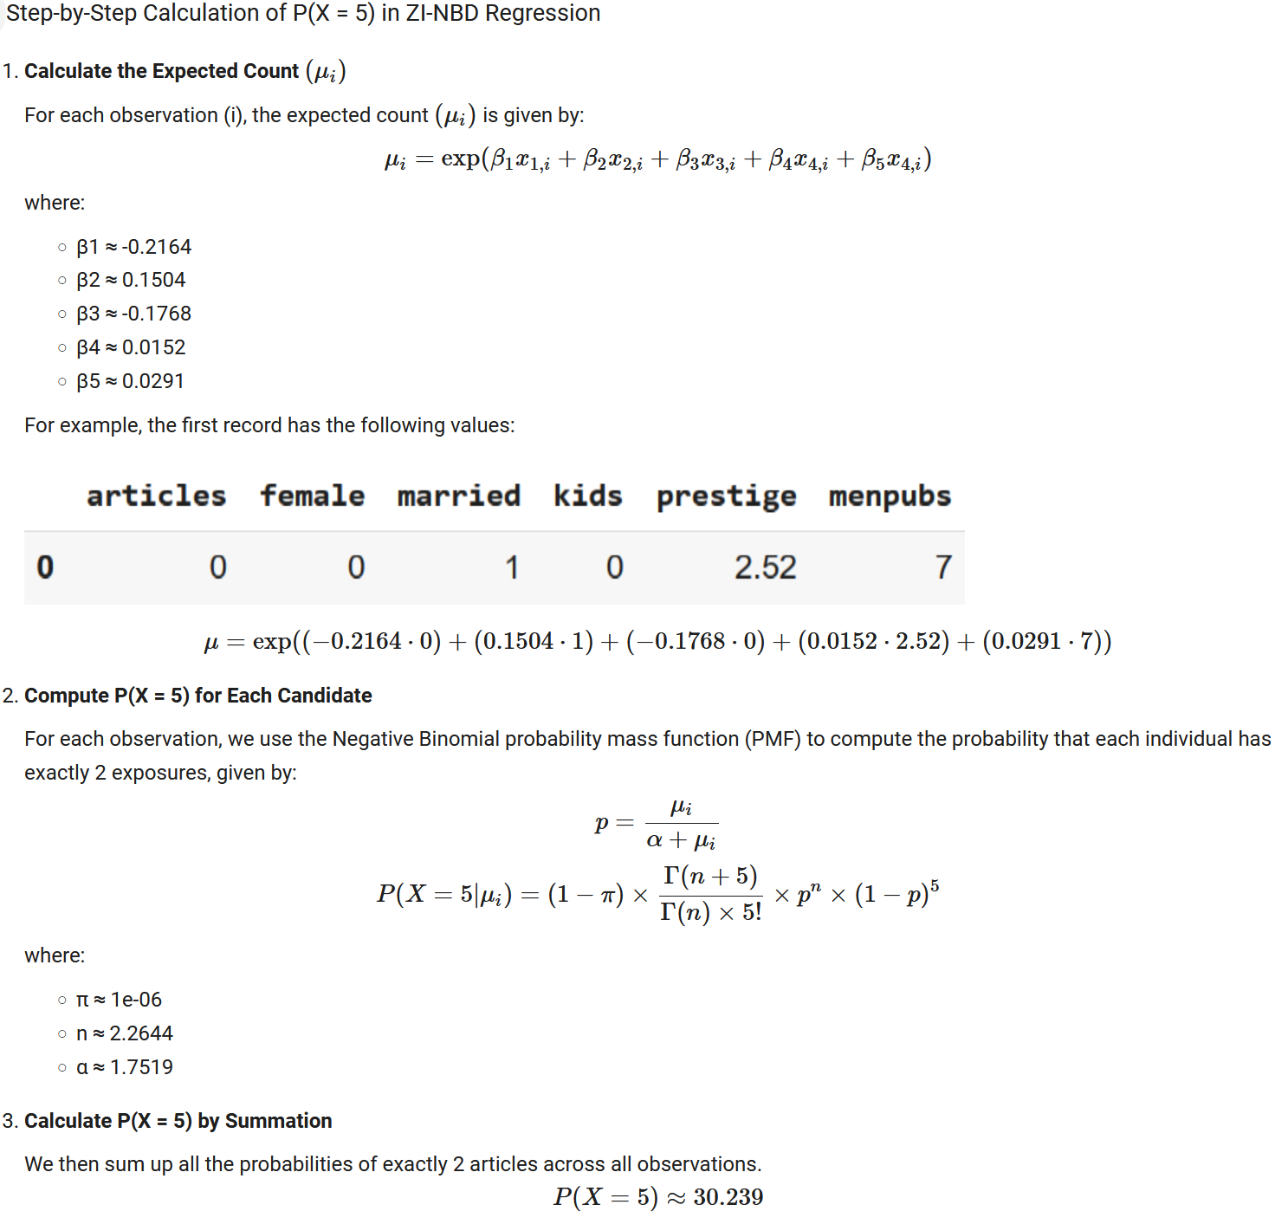

Graph the original and predicted number of articles.
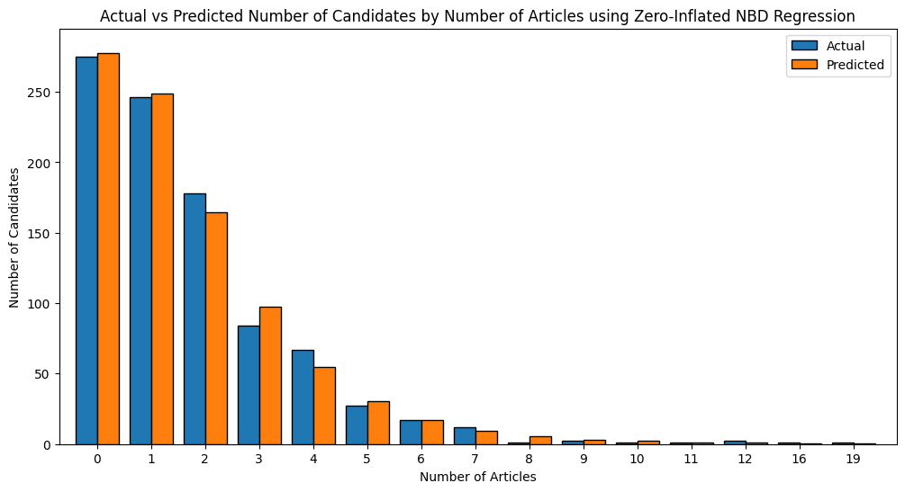

Evaluate the models developed
Table 5: Ranking of best models based on prediction, interpretability and simplicity in the model.
Goal | Best Model | Comments
Prediction | ZI- NBD Regression | Hands overdispersion and better suited for data with excess zeroes with tied for 1st log-likelihood value
Interpretability | ZI- NBD Regression | ZI-NBD Regression handles overdispersion and zero inflation while remaining relatively interpretable.
Simplicity is the priority | NBD Regression | - Offers strong predictive power without introducing unnecessary complexity, making it ideal when simplicity and practicality are key concerns.  - Also has the best performing AIC, BIC and LRT
Note: Although NBD Regression is the best model using maximum log-likelihood, AIC, BIC, and LRT, Zero-Inflated NBD Regression is a strong model.
Table 6: Ranking of best models using prediction accuracy, maximum log-likelihood, AIC, BIC, and LRT
Comparison Method | Best Model | 2nd Best
Actual vs. Predicted # | ZI-NBD Regression & NBD Regression Tied
Maximum Log-Likelihood | ZI-NBD Regression & NBD Regression Tied
AIC | NBD Regression | ZI- NBD Regression
BIC | NBD Regression | ZI- NBD Regression
LRT | NBD Regression Model | ZI- NBD Regression

Significant differences among the results from models
Simple models consistently underperform for this dataset, and more complex models are better suited for capturing the underlying structure of the data.
Top Performing Models handle overdispersion and excess zeroes:
- NBD Regression has the lowest AIC and BIC, showing a strong balance with fit vs. model complexity.
- ZI-NBD Regression has the same log-likelihood as NBD Regression but it the second lowest AIC and BIC.
Lowest Performing Models can’t capture enough:
- Poisson regression is the worst performing across maximum log-likelihood, AIC, BIC, and LRT
  - Indicating the model is not a good fit due to the lack of flexibility to capture zeroes or heterogeneity in the data.
- LRT favors NBD Regression and ZI-NBD Regression over Poisson, with chi-squared p-values near 0, indicating a statistically significant lack of fit for Poisson.

Reasons for differences
Simple models (Poisson Regression) under perform because:
- Assume less flexible distribution or fewer parameters.
- Poisson assumes Equi dispersion (λ= mean = variance), so may not capture overdispersion
- Data exhibits zero inflation and multiple subpopulations in the data
Complex models (NBD Regression, ZI- NBD Regression) outperform simple models because of the ability to:
- Account for dispersion: NBD Regression introduces parameters (n and α) to handle variance exceeding the mean.
- Addressing Zero Inflation: ZI-NBD Regression adds a parameter (π) to model excess zero counts.

Actual vs. Predicted Number
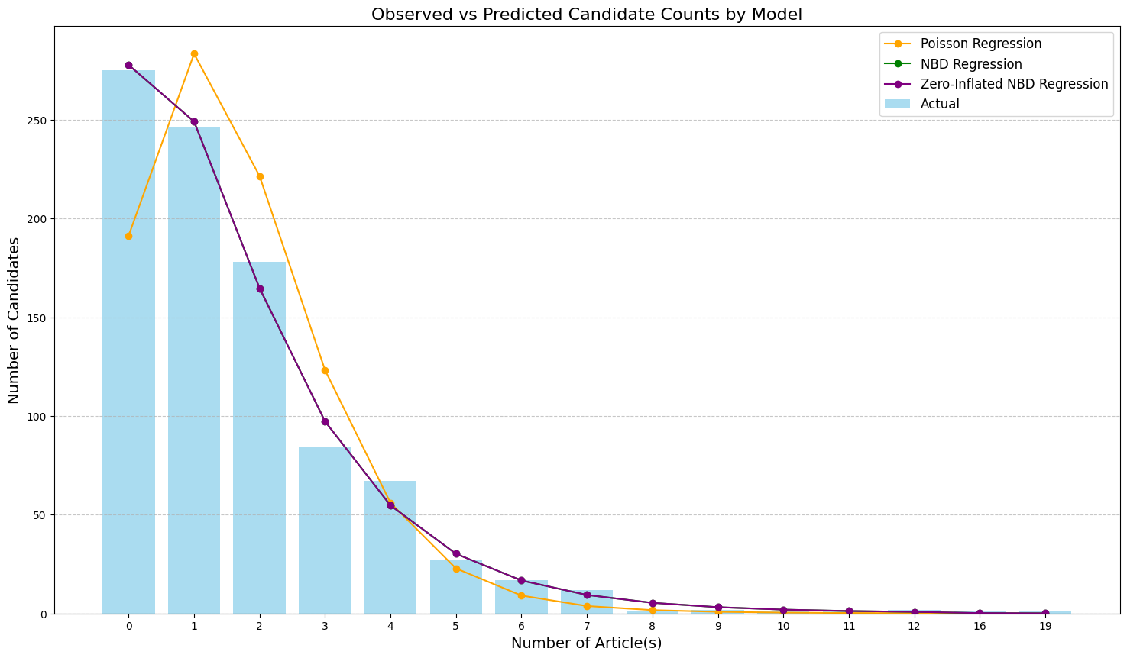
Note: NBD Regression and ZI-NBD Regression predictions almost match up. This is because π is extremely close to 0, meaning that there are no excess zeros for those who will never publish.
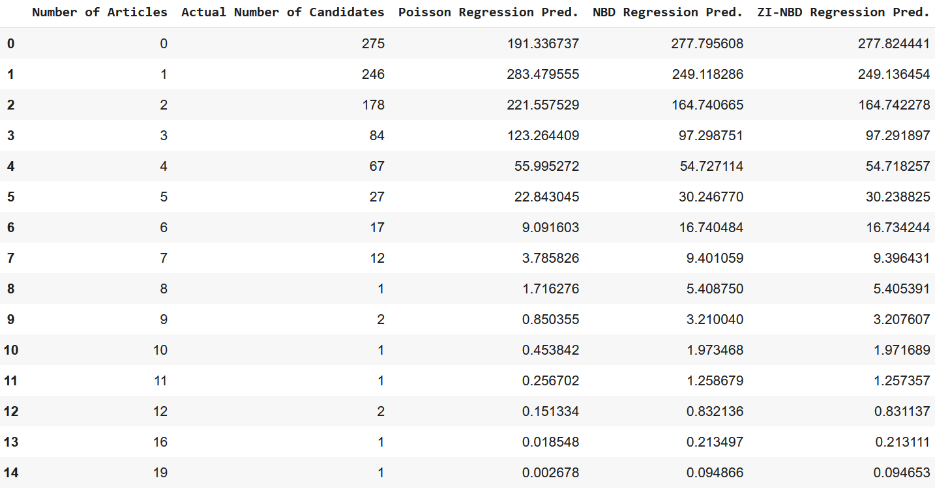
Figure 5: Comparison of actual vs. predictions from all models

AIC & BIC
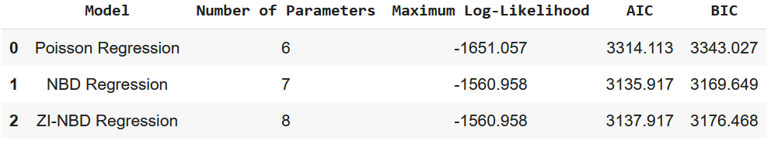
Figure 6: AIC & BIC comparison of all models (Poisson Regression, NBD Regression, and ZI-NBD Regression models)
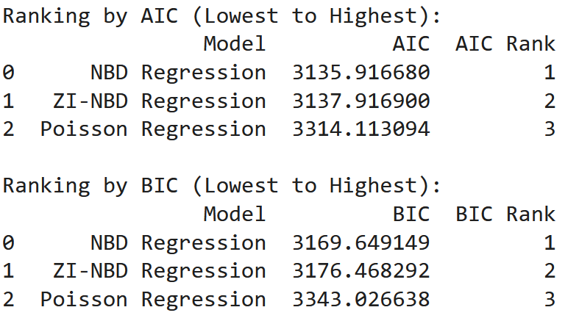
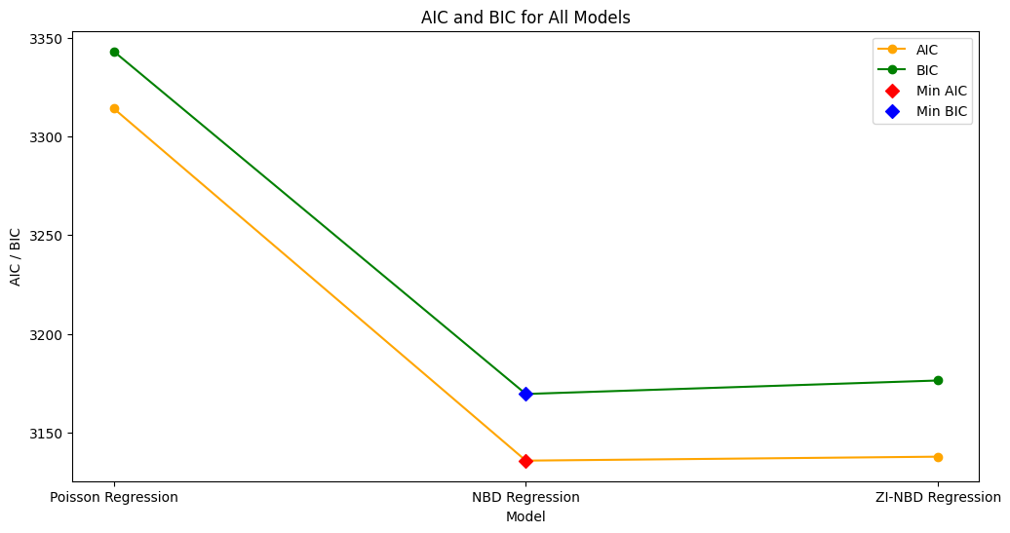
Note: While the NBD Regression and ZI-NBD Regression models are almost identical, AIC and BIC penalize the ZI-NBD Regression model for having 1 extra parameter, making ZI-NBD Regression less favorable.

LRT
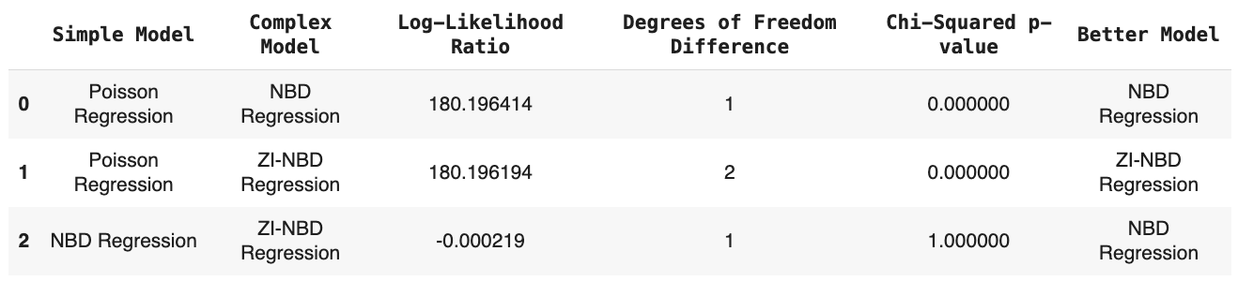

Team Discussion of Takeaways & Insights
Cat:
- Overall importance and impact of deciding which model to use based on data characteristics such as zero inflation, heterogeneity and establishing KPIs such as simplicity vs. accuracy in predictions.
- Part II: For the publications, I thought the significant factors were interesting..
  - Things that could potentially influence more publications numbers would be promoting benefits could include day care or more flexibility to work hybrid.
  - Do more research into if this is happening in other industries and what some companies have done to accommodate for working parents or returning parents to the workforce.
  - Leads to another question: Is a reason that there are less publications from women, because they are leaving the workforce due to child rearing.
Khanh:
- Part II Managerial takeaways:
  - Gender Audits: Conduct regular assessments of gender disparities in research outcomes.
  - Parental Support: Offer resources and infrastructure to help researchers with young children balance their responsibilities.
  - Mentorship Training: Focus on enhancing mentorship quality and fostering a collaborative culture.
  - Incentive Alignment: Recognize and reward contributions beyond publication counts, such as teaching and service.
Sriram:
- Part II Managerial takeaways:
  - Married employees who exhibit higher productivity and work output might serve as role models or mentors, encouraging similar behaviors among younger or unmarried colleagues.
  - Conduct audits to ensure data represents underrepresented groups (e.g., working mothers) and adjust strategies to support their inclusion.
  - Implement periodic reviews of publication data to detect declining trends and intervene with support programs.
  - Provide structured re-entry programs for employees returning from parental leave to improve retention and productivity.

