

Research & Development for
Point Of Sale System
using Web-based Application for Smart Books
Name : AUNG AUNG
NCC NO : 00121314
Report Date : 10 Oct 2021
Table of Contents
Table of Contents
1. Project Proposal 6
1.1 Overview 6
1.2 Current Business History 6
1.3 Current Business Process 7
1.4 Proposed System Scope 9
1.5 Aims and Objectives 10
1.6 Estimate Cost and Duration 10
Lenovo IdeaCentre AIO 5i 11
Dell UltraSharp 27 4K USB-C Hub Monitor (U2723QE) 11
1.7 Project Plan (Gantt chart) 15
1. Chapter – 1 Introduction 19
1.1 Background of the Current System 19
1.2 SWOT Analysis (Current System) 23
1.3 Proposed System Scope 25
1.4 Aims & Objectives of the Project 27
2. Chapter-2 Similar Product Comparison 32
2.1 Similar Product Introduction 32
2.2 Functional Comparison 35
10 Usability Heuristics (Nielsen, 2020) 39
3. Match between System and Real World: Create interface components, iconography, and terminology that correspond to users' mental models and known real-world notions. 40
4. Chapter-3 Feasibility Study 49
4.1 Technical Feasibility 49
4.1.1 Methodologies 49
A. Definition 49
B. Strengths and Weakness of Each Methodology (Waterfall vs RAD vs Agile – Which Method Is The Best For You?, 2023) 50
C. Recommendation for Methodology 54
4.1.2 Programming Languages 57
A. Comparison of Programming Languages 59
B. Recommendation for Programming Language 60
4.1.3 Databases 61
A. Definition 61
B. Strength and Weakness of each Databases (System Properties Comparison Microsoft SQL Server vs. Oracle vs. PostgreSQL, 2023) 61
C. Comparison of Databases 64
D. Recommendation for Database 64
4.2 DSDM Feasibility (DSDM eight principles) (Chapter 4: Principles, 2023) 65
4.3 Possible LESPI (Legal, Ethical, Social and Professional) Issues 67
4.1 Target User 73
4.2 Functional Requirement 74
4.3 MOSCOW Prioritization 76
4.4 Non-Functional Requirements for Point of Sale (POS) System: 78
(Md. Mijanur Rahman and Shamim Ripon, 2023) 78
1. Usability: 78
The POS system should provide an intuitive and user-friendly interface that is easily navigable by store staff, promoting efficient and error-free operation. 78
2. Security: 78
The system must ensure robust data security, including encryption of sensitive information, secure user authentication, and protection against unauthorized access. 78
3. Performance: 78
The system should exhibit optimal performance, with quick response times for transaction processing, minimal downtime, and efficient handling of peak loads. 78
4. Interface: 78
The POS system should seamlessly integrate with external systems, such as payment gateways, inventory databases, and customer relationship management (CRM) software. 78
5. Operational: 78
The system should support daily store operations, including continuous availability, accurate product pricing, real-time inventory updates, and reliable sales recording. 78
6. Resource: 78
The system should utilize hardware and software resources efficiently, minimizing memory usage, processing power, and network bandwidth consumption. 78
7. Portability: 78
The system should be adaptable to different devices and platforms, allowing store staff to access it via desktop computers, tablets, or mobile devices. 78
8. Reliability: 78
The POS system must consistently perform as expected, minimizing system crashes, errors, and disruptions to ensure uninterrupted store operations. 78
9. Maintainability: 79
The system should be easily maintainable, allowing for timely updates, bug fixes, and enhancements without disrupting ongoing business activities. 79
10. Safety: 79
The system should adhere to safety regulations and best practices, ensuring that customer and staff safety is not compromised during transactions or system usage. 79
11. Recovery: 79
The system should have robust backup and recovery mechanisms to quickly restore data in case of system failures or data loss, minimizing downtime and ensuring data integrity. 79
These non-functional requirements collectively contribute to the optimal functioning, security, and reliability of the POS system, ensuring a seamless and efficient point-of-sale experience for both store staff and customers. 79
4.5 Time box Plan 80
Time box 1: Manage Purchase Process Time box 80
Time box 2: XXX 83
Time box 3: XXX 83
4.6 Risk Management (Emmitt, 2023) 84
4.6.2 Risk Matrix (High-Medium-Low) 85
4.6.3 Critical Success Factors for the current project 86
5.1 Time-box 1: Manage Purchase Time-box Development 91
Project Plan for Time Box 1 91
5.1.1 Functional Requirements List 91
5.1.2 Use Case Diagram 92
5.1.3 Screen Design 93
5.1.4 Iteration for Screen Design 101
5.1.5 Class Diagram 102
5.1.6 Sequence Diagram for Booking Process 104
5.1.7 Functional Testing 105
5.1.8 Usability Testing 108
5.1.9 Iteration for Usability Testing 109
5.1.8 Time box Summary 110
6.1 Deployment 112
6.1.1 Deployment Diagram 112
6.2 Data Migration 113
6.2.1 Data to Migrate 113
6.2.2 Plan 113
6.3 Training 114
6.3.1 Training plan 114
6.3.2 User Manual 114
CHAPTER – 7 115
CONCLUSION 115
& 115
EVALUATION 115
7.1 Evaluation against Aim & Objectives 116
Aim 116
Objective 1 116
Objective 2 116
Objective 3 116
Objective 4 116
Objective 5 116
7.2 Evaluation Against Similar System 117
7.3 Evaluation against Justification Made 118
7.4 Evaluation against Time Box Plan 119
7.5 Personal Evaluation 120
7.6 Strength & Weakness of ABC POS 121
7.7 Future Amendment 122
APPENDIX 123
Section A: Use Case Descriptions 124
Timebox 1: Room and Table Booking Timebox 124
Section B: Detailed Class Definitions 124
Timebox 1: Room and Table Booking Timebox 124
Section C: Coding 124
Section D: Test Scripts 125
Section F: Interview Scripts 126

Abstract

Acknowledgement

Project Proposal

Project Proposal

Overview
Smart Books has been in the industry since 2017, standing firm for more than 5 years. This project will focus on developing a point-of-sale system for Smart Books. Such a system will be a dynamic website, its main aim is to bring the system to further heights. Smart Books sell various types of books, it ranges from university textbooks to illustrated storybooks. Currently, the manual processes lead to various issues, such as records not matching. One such issue is sales recorded and books sold do not match. The manual data recording has resulted in hurting data integrity and overall slow business transactions.
The computerized system is believed to solve all such problems, it will accumulate and store information about the products such as their cost, and stock.
It is to retain the basic functions of an online store like the search function to easily find desired products. Needless to say, the system will
Because it is more accessible, has more features, and functions, and is simpler to use than a manual paper-based system, the online sales system is more beneficial. Thus, the information will be well-organized and simple to search in depth.
Overall, the sales and purchases system can help the store with a nice set of tools and functions, which reduce the time busy to perform the tasks and increase the work done by the store.

Current Business History
The Smart Book's Evolution: Bridging Tradition and Technology
The Smart Books, founded in 2017 by avid book lover John Smith, signalled the advent of a literary refuge. Its early days were marked by a hands-on approach that emphasized the tactile connection between reader and book. However, the advancement of technology spurred a paradigm shift, causing the store to embrace digital transformation and e-commerce. This study follows the growth of The Smart Books from manual tradition to a balanced blend of historical essence and modern ease.
The Smart Books reflected a dedication to tactile literary exploration, which was built on John Smith's enthusiastic love of reading. Its original objective was to provide a safe refuge for book lovers to experience the tactile joys of the printed word, which is reflected in its manual operations.
The manual method harkened back to a time when purchasing and reading books held personal appeal. Transactions were personal, forming a unique link between customers and their chosen works. As a result of this ancient attitude, each visit was imbued with a sense of historical continuity and proximity.

Current Business Process
- Product Process- store book information such as name and prices and their design details with book and document.
- Purchase Supply Process- resupply books from suppliers.
- Customer Process- record the customer’s name, phone number, email, address and NRC with the paper database system. Customers can get a debit payment type at smart books.
- Employee Process – Record employees’ personal information with paper documents. There are 15 employees at Smart Books a CEO, a co-founder, a general manager, a store manager and a marketing manager.
- Customer Order Process- to make an order, the customer needs to make a contract with the manager to confirm the customer's order. If the customer order process is successful, customer-relevant information and order data will be stored.
Current Business issues

1. Sales Downturn due to COVID-19 Impact:
The ongoing global pandemic, COVID-19, has led to significant changes in consumer behavior. With a substantial portion of the population opting to stay at home, the absence of an established online sales system has resulted in a notable decline in Smart Books' sales rates. The company's inability to swiftly adapt to this shift in consumer preferences has hindered its revenue generation during this challenging period.

2. Procurement Complexity and Potential for Human Error:
Within the purchase process, there exists a potential vulnerability stemming from human error. Instances of inaccuracies, such as erroneously recording product prices, can adversely affect the procurement process. These inadvertent errors have the potential to disrupt inventory management and financial transactions, thereby impacting overall operational efficiency.

3. Customer Data Integrity and Manual Input Risks:
The manual nature of the customer data process presents inherent risks. The manual addition of customer information, including phone numbers and email addresses, is susceptible to inaccuracies due to human error. This jeopardizes the integrity of the customer database, leading to a scenario where incorrect details are recorded. Such inaccuracies can impede effective communication and undermine customer relations.

In light of these challenges, it is imperative for Smart Books to address these concerns proactively and implement appropriate measures to mitigate potential pitfalls. The company must prioritize digital transformation, augmenting its online presence and sales capabilities to align with the evolving consumer landscape. Additionally, instituting robust quality control mechanisms within procurement and customer data processes will aid in minimizing errors and safeguarding the integrity of essential business operations. By strategically addressing these issues, Smart Books can navigate the current business landscape with resilience and fortify its position in the market

Proposed System Scope
System Scope Proposed
The suggested system contemplates a shift from the current paper-based methodology to a sophisticated online sales system. This transformation intends to address the issues that have arisen in the current store configuration. The upcoming online sales system promises to streamline processes and improve customer experience.
Customers will benefit from quicker purchasing processes inside this online framework, avoiding unnecessary time consumption. Comprehensive customer and product information will be rigorously preserved within the system, allowing for fast retrieval and management. Notably, the product catalogue will include a simple search engine that will allow users to quickly identify requested items.
Furthermore, the system will make inventory tracking and delivery coordination easier. Store managers and designated workers will be able to manage stock levels and oversee delivery services with ease. This technology-driven strategy ensures that stock management and delivery logistics activities are carried out precisely.

In essence, the proposed system's scope includes a comprehensive transformation that would replace manual activities with a dynamic online sales platform. This transformation is set to reshape the customer experience and boost operational efficiency, ultimately setting the company for growth and adaptation in an ever-changing commercial context.

Aims and Objectives
    - Aims
The primary goal of this endeavour is to create an ideal and user-centric online sales platform for Smart Books in the form of an e-commerce website. This strategic initiative aims to improve the efficiency of sales operations and order management processes, resulting in a higher level of store management. the planned e-commerce platform aims to create an environment of simplicity and efficiency, assuring a better shopping experience for customers. The system seeks to smoothly simplify sales transactions by employing cutting-edge technical solutions, thereby eliminating traditional obstacles and optimizing the overall consumer trip.
1.5.2 Objectives
Analysis
- Requirements Collect (Interview) (1 week)
- SWOT Analysis (2 days)
- Similar System Research
- Functional Comparison
- Non-functional Comparison
Design
Implementation
- Development for Timebox (1) (2 weeks)

Evaluation

Estimate Cost and Duration
    - Hardware Cost
No | Item | Description | Unit Price | Quantity | Sub-Total
1 | All in one pc | Lenovo IdeaCentre AIO 5i | $ 1303 | 2 | $2606
2 | monitor | Dell UltraSharp 27 4K USB-C Hub Monitor (U2723QE) | $625 | 2 | ＄1250
Keyboard & Mouse | Fantech Office Keyboard and Mouse Combo KM100 | 2 | $10 | 2 | $20
Data Server | Synology DiskStation DS220+ data storage server J4025 Ethernet LAN Compact Black NAS (DS220+) | 1 | $540 | 1 | $540
Keyboard & Mouse | Fantech Office Keyboard and Mouse Combo KM100 | 2 | $10 | $2 | $20
Total Hardware Cost |  |  |  |  | $4336

    - Software Cost
No | Item | Description | Unit Price | Quantity | Sub-Total
1 | Antivirus Software | Avast Antivirus Small Office Protection. Blocks virus, spyware and other threats in real-time, Advanced ransomware protection, multi OS support up to 10 devices | 2 | $150 | $300
2 | Microsoft Office | Microsoft 365 Business Standard. Desktop 2019 version of Word, Excel, PowerPoint, Outlook and OneNote (Plus Access and Publisher for PC only). One license covers fully installed five devices per user. | 1 | $200/year | $200
3 | Operating System | Window 11 pro key global | 2 | $30 | $60
Total Software Cost |  |  |  |  | $560

    - Development Cost
No | Item | Description | Unit Price | Quantity | Sub-Total
1 | Web Development Cost | PHP language with MySQL Database  Data Entry: Hourly Rates ($6/hour)  Staff Training: FOC | $2000 | 1 | $2000
2 | Hosting | www.hostinger.com  Business shared Hosting.  Unlimited Website and Email and bandwidth, Free SSL Certificate, Unlimited MySQL Databases and 100 subdomains, Daily Backups | $3.99/month | 1 year | $47.88
3 | Domain Name Registration | www.domain.com  Name: SmartBooks  Domain Purchase + Privacy and Protection | Domain: $29.98/2 years  Privacy + Protection: $17.98/ 2 years | 1 | $47.96
 |  |  |  | Total Amount | $2095.84

    - Summary Cost
Category | Cost
Software | $560
Hardware | $4336
Development | $2095.84
Total | $6991.84

Project Plan (Gantt chart)

Fig (1) Project Proposal
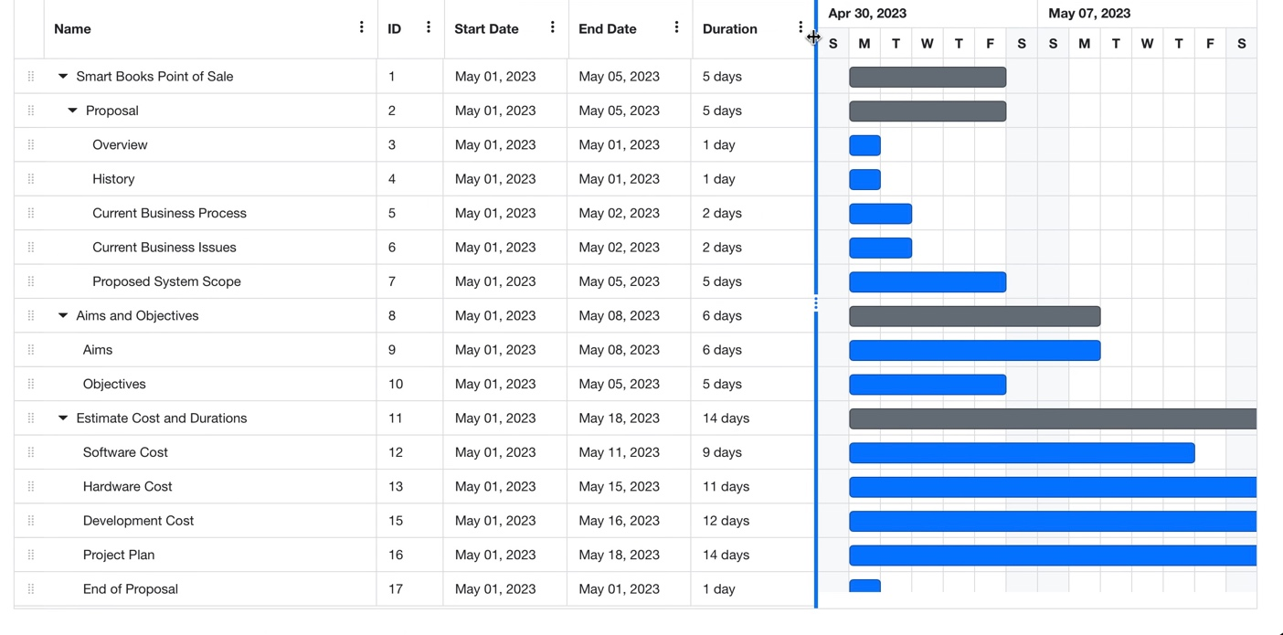
Fig (2) Project Introduction
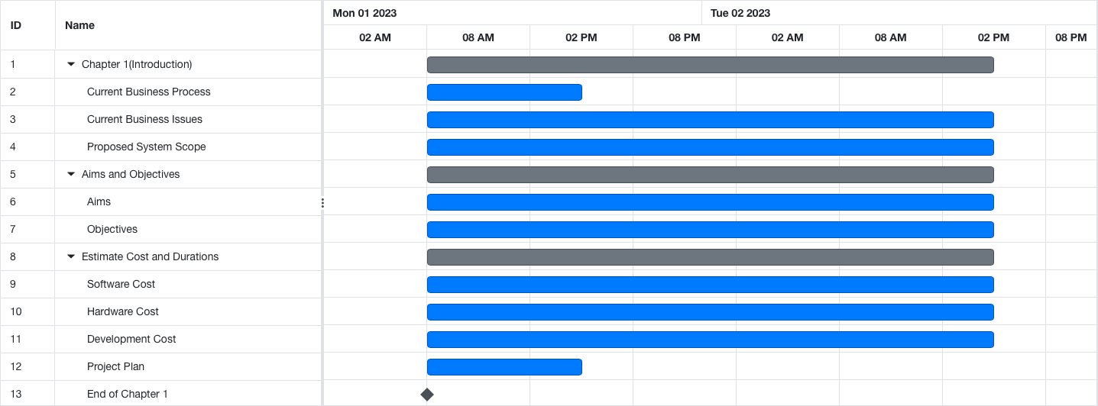
Fig (3) Similar Product Comparison


Fig (4) Feasibility Study
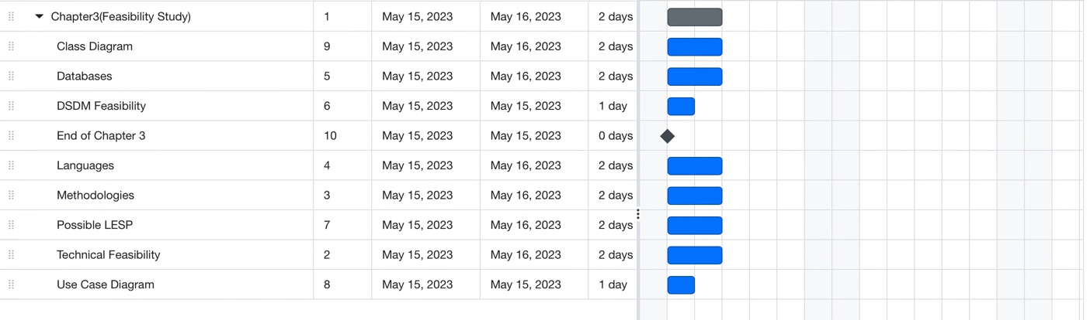
Fig (5) Foundation
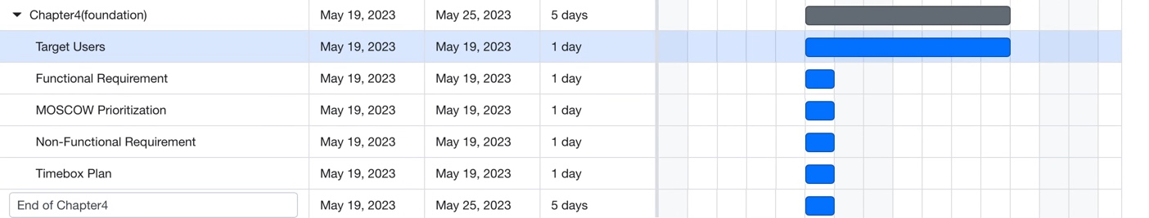
Fig (6) Exploring and Engineering
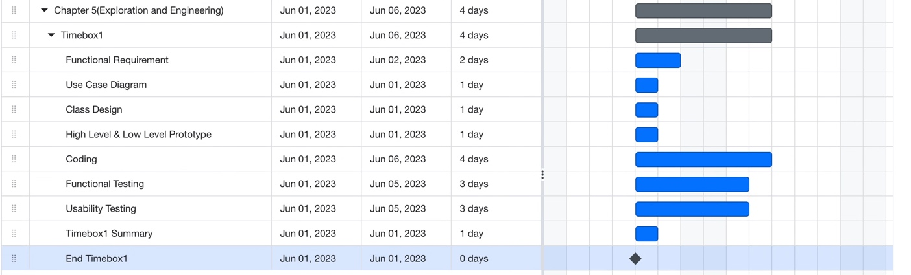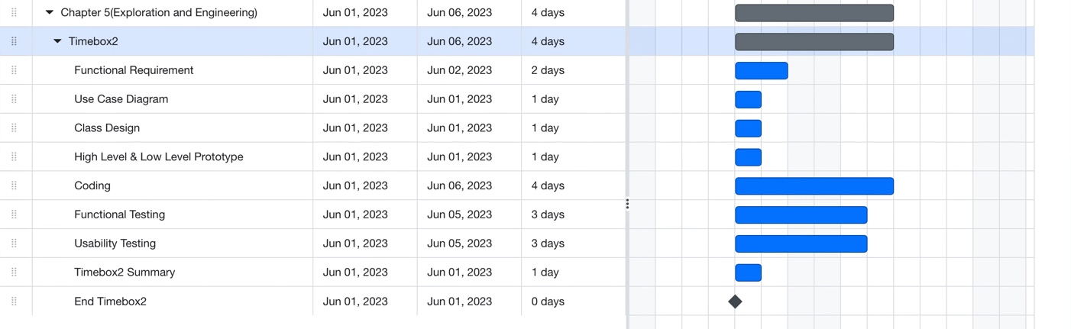

Fig (7) Deployment
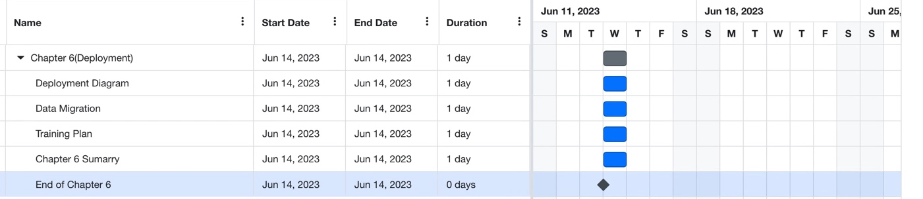
Fig (8) Conclusion and Evaluation

Chapter-1
Introduction

Chapter – 1 Introduction

Background of the Current System
History
Established in the year 2002, Smart Books emerged as a purveyor of literary treasures within the vibrant metropolis of London, United Kingdom. The establishment's initial presence was rooted in a physical store located amidst the bustling cityscape. This emporium catered to the diverse literary preferences of its patrons.
Operational hours, extending from 9 AM to 8 PM were meticulously structured to accommodate the bustling rhythms of urban life. Commencing as a modest enterprise, Smart Books gradually ascended the echelons of commercial prominence owing to its unwavering commitment to superior customer service. Earning a reputation for facilitating tailored customer orders that engendered utmost satisfaction, the establishment garnered a loyal clientele. Moreover, the enterprise distinguished itself by striking a harmonious balance between offering products of discernible quality at equitable prices, supplemented by comprehensive warranty provisions.
The evolutionary trajectory of Smart Books has been inextricably intertwined with its steadfast adherence to a paper-based operational system. This traditional approach, prevalent since the establishment's inception, underscored the store's distinct character within an evolving retail landscape. However, recognizing the burgeoning prevalence of e-business paradigms and technological advancements in the contemporary milieu, Smart Books embarked on a transformative path.
In response to a prevailing trend whereby numerous retail enterprises were transitioning toward e-commerce models, Smart Books elected to embrace innovation. The decision to augment its existing infrastructure with a computerized system and an e-commerce shopping interface was prompted by an earnest desire to alleviate the challenges encountered by customers hindered by logistical constraints. This strategic move is envisaged to enhance accessibility, rendering the literary offerings more attainable to a broader spectrum of patrons.

In summation, Smart Books, founded in 2002 as a modest bookstore in London, has traversed an evolutionary arc characterized by diligent customer service, judicious pricing strategies, and a commitment to traditional operational methodologies. The imminent transition to a computerized system and an e-commerce platform is poised to further augment the establishment's accessibility and resonate with the contemporary retail landscape.
Current Business Process
Process of Recording Product Information

The store employs physical books and documents to meticulously gather and store information pertaining to the products it offers. These records encompass vital details, including product names, comprehensive product descriptions, and associated pricing.

Procedure for Documenting Purchase Transactions

Procurement operations involve the acquisition of gems, jewellery, and supplies from external suppliers. Each acquisition is diligently documented, encompassing particulars such as the quantity of goods obtained, their corresponding costs, and the cumulative expenditure. Purchases are made following a meticulous daily assessment of existing stock levels.

Method for Capturing Customer Data

The records of loyal patrons, colloquially referred to as regular customers, are meticulously preserved within the purview of the paper-based system. This dossier encapsulates essential customer information, comprising names, telephone numbers, and residential addresses.

Protocol for Maintaining Employee Records

A repository of employee data, encompassing crucial details such as contact numbers, addresses, and full names, is meticulously archived. This meticulous recording serves as a contingency measure in scenarios necessitating prompt communication with employees or during emergency situations.

Process of Documenting Customer Orders

The primary mode of interaction with customers involves on-site purchases of jewelry products. However, there exists a parallel avenue wherein customers place orders through telephonic communication or electronic messages. Subsequent to the receipt of such orders, dedicated employees meticulously transcribe the pertinent information within a designated customer order notebook.

This amalgamation of detailed recording processes ensures the systematic management of essential store operations, thereby fostering an environment of precision and efficiency within the organizational framework.

Current Business Issues
1. Procurement Process Documentation
The process of documenting purchases within the current paper-based system is vulnerable to human error. This includes the inadvertent recording of incorrect product prices, which has the potential to disrupt the integrity of procurement records.

2. Product Information Recording
The process of recording product details is time-consuming for employees. To complete this task, employees are required to navigate through updates on product prices and available quantities in the store. This not only consumes valuable time but also poses operational inefficiencies.

3. Customer Information Management:
Recording customer information manually introduces a risk of inaccuracies in vital details such as phone numbers, addresses, and email addresses. These errors can occur due to typographical mistakes or other forms of human error.

4. Employee Information Recording
The manual recording of employee information increases the likelihood of inaccuracies. Mistakes in data entry can lead to discrepancies in employee records, affecting operational transparency and accuracy.

5. Order Documentation Process:
The process of recording customer orders, particularly for regular patrons, is susceptible to errors. Issues such as unclear audio during phone orders or connectivity problems can result in incorrect orders being documented.

Addressing these challenges requires a strategic approach that emphasizes technological integration, standardized procedures, and stringent quality control measures. By mitigating these issues, Smart Books can enhance operational efficiency, improve customer satisfaction, and uphold its reputation as a reputable purveyor of literary treasures.

SWOT Analysis (Current System)

The current operational system of Smart Books is subject to a comprehensive SWOT analysis to illuminate its internal strengths and weaknesses, as well as external opportunities and threats. This analytical framework provides valuable insights into the system's current state and its alignment with the business's strategic goals.
Strengths:
- -Established Presence: Smart Books boasts a legacy of over two decades since its inception in 2002, endowing it with a recognizable and established brand identity.
- Diverse Product Range: The store offers a wide array of ready-to-wear books, catering to diverse literary preferences and thus enhancing its appeal to a broad customer base.
- Quality Customer Service: Smart Books has a track record of providing commendable customer service, epitomized by tailored orders and comprehensive warranty provisions.
- Physical Store Advantage: The physical store format fosters a tangible and immersive shopping experience, fostering customer engagement and exploration.

Weaknesses:
- Paper-Based Operations: The reliance on manual paper-based systems for processes such as purchase recording, customer data management, and order documentation can lead to inefficiencies and inaccuracies.
- limited Accessibility: The absence of an online sales system restricts access for customers who prefer or require remote purchasing options.
- Human Error Vulnerability: Manual data entry increases the potential for human errors, such as inaccuracies in recording product prices or customer details.

Opportunities:
- E-Commerce Integration: The current market trend towards e-commerce presents an opportunity for Smart Books to expand its reach and accessibility by embracing online sales platforms.
- Efficiency Enhancement: Transitioning to computerized systems and e-commerce can streamline operations, minimize errors, and enhance overall efficiency.
- Expanded Customer Base: Online platforms can attract a broader customer base, transcending geographical limitations and catering to digital-savvy consumers.

Threats:
- Market Competition: The dynamic retail landscape, especially in the book industry, exposes Smart Books to intense competition from both traditional and online booksellers.
- Digital Disruption: Failure to adapt to the digital era may lead to declining relevance and loss of customers to more technologically advanced competitors.
- Data Security Concerns: The adoption of digital systems necessitates robust cybersecurity measures to safeguard customer and business data from potential breaches.

This SWOT analysis underscores the current system's inherent strengths and weaknesses, while also highlighting the transformative potential of embracing technological advancements. Addressing the system's weaknesses and capitalizing on emerging opportunities can position Smart Books for sustained growth and resilience in the ever-evolving marketplace.

Proposed System Scope

The proposed system aims to revolutionize the operational landscape of Smart Books, heralding a comprehensive transformation from the prevailing paper-based infrastructure to a cutting-edge digital paradigm. This strategic evolution encompasses several key dimensions, each designed to enhance efficiency, accessibility, and customer experience.

1. Digital Sales Platform Implementation:
The focal point of the proposed system is the establishment of a robust online sales platform. This digital storefront will enable customers to peruse, select, and purchase products remotely, overcoming geographical constraints and offering a seamless shopping experience.

2. Streamlined Purchase Process:
The proposed system seeks to eradicate the vulnerabilities associated with human error in purchase documentation. By transitioning to digital procurement recording, the accuracy and transparency of purchase details, including product costs and quantities, will be vastly improved.

3. Enhanced Customer Data Management:
Manual recording of customer information often leads to inaccuracies. The new system will introduce digital customer data management, ensuring the integrity of critical details such as phone numbers, addresses, and email information.

4. Automated Employee Information System:
The proposed system will encompass an automated employee information repository, minimizing the likelihood of errors inherent in manual data entry. This ensures that crucial employee contact data remains accurate and readily accessible.
5. Streamlined Order Processing:
The system will institute a seamless order processing mechanism, minimizing errors arising from unclear communication during customer orders. Through digitized communication channels, the accuracy and efficiency of order recording will be significantly elevated.

In essence, the proposed system's scope is expansive, encompassing the digitization of core operational processes, ranging from sales to employee management. By embracing technological innovation, Smart Books is poised to revolutionize its operations, optimize customer interactions, and position itself at the forefront of modern retail in an increasingly digital age.

Aims & Objectives of the Project
    - Aims
The objective of the system is to establish a streamlined and effective sales platform for Smart Books, enhancing sales operations and optimizing overall store management.
1.4.2 Objectives
Introduction
- Explain the current system’s background
- Define the new system scope and objectives
- Overview of remaining chapters
Investigation (Research)
- Introduce the similar products
- Comparing the products
Feasibility Study
- Researching Methodologies
- Researching Programming Languages
- Researching Databases
- Analyzing DSDM feasibility and LESP issues
Foundations
- Deciding Requirements and MOSCOW Prioritization
- Time Box Plan
- Risk Management
Explorations & Engineering
- Planning Time Box
- Use Case Diagram
- Screen Diagram
- Class Diagram
- Functional and Usability Testing
Deployment
- Explaining and Designing Deployment Diagram
- Planning Data Migration
- Training and User Manual
Conclusion & Evaluation
- Evaluating Aims and Objectives
- Evaluating the Justifications made
- Evaluating Time Box Plan
- Personal Retrospection
- Assessing Strengths and Weaknesses
- Future Plan and Modifications

1.6 Short overview of the remaining chapters
Chapter 2 entails a comparative analysis of similar products, examining both functional and non-functional aspects of two parallel projects.

Chapter 3 encompasses a feasibility study, delving into suitable programming languages, methodologies, and databases for the project.

Chapter 4 focuses on establishing the project's foundation, delineating essential prerequisites and outlining a prioritized MOSCOW framework.

Chapter 5 engages in exploratory and engineering endeavors. It encompasses the formulation of a time-bound project plan, encompassing the creation of use case diagrams, class diagrams, and screen designs. Furthermore, comprehensive testing procedures are executed.

Chapter 6 pertains to deployment strategies, meticulously detailing step-by-step deployment plans. Additionally, data requiring migration is identified, and user training protocols are formulated.

Chapter 7 encapsulates the conclusion and evaluation phase, wherein the preceding work is critically assessed and recommendations are provided. The chapter also appraises strengths, weaknesses, and envisages future modifications.

Chapter-2
Similar Product Comparison (Investigation)

Chapter-2 Similar Product Comparison

Similar Product Introduction
Chapter 2 involves a comprehensive examination of two akin products vis-à-vis the current project. A comparative analysis of these products will encompass both functional and non-functional attributes. This research endeavor serves as a wellspring of inspiration for UI/UX designs, requisite functionalities, and indispensable considerations for the project. The products under scrutiny, namely Shop.com
and City Mall will undergo a thorough juxtaposition based on both their functional and non-functional traits.
Shop.com Website
In the realm of online shopping, Myanmar has witnessed a remarkable transformation with the emergence of platforms like Shop.com.mm. Serving as a reliable and user-friendly online shopping mall, Shop.com.mm has become a go-to destination for Myanmar's digital shoppers. This platform offers a seamless and secure shopping experience, enabling customers to explore an extensive range of products, from trendy clothing to formal wear and captivating party ensembles, catering to the diverse preferences of individuals across all age groups. Notably, the convenience of Cash on Delivery payment method ensures stress-free transactions. Boasting an impressive inventory of over 16000 items, Shop.com.mm presents a treasure trove of choices that address a myriad of needs and desires. The platform's commitment to premium brands further establishes its credibility, assuring customers of quality and authenticity. Shop.com.mm's dedication to customer satisfaction is evidenced by its consistent offering of enticing deals and promotions, exemplified by events like Black Friday. Furthermore, the introduction of Shop gift cards enhances convenience and expands the avenues of delightful shopping experiences. As Myanmar's leading online marketplace, Shop.com.mm continues to redefine the landscape of e-commerce, offering a blend of convenience, variety, and authenticity to its discerning clientele.

Fig (1) Shop.com home page design
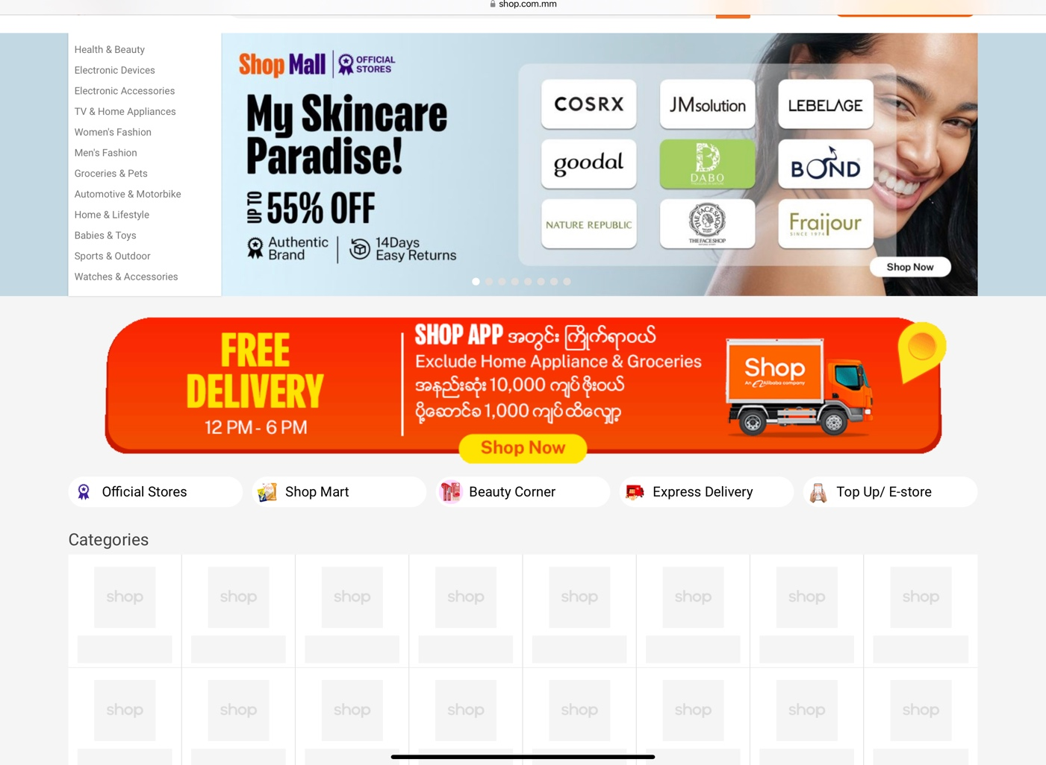

City Mall
City Mall Online provides convenient delivery of fresh groceries, including meats, fruits, and vegetables, straight to your doorstep. With an impressive selection of over 20,000 products, you can enjoy the best deals in town, with delivery options as soon as 2 hours from ordering. This service is part of CMHL's comprehensive retail offerings.

Originating in 1996 as a supermarket located at Aung San Stadium, City Mart Holding has since become a dominant force in various retail formats within Myanmar. It has emerged as a prominent figure in the nation's retail sector. Our goal is to expand our presence through new retail concepts and outlet expansions, with a focus on serving a larger portion of Myanmar's population. Throughout our growth, we remain committed to considering the effects of our actions on our employees, customers, society, and the environment.
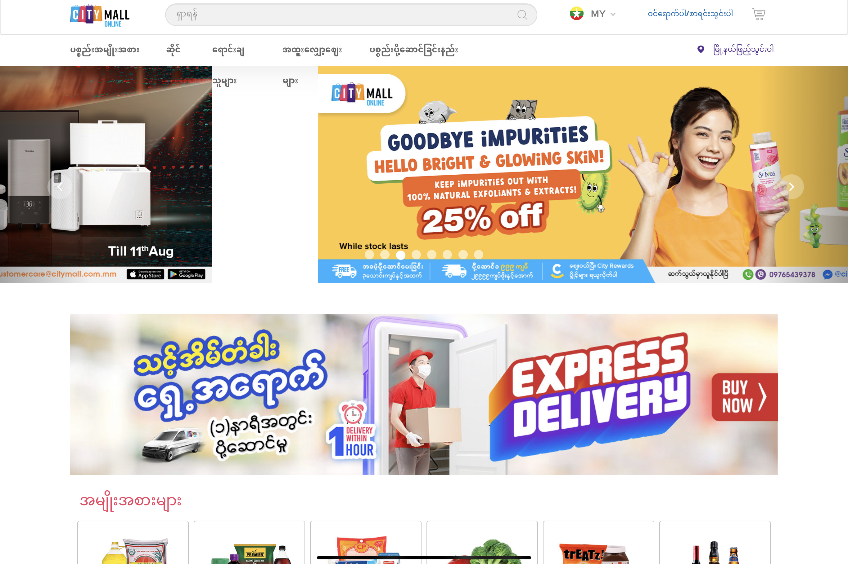
Fig (2) City Mall home page design

Functional Comparison
(1) Customer Registration
Shop.com
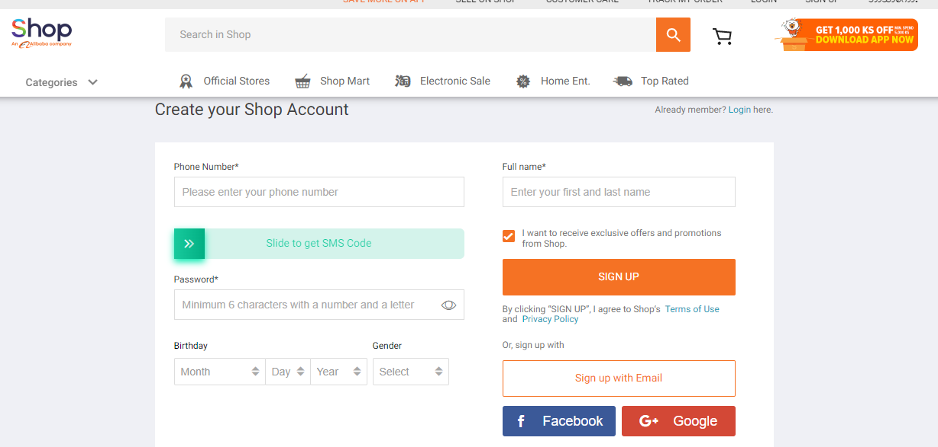
Fig (1) Customer Signup Form from Shop.com (__)
The registration process for Shop.com requires customers to provide essential information. To create an account, customers need to enter their full name, email address, and accurate phone number. Once this information is submitted, a verification code will be sent to the customer's email. This code is crucial for verifying the email address. Upon successful verification, customers will be prompted to set a password for their account. This password ensures the security of their personal details and enables a secure and convenient shopping experience on the platform.
City Mall
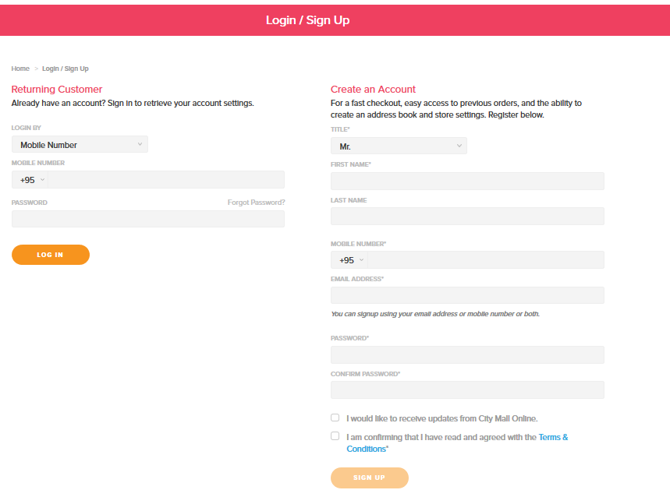
Fig (2) Customer Signup Form from City Mall
The registration process for City Mall involves several steps to ensure accurate and secure sign-up. To create an account, customers are required to provide their complete name, citizenship number, email address, accurate delivery address, and correct phone number. There is also an option to tick a checkbox indicating that the billing address matches the delivery address. Once the necessary information is entered and submitted, an email containing a verification code will be sent to the customer. This code is essential for verifying the email address. After successfully verifying the email, customers will be prompted to set a password for their account, ensuring the security of their personal information and ensuring a seamless shopping experience.
Product Details
Shop.com
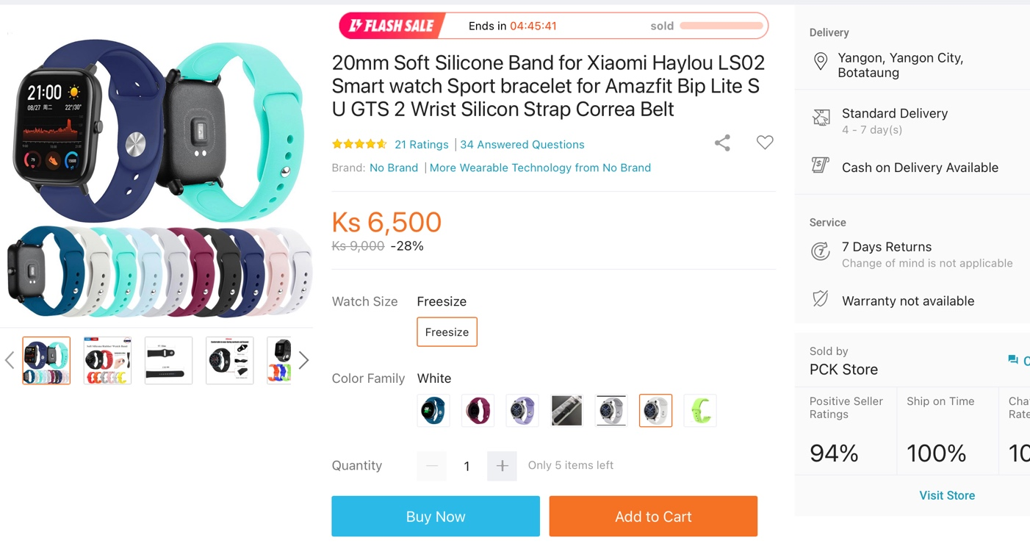
A plethora of product images captured from various perspectives are showcased. Detailed product information, encompassing pricing and color options, is seamlessly integrated. Customers have the liberty to select their desired quantity of the product and add it to their virtual shopping cart. Essential details pertaining to delivery logistics, payment methods, and product warranties are thoughtfully provided.
City Mall Online
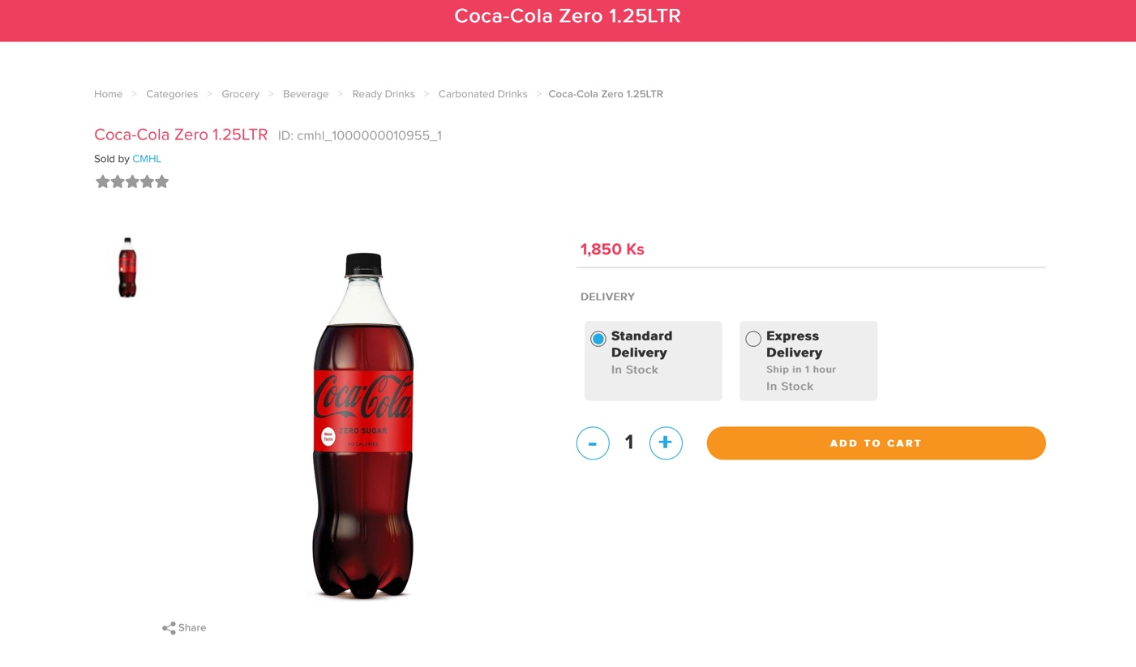
The webpage displays comprehensive information about the selected product. Initially, a visual representation of the product is showcased through an image. Adjacent to the image, the product's name is presented, while a detailed description is provided at the lower section of the page. The "Add to Cart" button stands out with a prominent orange colour, inviting users to take action.

Non-Functional Comparison

10 Usability Heuristics (Nielsen, 2020)
Here are ten usability heuristics that are often used in user interface design:

1. System Status Visibility: Ensure that users are always aware of the system's present condition and the activities that are being taken. To deliver unambiguous status updates, use indicators, feedback, and progress bars.
Explain??????????????????
Shop.com

A number of Item added to shopping cart is displayed
Fig (1)Item added to the cart in Shop.com

CityMall
A number of Item added to shopping cart is displayed

Fig (2)Item added to the cart in CityMall

Match between System and Real World: Create interface components, iconography, and terminology that correspond to users' mental models and known real-world notions.
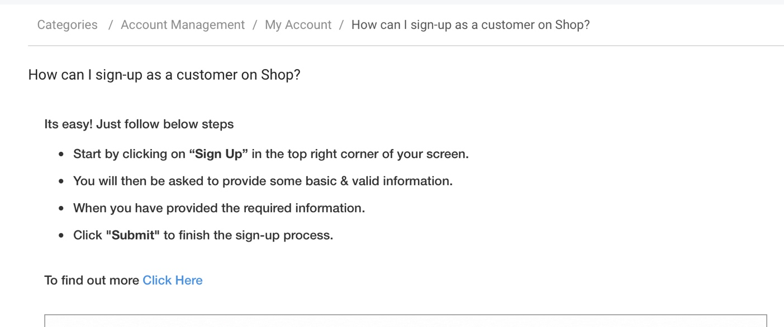
A set of clear instructions written for user
Fig (3)Item added to the cart in Shop.com

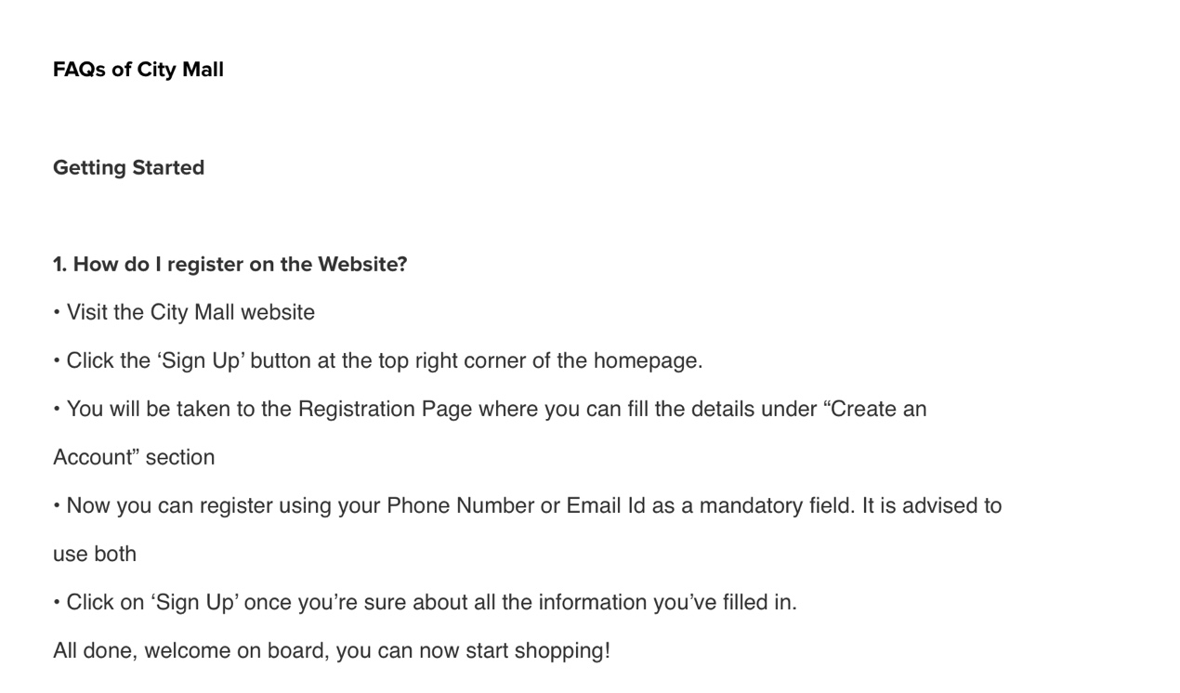
A set of clear instructions written for user
Fig (4)Item added to the cart in CityMall

3. Control and Freedom of the User: Allow users to undo activities and traverse the interface without feeling confined. Give explicit exit points and cancellation choices.
4. Consistency and Standards: To improve predictability and reduce confusion, maintain similar design patterns, vocabulary, and layout throughout the interface.

5. Error Prevention: Create interfaces that reduce the possibility of user errors. Put protections, confirmations, and error-checking measures in place.

6. Recognition Rather than Recall: Make information, alternatives, and actions visible to users, decreasing the need for them to memorize details. To improve recognition, use menus, labels, and cues.

Everything is clearly listed
Fig (5)Item added to the cart in Shop.com

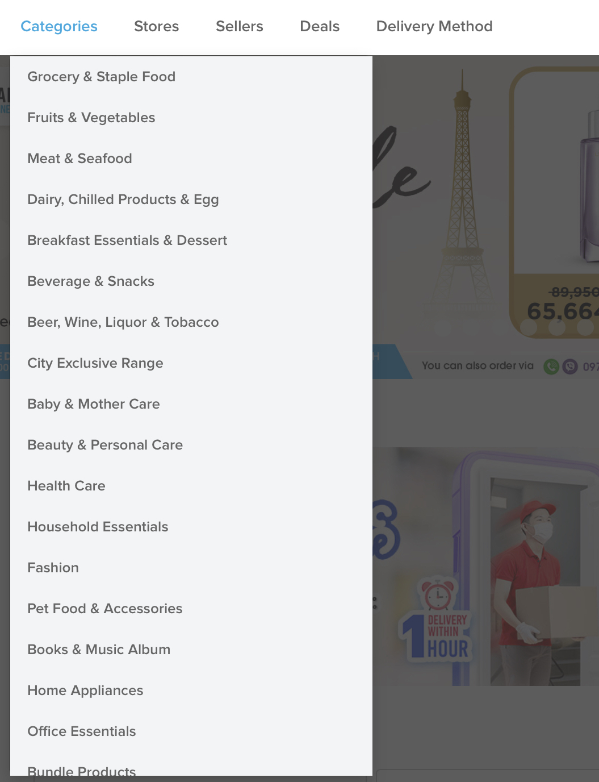
Everything is clearly listed

Fig (6)Item added to the cart in CityMall

7. Use Flexibility and Efficiency: Provide shortcuts, accelerators, and efficient workflows to both novice and expert users while not limiting newcomers.
8. Aesthetic and Minimalist Design: Create visually appealing interfaces that emphasize important content while minimizing visual clutter. Prioritize essential information and actions.
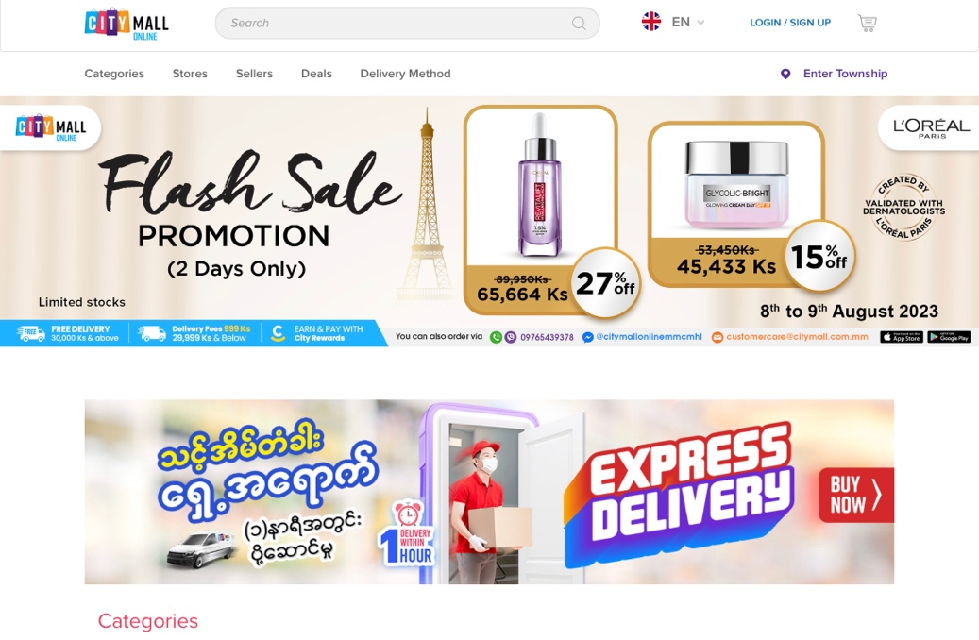
The user face is easy to navigate and pleasant to look at

The user face is easy to navigate and pleasant to look at
Fig (7)Item added to the cart in CityMall
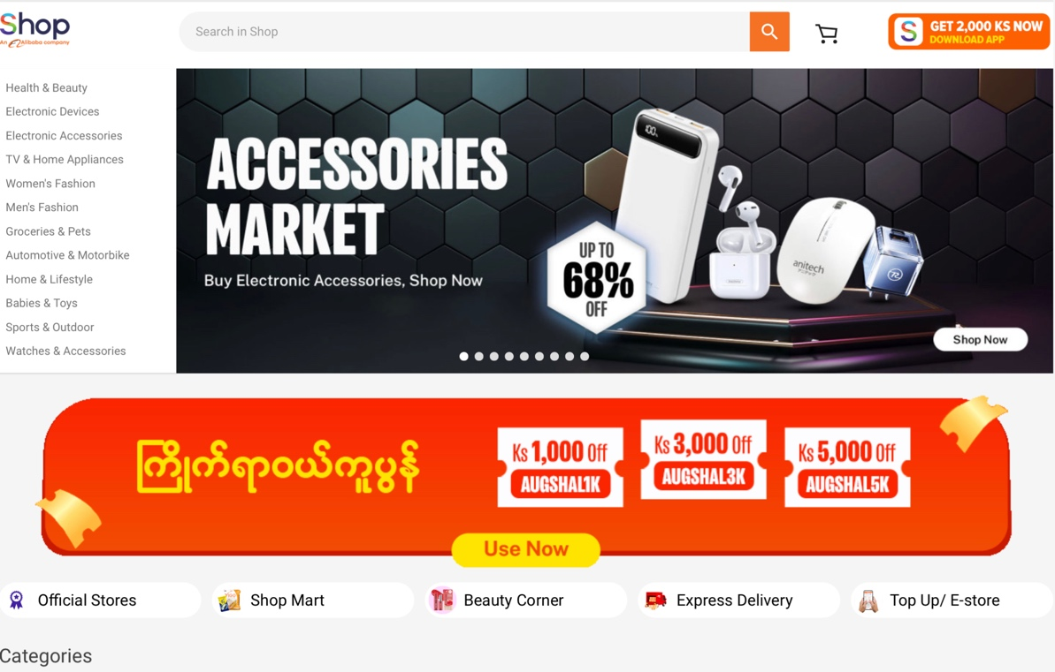
Fig (8)Item added to the cart in Shop.com

9. Help Users Recognize, Diagnose, and Recover from Errors: Clearly communicate error messages, provide explanations, and suggest solutions for users to rectify mistakes.

10. Help and Documentation: Design interfaces to be intuitive and self-explanatory, reducing the reliance on external help. When necessary, offer easily accessible and context-sensitive help resources.

These usability heuristics, introduced by Jakob Nielsen, serve as guidelines for designing user-friendly and efficient interfaces.

- Functional Comparison Evaluation
- No. | Function Name | metro-wholesale.com | spree.com.mm
1. | Customer Registration | 1 2 3 4 5 | 1 2 3 4 5
2. | Customer Login | 1 2 3 4 5 | 1 2 3 4 5
3. | Product Details | 1 2 3 4 5 | 1 2 3 4 5
4. | Shopping Cart | 1 2 3 4 5 | 1 2 3 4 5
5. | Delivery Address | 1 2 3 4 5 | 1 2 3 4 5
6. | Payment methods | 1 2 3 4 5 | 1 2 3 4 5

The shop.mm website offers a notably streamlined account creation process, enabling users to swiftly set up their accounts. Additionally, its intuitive design ensures efficient navigation, allowing users to move through the platform with ease. Furthermore, the purchasing process is simplified, making it convenient for users to buy items hassle-free. This user-friendly approach sets shop.mm apart by prioritizing seamless account management, effortless navigation, and simplified purchasing, ultimately enhancing the overall online shopping experience.
Non-Functional
No. | Function Name | metro-wholesale.com | spree.com.mm
1. | Visibility of system status | 1 2 3 4 5 | 1 2 3 4 5
2. | Match between system and the real world | 1 2 3 4 5 | 1 2 3 4 5
3. | User control and freedom | 1 2 3 4 5 | 1 2 3 4 5
4. | Consistency and standards | 1 2 3 4 5 | 1 2 3 4 5
5. | Error prevention | 1 2 3 4 5 | 1 2 3 4 5
6. | Recognition rather than recall | 1 2 3 4 5 | 1 2 3 4 5
7. | Help users recognize, diagnose, and recover from errors | 1 2 3 4 5 | 1 2 3 4 5

The website, shop.mm, stands out due to its remarkable longevity, which has contributed to its consistently smooth performance and delightful graphic user interface (GUI) that enhances user navigation. Over time, this website has honed its efficiency, resulting in a seamless and fluid user experience. The aesthetically pleasing GUI not only captures users' attention but also facilitates effortless browsing through its well-organized layout and intuitive design. This unique combination of longevity, smooth functionality, and visually appealing interface sets shop.mm apart as a standout example of a user-friendly online platform.

Recommendation of Functional and Non-Functional Comparison
The verification email system implemented by Shop. mm boasts a higher level of security when compared to that of City Mall. However, Shop. mm also offers the added convenience of allowing users to swiftly register and log in using their Facebook accounts. This integration of social media login options expedites the registration process, making it not only faster but also more user-friendly.
Additionally, Shop. mm stands out in terms of its product presentation. The website excels in displaying product details, particularly through its utilization of multiple product images captured from various angles. This approach provides users with a comprehensive view of the product, enabling them to examine it in intricate detail. This advantage enhances the overall shopping experience by granting users a closer, more insightful look at the items they are considering purchasing. In contrast, City Mall may not offer this level of visual detail in its product display, which could potentially limit the customer's ability to thoroughly assess a product before making a decision.

Chapter-3
Feasibility Study

Chapter-3 Feasibility Study

Technical Feasibility

Methodologies

Definition
DSDM (Agile) (what is the dsdm agile methodology, 2023)
The Dynamic Systems Development Method (DSDM) is an Agile project delivery methodology and approach that is utilized in software development and other commercial initiatives. It emphasizes flexibility and collaboration while providing a systematic and disciplined approach to project management and product development.

DSDM is committed to providing high-quality solutions that fulfil the needs of both users and businesses. It encourages iterative and incremental development, which allows for changes and adaptations to be implemented throughout the project's lifecycle. Key aspects of DSDM include frequent user participation, continuous testing, and providing functional increments of the product.

The DSDM framework defines the roles, responsibilities, and processes that will guide the development team and stakeholders throughout the project. Its goal is to ensure that projects are completed on schedule, within budget, and to the requisite quality standards, while also remaining adaptable to changing requirements and priorities.

Overall, DSDM is intended to help enterprises to develop and deliver valuable products and solutions in an efficient and effective manner while adapting to changes and focusing on customer satisfaction.

SSADM (Lutkevich, 2023)
SSADM, or Structured Systems Analysis and Design Method, is a widely used waterfall methodology for analyzing and designing information systems. It was developed in the United Kingdom and gained popularity in the 1980s and 1990s for its structured and systematic approach to the development of large-scale, complex information systems.

SSADM consists of a set of guidelines, techniques, and procedures for the entire systems development life cycle, including requirements analysis, system design, and implementation. It emphasizes a thorough understanding of the user requirements and business processes before proceeding with system design and development. The method aims to ensure that the resulting information system meets the needs of the users and the organization while adhering to quality and documentation standards.

Key features of SSADM include:

1. Logical Data Modeling: SSADM focuses on modelling the data and processes within the organization using techniques like Entity Relationship Diagrams (ERDs) to represent data relationships.

2. Structured Analysis: The method employs structured techniques for analyzing and defining system requirements, including data flow diagrams (DFDs) to depict the flow of data within the system.

3. Functional Decomposition: SSADM breaks down complex systems into smaller, manageable components, making it easier to analyze and design each part separately.

4. Phased Approach: Like other waterfall methodologies, SSADM follows a sequential and phased approach, where each phase must be completed before moving on to the next.

5. Documentation: SSADM places a strong emphasis on documentation throughout the development process, ensuring clear and comprehensive records of requirements, design decisions, and implementation details.

While SSADM was widely used in its time, it has become less popular in recent years with the rise of more flexible and iterative methodologies like Agile. However, its structured approach and focus on thorough analysis and documentation remain valuable in situations where a well-defined, highly structured development process is required.
DSDM VS SSDAM VS Waterfall VS OOAD VS RAD VS Scrum

Strengths and Weakness of Each Methodology (Waterfall vs RAD vs Agile – Which Method Is The Best For You?, 2023)

1. DSDM (Dynamic Systems Development Method):
- Type: Agile methodology.
- Focus: Rapid development while ensuring high quality and collaboration.
- Key Features: Emphasizes user involvement, incremental development, and frequent delivery of working software. Adaptable and flexible to changes in requirements.

2. SSADM (Structured Systems Analysis and Design Method):
- Type: Waterfall methodology.
- Focus: Structured approach to analyzing and designing information systems.
- Key Features: Emphasizes thorough analysis, documentation, and logical data modelling. Proceeds through distinct phases in a sequential manner.

3. Waterfall:
- Type: Traditional and sequential methodology.
- Focus: Linear and phased development with distinct stages.
- Key Features: Divides the development process into sequential phases (requirements, design, implementation, testing, deployment) with minimal room for changes after each phase is completed.

4. OOAD (Object-Oriented Analysis and Design):
- Type: Methodology for modelling and designing software systems using object-oriented principles.
- Focus: Designing software systems by modelling them as objects with properties and behaviours.
- Key Features: Emphasizes encapsulation, modularity, and reusability. Involves creating class diagrams, sequence diagrams, and other UML (Unified Modeling Language) diagrams.

5. RAD (Rapid Application Development):
- Type: Incremental methodology.
- Focus: Rapidly developing software through iterative prototyping and user feedback.
- Key Features: Accelerates development by using prototypes for user feedback, emphasizes time-boxed iterations, and iterative design and development.

6. Scrum:
- Type: Agile framework.
- Focus: Iterative and incremental development with a strong emphasis on collaboration, adaptability, and continuous improvement.
- Key Features: Employs time-boxed iterations called sprints, with a focus on delivering working software in each sprint. Roles include Product Owner, Scrum Master, and Development Team.
Certainly, here's a summary of the pros and cons for each of the mentioned software development methodologies:

DSDM (Dynamic Systems Development Method):

Pros:
- Emphasizes collaboration and user involvement.
- Adaptable to changing requirements.
- Frequent delivery of working software.
- Focus on high-quality development.
- Efficient use of resources through time-boxed iterations.

Cons:
- May require active user involvement, which can be challenging to maintain.
- Complex to manage for larger teams or projects.
- Requires skilled facilitation to ensure effective collaboration.

SSADM (Structured Systems Analysis and Design Method):

Pros:
- Thorough and structured analysis of system requirements.
- Well-documented processes and artifacts.
- Sequential and predictable process.
- Suitable for projects with well-defined requirements and scope.

Cons:
- Limited adaptability to changing requirements.
- Can lead to lengthy development cycles.
- May not be suitable for projects with evolving or dynamic requirements.

Waterfall:

Pros:
- Clear and well-structured development phases.
- Predictable timeline and budget (assuming requirements don't change).
- Well-suited for projects with stable and well-understood requirements.

Cons:
- Limited flexibility for changes after initial planning.
- High risk of late-stage surprises or mismatches with user needs.
- Minimal user involvement until late in the process.

OOAD (Object-Oriented Analysis and Design):

Pros:
- Emphasizes modularity, reusability, and maintainability.
- Enables accurate modeling of complex systems.
- Supports visual representation of system architecture.

Cons:
- May require a steep learning curve for beginners.
- Can lead to over-engineering if not properly managed.
- Focuses more on design and modelling than on development and testing.

RAD (Rapid Application Development):

Pros:
- Accelerated development through iterative prototyping.
- Frequent user feedback helps refine requirements.
- Quick delivery of usable software.

Cons:
- Requires active user involvement throughout the project.
- Complexity can increase with iterative cycles.
- May not be suitable for large or complex projects.

Scrum:

Pros:
- Promotes collaboration and cross-functional teams.
- Adaptable to changing requirements and priorities.
- Frequent delivery of working increments.
- Continuous improvement through retrospectives.

Cons:
- Relies heavily on self-organizing teams and disciplined practices.
- Can be challenging to implement in organizations unfamiliar with Agile principles.
- May not provide a clear long-term project plan.

Each of these methodologies has its own strengths, weaknesses, and suitability for different project scenarios. DSDM and Scrum are both Agile methodologies that prioritize flexibility and collaboration, while Waterfall and SSADM are more structured and sequential. RAD emphasizes rapid prototyping and user feedback, while OOAD focuses on object-oriented modelling and design principles. The choice of methodology depends on factors such as project size, complexity, requirements, team dynamics, and organizational culture.

Recommendation for Methodology
For a Point of Sale (POS) software development project, several factors come into play when selecting a methodology. POS systems typically require efficient transaction processing, user-friendly interfaces, and a seamless customer experience. Here's a recommendation based on the nature of a POS project:

Recommendation: Agile with Elements of Scrum or DSDM

1. Agile Approach:
An Agile methodology is recommended for POS projects due to their evolving nature and the need to quickly respond to changing market demands and customer preferences. Agile promotes flexibility, adaptability, and frequent iterations, which are essential for ensuring that the POS system remains up-to-date and aligned with business needs.

2. Scrum or DSDM Elements:
Incorporate elements of Scrum or DSDM within the Agile framework. Both Scrum and DSDM emphasize iterative development and collaboration, which are crucial for POS systems that require continuous improvement and customer interaction.

Advantages:
- Flexibility: Agile methodologies allow you to adjust the system based on changing business needs and customer feedback.
- User Involvement: Regular iterations involve end-users, ensuring the system meets their requirements and enhances the customer experience.
- Incremental Delivery: You can deliver functional components incrementally, allowing for quicker deployment of essential features.
- Adaptive Planning: Agile methodologies allow you to adjust priorities and features as the project progresses.
- Efficient Updates: Frequent iterations ensure that the POS system can easily accommodate updates, new payment methods, and regulatory changes.

Considerations:
- Active Participation: Key stakeholders, including end-users and business owners, need to be actively involved throughout the project.
- Skilled Team: Require a skilled development team experienced in Agile methodologies.
- Prioritization: Clearly define and prioritize features to ensure essential aspects of the POS system are developed first.
- Regular Review: Regularly review the system with stakeholders to ensure it aligns with their needs and expectations.

Tailoring the Approach:
Depending on the specific requirements of your POS project, you can tailor the Agile approach to suit your needs. For instance, you may choose to adopt Scrum's roles, ceremonies, and artifacts for more structured management, or incorporate DSDM's focus on user involvement and high-quality deliverables.

Ultimately, an Agile approach with Scrum or DSDM elements is recommended for a POS software development project due to its ability to adapt to changing requirements, deliver value incrementally, and provide a user-centric customer experience.

Programming Languages
A. Definitions: (Dev, 2022)

1. PHP (Hypertext Preprocessor):
PHP is a server-side scripting language designed for web development. It is embedded within HTML code and executed on the server, generating dynamic web content. PHP is widely used for creating dynamic web pages, web applications, and e-commerce platforms.

2. ASP.NET:
ASP.NET is a web application framework developed by Microsoft. It enables developers to build dynamic and interactive web applications using various programming languages, including C#. ASP.NET provides a set of tools and libraries for web development.

3. C# (C Sharp):
C# is a versatile programming language developed by Microsoft. It is commonly used for building a wide range of applications, including desktop, web, and mobile applications. C# is closely associated with the .NET framework and is a primary language for developing applications on the .NET platform.

4. Python:
Python is a popular high-level programming language known for its simplicity and readability. It is widely used in web development, scientific computing, data analysis, artificial intelligence, and more. Python's extensive libraries and frameworks make it versatile and suitable for various applications.

5. JSP (Java Server Pages):
JSP is a technology used for developing dynamic web content within Java-based web applications. It allows embedding Java code directly into HTML pages, which are then compiled and executed on the server to generate dynamic web content.

B. Strengths and Weaknesses of Each Programming Language:

Strengths of PHP:
- Ease of Use: PHP is relatively easy to learn and use, making it accessible for beginners.
- Web-Focused: PHP was designed for web development, and it excels at creating dynamic web content.
- Large Community: PHP has a large and active community of developers, leading to extensive documentation and support.
- Versatility: PHP can be embedded into HTML code and supports various databases, making it suitable for a wide range of applications.

Weaknesses of PHP:
- Inconsistent Syntax: PHP's syntax can sometimes be inconsistent and confusing.
- Security Concerns: Poorly written PHP code can lead to security vulnerabilities.
- Scalability Issues: PHP may face challenges in handling large-scale applications and high traffic.

Strengths of ASP.NET:
- Integration with Windows: ASP.NET integrates well with Windows environments and is often used for building enterprise-level applications.
- Rich Development Tools: ASP.NET provides a robust set of tools and libraries for web development.
- Language Flexibility: ASP.NET supports multiple programming languages, including C#, VB.NET, and F#.
- Strong Security Features: ASP.NET includes built-in security features for protecting applications against common threats.

Weaknesses of ASP.NET:
- Windows-Centric: ASP.NET is closely tied to the Windows operating system, which can limit cross-platform capabilities.
- Learning Curve: ASP.NET can have a steeper learning curve compared to some other frameworks.
- Resource Intensive: ASP.NET applications might require more resources compared to simpler frameworks.

Comparison of Programming Languages

Criteria | PHP | ASP.NET
Purpose | Web development, dynamic content | Web apps, services, enterprise-level
Language Integration | Embedded within HTML using <?php ?> tags | Supports C#, VB.NET, F#
Platform Compatibility | Windows, Linux, macOS | Cross-platform (via .NET Core)
Development Environment | Text editors, XAMPP, PHPStorm | Visual Studio, Visual Studio Code

Recommendation for Programming Language
PHP is often a more recommended choice for developing a Point of Sale (POS) system due to its cost-effectiveness, rapid development capabilities, and strong focus on web development. With its open-source nature, PHP provides a budget-friendly option, making it particularly attractive for small businesses or startups. Its simplicity and ease of learning enable faster development cycles, crucial for promptly launching a POS system. PHP's web development prowess suits web-based POS systems exceptionally well, allowing seamless integration with existing websites. Furthermore, its customization flexibility, extensive community support, and easy integration with other systems make PHP an appealing choice for tailoring the POS system to specific business needs while enjoying a wealth of resources.

Databases

Definition
MYSQL (What is MySQL?, 2023)
MySQL is an open-source relational database management system (RDBMS) that is widely used for managing and organizing structured data. It provides a platform for creating, storing, and manipulating data in tables, and it uses Structured Query Language (SQL) for querying and managing databases. MySQL is known for its speed, reliability, and ease of use, making it a popular choice for various applications, from small websites to large-scale enterprise
Microsoft SQL Server VS Access VS PostgreSQL VS Oracle

Strength and Weakness of each Databases (System Properties Comparison Microsoft SQL Server vs. Oracle vs. PostgreSQL, 2023)
MySQL:
- Strengths:
- Performance: Known for fast and efficient performance, especially in read-heavy scenarios.
- Ease of Use: User-friendly and easy to set up, making it suitable for small to medium-sized projects.
- Community and Resources: Large and active community with extensive documentation and online resources.
- Scalability: Scales well for growing applications with proper configuration.

- Weaknesses:
- Limited Features: Compared to some enterprise-level databases, MySQL might have limitations in terms of advanced features and functionality.
- Lack of Built-in Security: While security features are available, they might not be as comprehensive as in some other databases.

Microsoft SQL Server:
- Strengths:
- integration: Seamless integration with other Microsoft products and technologies.
- Enterprise-Level Features: Offers advanced features like data warehousing, analytics, and reporting.
- Security: Strong built-in security features and comprehensive access controls.
- Performance Optimization: Optimized for Windows environments and provides efficient performance.

- Weaknesses:
- Cost: Licensing costs can be high, especially for enterprise editions.
- Platform Dependence Tightly integrated with Windows, which may limit cross-platform capabilities.

Access:
- Strengths:
- Ease of Use: Very user-friendly and suitable for small-scale applications.
- Rapid Development: Quick and easy to set up, making it ideal for simple projects.
- Integration with Microsoft Office: Seamless integration with other Microsoft Office applications.

- Weaknesses:
- Limited Scalability: Not suitable for large or complex applications due to performance and scalability limitations.
- Concurrency Issues: Struggles with handling multiple users and concurrent access.

PostgreSQL:
- Strengths:
- Open Source: Free and open-source with a strong commitment to standards compliance.
- Advanced Features: Offers advanced features like JSON support, full-text search, and spatial data.
- Scalability: Designed for scalability and can handle large and complex datasets.
- Community: Active community and frequent updates.

- Weaknesses:
- Complexity: While powerful, its advanced features can result in a steeper learning curve.
- Resource Intensive: Performance might require more system resources compared to simpler databases.

Oracle:
- Strengths:
- Scalability and Performance: Designed for high performance and scalability, suitable for large enterprise applications.
- Advanced Features: Offers a wide range of advanced features, including partitioning, clustering, and in-memory processing.
- Security: Comprehensive security features for data protection.

- Weaknesses:
- Cost: High licensing and maintenance costs can be a significant factor.
- Complexity: Setting up and managing Oracle databases can be complex and require specialized skills.

Comparison of Databases
Criteria | Oracle | Microsoft SQL Server
Type | Relational Database Management System (RDBMS) | Relational Database Management System (RDBMS)
Platform Compatibility | Cross-platform (Windows, Linux, Unix) | Primarily Windows, some Linux support
Advanced Features | Partitioning, clustering, in-memory processing | Data warehousing, analytics, reporting
Cost | High licensing and maintenance costs | Licensing costs depend on editions
Scalability | High scalability and performance | High scalability and performance

Recommendation for Database
SQL databases are preferred for point of sale (POS) systems due to their ability to ensure data integrity, provide a relational structure for efficient data management, offer flexible querying and reporting capabilities, support scalability to handle increasing transaction loads, ensure data security, facilitate integration with other systems, enable effective transaction management, allow historical data tracking, provide standardization, and offer backup and recovery options. These attributes collectively make SQL databases a reliable and efficient choice for building robust and feature-rich POS systems that can meet the needs of businesses and provide a seamless and secure customer experience.

DSDM Feasibility (DSDM eight principles) (Chapter 4: Principles, 2023)
Dynamic Systems Development Method (DSDM) is an Agile project management and delivery framework that emphasizes collaboration, flexibility, and delivering business value. The eight principles of DSDM provide a foundation for assessing the feasibility of a project. Here's a brief overview of how DSDM's eight principles relate to feasibility:

1. Focus on the Business Need: DSDM emphasizes understanding and prioritizing the business need. Feasibility assessment ensures that the project aligns with business goals and addresses genuine needs, increasing the likelihood of success.

2. Deliver on Time: Feasibility assessment considers the project's time constraints and whether it's achievable within the desired timeframe. DSDM's timeboxing approach helps ensure timely delivery of incremental project increments.

3. Collaborate: Collaboration between all stakeholders, including business representatives and technical teams, is essential for feasibility assessment. Early involvement of stakeholders helps gather diverse perspectives and ensures project viability.

4. Never Compromise Quality: Feasibility evaluation includes assessing whether the project can maintain the required level of quality. DSDM's focus on iterative development and continuous testing supports the delivery of high-quality outcomes.

5. Build Incrementally from Firm Foundations: Feasibility analysis determines whether the project's foundations are strong and whether incremental development aligns with the project's goals. DSDM's iterative approach ensures that each increment builds upon a solid foundation.

6. Develop Iteratively: Feasibility assessment considers whether the project can benefit from iterative development. DSDM's iterative and incremental approach enables ongoing refinement and adaptation based on feedback.

7. Communicate Continuously and Clearly: Feasibility evaluation emphasizes effective communication among stakeholders to ensure shared understanding. DSDM's focus on active and regular communication helps address concerns and keep all parties informed.

8. Demonstrate Control: Feasibility assessment examines whether the project can maintain control over scope, cost, and other constraints. DSDM's emphasis on active project control and regular reviews aids in keeping the project on track.

By applying these principles, DSDM helps assess the feasibility of a project from multiple angles, ensuring that the project is well-aligned with business needs, can be delivered within the desired timeframe, maintains high quality, and involves active collaboration among stakeholders.

Possible LESPI (Legal, Ethical, Social and Professional) Issues
Potential LESPI Concerns in Smart Books' Point of Sale System (Malik, G. and Kretsis, M., 2023)

In this section, an exploration of potential legal, ethical, social, and professional issues (LESPI) inherent to the implementation of Smart Books' point of sale system is undertaken. This comprehensive analysis aims to ensure the system's congruence with established standards and its harmonious integration within the broader business and societal context.

Legal Concerns:
1. Data Privacy and Compliance: Adherence to data protection regulations, such as GDPR or HIPAA, to safeguard customer information and ensure lawful data handling.
2. Contractual Obligations: Ensuring that the system's usage aligns with contractual agreements, including vendor terms and customer data usage policies.

Ethical Considerations:
1. Customer Data Usage: Ethical handling of customer data, including transparent consent mechanisms and responsible data management practices.
2. Fair Pricing and Transparency: Ensuring that pricing practices are fair and transparent, preventing any unethical practices that could mislead customers.

Social Implications:
1. Accessibility: Ensuring the system's accessibility for all customers, including those with disabilities or limited technological proficiency.
2. Local Community Impact: Considering the local community impact of the system's implementation, including potential displacement of traditional retail experiences.

Professional Standards:
1. Security Measures: Adhering to industry standards for data security and cybersecurity to safeguard customer information from breaches or unauthorized access.
2. Employee Training: Ensuring employees are adequately trained to use the system, fostering professional competence and seamless customer interactions.

Addressing these potential LESPI concerns proactively is essential to the successful integration of Smart Books' point of sale system, bolstering its operational efficiency and enhancing its contribution to both the business and broader societal landscape.

Professional Issues (BCS Code of Conduct)
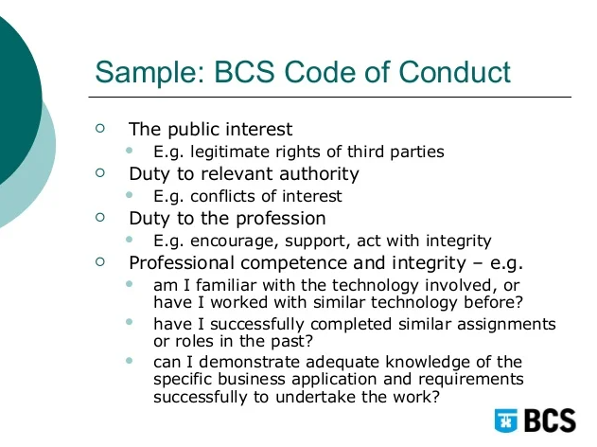
Professional Issues and BCS Code of Conduct

The implementation and operation of Smart Books' point of sale system raise significant professional issues that align with the ethical principles outlined in the BCS (British Computer Society) Code of Conduct. This framework provides a comprehensive guide for ethical behavior and responsible conduct within the field of information technology.

1. Public Interest:
Ensuring that the point-of-sale system serves the public's best interests by safeguarding customer data, ensuring secure transactions, and providing a seamless user experience.

2. Professional Competence and Integrity:
Demonstrating technical proficiency and honesty throughout the system's lifecycle, from design and development to operation and maintenance.

3. Duty to Relevant Authority:
Complying with legal and regulatory requirements governing data protection, financial transactions, and other aspects relevant to the system's operation.

4. Duty to the Profession:
Contributing to the advancement of the IT profession by adhering to best practices, staying informed about industry developments, and promoting ethical conduct among peers.

5. Public Relations:
Maintaining clear and transparent communication with customers, vendors, and stakeholders about the system's capabilities, limitations, and potential risks.

6. Professional Development:
Continuously improving technical skills and knowledge to ensure the system's effectiveness, security, and compliance with evolving industry standards.

7. Duty to Colleagues:
Collaborating with fellow professionals to enhance the quality of the system's design, implementation, and ongoing maintenance.

8. Respect for Confidentiality:
Safeguarding sensitive information related to the system, respecting user privacy, and upholding confidentiality requirements.

9. Ethical Considerations:
Ensuring that the system's features, functionalities, and data usage adhere to ethical principles, promoting fairness, transparency, and responsible decision-making.

10. Professionalism:
Exemplifying professionalism in all interactions, treating customers, colleagues, and stakeholders with respect, integrity, and a commitment to accountability.

In essence, Smart Books' point of sale system must adhere to the principles outlined in the BCS Code of Conduct to ensure that it operates ethically, responsibly, and in alignment with established professional standards.

Chapter-4
Foundations

4.1 Target User

Type of User | Age | Computer skill / IT Literacy | Language skill  (especially English skill)
Customers | 18+ | Basic Computer Proficiency | Pre-Intermediate Level in English Language
Admin Managers and Head Officers | 25-50 | Proficiency and expertise in computer skills, email usage, and IT knowledge. | Upper Intermediate in English Language /Proficient in Business English
Deliverymen | 20-35 | Fundamental proficiency in computer usage  Basic familiarity with navigating websites | Basis English Language Skill  Upper Basis English Skill is more preferred
Store Manager | 20-50 | Advanced Software Proficiency | Proficient in English Language Skill

4.2 Functional Requirement
- Manage Purchase Process (Timebox 1)

  - Manage Staff (HL) (M)
- Register Staff (ML)
  - Email already exists check (LL)
  - Password Length check (LL)
  - Check text Fields Null (LL)
- Update Staff
- Delete Staff
- Search Staff
- Staff Login
  - Manage Supplier (HL) (M)
- Register Supplier
- Update Supplier
- Delete Supplier
- Search Supplier
  - Manage Brand (M)
- Register Brand
- Update Brand
- Delete Brand
- Search Brand
  - Manage Category (S)
- Register Category
- Update Category
- Delete Category
- Search Category
  - Manage Product (S)
- Register Product
- Update Product
- Delete Product
- Search Product
  - Manage Purchase (HL) (C)
- Record Purchase (ML)
  - Add Product (LL)
  - Remove (LL)
  - Calculate Total-Amount (LL)
  - Calculate Total-Quantity (LL)
- Confirm Purchase
- Search & Report Purchase

Manage Order & Delivery Process (Timebox 2)
  - Manage Customer (HL)
- Register Customer (ML)
Email already exists check (LL)
Password Length check (LL)
- Update Customer
- Delete Customer
- Search Customer
- Customer Login

4.3 MOSCOW Prioritization
Moscow Prioritization Justifications:

Must-Have:
- Manage Staff: Staff management is crucial for secure and efficient system access. It ensures proper user registration, authentication, and control.
- Manage Supplier: Supplier management is essential for inventory replenishment and tracking of external partners.
- Staff Login: Secure staff login functionality is a fundamental requirement to ensure authorized access and data protection.
- Manage Purchase (Record Purchase, Confirm Purchase): This core functionality underpins the purchasing process, enabling accurate recording and confirmation of transactions.

Should Have
- Manage Brand: Brand management contributes to categorizing products and enhancing user experience by providing brand-specific information.
- Manage Category: Category management aids in organizing products and streamlining the user interface.
- Manage Product: Product management ensures accurate representation of items available for purchase.

Could Have:
- Manage Purchase (Search & Report Purchase): While valuable for tracking and reporting, this feature is not as essential as the core functions.

The prioritization aligns with ensuring essential operations (Must Have) are functional, followed by important features (Should Have), while considering potential enhancements (Could Have). This approach ensures the system's fundamental integrity, user experience, and potential for future expansion.

4.4 Non-Functional Requirements for Point of Sale (POS) System:

(Md. Mijanur Rahman and Shamim Ripon, 2023)

1. Usability:

The POS system should provide an intuitive and user-friendly interface that is easily navigable by store staff, promoting efficient and error-free operation.

2. Security:

The system must ensure robust data security, including encryption of sensitive information, secure user authentication, and protection against unauthorized access.

3. Performance:

The system should exhibit optimal performance, with quick response times for transaction processing, minimal downtime, and efficient handling of peak loads.

4. Interface:

The POS system should seamlessly integrate with external systems, such as payment gateways, inventory databases, and customer relationship management (CRM) software.

5. Operational:

The system should support daily store operations, including continuous availability, accurate product pricing, real-time inventory updates, and reliable sales recording.

6. Resource:

The system should utilize hardware and software resources efficiently, minimizing memory usage, processing power, and network bandwidth consumption.

7. Portability:

The system should be adaptable to different devices and platforms, allowing store staff to access it via desktop computers, tablets, or mobile devices.

8. Reliability:

The POS system must consistently perform as expected, minimizing system crashes, errors, and disruptions to ensure uninterrupted store operations.

9. Maintainability:

The system should be easily maintainable, allowing for timely updates, bug fixes, and enhancements without disrupting ongoing business activities.

10. Safety:

The system should adhere to safety regulations and best practices, ensuring that customer and staff safety is not compromised during transactions or system usage.

11. Recovery:

The system should have robust backup and recovery mechanisms to quickly restore data in case of system failures or data loss, minimizing downtime and ensuring data integrity.

These non-functional requirements collectively contribute to the optimal functioning, security, and reliability of the POS system, ensuring a seamless and efficient point-of-sale experience for both store staff and customers.

4.5 Time box Plan

Time box 1: Manage Purchase Process Time box
Time box Name |  | Manage Purchase Process Time-box
Start Date |  | 29 January 2021
End Date |  | XXX
Task | Duration | Start Date | End Date
Functional Requirement | 1 day | July 20, 2018 | July 20, 2018
Use Case Diagram | 1 day | July 20, 2018 | July 20, 2018
Class Design | 1 days | July 23, 2018 | July 23, 2018
Sequence Diagram | 1 days | July 23, 2018 | July 23, 2018
High Level & Low-Level Prototype | 2 | ?? | ??
Coding | 6 days | July 24, 2018 | July 31, 2018
Functional Testing | 1 days | August 1, 2018 | August 1, 2018
Usability Testing | 1 days | August 2, 2018 | August 2, 2018
Time Box Summary | 1 day | August 3, 2018 | August 3, 2018
Key Deliverables (Output)
Design
- Use Case Diagram for Mange Purchase Process
- Prototype for Manage Purchase Process
Coding
- Office Member Manage Page
- Employee Role Manage Page
- Member Login Page
- Brand Manage Page
- Category Manage Page
- Product Manage Page
- Supplier Manage Page
- Purchase Manage Page
Testing
- Unit Test Document
- Usability Test Document
- Test Cases

Time Box 2: Manage Orders
Time box Name |  | Manage Order Process Time-box
Start Date |  | 2/June/2023
End Date |  | 23/June/2023
Task | Duration | Start Date | End Date
Functional Requirement | 2 day | 2/July/2023 | 3/July/2023
Use Case Diagram | 1 day | 4/July/2023 | 4/July/2023
Class Design | 1 day | 5/July/20233 | 5/July/2023
Sequence Diagram | 1 day | 6/July/2023 | 6/July/2023
High Level & Low-Level Prototype | 2 days | 7/June/2023 | 9/July/2023
Coding | 6 days | 10/July/2023 | 15/July/2023
Functional Testing | 3 days | 16/July/2023 | 18/July/2023
Usability Testing | 3 days | 19/July/2023 | 21/July/2023
Time Box Summary | 2 day | 22/July/2023 | 23/July/2023
Key Deliverables (Output)
Design
- Use Case Diagram for Mange Order Process
- Prototype for Manage Order Process
Coding
- Customer Manage Page
- Customer Login Page
- Order Manage Page
- Delivery Manage Page
- Payment Manage Page
Testing
- Unit Test Document
- Usability Test Document
- Test Cases

Time box 2: XXX

Time box 3: XXX

4.6 Risk Management (Emmitt, 2023)
Risk Management for Smart Books POS System:

4.6.1 Identification of Possible Risks

Technical Risks:
1. Security Risk: Vulnerabilities in the system could lead to unauthorized access or data breaches, compromising customer and business information.
2. Outsourcing Risk: Dependence on external vendors for system components could result in delays, subpar quality, or compatibility issues.

Functional and Non-Functional Requirement Risks:
3. FR NFR Requirements Risk: Failure to accurately define and prioritize functional and non-functional requirements may lead to an inadequate or ineffective system.
4. Requirement Changes: Frequent changes in requirements could disrupt the development process, impacting project timelines and delivery.

Operational Risks:
5. Performance Degradation: Inadequate system performance during peak usage periods could lead to slow transactions and frustrated customers.
6. Integration Challenges: Difficulties in integrating the POS system with existing systems could hinder smooth operations and data flow.

Financial and Business Risks:
7. Budget Overrun: Unforeseen expenses during development and implementation could exceed the allocated budget.
8. Market Competition: Inadequate system features or delays in deployment may lead to a loss of competitive advantage in the market.

User and Adoption Risks:
9. User Acceptance: Resistance from store staff to adopt the new system due to complexity or lack of training could hinder successful implementation.
10. Customer Adoption: Inadequate user experience could discourage customers from using the system, impacting sales and customer satisfaction.

Change Management Risks:
11. Employee Training: Insufficient or ineffective training for staff on using the new system could lead to errors and inefficiencies.
12. Resistance to Change: Staff resistance to transitioning from manual processes to the new system could impede successful adoption.

Identifying and addressing these potential risks through proactive risk management strategies will mitigate their impact and contribute to the successful development, deployment, and operation of the Smart Books POS system.

4.6.2 Risk Matrix (High-Medium-Low)
Risk | Probability | Impact | Proactive Action | Reactive Action | Risk Owner
Security Risk | Medium | High | Enhance Encryption | Incident Response | IT Manager
User Acceptance | Medium | Medium | User Training | Issue Resolution | Training Team
Customer Adoption | Low | Medium | User-Centric Design | UX improvement | Design Team
Outsourcing Risk | Low | Medium | Vendor Assessment | Contingency Plan | Procurement
Requirement Changes | High | Medium | Change Control | Agile Development | Project Team

4.6.3 Critical Success Factors for the current project
(Zhao, 2023)
1. Effective Requirement Gathering: Thoroughly understanding and documenting the functional and non-functional requirements of the Smart Books POS system is crucial to ensure its alignment with business needs.

2. Robust Security Implementation: Implementing strong security measures, such as data encryption, access controls, and vulnerability assessments, is essential to safeguard customer data and business information.

3. Accurate System Integration: Ensuring seamless integration with existing systems, such as inventory management and e-commerce platforms, is vital for smooth operations and data flow.

4. Usability and User Training: Designing an intuitive user interface and providing comprehensive user training will enhance system adoption by store staff and customers.

5. Stakeholder Communication: Establishing clear and consistent communication channels among project stakeholders, including developers, managers, and end-users, fosters alignment and mitigates misunderstandings.

6. Effective Change Management: Managing resistance to change and ensuring staff buy-in through change communication and training will facilitate the successful adoption of the new system.

7. Timely Project Management: Adhering to project timelines, milestones, and deliverables is crucial to ensure on-time and within-budget project completion.

8. Quality Assurance and Testing: Rigorous testing and quality assurance measures must be employed to identify and rectify any defects or issues before system deployment.

9. Supplier and Vendor Management: Effective management of external vendors and suppliers contributes to the timely delivery of components and system elements.

10. Post-Implementation Support: Providing ongoing technical support, maintenance, and continuous improvements post-implementation will sustain the system's functionality and user satisfaction.

These critical success factors collectively contribute to the achievement of project goals, successful deployment of the Smart Books POS system, and its seamless integration into the bookstore's operations.
The Whole System Use Case & Class
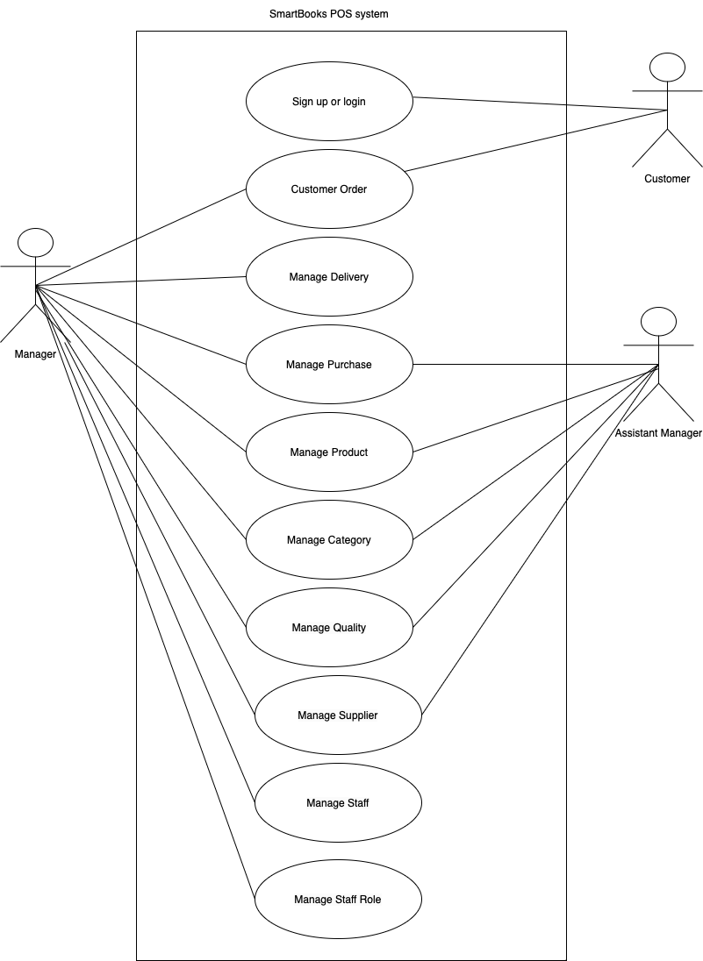

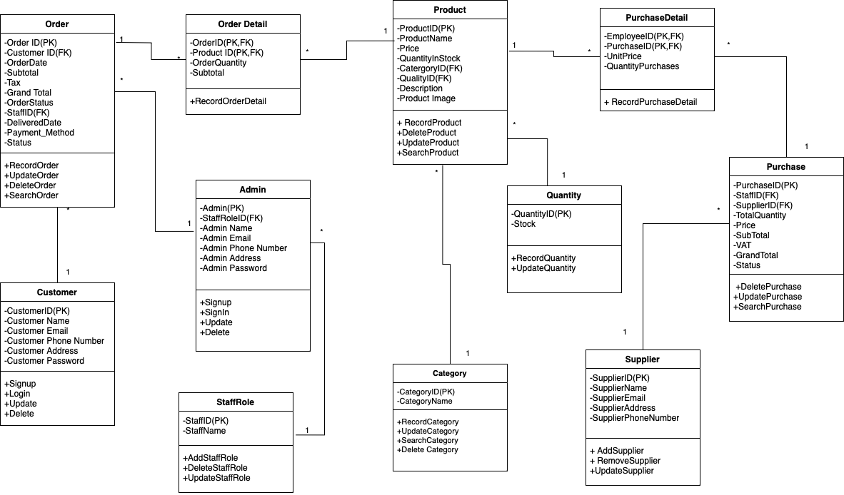

Chapter-5
Exploration & Engineering

5.1 Time-box 1: Manage Purchase Time-box Development

Project Plan for Time Box 1

5.1.1 Functional Requirements List
Manage Purchase Process Timebox (1)
  - Manage Staff (HL)
- Register Staff (ML)
Email already exist check (LL)
Password Length check (LL)
- Update Staff
- Delete Staff
- Search Staff
- Staff Login
  - Manage Supplier
- Register Supplier
- Update Supplier
- Delete Supplier
- Search Supplier
  - Manage Brand
- Register Brand
- Update Brand
- Delete Brand
- Search Brand
  - Manage Category
- Register Category
- Update Category
- Delete Category
- Search Category
  - Manage Product
- Register Product
- Update Product
- Delete Product
- Search Product
  - Manage Purchase
- Record Purchase
- Confirm Purchase
- Search & Report Purchase

5.1.2 Use Case Diagram
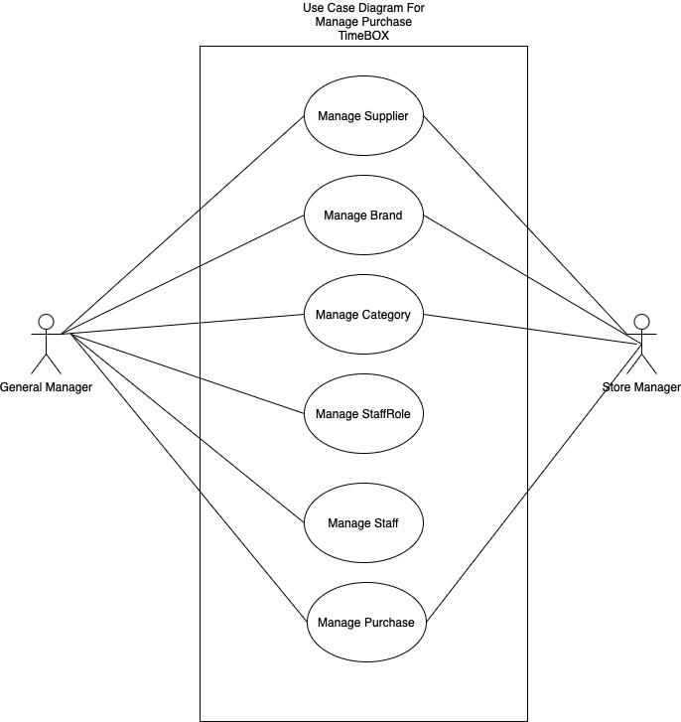

Use Case Descriptio
Use Case Name | Record and Manage Supplier
Actor | Manager
Flow of Event | Complete the supplier information within the customer form and then proceed by clicking the "Register" button.

For remaining, see Appendix.

5.1.3 Screen Design
Low level prototype
Supplier Registration form

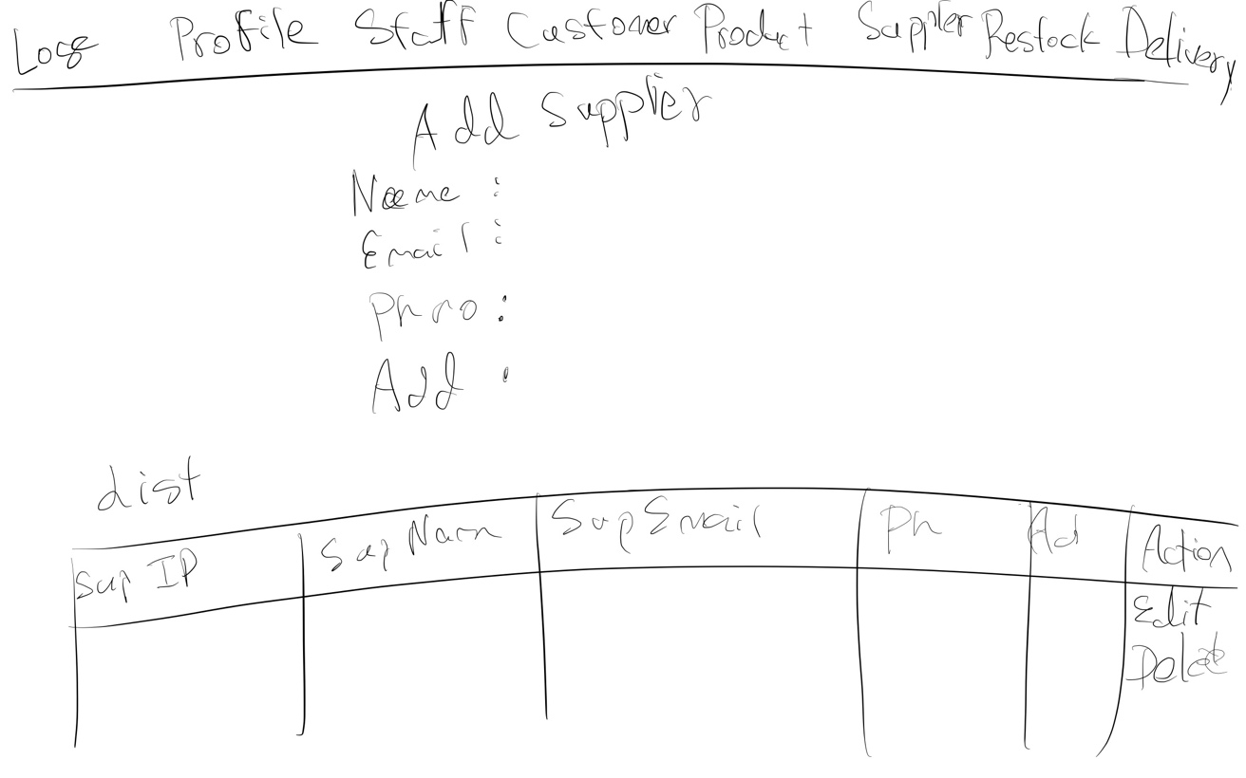

Brand Registration Form
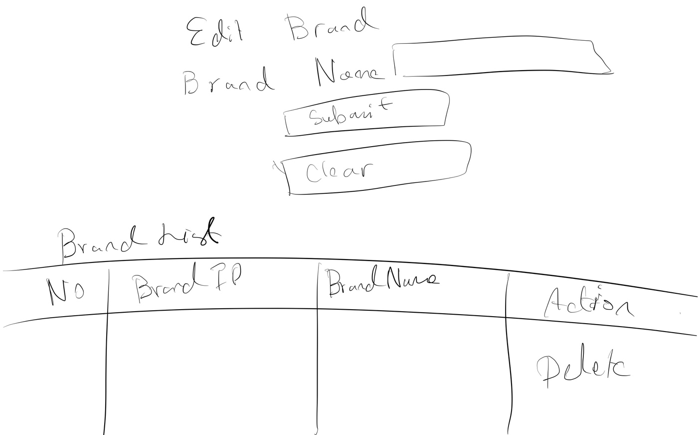

Staff registration Form
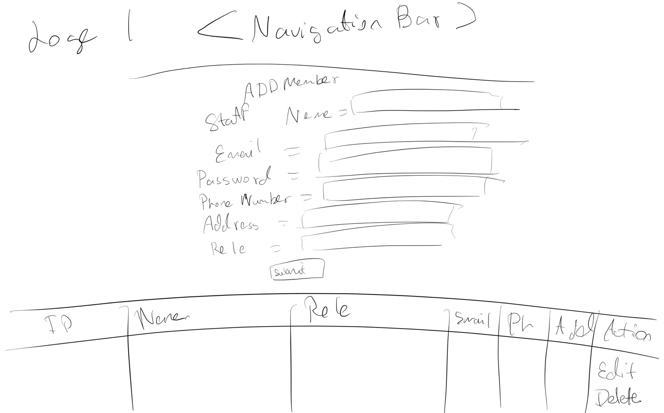

Category Registration form
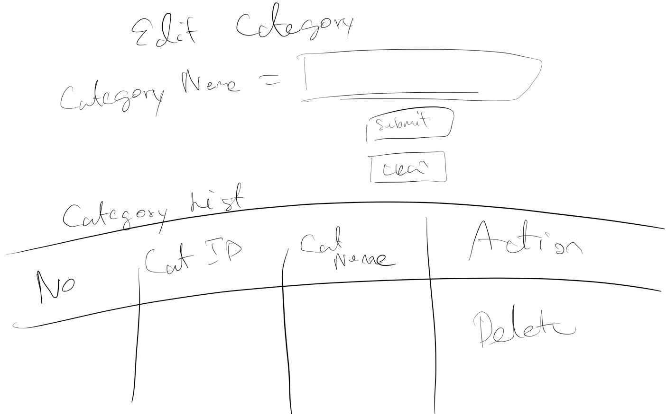

Staff Role registration Form
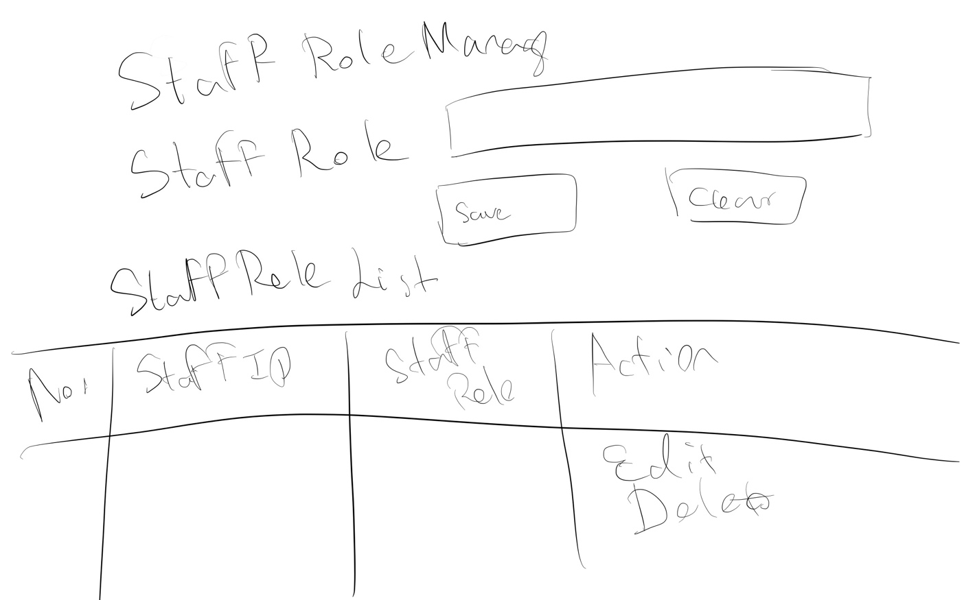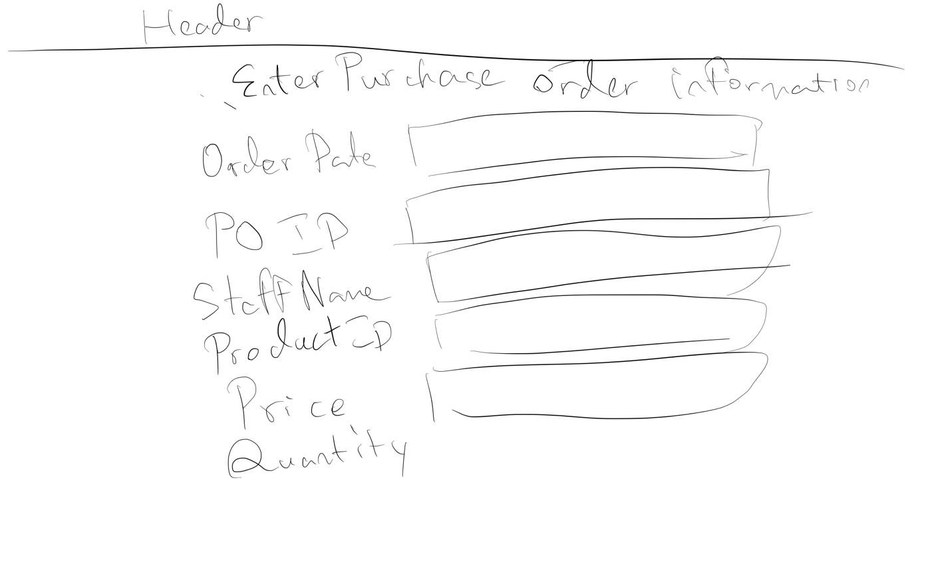

Customer Sign In Form
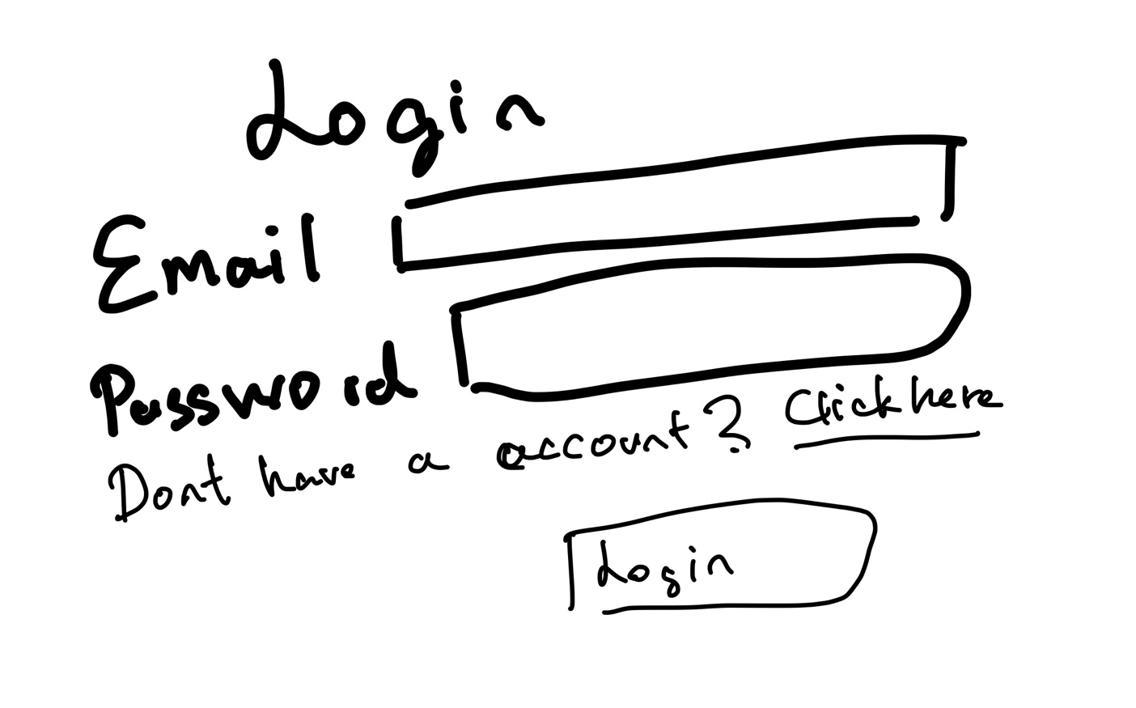

Search Bar prototype
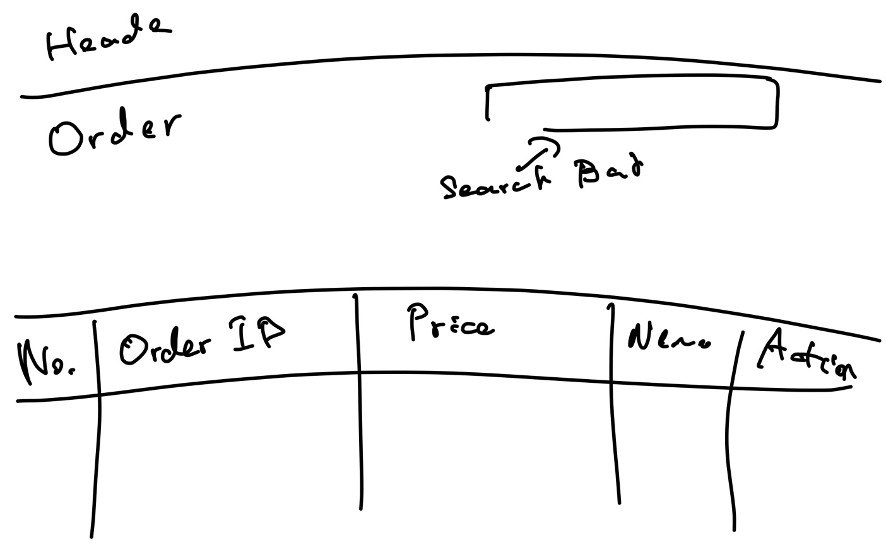

Fig (2) High Level Prototype for Customer Registration

High Level Prototype for Brand Registration


High Level Prototype for Supplier Registration


High Level Prototype for Role Registration


High Level Prototype for Search Function

5.1.5 Class Diagram

Initial Class Diagram
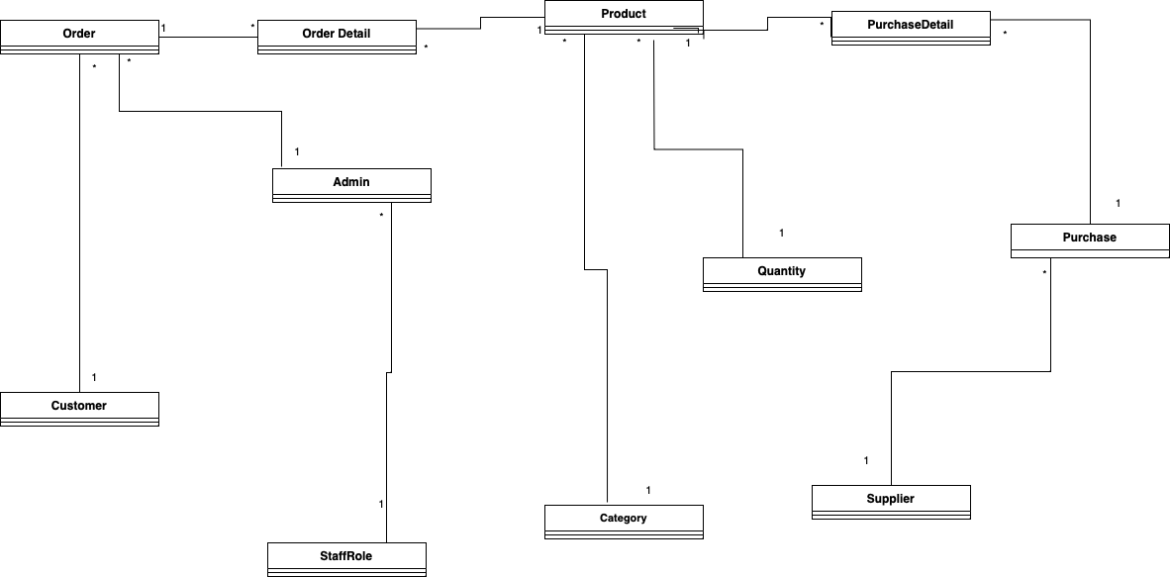

Detailed Class Diagram
Detail Class Definitions
Class Name | Customer
Attributes | Customer ID, Customer Name, Phone No, Address, Email,
Operation | Register (),Cancel (), AutoID(), Checkdata()
Description | << The Customer class is used to register customers who booked.>>

Class Name | Order
Attributes | OrderID, Customer Name, Order Date, Subtotal, tax,GrandTotal, OrderStatus, StaffID,DeliveredDate,PaymentMethod,Status
Operation | Register (),Cancel (), AutoID(), Checkdata()
Description | << The Order class is used to do register for customers who Ordered.>>
Class Name | OrderDetail
Attributes | Order ID, Product ID, OrderQuantity,Subtotal
Operation | Register (),Cancel (), AutoID(), Checkdata()
Description | << The Order Detail class is used to do register for Order.>>

Class Name | Quantity
Attributes | Quantity ID, Stock
Operation | Register (),Cancel (), AutoID(), Checkdata()
Description | << The Quantity class is used to register for stock.>>

Class Name | Category
Attributes | Category ID, Category Name, Phone No,
Operation | Register (),Cancel (), AutoID(), Checkdata()
Description | << The Category class is used to do register for Category.>>

5.1.6 Sequence Diagram for Booking Process
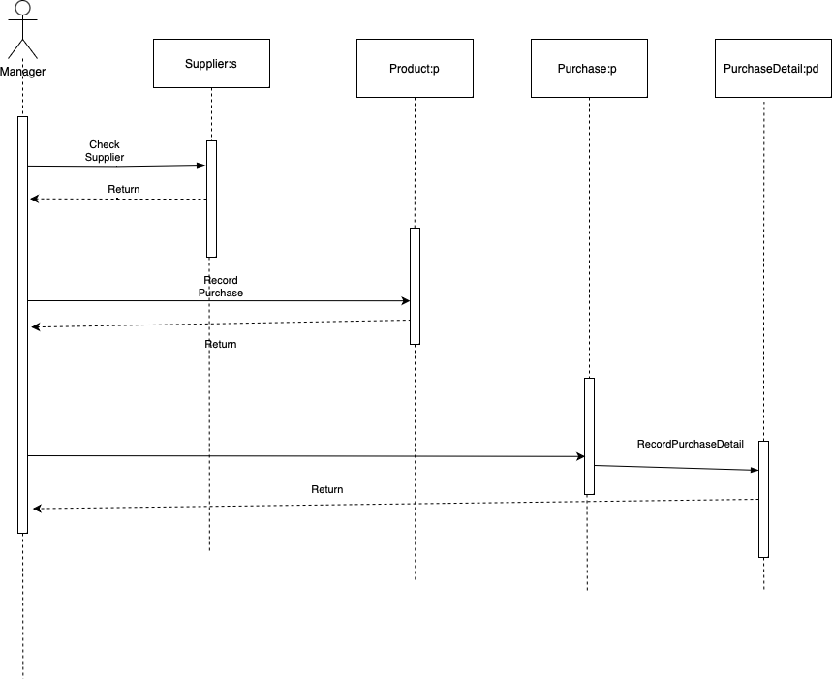

5.1.7 Functional Testing

Test Plan
Module 1: Staff Management
Test Script | Description | Date | Tester
1.1 | Test the Empty Text Box | 24-May-2023 | Kitty
1.2 | Test the Email exists check | 24-May-2023 | Kitty
1.3 | Test the password strength | 24-May-2023 | Kitty
1.4 | Test the reset password | 24-May-2023 | Kitty
1.5 | Test Register Button | 24-May-2023 | Kitty
1.6 | Test Update Button | 24-May-2023 | Kitty
1.7 | Test Delete Button | 24-May-2023 | Kitty

Module 2: Product Management
Test Script | Description | Date | Tester
2.1 | Test the Empty Text Box | 24-May-2023 | Kitty
2.2 | Test the Product exists check | 24-May-2023 | Kitty
2.3 | Test the Register Button | 24-May-2023 | Kitty
2.4 | Test the Update Button | 24-May-2023 | Kitty
2.5 | Test the Delete Button | 24-May-2023 | Kitty

Module 3: Supplier Management
Test Script | Description | Date | Tester
3.1 | Test the Empty Text Box | 24-May-2023 | Kitty
3.2 | Test the Supplier exists check | 24-May-2023 | Kitty
3.3 | Test the ‘@’ in the E mail | 24-May-2023 | Kitty
3.4 | Test Register Button | 24-May-2023 | Kitty
3.5 | Test Update Button | 24-May-2023 | Kitty
3.6 | Test Delete Button | 24-May-2023 | Kitty

Module 4: Category Management
Test Script | Description | Date | Tester
4.1 | Test the Empty Text Box | 25-May-2023 | Kitty
4.2 | Test the Category exists check | 24-May-2023 | Kitty
4.3 | Test the Register Button | 24-May-2023 | Kitty
4.4 | Test the Update Button | 24-May-2023 | Kitty
4.5 | Test the Delete Button | 24-May-2023 | Kitty

Module 5: Brand Management
Test Script | Description | Date | Tester
5.1 | Test the Empty Text Box | 24-May-2023 | Kitty
5.2 | Test the Brand exists check | 24-May-2023 | Kitty
5.3 | Test the Register Button | 24-May-2023 | Kitty
5.4 | Test the Update Button | 24-May-2023 | Kitty
5.5 | Test the Delete Button | 24-May-2023 | Kitty

Module 6: Purchase Management
Test Script | Description | Date | Tester
6.1 | Test the Empty Product Text Box | 25-May-2023 | Kitty
6.2 | Test the Add Button | 25-May-2023 | Kitty
6.3 | Test the existing product addition | 25-May-2023 | Kitty
6.4 | Test the remove button | 25-May-2023 | Kitty
6.5 | Test the Clear All button | 25-May-2023 | Kitty
6.6 | Test the Empty Supplier text box | 25-May-2023 | Kitty
6.7 | Test the Save button | 25-May-2023 | Kitty

Module 7: Purchase Order Search
Test Script | Description | Date | Tester
7.1 | Test Search by Purchase Order ID | 25-May-2023 | Kitty
7.2 | Test Search by Purchase Order Date | 25-May-2023 | Kitty
7.3 | Test Search by Status | 25-May-2023 | Kitty

Test Script 1
Unit Test 1 |  | Test Case: Register by data entry Staff | Designed by: Kitty
Data Source: Staff Table |  | Objective: To test the Register of data entry Staff table | Tester: Kitty
Test Case | Description | Test Procedure | Expected Result | Actual Results
1.1 | Test text box | 'Add' button is clicked with blank employee name. | Show ‘Please fill out this field’ message.

Test Script (2)
Unit Test 2 |  | Test Case: Register by data entry products | Designed by: Kitty
Data Source: Product Table |  | Objective: To test the Register of data entry products | Tester: Kitty
Test Case | Description | Test Procedure | Expected Result | Actual Results
2.1 | Test Empty text box | 'Register' button is clicked with blank product name. | Show ‘Please fill out this field’ message. | See Fig.2.2

Test Script (3)
Unit Test 3 |  | Test Case: Register by data entry suppliers | Designed by: Kitty
Data Source: Supplier Table |  | Objective: To test the Register of data entry suppliers | Tester: Kitty
Test Case | Description | Test Procedure | Expected Result | Actual Results
3.1 | Test Empty text box | 'Register' button is clicked with blank supplier name | Show ‘Please fill out this field’ message. | See Fig.3.2

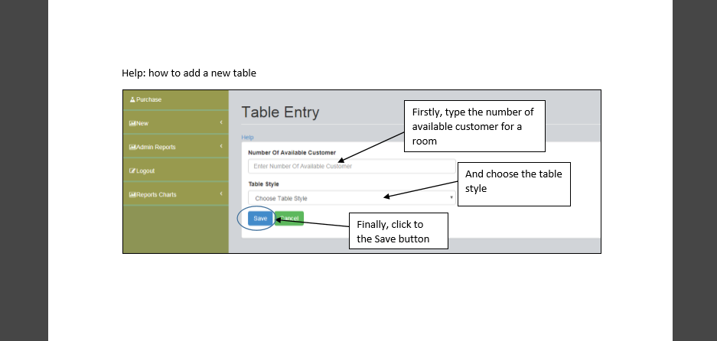

5.1.8 Time box Summary

Work Accomplished

In Chapter 4, two timeboxes were established for the project. One of these, the Manage Purchase timebox, has been completed. The initial step involved outlining the functional requirements for this timebox. Subsequently, screen designs and necessary functions were developed and rigorously tested for both functionality and user-friendliness. Revisions were made iteratively to address any identified issues related to functionality or user experience.

Challenges Faced

Executing the entire project as a solo endeavor has proven to be demanding. Sourcing relevant information on various subjects has proven to be challenging, and while certain solutions may address existing issues, they often give rise to new complications. Many problems have arisen during the coding phase. Designing the user interface of the website and implementing changes has been particularly arduous, as a single modification can unexpectedly disrupt the entire design.

Proposed Solutions

To address these challenges, the project has been shared with the teacher for feedback and validation. This collaborative approach ensures that any necessary adjustments are identified and incorporated.

Remaining Timeboxes

One of the designated timeboxes has been successfully completed. The second outstanding timebox pertains to the Manage Order functionality. This involves enabling customers to place orders, create accounts, and providing employees with the means to manage these orders.

CHAPTER – 6
Deployment

6.1 Deployment

6.1.1 Deployment Diagram
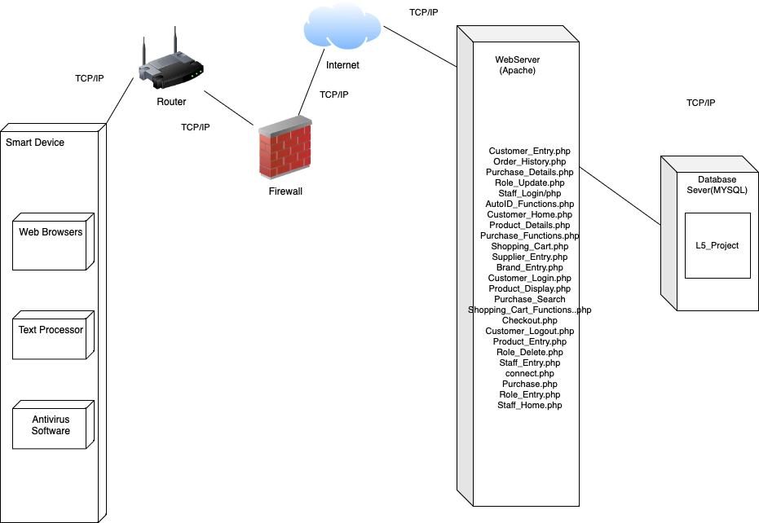Explanation for diagram
<<MYSQL>>
<<Apache>>

The provided diagram illustrates the deployment structure of the system, depicting its various components and processes. According to the diagram, devices capable of utilizing web browsers and connecting to the internet will include browsers like Firefox or Chrome, along with software such as Office 365 and Avast Antivirus. These technical devices are then linked to the internet through a router or switch, which is safeguarded by a Firewall. The Firewall plays a protective role by offering features like packet-filtering, inspection, and other security measures to ensure the security of both technical devices and data.

The Firewall is connected to a Web Server (Apache), which serves as the hosting platform for the project's PHP pages. This server maintains a connection with a database server (MySQL), housing the L5_Project database.

6.2 Data Migration

6.2 Data Migration (Gillis, 2023)

Data migration is the process of moving data from one location, format, or system to another. It is often undertaken to achieve goals such as system upgrades, data center migrations, technology platform changes, or consolidation efforts. Data migration ensures that data remains accurate, consistent, and available during the transition. There are different types of data migration, each serving specific purposes:

1. Storage Migration This involves moving data from one storage system to another. It could be within the same data center or between different data centers. The goal is often to improve storage efficiency, performance, or to replace outdated hardware.

2. Database Migration: This type involves moving data from one database system to another. It could be necessary when upgrading database versions, changing database vendors, or consolidating databases.

3. Application Migration: In this case, data is moved from one application to another. This might occur when replacing an old application with a new one, or when integrating data from multiple applications into a single unified system.

4. Cloud Migration: Moving data from on-premises systems to cloud-based platforms. Cloud migration aims to take advantage of cloud benefits such as scalability, flexibility, and reduced infrastructure management.

5. Business Process Migration: This type involves moving data as part of a larger business process change. For example, when a company adopts a new customer relationship management (CRM) system, data related to customers and interactions might need to be migrated.

6. Platform Migration: Data is moved from one technology platform to another. This could involve moving from one operating system to another, or from one server platform to a different one.

7. Format Migration: Converting data from one format to another. For instance, converting data from a legacy file format to a modern, more compatible format.

8. Data Center Migration: This encompasses moving an entire data center, including hardware, applications, and data, from one physical location to another. It involves meticulous planning and execution to minimize downtime and ensure data integrity.

9. Content Migration: Focusing on moving unstructured data, such as documents, images, and multimedia, from one repository to another. This is often relevant in content management systems and digital asset management.

10. ETL (Extract, Transform, Load) Migration: This involves extracting data from the source, transforming it to meet the target system's requirements, and loading it into the destination system. ETL migrations are common in data warehousing and data integration scenarios.

Each type of data migration requires careful planning, testing, and execution to ensure that the data remains accurate, consistent, and accessible throughout the process. It's important to consider factors such as data mapping, data cleansing, validation, and potential downtime or disruption during the migration process.

6.2.1 Data to Migrate

6.2.2 Data to Migrate
Time Box | Master Data | Transaction Data
Time Box 1: Manage Purchase Supply Process Time Box (Web Admin Site) | Employee Information  Supplier Information  Purchase Supply Information  Product Information | Purchase Supply Order
Time Box 2: Manage Order Process for Customer Time Box (Customer Site) | Customer Information  Customer Order Information  Delivery Service Information | Customer Order for Product

6.2.3 Migration Plan
Timebox | Data to Migrate | Duration | Start Date | End Date | Responsible person
Time Box 1: Manage Purchase Supply Process Time Box (Web Admin Site) | - Staff Role  - Supplier  - Brand  - Category  - Product  - Purchase Order | 4 days | 10 July 2023 | 13 July 2023 | Admin Manager,  Store Manager
Time Box 2: Manage Order Process for Customer Time Box (Customer Site) | - Customer  - Township  - Customer Order | 4 days | 24 July 2023 | 27 July 2023 | Admin Manager,  Customer Service Staffs

6.3 Training Plan

No | Contact | Trainee | Start Date | End Date | Venue | Time
1 | Time Box 1  - Employee Role  - Office Member  - Purchase | Admin Manager,  Store Manager | 14 July 2023 | 18 July 2023 | SmartBooks | 5 pm – 7 pm
2 | Time Box 2  - Customer  - Township  - Customer Order | Admin Manager,  Customer Service Staffs | 28 July 2023 | 30 July 2023 | SmartBooks | 5pm – 7 pm

6.3 Training

6.3.1 Training plan
No | Content | Trainee | Start Date | End Date | Venue | Time
1 | Time Box 1  - Customer  - Room  - Table  - Booking  - Staff | Receptionist, Restaurant Manager, | 15 August 2018 | 17 August 2018 | Jame Restaurant | 5 pm – 7 pm

6.3.2 User Manual
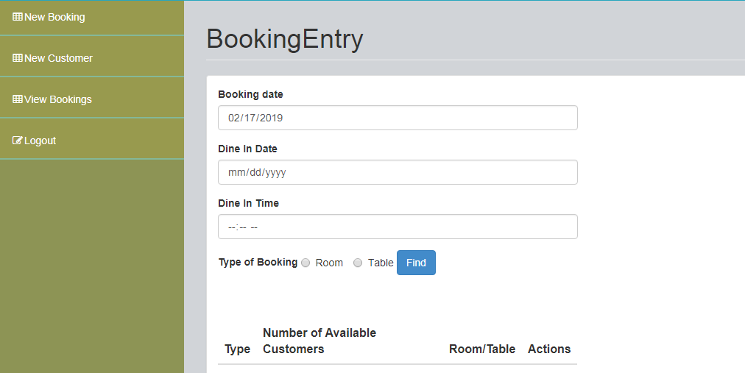
Firstly, set the booking date
And set the booking time
After choosing the booking type click to the Find button
And Choose the booking type

CHAPTER – 7

CONCLUSION

&

EVALUATION

7.1 Evaluation against Aim & Objectives

Evaluation against Aim & Objectives:

Aim;

To create an efficient and user-friendly point of sale (POS) system for Smart Books to enhance sales management and customer experience.

Objective 1: Analysis

Evaluation: The analysis phase was executed comprehensively, with thorough assessment of the bookstore's requirements, user needs, and system functionalities. Stakeholders' inputs were considered, ensuring a solid foundation for system development.

Objective 2: Design

Evaluation: The design phase successfully translated the analysis into a well-structured system blueprint. User interfaces were thoughtfully designed, aligning with usability principles and accommodating both staff and customer interactions.

Objective 3: Coding

Evaluation: The coding phase demonstrated technical proficiency, resulting in the successful implementation of system functionalities. Code quality and adherence to coding standards contributed to the system's reliability and maintainability.

Objective 4: Testing

Evaluation: The testing phase was rigorous and systematic, encompassing unit, integration, and user acceptance testing. Identified issues were promptly addressed, leading to a stable and functional POS system.

Objective 5: Training

Evaluation: The training phase ensured that store staff received comprehensive training on system usage, minimizing resistance to change and facilitating smooth adoption of the new POS system.

In summary, the project's execution aligns well with its aim and objectives. Each phase was executed with diligence, resulting in the development of an efficient and user-friendly point of sale system that enhances sales management and customer experience for Smart Books.

7.3 Evaluation against Justification Made
Methodology - Agile:
Evaluation: The adoption of the Agile methodology was instrumental in achieving project success. Regular iterations and collaboration ensured alignment with stakeholder expectations and timely adjustments to changing requirements.
Problems Encountered: Balancing flexibility with maintaining project scope proved challenging at times, requiring continuous communication and adaptation.
Lessons Learnt :Agile's incremental approach enhances adaptability, but meticulous scope management and clear communication are vital to prevent scope creep.

Language - PHP:
Evaluation: Utilizing PHP as the primary programming language enabled dynamic web development and efficient server-side scripting. It facilitated seamless integration with web interfaces and database interactions.
Problems Encountered: Handling security vulnerabilities, such as SQL injection, posed challenges, necessitating rigorous input validation and implementing secure coding practices.
Lessons Learnt: Security considerations are paramount; implementing coding best practices and security measures is essential to safeguard the system against potential threats.

Database - SQL:
Evaluation:Employing SQL as the database language facilitated structured data management, retrieval, and manipulation. It ensured data integrity and supported complex queries.
Problems Encountered: Ensuring optimal query performance and handling concurrent transactions required fine-tuning and indexing strategies.
Lessons Learnt: Database optimization is critical for efficient system performance; continuous monitoring and refinement of query execution are integral.

In summary, Agile methodology promoted flexibility and stakeholder engagement, PHP empowered dynamic web development, and SQL facilitated effective database management. Challenges encountered underscored the significance of meticulous scope control, security measures, and optimization strategies. The project's execution against the chosen methodology and technologies showcases the project team's ability to address complexities and deliver a successful solution.

7.4 Evaluation against Time Box Plan
Time Box 1: Manage Purchase Time Box - Progress and Challenges

Work Accomplished:
The first time box, focused on managing purchases, has been successfully completed. Functional requirements were outlined initially, followed by the creation of screen designs and essential functions. Rigorous testing was conducted to ensure functionality and user-friendliness, with iterative changes made to enhance both aspects.

Challenges Encountered:
Undertaking the entire project single-handedly posed a challenge, especially when encountering subjects that were challenging to research. Some solutions introduced new complexities. Issues mainly surfaced during the coding phase. Designing the website's user interface also proved intricate, as minor changes could disrupt the overall design coherence.

Mitigation Strategies:
Regular discussions and presentations to the teacher provided confirmation and valuable input, aiding in refining the project and addressing identified issues.

Remaining Time Box:
One of the project's two time boxes has been successfully completed. The remaining time box focuses on "Manage Order," involving customer account creation, order placement, and employee order management.

Time Box 2: Manage Order Time Box - Progress and Resolutions

Work Accomplished:
The second time box aims to establish a customer-centric system. All tasks outlined in the time box plan were effectively executed prior to commencing system development.

Challenges Encountered:
Similar to the previous time box, coding complexities persisted, particularly within the PHP programming domain. Some code behaved unexpectedly, leading to unforeseen errors. Additionally, certain screen designs did not meet desired visual standards.

Mitigation Strategies:
Online research aided in addressing coding and design challenges. Real-world website designs were referenced for inspiration. Code underwent rigorous review, and discussions with the teacher provided insights for necessary modifications.

Conclusion:
With the completion of the second time box, the project's entirety is now realized. Challenges were met with strategic research and discussions, contributing to a successful project outcome. The iterative approach and problem-solving strategies showcased adaptability and a commitment to overcoming obstacles.

7.5 Personal Evaluation
Personal Evaluation of Current Project:

Participating in the development of the Smart Books Point of Sale (POS) system has been a valuable and enriching experience. This project allowed me to apply theoretical knowledge to real-world scenarios, honing my skills in various aspects of software development and project management. Here is my personal evaluation of the project:

Learning and Skill Development:
The project provided an excellent platform for enhancing technical skills. I gained proficiency in PHP programming, SQL database management, and web interface design. Overcoming coding challenges and optimizing code efficiency deepened my understanding of software development principles.

Teamwork and Collaboration:
Working independently on a project of this scale allowed me to manage tasks efficiently. However, I recognize the importance of collaboration and team dynamics in larger projects. Regular interactions with my teacher provided valuable insights and guidance that contributed to project success.

Problem-Solving and Adaptability:
Encountering coding complexities and unexpected errors required me to adopt a problem-solving mindset. I learned to research and implement effective solutions, enhancing my ability to troubleshoot and debug code effectively.

Time Management and Planning:
The project's time boxing approach underscored the significance of effective time management and planning. Balancing different project phases and ensuring timely delivery of milestones helped me develop better organizational skills.

User-Centric Design:
Designing user interfaces taught me the importance of user-centered design principles. Ensuring usability and a seamless experience for both store staff and customers was a rewarding aspect of the project.

Continuous Learning:
Throughout the project, I embraced a learning-oriented approach. Researching online resources, seeking feedback, and iterating on designs and functionalities highlighted the necessity of continuous learning and improvement.

Challenges and Growth:
Overcoming challenges, such as implementing security measures and optimizing database performance, pushed me beyond my comfort zone. While these challenges were daunting, they ultimately facilitated my growth as a developer.

Conclusion:
Overall, the Smart Books POS system project was a significant learning journey. It exposed me to practical challenges in software development, reinforced the importance of effective communication and collaboration, and underscored the need for continuous skill enhancement. This experience not only equipped me with technical prowess but also fostered personal growth and adaptability, which will undoubtedly contribute to my future endeavors in the field of technology.

7.6 Strength & Weakness of Smart Books POS
Strengths of Smart Books POS:

1. Efficient Sales Management: The POS system streamlines sales processes, enhancing efficiency in handling transactions and reducing manual efforts.

2. Accurate Inventory Tracking: Real-time inventory updates ensure accurate stock management, preventing overstocking or stockouts and optimizing supply chain operations.

3. Customer Experience: The user-friendly interface and intuitive design enhance the overall shopping experience, encouraging repeat purchases and customer loyalty.

4. Data-Driven Insights: The system generates valuable sales and customer data, enabling informed decision-making, targeted marketing strategies, and business growth.

5. Security Measures: Implemented security features, such as user authentication and data encryption, safeguard sensitive customer and business information.

6. Customizable Features: The system's modular design allows for easy customization and scalability, accommodating future business needs and expansion.

Weaknesses of Smart Books POS:

1. Initial Implementation Complexity: Transitioning from manual processes to a digital system may require significant time and effort for staff adaptation and training.

2. Technical Challenges: Overcoming technical challenges during coding, database optimization, and integration could lead to delays or performance issues.

3. Limited User Skillset: Store staff may face a learning curve when adapting to the new system, potentially impacting initial operational efficiency.

4. Continuous Maintenance: The need for ongoing system updates, security patches, and technical support requires dedicated resources and can lead to additional costs.

5. Design Consistency: Ensuring consistent and visually appealing design across all screens and user interactions may require meticulous attention to detail.

6. Dependency on Technology: Reliance on technology introduces the risk of system downtime due to technical glitches or external factors like power outages.

Addressing these weaknesses with proactive strategies, continuous training, regular maintenance, and efficient support can contribute to further strengthening the Smart Books POS system and maximizing its benefits.

7.7 Future Amendment
Future Amendments for Smart Books POS:

Program:
Future amendments to the program could focus on enhancing system functionality and performance. This may involve adding new features, optimizing existing code for better efficiency, and ensuring compatibility with evolving technologies and platforms.

Design:
In terms of design, future amendments could encompass improving the user interface and user experience (UI/UX). This might involve refining visual elements, layout, and navigation to enhance user engagement and satisfaction.

Report:
For reporting, future amendments could include expanding and refining the reporting capabilities of the POS system. This might involve developing more comprehensive and customizable reports that provide valuable insights into sales trends, inventory management, and customer behavior.

It's important to approach these future amendments with a strategic mindset, involving stakeholders, conducting thorough testing, and considering the potential impact on both users and the overall business operations.

APPENDIX

Section A: Use Case Descriptions

Timebox 1: Room and Table Booking Timebox

Section B: Detailed Class Definitions

Timebox 1: Room and Table Booking Timebox

Section C: Coding

Form | Function | Purpose
Ingredient Entry, Table Entry, Room Entry, Food Entry, | Save () | To save the data from the forms into the database. When SAVE button is clicked the input data are loaded into variables and then using sql statements, inserting is made.
Shopping Cart Functions | AddProduct() | XXXXXXXXXXXXXXXXXXXXXXXXX  XXXXXXXXXXXXXXXXXXXXXXXXX
Shopping Cart Functions | RemoveProduct() | XXXXXXXXXXXXXXXXXXXXXXXXX  XXXXXXXXXXXXXXXXXXXXXXXXX

Section D: Test Scripts
Test Case | Description | Test Procedure | Expected Result | Actual Results
1.3 | Test Customer Phone no text box | 'Register' button is clicked. Customer Name is blanked. | Show ‘Please fill out this field’ message. | See Fig.1.2

Before Testing
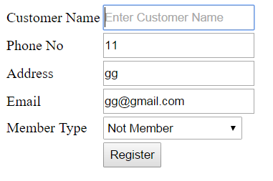
Fig.1.1
After Testing
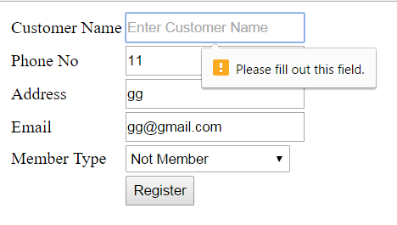
Fig.1.2

Section F: Interview Scripts
When interview with manager

References

References List

Bibliography
Nielsen, J. (2020, 11 15). 10 Usability Heuristics for User Interface Design. Retrieved from nngroup: https://www.nngroup.com/articles/ten-usability-heuristics/
what is the dsdm agile methodology. (2023, 7 1). Retrieved from airfocus.com: https://airfocus.com/glossary/what-is-the-dsdm-agile-methodology/
Lutkevich, B. (2023, 7 1). SSADM (Structured Systems Analysis and Design Method). Retrieved from techtarget.com: https://www.techtarget.com/searchsoftwarequality/definition/SSADM
Waterfall vs RAD vs Agile – Which Method Is The Best For You? (2023, 7 13). Retrieved from kissflow.com: https://kissflow.com/application-development/rad/rad-waterfall-agile-which-one-is-best-for-you/
Dev, W. (2023, 7 20). PHP, ASP.NET, JSP, Python - which server side script is better for you? Retrieved from geekboots: https://www.geekboots.com/story/php-aspnet-jsp-python---which-server-side-script-is-better-for-you
What is MySQL? (2023, 6 12). Retrieved from oracle: https://www.oracle.com/mysql/what-is-mysql/
System Properties Comparison Microsoft SQL Server vs. Oracle vs. PostgreSQL. (2023, 7 12). Retrieved from db-engines: https://db-engines.com/en/system/Microsoft+SQL+Server%3BOracle%3BPostgreSQL
Chapter 4: Principles. (2023, 7 20). Retrieved from agilebusiness: https://www.agilebusiness.org/dsdm-project-framework/principles.html
Malik, G. and Kretsis, M. (2023, 7 4). Challenges and Success in Teaching Legal, Ethical, Social and Professional Issues to Computing Undergraduates. Retrieved from repository.: https://repository.uel.ac.uk/item/86274
Md. Mijanur Rahman and Shamim Ripon. (2023, 7 12). Retrieved from https://arxiv.org/pdf/1403.1936.pdf
Emmitt, J. (2023, 7 12). 3 Ways to Handle POS Security Risks in Retail IT. Retrieved from kaseya: https://www.kaseya.com/blog/3-ways-to-handle-pos-security-risks-in-retail-it/
Zhao, S. (2023, 7 15). Critical Success Factors – Verifone EFTPOS Terminal. Retrieved from payplusinc.: https://www.payplusinc.com/blog/critical-success-factors-verifone-eftpos-terminal/

