1) Identify whether the following variables are numeric or categorical. If numeric, state

whether the variable is discrete or continuous. If categorical, state whether the variable is

nominal or ordinal (4 pts):

a) Time of the fastest runner in the Broad Street Run. Numeric (continuous)

b) Milk types, denoted by non-fat, 1%, 2%, or whole milk. Categorical (Ordinal)

c) Circumference of potholes in North Philly. Numeric (discrete)

d) Number of red flowers in a garden. Numeric (discrete

2) Match the following boxplots to the distribution each represents (4 pts):

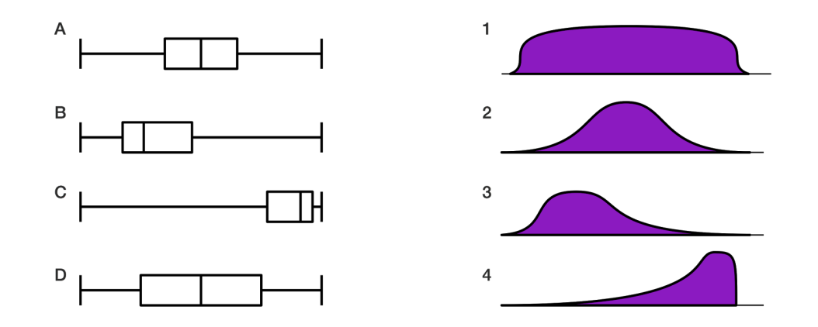

A – 2

B – 3

C – 4

D-1

Download the dataset sparrows.csv, and read the data frame into R. Explore the data frame using functions such as head(), etc. What type/subtype (i.e. numeric/discrete) of variable is each column? (2 pts)