MIDTERM EXAM + SOLUTIONS

This exam is open:

books

notes

and closed:

neighbors

calculators

The upper bound on exam time is 3 hours.

Please write your name at the top of each page.

Please put all your work on the exam paper.

(Partial credit will only be given if your work is shown.)

Good luck!

PART I
91.404 Review (27 points)

1. (9 points) Function Order of Growth
4^{lgn} = n²
f₃
f₂
Given: 1) f₁(n) is in Ω(n lg(lgn))
n lg² n
2) f₂(n) is in Ο(4^{lgn})
n lg(lgn)
f₁
3) f₂(n) is in Θ(f₃(n))
(2/5)^{n}
4) f₃(n) is in Ω(n lg²n)

(a) (3 points) Can we conclude from statements (1)-(4) that

f₃(n) must be in Ο(n²)? Why or why not?

Solution: YES. f₂(n) is in Θ( f₃(n)) -> f₃(n) is in Ο( f₂(n))
This, combined with f₂(n) is in Ο(4^{lgn}) implies (via transitivity) that f₃(n) is in Ο(4^{lgn}). Now, observe that 4^{lgn} = 2^{2lgn} = 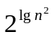= n². Thus, f₃(n) is in Ο(n²).

(b) (3 points) Can we conclude from statements (1)-(4) that

f₁(n) must be in Ω((2/5)^{n})? Why or why not?

Solution: YES. f₁(n) is in Ω(n lg(lgn)) implies f₁(n) is in Ω(g(n)) for all g(n) smaller than nlg(lgn). Now, observe that n lg(lgn)) is in Ω((2/5)^{n}) since Ω((2/5)^{n}) is <=1 for all positive n. This, combined with f₁(n) is in Ω(n lg(lgn)) implies (via transitivity) that f₁(n) is in Ω((2/5)^{n}).

(c) (3 points) Can we conclude from statements (1)-(4) that

f₁(n) must be in Ο(n lgn)? Why or why not?

Solution: NO. f₁(n) is in Ω(n lg(lgn)) only provides a lower bound on f₁(n). n lgn is in Ω(n lg(lgn)). It is possible for f₁(n) to be larger than n lgn; for example, f₁(n) = n². In this case, f₁(n) is not in Ο(n lgn).
2. (9 points) Recurrence

In this problem, you will find a closed-form solution for the following recurrence:

T(n) = T(n/4) + Θ(n)

That is, you will find f(n) such that T(n) is in Θ(f(n)).

You may assume that:

- n = 4^{k} for some positive integer k
- T(1) = 1

(a) (3 points) Solve the recurrence using the Master Theorem.

Solution: The recurrence is of the form T(n) = aT(n/b) + f(n) with a=1, b=4, and f(n)= Θ(n).

Ratio test yields:

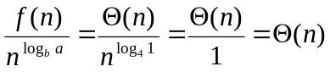
This is case 3, so the solution is T(n) = f(n) = Θ(n).

(b) (6 points) Solve the recurrence by building a recursion tree and finding a closed-form solution of the resulting summation.
work

T(n)
T(n/4)
T(n/16)
Θ(n/4¹)
Θ(n/4²)
...
...
Θ(n/4⁰)
geometric series
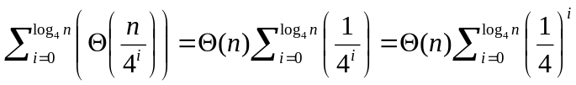

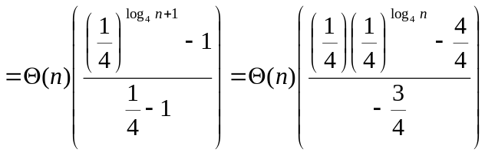

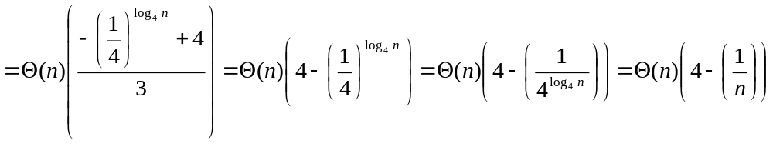
absorb the factor of 1/3 into Θ(n)

now, since 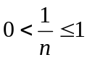 for positive n, (4 – (1/n)) is between 3 and 4 and therefore is bounded by a positive constant. The expression therefore reduces to Θ(n).

3. (9 points) Consider the set S of binary trees that have 3 nodes (including the root node):

Now consider the set S’ of labeled binary trees formed from S as follows: for each tree in S, each node (except the root) can be labeled either A or B. Assume that the root always has the label A.

(a) (3 points) How many labeled binary trees are in S’?

Solution: 20

A
A
A
A
A
B
A
B
B
A
B
A
A
A
A
A
A
B
A
B
A
A
B
B
A
A
A
A
A
B
A
B
A
A
B
B
A
A
A
A
A
B
A
B
B
A
B
A
A
A
A
A
A
B
A
B
B
A
B
A

(b) (6 points) If one tree s’ of S’ is chosen randomly, what is the expected number of nodes in s’ that have the label A? Assume that, for any two trees s’₁ and s’₂ in S’, the 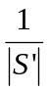probability of choosing s’₁ = the probability of choosing s’₂ =

Solution: The expected number of nodes labeled A = 2 =
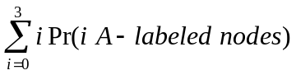
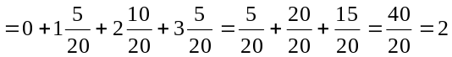
A
A
A
A
A
B
A
B
B
A
B
A
A
A
A
A
A
B
A
B
A
A
B
B
A
A
A
A
A
B
A
B
A
A
B
B
A
A
A
A
A
B
A
B
B
A
B
A
A
A
A
A
A
B
A
B
B
A
B
A
There are 5 3-node, A/B labeled, binary trees containing 1 A-labeled node (assuming root is labeled A).
There are 10 3-node, A/B labeled, binary trees containing 2 A-labeled nodes (assuming root is labeled A).
There are 5 3-node, A/B labeled, binary trees containing 3 A-labeled nodes (assuming root is labeled A).

PART II
91.503 Questions (33 points)

1. (16 points) Given a sequence X = < x₁, x₂, ..., x_{m} >, another sequence Z = < z₁, z₂, ..., z_{k} > is a subsequence of X if there exists a strictly increasing sequence < i₁, i₂, ..., i_{k} > of indices of X such that, for all j = 1, 2, ..., k, 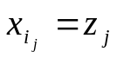we have:

Consider the following pseudocode for an algorithm that, given an instance of X and Z (where these sequences are defined over the same, finite alphabet), is supposed to determine whether or not Z is a subsequence of X. The algorithm should return TRUE if Z is a subsequence of X and FALSE otherwise.

SubsequenceCheck( X, m, Z, k )
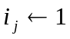
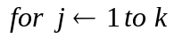
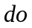
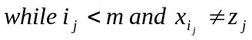
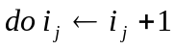
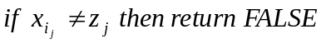
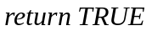

(a) (4 points) Is the pseudocode for SubsequenceCheck( ) correct? If not, fix it.
Prove that the (potentially corrected) pseudocode is correct.

Solution: NO, it is not correct. To correct it, we need to add the following 2 lines just before the final line (inside the for loop, immediately after the end of the while loop):
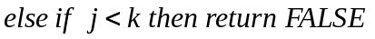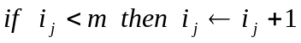
Proof of correctness for the revised pseudocode is by induction on j. We discuss only the crux of the proof here, which is the use of the following for loop invariant for the inductive hypothesis: after each iteration of the for loop, the code has returned FALSE if z₁,..., z_{j} is not a subsequence of X; otherwise it proceeds to the next iteration. To see why this invariant holds, observe that the while loop steps through X (starting at the current value of i_{j}) until either a match is found for z_{j} or the last element of X is encountered. If no match is found by the while loop, FALSE is returned. If a match is found by the while loop, then, if the end of X has not yet been encountered, it is possible that Z is a substring of X, i_{j} is incremented by one, and the invariant holds. However, if the end of X has been encountered, then Z is only a substring of X if j = k (i.e. the full Z pattern has been examined); in this case the invariant also holds. If the end of X has been encountered and the full Z pattern has not yet been examined, then Z is not a substring of X. In this case the pseudocode returns FALSE, so the invariant also holds.

(b) (4 points) Derive a tight upper bound on the asymptotic running time of the (potentially corrected) pseudocode as a function of m.

Solution: Both j and i_{j} increase monotonically throughout the execution of the algorithm. The algorithm only requires one linear scan of X. Hence its worst-case running time is in O(m).

(c) (4 points) Use amortized analysis to show that, inside a single call to SubsequenceCheck( ), the amortized cost of finding a sequence of m indices of the form i_{j} is Ο(1) (note that, in this case, m=k). State which of the 3 types of amortized analysis techniques you are using from Chapter 18.

Solution: We use the aggregate method. The solution to (b) shows that finding the sequence of k indices of the form i_{j} requires a total of worst-case time in O(m). Since m=k here, the amortized cost to find an index i_{j} is O(m)/m = O(1).

(d) (4 points) Describe the similarities and differences between this problem and the Longest Common Subsequence problem defined in Section 16.3 of Chapter 16 in our textbook.

Solution:
- Similarities:
- Both problems use the same definition of subsequence.
- Differences:
- The LCS problem in our textbook involves finding the longest subsequence that is common to 2 sequences. The test problem only treats a subsequence of 1 sequence.
- In the LCS problem in our textbook, the common subsequence is not given, but must be derived. In the test problem, a candidate subsequence is provided and only needs to be checked.
2. (7 points) Consider the Floyd-Warshall All-Pairs-Shortest-Paths pseudocode on p. 560 of Chapter 26 (see pseudocode below). This algorithm is guaranteed to find All-Pairs-Shortest-Paths, assuming that the input graph may have negative edge weights but does not contain any negative-weight cycles. The shortest path is simple (i.e. all vertices are distinct).
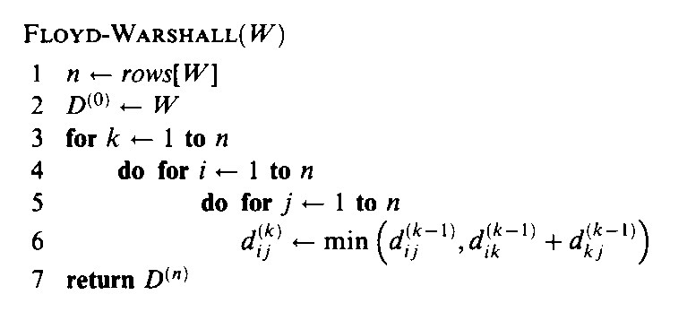

Here we investigate the All-Pairs-Longest-Paths problem. This problem is the same as All-Pairs-Shortest-Paths, except that it finds the length of the longest (simple) path for each pair of vertices in the graph.

Consider the pseudocode Floyd-Warshall2( ) below. Assume that the input W for Floyd-Warshall2( ) initially contains 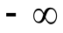 for each entry that contains 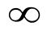in the input for Floyd-Warshall( ).

Floyd-Warshall2( W )
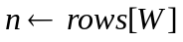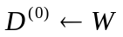

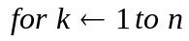
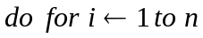
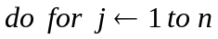
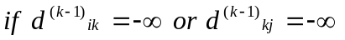
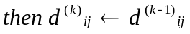
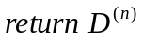

Will Floyd-Warshall2( ) correctly find the length of the longest path between each pair of vertices? Why or why not?

Solution: NO. It will not. It does not correctly treat cycles, even positive weight cycles for graphs whose edge weights are all positive. In fact, the All-Pairs-Longest-Paths problem is NP-complete, even for simple paths on graphs with only positive edge weights.
3. (5 points) This question is related to FLOWS, Chapter 27. As in Chapter 27, the question assumes a flow network G = ( V, E ). G is a directed graph. Each edge capacity c(u,v) is nonnegative. The source is denoted by s and the sink by t. The value of a flow is denoted by | f |.

For the statement below, circle TRUE if the statement is TRUE and FALSE if the statement is FALSE. Explain your answer.

Statement: 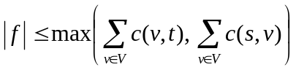

TRUE FALSE

Why? Explain your answer.

Solution: TRUE. The Max-Flow Min-Cut theorem implies that the value of a flow is at most the capacity of any cut. Thus:

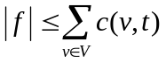 and 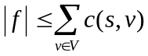

which implies that: .

4. (5 points) Consider the following algorithm to determine whether or not an undirected graph has a clique of size k. First, generate all subsets of the vertices containing exactly k vertices. Next, check whether any of the subgraphs induced by these subsets is complete (i.e. forms a clique).

Why is this not a polynomial-time algorithm for the clique problem, thereby implying that P = NP?

Solution: If the algorithm ran in polynomial time, then, because the clique problem is NP-complete, this would imply that P=NP. However, we show below that the algorithm does not run in polynomial time.

The inputs to this decision problem are G = (V,E) and k. In order for the algorithm to run in polynomial time, the worst-case asymptotic running time must be polynomial in the size of the inputs. That is, the running time cannot be exponential in k, |V|, or |E|.

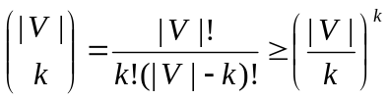Now, the number of subsets of vertices containing exactly k vertices is:

(The inequality is formula 6.7 from Chapter 6 of our textbook.)

This is not polynomial in k; it is exponential in k. Furthermore, the worst case size of a subset is achieved when k is a function of |V| (such as k=|V|/c). In such cases, the size is:
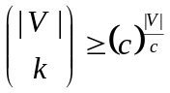

which is exponential in the number of vertices of G.

Since the number of subsets is exponential in the size of the input and the worst-case number of subsets provides a lower bound on the worst-case running time, the algorithm does not run in polynomial time. Hence, the algorithm does not provide evidence that P=NP.

PART III
91.503 Question (40 points)

Although the VertexCover problem for an undirected graph G = ( V, E ) is NP-complete, the VertexCover problem for a tree can be solved in polynomial time. A minimum-sized vertex cover for a tree T = ( V, E ) can be found in Θ( |V| + |E|) time.

In this part of the exam, you’ll design an efficient algorithm that finds an optimal vertex cover for a connected, rooted tree.

Problem (1) asks you to provide pseudocode for your algorithm.
Problem (2) asks you to prove the correctness of your algorithm and its pseudocode. Problem (3) asks you to prove that the worst-case running time of your algorithm is in Θ( |V| ).

Your algorithm should accept, as input, a tree T = ( V,E ). (This need not be a binary tree. That is, the number of children of each node is not limited to 2).

Your algorithm should output a minimum-sized vertex cover of T. A minimum-sized vertex cover of T is a subset of vertices V’ of V such that:
1) V’ is a cover of the edges of T: for each edge (u,v) in E, either u is in V’ or v is in V’ (or both);
2) the size of V’ should be minimal: there should not exist any vertex subset V’’ of V’ such that V’’ is a vertex cover of T and |V’’| < |V’|.

You may assume the following about the representation of T:
- Children of a node t are in the list children[t]; this is essentially an adjacency list for node t. (Information about the order of children within this list is not needed by the algorithm.)
- The parent of a node t is denoted by parent[t]
- Each node t has a mark bit denoted by mark[t]; this may be used to record membership in the vertex cover
- the root of T is denoted by root[T]
1. (13 points) Provide pseudocode for your algorithm.

(Note: If you use a slight variation on some graph algorithm in our text, you need not include that pseudocode; just describe the variation in sufficient detail to allow correctness and running time to be justified in problems (2) and (3). )

SOLUTION: Greedy algorithm

Preprocessing: First, use a slight variation on BFS or DFS to build a list L of leaves of T. In the process of building L, initialize mark bits to FALSE for each node.

while L is not empty
do f remove first leaf from L
if f is in T
then if mark[f] is FALSE and parent[f] is null
then mark[f] TRUE
else if mark[f] is FALSE and parent[f] is not null
then mark[parent[f]] TRUE
remove f from T
(this implicitly removes leaf-parent edge if it exists)
if parent[f] is not null and parent[f] is not root[T]
then if children[parent[f]] is null
then append parent[f] to L

Sample tree and minimal vertex cover:
2
3
4
5
6
7
8
9
10
11
12
1
A Minimal Vertex Cover =
{1, 2, 3, 10}

2. (15 points) Prove the correctness of your pseudocode and algorithm. That is, prove that, for any tree that is provided as input to the algorithm, the algorithm returns a vertex cover whose size is minimal. This requires showing that conditions (1: V’ is a cover) and (2: |V’| is minimal) are satisfied by your algorithm.

SOLUTION: To establish (1) and (2) below, we need facts (a)-(c) below.
- V’ is a cover of the edges of T: for each edge (u,v) in E, either u is in V’ or v is in V’ (or both);
- the size of V’ should be minimal: there should not exist any vertex subset V’’ of V’ such that V’’ is a vertex cover of T and |V’’| < |V’|.

a) Never need to include original leaf of T in vertex cover unless leaf is root. This is because (unless leaf is root) degree of leaf < degree of its parent.
b) Must cover edge from leaf to parent of leaf. Since T is a tree, only one edge comes from a parent. Thus, we must include parent of each leaf in cover if we choose to not include leaf in cover.
c) If parent x of a node is in cover, parent x also covers edges to all children of x and the edge to parent[x].

Due to (a)-(c) above, adding the parent of each unmarked leaf is always better than adding leaves to the cover (note that all leaves are unmarked at the start). We therefore make that choice for each unmarked leaf that has a parent (i.e. we mark its parent as belonging to the vertex cover). After making that choice for all leaves, the edges from leaves to parents are covered.

Since adding to the cover the parent of each unmarked leaf is always better than adding leaves to the cover, and all edges from leaves to parents must be covered, a minimal cover of T is the union of the set of parents of leaves with the set of nodes that form a minimal cover of the modified T consisting of T without the leaves and their edges. The tree cover problem therefore has the optimal substructure property.

Once we make the choice for each leaf, the leaves are therefore no longer relevant. We therefore remove leaves and all incident edges from the tree and from the leaf list. Next, append to the leaf list all nodes that become new leaves in the modified tree. We now apply the same process recursively to this modified tree as to the original. However, some leaves may already be marked. A marked leaf already covers the edge to its parent, so we need not mark its parent; we simply remove a marked leaf from T and L and check if this creates a new leaf. (Note that this does not increase the size of the vertex cover.)

The choice made at a leaf requires no consideration of subproblems and it leads to an optimal solution. The algorithm therefore has the greedy choice property.
(2) is satisfied by establishing that the problem has optimal substructure and the algorithm has the greedy choice property. (1) is satisfied because each edge is covered before it is removed from the tree. The pseudocode is correct because it is consistent with the above description.

3. (12 points) Analyze the worst-case running time of your tree vertex cover pseudocode and algorithm. Prove that your algorithm has worst-case running time bound in Θ( |V| ).

SOLUTION:
- The adjacency-list-like representation for children of each node allows us to use Θ( |V| + |E|) time graph processing algorithms. Since |E| = |V|-1 for a connected tree, this time is actually Θ( |V| )
- The list of leaves can be built in worst-case Θ( |V| ) time using a slight variation on DFS or BFS. This variation can also initialize the mark bits without increasing the asymptotic running time.
- Each node appears only once in T and L. After it leaves T or L, it never reappears. The total number of nodes added to L (summed across the entire algorithm’s execution and including preprocessing) is |V|. The while loop therefore executes |V| times.
- Each iteration of the while loop can be executed in Θ( 1 ) time. This is because:
- Each node has a mark bit
- Each node’s parent can be accessed in Θ( 1 ) time.
- Each node’s child list can be accessed in Θ( 1 ) time (to check if it is null).
- A node can be disconnected from T in Θ( 1 ) time.
- The list L can be represented as a linked list with both head and tail pointers. In this case, removing the first item and appending onto the end can each be done in Θ( 1 ) time.
- Since while loop therefore executes |V| times and each iteration requires Θ( 1 ) time, total while loop time is Θ( |V| ).
- Preprocessing plus total while loop time is therefore Θ( |V| ) + Θ( |V| ), which is in Θ( |V| ), as required.

