TransMerc is a Quantum GIS (QGIS) plugin for projecting VECTOR GIS data to Transverse Mercator (TM) projection accurately and universally.
As shown in Fig.1, The default projection engine in QGIS refuses to transform objects far away from the prime meridian (central longitude). Theoretically, TM projection splits the equator into two at the branch latitude (+/- 82.63 degrees from the prime meridian). In most cases, the use of TM projection is limited to data lying between +/- 3 degrees in latitude from the central meridian, so the default projection engine would be sufficient for them. This plugin is for the rest rare cases of TM projection which screws the default engine.
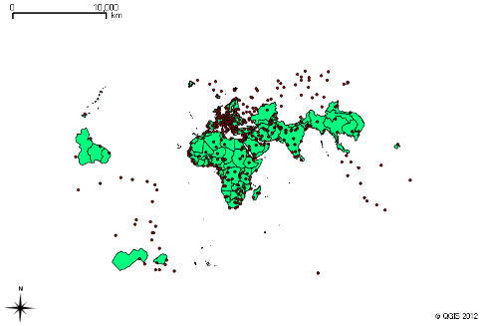
Fig.1 Result of transforming the coordinate system of a global map data from WGS84 to Transverse Mercator (UTM Zone 35) using the default functions of Quantum GIS.
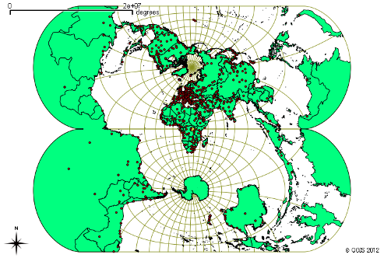
Fig.2 Result of WGS84→UTM (Zone 35) transformation of global map by TransMerc.
Version Requirement
TransMerc plug-in is developed and working properly with Quantum GIS later than 1.7.4 (Wroclaw) on Windows XP Service Pack 4.

How to use
- Load the vector map data you want to transform into Quantum GIS.
- Choose “Plugins” > “TransMerc” > “TransMerc” from the top menu. Then a dialog shown in Fig. 3 will open.
- Choose the vector layer you want to transform from the “Convert layer of” dropdown list
- Click “Browse” button and set the path and name of the file to save the transformed vectors. You can save the results in either ESRI Shapefile, AutoCAD DXF, MapInfo or GML format.
- If you want to load the transformed data immediately after the transformation completed, tick “Load the output to current project”
- Set the longitude of the central meridian (prime meridian) of the TM projection in decimal degree
- If necessary, set the scale factor. By default, the scale factor is set to 0.9996 which is the value used for Universal Transverse Mercator (UTM) projection.
- If necessary, set the false easting and northing values.
- Click “Transform” to start transformation process.

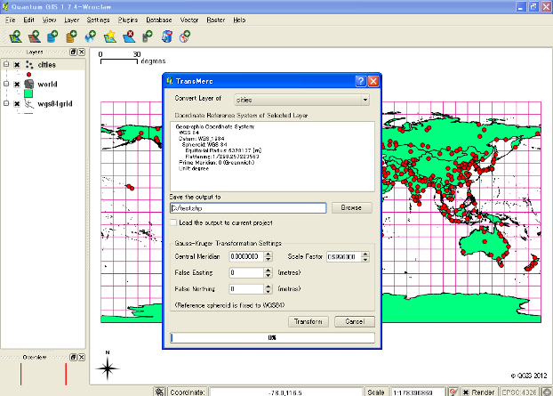
Fig. 3 User Interface of TransMerc

