flame m0dul kit  Acrylic glass m0dul for the r0ket  kiu/muccc  Rev B | 10 EUR
Remarks
- The kit contains more capacitors/resistors than needed (spare parts)
- The packaging of the capacitor/resistors are color coded
- Do NOT solder the LED before attaching the acrylic glass

Assembly
- BOTTOM: Solder resistor R1/100k (RED).
- BOTTOM: Solder resistor R2/60|65 (GREEN).

- TOP: Solder IC U1/PCA9553. Be aware of the orientation! The slightly beveled side must be left (yellow line). The imprint “NXP” must not be upside down.
- TOP: Solder capacitor C1/100nF (BLUE).

- BOTTOM: Attach acrylic glass. Etched side facing away from the m0dul. Fixate with screws. Heads on TOP - nuts on BOTTOM.

- BOTTOM: Solder U2/LED. Align LED with edge of acrylic glass.
- BOTTOM: Solder stack through connectors. Insert from TOP. Female sockets are on TOP - male pins on BOTTOM. Optional: Shorten pins by 5mm.

Run
- Turn r0ket off
- Plug flame m0dul onto r0ket
- Turn r0ket on
- Shout out loud: "Booster ignition and liftoff!"

Help
Dig through the r0ket wiki, join the IRC channel or find someone from team r0ket at Fpletzvillage.

Links
- https://github.com/kiu/flame
- https://r0ket.badge.events.ccc.de
- https://events.ccc.de/camp/2011/wiki/Fpletzvillage

TOP
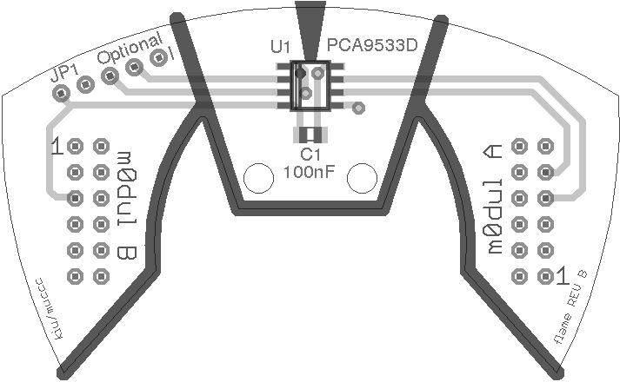
C1 100nF (BLUE)
U1 PCA9533
BOTTOM
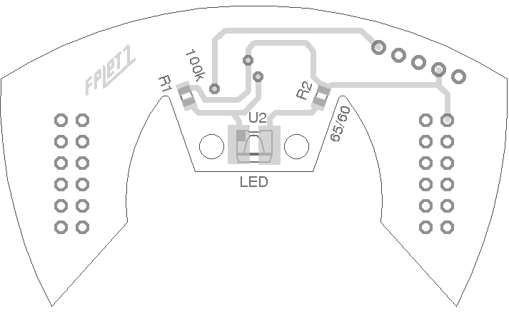
R1 100k (RED)
R2 60|65 (GREEN)
U2 LED

