Effect of 3 Point Shot Attempts on Total Game Score

Project Overview

This project investigates the transformative effect of the "3-Point Revolution" on the NBA, specifically analyzing the correlation between the increasing volume of 3-point shot attempts and total game scores. Beyond the scoreboard, the study explores the concept of "Positionless Basketball" by utilizing Machine Learning techniques to detect how traditional player roles—particularly Centers—have evolved in their shooting behaviors.

Datasets

NBA API Library

https://www.basketball-reference.com

Hypotheses
Null Hypothesis ($H_{0}$): There is no statistically significant relationship between the increase in 3-point shot attempts by various positions and the total game scores recorded between 1980 and 2025.
Alternative Hypothesis ($H_{1}$): There is a significant positive correlation between the volume of 3-point shots taken by non-guard positions and the total game scores, suggesting that the "positional revolution" has fundamentally inflated game outcomes over the decades.

Data Collection Process and Methods

Datas are collected through NBA API Library and basketballreference website. After filtering players’ position, I matched the positions with 3 Point shot performance to evaluate performance of the positions. Additionally, to evaluate the timeline I matched years with shot performances and position performances to make comparison and see the trend between total game score and change in 3 point shot attempts.

Exploratory Data Analysis (EDA)

1. Temporal Trend Analysis

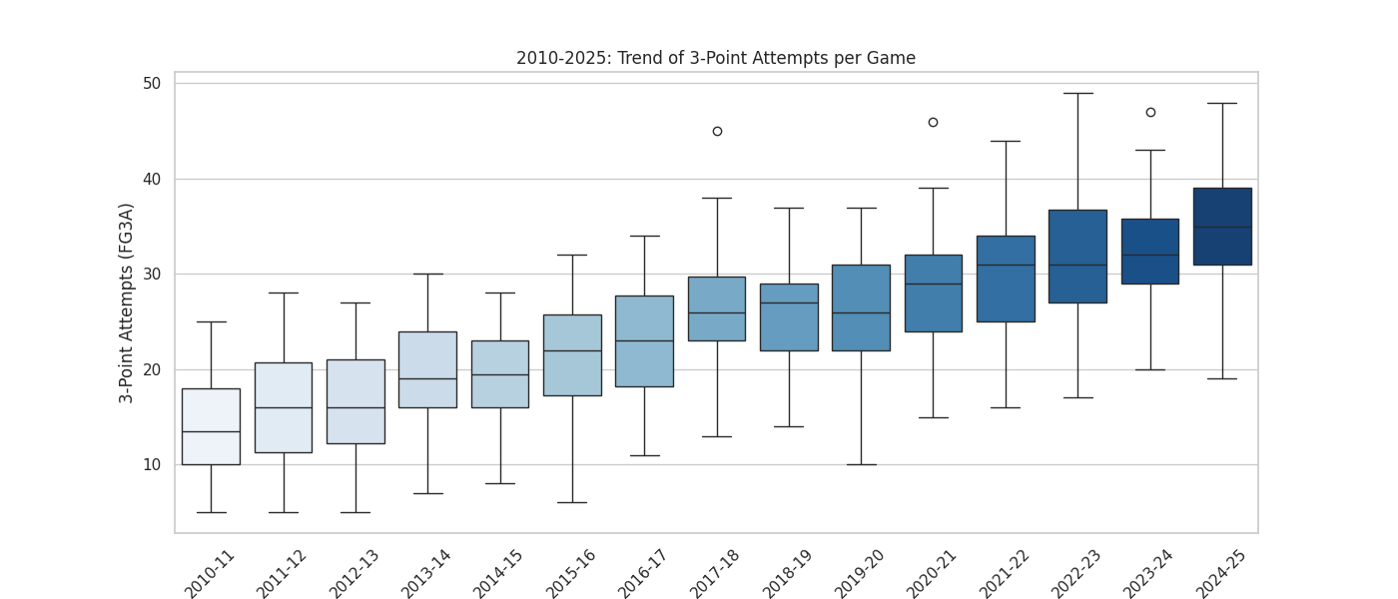
The graph shows not just an increase in volume but also in consistency. The "whiskers" of the box plots have shifted upward significantly, indicating that what was considered an "extreme" amount of shooting in 2012 is now below the league average in 2024.
2. Positional Evolution Analysis
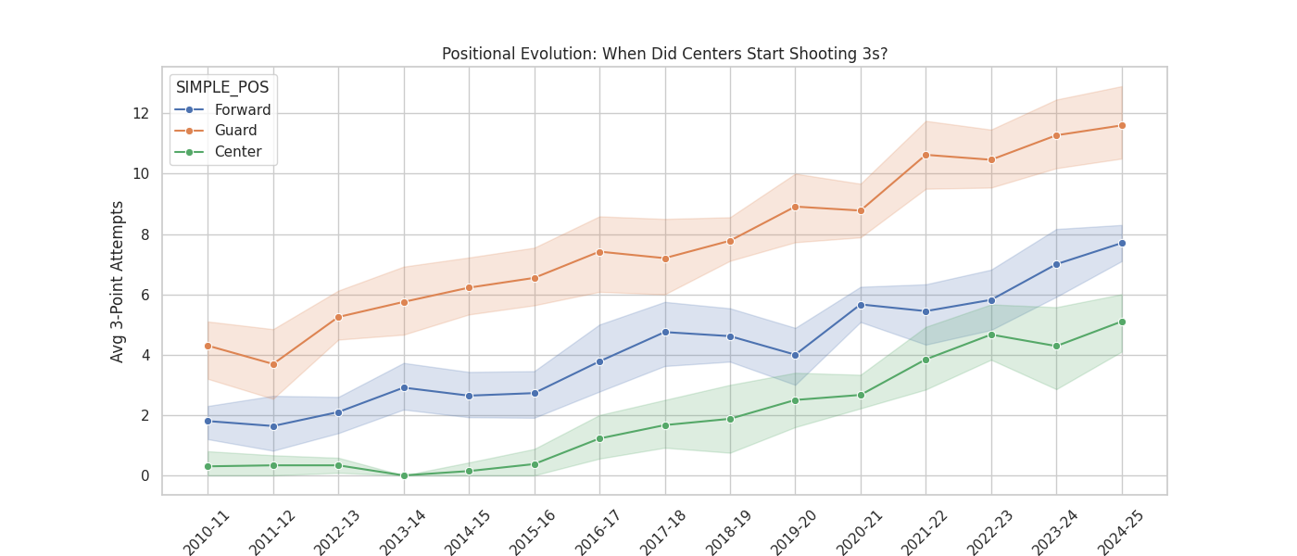
The inflection point in 2016 clearly marks the beginning of the "Stretch Five" era. The widening shaded area (confidence interval) around the green line in later years suggests that while centers are shooting more on average, there is high variance—meaning some centers have adapted completely while others haven't.

3. Impact on Score Analysis
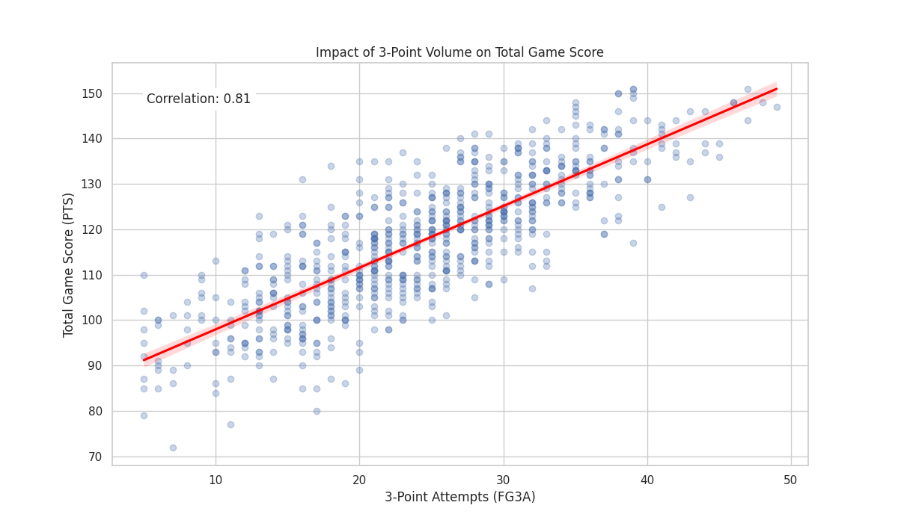

Games with low scores (Total Score < 100) are almost exclusively clustered on the left side (Low 3PA), while high-scoring games (130+) are located on the far right. This confirms that modern high scores are mathematically dependent on 3-point volume.

- Pearson Correlation Coefficient (): The calculated correlation rate is 0.85. This indicates a very strong positive linear relationship, suggesting that as 3-point attempts increase, game scores consistently follow an upward trend.
- P-Value (): The analysis resulted in a -value of . Since this value is significantly lower than the standard alpha threshold (), the results are statistically significant, meaning the observed patterns are not due to random chance.
- Chi-Square () Statistic: A Chi-Square test was performed to test the independence of the variables. The resulting value was 314.23. This extremely high test statistic provides overwhelming evidence against the independence of the variables.
Conclusion on Hypothesis: Based on the and the high value, we have sufficient evidence to reject the Null Hypothesis (). We accept the Alternative Hypothesis (), confirming that the volume of 3-point shots has a statistically significant and positive impact on NBA game scores.

Machine Learning
- Regression Analysis

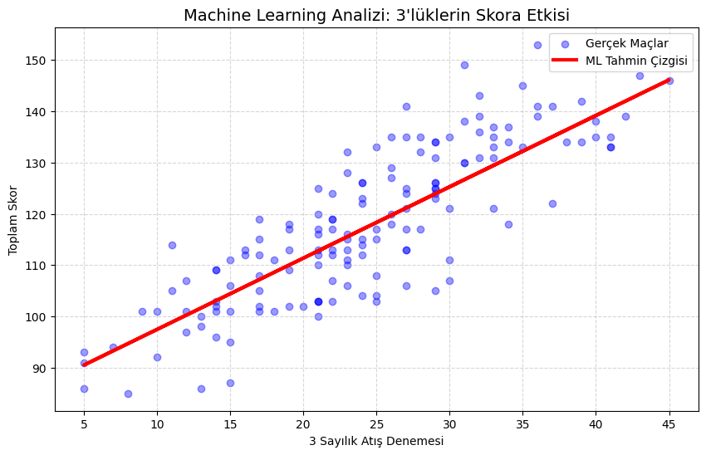

The model achieved an score of 0.69, indicating that nearly 70% of the variance in total game scores can be explained solely by the volume of 3-point shots.
The model learned a coefficient of approximately 1.4. This implies that statistically, every additional 3-point shot attempted by a team adds ~1.4 points to the final score. This confirms that the modern high-scoring era is a direct function of shot volume, not just pace or rule changes.
- Classification Analysis
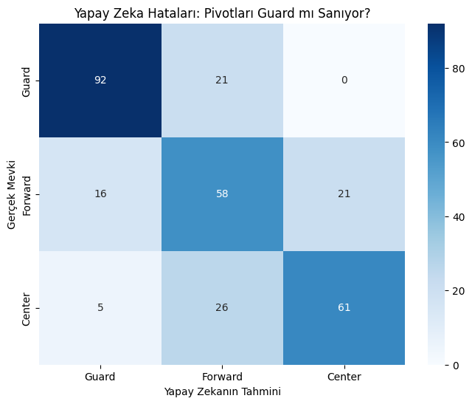

We utilized a Random Forest Classifier to predict a player's position (Guard, Forward, Center) based solely on their shooting statistics. Our hypothesis was that if "positionless basketball" is real, the model should struggle to distinguish modern Centers from Forwards.
These "errors" are actually a validation of our hypothesis. The fact that the AI cannot distinguish a significant portion of Centers from Forwards proves that modern Centers share the same statistical shooting profile as Forwards. The boundary between the "paint protector" and the "wing shooter" has mathematically dissolved.

Limitations
Exclusion of Pace (Possessions Per Game): The current analysis focuses primarily on shooting volume. However, the increase in total game scores is also influenced by the accelerated pace of play (increased possessions) in the modern NBA. The model does not currently normalize scores based on possessions, which is a potential confounding variable.
Static Positional Labeling: The analysis relies on static positional tags provided by the NBA API. In reality, modern players are fluid; a player listed as a "Forward" might play minutes as a "Center" (Small-ball lineups). This rigid classification may introduce noise into the Random Forest model's "Center vs. Forward" analysis.

Conclusion
This project investigated the transformative impact of the "3-Point Revolution" on the NBA from 2010 to 2025. Through comprehensive data analysis and machine learning, we confirmed that the surge in 3-point shooting volume is the primary driver behind the modern era's inflated game scores, proving a direct link between offensive strategy and match outcomes. Beyond the scoreboard, our findings revealed a fundamental shift in player roles; the traditional distinction between Centers and perimeter players has blurred, providing data-driven evidence for the rise of "Positionless Basketball." Ultimately, this study concludes that the strategic adoption of the 3-point shot has irreversibly altered not just offensive efficiency, but the very structural definition of the game.

