PRODUCT · DESIGN · TECHNICAL OVERVIEW
Atelier
The current platform, explained end to end
●
A detailed description of what exists today: the product model, user experience, AI capabilities, design system, technical architecture, data model, trust rules, implementation status and known gaps.
Snapshot | Frontend | Engine | Audience
25 July 2026 | Next.js app · 0c46d55 baseline | FastAPI engine · c3b22ea baseline | Founders, designers, merchandisers, engineers

SNAPSHOT NOTE
The inspected worktrees were actively evolving. This document distinguishes the durable architecture from the live pilot condition and records known regressions observed during the inspection.

1. Executive overview
PLATFORM THESIS
Atelier is an AI taste and merchandising team for fashion brands: it helps teams observe better, form a point of view, create collections, make smaller product bets, govern decisions and learn from outcomes.

Atelier is designed as a decision layer between the tools a fashion company already uses and the human team responsible for product. It is not intended to replace an ERP, PLM, factory execution system, patternmaking suite, warehouse system or accounting platform. Its job is to connect evidence, creative judgment, commercial planning and measured results around the collection.
The central product object is not a trend card or an AI image. It is a traceable product decision: what the team believed, which brief and evidence governed it, which concept version was approved, what quantity and price were committed, what launched, and what happened afterward.

The operating model
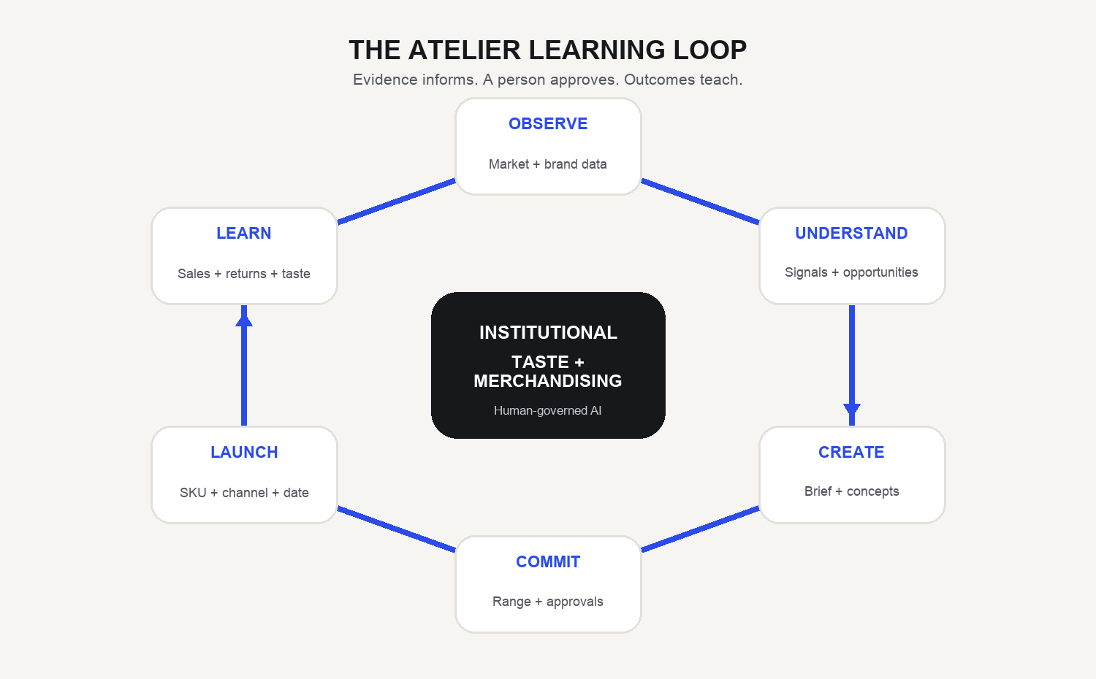
Figure 1. Atelier’s intended closed learning loop.

What exists today
- A five-workspace product shell: Today, Collection, Market, Results, and Data & Brand.
- A collection spine from approved brief through range, development, review, launch and results.
- Server-owned briefs, range-plan versions, assortment slots, approvals, launches and lineage.
- A real AI Concept Studio with brand references, materials, generation, variants and version history.
- Visual taste calibration using blind comparisons between actual garments.
- An evidence-bounded AI Taste Team that exposes disagreement and abstention instead of producing one score.
- Market observation, competitor monitoring, proposals, decision records, forecasts, returns and outcomes.
- Explicit truth labeling for live, mixed, sample, offline, unknown and not-measurable states.

What is not complete
- A true Collection Director that composes three coherent Core / Evolution / Experiment directions.
- A learned visual taste model that actively steers generation and privately ranks generated concepts.
- Universal brand-data import and production-grade Shopify / ERP / PLM integration.
- A fully production-ready authentication and collaboration experience.
- Professional export packs and complete enterprise deployment operations.

2. Product structure and information architecture
The navigation was reorganized around work rather than features. Five global workspaces remain visible; contextual tools appear only inside the relevant workspace. Collection stages are represented separately as a persistent rail because they are states in one lifecycle, not unrelated destinations.
Workspace | Purpose | Primary questions
Today | Operational inbox | What needs attention? What can be acted on with current evidence?
Collection | Brief-to-result workspace | What are we making, why, at what cost, and what is blocked?
Market | External evidence | What is changing, where, and what does it mean for this brand?
Results | Measured learning | What did we decide, launch and learn?
Data & Brand | Inputs and governance | What does Atelier know, from where, and how is taste calibrated?

Collection stage rail
Stage | Primary object | Completion logic
Brief | Versioned collection brief | Approved intent and evidence
Range | Plan version + assortment slots | Commercial rows, readiness and approval
Development | Concepts, materials, bets and milestones | Design work, ownership and feasibility
Review | Concept versions and annotations | Creative/technical criteria resolved
Launch | Launch + launch products | Approved concept and plan connected to SKU
Results | Launch results + outcomes | Measurable post-launch evidence

Primary user roles

Creative director / founder
Defines identity, compares concepts, protects the point of view and approves creative direction.

Designer
Builds concepts, variants, materials and development detail.

Merchandiser / buyer
Owns category mix, prices, units, margin, open-to-buy and commercial readiness.

Technical / production team
Assesses supplier, MOQ, lead time, milestones and development feasibility.

Leadership
Reads portfolio risk, decision velocity and evidence quality without opening every product.

Analyst / operator
Maintains source quality, runs imports, monitors models and audits outcomes.

3. End-to-end product workflow
- Connect and establish the brand. Catalogue, market runs, sales, stock and returns enter the engine. Brand DNA is proposed from real catalogue evidence; user declarations override or extend it.
- Observe the market. The Observatory and market library show dated, sourced external supply signals, competitor products, price movement and normalized panels.
- Form a direction. Signals, whitespace and proposals become evidence and candidate directions. Decisions are logged rather than disappearing after a swipe.
- Write and approve the brief. A collection brief records customer, occasion, objective, creative direction, margin/newness targets and linked evidence. Approved versions are immutable.
- Build the range. A server-owned range-plan version contains assortment slots with category, type, PVP, landed cost, units, MOQ, lead time and delivery date.
- Create concepts. The AI Studio explores silhouette × fabric × colour, uses brand references and swatches, generates versions and records prompt/provider/cost lineage.
- Critique and review. The Taste Team exposes evidence-bounded positions; human reviewers compare versions, annotate the image, request changes or approve.
- Launch a measurable product. An approved concept version is connected to an approved range slot and a SKU. The launch records market, channel, date, units and price.
- Measure and learn. Sales, stock, returns and explicit outcomes grade the prior belief. Taste judgments and decision history become institutional memory.
NON-NEGOTIABLE RULE
A missing datum is not zero. An unavailable answer is shown as unavailable, with the exact input needed to answer it.

4. Complete screen and capability inventory

4.1 Today — operational inbox
Today presents only server-owned decision cases and actions derived from first-party sales and stock. It avoids manufacturing margin, confidence, owner, budget or urgency when those inputs are absent.
- Decision cases: reorder, reduce, price, extend and new-product actions.
- Status lifecycle: proposed, modified, approved, rejected, executed and measured.
- Weekly commercial plan generated from connected sales/stock.
- Explicit empty state when first-party demand is unavailable.
- Direct CSV entry point for sales and optional stock.

4.2 Collection portfolio
The portfolio is the director-level view across collections. Each card is derived from the same engine assembly as the collection Command Centre, preventing the portfolio and detail view from disagreeing.
- Sorts collections by decision need rather than alphabetically.
- Shows stage, blockers, approvals, risky styles, unanswered questions, rows and launches.
- Names missing information instead of converting it to a positive zero.

4.3 Collection Command Centre
The Command Centre answers eight operational questions: intent, stage, blockers, budget, approvals, style risk, timing and next decision. The engine computes the answers; React only renders them.
DESIGN PRINCIPLE
The collection state is its worst answer, not an average. One blocked issue cannot be hidden by five green cards.

4.4 Versioned collection brief
- Fields include season, drop, customer, occasion, commercial objective, creative direction, target margin and target newness.
- Evidence links can support, contradict or contextualize the brief.
- Workflow supports draft, in-review, approved, superseded and revision states.
- Approved/superseded versions are immutable; changes create a new version.
- Opening an empty collection no longer creates a database draft; saving requires at least a season.

4.5 Market direction, opportunities and proposals

Direction of market
A team brief combines available market evidence with the brand’s current state and can reveal a weekly commercial plan when sales are connected.

Opportunities
Whitespace compares the brand catalogue with competitor items and live trends. It shows real reference imagery when available, distinguishes make/explore/watch, supports dismissal by brand and can seed a Studio brief.

Proposals
The image-led decision feed presents candidate products, evidence dimensions and an action. Accept/reject/watch events enter a durable decision ledger. A server recommendation is required before an acceptance becomes an operational bet.

4.6 Inspiration room
A visual studio wall for uploaded or pasted references. It supports positioning, tags, colour extraction, story clustering and brief creation. Current clustering is deterministic and labelled as such; the workspace remains predominantly browser-local.

4.7 Range plan and assortment slots
- One server representation drives the financial grid, headline metrics and visual assortment.
- Per-row fields: code, category, carryover/new/variation, PVP, landed cost, units, MOQ, lead time and delivery.
- Money uses exact server-side decimal arithmetic; derived totals are computed, not stored copies.
- Approval blockers include missing brief, missing rows, mixed currency, missing price/units, MOQ, lead-time and budget problems.
- Warnings and blockers are returned verbatim by the engine; selected exceptions require a recorded reason.
- The Taste Team can be convened contextually for an individual assortment slot.

4.8 AI Concept Studio
The Studio works at collection level. Exploration defines a design space and batch-generates candidates; the collection board promotes selected candidates into trackable product items.
Capability | Current implementation
Design space | Silhouettes × fabrics × colours; detail and fit rotate across combinations
Sampling | Deterministic, balanced breadth controlled by per-axis weights
Brand control | Brand DNA fidelity slider with an explicit experimental share
References | Real catalogue products, brief image and fabric swatch; UI sends up to two selected references
Generation | OpenAI GPT Image / Google image provider through engine endpoint
Quality and cost | Draft ≈ 1¢; final ≈ 6¢; batch cost disclosed before generation
Curation | Grouping, near-duplicate removal, novelty/DNA ordering and preselection balance
Versioning | Prompt, reference, provider, quality, cost, creator and timestamp kept per version
Product views | Concept, detail and model visualization; FASHN try-on when configured
Exports | Per-image and collection PNG export; PSD is intentionally out of scope

4.9 Materials
- Seeds materials from the active brand’s own DNA rather than a shared hardcoded catalogue.
- Captures composition, construction, weight, width, stretch, drape, opacity, finish and supplier.
- Commercial fields include price/metre, currency, MOQ and lead time.
- Swatch photos condition image generation.
- Where-used and approximate material cost connect the material record to product items.

4.10 AI Taste Team
The Taste Team is a structured panel rather than one assistant pretending to be eight people. Each role receives only its permitted evidence. Positions are objection, concern, support or abstention; objections lead the display.
- No single score, recommendation badge or automated verdict.
- Every role names its evidence boundary.
- Abstentions state the missing evidence.
- The facilitator names the human decision required but does not take it.
- Current implementation is deterministic and testable; an LLM may phrase critique but does not own the underlying judgment.

4.11 Development pipeline and critical path
Accepted, server-approved product bets move through Decided, In design, Sample, Production and In store. Every move appends an event. A separate critical path records design freeze, tech pack, proto, fit approval, sales sample, production order and ex-factory milestones.

4.12 Review
- Compares concept versions A/B.
- Allows annotations pinned to the image and review comments.
- Requires concept, brand criterion, material, target price, due date, distinct owner/approver and no unresolved annotations.
- Supports request changes and approval while preserving the version history.

4.13 Capsule render
The capsule surface generates evidence-backed assortment proposals from brand palette, price architecture, market gaps and verified trends. Renders are produced only when an image key has capacity; otherwise an honest structured placeholder remains. Individual styles can be regenerated.

4.14 Launch and results
- Launch requires an approved concept and an approved plan slot.
- The SKU is checked against sales records; an unmatched SKU is explicitly confirmed or left unmeasurable.
- Lineage links launch product → concept version → slot → plan version → brief version → evidence.
- Results distinguish measured, no sales yet and not measurable.
- A decision that never launched is not given a sales outcome.

4.15 Market workspace
Surface | What it does | Truth boundary
Observatory | Coverage, drops, movement, mix, prices and proxies | Dated crawled rows; external supply, not customer demand
Signals | Lifecycle and brand-fit lanes | Fit/movement explainable; sample fallback labelled
Competitors | Watched-brand arrivals and refresh | Live arrivals plus some sample comparative intelligence
Library | Filterable market product corpus | Real image/store/date required; price stats avoid mixed currencies
Visual search | Archive and market precedents | Lexical/attribute matching; not a calibrated pixel oracle

4.16 Results workspace
Results combines decision memory, open market-read windows, explicit outcome capture and launch-grounded measurement. The interface asks not only whether a product worked, but which prior belief was supported or contradicted.

4.17 Data & Brand

Catalogue
Product identity leads; seeded sell-through, returns and benchmark analytics are hidden behind an explicit sample-data toggle. The engine also contains a normalized product master for style, colourway and SKU.

Brand DNA
Five editable layers: visual language, product language, commercial language, customer language and creative boundaries. Each item carries a source label: engine, catalogue or user.

Taste calibration
Blind pairwise comparisons use actual archive and concept photographs. Five dimensions remain separate: creative, customer, merchandising, commercial and technical. A Bradley–Terry rank remains provisional until held-out accuracy beats chance.

Integrations
The Atelier engine connection and run refresh are real. Other connector cards remain sample/disabled. Sales, stock and returns CSV endpoints exist, but a universal mapping/import centre is not yet implemented.

5. AI capabilities: what is real today
Atelier combines generative models, statistical preference learning, deterministic policy logic and human decisions. The architecture deliberately avoids asking one large language model to do every job.
AI / analytical function | Method | Current role
Brand DNA extraction | LLM/vision + catalogue structure + embeddings | Proposes editable brand language and references
Market interpretation | Crawl, taxonomy, normalization, matching and LLM explanation | Turns external supply into dated, sourced signals
Image generation | GPT Image / Google providers with references | Concepts, variants, details and model visualizations
Preference learning | Bradley–Terry pairwise ranker | Learns per-dimension order from designer judgments
Pair selection | Deterministic active learning | Asks uncertain and graph-bridging comparisons
Taste Team | Evidence-bounded deterministic roles | Surfaces disagreement, risk and missing evidence
Forecasting | Tournament-gated statistical forecasts | First-party demand planning where history exists
Recommendation gates | Explicit server rules | Requires market, brand, feasibility and confidence conditions
Explanation | LLM where configured | Explains or synthesizes evidence; does not invent demand
Outcome grading | Lineage + sales/returns comparisons | Tests prior beliefs against actual results

Visual taste memory
The new calibration system is a meaningful foundation: actual garment images enter separate preference models for five questions. It creates the human-labelled data needed for future visual intelligence without pretending that an off-the-shelf model already understands this brand’s silhouette or proportion.
CURRENT LIMITATION
The learned ranking is not yet wired back into Studio generation, concept ordering or private curation. Atelier can collect taste, but the generative system still relies mainly on declared DNA, references and deterministic heuristics.

What AI does not claim
- External crawl volume is supply, not demand.
- A generated model view is a visualization, not fit validation.
- A concept image is not a production-ready specification.
- A planning range is not a trained forecast.
- A missing returns feed is not a 0% return rate.
- Caption similarity is not pixel-level visual understanding.
- The Taste Team does not make the human approval decision.

The next AI product: Collection Director
The highest-value creative extension is one approved brief producing three coherent directions—Core, Evolution and Experiment—each as a 12–30 piece capsule with assortment logic, hero/support roles, palette, materials, price architecture and explicit brand codes preserved or challenged. Generated candidates should then be privately ranked using learned visual taste, with a small deliberate experimental set retained.

6. Domain model and lifecycle
The backend is structured around immutable snapshots and append-only events where historical interpretation matters. Mutable operational objects exist where workflow state must change, but approved versions remain frozen.
Domain | Principal entities | Why they exist
Brand and identity | Brand, User | Tenant scope, authenticated attribution and approval permission
Market intelligence | BrandRun, TrendHistory, CompetitorSnapshot, CompetitorItem | Dated evidence and reproducible market reads
Commercial inputs | SalesRecord, StockLevel, ReturnEvent, UploadBatch | First-party demand, availability, satisfaction and idempotent imports
Product master | ProductStyle, ProductColourway, ProductSku | Stable identity across catalogue, sales, returns and launch
Decision memory | Recommendation, FeedDecision, ProductBet, BetEvent, DecisionCase, DecisionEvent | Belief, choice, operational commitment and event history
Collection governance | StudioCollection, CollectionBrief/Version, CollectionPlan/Version, AssortmentSlot | One collection graph from intent to money
Creation | Concept, ConceptVersion | Auditable design lineage and immutable approved image
Execution | CollectionMilestone, Supplier, SupplierQuote, Approval/Policy | Timing, feasibility, supplier economics and discipline gates
Launch and learning | Launch, LaunchProduct, DecisionOutcome, EvidenceSnapshot | Measurable product, complete lineage and post-launch grading
Taste learning | FitJudgment | Per-dimension pairwise preference record

Versioning and immutability
- Brand runs are append-only result snapshots.
- Recommendations are immutable and may expire or be revoked without rewriting their evidence.
- Approved brief versions and plan versions are frozen; revisions create new versions.
- Concept versions preserve parentage, references, prompt, provider and selection history.
- Decision, bet, activity and milestone changes append events for reconstructability.

Server-owned financial truth
Assortment arithmetic lives in Python and PostgreSQL, not duplicated in React. Money fields use NUMERIC/Decimal; gross sales, cost and margin are derived on read. Cross-currency totals refuse to exist, and missing values remain missing.

7. Technical architecture
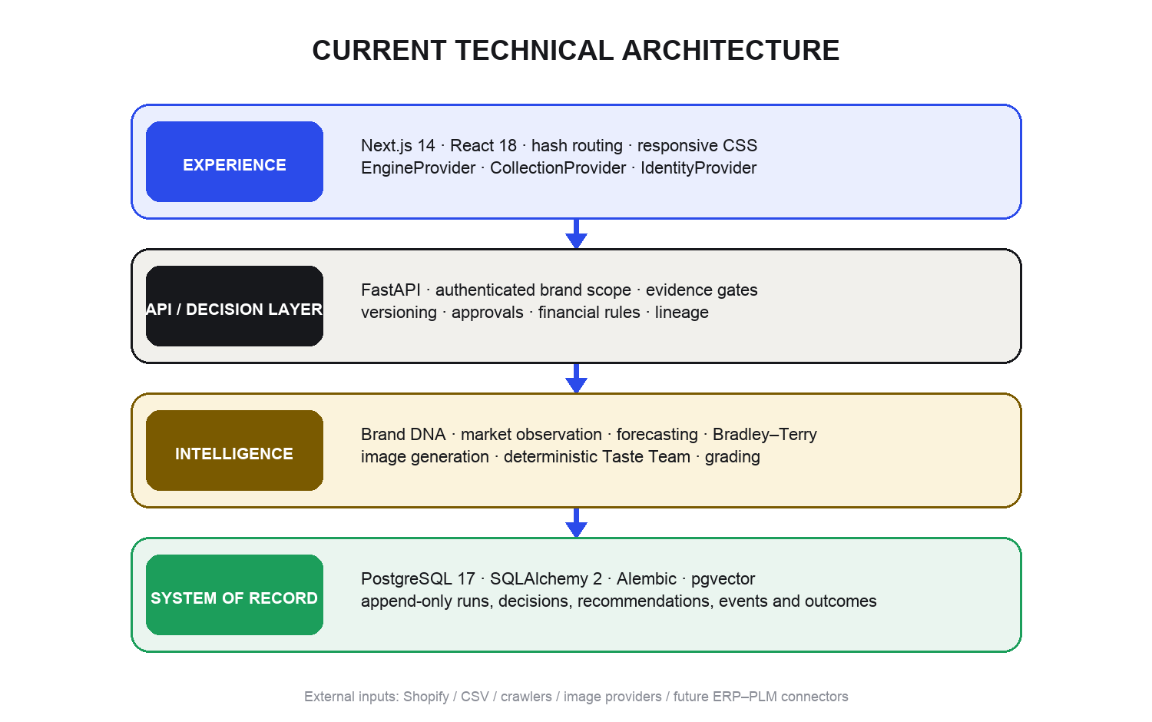
Figure 2. Current runtime layers and responsibility boundaries.

7.1 Frontend
- Next.js 14.2 and React 18; JavaScript rather than TypeScript.
- Hash-based client routing with collection id carried in the URL query.
- Global state through EngineProvider, CollectionProvider and IdentityProvider.
- Large plain-CSS design system with view-local CSS for specialized workspaces.
- Engine-first persistence for collection-critical objects; brand-scoped localStorage/IndexedDB for selected fallbacks and large generated image batches.
- Presentation mode hides the tenant switcher but does not hide pilot, sample or missing-data labels.
- Docker multi-stage build; NEXT_PUBLIC API and brand variables are baked at build time.

7.2 Backend
- Python 3.11+ application built with FastAPI.
- SQLAlchemy 2 ORM and Alembic migrations.
- PostgreSQL 17 with pgvector for future/live vector storage.
- Postgres job queue using row locking; no Redis dependency.
- Pydantic settings with environment-specific database, CORS and mode controls.
- Brand-scoped bearer-token authentication; demo mode allows an explicitly unverified pilot flow.
- Static mount for generated render assets.

7.3 API domains
Domain | Representative API groups
Brands and runs | /brands, /runs, /result, /trends
Market | /observatory/*, /competitors, /product-identity
Data | /sales/upload, /returns/upload, /styles, /product-master/export
Recommendations | /recommendations/preview, mint, revoke, decisions
Collections | /collections/portfolio, /command-centre, /workspace
Briefs | /brief, /brief-versions, evidence, submit, approve
Range | /collection-plans, /plan-versions, /slots, submit, approve
Creation | /studio/generate, /studio/swatch, /concepts and versions
Taste | /fit/pool, /fit/next-pair, /fit/judgments, /fit/ranking, /taste-team
Execution | /bets, /critical-path, /approvals, /suppliers, /quotes
Launch and learning | /launches, /launch-products, /launch-results, /lineage, /outcomes

7.4 Model and provider layer
The engine can run deterministic offline paths without provider keys. Live paths are designed for Anthropic/OpenAI-style analysis, embeddings, web/crawl intelligence and image generation. Studio generation rotates configured image providers and returns explicit no-key/quota failures rather than fabricating an output.

7.5 Persistence and offline behavior
The product distinguishes durable team state from browser-local convenience state. Collection briefs, financial plans, slots, approvals, launches and core concepts are server-owned. Local storage is used for selected draft/fallback surfaces, brand preferences, inspiration and offline decision outbox behavior; IndexedDB holds larger generation batches.

7.6 Testing
At the inspected baseline the frontend suite reported 59 passing tests. The engine handoff recorded 541 passing and six skipped tests at migration 0044. Coverage is strongest around domain rules, tenant isolation, persistence, immutability, arithmetic and trust boundaries. React rendering coverage remains a material weakness: the product-workspace runtime regression passed the test suite.

8. Trust, safety and governance architecture
Atelier’s strongest architectural idea is that honesty is a product feature, not a disclaimer. The interface is designed to refuse false precision at the moment a team could act on it.
- Separate supply from demand. Competitor listing activity does not prove customer purchase intent.
- Cross-signal or abstain. Recommendations require independent market, brand, feasibility and confidence gates.
- Preserve unknown. Missing information remains unavailable and names what would resolve it.
- Version what was approved. Briefs, plans and concepts retain the exact approved version.
- Attribute human authority. The server identifies who acted and whether the person had permission.
- Keep evidence immutable. Recommendations expire or are revoked without rewriting the past.
- Make disagreement visible. Taste roles keep separate positions and evidence boundaries.
- Do not average away risk. The Command Centre uses the worst operational answer.
- Trace launch to belief. Results begin from a launched SKU, not from a loose historical guess.
- Grade prospectively. Beliefs are recorded before outcomes, then evaluated afterward.

Truth states in the interface
State | Meaning | Expected UI behavior
Live | Engine and market run available | Show source/model/provenance badge
Connected, no run | Collection data is real; market evidence absent | Keep collection editable; empty only market surfaces
Mixed | Some real evidence and some estimates/sample | Label each estimate or sample
Sample | Demonstration-only data | State ‘do not decide’
Offline | Engine unreachable | Persistent recovery banner; no false saves
Unknown | Required input missing | Name the missing datum
Not measurable | No valid SKU/data lineage | Never display as zero sales

9. Product and interface design
The visual design is intentionally fashion-aware without becoming a moodboard. It combines a near-black studio sidebar, warm neutral working field, white decision surfaces, cobalt interaction color and restrained semantic status colors.

9.1 Visual tokens
Token | Hex | Primary use
Paper | #F6F5F2 | Main working canvas
Surface | #FFFFFF | Cards, grids and editable panels
Ink | #17181C | Sidebar and primary text
Cobalt | #2B4BEA | Primary action, focus and active navigation
Ember | #C4582B | Warm opportunity and directional emphasis
Sage | #1C9E5B | Positive / complete state
Ochre | #D9A22B | Caution and provisional state
Clay | #C24435 | Blocked, rejected and risk state

9.2 Typography
Role | Typeface | Use
Display | Bricolage Grotesque | Headings, product personality and high-level hierarchy
UI | Hanken Grotesk | Body copy, controls and dense operational content
Technical | IBM Plex Mono | Eyebrows, metadata, provenance and compact labels
Editorial accent | Fraunces | Used sparingly for marquee/editorial moments

9.3 Interaction patterns
- Contextual navigation reduces the 21-view toolbox effect.
- The collection selector persists across all collection-linked stages.
- Status is communicated through label, copy and color rather than color alone.
- Blockers remain clickable so users can inspect a stage they cannot complete.
- Editable financial cells save on blur/Enter, preserve intermediate input and allow Escape.
- Image-first cards lead creative decisions; financial and evidence details remain inspectable.
- Presentation mode reduces tenant-switch risk while preserving honesty labels.

9.4 Design strengths
- The visual language feels like a professional fashion product rather than a generic BI dashboard.
- Operational information and creative imagery coexist in one system.
- Provenance and missing-data states are visible without overwhelming every card.
- The Stage Rail makes the collection lifecycle legible.
- The visual calibration screen is immediately understandable to designers.

9.5 Design weaknesses
- The strongest creative AI surface is still difficult to discover through the contextual navigation.
- Some screens mix server-owned and browser-owned work, creating occasional count/state contradictions.
- A few English engine messages remain in a Spanish-first interface.
- Dense screens can require wide desktop space; mobile is supported structurally but is not the primary workflow.
- Some older sample-data views remain visually polished enough to be mistaken for production capability unless labels are read.

10. Current implementation status
This matrix describes the platform at the inspected July 2026 snapshot. ‘Implemented’ means a real frontend/backend path exists. ‘Partial’ means the workflow exists but remains limited, mixed with local state or missing enterprise depth.
Capability | State | Current note
Operational inbox | ImplementedImplemented | Server-owned cases; depends on first-party inputs
Collection portfolio / command centre | ImplementedImplemented | Shared engine assembly
Versioned brief | ImplementedImplemented | Server-owned, approvable, immutable versions
Range plan / assortment slots | ImplementedImplemented | Exact arithmetic, blockers and approval
AI Concept Studio | BlockedBlocked | Studio opens; product editor currently crashes
Materials and swatches | PartialPartial | Useful creation fields; not full PLM material master
Taste Team | ImplementedImplemented | Deterministic, evidence-bounded panel
Visual taste calibration | ImplementedImplemented | Real garments; five dimensions; zero live judgments in inspected brand
Learned taste steering generation | PlannedPlanned | No Studio integration yet
Collection Director | PlannedPlanned | Core / Evolution / Experiment not built
Development pipeline | ImplementedImplemented | Server product bets and event history
Review / approvals | PartialPartial | Strong workflow; rendering path affected by editor regression
Critical path | ImplementedImplemented | Server milestone model
Supplier costing | ImplementedImplemented | Quotes and decomposed landed cost
Launch / lineage | ImplementedImplemented | Approved concept + plan + SKU chain
Launch results | ImplementedImplemented | Measured / no-sales / unmeasurable separation
Observatory / market library | ImplementedImplemented | External supply evidence, not demand
Competitor intelligence | Mixed/sampleMixed/sample | Live arrivals plus sample analytical sections
Catalogue UI | Mixed/sampleMixed/sample | Real identity; sample analytics behind toggle
Visual search | PartialPartial | Lexical/attribute, not learned pixel retrieval
Brand DNA | ImplementedImplemented | Editable five-layer model with provenance
Sales / stock / returns CSV | PartialPartial | Endpoints and entry points exist; no universal mapping centre
Integrations | PartialPartial | Engine real; other connectors disabled/sample
Identity | PartialPartial | Bearer-token paste; no managed login/invite
Collaboration | PartialPartial | Activity log exists; mentions/notifications/comments incomplete
Professional exports | PartialPartial | PNG and product-master CSV; approval/line-sheet packs missing

Known live issues observed
- Opening a product workspace throws a ReferenceError because personaBrandId is used before declaration; team is also referenced before useTeam().
- The Stage Rail reported zero concepts while the Studio collection showed one item with a concept.
- Client-facing collection names included Colección 4, Pilot and Con token.
- The inspected brand had no approved brief, no populated range, no connected sales rows and no taste judgments.
- The calibration warning exposed an English engine string inside the Spanish interface.
- Both worktrees were actively receiving uncommitted changes during inspection; this is not a frozen release build.

11. Recommended next sequence
THE STRONGEST DEFENSIBLE PRODUCT
Import what the brand knows → learn its visual and commercial taste → compose coherent collections → help humans make smaller commitments → measure the outcome → improve the next collection.

Immediate stabilization
- Fix StudioItemEditor declaration order and add a component-level runtime test that opens a product workspace.
- Reconcile Studio collection items with engine Concept/ConceptVersion objects and Stage Rail counts.
- Translate server policy/calibration reasons through stable error codes rather than displaying raw English.
- Seed one credible golden collection with an approved brief, populated range, 8–12 concepts, approvals, launch and results.
- Freeze a demo build and verify the exact client-session path end to end.

High-value product work
- Collection Director: one brief → Core / Evolution / Experiment capsules.
- Feed per-dimension learned taste into generation, ranking and curation.
- Multimodal collection critic, gated by labelled evaluation data.
- Precision visual editing with locked construction attributes.
- Universal import centre for deck, moodboard, catalogue, sales, stock, returns and material sheets with mapping and provenance.
- Outcome-driven visual and commercial memory.
- Managed identity, role invitations, comments, mentions, notifications and professional exports.

What Atelier should continue to avoid
- Claiming market supply is demand, presenting a universal ‘will sell’ score, or hiding missing data in a polished dashboard.
- Replacing ERP, PLM, 3D simulation, accounting or factory execution; generating images without collection logic or learning; or letting an LLM make an irreversible production decision.

Appendix A. Complete frontend view map
View id | User label | Purpose
today | Hoy | Operational decisions and weekly plan
portfolio | Colecciones | Cross-collection health and priorities
command | Centro de colección | Eight executive collection questions
collectionbrief | Brief | Versioned intent and evidence
dashboard | Dirección de mercado | Team brief and weekly plan
whitespace | Oportunidades | Catalogue vs market gaps
feed | Propuestas | Candidate decision feed
inspiration | Inspiración | Visual board and brief creation
studio | Estudio de concepto | AI exploration and collection board
materials | Materiales | Fabric and supplier-aware development
lineplan | Plan de rango | Commercial assortment planning
boards | Desarrollo | Product-bet execution board
review | Revisión | Version compare, annotation and approval
launch | Lanzamiento | Approved concept to measurable SKU
launchresults | Resultados | Launch-grounded measurement
collections | Render de cápsula | Evidence-backed capsule generation
observatory | Observatorio | Market coverage and movement
trends | Señales | Brand-relevant signal lanes
competitors | Competidores | Watched-brand product arrivals
library | Biblioteca | Dated market product corpus
products | Búsqueda visual | Archive and market precedents
decisions | Memoria de decisiones | Decision/outcome ledger
catalog | Catálogo | Product identity and limited analytics
brand | ADN de marca | Editable five-layer brand model
calibration | Calibración | Visual pairwise taste learning
integrations | Integraciones | Engine status and future connectors

Appendix B. Key terminology

Brand DNA
Editable representation of visual, product, commercial and customer language plus creative boundaries.

Recommendation
Immutable, evidence-backed engine judgment with shelf life and gate result.

Decision
Human accept/reject/watch event recorded prospectively.

Product bet
Operational commitment born only after a server-approved acceptance.

Decision case
Actionable unit in Today with owner, status and event history.

Brief version
Frozen statement of collection intent and evidence.

Plan version
Frozen commercial assortment and budget snapshot.

Assortment slot
One commercial row in the range plan.

Concept version
One auditable generated or edited visual proposal.

Launch product
A concept/slot/SKU placed into a channel on a date.

Fit judgment
Human answer to a blind pairwise taste question for one dimension.

Outcome
Measured evidence that evaluates a prior decision after launch.

Appendix C. Snapshot and source note
This overview was produced from the live application inspection and the local frontend and engine source trees on 25 July 2026. Primary source areas included the Next.js view components, navigation and state providers; FastAPI routers; SQLAlchemy models; Alembic migrations; trust architecture; engine handoff; and live browser verification of Today, Collection, Concept Studio and visual calibration.
The document is descriptive rather than a guarantee of production readiness. Where implementation and interface claims diverged, the status section records the observed behavior.

