607410069 徐偉哲

HW2: Car classification

1. Describe the models you use, including how to run you test?

Train ResNet101 model with/without pre-training weights.

seed = 123, epochs = 20, batch_size = 32, optimizer = ‘Adam’, lr = 0.0001

Files:

prepare.py 裁切圖片

dataset.py 準備資料

train.py訓練

test.py 測試

out.py 畫圖

Steps:

python prepare.py

python train.py

2. In experiment, plot two figures of accuracy and loss curves and the testing accuracy.

T1 model: without pre-training weights.

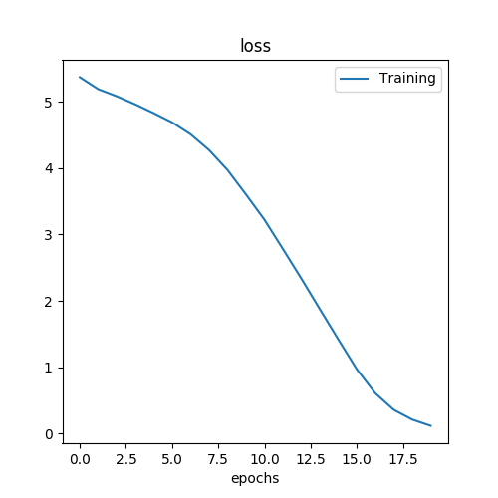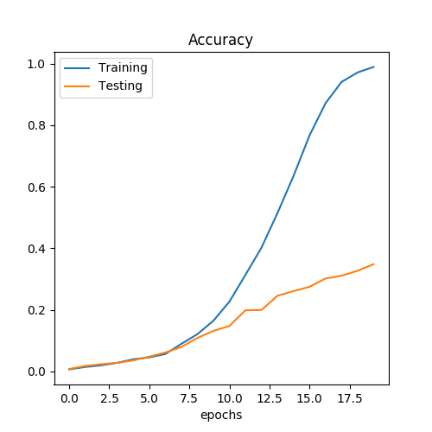

T2 model: with pre-training weights.

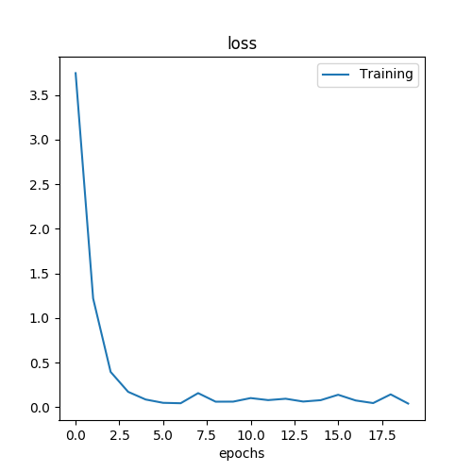 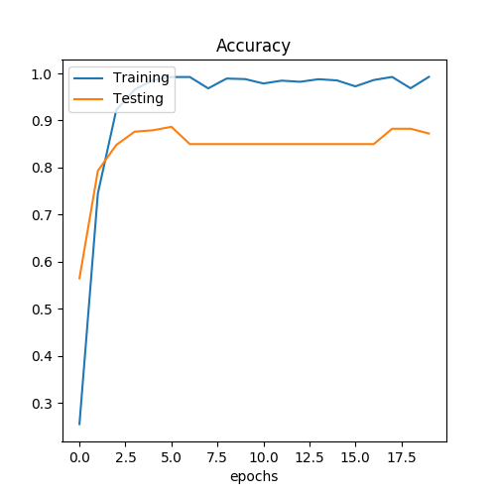

T1 test results.

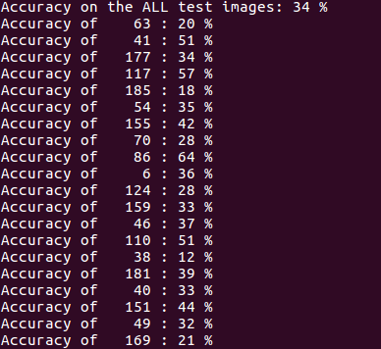

T2 test results.

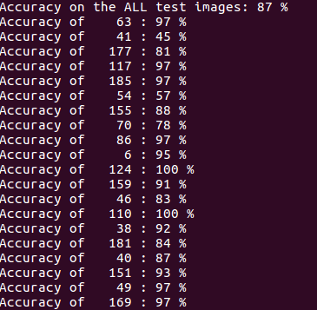

3. Discussion

用pre-training weights的模型可以得到all image test 87%的準確率，對應到同樣訓練20個epoch，without pre-training weights的模型只有34%的準確率。討論到curve，用pre-training weights可以看到loss在前面幾個epoch已經快速下降，到4至5個epoch就開始收斂，accuracy 同理，然而without pre-training weights則是平滑的下降，到第20個epoch也還沒收斂。訓練的accuracy雖然很高到98至99%，不過拿去測試後accuracy並沒有如同pre-training weights的模型來的高。

4. Problem and difficulties

一開始pre-training weights model的learning rate = 0.001來使用，結果all test accuracy只有57%，所以learning rate的選用其實很重要。