607410069 徐偉哲

HW4: Stanford Car Classification

1. Method description – what is your strategy for parameter selection?

Train my own model without pre-training weights.

Seed = 123, epochs = 50, batch_size = 32, optimizer = ‘Adam’, lr = 0.0001

Build model

CNN 5個 layer

每層後面加 relu 激活函數和Max pooling

Fc 3個 layer

前兩層加relu 激活函數和Dropout

Data augmentation

圖片顏色調整

水平翻轉圖片

旋轉圖片

2. Experimental results

My model

Training loss & Training accuracy:

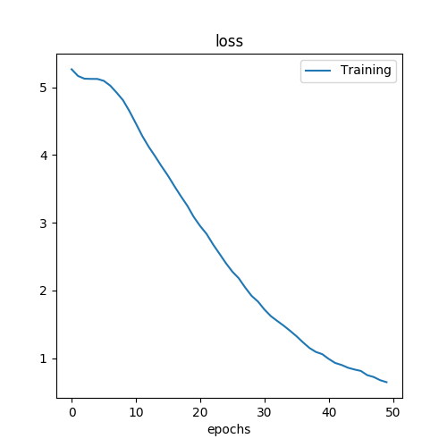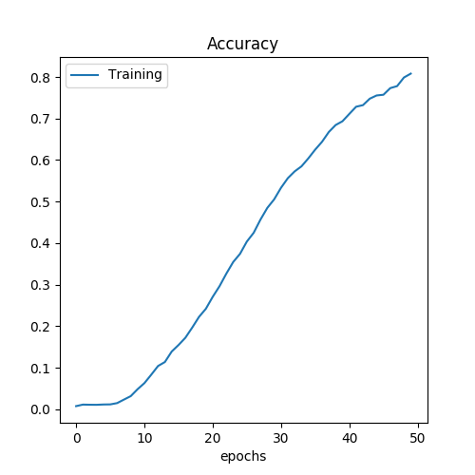

HW2 model without pre-training weights

Training loss & Training accuracy:

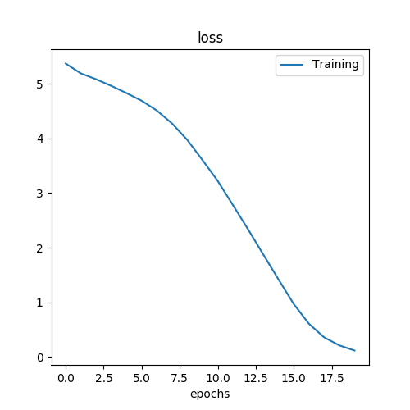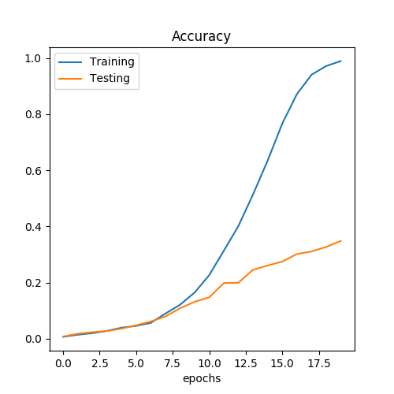

My model Testing accuracy:

Accuracy on the all test images: 42 %

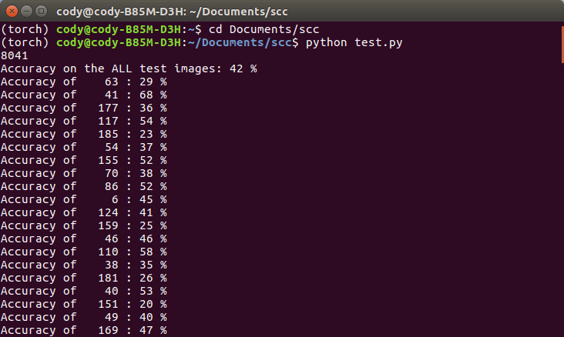

HW2 model without pre-training weights Testing accuracy:

Accuracy on the all test images: 34 %

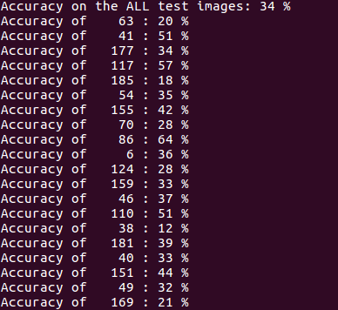

3. Discussion

資料量的增加有助於模型的準確率提升。沒有做資料量增加，跑epoches的次數到50次數，測試所有圖片的準確率為22%。

比起作業二，我的模型有比沒有pre-training weights的模型好。原因為epoches的次數從20變為50次，資料量做擴增。

4. Problem and difficulties

自己設計模型，讓模型收斂還滿難的，一開始無法收斂，所以調整模型的中間層，後來改動epoches的次數到50次，綜合來說，自己設計模型是有難度的。