Control4 Driver
Telegram Bot
Version 2000 – 2022-05-02

This driver is intended to be used only with Telegram app. Please refer to https://telegram.org/ for more info.
Main features
- Send text message from Control4 to Telegram by Advanced Programming
- Connect a Control4 system to several Telegram users
- Three dedicated bot so you can divide user messages from dealer and testing messages

Activating the License
The driver enabling process is simple. Buy the license from your preferred online store and select it from License Provider property.
Follow the instruction provided by the store to set the additional fields.

Pairing Telegram Users
- Specify Telegram Users (on the Composer)
- Type the Telegram usernames you want to pair in the “Username” driver property. Multiple users are accepted using a comma to separate the accounts (e.g. “Goophy, Mickey, Minnie”).
- Type an arbitrary numeric pairing code (e.g. “12345”) in the "User Code" driver property (this will be used to pair the driver with your Telegram users).
- Select wich bot you want to use. We provide 3 different bot so separate user usage from dealer needs or testing purpo

Note: Make sure that your users have set a username on their Telegram Apps (Settings > Info > Username), you have to specify such username in the driver.

2.2. Send the pairing code (on Users’ Telegram Apps)
- Create a chat with the bot, by typing the chat bot name of the bot you selected. On the search bar of the app:
- type @c4telegrambot if you selected USER int Telegram Bot Type property
- type @c4telegram_techbot if you selected TECH int Telegram Bot Type property
- type @c4telegram_testbot if you selected TEST int Telegram Bot Type property
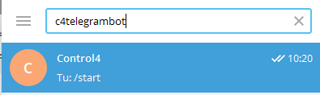

- Send a message to the bot, containing only the arbitrary numeric pairing code entered on the composer.
- Repeat the operations above for each user that you want to abilitate.

2.3. Confirm the pairing (on the Composer)
- Go to the “System Design” section and select in the “Actions” tab of the Telegram Bot driver.
- Click on “test username” button.
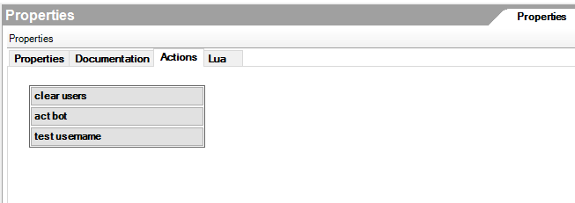
- The driver will check for the last messages sent to the bot looking for the pairing code received from the users in the “Username” property.
- The paired users will receive a message confirming the pairing, and the new property "Username Associated" will appear, to confirm the associations.
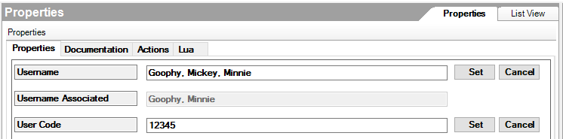

Note: Only the users present in the "Username Associated" property will receive the messages. In the example in the picture above, Mickey will not receive the messages, since his pairing process was not confirmed.

3. Sending Messages to Telegram
On the Composer, in the “Programming” section, you will find a new string-type variable called “WriteToBot”. Each time the content of “WriteToBot” is changed, its new content is sent to all the paired Telegram users and the variable value is cleared.
Note: The messages addressed to a given Telegram Bot driver are sent to all users paired with such driver. If you need to send distinct messages to different users, you should install multiple copies of the driver, with the same licence, pairing a different set of users to the different driver copies.

Acknowledge
Driver developed by Kiwifarm Srl (https://wedevelopdrivers.com/)
The software is not designed to be used for applications that may be considered critical by any means, especially in terms of security or safety. In particular, it is not designed to monitor or control devices or to be part of systems or algorithms where people or animals may be at risk to be injured, things lost or damaged, or data lost, corrupted or breached. To the full extent permissible by law, Kiwifarm disclaims all warranties and will not be liable for any tangible or intangible damages arising, directly or indirectly, from the use, misuse, misconfiguration or malfunctioning of the software. The software is designed to be installed and configured exclusively by professional Control4 dealers.

