Control4 Driver

KMTronic

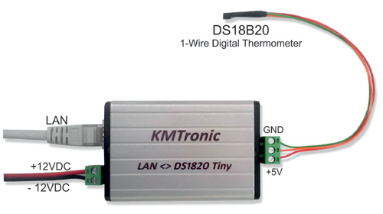LAN Temperature Monitoring

## Buying the device

On the KMTronic (kmtronic.com) online shop ,search for: **LAN Temperature Monitoring**

## License

To obtain a free showroom DEALER license code for the driver, you have to send us a message through the contact form you can find at:

<http://c4.soft.kiwi/kmtronic_relay.html>

For CUSTOMERS license buy the driver at

<https://www.houselogix.com/shop/control4-drivers>

There are two driver, one that support 1 device Board and other that support unlimited devices.

## Device setting (from the KMTronic Howto)

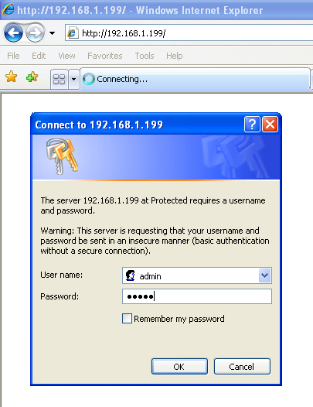The default IP address of the device is 192.168.1.199. If your LAN IP mask is different, you need one time access to network 192.168.1.x to change default setting of KMTronic.

Open a browser and type 192.168.1.199.

The default user is *admin* with password *admin.*

In “Configuration” menu you can change default IP Address, Gateway and HTTP Port.

For the integration with Control4, the device must have a fixed IP address. Please, set it on the device or in your DHCP server setting.

In “Authorization Configuration” you can change username name and password for device authentication. They will be required during the Driver configuration, so write them down.

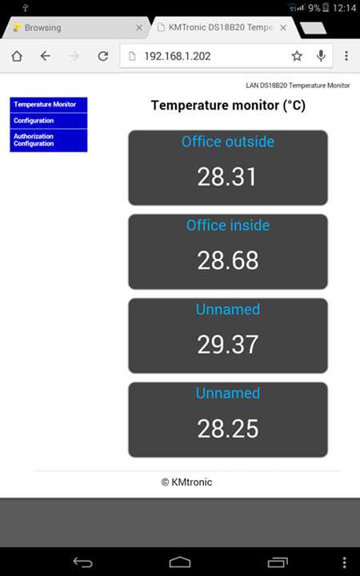

Verify on web page of Temperature Monitor if your sensors work.

## Driver installation

Install the driver in your Control4 project using the composer (as any other driver) and set the folllowing properties:

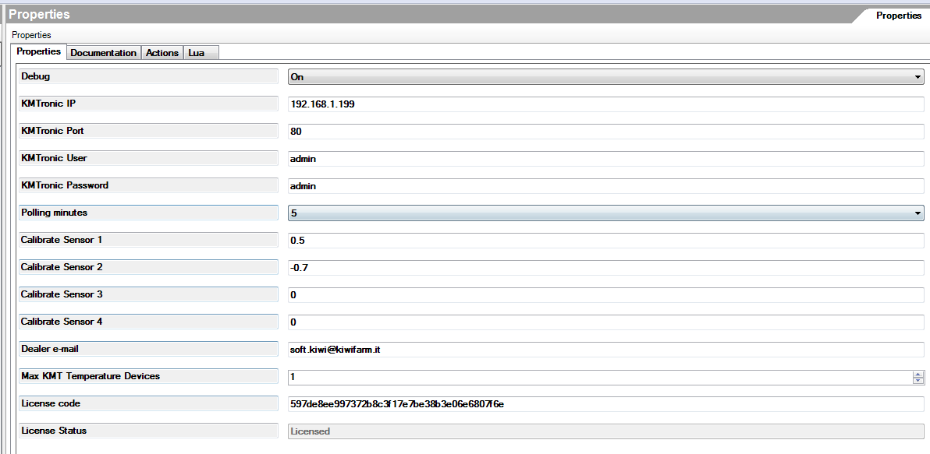

* Debug: in normal operating conditions is better to set it to “Off”
* **KMTronic IP**: device IP you set in the previous step.
* **KMTronic Port**: device HTTP Port if you changed it.
* **KMTronic User & KMTronic Password**: the one you use to access to the device from a browser (web interface).
* **Polling minutess**: select the frequency you want to update Control4 about the change of sensors status.
* **Calibrate sensor**: you can calibrate your sensor here.
* **Dealer e-mail:** the email you communicated to obtain the license of the driver. The license is bound to such email.
* **Max KMT Temperature Devices**: maximum number of KMT Temperature boards you are connecting to the C4 controller. It is the number we asked during the license buying process and the license is bound to such number. The first license dealers get for free is limited to 2 boards.
* **License code**: copy & paste here the license code we sent to you during the license buying process.

## Connection

For each temperature sensor, you will find a Temp_Sensor *connection* that allows to connect it to the Yatun Software Thermostat (Free) - [www.yatundev.eu/drivers/software-thermostat-free](http://www.yatundev.eu/drivers/software-thermostat-free)

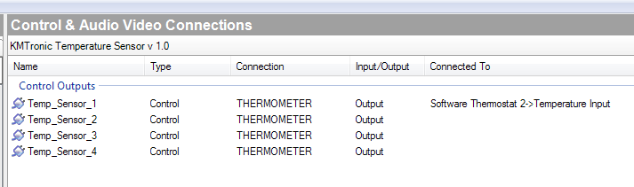

You simply have to create new connections with Temperature Input.

## Variable

For each temperature sensor, you will find a read only variable in number format that contain integer signed value of temperature.

Have fun with our Made in Italy, Homemade Organic Drivers!

[c4.soft.kiwi](http://c4.soft.kiwi)