S4 Fig1. Abdominal cross-sectional CT scan image of a 57-year-old male donor with discrimination index of 2.14 and operative time of 270 min.

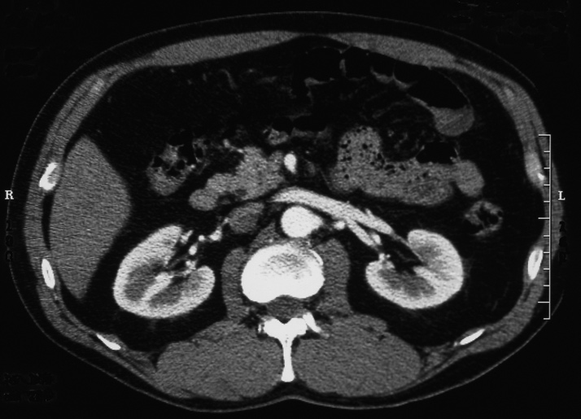

S4 Fig2. Abdominal cross-sectional CT scan image of a 61-year-old female donor with discrimination index of -6.77 and operative time of 120 min.

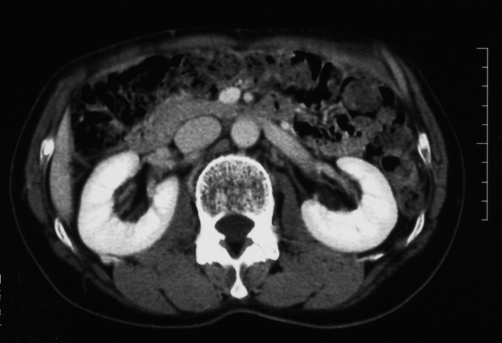

S4 Fig3. Abdominal cross-sectional CT scan image of a 47-year-old female donor who had pear-shaped adiposity with discrimination index of -2.30 and operative time of 120 min.

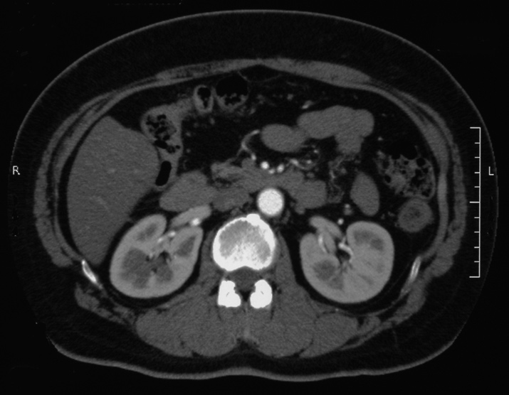

S4 Fig4. Abdominal cross-sectional CT scan image of a 61-year-old male donor who had apple-shaped adiposity with discrimination index of 1.93 and operative time of 360 min.

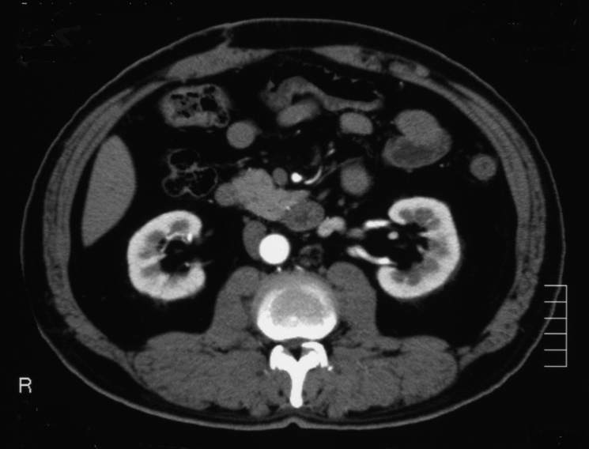

S4 Fig5. Notations of parameters in the abdominal CT image

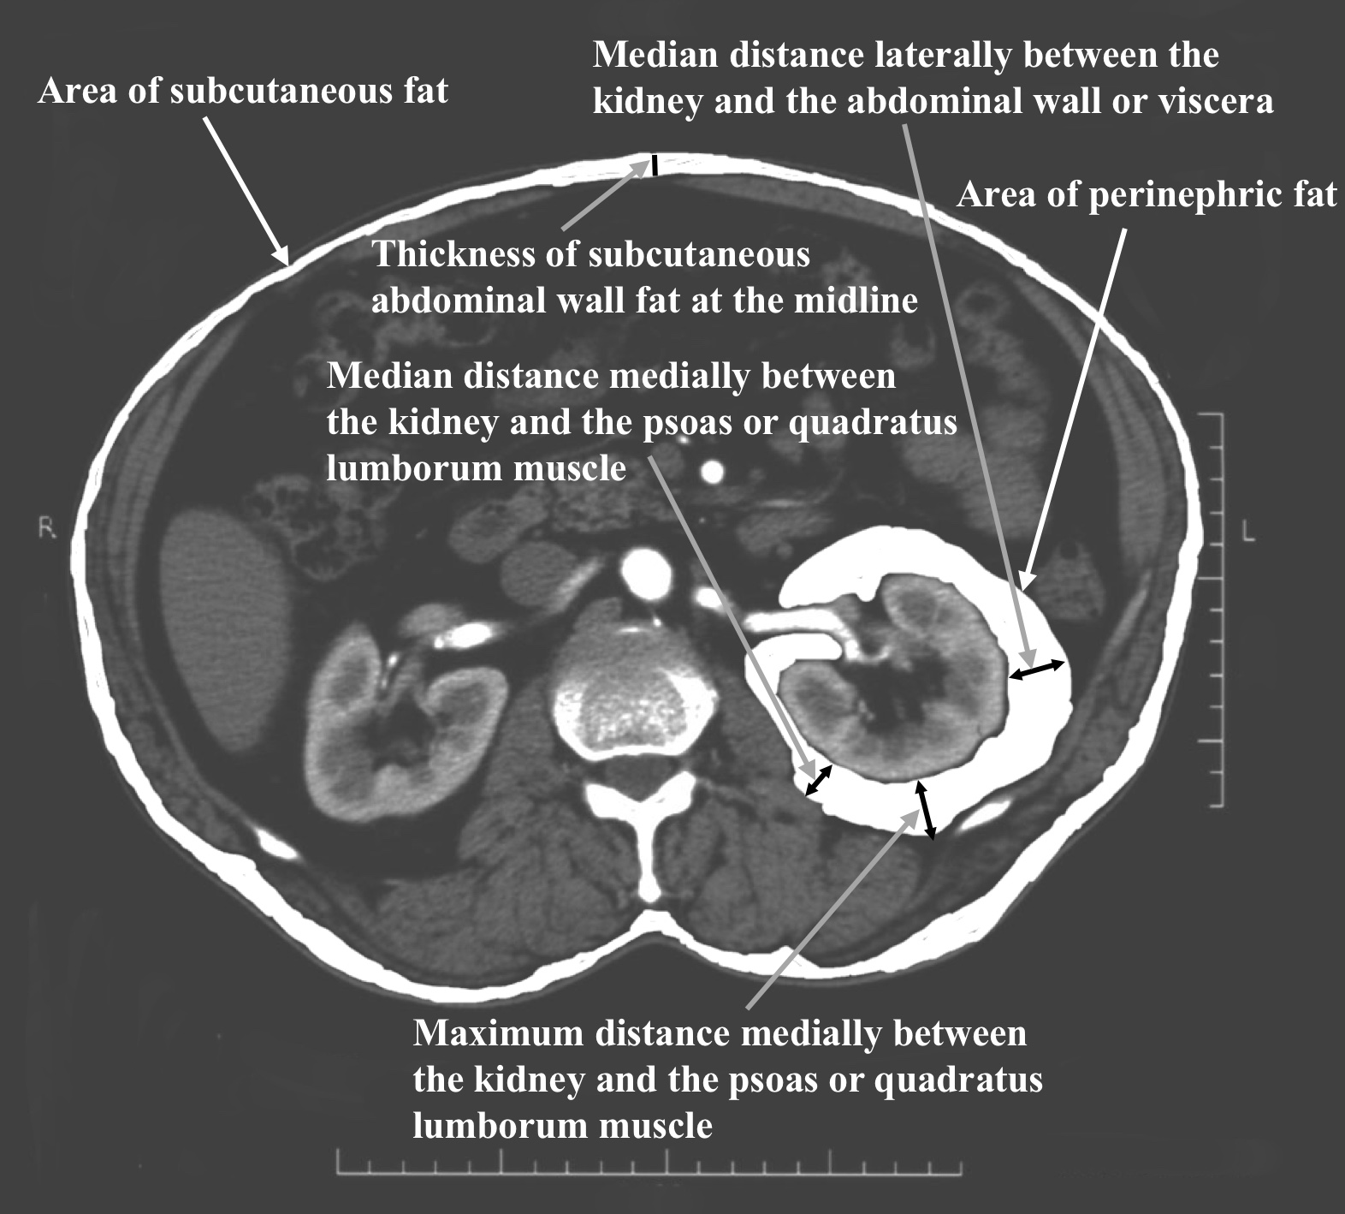

S4 Fig6. Changes in total hit rate in PDA according to threshold percentile of operative time between easy and difficult cases

Total hit rate (%)

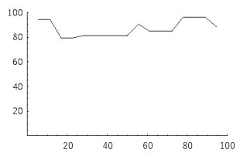 Percentile

Horizontal axis is threshold percentile of operative time between easy and difficult cases. Vertical axis is total hit rate of the preoperative assessment system in HALapNx.

Mean hit rate in all thresholds was 86.79 ± 6.54%; median hit rate was 84.91%. PDA: predictive discriminant analysis.

S4 Fig7. Changes in HREC and HRDC in PDA according to threshold percentile of operative time between easy and difficult cases

Hit rate (%)

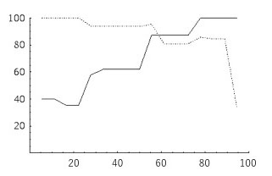Percentile

Horizontal axis is threshold percentile of operative time between easy and difficult cases. Vertical axis is hit rate of preoperative assessment system in HALapNx. The black line represents HREC, and the dashed line represents HRDC. Mean hit rate of difficult cases in all thresholds was 70.95 ± 24.27%; median was 61.90%. Mean hit rate of easy cases was 87.97 ± 15.74%; median was 93.75%. PDA: predictive discriminant analysis.

S4 Fig8. Changes in sensitivity and specificity of difficult cases in PDA according to threshold percentile of operative time between easy and difficult cases

­­­ Sensitivity/Specificity

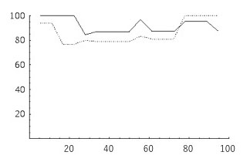Percentile

Horizontal axis is threshold percentile of operative time between easy and difficult cases. Vertical axis is hit rate of preoperative assessment system in HALapNx. The black line represents sensitivity and the dashed line represents specificity for easy cases. Mean sensitivity for easy cases throughout all thresholds was 92.00 ± 5.88%; median was 88.00%. Mean specificity for easy cases was 86.08 ± 9.39%; median was 80.95%. PDA: predictive discriminant analysis.