- Install Packages
<Project Sdk="Microsoft.NET.Sdk.Web">

<PropertyGroup>
<TargetFramework>netcoreapp2.0</TargetFramework>
<TypeScriptCompileBlocked>true</TypeScriptCompileBlocked>
<TypeScriptToolsVersion>Latest</TypeScriptToolsVersion>
<IsPackable>false</IsPackable>
</PropertyGroup>

<ItemGroup>
<PackageReference Include="Microsoft.AspNetCore.All" Version="2.0.3" />
</ItemGroup>

<ItemGroup>
<DotNetCliToolReference Include="Microsoft.VisualStudio.Web.CodeGeneration.Tools" Version="2.0.1" />
</ItemGroup>

<ItemGroup>
<!-- Files not to publish (note that the 'dist' subfolders are re-added below) -->
<Content Remove="ClientApp\**" />
</ItemGroup>

<Target Name="DebugRunWebpack" BeforeTargets="Build" Condition=" '$(Configuration)' == 'Debug' And !Exists('wwwroot\dist') ">
<!-- Ensure Node.js is installed -->
<Exec Command="node --version" ContinueOnError="true">
<Output TaskParameter="ExitCode" PropertyName="ErrorCode" />
</Exec>
<Error Condition="'$(ErrorCode)' != '0'" Text="Node.js is required to build and run this project. To continue, please install Node.js from https://nodejs.org/, and then restart your command prompt or IDE." />

<!-- In development, the dist files won't exist on the first run or when cloning to
a different machine, so rebuild them if not already present. -->
<Message Importance="high" Text="Performing first-run Webpack build..." />
<Exec Command="node node_modules/webpack/bin/webpack.js --config webpack.config.vendor.js" />
<Exec Command="node node_modules/webpack/bin/webpack.js" />
</Target>

<Target Name="PublishRunWebpack" AfterTargets="ComputeFilesToPublish">
<!-- As part of publishing, ensure the JS resources are freshly built in production mode -->
<Exec Command="npm install" />
<Exec Command="node node_modules/webpack/bin/webpack.js --config webpack.config.vendor.js --env.prod" />
<Exec Command="node node_modules/webpack/bin/webpack.js --env.prod" />

<!-- Include the newly-built files in the publish output -->
<ItemGroup>
<DistFiles Include="wwwroot\dist\**; ClientApp\dist\**" />
<ResolvedFileToPublish Include="@(DistFiles->'%(FullPath)')" Exclude="@(ResolvedFileToPublish)">
<RelativePath>%(DistFiles.Identity)</RelativePath>
<CopyToPublishDirectory>PreserveNewest</CopyToPublishDirectory>
</ResolvedFileToPublish>
</ItemGroup>
</Target>

</Project>
Open the *.csproj
Add the following packages :
dotnet add package Microsoft.EntityFrameworkCore
dotnet add package Microsoft.EntityFrameworkCore.Design
dotnet add package Microsoft.EntityFrameworkCore.SqlServer
dotnet add package Microsoft.EntityFrameworkCore.Tools

Add the highlighted line into the csproj file as shown as following:

dotnet restore
<ItemGroup>
<PackageReference Include="Microsoft.AspNetCore.All" Version="2.0.3" />
<PackageReference Include="Microsoft.EntityFrameworkCore" Version="2.0.1" />
<PackageReference Include="Microsoft.EntityFrameworkCore.Design" Version="2.0.1" />
<PackageReference Include="Microsoft.EntityFrameworkCore.SqlServer" Version="2.0.1" />
<PackageReference Include="Microsoft.EntityFrameworkCore.Tools" Version="2.0.1" />
</ItemGroup>

<ItemGroup>
<DotNetCliToolReference Include="Microsoft.VisualStudio.Web.CodeGeneration.Tools" Version="2.0.1" />
<DotNetCliToolReference Include="Microsoft.EntityFrameworkCore.Tools.DotNet" Version="2.0.1" />
</ItemGroup>
- Import Data Model
Find out the database connection string
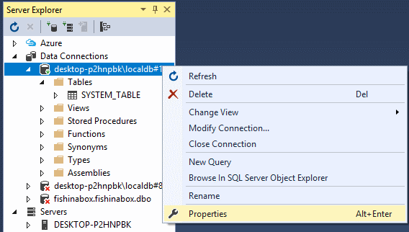
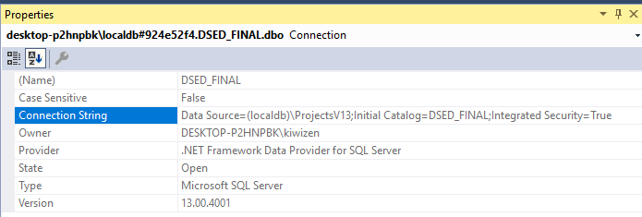
Execute the following command:
dotnet ef dbcontext scaffold "Data Source=(localdb)\ProjectsV13;Initial Catalog=DSED_FINAL;Integrated Security=True" Microsoft.EntityFrameworkCore.SqlServer -d -c DSEDContext -f -o Models

Here is the syntax for the above command:
Arguments:
<CONNECTION> The connection string to the database.
<PROVIDER> The provider to use. (E.g. Microsoft.EntityFrameworkCore.SqlServer)

Options:
-d --data-annotations Use attributes to configure the model (where possible). If omitted, only the fluent API is used.
-c --context <DBCONTEXT> The DbContext to use.
-f --force Overwrite existing files.
-o --output-dir <PATH> The directory to put files in. Paths are relative to the project directory.

- Modify the following source file.
3.1 Amend AIMSContext.cs
Delete the code highlighted in Yellow. (Remove the database connection string)
Add the line of code in Blue.
using System;
using Microsoft.EntityFrameworkCore;
using Microsoft.EntityFrameworkCore.Metadata;

namespace DSED_FINAL.Models
{
public partial class DSEDContext : DbContext
{
public AIMSContext(DbContextOptions<DSEDContext> opts) : base(opts) {}

public virtual DbSet<SystemTable> SystemTable { get; set; }

protected override void OnConfiguring(DbContextOptionsBuilder optionsBuilder)
{
if (!optionsBuilder.IsConfigured)
{
#warning To protect potentially sensitive information in your connection string, you should move it out of source code. See http://go.microsoft.com/fwlink/?LinkId=723263 for guidance on storing connection strings.
optionsBuilder.UseSqlServer(@" Data Source=(localdb)\ProjectsV13;Initial Catalog=AIMS;Integrated Security=True ");
}
}

protected override void OnModelCreating(ModelBuilder modelBuilder)
{
modelBuilder.Entity<Tank>(entity =>
{
entity.HasOne(d => d.LaneFkNavigation)
.WithMany(p => p.Tank)
.HasForeignKey(d => d.LaneFk)
.OnDelete(DeleteBehavior.ClientSetNull)
.HasConstraintName("FK_TANK_LANE");
});
}
}
}

  - Amend appsetting.json
Add lines of code highlighted in Blue. (Add the connection string inside appsetting.json).
{
"Logging": {
"IncludeScopes": false,
"LogLevel": {
"Default": "Warning"
}
},
"Database": {
"ConnectionString": " Data Source=(localdb)\\ProjectsV13;Initial Catalog=AIMS;Integrated Security=True"
}
}
  - Amend Startup.cs
Add line of code in Yellow to add database service to the application.
using System;
using System.Collections.Generic;
using System.Linq;
using System.Threading.Tasks;
using Microsoft.AspNetCore.Builder;
using Microsoft.AspNetCore.Hosting;
using Microsoft.Extensions.Configuration;
using Microsoft.Extensions.DependencyInjection;
using Microsoft.EntityFrameworkCore;
using Microsoft.AspNetCore.ResponseCompression;
using System.IO.Compression;

namespace IMSWebApp
{
public class Startup
{
public Startup(IConfiguration configuration)
{
Configuration = configuration;
}

public IConfiguration Configuration { get; }

// This method gets called by the runtime. Use this method to add services to the container.
public void ConfigureServices(IServiceCollection services)
{
services.AddDbContext<Models.AIMSContext>
(options => options.UseSqlServer(Configuration["Database:ConnectionString"]));
/*
* Enable Response Compression In ASP.NET Core
* http://www.binaryintellect.net/articles/85973b21-5466-413d-9cc5-f44c63686859.aspx
*/
services.Configure<GzipCompressionProviderOptions>
(options => options.Level = CompressionLevel.Optimal);
services.AddResponseCompression(options => {
options.Providers.Add<GzipCompressionProvider>();
});
/* */
services.AddMvc();
}

// This method gets called by the runtime. Use this method to configure the HTTP request pipeline.
public void Configure(IApplicationBuilder app, IHostingEnvironment env)
{
if (env.IsDevelopment())
{
app.UseDeveloperExceptionPage();
app.UseBrowserLink();
}
else
{
app.UseExceptionHandler("/Home/Error");
}
/*
* Enable Response Compression In ASP.NET Core
* http://www.binaryintellect.net/articles/85973b21-5466-413d-9cc5-f44c63686859.aspx
*/
app.UseResponseCompression();

app.UseStaticFiles();

app.UseMvc(routes => {
routes.MapRoute(
name: "default",
template: "{controller=Home}/{action=Index}/{id?}");
});
}
}
}
Note: The lines of code (in Green) is added to enable compression in response so as to improve the response speed ??!!

