Name: Kwizera Dieudonne

Student ID: 12345

Date: 07 October 2025

## Task 1: Create a New Pluggable Database

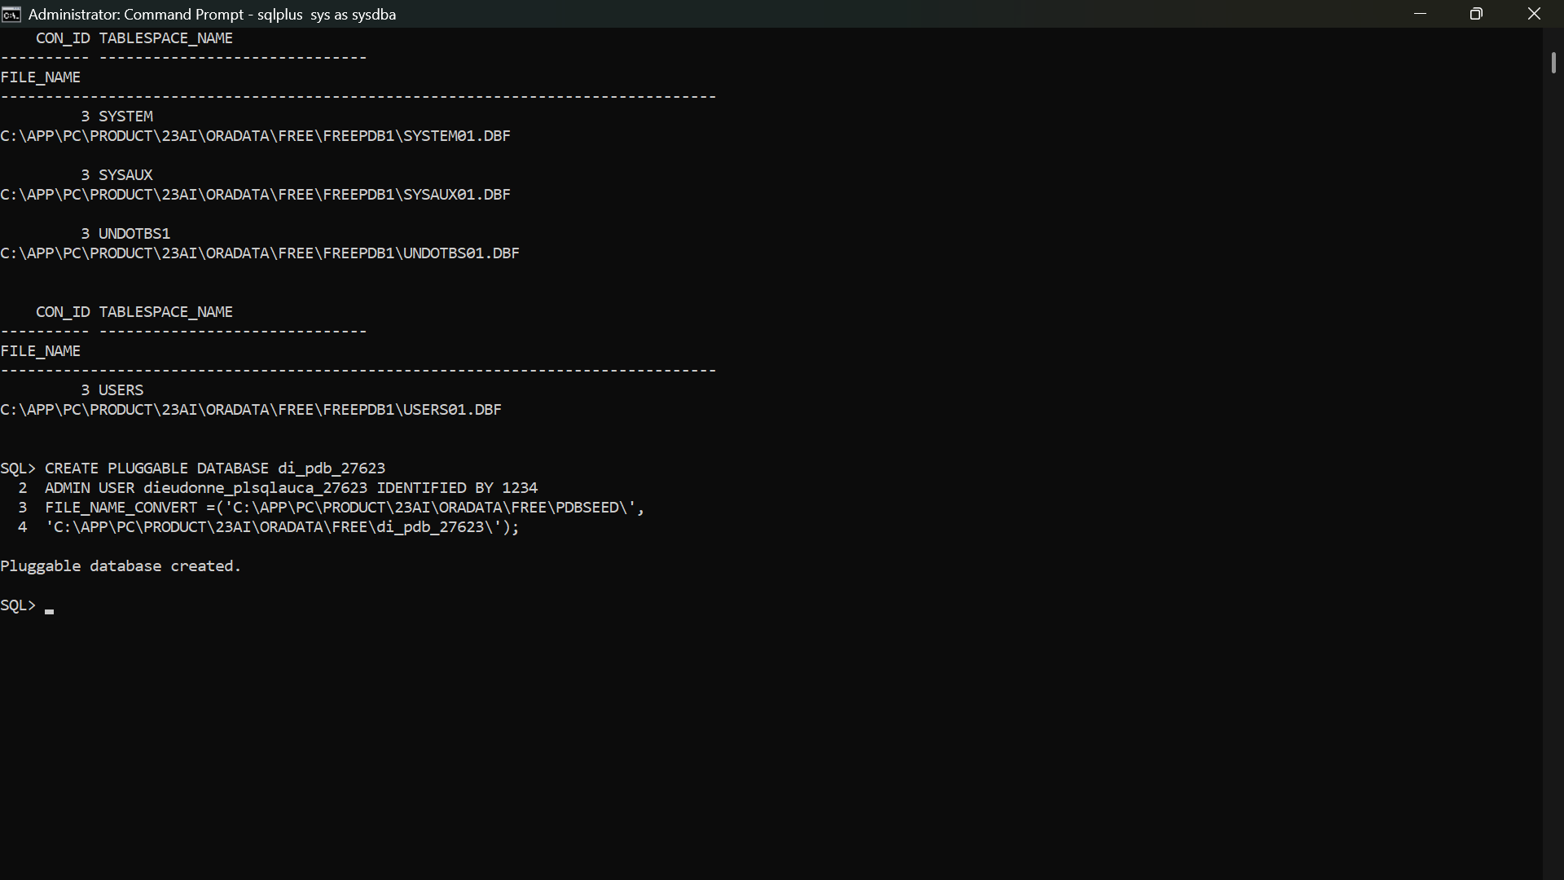I created a new PDB named 'di_pdb_27623' with an admin user 'di_plsqlauca_27623' and password '1234'.

## Task 2: Create and Delete Another PDB

I created a temporary PDB named 'di_to_delete_pdb_27623' and deleted it after verifying successful creation.

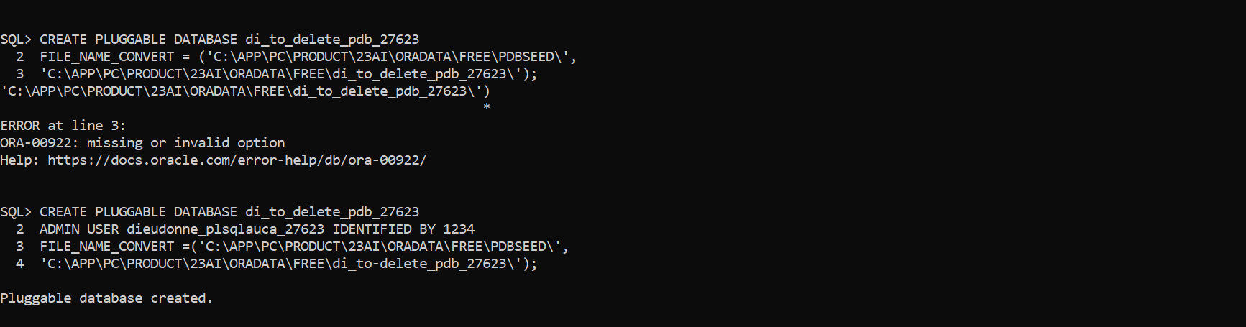

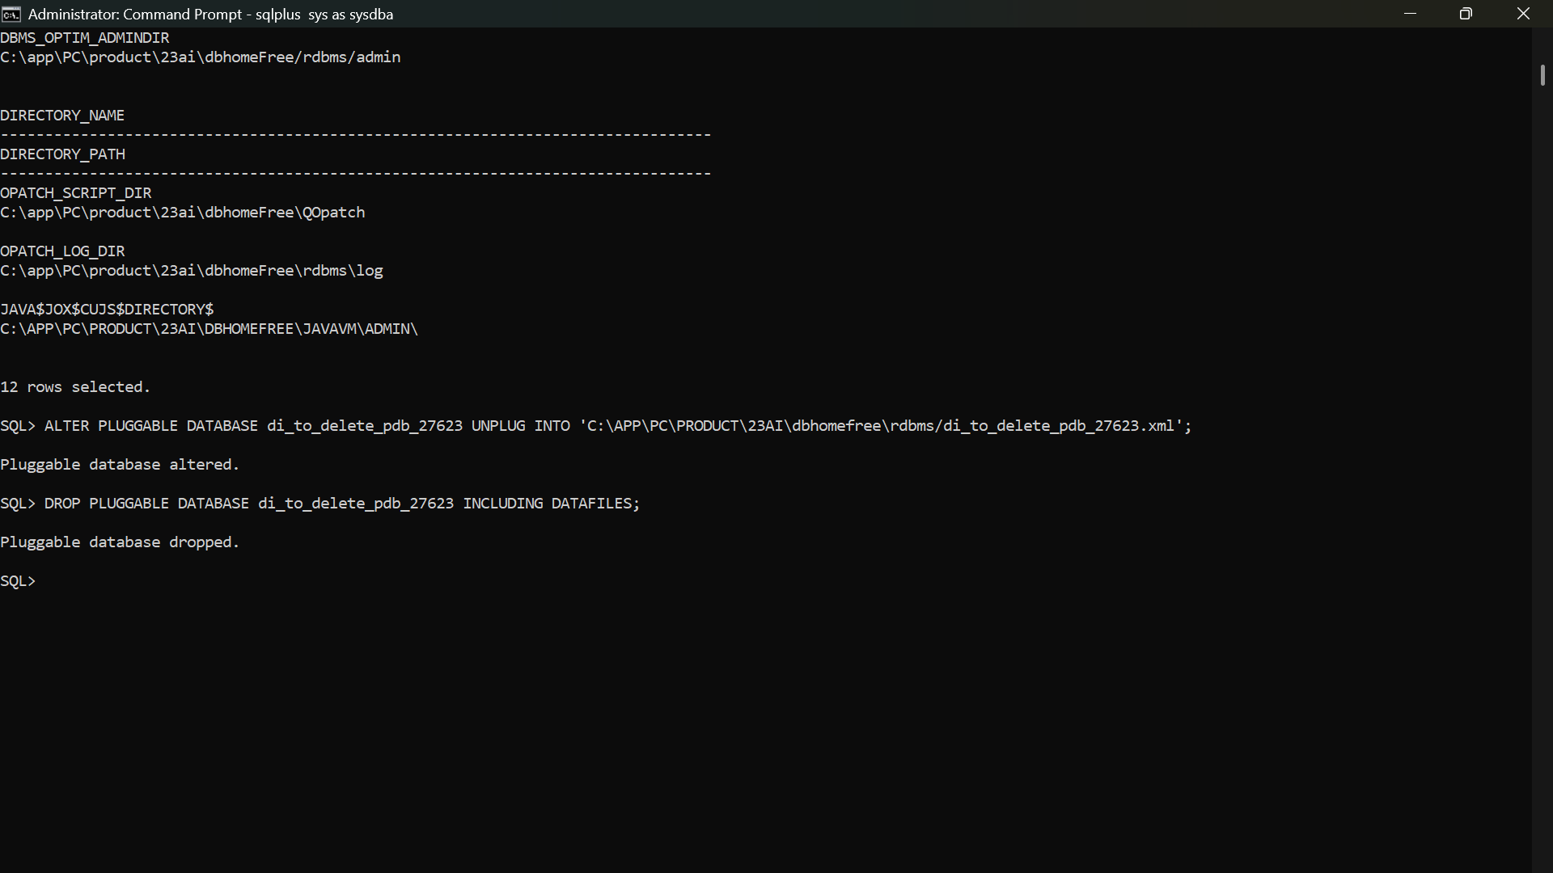

## Task 3: Oracle Enterprise Manager (OEM) / SQL Developer Dashboard

Since 'emctl' was not recognized in Oracle 23c AI, I used Oracle SQL Developer as an alternative dashboard.

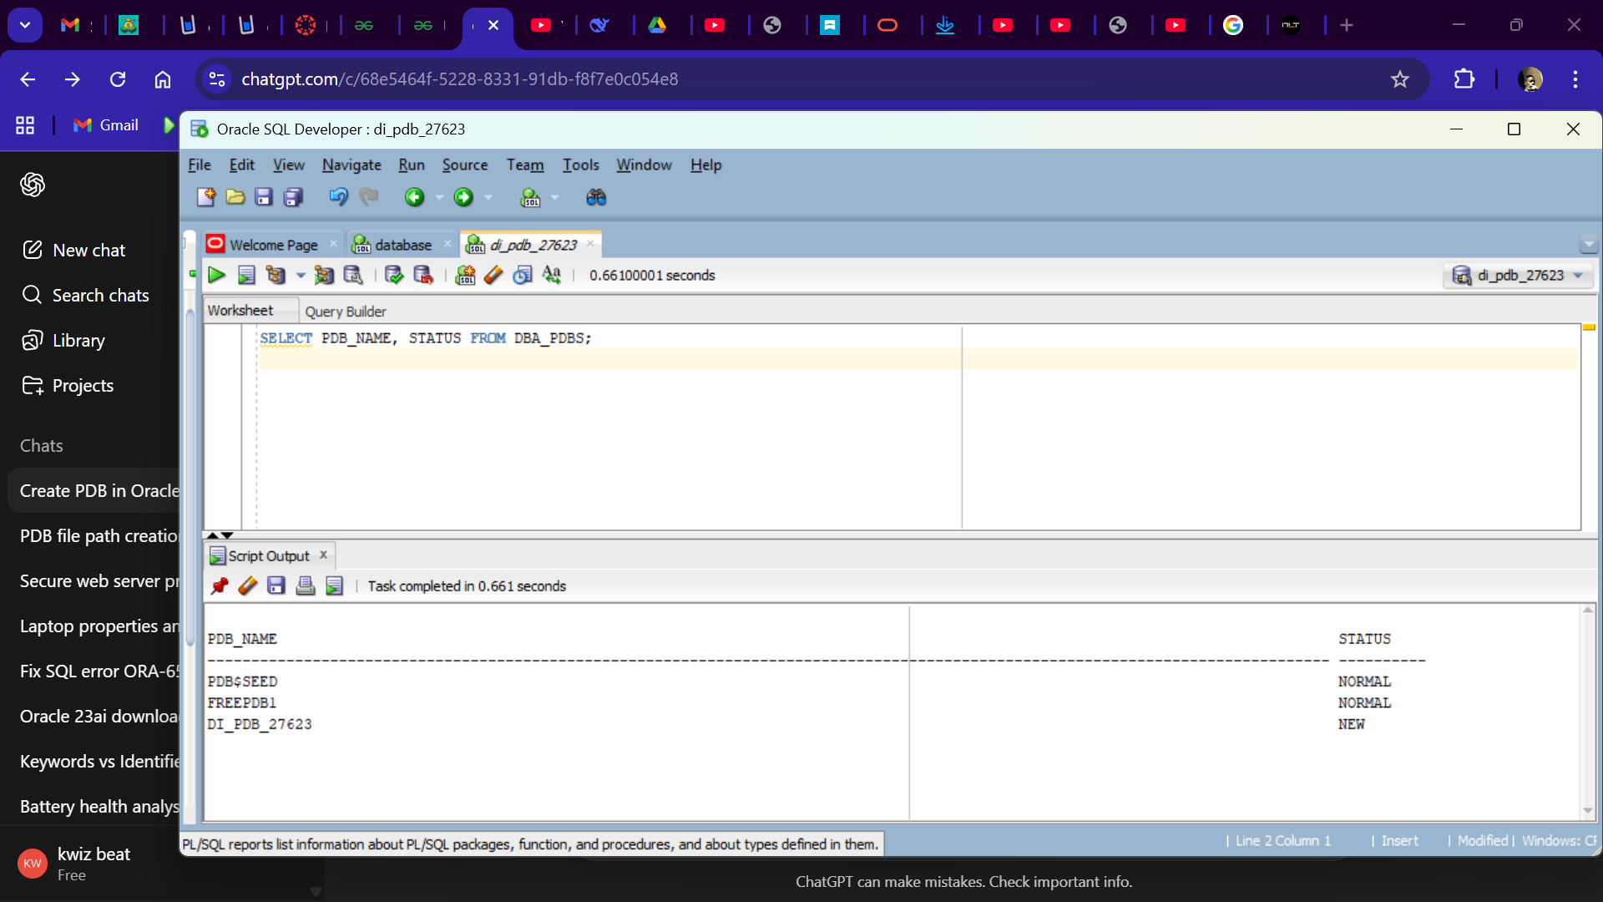

# 3. Issues Encountered and Solutions

The emctl command was unavailable in Oracle 23c AI.**:** Used Oracle SQL Developer as an alternative .

# 4. Conclusion

- Successfully created a PDB with an admin user  
- Created and deleted a second PDB for testing  
- Verified and documented all results using SQL Developer dashboard