ExternalSupplierForwarding
                - c.a.p.e. IT® GmbH
                - Version: 1.2.1 / 7

GNU AFFERO GENERAL PUBLIC LICENSE
Version 3, 19 November 2007

Title: | Usage Documentation
Topic: | ExternalSupplierForwarding
Author: | c.a.p.e. IT® GmbH
Keywords: | OTRS
Version: | ExternalSupplierForwarding1.2.1 / 7
Filename: | ExternalSupplierForwarding.odt
Table of Contents
1 Document Related Remarks 3
1.1 Document Information 3
1.1.1 Intention of this Document 3
1.1.2 Delimitation 3
1.1.3 Document History 3
1.1.4 Authors / Responsible 3
1.1.5 Document Owner 3
2 General Remarks and Preconditions 4
2.1 Used Terms and Abbreviations 4
2.2 OTRS-external Requirements 4
2.3 OTRS-internal Requirements 4
3 Package Installation and Setup 5
3.1.1 How to Use 5
4 Functionality 6
4.1 Ticket Forwarding From Selected Queues 6
4.2 Ticket action “Print Forward Fax” 7
5 Configuration – SysConfig Options 9
5.1.1 Automatically forward tickets from forward-queue 9
5.1.2 Content of the forwarded emails 9
5.1.3 Ticket action “Print Forward Fax” 9
6 Geänderte Standardkonfigurationsschlüssel 11

Document Related Remarks

Document Information

Intention of this Document
This document describes specific modifications and extensions as they are part of project „Doc-Props/Info3“. It contains a short technical description as well as short advisories on how to use this extension.

Delimitation
This document does not claim to be a complete documentation on the administration or configuration of OTRS. For more information on these issues please check the publicly available documentaion of the OTRS-project at http://www.otrs.org. More information may be found in the forum area http://forums.otrs.org.
Changes and configuration, i.e. in SysConfig or in the file system, which have been performed manually or separately are not subject of this document either.

Document History
Version | Date | Changed Section | Changed By
1.0.0 | 2013-03-29 | all | Anna Litvinova
1.0.1 | 2013-10-25 | properties | Stefan Mehlig
1.0.2 | 2014-04-04 | 4.2, 5.1.3 | Stefan Mehlig
1.1.0 | 2014-08-07 | complete rework | Torsten Thau
1.2.0 | 2015-11-27 | 2.3 | Mario Illinger
1.2.1 | 2016-09-23 | Added sysconfig option ExternalSupplierForwarding::ArticleType | Torsten Thau

Authors / Responsible
Lastname, Firstname | Organization | Function
Illinger, Mario | c.a.p.e. IT® GmbH | SW-Ing. / Consultant Service Management
Litvinova, Anna | c.a.p.e. IT® GmbH | SW-Ing. / Consultant Service Management
Mehlig, Stefan | c.a.p.e. IT® GmbH | SW-Ing. / Consultant Service Management
Thau, Torsten | c.a.p.e. IT® GmbH | Head of Project Department

Document Owner
Organization | Address | Contact
c.a.p.e. IT® GmbH | Schönherrstr. 8  09113 Chemnitz, Germany | info@cape-it.de  +49 371 27095 620

General Remarks and Preconditions

Used Terms and Abbreviations
Term | Description
CI | Config Item
CLI | Command Line Interface
GUI | Graphical User Interface
OTRS | Open Ticket Request System
Table 1: Used Terms and Abbreviations

OTRS-external Requirements
Aspect | Minumum Requirement
n.a. | n.a.
Table 2: OTRS-external Requirements

OTRS-internal Requirements
Packagename | Ver-sion (≥) | Vendor | Free | Requirement | Description
OTRS-Framework | 5.0.1 | OTRS AG | X | R
Table 3: OTRS-Internal Requirements

Package Installation and Setup
You can install the package „ExternalSupplierForwarding“ via the Package Management in the OTRS GUI or using the CLI package manager.
This packages provides functions to automatically forward tickets from configured “forward-queues” to external suppliers. The forwarded data can also include the data of related config items. The forwarded mail is PGP-encrypted if a key for the destination mail address can be found.

How to Use
The installation of OTRS-extension package can be done via the OTRS-GUI: within the package manager within the admin-area. Select the package file and install it by clicking upload. Depending on the package various information may be displayed before the actual installation.
In case you get a notice, that this package is not verified by the OTRS Group, this does not mean that this package contains malware or will affect your OTRS-installation negatively as the notice suggests.
The installation may also be done by the command line interface:
OTRSuser@system:/<OTRS_HOME>$ /bin/otrs.PackageManager.pl -a install -p /path/to/ExternalSupplierForwarding-x.y.z.opm

Due to the configuration of your OTRS installation it may be necessary to clear the OTRS cache as well as to restart the web server:
OTRSuser@system:/<OTRS_HOME>$ ./bin/otrs.DeleteCache.pl
OTRSuser@system:/<OTRS_HOME>$ ./bin/otrs.RebuildConfig.pl
root@system:/$ service apache2 restart

After you have installed the ExternalSupplierForwarding extensions additional configuration is required to fully use the functionality of this package. First of all you have to configure the forward-queues with corresponding email addresses. Then you can change some default parameters according to your needs.

Functionality

Ticket Forwarding From Selected Queues
Some queues can be configured by the OTRS administrator to be the co called “forward-queues”. An email-address of an external supplier should be assigned to each forward-queue. There are also some article types that are configured as relevant for external supplier forwarding (initially only “note-supplier-external” and “note-supplier-internal”).
When a new ticket is created in a forward-queue or a new article of relevant type is added to a ticket in a forward-queue, the system will automatically send an email to the email address of the external supplier assigned to this particular queue and a new article with the contents of the sent email will be added to the ticket.
The forwarded mail is PGP-encrypted if a key for the destination mail address is configured.
The forwarded information (automatically generated article) consists of three sections: and is shown in the following illustration.
- PROBLEM DESCRIPTION: This section includes the text of the first article in case of ticket creation or the text of the added article, if case of a new article of a relevant type.
- CUSTOMER DATA: This section provides customer data based on customer attributes defined in Customer-Backend configuration. There is a possibility to exclude some of the attributes configured in Customer-Bachend mapping (s. Configuration section).
- RELATED OBJECT DATA: This section provides information about related objects (linked configuration items). It is configurable, which CI classes and CI attributes are relevant and should be included in the forwarded emails (s. Configuration section for details).

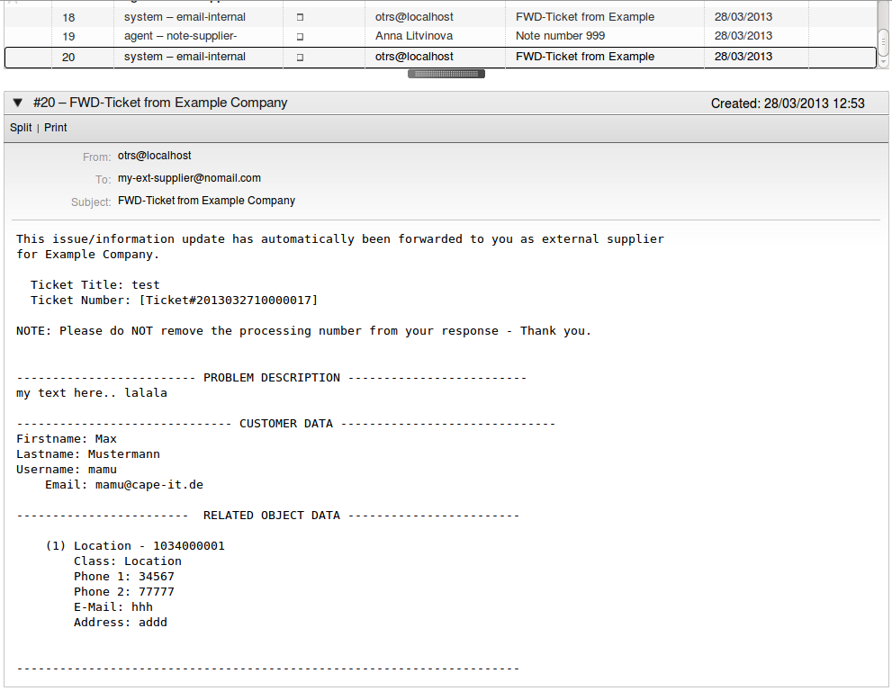Illustration 1: Sample Content

Ticket action “Print Forward Fax”
This ticket action can be used to create/print a PDF for manual ticket forwarding.
The content of the PDF/fax contains general ticket information, ticket customer information and related object information. Besides this, it also includes configured ticket dynamic fields and the content of selected ticket articles. The fax header is built automatically. The data used in the header must be configured by the OTRS administrator.
After the package installation this ticket action is visible in tickets in all queues. The OTRS administrator can activate an ACL to show this action only in queues that are configured as forward queues or forward fax queues (s. Configuration section for details).
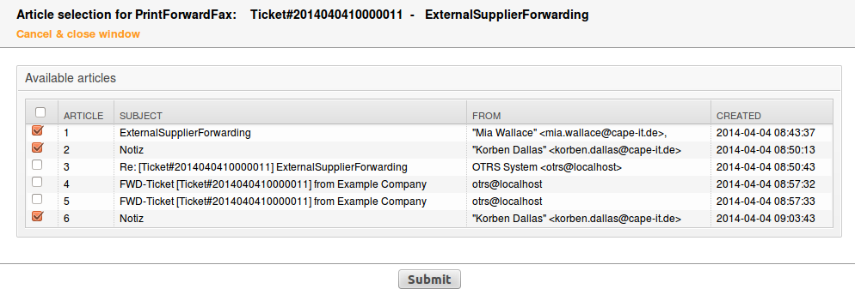Illustration 2: Selection of ticket articles included in fax/PDF

Configuration – SysConfig Options
The following section provides an overview of available configuration options.

Automatically forward tickets from forward-queue
Config Key | Description
ExternalSupplierForwarding::-ForwardQueues | Defines mapping of OTRS queues to be forwarded and corresponding email-addresses.
ExternalSupplierForwarding::-RelevantFwdArticleTypes | Defines article types which are forwarded if added to tickets in fwd-Queues.
Ticket::EventModulePost###999-ExternalSupplierForwarding | Workflow module which forwards the ticket (1st article) and related Cis.
ExternalSupplierForwarding::BCC | Defines BCC-Mailaddress for ExternalSupplierForwarding-Submissions – useful for debugging, does not provide separate encryption forr bcc-receipient.
PostMaster::PreFilterModule###-000-PGPInlineDecrypt | Module to decrypt PGP-encrypted mails before any other processing.
ExternalSupplierForwarding::-ForwardEmailPGPKeys | Defines PGP-Keys for mail addresses which are not registered in the key.
ExternalSupplierForwarding::ArticleType | Defines article type for generated message. Do not use article types which trigger an external supplier forwarding itself.
Table 4: Forward-Tickets

Content of the forwarded emails
Config Key | Description
ExternalSupplierForwarding::-ForwardObjectClasses | Defines the classes of linked object which are relevant to be forwarded (included).
ExternalSupplierForwarding::-CustomerUserAttrBlacklist | Defines customer user attributes which should not be shown in forwarded documents.
FwdLinkedObjectData::-OnlyCIAttributeKeys | Defines only CI-attributes for CI-Classes which are forwarded.
FwdLinkedObjectData::-ExcludedCIAttributeKeys | Defines CI-attributes for CI-Classes which are not forwarded.
Table 5: Forward-Content

Ticket action “Print Forward Fax”
Config Key | Description
Ticket::Frontend::MenuModule###210-PrintForwardFax | Module to show print forward fax link in menu.
Frontend::Module###AgentTicket-PrintForwardFax | Frontend module registration for the AgentTicketPrintForwardFax object in the agent interface.
ExternalSupplierForwarding::-ForwardFaxQueues | Defines mapping of OTRS queues to be fax-forwarded and corresponding fax-numbers.
ExternalSupplierForwarding::-PDFOutputTicketDynamicFields | Defines which ticket dynamic fields are forwarded.
OrganizationHotline1 | Extended organization description
OrganizationHotline2 | Extended organization description
OrganizationLong | Extended organization description
Ticket::Acl::Module###500-ExternalSupplierForwarding | Ticket-ACL to show/hide ticket action AgentTicketPrintForwardFax.
Ticket::Frontend::AgentTicketPrint-ForwardFax###ShownArticleAttributes | Defines which article data parameters are displayed.
Table 6: Print Forward-Fax

Geänderte Standardkonfigurationsschlüssel
This section lists SysConfig keys which have been changed within this extensions and which are not mentioned within other sections of this documents. Manually set configuration options are not listed.
Keyname | New Default Value

List of Figures
Illustration 1: Sample Content 7
Illustration 2: Selection of ticket articles included in fax/PDF 8

List of Tables
Table 1: Used Terms and Abbreviations 4
Table 2: OTRS-external Requirements 4
Table 3: OTRS-Internal Requirements 4
Table 4: Forward-Tickets 9
Table 5: Forward-Content 9
Table 6: Print Forward-Fax 10

package is available for free or provided within project or extension
R = required; S = suggested/recommended

