Project 2:
miartman@2630995
Michael Artman

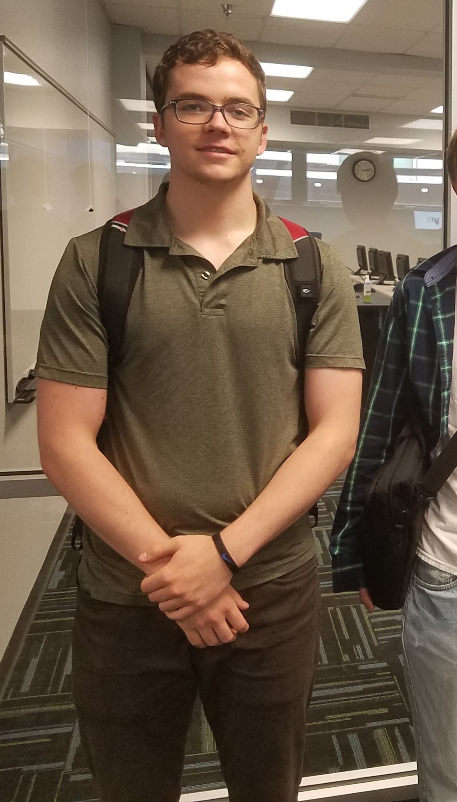

For the second project we were evaluating a code based on a fictional tiny language. In my code I had created functions for the different requirements. After reviewing the code to the book I realized that I had the correct logic, however I named my lex and tokens as pos and factors. I used this alternative naming convention because it made it easier for me to understand with my background, rather then reinventing the wheel and relearning the values in my head. One area that I know the code has problems with is using parenthesis. When it using parenthesis in an expression it will error out and loop until it returns max recursion depth. The interpreter will however work will all expression that do not use parenthesis and return the correct values based on the correct order of operations. The code values are passed down through the functions until a single number is returned from the expression function and will print a single number for each let statement. This assignment helped me learn more about the recursion of functions and will help improve my coding skills in the future. On top of that I will have another language, python, which I had no prior experience with before this class.

