**Minutu**

**Project Summary**

Provides students with the ability to leave a fine-grained feedback on the lecture and specific parts of the lecture linking it with the emotion they experience about it. From the other side, provide professors with the ability to see all the feedbacks and design their lectures according to it. They can also review some confusing concepts from the previous lectures or give more information about the class interest. The key concept which is different from similar systems is connecting a feedback with a specific emoji.

**Instruction**

1. Choose a course and a topic

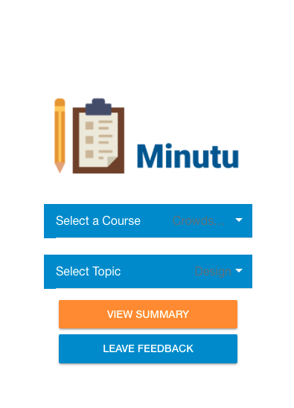

2. Now you can either view the summary of all the feedbacks given or write your own!

3. For your feedback, choose an emoji which describes your feeling about the topic most accurately

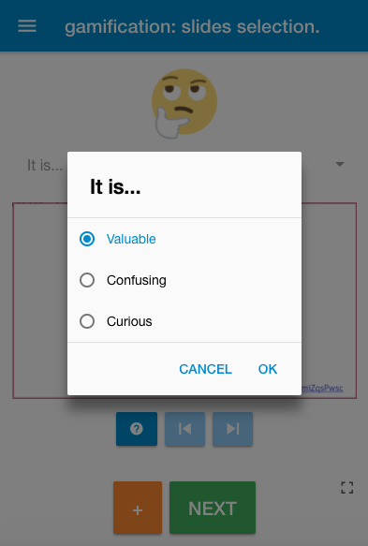

4. Give the feedback.

5. You can also add the slide and highlight something on it to make your feedback more specific

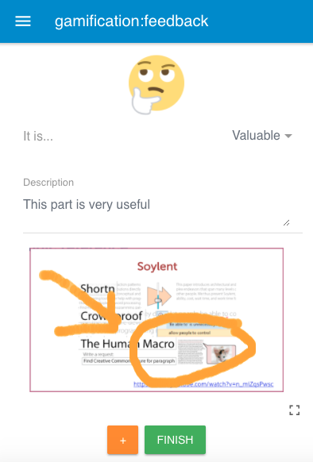

6. Read other students’ feedbacks. Upvote and Downvote it

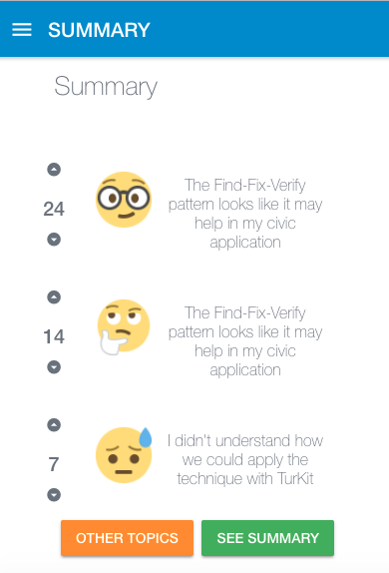

**Technical Description**

We developed minutu prototype with Ionic framework version 2. It is a framework based on Javascript and HTML & CSS. The API is a Ruby on Rails version 4 RESTful API. We chose Ionic because it gives us a convenient way to export applications that run natively on iOS and Android. For the emojis we used Open Source emojis provided by emojione.com and for implementing the functionality of drawing on top of PPT slides we have implemented HTML5 Canvas that with some CSS it looks like if you were drawing on top of the PPT slides. We would like to later develop a functionality that let us make a heat map of comments on presentations. We want to launch

**Prototype URL**

<http://minutu.noedominguez.com/>

<http://minutu.noedominguez.com:8100>

**Git URL**

<https://github.com/poguez/minutu>

<https://github.com/poguez/minutu-api>