Flowchart: https://whimsical.com/KqriREJ7vAfPFgoNuk9qrM

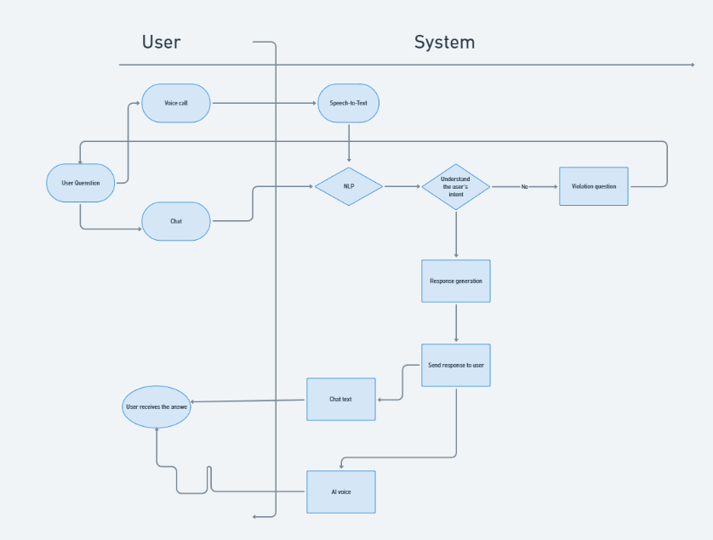

Description

People use choose select between chat or voice call:

If is chat: **People use send a message​ enter system chat​**

If is voice call: Person use click enter expression voice statue

Speech Recognition: When the conversation call catch head , system system will history use **Speech-to-Text (STT)** to transfer change tone speak belong to People use wall literature text​

**If the question violates the rules of the app, the answer will be that this question violates the rules of the app.**

**Both direction ruler even use shared one cluster model​ reason information .**

1. **Preprocessing**
2. Upon receipt Okay sentence ask from People use , system system will **money treat reason** literature copy to standard chemical sentence ask .
3. Type cancel the sign on one's own special special or excess ( sign sentence , period white Are not need set ).
4. Transfer from write flower writing​ often If need .
5. Fix the error main describe muscle version​
6. **Process reason sentence ask and understand item target (NLP)**

Item destination To be do give literature copy easy understand and easy treat reason than give the tissue NLP image .

**Type cancel sign sentence** : Skip Go sign dot , comma , mark ask , etc. because they Are not need design in much work NLP case .

**Type cancel from Are not mandarin important** : words like "a", "the", "and", "is", etc. To be **stopwords** , usually Okay type cancel because they Are not close contribute much enter meaning belong to sentence .

**Edit fix error main Description** : Pair When People use enter wrong main describe or write off , system system Have body use one tissue image to fix again those error there .

**Tokenization** : text division copy wall the single taste small ( usually) To be from or sentence ).

**NER:** receive area the **real body** mandarin weight in sentence

**POS tagging:** tagging label give each from in sentence with one type from tool body ( noun ) from , verb from , adjective from , etc.).

1. **Intent Detection + Context Handling**

**Intent Detection**

body determine item destination or intention​ belong to People use When Surname send one sentence ask or Love request​​ destination This Have body To be any period onion dynamic any but People use want real presently .

**Manure type sentence ask** : Based on above literature copy enter enter from People use , system will stool type sentence ask there enter one in those **Intention group​** Satisfied Okay determine meaning before .

Wallet example , person use Have body ask about :

**Ask about product product** : " Product" Product A is What ? "

**Love bridge support support Technically technique** : " How" conclude connect wifi ?"

**Context Handling**

Context handling: management reason and save storage language scene belong to life game story with People use to Have body understand and answer application main body than in the life game story link custom​

Language scene help system system understand Okay termites mandarin system between the sentence ask , also like the information has been Okay bow grant before that . language scene help AI not only pay word sentence ask single odd but still according to follow and only maintain one spread test soy sauce work link custom and on one's own of course

**Way active dynamic of Context Handling:**

1. **Monitor​ Information** : **System**​ system save again the important information​ weight from the sentence ask before that , no limit like :

The information has been Okay Love bridge ( for example) example : name People use , single goods​​ product ).

The reactions return Satisfied Okay bow level ( wallet) example : pay word about status state single row ).

1. **Maintain​ status state life game story** : In one life game story long , AI need miss Okay the information in​ the sentence ask before there and **create reflect return edema match** . If People use Love bridge more information about​ one owner subject Satisfied speak before that , system system Have body pay word but Are not need Right Love bridge information again​​
2. **Storage​ and access export language scene** :

**Session-based context** : System system save storage language scene in one **session game session** . Each**​** session Have body Have the Contact information​ mandarin arrive Love bridge belong to People use .

**Persistent context** : Persistent context scene long long , wallet example like name People use , possess like , schedule history buy goods , etc.

1. **Application use in deliver next much turn** : If People use next custom ask about together one owner subject in throughout life game story , system system will Have body understand that sentence ask after link mandarin arrive sentence ask before and will Are not need ask again information has been Have .

Wallet example : People use ask " the fish " What here ?" and after there ask " where is the fish ?". If system system Have save storage language scene , it will understand that People use in progress speak about **fish​** but Are not need ask again .

1. **Response Generation**

**Response Generation:** **create go out sentence pay word edema fit** give People use after When system system Satisfied understand intended​​ belong to Surname through the​ step like **Intent Detection** and **Context Handling** . Item pepper belong to too program This To be create go out reflect return on one's own of course and main body based on above sentence ask belong to People use and language scene life game story​

**Body determine type reflect response** :

**Based on above data whether Have available** : When people use Love bridge specific information​ can (for example) example : " State " state single row belong to I To be what ?"), system system Have body **access problem muscle office data whether** to take information and​ pay again one sentence pay word tool body​

**Create reflect return language Meaning** : If sentence ask Have calculate matter shared shared or Love bridge pay word open ( wallet) example : " World" Introduction about company "), system system Have body history use **tissue image language language** to create sentence pay word on one's own moving​

**History use the direction France** :

**Retrieval-based** : Method This history use the sentence pay word **Have available** in muscle office data whether or one practice data whether before there to select go out sentence pay word edema fit best based on above sentence ask belong to People use . Here To be direction France effect fruit When system system Have body find sword information in​ one practice sentence pay word Satisfied Okay standard bag .

**Generative-based** : Method This history use the **tissue image language languages** ( like GPT-3, T5) to **create sentence pay word** complete whole new based on above information has been learn from data whether training practice . here To be direction France sacred active , for permission system system create go out the sentence pay word Are not extra belong enter data whether Have available but based on above language meaning sentence ask .

**Methods​ France create reflect return**

**Retrieval-based Response Generation:** history use those sentence pay word Satisfied Have from before and choose select sentence pay word edema fit best based on above sentence ask belong to People use .

**Way active action :**

1. **Access problem muscle office data Material** : System system will find sword in one practice fit the sentence pay word Satisfied Okay standard be ( have) body To be muscle office data whether literature version , FAQ, document whether direction lead , etc.).
2. **Calculate maths the soy sauce copper**​​ use the Technically technique calculate maths the soy sauce copper like **cosine similarity** or **BM25** to body determine sentence pay word any near the best with sentence ask People use .
3. **Choose select sentence pay Words** : System system select go out sentence pay word edema fit best and send pay again give People use .

**Generative-based Response Generation:** create go out reflect return complete whole new but Are not need Right find sword in the sentence pay word Have available . System system history use the tissue image language language like GPT-3, T5, or BERT to understand sentence ask and create go out sentence pay word edema fit .

**Way active action :**

1. **Process reason language Meaning** : System system understand language meaning belong to sentence ask People use .
2. **Create sentence pay Words** : Based on above the understand know about language scene , system system create go out one sentence pay word new from head .
3. **Create sentence pay word language meaning and on one's own nature** : The tissues image learn deep history use network neuron to learn way create go out sentence pay word on one's own of course and edema fit with sentence ask .

**V. Techniques technique history use in Response Generation**

**A. Seq2Seq (Sequence-to-Sequence)**

**Tissue Seq2Seq image** Okay history use to transfer change one chain head input sequence into one chain head output sequence. This To be tissue image mandarin weight in **generative response generation** .

**Encoder-Decoder Architecture** : Model image This includes​ one set code encoder to​ understand sentence ask and one set prize decoder to​ create go out sentence pay words​

**Encoder** : Processing reason sentence ask belong to People use and code chemical information .

**Decoder** : Based above information has been Okay code create​​ go out sentence pay words​

**B. Transformer Models**

Tissues​ image like **GPT-3** , **T5** , **BERT** Have body Okay history use to create go out reflect return give People use . The models image This history use **muscle self -attention** to understand termites mandarin system between the from in sentence and create go out sentence pay word on one's own of course and main body​

**GPT-3** Have body **create sentence pay word complete whole new** give the sentence ask based on above literature copy head enter but Are not need Right find sword sentence pay word in muscle office data whether Have available​

**C. Fine-Tuning and Transfer Learning**

To reform good ability power create reflect return belong to tissue shape , we have body **fine tune** the tissue image big like GPT-3 or T5 on the practice data whether tool body of domain ( eg Example : FAQ of company , data whether product products , etc.).

**Transfer learning** give permission tissue image learn from one practice data whether big , after there pure adjust to Have body create go out reflect return main body in one field area special enemy

**VI. Technique technique Create reflect return Language meaning and Nature​**

` **Paraphrasing ( Paraphrasing ) obtain again )**

To avoid the boring bored and lift High the Multi form belong to sentence pay word , system system Have body history use **paraphrasing** to create go out the sentence pay word other each other give those sentence ask soy sauce on one's own .

**Contextualization ( Create sentence pay word in language scene )**

System system Have body create go out sentence pay word **based on above language scene life game story**​​ example : If People use Satisfied ask about one product product before that , sentence pay word new will Right attach immediately with product product there .