Name Do this individually.

Create a matrix diagram plots.

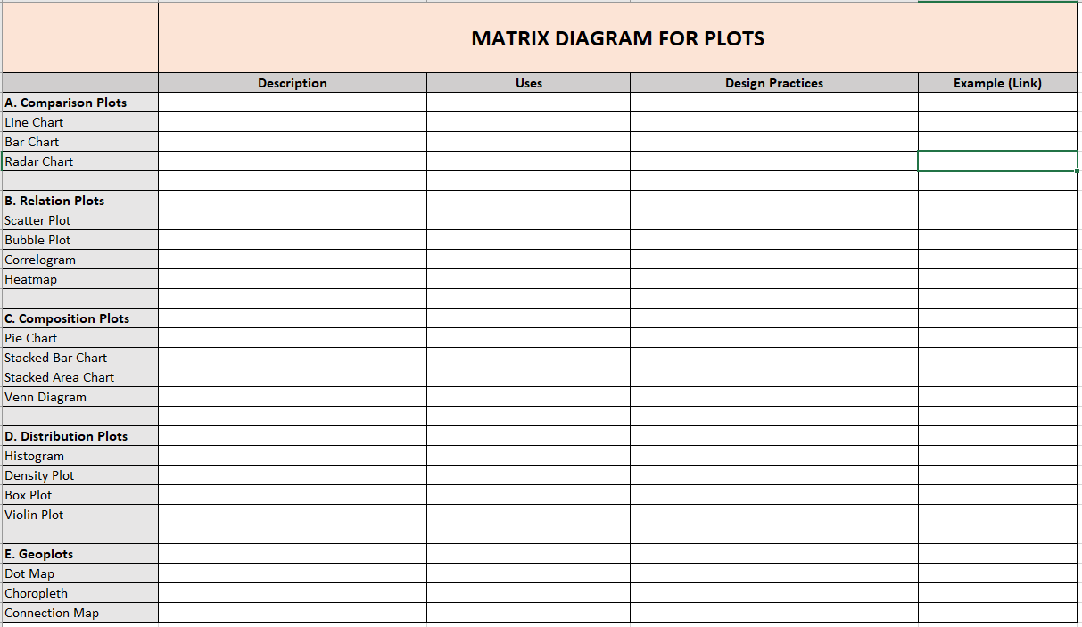

Laboratory Exercises #4 Matrix Diagram Plots