高等影像處理

**作業四: 影像卷積運算:平滑化與邊緣偵測**

1. 請於作業一的程式中加入一個新的卷積運算功能，可進行影像平滑化(image smoothing)以及邊緣偵測(edge detection)等效果，並將程式執行檔名稱改為“HW4學號.exe”。
2. 主視窗請命名為 “AIP+學號”。
3. 輸入的影像為灰階影像，輸出則為卷積運算後之影像，輸出之影像可能分別會有影像平滑化以及邊緣偵測等效果。範例如附件所示。影像平滑化與邊緣偵測需由使用者輸入不同的convolution masks，大小至少為5X5 pixels (也可以由使用者自訂)。
4. 本作業convolution的函式需自己撰寫，不可以採用其他人的程式碼。
5. 程式語言限C、C++、C#、Python與JAVA系列(若用其他語言需事先告知並酌量扣分)，但作業繳交時必需編譯成EXE檔且在沒有COMPILER的情況下亦能執行。
6. 程式需可選擇要輸入的檔案名稱並自動利用附檔名判斷影像格式以及影像大小，界面設計需符合要求。

卷積運算

…

檔案

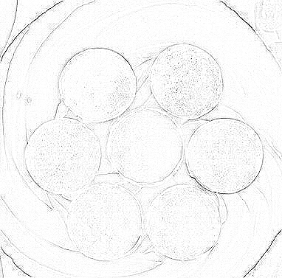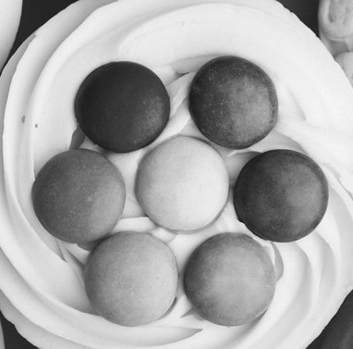

1. WORD報告內容需說明程式功能，程式流程或演算法，測試結果以及程式撰寫心得。
2. 報告格式請參閱公告欄中之[Template of program homework report (程式作業報告格式範本)](https://moodle3.ntnu.edu.tw/mod/resource/view.php?id=461277)。
3. 內容至少為A4二頁，最多為A4四頁。
4. 內容文字需為12點字，單行間距，標楷體。
5. 測試結果(請附至少四組畫面截圖，二組做影像平滑化，二組做邊緣偵測，並說明附對應的convolution masks)。
6. 程式撰寫心得(至少100字)。
7. 本作業請於10月15日晚上10時前上傳至MOODLE中，包括一個你撰寫的程式原始碼檔案“HW4學號.XXX”(不含其他程式庫)、一個程式執行檔“HW4學號.exe”(或程式執行檔的連結)、一份pdf檔報告“HW4學號.pdf”。

Advance Image Processing

**Homework 4: Convolution: Image smoothing and edge detection**

1. Please add one convolution function in HW1, which can do image smoothing and edge detection respectively using different convolution masks. Compile it to an execution file named “HW4student_number.exe.”
2. The program should obtain the input convolution mask by users and be coded by yourself. The size of masks should be at least 5X5 pixels. These masks should be shown in your report with their corresponding convolution results.
3. The inputs of the function are the gray-level image. The output is the convolution result using the selected masks. The following example is one of the edge detection result.
4. The inputs of the function are the gray-level image. The outputs should include the results of histogram equalization and their corresponding histograms.
5. An example of the user interface:

**Convolution**

…

**File**



1. The report should include project topic, programming language and compiler, the main functions of the program, the flowchart of the program, testing results, and discussion (learning experience).
   1. The format is shown in “[Template of program homework report](https://moodle3.ntnu.edu.tw/mod/resource/view.php?id=461277).”
   2. At least A4 2 pages, no more than 4 pages.
   3. 12 point text, single line spacing, times font type.
   4. Testing results should be more than 4 examples (two examples for image smoothing and two examples for edge detection) and their corresponding convolution masks.
   5. Learning experience should be more than 100 words.
2. This homework should be uploaded to https://moodle3.ntnu.edu.tw/ before 15/10/2023 10 PM, including one source code file, one executable file (or a link point to the executable file), and one report pdf file.