# Scientific Visualization Homework1

61247001S 蕭瀜

1. 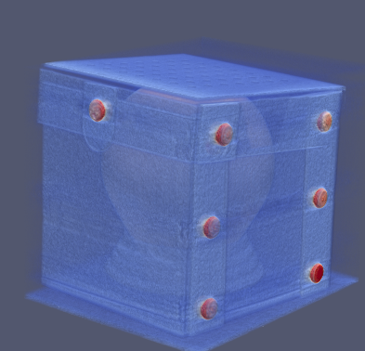There is another box in the present box.
2. 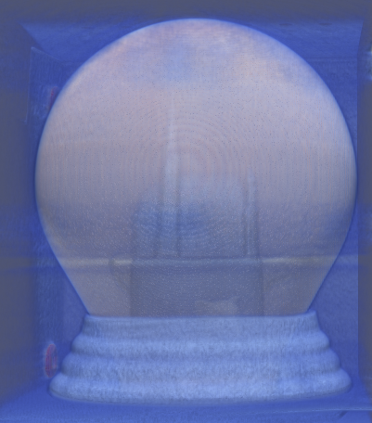There is a lamp or a snow globe in the box.
3. 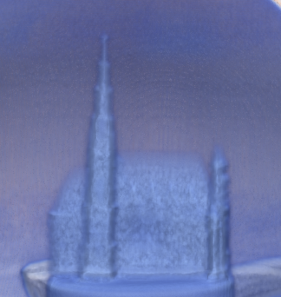There is a church in the the lamp.
4. 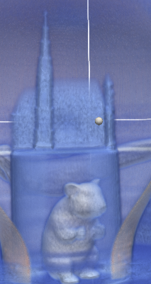There is a rat in a cup which under the church.
5. 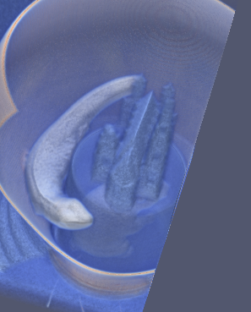There is a fish surround by the church.