CSE 305 SOFTWARE ENGINEERING MIDTERM PROJECT

4-PRODUCT BACKLOG

DUE DATE (20/11/2020)

181805080 ANIL DURMAZ

Team Name : SoftTouch

Project Title : KaraokeNight (Website Project)

SoftTouch Members

Anıl Durmaz 181805080

Betül Başan 181805028

Betül Şahin 201805002

Ferhat Kamalı 171805056

|  |  |  |  |  |  |  |  |  |
| --- | --- | --- | --- | --- | --- | --- | --- | --- |
| User Story with Pre- and Post Conditions | | | | | | | | |
| **Use case ID** | **which user stories came from which epic** | **Sprint**  **1**  **2**  **3** | **Estimate** | **Use case name** | **User story** | **Pre-condition** | **Standard flow** | **Post condition** |
| 1 |  | 2 | 5 | Login | As a site admin, I can login the admin panel so I can make some changes in site. | - | 1- Admin opens the admin panel and admin enters “username” and “pasword”  2- The system queries the user name and password information from DB  3- If the information is correct. Admin can enter the administration panel. | Admin logged in |
| 2 |  | 3 | 5 | Add Comment | As a site visitor, I can post comments about contents so that others can read them. | Comment section exist on the sytem | 1- A site visitor writes a comment in the empty textbox where is bottom of the homepage.  2- And click the “Add comment” button and the sytem saves the comment in DB.  3- The site admin check the the comment for 3 days.  4- If there is nothing innapproiate in the comment, the comment is published. | System added comment |
| 3 |  | 1 | 3 | View Homepage | As a site visitor, I can look at the about, and other menus links on the home page so that I learn about the Karaokenight. | - | 1- A visitor click on “Home” tab or the web site logo and the homepage opens. | Homepage viewed |
| **4** | View Content Pages  **(Epic)** | 1 | 2 | View Drinks | As a site visitor, I can look at the drinks and their prices on the drinks so that I learn about the Karaokenight drinks prices. | Drinks options exist on the system | 1- A vistor click “Drinks” button on “homepage” and the html extension page that has dirinks opens. | Drinks  options  viewed |
| **5** | 1 | 2 | View Menu | As a site visitor, I can look at the foods and their prices on the drinks so that I learn about the Menu. | Menu options exist on the system | 1- A vistor click “Menu” button on “homepage” and the html extension page that has menus opens. | Menu  options  viewed |
| **6** | 1 | 2 | View Rooms | As a site visitor, I can look at the rooms on the rooms menu so that I can see the rooms. | Rooms types exist on the system | 1- A vistor click “Rooms” button on “homepage” and the html extension page that has rooms opens. | Rooms  types  viewed |
| **7** | 1 | 2 | View  Photo Gallery | As a site visitor, I can look at the photos so that I can see atmosphere of the place. | Photo Gallery exist on the system | 1- A vistor click “Photo Gallery” button on “homepage” and the html extension page that has rooms opens. | Photos  viewed |
| **8** | 1 | 2 | View Events | As a site visitor, I can see a list of all upcoming “Events” so I can decide if I want to attend any. | Events exist on the system | 1-A vistor click “Events” button on “homepage” and the html extension page that has events opens. | Events viewed |
| **9** | Edit Comments  **(Epic)** | 3 | 2 | Delete comment | As a site admin, I can delete comments so that any improper comments. | -Login as a admin  -Comments exist on the system | 1- A site admin nt” button on her/his own comment.  2- The system delete the comment from DB. | Comment deleted |
| **10** | 3 | 2 | Update  Comment | As a site visitor, I can edit comments so that any problem about comments. | Click on “edit comment” button. | 1- The vistor click “Edit Comment” button on her/his own comment.  2- The visitor write new her/his own comment.  3- The visitor click “Add comment”.  4- The old comment of the visitor in DB is replaced by the system with her/his new comment. | Click on “Update comment” button. |
| **11** | Redesign Pages  **(Epic)** | 3 | 2 | Edit Photos | As a site admin, I want to be able to edit all of photos that are on website. | Login as a admin | 1- A site admin clicks on “edit photos” button where is on admin panel.  2- The admin selects  any of the photos where are on website.  3- The admin clicks on “change”, “delete” or “add” button. If the admin clicks on “change” or “add” button, the admin have to select a new photo from PC.  4- The photo that is seleted is changed, deleted or added by the system. | Click on “Ok” Button |
| **12** | 2 | 8 | Edit Content | As a site admin, I want to be able to edit all of contents that are on website. | Login as a admin | 1- A site admin clicks on “edit Content” button where is on admin panel.  2- The admin selects  any of the contents where are on website.  3- The admin clicks on “change”, “delete” or “add” button. If the admin clicks on “change” or “add” button, the admin have to create a new content.  4- The content is changed, deleted or added by the system. | Click on “Ok” Button |
| **13** | 3 | 2 | Change Website Logo | As a site admin, I want to be able to change the website logo that is on website. | Login as a admin | 1- A site admin clicks on “edit Logo” button where is on admin panel.  2- The admin selects a new logo from PC.  3- The admin click on “ok” button.  4- The logo is changed by the system. | Click on “Ok” Button |

Total estimate is 39. We have 3 sprint. We are doing 13 every sprint.

|  |  |  |  |
| --- | --- | --- | --- |
| **Sprint #1** | **Use Case ID** | **Use Case Name** | **Estimate** |
| 3 | View Homepage | 3 |
| 4 | View Drinks | 2 |
| 5 | View Menu | 2 |
| 6 | View Events | 2 |
| 7 | View Photo Gallery | 2 |

User Interface Sketches of our design

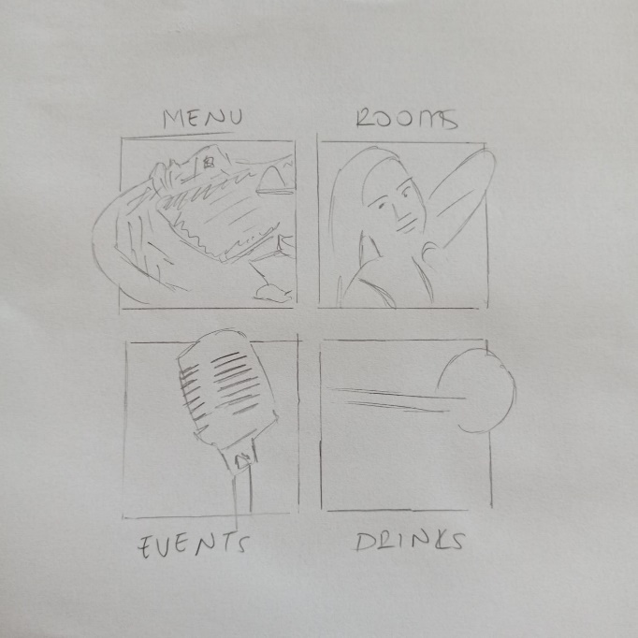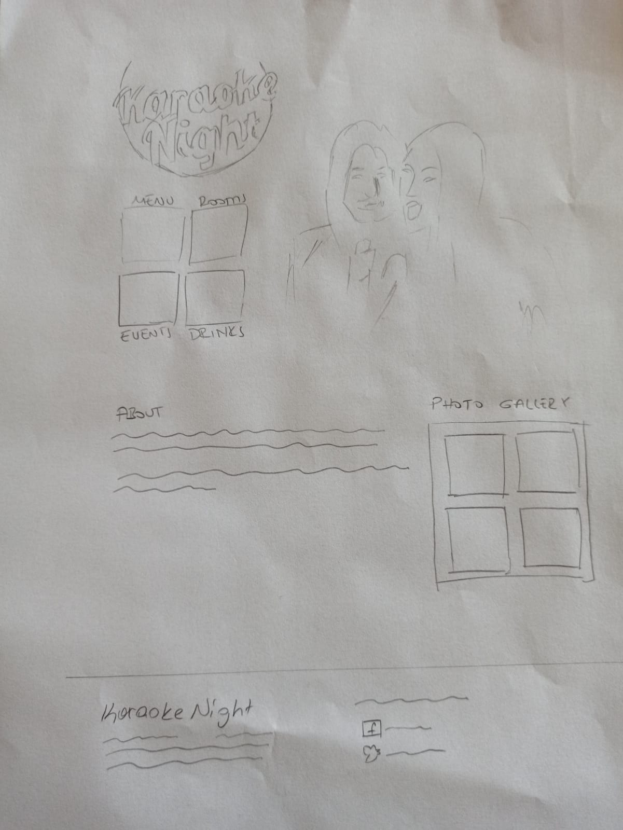Homepage