**KaraokeNight** **SoftTouch Members :**

* Anıl Durmaz 181805080
* Betül Başan 181805028
* Betül Şahin 201805002
* Ferhat Kamalı 171805056

Drinks Page

* View Drinks
* View Menu
* View Rooms
* Photo Gallery
* View Events

User Story Names

**Main Companent of The System**

Home Page

Menu Page

Room Page

Admin Page Page

Photo Gallery

Events Page

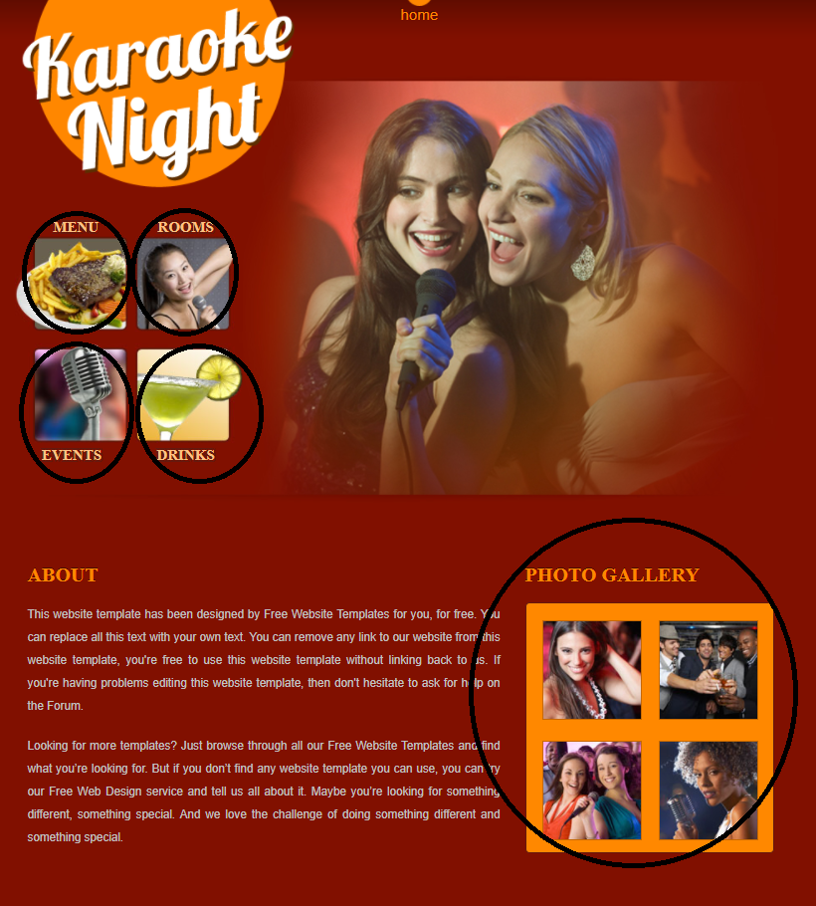

**View Content Pages (Epic)**

* Delete comment
* Update Comment
* Add Comment
* Edit Photos
* Edit Content
* Change Website Logo

**Medium**

**Low**

**Hight**

Priority :

**Redesign Pages (Epic)**

**Edit Comments (Epic)**

**Login**

**View Homepage**

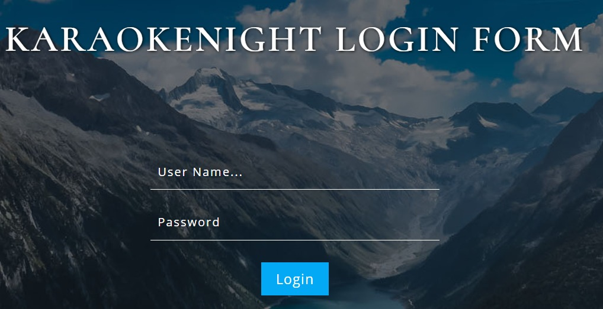

|  |  |
| --- | --- |
| Sprint Name | Due Date |
| 1.Sprint (User Interface) | **29/12/2020** |
| 2.Sprint(Management Interface) | **05/01/2021** |