CSE 305 SOFTWARE ENGINEERING MIDTERM PROJECT

USER MANUEL

181805080 Anıl Durmaz

Team Name : SoftTouch

Project Title : KaraokeNight (Website Project)

SoftTouch Members

Anıl Durmaz 181805080

Betül Başan 181805028

Betül Şahin 201805002

Ferhat Kamalı 171805056

Content

INTRODUCTION …………………………………………………………………………………………………………………………………3

1. ADMIN PANEL…………………………………………………………………………………………………………………….….4

A.1. Access Admin Panel………………………………………………………………………………………………………..4

A.1.1. Log in…………………………………………………………………………………………………………………….4

A.1.2. Go to User Interface……………………………………………..………………………………………………4

A.1.3. Log out…………………..……………………………………………………………………………………………..4

A.2. Folder Structure and View………………………………………………………………………………………………5

A.3. Editing Content ………………………………………………………………………………………………………………6

A.3.1. Upload New Content…………………………………………………………………………………………….6

A.3.1.1. Drinks……………………………………………………………………………………………………....6

A.3.1.1. Menu…………………………………………………………………………………………………..…..7

A.3.1.1. Rooms………………………………………………………………………………………………….…..8

A.3.1.1. Events…………………………………………………………………………………………….………..9

A.3.1.1. Photo Gallery………………………………………………………………………………………….10

A.3.2. Delete Content………………………………………………………………………………………...…………11

A.3.3. Update Content………………………………………………………………………………………………..…12

A.4. Editing Comments…………………………………………………………………………………………………..…….13

A.4.1. Delete Comments……………………………………………………………………………………………….13

A.4.2. Update Comments………………………………………………………………………………………………13

1. USER INTERFACE………………………………………………………………………………………………….………………14

B.1. Homepage…………………………………………………………………………………………………………..………..14

B.2. Content Pages……………………………………………………………………………………………………………….15

B.2.1. Drinks………………………………………………………………………………………………………………….15

B.2.2. Menu…………………………………………………………………………………………………………………..15

B.2.3. Rooms…………………………………………………………………………………………………………………15

B.2.4. Events…………………………………………………………………………………………………………………16

B.2.5. Photo Galllery……………………………………………………………………………………………………..16

B.3. Add Comments…………………………………………………………………………………………………………..…17

Introduction

Karaoke bars are one of the places people often go to have fun. We designed a website for a karaoke bar called ‘Karaoke Night’ for our project.

Objectives

* To make it easier for people to learn about karaokenight
* To provide users to access location and contact information about the place
* To enable users to see the options in the karaoke bar
* Provide a web interface for users

Target Customers

Students and also people in that area who love to have fun.

Its Overall Functionality

Website Features and Description

The users of the site can easily access our site at http://karaokenight.com/

1. Users, can learn the prices and types of food and beverages in the menu and drinks section on the site
2. Users can get information about the place from the About us section
3. Users can see the different options in different rooms and the number of capacity for which room from the rooms section
4. Users can look at the events that took place before and look at them, organize their own activities
5. In the photo gallery section, they can see the fun moments of people who have come to the venue before.
6. They can access communication options such as social media, e-mail and phone numbers and the location of Karakokenight from the contact section at the bottom.
7. ADMIN PANEL

A.1. Access Admin Panel

A.1.1. Log in

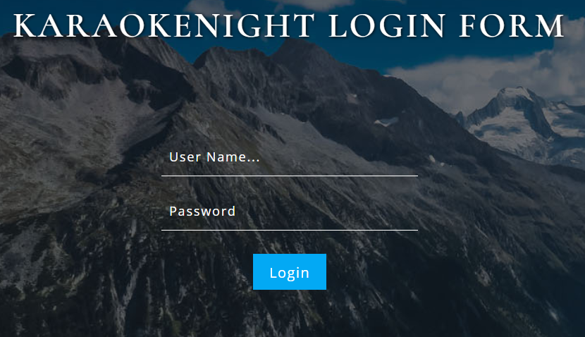

Enter your login and password into the login mask.

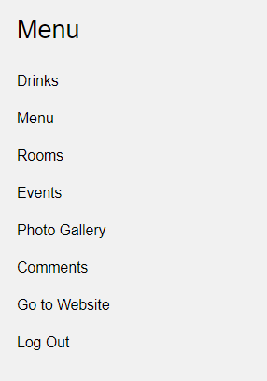

A.1.2. Go to User Interface

Click Go to Website button to return to the user interface.



A.1.3. Log out

Click logout button to return to the login mask.

NOTE

Always log out correctly using the logout button. Do not simply close the window.

A.2. Folder Structure and View

Drinks folder should be used as a repository of all drink pages.

Menu folder should be used as a repository of all menu pages.

Rooms folder should be used as a repository of all room pages.

Events folder should be used as a repository of all event pages.

Photo Gallery folder should be used as a repository of all images.

Comments folder should be used as a repository of all comments.

A.3. Editing Content

A.3.1. Upload New Content

A.3.1.1. Drinks

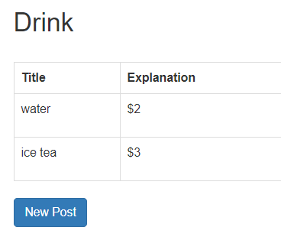

C:\Users\Aurora\AppData\Local\Microsoft\Windows\INetCache\Content.Word\newpost.jpgIn order to create a content click on add new post icon.

The dialogue window will open.

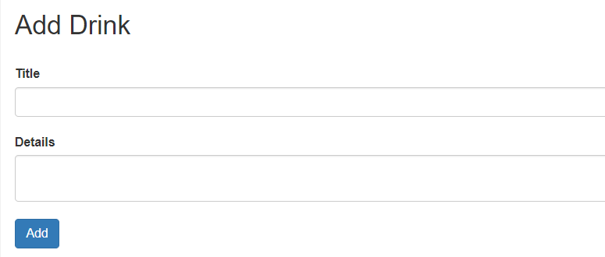

Here you can:

1. Enter title of new entry
2. Enter additional information in description field
3. Clicking on [Add] confirms your input and you return to the list view.

A.3.1.2. Menu

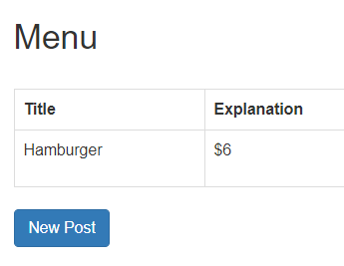

C:\Users\Aurora\AppData\Local\Microsoft\Windows\INetCache\Content.Word\newpost.jpgIn order to create a content click on add new post icon.

The dialogue window will open.

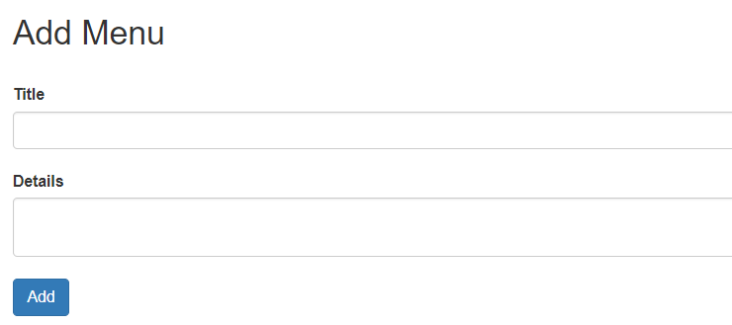

Here you can:

1. Enter title of new entry
2. Enter additional information in description field
3. Clicking on [Add] confirms your input and you return to the list view.

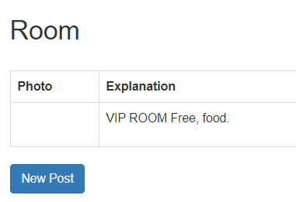A.3.1.3. Rooms

C:\Users\Aurora\AppData\Local\Microsoft\Windows\INetCache\Content.Word\newpost.jpgIn order to create a content click on add new post icon.

The dialogue window will open.

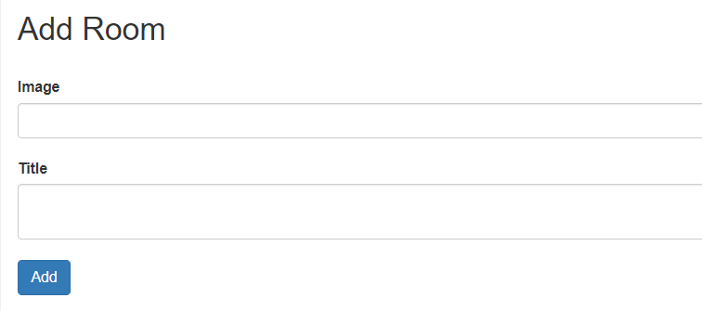

Here you can:

1. Enter image about room type
2. Enter title and additional information of new entry
3. Clicking on [Add] confirms your input and you return to the list view.

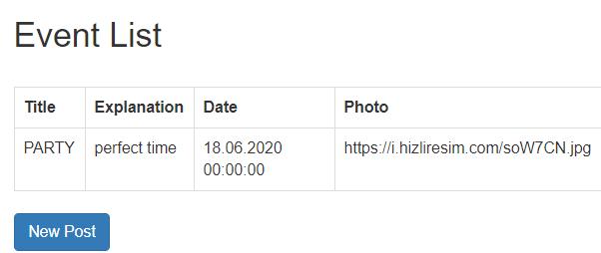A.3.1.4. Events

In order to create a content click on

C:\Users\Aurora\AppData\Local\Microsoft\Windows\INetCache\Content.Word\newpost.jpg add new post icon.

The dialogue window will open.

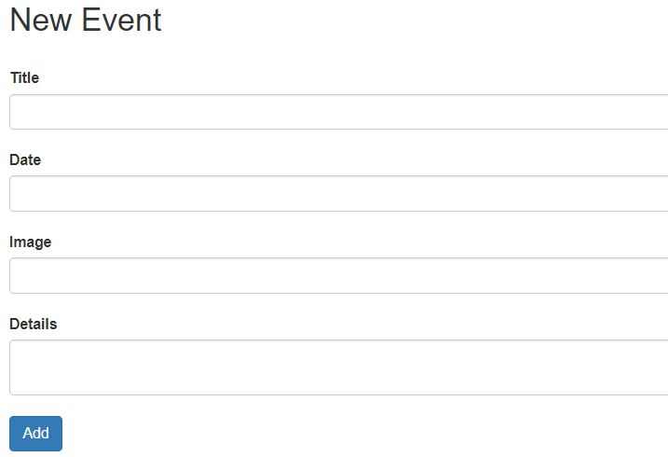

Here you can:

1. Enter title of new entry
2. Enter date of event
3. Enter image about the event
4. Enter additional information in description field
5. Clicking on [Add] confirms your input and you return to the list view.

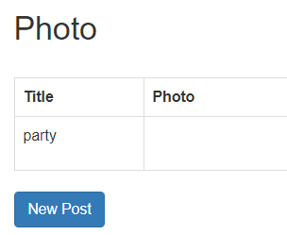A.3.1.5. Photo Gallery

C:\Users\Aurora\AppData\Local\Microsoft\Windows\INetCache\Content.Word\newpost.jpgIn order to create a content click on add new post icon.

The dialogue window will open.

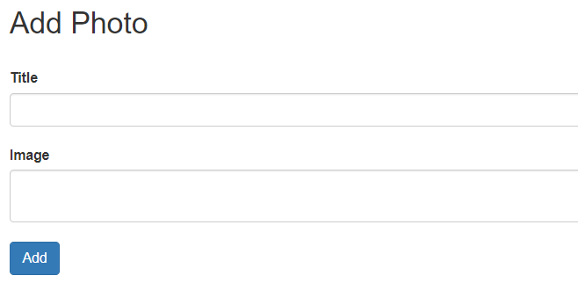

Here you can:

1. Enter title of new entry
2. Enter additional information in description field
3. Clicking on [Add] confirms your input and you return to the list view.

A.3.2. Delete Content

Clicking on [Delete] confirms deleting and you return to the list view.

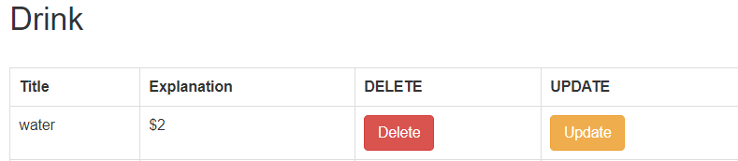

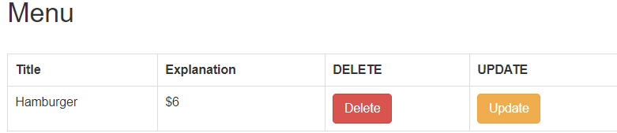

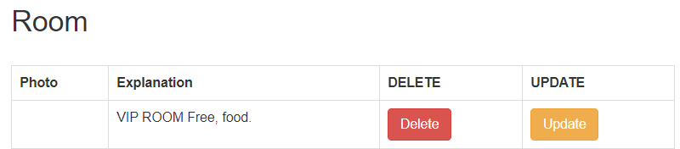

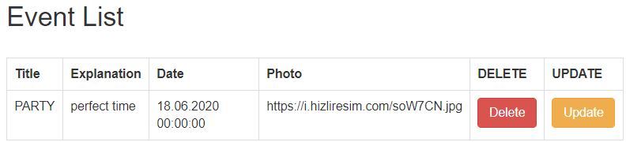

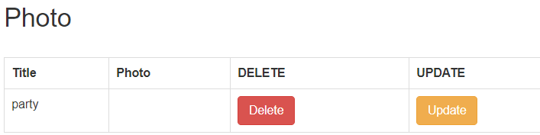

A.3.3. Update Content

 Clicking on [Update] confirms deleting and you return to the update page.









A.4. Editing Comments

A.4.1. Delete Comments

Clicking on [Delete] confirms deleting and you return to the list view.

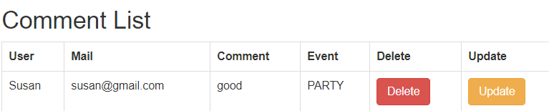

A.4.1. Update Comments

Clicking on [Update] confirms deleting and you return to the update page.

1. USER INTERFACE

B.1. HOMEPAGE

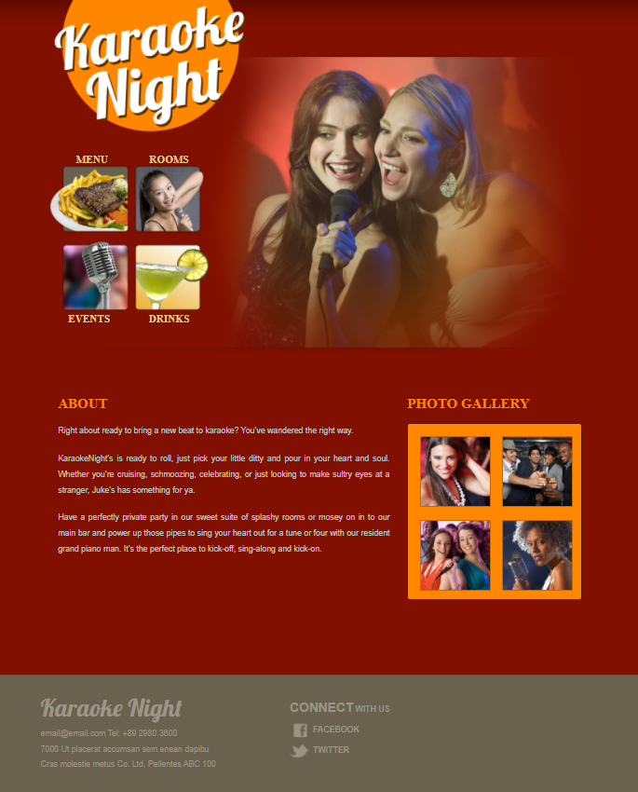

Drinks icon should be used as a repository of all drink pages.

Menu icon should be used as a repository of all menu pages.

Rooms icon should be used as a repository of all room pages.

Events icon should be used as a repository of all event pages.

Photo Gallery icon should be used as a repository of all images.

About part should be used giving information about KaraokeNight.

Footer part should be used to find out the contact details of KaraokeNight.

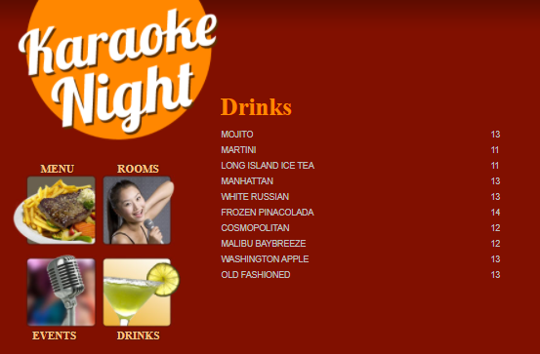B.2. CONTENT PAGES

B.1.1. Drinks

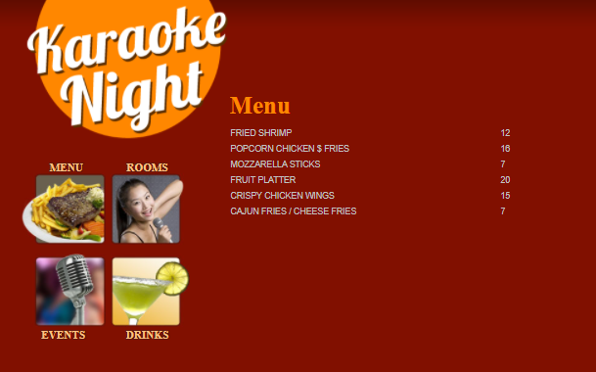

B.1.2. Menu

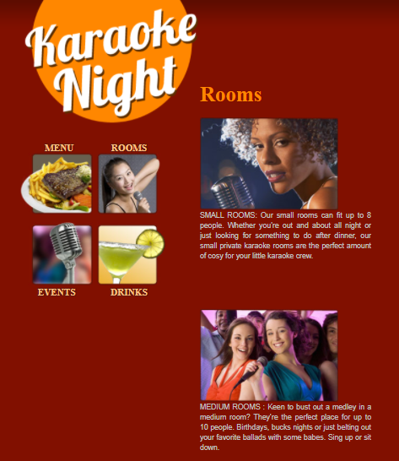

B.1.3. Rooms

B.1.4. Events

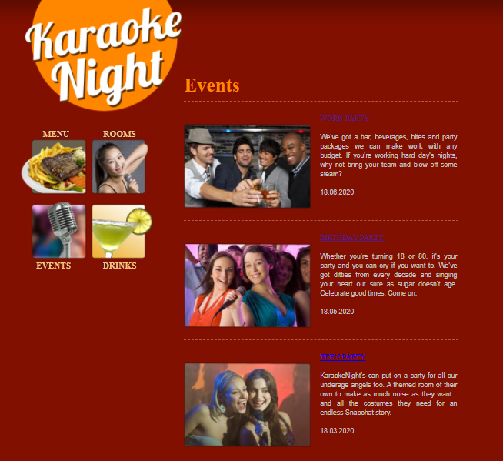

B.1.5. Photo Gallery

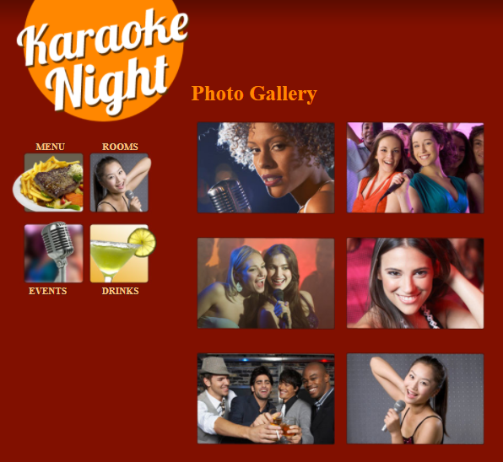

B.3. ADD COMMENTS

You can add comment Events detail page.

Here you can:

1. Enter your name
2. Enter your mail
3. Enter your messagge
4. Clicking on [SEND] confirms your input and you return to the event page again.

