Upgrade
RPMS software from V3.2 to V3.2x

Step 1 | Backup your RPMS software (refer manual) *recommend new backup disk. After backup check disk to ensure it has a file similar to “RPymmdd” e.g., “RP01001”.
Step 2 | After you are happy backup completed - Double Click on “My Computer”
Step 3 | Place RPMS Upgrade Floppy disk in drive
Step 4 | Double Click Drive A: (Files will be displayed).
Step 5 | In the A:\ window - Double click “Upgrade”
Step 6 | Upgrade Program starts – Click on “Upgrade to V3.2x”
Step 4 | Click on UNZIP (Observe files being copied).
Step 5 | Double Click on A:\
Step 6 | Double click on “Upgrade” – This will update your database to latest editions.
Step 7 | You will be asked to click OK during installation.
Step 8 | Answer ‘Y’ for yes to overwrite existing files (you may have to do this several times).
Step 7 | After update completed - Start RPMS software as normal
Step 8 | Goto File then Owner, type in your full Federation name (note: this is because the upgrade has cleared this field).
Step 7 | Check to ensure all is working fine, observe the new reports in the “Reports” module. This upgrade includes additional features requested by users and changes as detailed below.
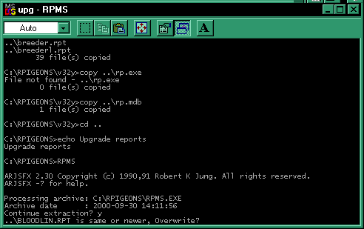  Step 8 | Give yourself a pat on the back for a job well done!

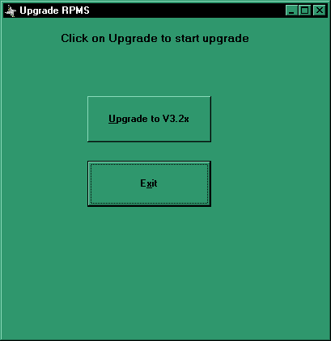

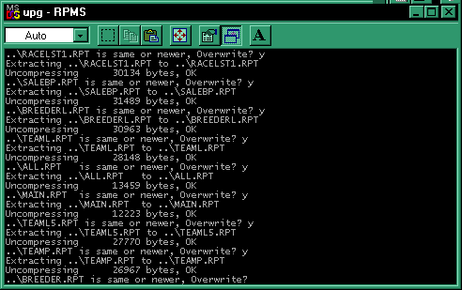
Upgrade
New Reports | - Report of current birds by Pen/cage  - Report of user selectable birds with Notes  - New Team report in Landscape ideal for Breeder Plate bird listing.
New Race sheet styles | Now 10, specifically QPF & Tasmania
Report enhancements | Miscellaneous enhancements to majority of reports, larger fonts etc.
Results report | Will sort in order as requested for screen sort.
Bug Fixes | When owner details changed didn’t use until program exited then started again – FIXED.
 | When race point added it was not available to use until exit program and start again – FIXED.
 | Sort order for ring nos relied on the entry of leading zeros. Now does standard numeric sort then alpha sort – FIXED

