SWE 573
Software Development Practice
Fall 2025
Final Project Report

The Hive

Kenan Onur Altunbaş
December 19, 2025

Deployment URL:
https://thehivefrontend-f8d6o.ondigitalocean.app/
Git Repository:
https://github.com/kj-kenan/SWE573-Kenan-s-Repo
Git Tag Version
https://github.com/kj-kenan/SWE573-Kenan-s-Repo/releases/tag/v0.9

HONOR CODE
Related to the submission of all the project deliverables for the SWE 573 Fall 2025 semester project reported in this report, I Kenan Onur Altunbaş declare that:
- I am a student in the Software Engineering MS program at Bogazici University and am registered for SWE 573 course during the Fall 2025 semester.
- All the material that I am submitting related to my project (including but not limited to the project repository, the final project report, and supplementary documents) have been exclusively prepared by myself.
- I have prepared this material individually without the assistance of anyone else with the exception of permitted peer assistance, which I have explicitly disclosed in this report.

Kenan Onur Altunbaş

TABLE OF CONTENTS

1. Test Credentials
2. Design Documents
3. Project Overview
4. Software Requirements Specification
5. Status of Project Requirements
6. Status of Deployment
7. Full Installation Instructions
8. User Manual
9. End-to-End Use Case Demonstration
10. Test Plan and Results
11. Third-Party Software and AI Usage Declaration
12. References

1. Test Credentials
The following test accounts are available for evaluating the deployed system:
Username | Password
fikretbaker | Ilovespace
adnanpekdemir | Ilovespace
elifbee | iliketoshare
keremeco | hive2025
denizfit | hive2025
onurfoto | hive2025
All test accounts have verified email addresses.

2. Design Documents

2.1 Mock-up Design
Log-in Page:
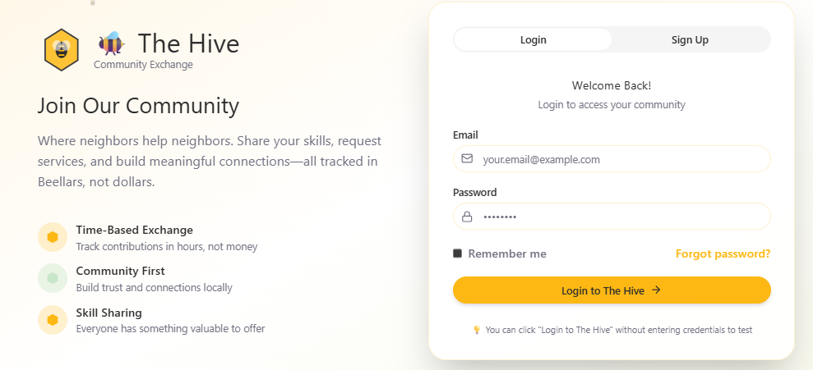
Main Page:
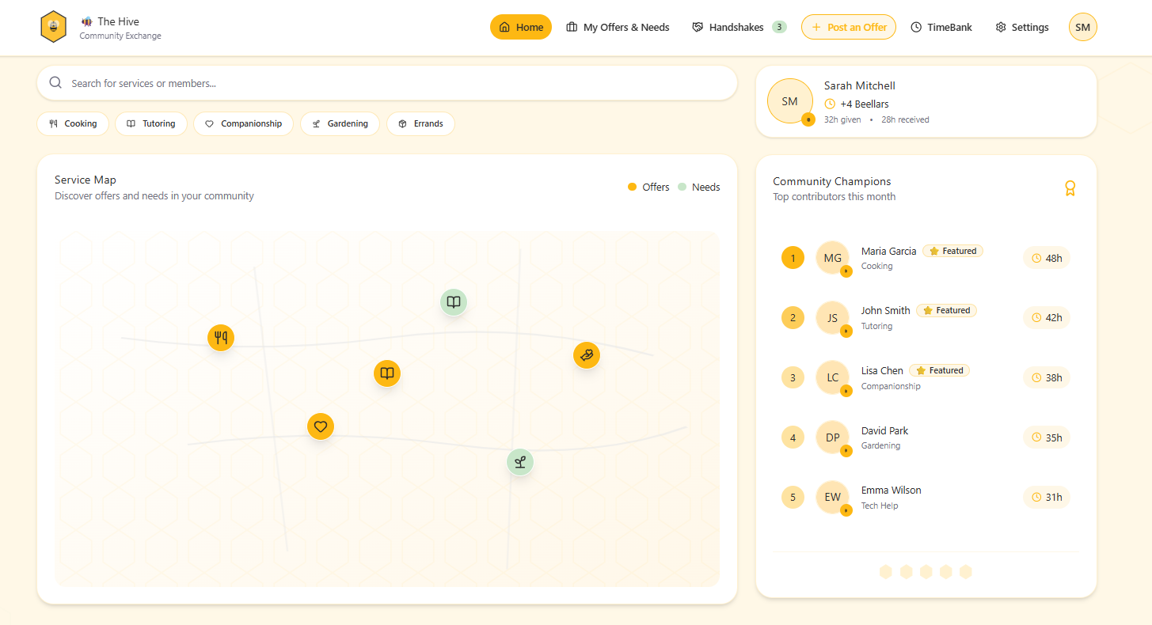

Handshakes Page:

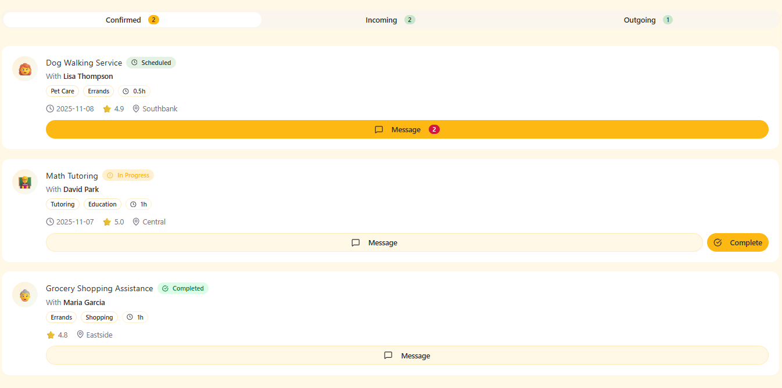
TimeBank Page:
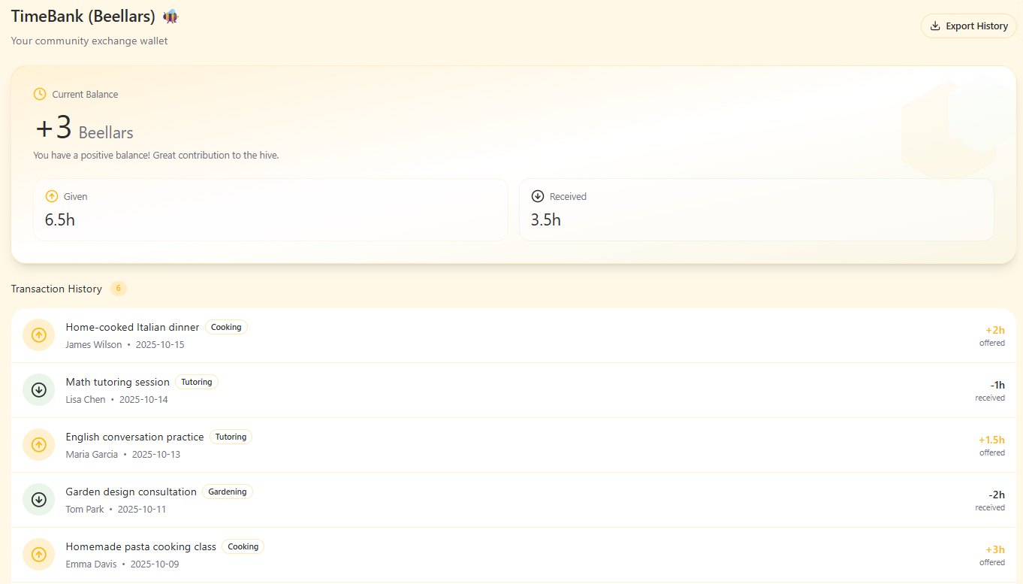

3. Project Overview
The Hive is a community-oriented service exchange platform that enables local community members to meet through non-monetary, time-based interactions. Users can express both their needs and what they are willing to offer, discover relevant opportunities within their community, and connect through a mutual exchange model rather than financial transactions. By focusing on trust, reciprocity, and accessibility, The Hive aims to provide a structured and simple way for people to help each other using their skills, knowledge, and time.

3.1 Core Problem Statement
In everyday life, people often have needs they cannot easily fulfill and things they would like to offer to others and maybe find people for their casual needs but there is no practical way to connect the right people. Such exchanges usually depend on chance, personal networks, or awkward interactions, while most existing platforms turn them into paid services. The Hive aims to provide a simple and trusted way for people to express their needs and offers and meet through community-based exchange rather than money.

3.2 Target Users
The Hive is designed for local community members seeking non-monetary service exchange opportunities within their geographic area.

4. Software Requirements Specification

4.1 Introduction

4.1.1 Purpose
Define functional and non-functional requirements for The Hive — an open, community-oriented service exchange platform using a TimeBank model ("beellars"). Audience: developers, maintainers, and moderators.

4.1.2 Scope
The Hive lets members post Offers/Requests, discover nearby opportunities via an interactive Service Map, match via a mutual Handshake, message, and settle transfers in beellars (1 hour = 1 credit). No commercial payments or ads. Focus: reciprocity, safety, and accessibility.

4.1.3 Definitions, Acronyms, Abbreviations
- Provider / Seeker: Roles in an exchange (a user may be both)
- Offer / Request: Listings to give or receive help
- Handshake: Mutual acceptance forming a planned exchange
- TimeBank (beellars): 1 hour service = 1 credit
- Service Map: Map view of Offers/Requests with privacy controls
- The Commons: Community forum outside individual listings
- Badge: Profile recognition for milestones

4.2 System Constraints
- The system must be developed using Django for the backend and React for the frontend
- The database must use PostgreSQL for data storage
- The platform must run in a Dockerized environment for deployment consistency
- All communication between frontend and backend must occur via RESTful APIs
- User authentication must follow JWT standards for security
- The system must support responsive design for desktop and mobile devices
- The application must operate within the hosting provider's free-tier resource limits
- Only authenticated users can create or edit offers and needs

4.3 Functional Requirements

4.3.1 User Management
- The system shall allow new users to register with a unique username and password
- The system shall verify user credentials during login
- The system shall prevent duplicate usernames during registration
- The system shall authenticate users using JWT-based tokens
- The system shall allow users to edit their profile information (bio, skills, interests, and profile picture)
- The system shall allow users to view other users' public profiles
- The system shall allow users to delete or deactivate their accounts
- The system shall allow administrators to view and manage all registered users
- The system shall store and publicly display user ratings and feedback on user profiles
- The system shall allow users to view and track their earned badges on their profiles
- The system shall only allow users to rate each other after a handshake is fully completed
- Ratings shall not be given for posts, questions, or any interaction other than a completed handshake

4.3.2 User Email & Verification
- The system shall require users to register with a unique and valid email address
- The system shall prevent duplicate email addresses during registration
- The system shall allow users to reset their passwords via email
- The system shall notify users upon successful registration or account changes
- The system shall send a verification email containing a secure, time-limited activation token to newly registered users
- The system shall require users to verify their email address before allowing login or access to any authenticated features
- The system shall store an "email_verified" status flag for each user in the database
- The system shall prevent unverified users from logging in until their email has been successfully activated
- The system shall provide an endpoint for email verification using a token-based activation link
- The verification token shall expire after a predefined time period (e.g., 24 hours)
- The system shall allow users to request a new verification email if the token has expired or was not received
- After registration, the system shall display a "Check your email to activate your account" confirmation message
- The system shall display appropriate success or error messages when a user attempts to verify their email or log in without verification
- The system shall notify users upon successful verification of their email address

4.3.3 Post Management
- The system shall allow users to create new posts for offers and needs
- The system shall require a title, description, and semantic tag for each post
- The system shall allow users to add fuzzy location data to their posts
- The system shall display all posts on the interactive service map
- The system shall allow users to edit or delete their own posts
- The system shall allow users to filter and search posts by category, tag, or distance
- The system shall ensure only authenticated users can create, edit, or delete posts
- The system shall mark completed posts as inactive after a successful handshake
- The system shall prevent empty or duplicate posts from being submitted
- The system shall allow administrators to remove or hide inappropriate posts
- The system shall allow users to specify their available time slots when creating or editing an offer or need post
- The system shall visually distinguish posts owned by the logged-in user in public listings
- The system shall display owner-specific controls (Edit, Delete, Answer Questions, Manage Handshake) only on posts created by the logged-in user
- The system shall rename the navigation item "Offers & Needs" to "Offers & Requests"
- The system shall provide secure API endpoints for editing and deleting posts
- The system shall allow offer creators to specify a maximum number of participants when creating or editing an offer
- The system shall not allow participant limits to be set for requests
- The system shall display remaining participant slots for offers

4.3.4 Map & Discovery
- The system shall display all active offers and needs on an interactive map
- The system shall represent each post as a fuzzy location on the map
- The system shall use different icons or colors to distinguish offers and needs
- The system shall allow users to click an icon to view post details
- The system shall allow users to filter visible markers by category or distance
- The system shall automatically update the map when new posts are created or removed
- The system shall support zooming and panning interactions
- The system shall allow users to filter map markers by tag, category, and distance
- The system shall provide a distance slider on the map to limit visible posts based on proximity to the user's current location
- The system shall update all map markers dynamically when filters change

4.3.5 Handshake and Interaction
- The system shall allow a user to send a handshake request to another user's post
- The system shall notify the recipient when a handshake request is received
- The system shall allow the recipient to accept or decline a handshake request
- The system shall mark a post as "in progress" once a handshake is accepted
- The system shall mark a post as "completed" after both users confirm service delivery
- The system shall automatically transfer Beellar credits upon completion of the handshake
- The system shall record all handshake transactions in the database
- The system shall allow users to view their active and past handshakes
- The system shall display all pre-handshake questions publicly under the related post
- The system shall switch the conversation to private mode once a handshake is accepted
- The system shall not allow users to ask questions on their own posts
- The system shall automatically create a private conversation channel when a handshake is accepted
- The system shall allow multiple users to participate in a single offer, up to the defined maximum participant limit
- The system shall prevent new handshake requests once the offer's participant limit is reached

4.3.6 TimeBank System
- The system shall define 1 Beellar as equivalent to 1 hour of service
- The system shall only allow whole-hour transactions with no fractional Beellars
- The system shall assign Beellar credits to a user after successfully completing a handshake
- The system shall deduct Beellar credits from the user who receives the service
- The system shall record every credit transaction in a transaction history table
- The system shall allow users to view their current Beellar balance within their profile
- The system shall prevent transactions that would cause a negative Beellar balance
- The system shall initialize every newly registered user with 3 Beellars as a starting balance
- The user profile shall display the user's current Beellar balance
- The user profile shall display a chronological transaction history
- For multi-participant offers, each participant shall spend one Beellar upon service completion
- For multi-participant offers, the offer owner shall earn one Beellar total per completed offer, regardless of the number of participants

4.3.7 Ratings & Reputation
- The system shall allow both users to rate each other and leave comments after each completed handshake
- The system shall store and publicly display user ratings and feedback on profiles
- The system shall allow users to view and track their earned badges

4.3.8 Communication and Forum
- The system shall allow users to send direct messages after a handshake is established
- The system shall include a community forum where users can post public discussions
- The system shall allow users to create new topics and reply to existing ones
- The system shall allow administrators to moderate forum content and remove inappropriate posts
- The system shall display timestamps and usernames for all forum messages

4.4 Non-Functional Requirements
- The system shall respond to user requests within 3 seconds under normal load
- The system shall use HTTPS for all client–server communication
- All passwords shall be securely hashed and never stored in plain text
- The system shall be available at least 99% of the time
- The user interface shall be responsive and easy to use on both desktop and mobile
- The system shall use modular, maintainable code architecture
- The application shall run smoothly on all major web browsers

5. Status of Project Requirements
This section provides a high-level overview of the implementation status for each major feature category defined in the Software Requirements Specification.
Feature Category | Status
Core platform (authentication, profiles, security) | Completed
Offers & Requests management | Completed
Map-based discovery | Completed
Handshake & exchange flow | Completed
TimeBank (Beellar) system | Completed
Private messaging | Completed
Community forum | Completed
Ratings and reputation | Not implemented
Administration features | Not implemented
The core functionality required for The Hive's primary use case — enabling community members to discover services, coordinate exchanges, and complete time-based transactions — has been fully implemented and deployed. Features marked as "Not implemented" represent non-essential enhancements that do not block the system's primary objectives.

6. Status of Deployment
The Hive is deployed as a Dockerized web application and is accessible through the provided public deployment URL. The deployed system uses the same codebase as the final release (v0.9) and includes both backend and frontend components. Deployment is configured to ensure consistency between local development and the production environment.
Deployment Details:
- Frontend URL: https://thehivefrontend-f8d6o.ondigitalocean.app/
- Backend API: Hosted on DigitalOcean
- Database: PostgreSQL (containerized)
- Deployment Method: Docker Compose
- Git Tag: v0.9

7. Full Installation Instructions
This section provides complete instructions for running The Hive locally using Docker.

7.1 Prerequisites
- Docker (version 20.10+)
- Docker Compose (version 2.0+)
- Git
Verify installation:
docker --version
docker-compose --version
git --version

7.2 Quick Start

Step 1: Clone the Repository
git clone https://github.com/kj-kenan/SWE573-Kenan-s-Repo.git
cd SWE573-Kenan-s-Repo

Step 2: Set Up Environment Variables
Create a .env file in the project root directory with the following content:
# Django Settings
DEBUG=True
DJANGO_SECRET_KEY=dev-secret-key-change-in-production
ALLOWED_HOSTS=localhost,127.0.0.1
# Database (PostgreSQL via Docker)
DATABASE_URL=postgresql://hive:hive@db:5432/hive
# CORS Settings
CORS_ALLOWED_ORIGINS=http://localhost:3000,http://127.0.0.1:3000

Step 3: Build and Run Backend with Docker
From the project root directory:
docker-compose up --build
This command will:
- Build the Docker image
- Start PostgreSQL database container
- Start the backend (Django) container
- Initialize the database
- Install all dependencies
Note: First run takes 3-5 minutes. Subsequent runs are faster.

Step 4: Run Frontend (Separate Terminal)
Open a new terminal and run:
cd frontend
npm install
npm start
Frontend will start at http://localhost:3000

Step 5: Access the Application
Once both backend and frontend are running, open your browser:
Service | URL | Description
Frontend | http://localhost:3000 | React app (main interface)
Backend API | http://localhost:8000 | Django REST API
Admin Panel | http://localhost:8000/admin | Django admin (if superuser created)

7.3 System Requirements
- Operating System: Linux, macOS, or Windows (with WSL2)
- RAM: Minimum 4GB
- Disk Space: At least 2GB free space
- Network: Internet connection required for initial setup

8. User Manual
This section describes how users interact with The Hive to exchange services using the time-based Beellar system.

8.1 Account Registration and Login
Users start by creating an account using a username, email address, and password. After email verification, users can log in to access the platform. Upon first login, each user is assigned an initial Beellar balance, allowing immediate participation in exchanges.

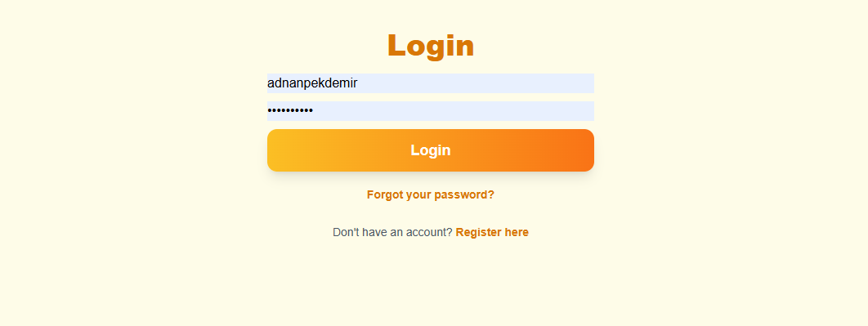

8.2 Home
Home page shows the “Honey Map” which is the heart of the website where you can see all the offers and requests and you can filter tag, date and distance. Navigation bar and centered “Create Post” button are also on home page.
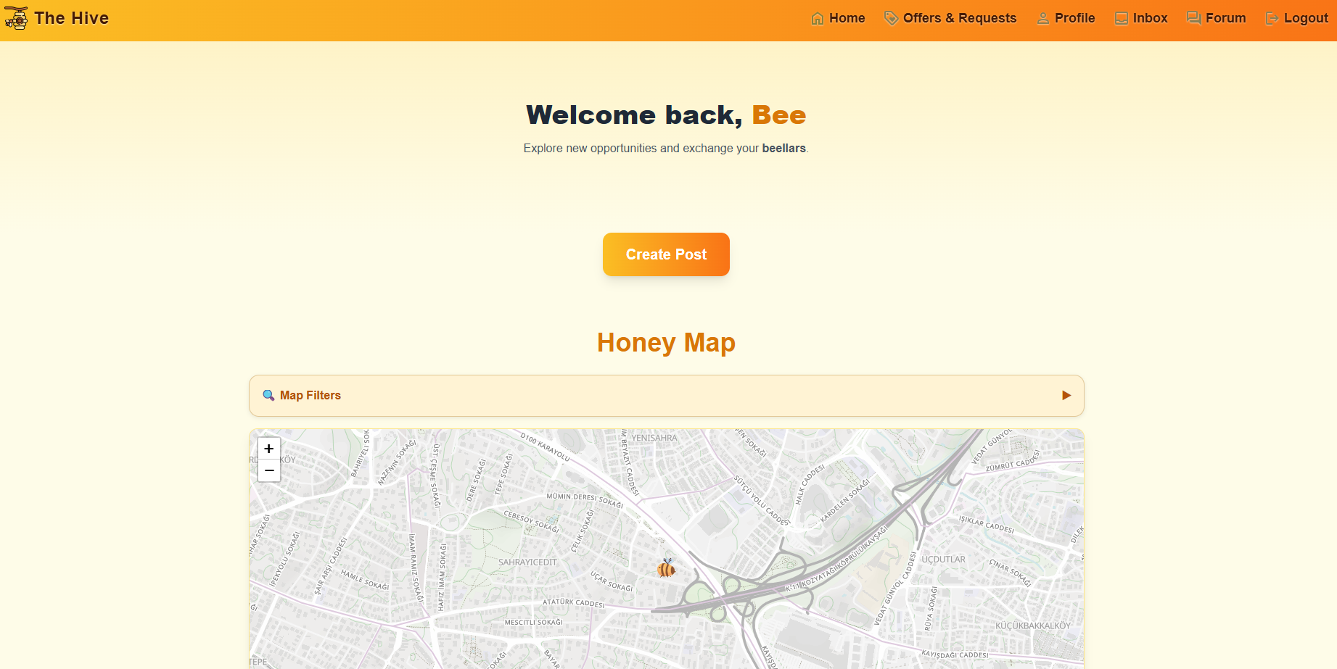

8.3 User Profile
Each user has a public profile that displays basic information such as bio, interests, and skills. Users can edit their profile information and view other users' public profiles to better understand potential exchange partners.

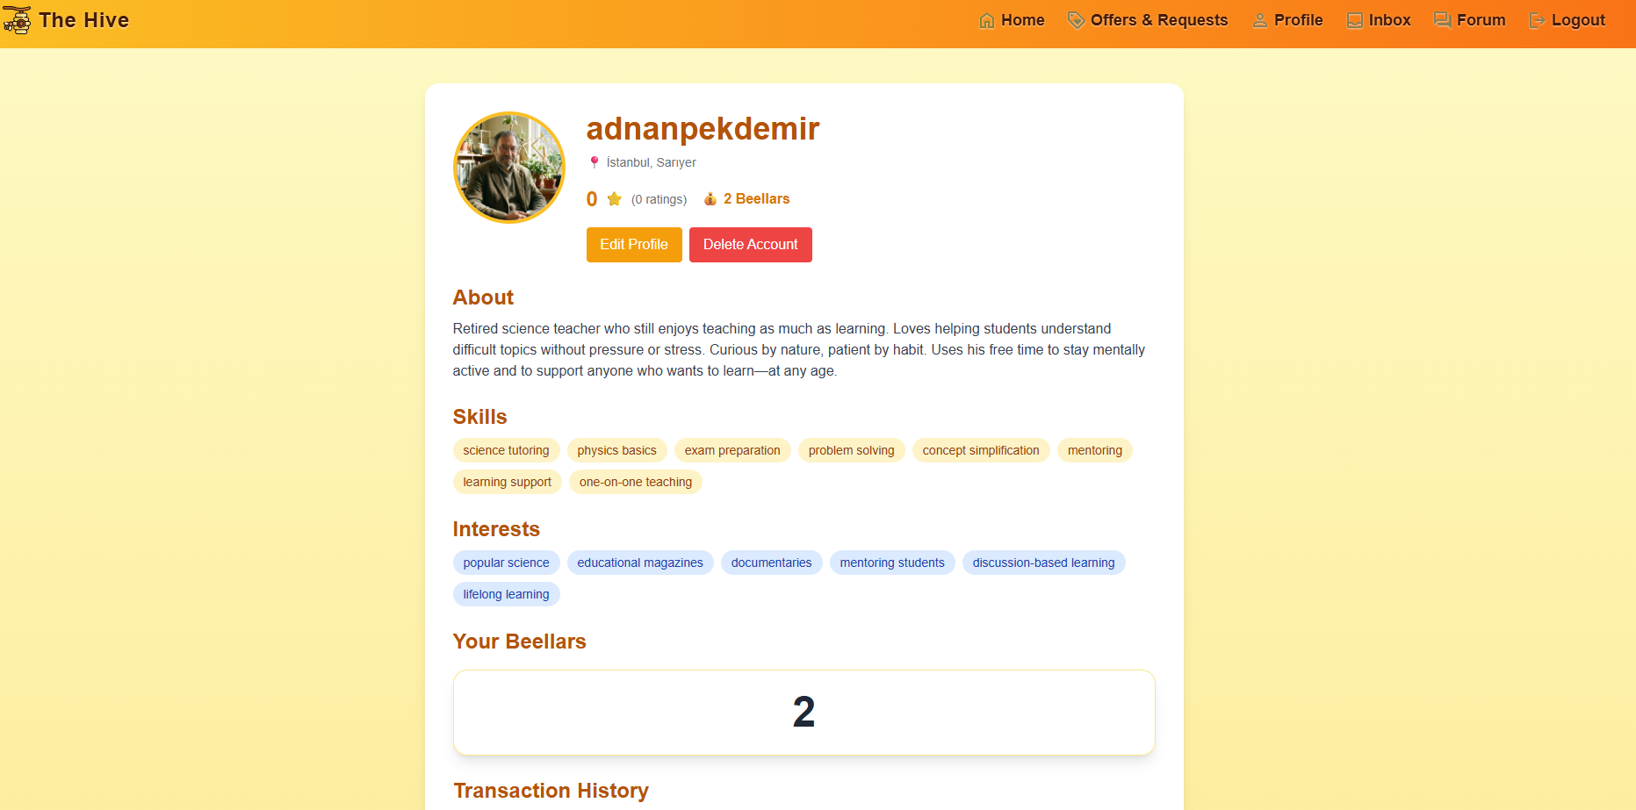

8.4 Offers & Requests
All active offers and requests are displayed on an interactive map using approximate locations for privacy. Users can browse, zoom, and filter posts based on category or distance. Selecting a post reveals detailed information about the service and its owner.
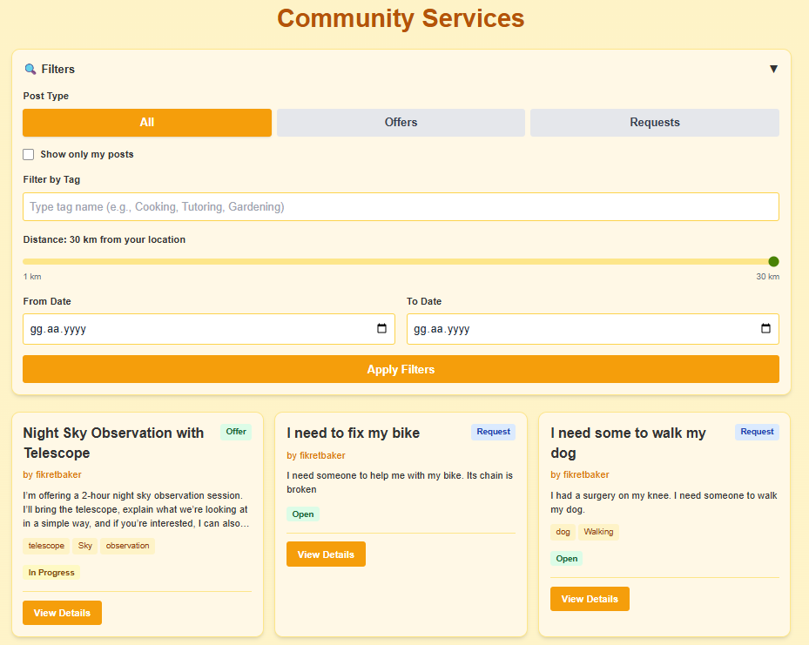

8.5 Create Post
Users can create two types of posts:
- Offers, representing services they can provide
- Requests, representing services they need
When creating a post, users specify a title, description, duration, and approximate location. Posts become visible to other users through the service listings and the interactive map.

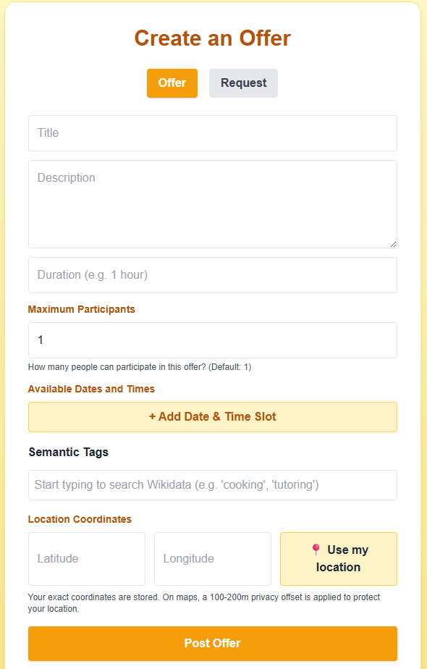

8.6 Inbox
Inbox is a page where user can see unread messages, pending handshakes and all conversations.
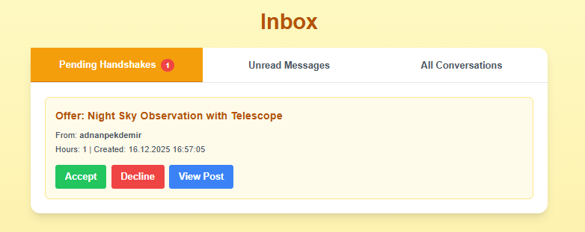

8.7 Completing an Exchange and Beellar Transfer
After the service is delivered, both parties confirm completion of the exchange. Once confirmed, the system automatically transfers Beellar credits according to the service duration (1 hour of service equals 1 Beellar). The completed exchange is recorded in both users' transaction history.

8.8 Community Interaction Forum
In addition to direct exchanges, The Hive includes a community forum where users can participate in public discussions, ask questions, and interact with other members outside individual service posts.
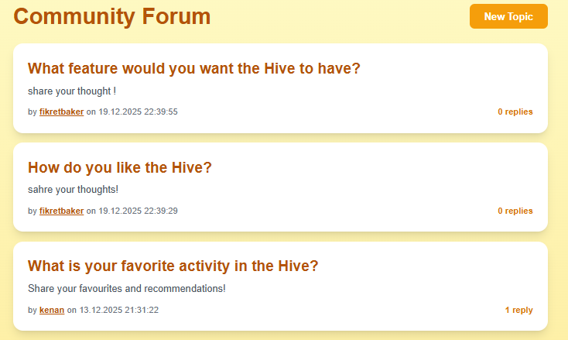

9. End-to-End Use Case Demonstration

Fikret Beykır is an aerospace engineer working in the satellite industry. He was born in a small, remote village in Anatolia—one of those places where the night sky is unbelievably clear. When he was a child, his grandmother told him stories about stars and constellations. He grew up curious, reading every space-related book his school library had, but it never felt like enough.
Years later, he became an aerospace engineer. He even chose to live a bit outside the city, just to see the stars better. He owns a telescope and all the equipment; observing planets, capturing photos, and tracking the sky is his biggest hobby. Still, it doesn't fully fill the gap inside him. He doesn't only want to look at the universe—he wants to share that feeling with other people: kids, elders, anyone who's curious.
But in real life, how do you even find the right person for that? You can't just go to a random park and ask strangers to join you for a night-sky observation session. It's awkward, unstructured, and it simply doesn't work.
One day at work, he hears about The Hive from a colleague. That same evening, he creates an offer: "Night Sky Observation with Telescope – 2 hours. I'll bring the equipment, explain the basics, and help you capture a few photos if you want." He describes the details, sets the duration, and posts it. For the first time, what he wants to give becomes something concrete—something other people can actually find.
The Service Seeker: Adnan Amca
On the other side, we have Adnan Amca, a retired science teacher. He has been subscribed to Bilim ve Teknik magazine for 28 years. He's a space enthusiast, but while raising two kids on a teacher's salary, he never had the chance to spend money on his passion.
Recently, he has been using The Hive for casual activities and small exchanges. One day, he sees Fikret's offer while browsing the service map. He gets excited like a child.
He applies immediately thinking that he has been waited years for something like this.
The Match and Exchange
They match and schedule the session. Fikret accepts the handshake, and they coordinate the details through private messaging.
After the stargazing night, both parties confirm the completion of the exchange. The system automatically transfers 2 Beellars from Adnan's account to Fikret's account.
The Ripple Effect
Adnan Amca leaves with more than just memories. A few days later, he posts his own activity on The Hive: "Science Mentoring for Students – 1 hour. Homework help, exam prep, or just building curiosity." It feels natural to him. Teaching was his life for years, and now it becomes a way to stay connected—to people, to learning, and to the community.
Fikret later sees Adnan Amca's profile again, this time from the other side. He smiles, leaves a positive rating, and realizes something important: this was never just about stars and telescopes. It was about people finally finding the right way to meet.

10. Test Plan and Results

10.1 Test Strategy
Testing for The Hive was conducted using a comprehensive two-tier approach:
- Automated Unit Testing: 46 tests validating backend models, business logic, and data integrity using Django's testing framework
- Manual User Acceptance Testing: 93 test cases executed on the deployed system to verify end-to-end workflows and requirements compliance
This combined approach ensures both technical correctness at the code level and functional accuracy from the user perspective.

10.2 Automated Unit Testing
Unit tests were implemented using Django's built-in testing framework. All tests execute against an isolated test database and validate core business logic, model behavior, and data integrity.
Test Suite Status: ✅ 46/46 Tests Passing
Execution Time: ~130 seconds
Framework: Django TestCase

10.2.1 User & Profile Tests (7 tests)
File: backend/core/tests/test_user_profile.py
Status: ✅ All Passing

Test Case 1: Profile Created Automatically
Test ID: test_profile_created_automatically_on_user_creation
Purpose: Verify that when a User is created, a UserProfile is automatically created via Django signal
- Steps:
- - Creates a new User with username, email, password
- - Checks that a UserProfile exists for that user
- - Verifies the profile is correctly linked to the user
Expected Result: Profile exists and is linked to user
Result: ✅ PASS

Test Case 2: Initial TimeBank Balance
Test ID: test_new_user_receives_initial_timebank_balance
Purpose: New users should receive an initial balance of 3 beellars
- Steps:
- - Creates a new user
- - Checks the automatically created profile's balance
- - Verifies it equals 3 beellars
Expected Result: Balance = 3 beellars
Result: ✅ PASS

Test Case 3: Profile Default Values
Test ID: test_profile_has_correct_default_values
Purpose: Verify UserProfile has sensible defaults when created
- Steps:
- - Creates a user
- - Checks all default field values
- - Verifies: balance=3, bio='', skills='', is_visible=True, email_verified=False
Expected Result: All defaults correct
Result: ✅ PASS

Test Case 4: Profile Fields Update
Test ID: test_profile_fields_can_be_updated
Purpose: Profile fields should be updatable and persist to database
- Steps:
- - Creates a user
- - Updates profile fields (bio, skills, interests, location)
- - Saves and reloads from database
- - Verifies updates persisted
Expected Result: Updates saved to database
Result: ✅ PASS

Test Case 5: Average Rating (No Ratings)
Test ID: test_average_rating_with_no_ratings
Purpose: Users with no ratings should have average_rating = 0.0
Expected Result: average_rating = 0.0
Result: ✅ PASS

Test Case 6: Username Property Access
Test ID: test_profile_username_property
Purpose: Profile should provide easy access to username
Expected Result: Username accessible via profile
Result: ✅ PASS
Test Case 7: User Profile Model Integrity
Purpose: Verify overall UserProfile model integrity
Result: ✅ PASS

10.2.2 Offer Tests (10 tests)
File: backend/core/tests/test_offers.py
Status: ✅ All Passing

Test Case 7: Create Basic Offer
Test ID: test_create_basic_offer
Purpose: Should be able to create an offer with required fields
- Steps:
- - Creates a user (offer owner)
- - Creates an offer with: title, description, duration, location
- - Verifies offer was created with correct attributes
Expected Result: Offer created successfully
Result: ✅ PASS

Test Case 8: Offer Has Correct Owner
Test ID: test_offer_has_correct_owner
Purpose: Offer should be correctly linked to its creator
Expected Result: Offer linked to correct user
Result: ✅ PASS

Test Case 9: Offer Default Status
Test ID: test_offer_default_status_is_open
Purpose: New offers should have status 'open' by default
Expected Result: status = 'open'
Result: ✅ PASS

Test Case 10: Offer With Tags
Test ID: test_offer_with_tags
Purpose: Offers should support tags stored as JSONField
- Steps:
- - Creates an offer with tags ['cooking', 'food', 'teaching']
- - Verifies tags are stored correctly
Expected Result: Tags stored as list
Result: ✅ PASS

Test Case 11: Offer With Future Date
Test ID: test_offer_with_future_date
Purpose: Offers can have a scheduled date in the future
Expected Result: Future date stored
Result: ✅ PASS

Test Case 12: Offer With Available Slots
Test ID: test_offer_with_available_slots
Purpose: Offers can have available time slots (JSONField)
Expected Result: Slots stored as JSON
Result: ✅ PASS

Test Case 13: Max Participants
Test ID: test_offer_can_have_max_participants
Purpose: Offers can limit the number of participants
Expected Result: max_participants = 5
Result: ✅ PASS

Test Case 14: Single Participant Default
Test ID: test_single_participant_offer_by_default
Purpose: Default behavior for max_participants
Expected Result: None or 1
Result: ✅ PASS

Test Case 15: Query Offers By User
Test ID: test_query_offers_by_user
Purpose: Should be able to filter offers by creator
Expected Result: User1: 2 offers, User2: 1 offer
Result: ✅ PASS

Test Case 16: Query Open Offers
Test ID: test_query_open_offers
Purpose: Should be able to filter offers by status
Expected Result: Only open offers returned
Result: ✅ PASS

10.2.3 TimeBank Tests (12 tests)
File: backend/core/tests/test_timebank.py
Status: ✅ All Passing

Test Case 17: New User Starts With 3 Beellars
Test ID: test_new_user_starts_with_3_beellars
Purpose: Every new user should start with 3 beellars in their timebank
Expected Result: Balance = 3
Result: ✅ PASS

Test Case 18: Balance Can Be Updated
Test ID: test_balance_can_be_updated
Purpose: Profile balance should be updatable
- Steps:
- - Creates user (starts with 3)
- - Adds 5 beellars
- - Verifies balance = 8
Expected Result: Balance updates (3 + 5 = 8)
Result: ✅ PASS

Test Case 19: Balance Can Increase
Test ID: test_balance_can_increase
Purpose: Balance can increase when user provides services
Result: ✅ PASS

Test Case 20: Independent Balances
Test ID: test_multiple_users_have_independent_balances
Purpose: Each user should have their own independent balance
Expected Result: User2 balance unchanged when User1 balance modified
Result: ✅ PASS

Test Case 21: Create Transaction Between Users
Test ID: test_create_transaction_between_users
Purpose: Should be able to create a transaction recording transfer of beellars
Expected Result: Transaction created with correct sender/receiver/amount
Result: ✅ PASS

Test Case 22: Transaction Has Timestamp
Test ID: test_transaction_has_timestamp
Purpose: Transactions should automatically record creation timestamp
Expected Result: Timestamp exists
Result: ✅ PASS

Test Case 23: Handshake Creation Doesn't Change Balance
Test ID: test_handshake_creation_doesnt_change_balance
Purpose: Creating/accepting a handshake should NOT yet change balances
Expected Result: Balances unchanged until completion
Result: ✅ PASS

Test Case 24: Balance Changes After Service Completion
Test ID: test_balance_changes_after_service_completion
Purpose: After BOTH parties confirm completion, balances should update
- Steps:
- - Creates completed handshake (2 hours)
- - Provider gains 2 hours (3 → 5)
- - Seeker loses 2 hours (3 → 1)
Expected Result: Provider: +2, Seeker: -2
Result: ✅ PASS

Test Case 25: Multi-Participant Balance Distribution
Test ID: test_multi_participant_offer_balance_distribution
Purpose: For multi-participant offers, provider receives from each seeker
- Steps:
- - Creates group offer (1 hour, max 3 participants)
- - 2 seekers complete the service
- - Provider gains 1 hour from each = 2 hours total
- - Each seeker loses 1 hour
Expected Result: Provider: +2, Each seeker: -1
Result: ✅ PASS

Test Case 26: Balance Cannot Go Negative
Test ID: test_balance_cannot_go_negative
Purpose: Users cannot have negative balance (PositiveIntegerField constraint)
Expected Result: Balance = 0 (minimum)
Result: ✅ PASS

Test Case 27: Balance Can Be Very Large
Test ID: test_balance_can_be_very_large
Purpose: Balance can grow to large positive values
Expected Result: Balance = 1000
Result: ✅ PASS

Test Case 28: Balance Can Be Zero
Test ID: test_balance_starts_at_zero_when_depleted
Purpose: Balance can be reduced to zero
Expected Result: Balance = 0
Result: ✅ PASS

10.2.4 Handshake Tests (15 tests)
File: backend/core/tests/test_handshake.py
Status: ✅ All Passing

Test Case 29: Create Handshake
Test ID: test_create_handshake
Purpose: Should be able to create a handshake linking offer, provider, and seeker
Expected Result: Handshake created with correct links
Result: ✅ PASS

Test Case 30: Handshake Default Status
Test ID: test_handshake_default_status_is_proposed
Purpose: New handshakes should default to 'proposed' status
Expected Result: status = 'proposed'
Result: ✅ PASS

Test Case 31: Handshake Hours Match Offer
Test ID: test_handshake_hours_match_offer_duration
Purpose: Handshake hours should typically match the offer duration
Expected Result: Hours match duration
Result: ✅ PASS

Test Case 32: Transition Proposed to Accepted
Test ID: test_transition_from_proposed_to_accepted
Purpose: Provider can accept a proposed handshake
Expected Result: Status = 'accepted'
Result: ✅ PASS

Test Case 33: Transition to In Progress
Test ID: test_transition_to_in_progress
Purpose: Accepted handshake can move to in_progress
Expected Result: Status = 'in_progress'
Result: ✅ PASS

Test Case 34: Transition to Completed
Test ID: test_transition_to_completed
Purpose: In-progress handshake can be marked as completed
Expected Result: Status = 'completed'
Result: ✅ PASS

Test Case 35: Handshake Can Be Rejected
Test ID: test_handshake_can_be_rejected
Purpose: Provider can reject a proposed handshake
Expected Result: Status = 'rejected'
Result: ✅ PASS

Test Case 36: Initial Confirmation State
Test ID: test_initial_confirmation_state
Purpose: New handshakes should have both confirmations as False
Expected Result: Both False
Result: ✅ PASS

Test Case 37: Provider Can Confirm
Test ID: test_provider_can_confirm
Purpose: Provider can confirm service completion
Expected Result: Provider: True, Seeker: False
Result: ✅ PASS

Test Case 38: Seeker Can Confirm
Test ID: test_seeker_can_confirm
Purpose: Seeker can confirm service completion
Expected Result: Seeker: True, Provider: False
Result: ✅ PASS

Test Case 39: Both Parties Can Confirm
Test ID: test_both_parties_can_confirm
Purpose: Both provider and seeker can confirm
Expected Result: Both True
Result: ✅ PASS

Test Case 40: Status Changes After Both Confirm
Test ID: test_status_changes_to_completed_after_both_confirm
Purpose: When both parties confirm, status should become 'completed'
Expected Result: Completed with both confirmations
Result: ✅ PASS

Test Case 41: Query Handshakes By Offer
Test ID: test_query_handshakes_by_offer
Purpose: Should be able to get all handshakes for a specific offer
Expected Result: 2 handshakes found
Result: ✅ PASS

Test Case 42: Query Handshakes By Seeker
Test ID: test_query_handshakes_by_seeker
Purpose: Should be able to get all handshakes where user is seeker
Expected Result: Seeker's handshakes found
Result: ✅ PASS

Test Case 43: Query Handshakes By Provider
Test ID: test_query_handshakes_by_provider
Purpose: Should be able to get all handshakes where user is provider
Expected Result: Provider's handshakes found
Result: ✅ PASS

Test Case 44: Query Handshakes By Status
Test ID: test_query_handshakes_by_status
Purpose: Should be able to filter handshakes by status
Expected Result: Filtered correctly
Result: ✅ PASS

Test Case 45: Multiple Handshakes for Same Offer
Test ID: test_multiple_handshakes_for_same_offer
Purpose: Multi-participant offers can have multiple handshakes
Expected Result: 3 handshakes for one offer
Result: ✅ PASS

Test Case 46: Each Handshake Is Independent
Test ID: test_each_handshake_is_independent
Purpose: Each handshake in a multi-participant offer is independent
Expected Result: Independent statuses
Result: ✅ PASS

10.2.5 Unit Test Execution Summary
Total: 46 | Passed: 46 | Failed: 0
Status: ✅ All tests passing
Summary by Category:
Category | Tests | Passed | Status
User & Profile | 7 | 7 | ✅
Offers | 10 | 10 | ✅
TimeBank | 12 | 12 | ✅
Handshakes | 15 | 15 | ✅
TOTAL | 46 | 46 | ✅

10.3 User Acceptance Testing
User acceptance tests were executed manually on the deployed system to validate end-to-end functionality and requirements compliance. A total of 93 test cases were performed across 7 functional categories.

10.3.1 User Management (17 tests)
Test ID | Test Case | Result | Comment
TC-UM-01 | Register user with unique username and password | Pass
TC-UM-02 | Prevent registration with duplicate username | Pass
TC-UM-03 | Verify user credentials during login | Pass
TC-UM-04 | Reject login with incorrect password | Pass
TC-UM-05 | Issue JWT token on successful login | Pass
TC-UM-06 | Allow user to edit profile information | Pass
TC-UM-07 | Display updated profile information | Pass
TC-UM-08 | View another user's public profile | Pass
TC-UM-09 | Restrict editing of other users' profiles | Pass
TC-UM-10 | Delete own user account | Fail | Delete account not implemented
TC-UM-11 | Prevent access after account deactivation | Fail | Delete account not implemented
TC-UM-12 | Allow admin to view all registered users | Fail | Admin user not implemented but there is admin panel
TC-UM-13 | Allow admin to manage user accounts | Fail | Admin user not implemented but there is admin panel
TC-UM-14 | Display user ratings on profile | Fail | Rating not implemented
TC-UM-15 | Display earned badges on profile | Fail | Badges not implemented
TC-UM-16 | Allow rating only after completed handshake | Fail | Rating not implemented
TC-UM-17 | Prevent rating without completed handshake | Fail | Rating not implemented

10.3.2 Email & Verification (13 tests)
Test ID | Test Case | Result | Comment
TC-EMAIL-01 | Register user with valid and unique email address | Pass
TC-EMAIL-02 | Prevent registration with duplicate email | Pass
TC-EMAIL-03 | Send verification email after successful registration | Pass
TC-EMAIL-04 | Display email activation instruction after registration | Pass
TC-EMAIL-05 | Prevent login before email verification | Pass
TC-EMAIL-06 | Activate user account using valid token | Pass
TC-EMAIL-07 | Store email verification status after activation | Pass
TC-EMAIL-10 | Allow user to request resend verification email | Pass
TC-EMAIL-11 | Prevent login after resend but before verification | Pass
TC-EMAIL-12 | Display success message after email verification | Pass
TC-EMAIL-13 | Display error message for invalid activation attempt | Pass
TC-EMAIL-15 | Reset password via email | Pass
TC-EMAIL-08 | Expire verification token after 24 hours | Pass

10.3.3 Post Management (18 tests)
Test ID | Test Case | Result | Comment
TC-PM-01 | Create a new offer post with valid data | Pass
TC-PM-02 | Create a new request post with valid data | Pass
TC-PM-04 | Require title, description, and tag fields | Fail | Says 'something went wrong' when no location
TC-PM-05 | Prevent submission of empty or duplicate posts | Fail | Can be created
TC-PM-06 | Add fuzzy location data to post | Pass | Can be improved
TC-PM-07 | Display posts on interactive service map | Pass
TC-PM-08 | Edit own post successfully | Pass
TC-PM-09 | Prevent editing another user's post | Pass
TC-PM-10 | Delete own post without active handshake | Pass
TC-PM-11 | Prevent deletion of post with active handshake | Pass
TC-PM-12 | Allow admin to remove inappropriate posts | Fail | No admin type account
TC-PM-13 | Display owner-specific controls on own posts | Pass
TC-PM-14 | Hide owner controls on others' posts | Pass
TC-PM-15 | Specify available time slots when creating post | Pass
TC-PM-16 | Filter posts by category or tag | Pass
TC-PM-17 | Filter posts by distance | Pass
TC-PM-18 | Rename navigation item to 'Offers & Requests' | Pass
TC-PM-20 | Mark post inactive after successful handshake | Pass

10.3.4 Map & Discovery (13 tests)
Test ID | Test Case | Result | Comment
TC-MAP-01 | Display all active offers and requests on the map | Pass
TC-MAP-02 | Hide completed or inactive posts from map | Pass
TC-MAP-03 | Display fuzzy location for posts | Pass
TC-MAP-04 | Use different icons or colors for offers and requests | Pass
TC-MAP-05 | View post details by clicking map marker | Pass
TC-MAP-06 | Filter map markers by tag | Pass
TC-MAP-07 | Filter map markers by category | Pass
TC-MAP-08 | Filter map markers by distance from user location | Pass
TC-MAP-10 | Update map markers dynamically when filters change | Pass
TC-MAP-11 | Support zooming and panning interactions | Pass
TC-MAP-12 | Automatically update map when new post is created | Pass
TC-MAP-13 | Automatically update map when post is removed | Pass
TC-MAP-09 | Display accurate marker count | Pass

10.3.5 Handshake & Interaction (18 tests)
Test ID | Test Case | Result | Comment
TC-HS-01 | Send handshake request to a post | Pass
TC-HS-03 | Accept handshake request | Pass
TC-HS-04 | Decline handshake request | Pass
TC-HS-05 | Mark post as in progress after acceptance | Pass
TC-HS-06 | Hide post from public listings after acceptance | Pass
TC-HS-07 | Prevent multiple handshakes after acceptance | Pass
TC-HS-08 | Display public Q&A before handshake | Pass
TC-HS-09 | Prevent users from asking questions on own post | Pass
TC-HS-10 | Allow users to ask questions on others' posts | Pass
TC-HS-11 | Allow post owner to answer questions publicly | Pass
TC-HS-12 | Switch Q&A visibility to private after handshake | Pass
TC-HS-13 | Create private conversation after handshake | Pass
TC-HS-14 | Restrict private chat access | Pass
TC-HS-15 | Send message in private chat | Pass
TC-HS-16 | Load conversation history | Pass
TC-HS-17 | Automatically scroll to latest message | Pass
TC-HS-19 | Prevent duplicate completion confirmation | Pass
TC-HS-21 | Support multiple participants for offers | Pass

10.3.6 TimeBank System (11 tests)
Test ID | Test Case | Result | Comment
TC-TB-01 | Initialize new user with starting Beellar balance | Pass
TC-TB-02 | Display current Beellar balance | Pass
TC-TB-03 | Display transaction history | Pass
TC-TB-04 | Display transaction details correctly | Pass
TC-TB-05 | Distinguish earned and spent transactions | Pass
TC-TB-06 | Credit provider after completed handshake | Pass
TC-TB-07 | Debit service receiver after completed handshake | Pass
TC-TB-08 | Prevent fractional Beellar transactions | Pass
TC-TB-09 | Prevent negative Beellar balance | Pass
TC-TB-13 | Filter transaction history by type | Fail | No filter possible
TC-TB-16 | Debit each participant in multi-participant offer | Pass

10.3.7 Community Forum (3 tests)
Test ID | Test Case | Result | Comment
TC-CF-07 | Reply to an existing forum topic | Pass
TC-CF-08 | Display timestamps and usernames in forum | Fail | Not implemented
TC-CF-09 | View forum topics without authentication | Pass

11. Third-Party Software and AI Usage Declaration

11.1 Third-Party Libraries and Software
The Hive utilizes the following third-party libraries and frameworks, all of which are used in compliance with their respective open-source licenses:

Backend (Python/Django)
- Django - Web framework (BSD License)
- Django REST Framework - API creation (BSD License)
- Simple JWT - Authentication tokens (MIT License)
- django-cors-headers - Cross-origin requests (MIT License)
- Gunicorn - Production server (MIT License)
- PostgreSQL (psycopg2) - Database driver (LGPL License)
- Pillow - Image processing (PIL License)
- WhiteNoise - Static file serving (MIT License)
- python-dotenv - Environment variables (BSD License)
- dj-database-url - Database configuration (BSD License)

Frontend (React)
- React - UI framework (MIT License)
- React Router - Client-side routing (MIT License)
- Leaflet.js + React-Leaflet - Interactive maps (BSD License)
- Tailwind CSS - Styling (MIT License)
- Lucide React - Icons (ISC License)
- React Scripts - Build tooling (MIT License)

Infrastructure
- Docker + Docker Compose - Containerization (Apache License 2.0)
- PostgreSQL - Database (PostgreSQL License)
All libraries are used in accordance with their license terms. No modifications were made to the core library code.

11.2 AI Usage Declaration
I used Cursor, ChatGPT, and Claude extensively throughout the development of The Hive. As someone without a professional software development background and limited prior experience with Django, React, and Python, AI tools were essential to completing this project.
At the beginning of the project, I used AI tools as study partners to learn the fundamentals. I would ask for explanations of concepts, request examples of how things work. During this phase, I was careful to understand each piece of code and learn the underlying principles.
As the project needed to progress faster and the number of required features increased, my reliance on AI tools progressed as well. I used them more for code generation, implementation guidance, and problem-solving. The tools helped me implement features faster than I could have learned to build them from scratch.
Besides coding, I used AI when writing the Software Requirements Specification, AI tools helped me structure the requirements properly and ensure I covered all necessary functional and non-functional requiremetns. Also, I used AI to generate mockup ideas and refine the user interface concepts before implementation. During testing, AI tools assisted in creating comprehensive test cases, identifying edge cases I might have missed, and writing unit tests. For this final report, AI tools helped me organize and present the documentation in a clear, professional format.
I reviewed all AI-generated code to ensure it worked correctly and met the project requirements. I tested each feature thoroughly and made modifications when needed. While I may not have written every line of code independently, I understood what the code was doing and took responsibility for integrating it into a working system.
The final product reflects a combination of AI-assisted development and my own learning, testing, and problem-solving. AI tools enabled me to build a functional system despite my limited programming experience, but all design decisions, feature implementations, and system integration were my responsibility.

12. References
1. Django Documentation: https://docs.djangoproject.com/
2. React Documentation: https://react.dev/
3. Leaflet.js Documentation: https://leafletjs.com/
4. Django REST Framework: https://www.django-rest-framework.org/
5. PostgreSQL Documentation: https://www.postgresql.org/docs/
6. Docker Documentation: https://docs.docker.com/

