PPS
MINI – PROJECT
USING C

Project Name: Pharmacy Management Software
By:
Kevin Paul Jacob
RA2111050010014
CSE – BCT – Q1
DESCRIPTION:
This a project written in C Programming Language using File Input/Output operations. It is used to maintain the records of the medicines stored in the pharmacy.
Details Recorded are:
- Manufacturing Code
- Manufacturing Date
- Expiration Date
- Manufactures Name
- Medicine Name
- Price
The following records can be Inserted, Searched and Updated using the program.
Libraries Used:
- stdio.h – For scanf() and printf().
- stdlib.h – For system() and exit().
- conio.h – For fopen(), fclose(), fread(), fwrite() and fseek().

#include <stdio.h>
#include <stdlib.h>
#include <conio.h>

void insert();
void search();
void update();

struct medicines
{
int mfccode;
int mfcdate;
int expdate;
char mfcname[20];
char medname[20];
float price;
};
struct medicines medicine;

void main()
{
int choice;
while (choice != 4)
{
printf("\t**********************************\n");
printf("\t'WELCOME TO SRM PHARMACY DATABASE'\n");
printf("\t**********************************\n\n\n");
printf("\t****What would you like to do?****\n\n");
printf("\t~1: Insert Medicine record~\n");
printf("\t~2: Search Medicine record~\n");
printf("\t~3: Update Medicine record~\n");
printf("\t~4: Exit~\n\n");
printf("\tEnter Your Choice : ");
scanf("%d", &choice);
switch (choice)
{
case 1:
system("cls");
insert();
break;
case 2:
system("cls");
search();
break;
case 3:
system("cls");
update();
break;
case 4:
exit(1);
break;

default:
printf("\n\t\t!!! You Entered The Wrong Choice !!!\n\n");
}
getchar();
}
}

void insert()
{
FILE *fp;
fp = fopen("pharmacy.txt", "a+");
printf("\n\n\t~~~ENTER NEW MEDICINE DATA~~~");
printf("\n\n\tEnter Manufacturing Code : ");
scanf("%d", &medicine.mfccode);

printf("\n\tEnter Manufacturing Date : ");
scanf("%d", &medicine.mfcdate);

printf("\n\tEnter Expiration Date : ");
scanf("%d", &medicine.expdate);
fflush(stdin);

printf("\n\tEnter Manufacture Name : ");
gets(medicine.mfcname);

printf("\n\tEnter Medicine Name : ");
gets(medicine.medname);

printf("\n\tEnter Price : ");
scanf("%f", &medicine.price);

fwrite(&medicine, sizeof(medicine), 1, fp);
{
printf("\n\n\tMedicine Details Recorded Sucessfully !!!\n");
}
fclose(fp);
fflush(stdin);
printf("\n\t\tRecord Updated !!!\n\n");
}

void search()
{
int code, flag = 0;

FILE *fp;
fp = fopen("pharmacy.txt", "r");

if (fp == NULL)
{
printf("\n\t\tError : File Does Not Exist !!! ");
return;
}

printf("\n\n\tEnter Manufacturing Code To Search : ");
scanf("%d", &code);
while (fread(&medicine, sizeof(medicine), 1, fp) > 0 && flag == 0)
{
if (medicine.mfccode == code)
{
flag = 1;
printf("\n\tSearch Sucessfull And Medicine Details Is as follows");
printf("\n\n\tMFC Code\tMFC Date\tEXP Date\tMFC Name\tMedicine Name\t\tPrice\n");
printf("\t%d\t\t%d\t\t%d\t\t%s\t\t%s\t\t\t%.4f\n\n\n", medicine.mfccode, medicine.mfcdate, medicine.expdate, medicine.mfcname, medicine.medname, medicine.price);
}
}
if (flag == 0)
{
printf("\n\n\t\t!!! No Record Found !!!\n\n");
}
fclose(fp);
}
void update()
{
int code, flag = 0;

FILE *fp;
fp = fopen("pharmacy.txt", "r+");
if (fp == NULL)
{
printf("\n\t\tError : File Does Not Exist");
return;
}

printf("\n\n\tEnter Manufacturing Code of the Medicine Details To Update : ");
scanf("%d", &code);

printf("\n\n\t\t *** Previously Stored Medicine Details for the Manufacturing Code ***\n");
while (fread(&medicine, sizeof(medicine), 1, fp) > 0 && flag == 0)
{
if (medicine.mfccode == code)
{
flag = 1;
printf("\n\n\tMFC Code\tMFC Date\tEXP Date\tMFC Name\tMedicine Name\t\tPrice\n");
printf("\t%d\t\t%d\t\t%d\t\t%s\t\t%s\t\t\t%.4f\n\n", medicine.mfccode, medicine.mfcdate, medicine.expdate, medicine.mfcname, medicine.medname, medicine.price);

printf("\n\t\t*** Update the Medicine Details ***\n\n");
printf("\n\tEnter Manufacturing Code : ");
scanf("%d", &medicine.mfccode);

printf("\n\tEnter Manufacturing Date : ");
scanf("%d", &medicine.mfcdate);

printf("\n\tEnter Expiration Date : ");
scanf("%d", &medicine.expdate);
fflush(stdin);

printf("\n\tEnter Manufacture Name : ");
gets(medicine.mfcname);

printf("\n\tEnter Medicine Name : ");
gets(medicine.medname);

printf("\n\tEnter Price : ");
scanf("%.4f", &medicine.price);

fseek(fp, -(long)sizeof(medicine), 1);

fwrite(&medicine, sizeof(medicine), 1, fp);
printf("\n\n\t\tDetails Updated\n\n\n");
}
}
if (flag == 0)
{
printf("\n\t\tError : Something Went Wrong !!!\n\n");
}
fclose(fp);
}

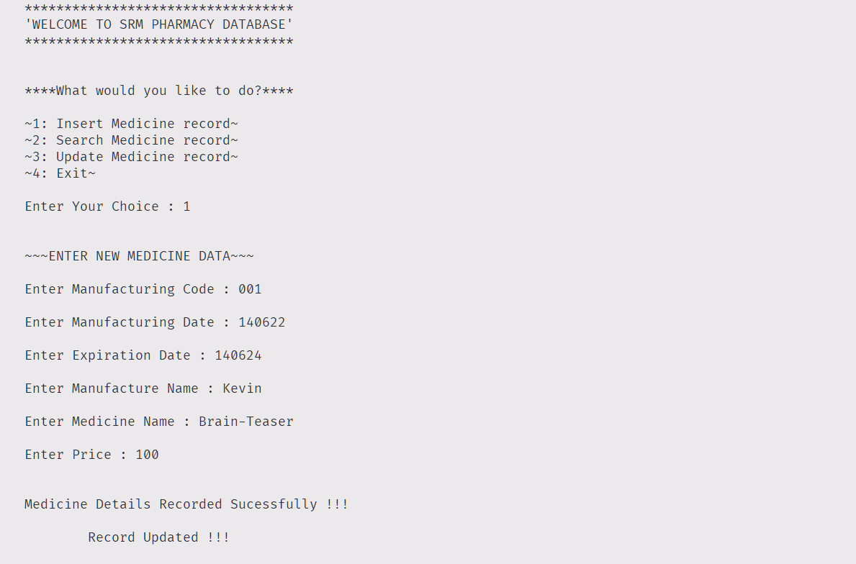
Inserting Record:
Updating Record:
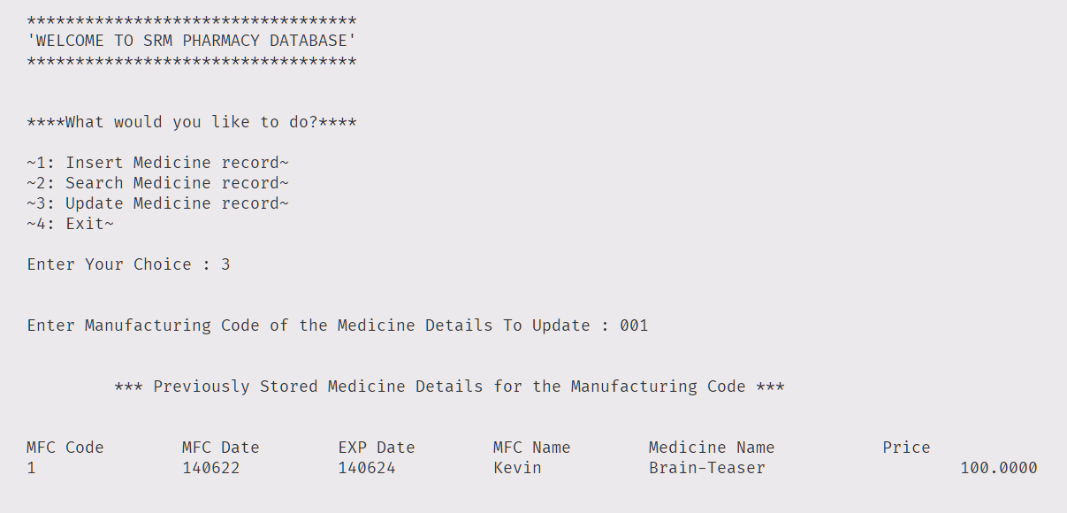

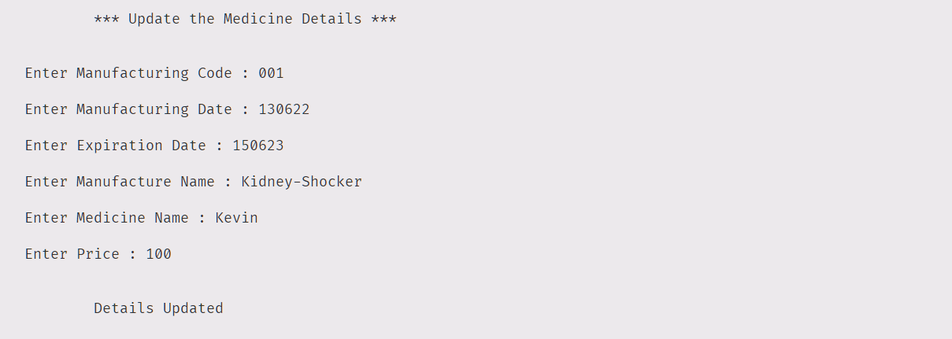

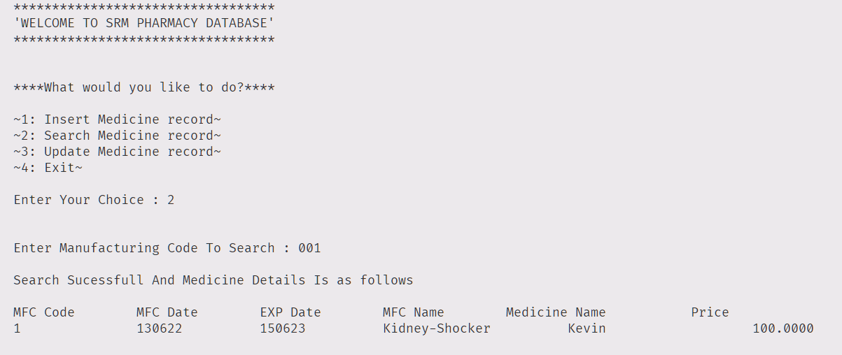
Searching Record:

