# 2021 ADVANCED ASTROPHYSICS

# CLASS PROJECT

“Halos in Cosmological Hydrodynamical Simulations”

2021.June.18 submitted

Team 2

20110170 Shin-Jeong Kim  
: Halo statistics (spin parameter distribution, spin parameter-Mvir relation, concentration parameter c-Mvir relation), Halo shape

21110106 Jun-Kwon

: Halo statistics (Mvir-Vmax correlation, relation between sub-halos and host halos)

21110111 Sung-Hwa Hong

: Did not contribute to data analysis. Prepared the introduction part of the presentation

**1. Introduction**

According to the Lambda-CDM model, galaxies form within dark matter halos, which are the first virialized objects in the universe, building blocks of the structure formation and a key component of the cosmic web. Thus, understanding the dark matter halos plays an important role in understanding galaxy formation and evolution. Cosmological hydrodynamic simulations enable us to constrain the cosmological parameters, and give us a better understanding of how the universe has evolved.

In our project, we will identify the dark matter halos from the Gadget-3 simulation snapshots using a halo finder algorithm, Rockstar (Behroozi et al (2012)). Then, we will investigate the fundamental properties of dark matter halos. Our paper is organized as follows. In section 2, we will introduce the simulation Gadget-3 snapshots we used to run Rockstar. Then, in section 3, we will explore the kinematics and morphology of dark matter halos identified with Rockstar. Finally, we will summarize the results we drew in our project in section 4.

**2. Cosmological Hydrodynamical Simulation snapshot**

GADGET is software for cosmological N-body/SPH(smoothed particle hydrodynamics) simulations. GADGET computes gravitational force using a hierarchical tree algorithm and represents fluids via SPH. After that process, GADGET gives the primary result ‘snapshots’, which show the state of the system at a specific time. In our study, we used the simulation GADGET-3 snapshots given in class, Data A and Data B, and their parameter values are described in Table 1.

|  | Data A | Data B |
| --- | --- | --- |
| Redshift (z) | 2 | 3 |
| Box Size | 25 Mpc/h | 25 Mpc/h |
| {"font":{"color":"#000000","size":12,"family":"Times New Roman"},"type":"$","backgroundColorModified":false,"code":"$\\Omega_{M}$","backgroundColor":"#ffffff","id":"24","aid":null,"ts":1623977921972,"cs":"09AJH37h5qpbULTda9jaoA==","size":{"width":22,"height":13}} | 0.308 | 0.308 |
| {"aid":null,"backgroundColorModified":false,"type":"$","code":"$\\Omega_{\\lambda}$","backgroundColor":"#ffffff","font":{"family":"Times New Roman","color":"#000000","size":12},"id":"25","ts":1623977959095,"cs":"RKFZw/shPxpKK4BTGyi1kQ==","size":{"width":16,"height":13}} | 0.768 | 0.768 |
| Hubble Parameter h | 0.678 | 0.678 |
| Scale Factor (a) | 0.333 | 0.25 |
| {"backgroundColorModified":false,"font":{"size":12,"family":"Times New Roman","color":"#000000"},"backgroundColor":"#ffffff","aid":null,"id":"26","type":"$","code":"$N_{gas}$","ts":1623977977997,"cs":"c0c1Rag1lyTIWD+FHuzUIw==","size":{"width":28,"height":16}} | 7709894 | 8161167 |
| {"type":"$","backgroundColorModified":false,"aid":null,"backgroundColor":"#ffffff","code":"$N_{DM}$","id":"27","font":{"color":"#000000","family":"Times New Roman","size":12},"ts":1623977991891,"cs":"fkwtiHD78M5ZCyczgx5lFg==","size":{"width":33,"height":12}} | 8998912 | 8998912 |
| {"backgroundColor":"#ffffff","id":"28","code":"$N_{star}$","font":{"color":"#000000","family":"Times New Roman","size":12},"type":"$","backgroundColorModified":false,"aid":null,"ts":1623978011375,"cs":"wUuRsHXX4191Yae2LQdxSg==","size":{"width":32,"height":12}} | 1289018 | 837745 |
| Flag SFR | On | On |
| Flag Feedback | On | On |

**Table 1. Parameter values of simulation Gadget-3 snapshots**

**2.1 Visualisation of simulation Gadget-3 snapshots**

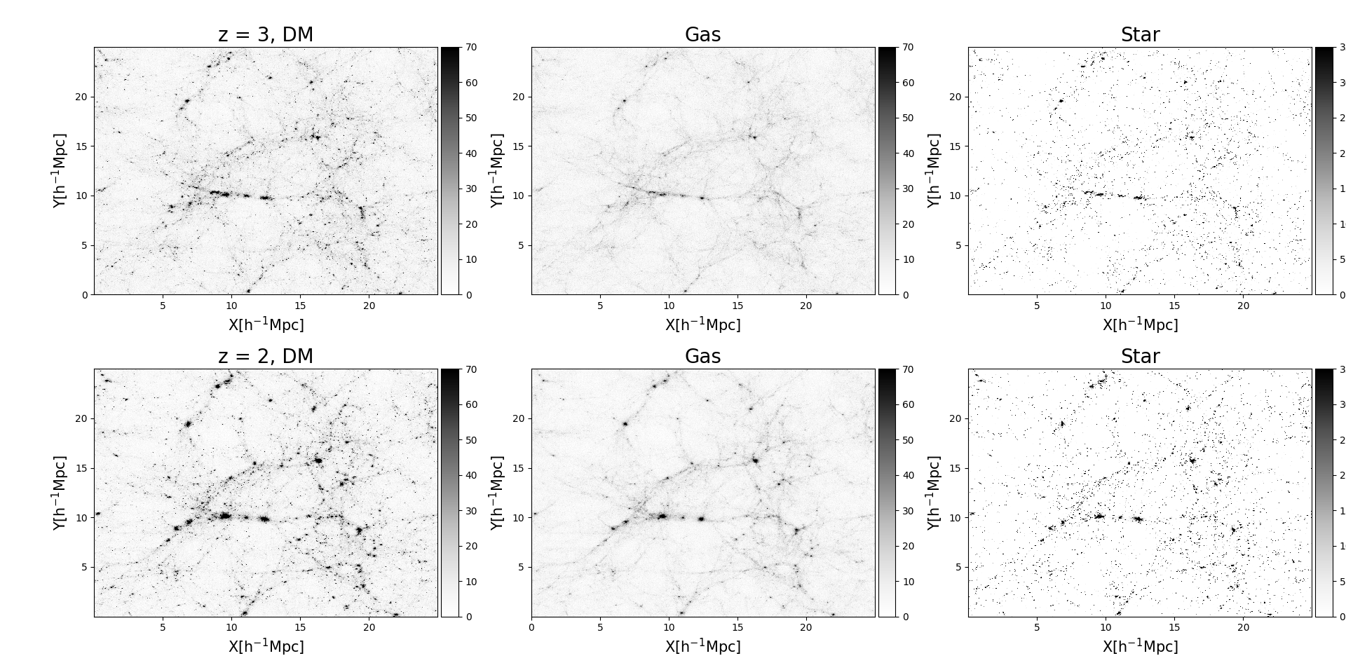

**Figure 1. From left-to-right, the density of DM, gas, and star from simulation Gadget-3 snapshots at z = 2 (top row), and z = 3 (bottom row). The box size is 25Mpc/h and the black color represents the high-density region.** *(code: snapshot\_visual\_plot.py)*

Figure 1 shows the density of DM, gas, and star from simulation Gadget-3 snapshots at z = 2 (top row), and z = 3 (bottom row). The box size is 25Mpc/h and the high-density regions are shown with black color. The large-scale structure composed of halo, filament, and void is clearly seen in the simulation snapshots. We notice that not only the high-density positions of DM, gas, and star are correlated to each other at certain times but also the particles are gathering together with cosmic time.

On the simulation snapshots, we focus on the dark matter particles, and we will find them using a Rockstar.

**3. Finding halos with Rockstar**

Rockstar (Robust Overdensity Calculation using K-Space Topologically Adaptive Refinement) is a halo finder based on FoF (friend-of-friend) algorithm in 7 dimensions (position, velocity, and time), which leads to robust tracing of substructure. The feature of Rockstar is that it handles large data very quickly and efficiently with massive parallel methods. Rockstar presents halo properties on the basis of NFW profile, Allgood method, Peebles/Bullock spin parameters, and so on (Behroozi et al. (2012)). The details are described below.

* Rs (klypin scale radius) is calculated by using Vmax (maximum circular velocity) and Mvir (virial mass) under the assumption of an NFW (Navarro-Frank-White) profile.
* Halo shapes and principal axes are calculated by using the Allgood method (iterative, weighted by 1/r^2) at both Rvir (virial radius) and R500c.
* Calculate the halo angular momentum and the halo spin parameter using the method introduced in Peebles (1969) and Bullock (2001).

Numerical simulations of halo formation revealed that dark matter halos may contain multiple subhalos bound to the gravity of a larger halo. Furthermore, cosmic models propose that halos and subhalos may have galaxies. Rockstar classifies the host halos and subhalos, but doesn’t notify which ones are host halos and subhalos. So, if you want to know, you should refer to ‘README.md’ contents 6. [Host / Subhalo Relationships](https://github.com/yt-project/rockstar#markdown-header-host--subhalo-relationships). For the study of halo and sub-halo relations, we classified the host halos and sub-halos by following the steps described in the above link.

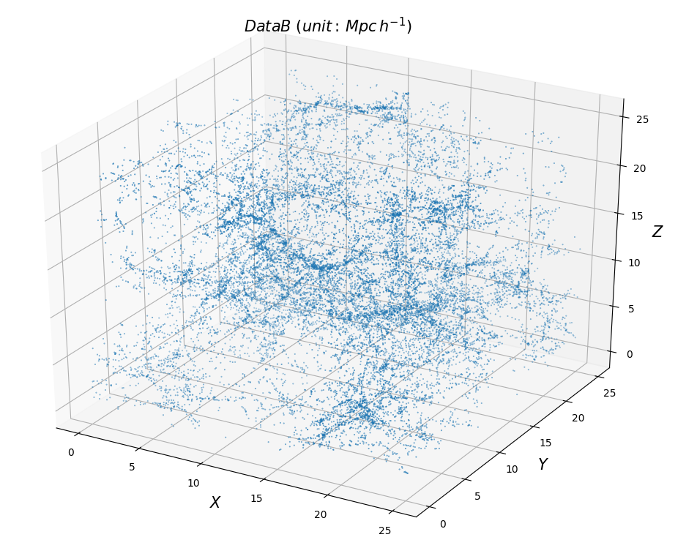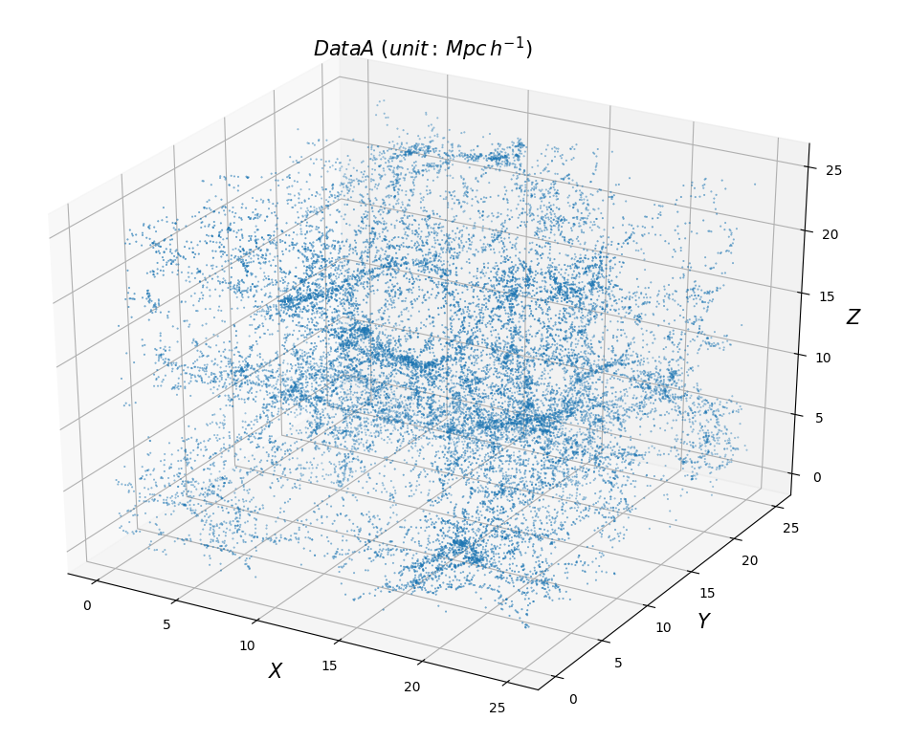

**Figure 2. Dark matter halo 3D distribution at z = 3 (top) z = 2 (bottom).** *(code: output\_3Dfig.py)*

After using rockstar, 18260 halo data for z = 3 (Data B) and 19992 halo data for z = 2 (Data A) were obtained. This figure shows the 3D DM halo distribution at z = 3 (top) and z = 2 (bottom) from Rockstar output. The box size is 25Mpc/h.

**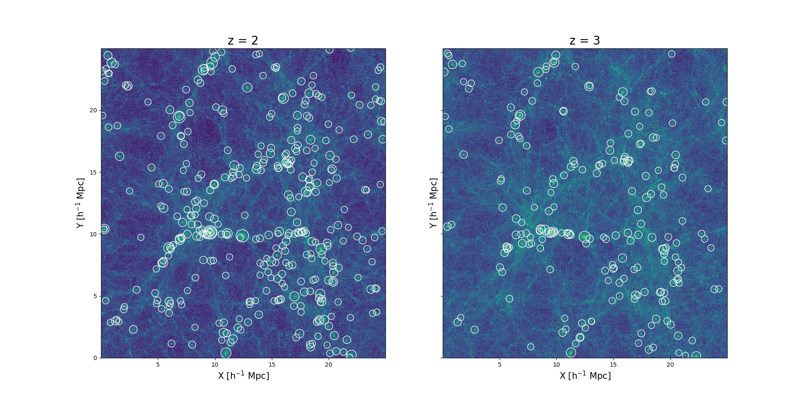**

**Figure 3. 2D distributions of DM halos larger than 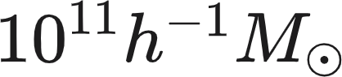 from Rockstar at z = 2 (left) and z = 3 (right). The white circle indicates the DM positions, and the radius indicates its Rvir (virial radius). The background density map shows the dark matter from simulation Gadget-3 snapshots.** *(code: visual.plot.py)*

Figure 3 shows the 2D distribution of dark matter halos (white circles) identified by the Rockstar at z = 2 (left panel) and z = 3 (right panel). The background density map is the dark matter halos from the simulation snapshots Since the number of halos is too many, we plotted only halos larger than ****. The radius of the circle indicates its virial radius.

**3.1. Halo statistics**

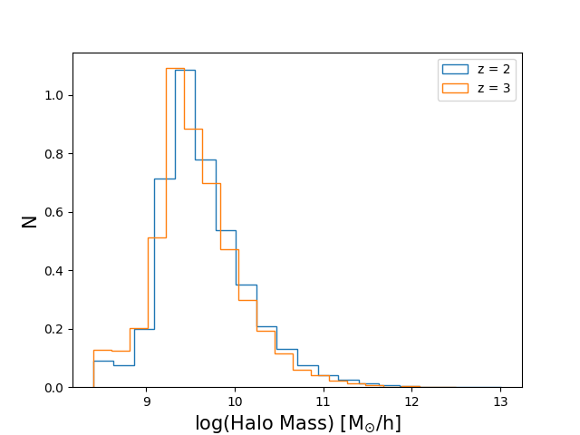

**Figure 4. Normalized Mvir distribution at z = 2 (blue) and 3 (orange).** *(code: visual.plot.py)*

Figure 4 shows the normalized histogram of Mvir identified with Rockstar from the simulation snapshot at z = 2 (blue) and z = 3 (orange). The mass range is from 10^8 ~ 10^12. The mean value of log Mvir at z = 2 (9.64) is ~ 15% larger than that of z = 3 (9.58). This can be interpreted as the subsequent merging of halos lead to a massive halo with time evolution.

**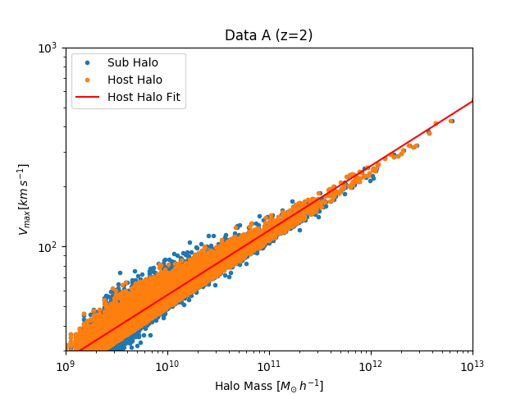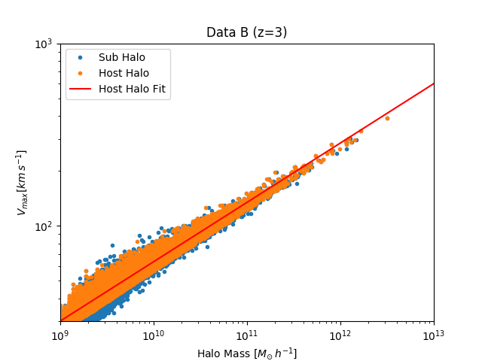**

**Figure 5. Relation between 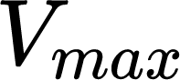 (maximum circular velocity) and Mvir at z = 2 (left) and z = 3 (right). Blue and orange dots indicate the sub-halo and host halo, respectively. The  and Mvir has a power-law relation with a power-law index of 0.3 at z = 2 and z = 3, shown with a red line on each plot.** *(code: Mvir\_Vmax.py)*

Figure 5. shows the relation between Mvir and Vmax (maximum circular velocity) for subhalo (blue dots) and host halo (orange dots) at z = 2 (left), and z = 3 (right). The correlation between Mvir and Vmax can be described by a power law. We fitted the power-law to the host halo with a red line. As can be seen, although sub-halos seem to follow the fitted red line, they have slightly more scatter in the low-mass regime than host halos, which might be due to dynamical stripping. Behroozi(2012) mentioned that sub-halos are more biased toward lower mass at fixed Vmax, which is inconsistent with our results. This might result from the halo finding process we used in Rockstar.

**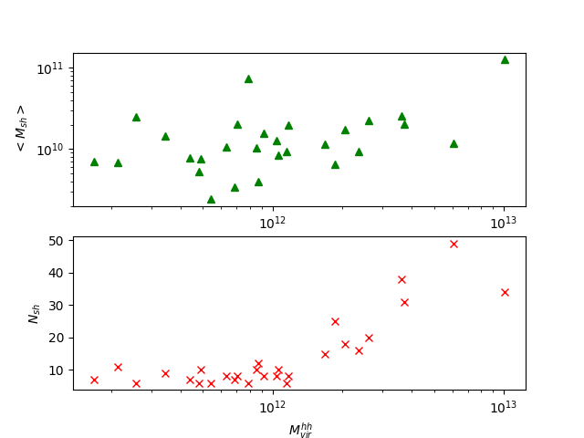**

**Figure 6. Mean mass of subhalos 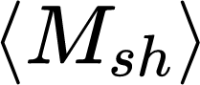 vs. host halo mass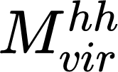 (top panel), and number of sub-halos 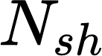 vs. host halo mass  (bottom panel) at z = 2. We only plotted the host halos that have 6 or more sub-halos.** *(code: sub\_host\_relation.py)*

We investigated the relation between sub-halo and host halo. The top panel of Figure 6 shows the relation between host halo mass and mean sub-halo mass. In this result, there is no correlation between them. The bottom panel of Figure 6 shows the relation between the host halo mass and the number of sub-halos. It shows that the number of sub-halos that reside in a host halo is proportional to the host halo mass.

Actually, we want to confirm that the *number of subhalos - host halo mass* relation is consistent with the halo occupation distribution (HOD) (Kravtsov et al.2004), where the *host halo mass - number of satellite galaxies* relation is well described by a simple power law.

Actually, this is not suitable for the following reasons. Firstly, Figure 6 is not HOD. Second, we only plotted host halos which have 6 or more subhalos. Finally, subhalos may contain multiple galaxies. For these reasons, we cannot compare our results with the HOD, but we want to address that the *number of subhalos - host halo mass* relation is still meaningful.

|  |
| --- |
| **Figure 7. Probability density distribution of spin parameters {"code":"$\\lambda^{\\prime}\\,$","font":{"size":11,"color":"#000000","family":"Lato"},"type":"$","backgroundColorModified":false,"id":"5","aid":null,"backgroundColor":"#ffffff","ts":1623828501470,"cs":"10NjLdN7dFUHKlNiWbpx0Q==","size":{"width":10,"height":10}} of dark matter halos larger than** {"backgroundColorModified":false,"id":"4","backgroundColor":"#ffffff","type":"$","font":{"color":"#000000","family":"Lato","size":11},"code":"$10^{10}\\,h^{-1}M_{\\odot}$","aid":null,"ts":1623825184761,"cs":"KVNj6qxSqmrs5HsaZSv/JQ==","size":{"width":72,"height":16}} **at z = 2 (blue dashed line), and z = 3 (orange solid line).** *(code: statistics.py)* |

The amount of rotation of a dark matter halo can be quantified with dimensionless bullock spin parameter (Bullock et al. 2001) expressed by

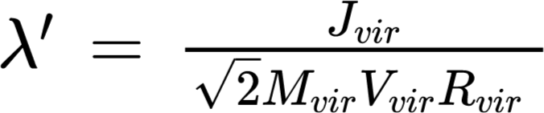,

where 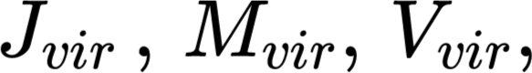 and 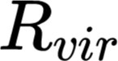are the total angular momentum, mass, circular velocity, and radius at virial radius, respectively. The non-rotating system has a 0 value of the spin parameter. Fig. 7 shows the probability density distribution of spin parameters of halos larger than 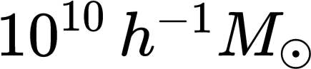 at z = 2 (blue dashed line) and z = 3 (orange solid line), respectively. The DM halos have a very small median value of spin parameter ~ 0.44 at z = 2 with a little bit higher median value of 0.45 at z = 3, indicating that the dark matter halo systems are not supported by their rotation, but by random motions.

|  |  |
| --- | --- |
| **Figure 8. The spin parameter {"code":"$\\lambda^{\\prime}\\,$","font":{"size":11,"color":"#000000","family":"Lato"},"type":"$","backgroundColorModified":false,"id":"5","aid":null,"backgroundColor":"#ffffff","ts":1623828501470,"cs":"10NjLdN7dFUHKlNiWbpx0Q==","size":{"width":10,"height":10}} vs. halo mass (left), and concentration c vs. halo mass (right) at z = 2. The dot-dashed line indicates the median value, and the two dashed lines indicate the 16th and 84th percentile, respectively.** *(code: statistics.py)* | |

We investigate the mass dependence of spin parameter **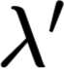** and concentration parameter c at z= 2. In our project, we define the concentration parameter c as 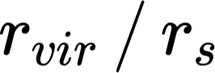, where {"backgroundColorModified":false,"aid":null,"id":"7","font":{"family":"Lato","color":"#000000","size":11},"code":"$r_{vir}$","type":"$","backgroundColor":"#ffffff","ts":1623829745571,"cs":"m0RPtOAlLWc9ugEQk1+deg==","size":{"width":20,"height":8}} is the virial radius, and {"aid":null,"code":"$r_{s}$","type":"$","backgroundColor":"#ffffff","font":{"size":11,"family":"Lato","color":"#000000"},"id":"8","backgroundColorModified":false,"ts":1623829755507,"cs":"Vp71SHWnnATJBN1kW1spXg==","size":{"width":10,"height":8}} is the scale radius from the NFW profile fitting to compare with the result of Andrea et al. 2007.Figure 8 shows the spin parameter **** as a function of halo mass (left), and concentration parameter c as a function of halo mass (right). The dotted-dashed line shows the median value, and the two dotted lines the 16th and 84th percentiles. As can be seen in the left panel, the value of the spin parameter is constant regardless of halo mass, which means the spin parameter is independent of the halo mass. Otherwise, the concentration parameter c is decaying with the increasing halo mass, indicating that the massive halo is less concentrated than the less massive halos. This can be explained by the merging history of massive halos that recent mass accretion has increased the density of the outer part of the host halo, leading to a decrease in the concentration c of the system. The trend seen in Figure 8 is consistent with the previous study of Andrea et al. 2007, although the slope and fitted power-law index are not exactly the same. The large scatter seen in Figure 8 might have originated from the unrelaxed halos since the relaxedness of halos is correlated with the spin and concentration parameter. We will look into the correlations between halo parameters in Figure 12 in detail.

**3.3. Halo shapes**

Someone might ask what is the shape of dark matter halos? Are they spherical or elliptical? Actually, in N-body simulations halos are often fitted with ellipsoidal with 3 axes, 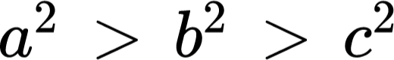. The rockstar provides the dimensionless axial ratio b/a and c/a, where they are measured at the virial radius and calculated using the Allgood method. If the axial ratio b/a and c/a are 1, the shape of the halo is spherical. We investigate the halo mass dependence of halo shape at z= 2 in Figure 9. Figure 9 shows that both mean axial ratio c/a and b/a are decaying with the increasing halo mass, indicating that bigger halos are more likely to be

|  |
| --- |
| **Figure 9. The mean axial ratio c/a vs. halo mass (left) and mean axial ratio b/a vs. halo mass (right) at z = 2. The mass range is the same on both panels.** *(code: shape.py)* |

|  |
| --- |
| **Figure 10. The relation between intermediate axis ratio b/a and minor axis ratio c/a for dark matter haloes larger than {"backgroundColorModified":false,"font":{"family":"Lato","size":11,"color":"#1d1c1d"},"backgroundColor":"#ffffff","aid":null,"id":"18","code":"$10^{10}h^{-1}M_{\\odot}$","type":"$","ts":1623933397437,"cs":"k3cT7Cd0U/jsH+3OyEpxyg==","size":{"width":68,"height":14}}at a z = 2 (left panel) and z = 3 (right panel). The dark matter halo shapes can be divided into oblate, triaxial, and prolate according to their T values, and the division between them appears at 1/3 and 2/3 T values, indicated with a solid black line on the plot.** *(code: shape.py)* |

aspherical than the less massive halos. This can be due to merging events. The merging is often directional and can change the halo’s morphology.

Figure 10. shows the relation between intermediate axis ratio b/a and minor axis ratio c/a for dark matter halos larger than 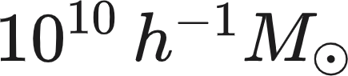 at a z = 2 (left panel) and z = 3 (right panel). The dark matter halo shapes can be divided into oblate, triaxial, and prolate according to their triaxiality T values. The parameter T is expressed with

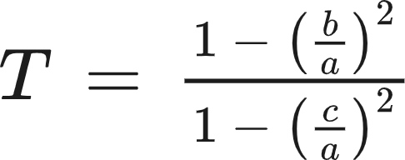,

introduced by Franx et al (1991). If T value is between 0 and ⅓, it is oblate (like a pancake) with a {"font":{"color":"#1d1c1d","size":11,"family":"Lato"},"code":"$\\approx$","aid":null,"backgroundColor":"#ffffff","id":"14","type":"$","backgroundColorModified":false,"ts":1623924782738,"cs":"e/saqgEMYCwik8IABHU/+w==","size":{"width":9,"height":5}} b > c. If T value is between ⅓ and ⅔, it is triaxial with a > b > c, and if T is between ⅔ and 1, it is prolate (like a sausage) with a > b {"font":{"color":"#1d1c1d","size":11,"family":"Lato"},"code":"$\\approx$","aid":null,"backgroundColor":"#ffffff","id":"14","type":"$","backgroundColorModified":false,"ts":1623924782738,"cs":"e/saqgEMYCwik8IABHU/+w==","size":{"width":9,"height":5}} c. The solid black lines in Figure 10 divide the halo shapes into oblate, triaxial, and prolate, and the division occurs at T = ⅓ and T = ⅔. As can be seen, the fraction of triaxial and prolate is much higher than that of oblate at both z = 2 and z = 3. It seems that Figure 10 is not an adequate plot to see any difference in halo shape distribution between two redshifts.

| {"aid":null,"id":"35","backgroundColor":"#ffffff","code":"$12\\,<\\,logMvir$","type":"$","backgroundColorModified":false,"font":{"color":"#000000","size":12,"family":"Times New Roman"},"ts":1624027536363,"cs":"DYKPM1xw7s//p3rUAeUOFQ==","size":{"width":98,"height":13}}{"type":"$","code":"$10\\,<\\,logMvir\\,<\\,11$","id":"31","aid":null,"backgroundColor":"#ffffff","backgroundColorModified":false,"font":{"size":12,"color":"#000000","family":"Times New Roman"},"ts":1624027360338,"cs":"fFlVTO9KSt9uyPcTJFnLog==","size":{"width":140,"height":13}}{"id":"37","code":"$10<\\,logMvir\\,<\\,11$","backgroundColor":"#ffffff","backgroundColorModified":false,"font":{"family":"Arial","color":"#000000","size":12},"aid":null,"type":"$","ts":1624028117818,"cs":"gMTNoCJJmgVIzYoy2kiixQ==","size":{"width":160,"height":16}}{"type":"$","backgroundColorModified":false,"code":"$11\\,<\\,logMvir\\,<\\,12$","id":"36","backgroundColor":"#ffffff","font":{"size":12,"color":"#000000","family":"Times New Roman"},"aid":null,"ts":1624027756046,"cs":"zwmi6rgEPbryKMILXmhoqg==","size":{"width":140,"height":13}}{"backgroundColorModified":false,"id":"38","font":{"size":12,"color":"#000000","family":"Times New Roman"},"code":"$12\\,<\\,logMvir$","aid":null,"type":"$","backgroundColor":"#ffffff","ts":1624028131538,"cs":"ls7wj3bnsM24syWHKQEClw==","size":{"width":98,"height":13}} |
| --- |
| **Figure 11. Histogram of triaxiality (T) of halos at redshift 2 (left panel) and 3 (right panel). The color shows the different halo mass regimes: black, orange, and dark blue show the halo mass between {"backgroundColor":"#ffffff","aid":null,"type":"$","backgroundColorModified":false,"id":"15","font":{"size":11,"color":"#1d1c1d","family":"Lato"},"code":"$10^{10}\\,h^{-1}M_{\\odot}$","ts":1623927983631,"cs":"QUKCCxZ9qOKoZnADoUXljg==","size":{"width":72,"height":14}} and {"id":"16","font":{"size":11,"color":"#1d1c1d","family":"Lato"},"backgroundColorModified":false,"type":"$","backgroundColor":"#ffffff","code":"$10^{11}h^{-1}M_{\\odot}$","aid":null,"ts":1623928025013,"cs":"XyFQ+dEwX/tFexPmrv+W+Q==","size":{"width":68,"height":14}}, between {"id":"16","font":{"size":11,"color":"#1d1c1d","family":"Lato"},"backgroundColorModified":false,"type":"$","backgroundColor":"#ffffff","code":"$10^{11}h^{-1}M_{\\odot}$","aid":null,"ts":1623928025013,"cs":"XyFQ+dEwX/tFexPmrv+W+Q==","size":{"width":68,"height":14}} and {"font":{"color":"#1d1c1d","family":"Lato","size":11},"code":"$10^{12}h^{-1}M_{\\odot}$","aid":null,"id":"17","backgroundColorModified":false,"backgroundColor":"#ffffff","type":"$","ts":1623928042229,"cs":"Q7bPFzz5h+BvG4Tc5ZCUeQ==","size":{"width":68,"height":14}}, and larger than {"font":{"color":"#1d1c1d","family":"Lato","size":11},"code":"$10^{12}h^{-1}M_{\\odot}$","aid":null,"id":"17","backgroundColorModified":false,"backgroundColor":"#ffffff","type":"$","ts":1623928042229,"cs":"Q7bPFzz5h+BvG4Tc5ZCUeQ==","size":{"width":68,"height":14}}, respectively. From left to the right, the mass is increasing. The solid and dashed line at each panel shows the z = 3 and z = 2, respectively. This histogram shows the mass and redshift dependence of halo shape.** *(code: shape.py)* |

Figure 11 shows the histogram of triaxiality T at z= 2, and z = 3. The colors show the different halo mass regimes : black shows the Mvir between 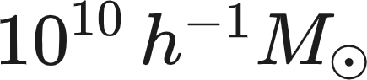 and  (first panel), orange shows the Mvir between  and 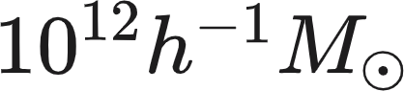 (middle panel), and dark blue shows the Mvir larger than  (last panel). The solid and dashed histogram indicate the z = 3, and z = 2, respectively. The two grey dashed lines on each panel indicate the T = ⅓ and ⅔ values to divide the halo shapes into oblate, triaxial, and prolate indicated with O, T, and P capital on top of each panel. Figure 11 shows similar results with Figure 10 that most halos are prolate with very few oblate ones at a given halo mass. The deficit of halos with T close to 1 is not physical but results from the iterative process in which we define the three axes. Figure 10 shows that the most massive halos have more fraction of prolate than less massive halos, which we can expect that massive halos are experiencing a higher rate of merging than lower mass halos. Prolate shape is likely due to merger events (Allgood et al. (2006)). If you look closer at the relation between redshift and halo shape, the probability of a prolate at z = 3 (solid line) is higher than at z = 2 (dashed line) at a given mass, indicating that halo shapes can change with time evolution.

|  |
| --- |
| **Figure 12. Correlations between halo parameters including Mvir, spin parameter, concentration, Xoff, and mean axial ratio at z = 2. Correlation coefficients ‘r’ values are shown on the left top of each plot. We highlight the noticeable r-value ( |r| > 0.3 ) with red color.** *(code: corrplot.py)* |

To better understand the dark matter halos at a glance, we correlate the fundamental halo properties including Mvir, spin parameter, concentration parameter, Xoff, and axial ratio with each other in Figure 12. The Xoff denotes the offset of the position of the density halo peak from the halo center-of-mass, indicating the relaxedness of a halo. The correlation coefficient r-values are shown on the left top panel of each plot. We highlight the meaningful r-value ( |r| > 0.3 ) with red color. The number of stars \* next to the r-value shows the statistical reliability given by the p-value. The one, two, and three stars indicate the p-value less than 0.1, 0.01, and 0.001, respectively, where the smaller the p-value is, the more reliable the correlation is. We notice that the Xoff parameter has a positive correlation with Mvir and spin parameter and has a negative correlation with concentration parameter c, and axial ratio (b/a, c/a). This suggests the scenario as follows. Recently merging occurs, the Mvir increases. The mass accretion from other halos increases the angular momentum, the spin parameter increases, the concentration parameter c decreases, the halo shapes become aspherical, and the Xoff parameter increases. In conclusion, we notice that all halo properties in Figure 12 are associated with the merging history.  
**4. Summary and Conclusion**

In our project, we found DM halos from the simulation Gadget-3 snapshots using the halo finder ROCKSTAR at z = 2, and z = 3. Then we characterized the fundamental properties of DM halo. Our main results can be summarized as follows.

1. On average, a massive host halo has more subhalos.
2. The mean value of the spin parameter is ~ 0.04, which indicates that DM is not supported by the rotation, but its random motions.
3. Massive halos that recently underwent mass accretion are less concentrated, unrelaxed, and more likely to be prolate,
4. At high z (z=3), halos at a fixed mass are more prolate.
5. Halo shape can change by merging process and with time evolution.

**References**

Allgood, Brandon, et al. "The shape of dark matter haloes: dependence on mass, redshift, radius, and formation." *Monthly Notices of the Royal Astronomical Society* 367.4 (2006): 1781-1796.

Bullock, James S., et al. "A universal angular momentum profile for galactic halos." *The Astrophysical Journal* 555.1 (2001): 240.

Bailin, Jeremy, and Matthias Steinmetz. "Internal and external alignment of the shapes and angular momenta of ΛCDM halos." *The Astrophysical Journal* 627.2 (2005): 647.

Behroozi, Peter S., Risa H. Wechsler, and Hao-Yi Wu. "The rockstar phase-space temporal halo finder and the velocity offsets of cluster cores." *The Astrophysical Journal* 762.2 (2012): 109.

Franx, Marijn, Garth Illingworth, and Tim de Zeeuw. "The ordered nature of elliptical galaxies-Implications for their intrinsic angular momenta and shapes." *The Astrophysical Journal* 383 (1991): 112-134.

Maccio, Andrea V., et al. "Concentration, spin and shape of dark matter haloes: scatter and the dependence on mass and environment." *Monthly Notices of the Royal Astronomical Society* 378.1 (2007): 55-71.

Kravtsov, Andrey V., et al. "The dark side of the halo occupation distribution." *The Astrophysical Journal* 609.1 (2004): 35.

**Appendix**

Python code we used for our project has been sent through email.**