Name: Kunal Jain

Roll No: 14AE10019

**SYSTEMS LABORATORY - Spring 2017**

1. **Series RLC Circuit**

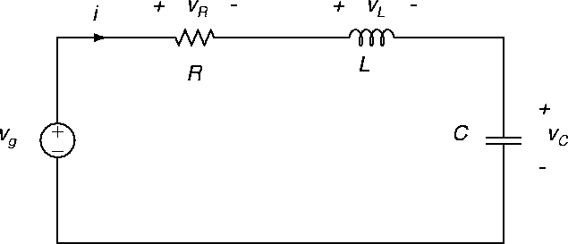

From Kirchoff’s Voltage Law,

**Lq¨ + Rq˙ + q/C = V**

The parameters were given as follows:

* Source Voltage, **V** = 10V
* Resistance, **R** = 1Ω
* Inductance, **L** = 0.001 H
* Capacitance, **C** = 0.0001 F

Using simulink, this equation of motion was modelled as shown below.

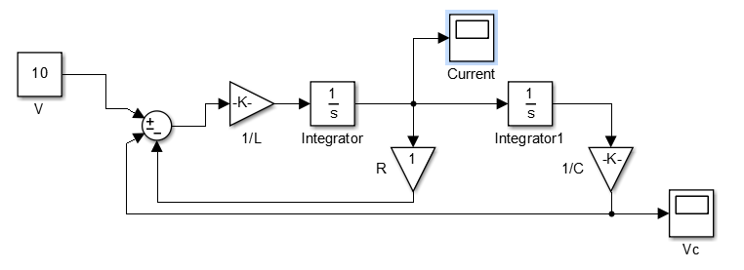

**The following is the Laplace transform solution of the equation.**

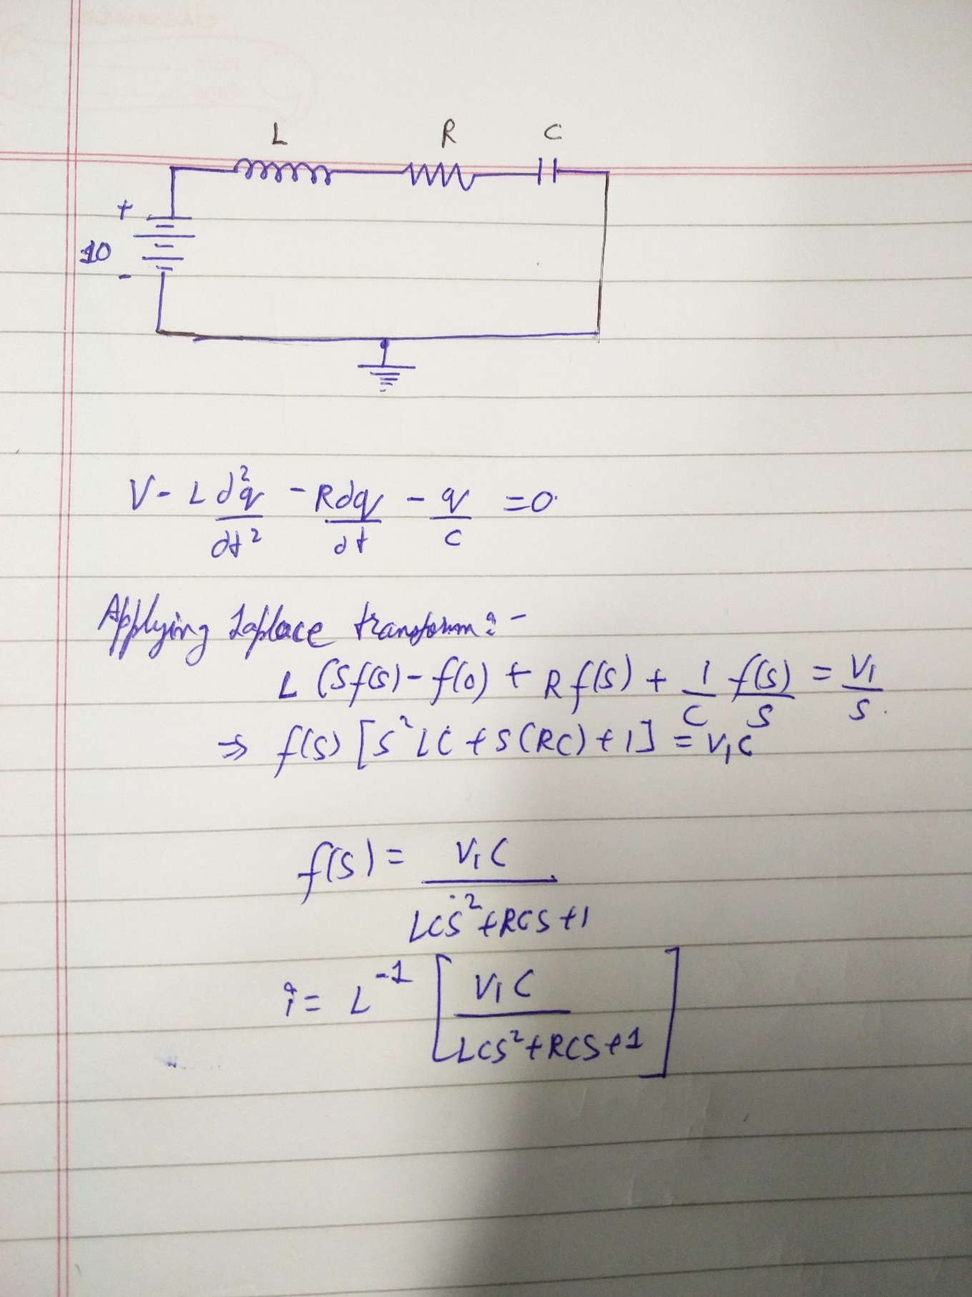

**The following transient response was obtained**.

**Voltage across the capacitor**

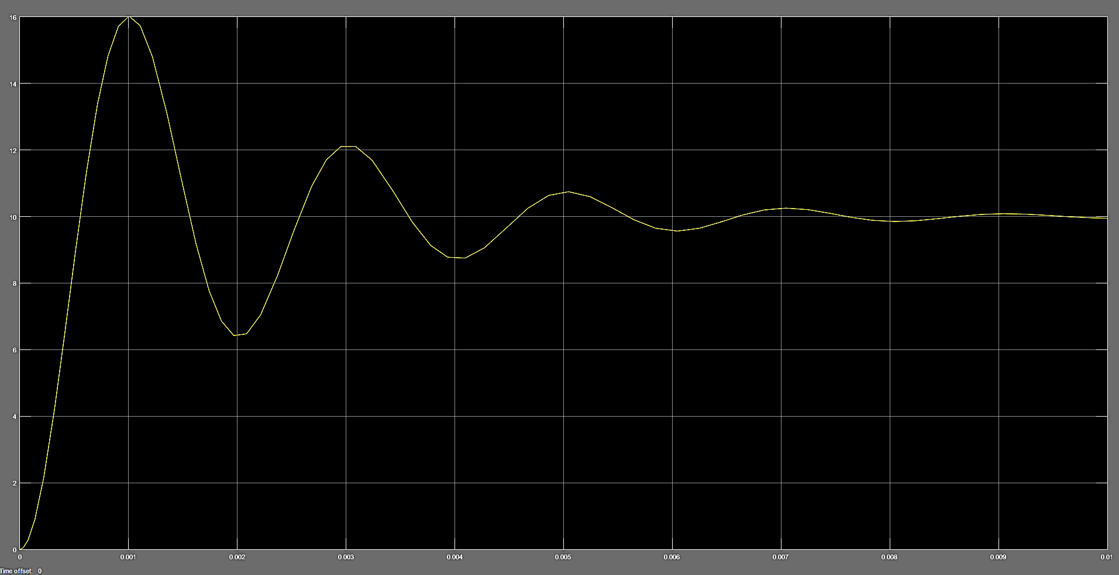

**Current across the capacitor**

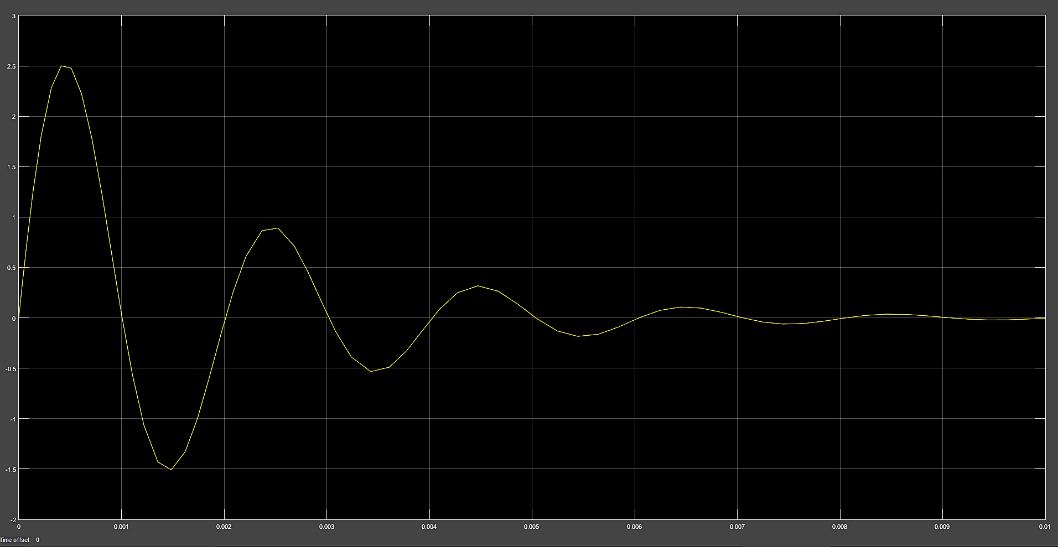

1. **Parallel RLC Circuit**

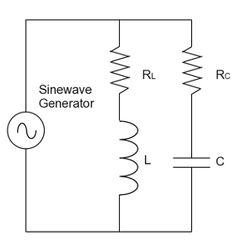

From Kirchoff’s Voltage Law,

**RCq1˙ + q1/C = V**

**Li2˙ + RLi2 = V**

From Kirchoff’s Current Law,

**i1 + i2 = i**

The parameters were given as follows:

* Source Voltage, **V** = 10V
* Resistance, **RL** = 0.1Ω
* Inductance, **L** = 0.1 H
* Resistance, **RC** = 10Ω
* Capacitance, **C** = 0.01 F

Using simulink, this equation of motion was modelled as shown below.

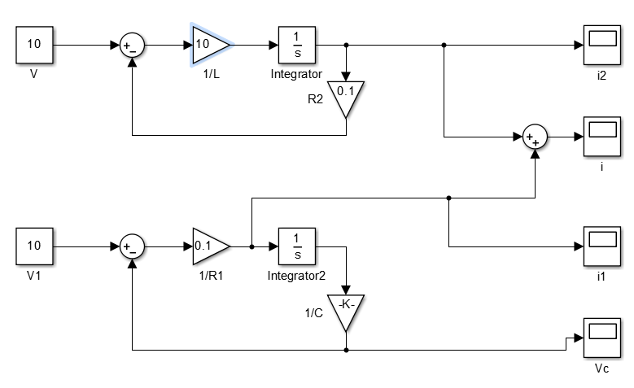

**The following transient response was obtained**.

**Voltage across the capacitor**

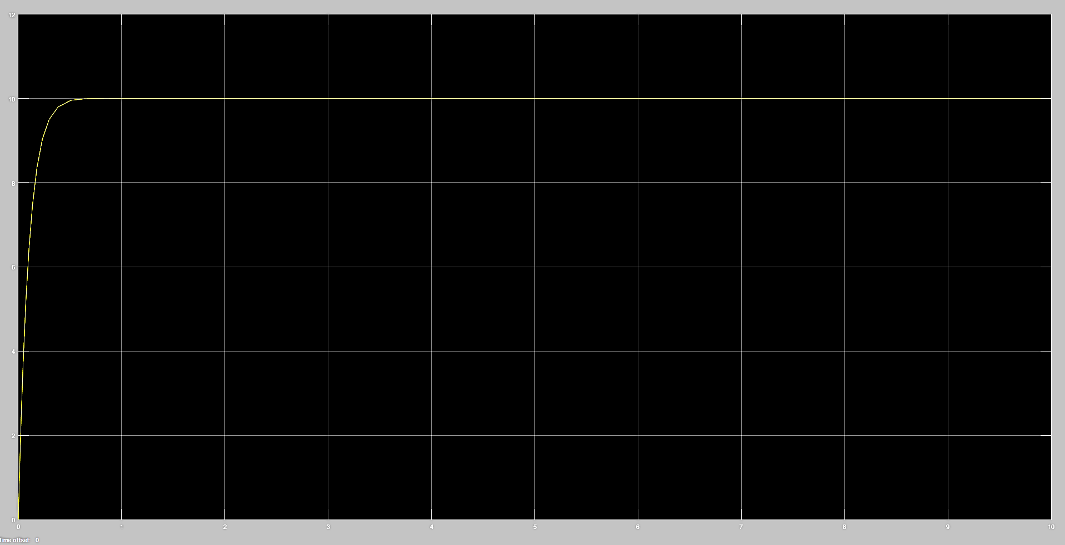

**Current across the capacitor**

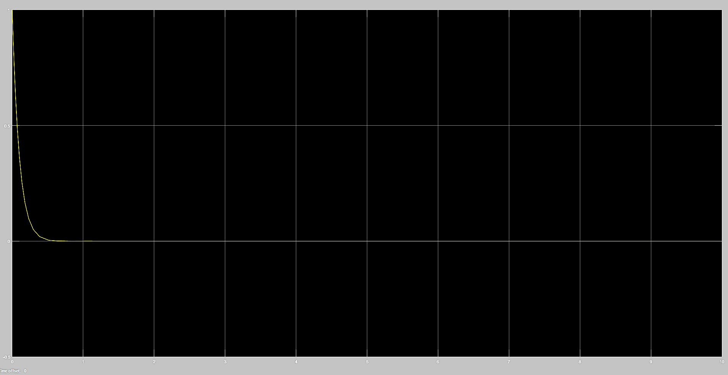

**Total Current in the circuit**

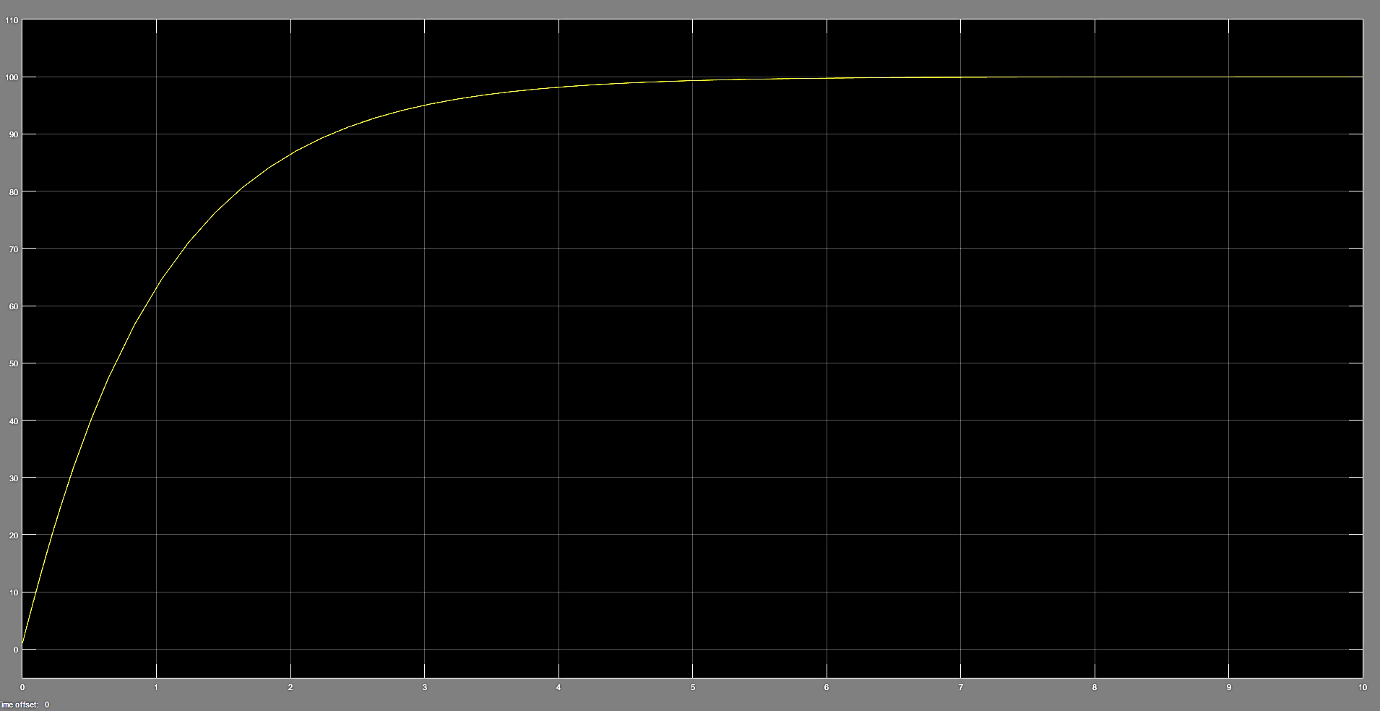

1. **DC Motor Circuit**

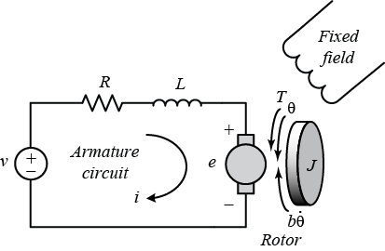

State Space equation:

The parameters were given as follows:

* Moment of inertia of rotor, **J** = 0.01 kg-m^2
* Motor Viscous Coefficient, **b** = 0.1 N-m-s
* Electromotive Force Constant, **ke** = 0.01 V/rad/s
* Motor Torque Constant, **kt** = 0.01 N-m/A
* Resistance, **R** = 1 ohm
* Inductance, **L** = 0.5 H

Using simulink, this equation of motion was modelled as shown below.

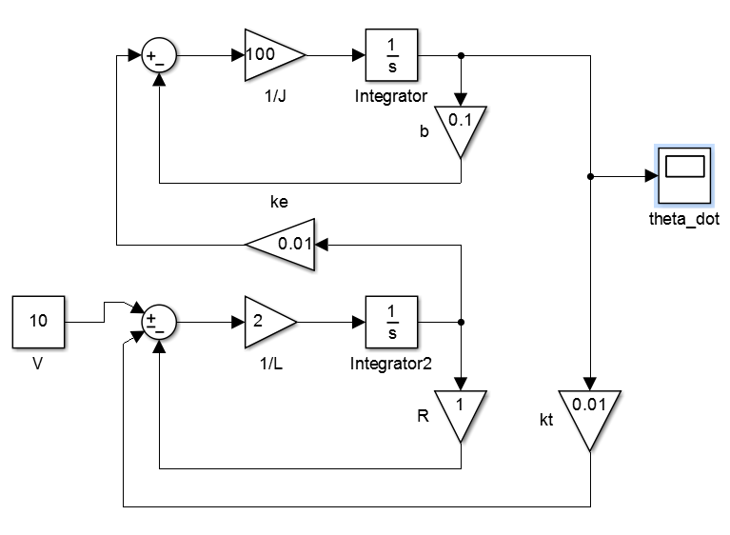

**The following transient response was obtained**.

