Name: Kunal Jain

Roll No: 14AE10019

**SYSTEMS LABORATORY - Spring 2017**

**MAGNETIC LEVITATION**

The Magnetic Levitation System (MLS) is a **nonlinear**, **open-loop** **unstable,** **frictionless** dynamical system.

The system is fully integrated with MATLAB/Simulink and operates in the real-time in MS Windows.

In the case of two electromagnets the lower one can be used for external excitation or as a contraction unit. This feature extends the MLS application and is useful in robust controller design in a fast and easy way.

**Physical System Description**

The MLS consists of

* Electromagnet as an actuator and ferromagnetic ball (PLANT)
* Ball position sensor (IR transmitter and receiver) (MEASUREMENT/FEEDBACK)

The specifications are as shown.

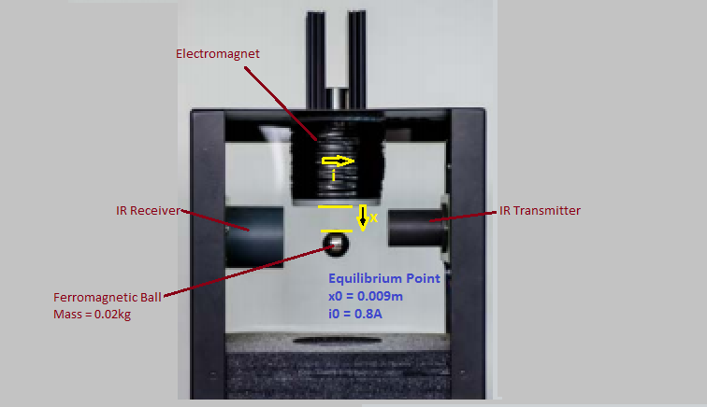

**Physical Dynamic Model**

The electromagnet along with the suspended metallic ball may be collectively termed as the plant. Input to the plant is the current flowing in the electromagnet’s coil. The plant’s output is the vertical displacement of the suspended ball, which is sensed by an optical sensor. The sensor used here is an IR Tx/Rx. As the metallic ball is attracted upwards by the electromagnet it partially covers the sensor, bringing about a change in its surface area exposed to the light source, which is thus converted into measured position of the ball. The measured position is sent back to the control loop as feedback, since, the MLS is inherently unstable in open-loop.

The PID control loop is used here, which takes the setpoint position and the feedback, and tries to minimize the error in the two. Hence, it produces a control signal, which is the voltage to be applied to the electromagnet. This voltage is directly proportional to the current in the coil.

The ball is acted upon by its weight due to gravitational force, and the electromagnetic force. Thus, a non-linear system is obtained, which can be linearized about the equilibrium point using a Taylor series expansion:

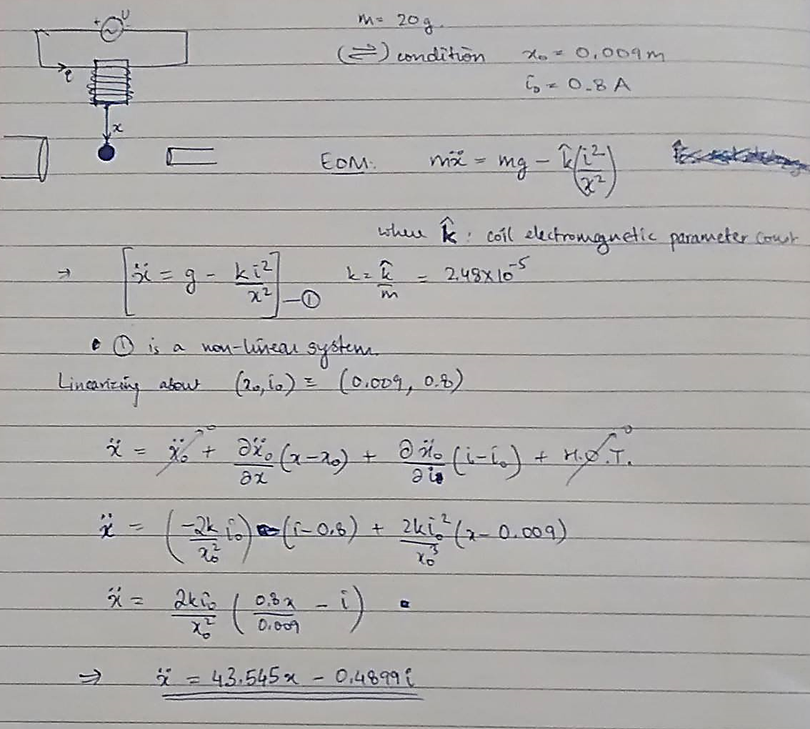

The **control variable** of the PID Loop is the voltage we apply to the electromagnet. This is the input for our plant, and the current used in the plant equation is directly dependent on it:



Thus, the final **plant** can be represented in the following ways:

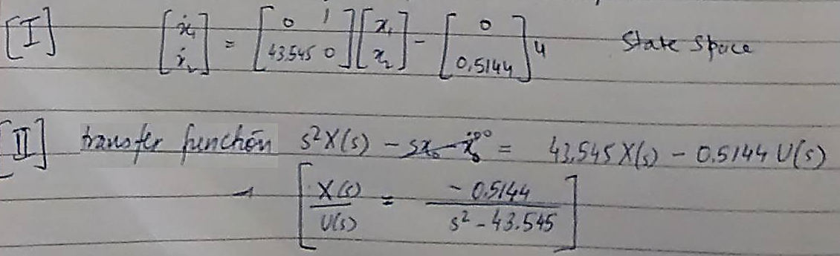

**Using Simulink, this system was modelled as shown below.**

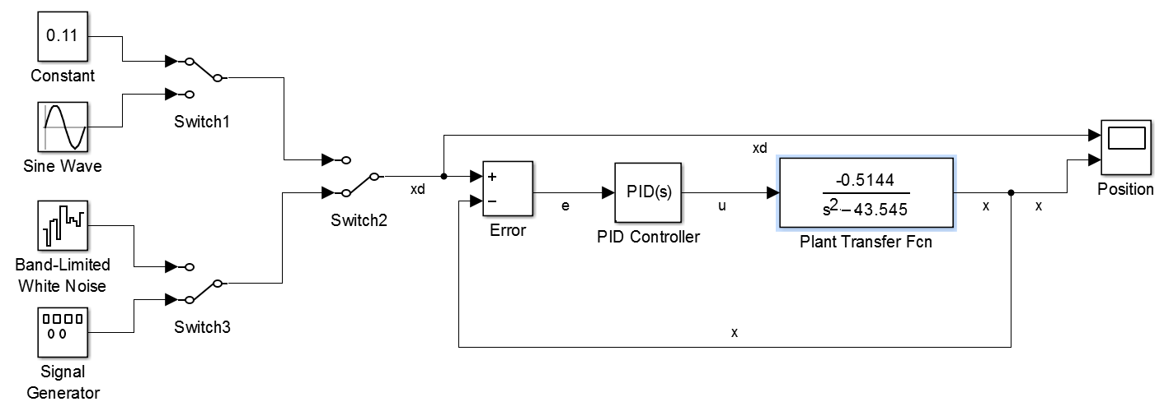

Tuned values of PID parameters:

* 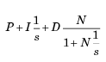**Kp**: -1802.63633168845
* **Ki**: -5937.61734268954
* **Kd**: -134.383925464391
* **Filter Coefficient, N**: 383.737180014477

**The desired trajectory and the trajectory followed are shown below.**

**Desired Trajectory: Constant levitation at 0.11m**

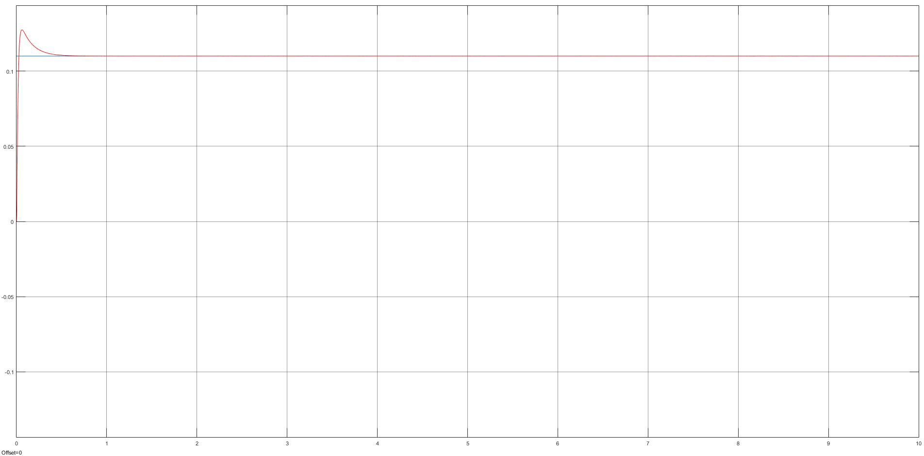

**Desired Trajectory: Sine Wave (Amplitude: 0.1m; Frequency: 10 rad/s)**

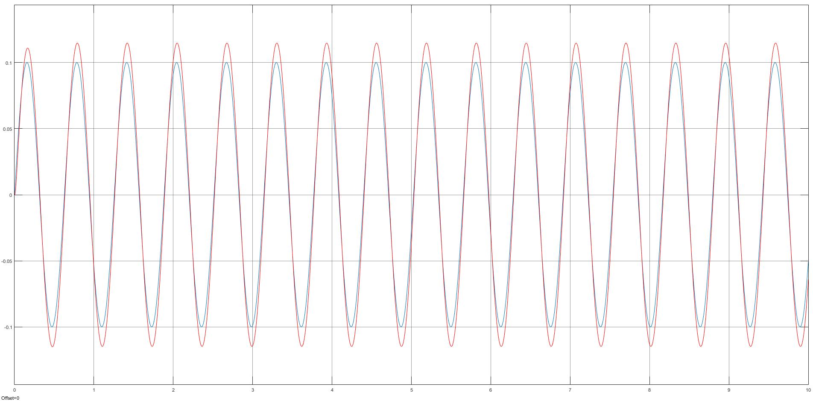

**Desired Trajectory: Random White Noise**

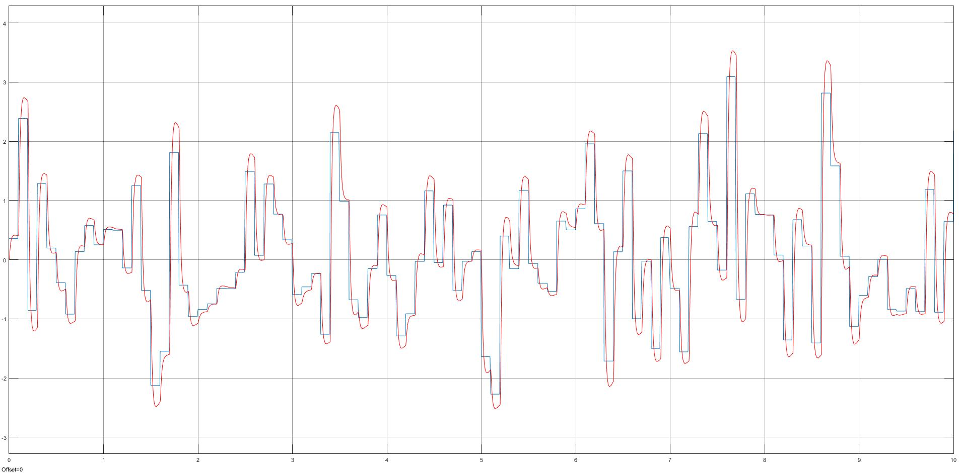

**Desired Trajectory: Sawtooth Function (Amplitude: 0.1m; Frequency: 10 rad/s)**

