**STREAMING TICKET ASSIGNMENT FOR EFFICIENT SUPPORT OPERATIONS**

**Team ID: NM2025TMID16623**

**Team Size: 4**

**Team Leader:** K.Monika

**Team Members:** V.Krishnaveni

**Team Members:** R.Mohanalakshmi

**Team Members:** K.Lavanya

**Project Overview:**

This project, Streaming Ticket Assignment for Efficient Support Operations, is implemented on the ServiceNow platform. The aim is to automate the assignment of incident tickets to appropriate support groups based on the issue type (Certification or Platform).  
  
The system reduces manual intervention by using Flow Designer to route tickets dynamically. This ensures quicker resolution, accurate ticket handling, and higher productivity in IT support.

**Objectives:**

1. To create and configure users and groups in ServiceNow.
2. To assign roles and responsibilities to each group.
3. To design and implement Flow Designer automation for ticket assignment.
4. To test and validate ticket routing for different issue categories.

**Tools and Technologies:**

Platform: ServiceNow (Developer Instance)  
Modules Used: Users, Groups, Roles, Flow Designer  
Languages: JavaScript (optional for scripting, if required)

**Skills Used:**

ServiceNow Administration  
Flow Designer Automation  
User and Group Management

Configuration & Testing  
Problem-Solving and Logical Thinking

**Task Initiation / Milestones:**

**Milestone 1: Create Users**

* Navigate to All → Users.
* Add new users with required details.
* Save user profiles for assignment.

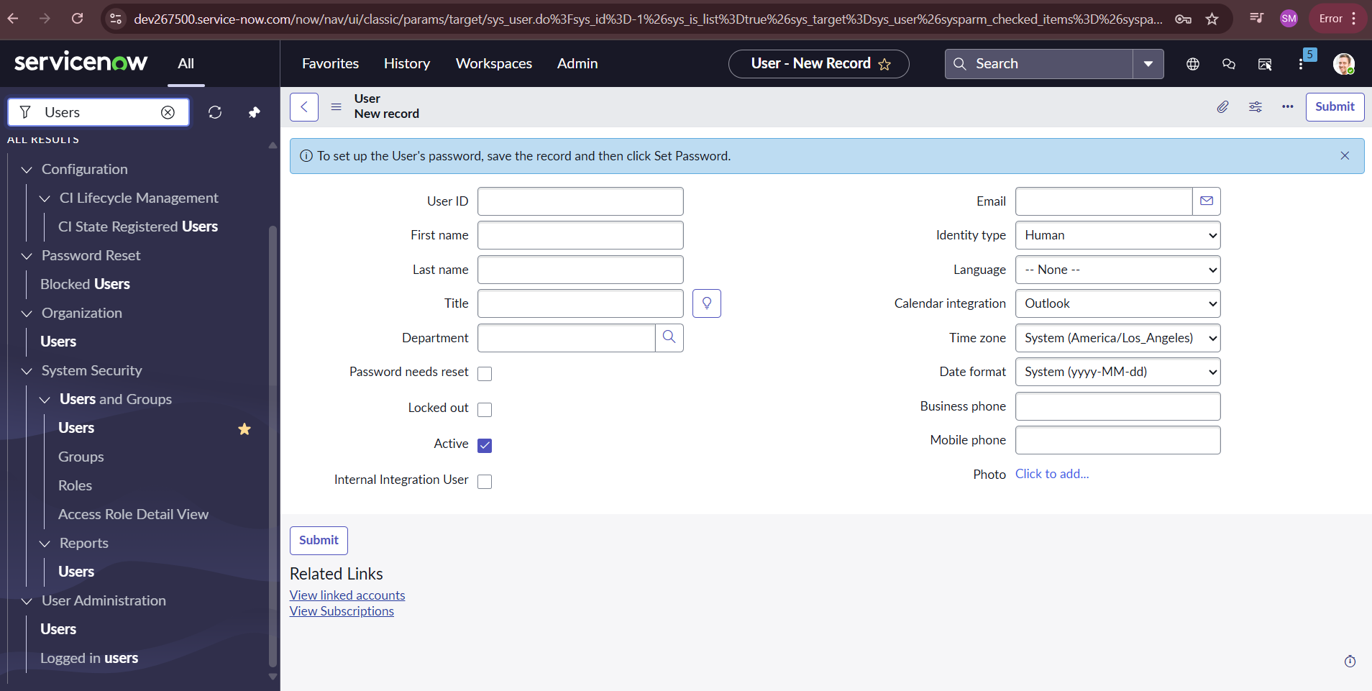

**Milestone 2: Create Groups**

* Navigate to All → User Administration → Groups.

**Create two groups:**

* Certification
* Platform

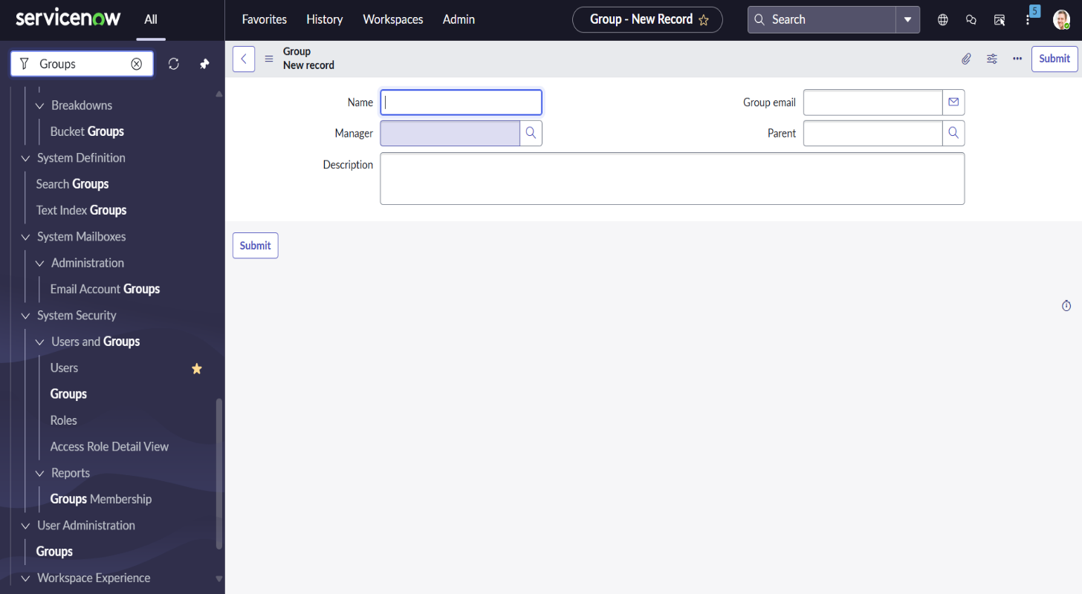

**Milestone 3: Assign Roles and Users**

* Assign roles like ITIL or Admin to groups.
* Add users into respective groups.
* Verify access rights and group membership.

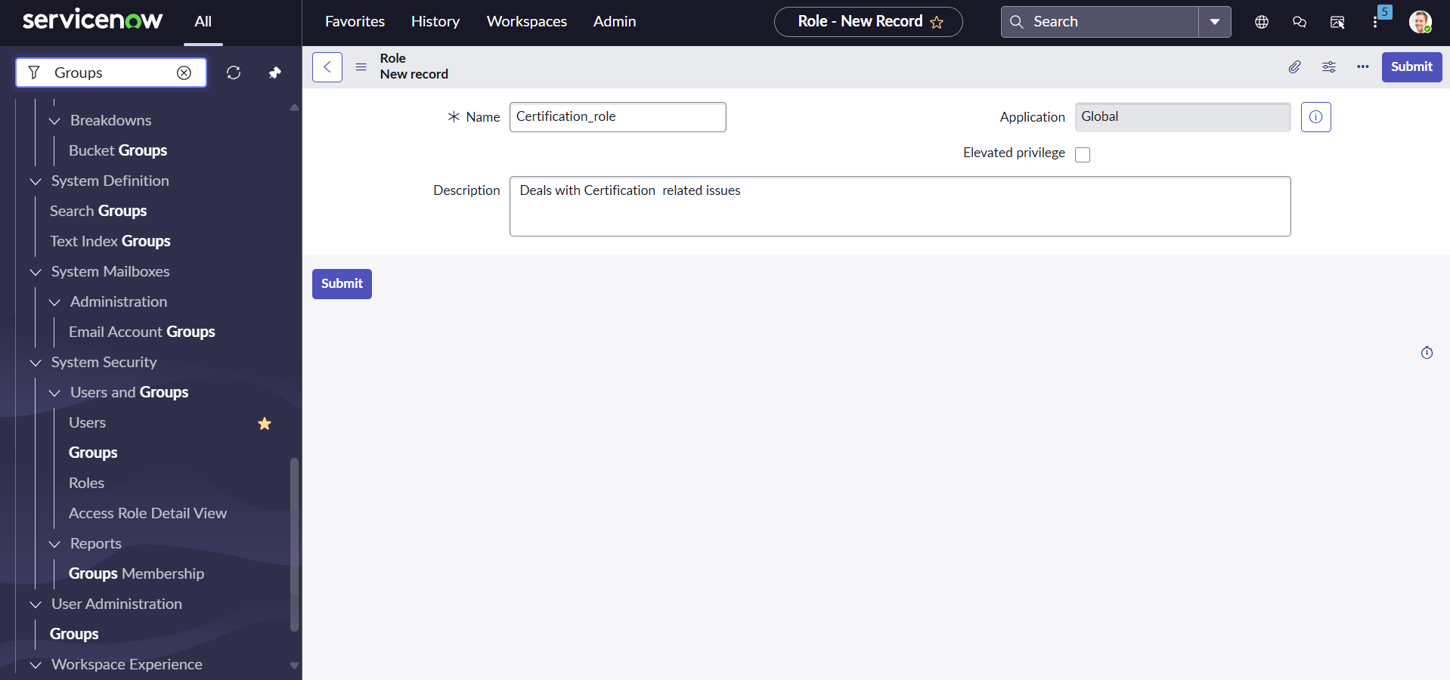

**Milestone 4: Create Flow**

* Open Flow Designer in ServiceNow.
* Create a new flow for incident assignment.

**Configure logic:**

* If Issue Type = Certification → assign to Certification Group.
* If Issue Type = Platform → assign to Platform Group.
* Save and activate the flow.

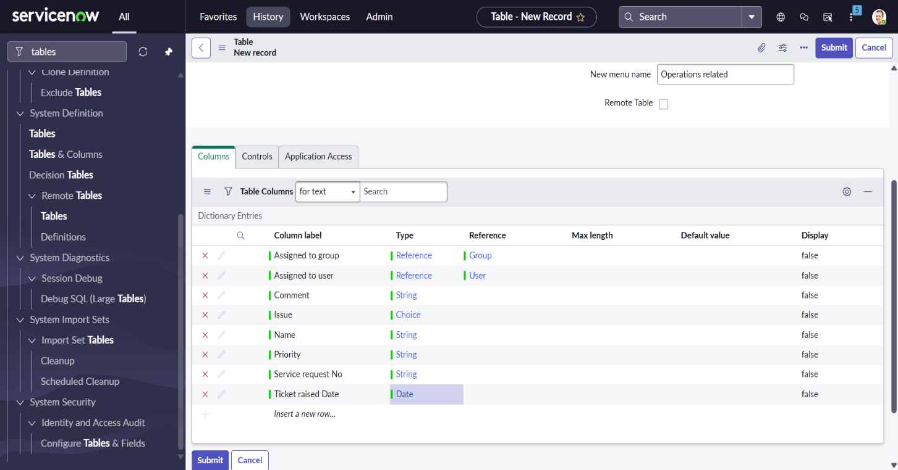

**Milestone 5: Testing**

* Create an incident ticket with Certification issue → verify assignment to Certification Group.
* Create an incident ticket with Platform issue → verify assignment to Platform Group.
* Confirm tickets are auto-assigned without manual input.

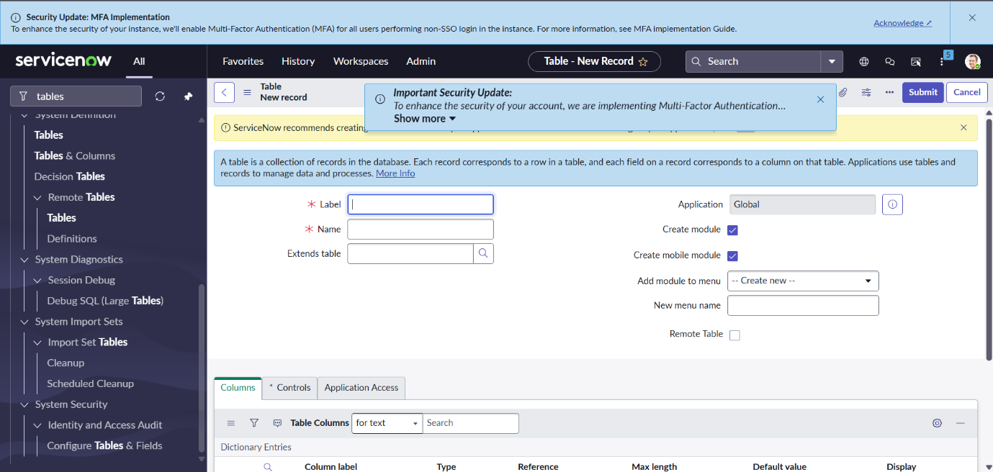

**Conclusion:**

The Streaming Ticket Assignment Project demonstrates how ServiceNow automation can improve IT service operations by ensuring efficient ticket routing.  
  
The project reduces errors, minimizes delays, and enhances support operations by automating ticket assignments. This highlights ServiceNow’s role in improving productivity and service delivery through streamlined workflows.