Statistical Characterization of a Gm-C Continuous-Time Filter in SKY130: Monte Carlo and PVT-Corner Study
A project report submitted in partial fulfilment
of the requirements for the degree of

Bachelor of Technology
in
Electronics and Computer Engineering
by
Jaidev K
25BEC1392
S Jai Akaash
25BECxxxx
Mohanakrishnan S
25BECxxxx
Jeswant P M
25BECxxxx


School of Electronics Engineering
Vellore Institute of Technology, Chennai
Vandalur - Kelambakkam Road
Chennai – 600127, India

October 2026


School of Electronics Engineering
Declaration
We hereby declare that the report titled Statistical Characterization of a Gm-C Continuous-Time Filter in SKY130: Monte Carlo and PVT-Corner Study submitted by us to the School of Electronics Engineering, Vellore Institute of Technology, Chennai, in partial fulfilment of the requirements for the course BAECE203 - Analog Electronics of Bachelor of Technology in Electronics and Computer Engineering, is a bonafide record of the work carried out by us under the supervision of Dr. Brintha Therese A.
We further declare that the work reported in this report has not been submitted and will not be submitted, either in part or in full, for any other course.
Signature of the Student: ․․․․․․․․․․․․․․․․․․․․․․
Name and Reg. No.: Jaidev K (25BEC1392)
Signature of the Student: ․․․․․․․․․․․․․․․․․․․․․․
Name and Reg. No.: S Jai Akaash (25BECxxxx)
Signature of the Student: ․․․․․․․․․․․․․․․․․․․․․․
Name and Reg. No.: Mohanakrishnan S (25BECxxxx)
Signature of the Student: ․․․․․․․․․․․․․․․․․․․․․․
Name and Reg. No.: Jeswant P M (25BECxxxx)
Date: ․․․․․․․․․․․․․․․․․․․․․․

School of Electronics Engineering
Certificate
This is to certify that the project report titled Statistical Characterization of a Gm-C Continuous-Time Filter in SKY130: Monte Carlo and PVT-Corner Study is submitted by Jaidev K (25BEC1392), S Jai Akaash (25BECxxxx), Mohanakrishnan S (25BECxxxx), Jeswant P M (25BECxxxx), Vellore Institute of Technology, Chennai, for the completion of the course BAECE203-Analog Electronics for degree of Bachelor of Technology in Electronics and Computer Engineering. The project report fulfils the requirements as per the regulations of this University and, in my opinion, meets the necessary standards for submission.
Supervisor
Signature: ․․․․․․․․․․․․․․․․․․․․․․
Name: Dr. Brintha Therese A
Date: ․․․․․․․․․․․․․․․․․․․․․․

(Seal of the School)
Abstract
Analog filters built on a modern process rarely hit their target frequency, because the process, the supply voltage and the temperature all move the transistor behaviour, and random mismatch between neighbouring transistors adds a further spread. This project studies how large that spread is for a second-order transconductor-capacitor low-pass filter, designed in the open SkyWater 130 nm process with a 1.6 MHz cutoff and a quality factor near 0.72. The filter uses three identical transconductance amplifiers and two 10 pF capacitors. Using free tools only, the work simulates 45 operating conditions (five process corners, three supply voltages and three temperatures) with 750 random mismatch trials each, 33,750 trials per design, and counts a trial as passing when the cutoff stays within 10 % of target and the quality factor lies between 0.6 and 0.8. A fixed voltage bias passes only 22.4 % of trials. A bias current that rises with absolute temperature raises this to 88.7 % with an ideal reference and to 71.7 % with a transistor-level reference circuit that includes its own mismatch. The result is an open, reproducible statistical baseline for such filters, with all netlists, seeds and scripts released.
Acknowledgements
We thank the School of Electronics Engineering, Vellore Institute of Technology, Chennai, for providing the opportunity and the environment to carry out this project as part of the course BAECE203 - Analog Electronics.
We wish to express our sincere thanks and deep sense of gratitude to our project guide, Dr. Brintha Therese A, School of Electronics Engineering (SENSE), for her consistent encouragement and valuable guidance offered to us in a pleasant manner throughout the course of the project work.
We also acknowledge the open-source communities whose work made a simulation-only study of this depth possible: the SkyWater and Google teams behind the SKY130 process design kit, the ngspice and Xyce developers, the maintainers of the iic-osic-tools container image, and the authors of the open reference material cited in the bibliography. Finally, we thank our families and friends for their support.
Codes and Standards
This project is a simulation-only study, so no product-certification standard applies. The following codes, conventions and tool licences were followed and are listed so that the work can be reproduced and audited.
Item | Where it is used
SkyWater SKY130A open process design kit (Apache-2.0 licence), model files sky130.lib.spice with corners tt, ss, ff, sf, fs and the mismatch variants tt_mm to fs_mm | All device models, all corners, all Monte Carlo mismatch statistics
SPICE netlist syntax as implemented by ngspice 47 and Xyce 7.10 | Netlists, AC, DC operating-point and transient analyses
Nominal supply 1.8 V with a +/-10 % tolerance (1.62 V to 1.98 V) | Supply axis of the PVT grid
Temperature range -20 degC to 85 degC (27 degC typical) | Temperature axis of the PVT grid
Pelgrom area law for transistor mismatch, sigma(dVT) = A_VT / sqrt(W L) | Independent cross-check of the mismatch spread (Chapter 4)
Binomial (normal-approximation) 95 % confidence interval for a yield estimate | All yield figures: mean over 45 conditions +/-0.4 points (750 runs per condition) or +/-2 points (40 runs per condition)
Open-source licences of ngspice (BSD-style), Xyce (GPL), Streamlit (Apache-2.0), Python scientific stack (BSD-style) | Tool chain and the live laboratory application

Mapping of Sustainable Development Goals (SDGs)
The table below maps the project to the United Nations Sustainable Development Goals. The contribution of a simulation study is indirect, so the justifications are limited to what the work actually provides.
Project Title | Mapped SDGs | Justification | Example Impact
Gm-C Filter Statistical Characterization in SKY130 | SDG 9 - Industry, Innovation and Infrastructure | Provides a complete, openly reproducible design-and-verification flow for an analog filter on an open process, lowering the barrier to custom silicon. | Small teams and institutions can design and verify analog circuits without a proprietary foundry agreement.
Gm-C Filter Statistical Characterization in SKY130 | SDG 4 - Quality Education | Uses only free tools and ships a live laboratory application in which students can change corner, supply and temperature and watch the distributions move. | Students can learn statistical analog design hands-on on any computer.
Gm-C Filter Statistical Characterization in SKY130 | SDG 12 - Responsible Consumption and Production | Statistical sign-off before fabrication shows which bias scheme raises yield from 22.4 % to 88.7 % (ideal) or 71.7 % (transistor-level). | Fewer failed chips and fewer re-spins mean less wasted silicon and energy (indirect, estimated from simulated yield only).
Gm-C Filter Statistical Characterization in SKY130 | SDG 17 - Partnerships for the Goals | All netlists, seeds, scripts and results are archived with checksums for open release, so others can verify and extend them. | Creates a shared, citable baseline for the open-silicon community.
Table of Contents
Declaration i
Certificate ii
Abstract iii
Acknowledgements iv
Codes and Standards v
Mapping of Sustainable Development Goals (SDGs) vi
List of Figures ix
List of Tables x
List of Acronyms xi

1 Introduction 1
1.1 Background and Motivation 1
1.2 Problem Statement 2
1.3 Objectives 2
1.4 Scope and Contributions 2
1.5 Organisation of the Report 3
2 Literature Survey 4
2.1 Review of Prior Work 4
2.1.1 Statistical Characterization of G_{m}-C and Continuous-Time Filters 4
2.1.2 Open-Source SKY130 Analog and OTA Design 4
2.1.3 Simulation Methodology: Monte Carlo and PVT Corners 5
2.1.4 Why PVT Sensitivity Matters 6
2.2 Gaps Identified 6
3 Methodology 8
3.1 System Architecture 8
3.1.1 G_{m}-C Biquad Topology 8
3.1.2 The OTA Cell 9
3.2 Bias Schemes Compared 11
3.2.1 Fixed Voltage Bias (baseline) 11
3.2.2 Ideal PTAT Current Bias 11
3.2.3 Transistor-Level PTAT Core (beta multiplier) 12
3.3 Process, Voltage and Temperature Grid 13
3.4 Monte Carlo Mismatch Analysis 14
3.4.1 Mismatch in the SKY130 PDK 14
3.4.2 Monte Carlo Procedure 14
3.4.3 Specification and Yield 15
3.5 Simulation Flow and Tools 15
3.6 Cross-Validation Plan 16
3.7 Testbench and Measurement Definitions 16
3.8 Statistical Estimators 17
4 Results and Discussion 18
4.1 Nominal Response of the Filter 18
4.2 PVT Drift: Voltage Bias versus PTAT Bias 18
4.3 Spec Yield over the 45 Conditions 20
4.4 Mismatch Statistics: Distributions of f₃ and Q 22
4.5 Correlation between f₃ and Q 23
4.6 Passband Ripple and Summary Statistics (Table T-I) 24
4.7 Reference-Mirror Sizing and Sources of Variance 25
4.8 Transistor-Level Reference Core (1,800 runs) 26
4.9 Cross-Validation Results 28
4.10 Additional Studies 29
4.10.1 Tolerance of the Bias 29
4.10.2 Reference Exponent 29
4.10.3 Large-Signal Behaviour and Step Response 30
4.10.4 A Resistor-Based Alternative Bias 30
4.10.5 Noise (nominal) 30
4.11 Live Laboratory Application and Demonstration 30
4.12 Output Explanation: How to Read the Results 32
4.13 Design Guidelines Derived from the Results 33
4.14 Discussion and Limitations 34
5 Conclusion and Future Scope 35
5.1 Conclusion 35
5.2 Limitations 36
5.3 Future Scope 36
Appendix 37
Appendix 1: Top-Level Netlist and OTA Cell (gmc_top.spice) 37
Appendix 2: Transistor-Level Bias Core (netlist excerpt) 37
Appendix 3: Monte Carlo Driver (ptat_mc.py) 38
Appendix 4: Results for all 45 Conditions 40
Appendix 5: Reproduction and Release 41
Bibliography 42
Biodata 44
List of Figures
1.1 Overview of the study 3
2.1 Qualitative placement of the prior work against this study along two axes 6
3.1 Block diagram of the three-OTA G_{m}-C biquad 8
3.2 Signal flow of the biquad 8
3.3 Schematic of the OTA cell 10
3.4 Ideal PTAT bias generator 11
3.5 PTAT bias current versus temperature 12
3.6 Beta-multiplier bias core (transistor level) 13
3.7 The 45-condition PVT grid 14
3.8 The Monte Carlo loop for one PVT condition 15
4.1 Nominal AC response, magnitude and phase 18
4.2 Mean f₃ versus temperature per corner 19
4.3 Mean f₃ across the 45 conditions 19
4.4 Typical-corner f₃ and yield versus temperature 20
4.5 Mean f₃ and spec yield by corner 21
4.6 Yield heat map, voltage bias 21
4.7 Yield heat map, ideal PTAT bias 21
4.8 Yield by supply and by temperature 22
4.9 Histograms of f₃ and Q at tt, 1.8 V, 27 °C 23
4.10 f₃ versus Q scatter, PTAT bias 24
4.11 Passband ripple distribution 24
4.12 Effect of reference-mirror area 25
4.13 Share of f₃ variance by transistor group 26
4.14 Yield of the transistor-level core 27
4.15 Yield in each condition, three designs 27
4.16 Core current and mean f₃ versus supply 28
4.17 Live Monte Carlo tab, 3,000 runs 31
4.18 Live results: response bundle, histograms, scatter, convergence 31
4.19 Cross-checks tab 32
4.20 Summary statistics, exponent scan, noise and limits 32
List of Tables
1.1 Project objectives and where they are addressed 2
2.1 Comparison of the most relevant prior work with this study 5
2.2 Research gaps and how this project addresses them 6
3.1 OTA device sizes (all devices SKY130A, 1.8 V) 10
3.2 Testbench settings and measurement definitions 16
4.1 Results by process corner (mean over the 9 supply and temperature points of each corner) 19
4.2 Typical corner at 1.8 V versus temperature (750 runs per row) 20
4.3 Summary of the two designs over all 45 conditions (33,750 runs each) 20
4.4 Summary statistics (Table T-I of the project), PTAT bias 25
4.5 Extra Monte Carlo sets (PTAT bias): seeds, tolerance and reference-mirror sizing 25
4.6 Three bias schemes compared 28
4.7 Cross-validation summary 28
4.8 Reading guide for the outputs 32
6.1 All 45 PVT conditions 40
List of Acronyms
Acronym | Full Form
AC | Alternating current (small-signal) analysis
ADC | Analog-to-digital converter
BSIM4 | Berkeley short-channel IGFET model, version 4
CMFB | Common-mode feedback
CMOS | Complementary metal-oxide-semiconductor
DC | Direct current (operating-point) analysis
ECG | Electrocardiogram
FF | Fast NMOS, fast PMOS process corner
FS | Fast NMOS, slow PMOS process corner
Gm-C | Transconductor-capacitor (filter)
GND | Ground (0 V reference)
MC | Monte Carlo
NMOS | N-channel metal-oxide-semiconductor transistor
OTA | Operational transconductance amplifier
PDK | Process design kit
PMOS | P-channel metal-oxide-semiconductor transistor
PTAT | Proportional to absolute temperature
PVT | Process, voltage and temperature
Q | Quality factor
SDG | Sustainable Development Goal
SF | Slow NMOS, fast PMOS process corner
SKY130 | SkyWater 130 nm open process
SNR | Signal-to-noise ratio
SPICE | Simulation program with integrated circuit emphasis
SS | Slow NMOS, slow PMOS process corner
THD | Total harmonic distortion
TT | Typical NMOS, typical PMOS process corner
VDD | Positive supply voltage
Xyce | Parallel circuit simulator from Sandia National Laboratories

CHAPTER 1
Introduction
1.1 Background and Motivation
Every sensor, radio and data converter needs filters. A filter removes the part of a signal that should not be there, whether that is noise, an interferer or the alias of a fast signal, and it does so with a frequency response set by a handful of component values. On a chip, the most compact way to build such a filter is to use transistors as the main elements. A transconductor-capacitor filter, written G_{m}-C, does exactly that: a transconductance amplifier turns a voltage into a current, the current charges a capacitor, and the ratio of the two sets the cutoff frequency. No on-chip resistor is needed, the circuit works at high frequency, and the cutoff can be tuned by changing a bias current.
The same property that makes the circuit easy to tune also makes it fragile. The cutoff frequency of a G_{m}-C filter is proportional to the transconductance of its amplifiers divided by the capacitance, and the transconductance of a transistor depends on how the silicon was made (process), on the supply voltage and on the temperature. A filter that meets its target at the typical condition can be tens of percent away from it at another condition. Published measurements of uncorrected continuous-time filters report time-constant errors of about 30 % from process and temperature alone and up to 50 % at the extremes, which is why commercial filters carry on-chip tuning loops [9], [10]. Even at a single operating condition, small random differences between nominally identical transistors, called mismatch, spread the response of every manufactured copy around its average.
The open-source silicon movement has recently made it possible to study these effects without a commercial foundry agreement. The SkyWater SKY130 process, released with a complete open process design kit (PDK), ships transistor models, corner files and mismatch statistics, and it can be simulated with the free ngspice and Xyce simulators [5]. Individual building blocks have already been published in this process, but the literature surveyed in Chapter 2 contains no filter-level statistical study that combines process corners, supply and temperature variation with Monte Carlo mismatch analysis, and publishes the files needed to repeat it. This project fills that gap.
1.2 Problem Statement
Design a second-order G_{m}-C low-pass filter in the open SKY130 process and quantify, with a statistical simulation campaign, how much its cutoff frequency f₃, its quality factor Q, its passband ripple and its power vary across process, voltage, temperature and device mismatch. Determine how much of the variation a temperature-compensating bias current can remove, and express the answer as a single number that a designer can use, the yield: the fraction of random trials that meet the specification.
The specification chosen for the study is a cutoff (-3 dB) frequency of 1.6 MHz within +/-10 %, and a quality factor between 0.6 and 0.8 (the Butterworth value is 0.707). Both limits must hold at the same time for a trial to count as a pass.
1.3 Objectives
The project was planned around six objectives at the first review. They are repeated here with the work that answers each of them.
Table 1.1: Project objectives and where they are addressed
No. | Objective | Section
1 | Design a working second-order G_{m}-C low-pass filter in SKY130 with a 1.6 MHz cutoff and Q near 0.7 | 3.1, 3.2, 4.1
2 | Run at least 500 Monte Carlo mismatch trials and report the distributions of f₃, Q and passband ripple | 3.4, 4.4, 4.5, 4.6
3 | Sweep process corners, supply and temperature, and compare a fixed voltage bias with a PTAT bias current | 3.2, 3.3, 4.2, 4.3
4 | Cross-validate the results (AC against transient, a second simulator, an independent sensitivity calculation) | 3.6, 4.9
5 | Fill the literature gap: an open-PDK, filter-level, statistical, reproducible study | 2.2, 5.1
6 | Release netlists, seeds, scripts and results openly | Appendix 5

1.4 Scope and Contributions
The work is a pre-layout, schematic-level simulation study. It does not include layout parasitics, package effects, supply noise or silicon measurements. Within that scope the main contributions are:
• A complete 3-OTA G_{m}-C biquad built from transistors of the SKY130A process, with all sizes, bias values and netlists documented.
• A statistical characterization of 33,750 Monte Carlo trials per design over 45 process, voltage and temperature conditions, for two bias schemes, giving distributions of f₃, Q, ripple and power.
• A quantified comparison: a fixed voltage bias gives 22.4 % yield, a temperature-proportional (PTAT) current bias gives 88.7 % with an ideal reference source, and a transistor-level beta-multiplier reference core gives 71.7 % when its own mismatch and supply sensitivity are included.
• A cross-validation package: AC against transient analysis, a tolerance rerun, an independent sensitivity calculation, a second simulator (Xyce) and seed-to-seed reproducibility.
• Supporting studies on reference-mirror sizing, bias tolerance, large-signal distortion, step response, a resistor-based alternative bias and a nominal noise analysis.
• An open release: netlists, seeds, scripts, result tables and a live laboratory web application, archived with checksums.

1.5 Organisation of the Report
Chapter 2 reviews the literature and identifies the gap. Chapter 3 describes the circuit, the three bias schemes, the PVT grid, the Monte Carlo method and the cross-validation plan. Chapter 4 presents the results and discusses them, including a walk-through of the live application used in the demonstration. Chapter 5 concludes and lists future work. The appendices contain the netlists, the Monte Carlo driver, the full 45-condition tables and the reproduction instructions.
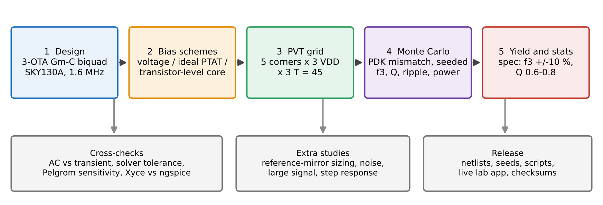
Figure 1.1: Overview of the study: design, bias schemes, PVT grid, Monte Carlo, yield, with the cross-checks, extra studies and release alongside.
CHAPTER 2
Literature Survey
2.1 Review of Prior Work
2.1.1 Statistical Characterization of G_{m}-C and Continuous-Time Filters
The sensitivity of continuous-time filters to process, supply and temperature is a long-recognised problem. Because the cutoff frequency of a G_{m}-C filter depends on the ratio of transconductance to capacitance, and the transconductance itself varies with process corner and temperature, an uncorrected filter can drift substantially, which is why on-chip tuning circuitry is standard in commercial designs. Leynes et al. report an uncorrected RC time-constant drift of about 30 % in a 0.35 micrometre CMOS process, rising to about 50 % at extreme conditions [9]. Chen et al. describe an auto-tuning scheme in 55 nm CMOS that reduces the average tuning error to 2.21 % (3.67 % maximum) [10]. These figures set the scale of the problem and the bar that a bias-compensation scheme should be measured against.
The closest precedent for a statistical study at the filter level is the 2020 paper of Kumngern, Aupithak, Khateb and Kulej [1], who built a 0.5 V fifth-order Butterworth low-pass filter from multiple-input OTAs for ECG applications in a proprietary TSMC 0.18 micrometre process and ran 200 Monte Carlo mismatch simulations, reporting the spread of the cutoff frequency. The paper shows that filter-level Monte Carlo characterization is feasible and publishable, and its protocol, mismatch-driven runs that produce a distribution of the key transfer-function parameters, is the template adopted here. It does not, however, use an open process, release its netlists or models, or report a combined corner, supply and temperature sweep in the form used in this project.
2.1.2 Open-Source SKY130 Analog and OTA Design
A separate and more recent strand of literature documents individual analog blocks in the open SKY130 process. Aiello et al. designed a linear transconductance OTA that uses source degeneration to widen the linear input range, built and simulated entirely with open tools, and explicitly suitable for G_{m}-C filters [2]. The block stops at the cell level: it is not assembled into a filter and is not subjected to Monte Carlo or PVT analysis. The SKY130_CT-DSM repository uses a Gm cell as the front end of a continuous-time delta-sigma modulator and documents a large flicker-noise coefficient in the PDK as a modelling characteristic that matters for precision analog work [3]. The AnalogGym benchmark suite presented at ICCAD 2024 documents more broadly that open PDKs such as SKY130 often lack precise subthreshold modelling compared with mature commercial nodes [4], a limitation that bears directly on any statistical claim drawn from SKY130 simulation.
A literature check repeated at the final review found one further related open project, tt_um_psei_ota_qboost, a second-order regenerative OTA-C filter for the Tiny Tapeout shuttle. Its repository describes a DAC-staircase smoothing filter with four OTAs, one used for Q-boosting, and reports no Monte Carlo, corner or PVT statistics. It is therefore an open filter-level design, but not a statistical study.
2.1.3 Simulation Methodology: Monte Carlo and PVT Corners
Across the analog design literature, Monte Carlo and PVT corner analysis are treated as complementary. Corner analysis captures global, die-to-die process shifts at a few predefined extremes, while Monte Carlo analysis samples local device mismatch across many random trials and reveals spread that corners alone cannot. Best practice is to combine both. SKY130 tutorials and the PDK documentation confirm that the process ships separate typical, slow and fast corner files together with built-in mismatch terms that support exactly this combined approach [5], [7]. The open_pdks community notes that mismatch is enabled globally through a switch carried by the _mm corner variants, that there is no per-device switch, and that a fresh random draw requires a new seed and a reset of the simulator for every run [11], [12]; these notes shaped the Monte Carlo driver of Section 3.4.
Table 2.1: Comparison of the most relevant prior work with this study
Study / source | Domain | Statistical? | Open PDK? | Filter-level? | Scripts released?
Aiello et al. [2] | Single OTA, SKY130 | No | Yes | No | No
Kumngern et al. [1] | 5th-order G_{m}-C-style filter, TSMC 0.18 um | Yes (200 MC) | No | Yes | No
SKY130_CT-DSM [3] | Gm cell as delta-sigma front end | No | Yes | No (sub-block) | Partial
AnalogGym [4] | Open-PDK analog benchmark suite | Framework-level | Yes | N/A | Yes (framework)
psei OTA Q-boost | Second-order regenerative OTA-C filter, SKY130 | Not found | Yes | Yes | Yes
SKY130 MC/PVT tooling [5], [7] | Device- and cell-level flows | Yes (cell level) | Yes | No | Yes (tooling)
This work | 3-OTA G_{m}-C biquad, SKY130 | Yes (750 MC x 45 PVT) | Yes | Yes | Yes (full release)

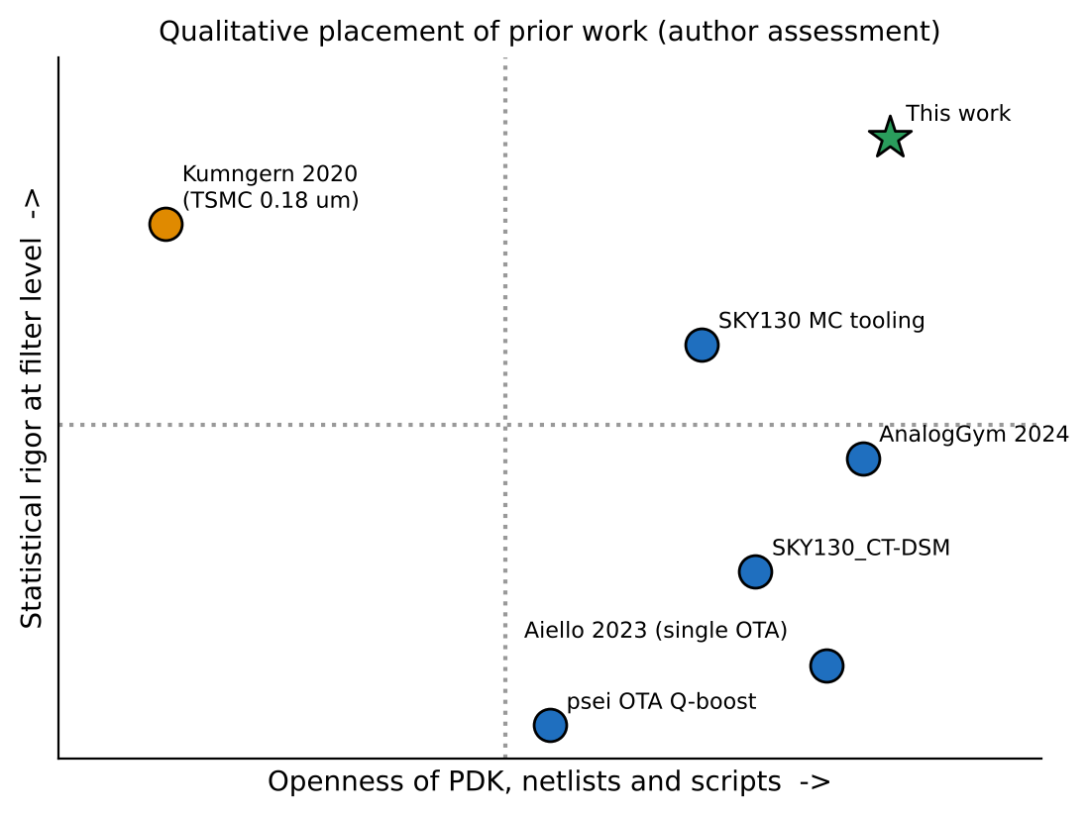
Figure 2.1: Qualitative placement of the prior work against this study along two axes: openness of the process, netlists and scripts, and statistical rigor at the filter level (author assessment).
2.1.4 Why PVT Sensitivity Matters
Every quantified drift figure found in the literature comes from a proprietary process (TSMC, STM PD-SOI or a commercial 55 nm node) [9], [10]. No equivalent figure exists for an open-source SKY130 G_{m}-C filter. The result of this project provides that missing number: with a fixed voltage bias the mean cutoff frequency moves by 0.94 MHz (59 % of the 1.6 MHz target) across the 45 conditions, against 0.08 MHz (5 %) with an ideal PTAT reference and 0.29 MHz (18 %) with a transistor-level reference core (Chapter 4).
2.2 Gaps Identified
Taken together, the literature on statistical characterization of G_{m}-C filters and the literature on open SKY130 analog design have developed largely independently. Rigorous Monte Carlo and PVT methodology exists only in proprietary processes, and open-SKY130 contributions exist only below the filter level and without statistical treatment. Table 2.2 maps each gap to the part of this project that addresses it.
Table 2.2: Research gaps and how this project addresses them
Gap identified in the literature | How this project addresses it
Open-SKY130 OTA work stops at the device level and has never been assembled and evaluated as a complete filter. | Three SKY130 transconductor cells form a working second-order G_{m}-C low-pass biquad (two integrators and a third OTA that sets Q, no output buffer), evaluated as an integrated system.
Statistical (Monte Carlo / PVT) characterization of G_{m}-C filters exists only in proprietary nodes. | The same methodology, 750 Monte Carlo runs at each of 45 PVT conditions (33,750 per design), is applied inside the open SKY130 PDK.
Open filter and OTA papers report a single nominal simulation and give no sense of expected spread. | The deliverable is the full distribution (mean, standard deviation, corner extremes) of f₃, Q and ripple, not one operating point.
No reproducible, openly released netlist and script package exists for SKY130 filter-level statistical analysis. | Every netlist, testbench, Monte Carlo seed and analysis script is archived with checksums for open release, so every histogram can be regenerated.
Known SKY130 modelling limits (flicker noise, subthreshold precision) are rarely stated as explicit boundaries. | These limits are stated up front and revisited wherever they could affect a reported number (Sections 4.14 and 5.2).
Cross-validation between simulation domains is uncommon in single-method open-PDK studies. | AC results are checked against transient analysis, against a tight-tolerance rerun, against an independent sensitivity calculation and against a second simulator (Xyce).

The novelty claim is deliberately limited to what was found in the search: no published work was found that performs Monte Carlo and PVT statistical characterization of a complete G_{m}-C filter in an open-source PDK with a full release of the artifacts. The claim should be re-checked against a fresh literature sweep before any submission, because open-SKY130 analog work is proliferating quickly.
CHAPTER 3
Methodology
3.1 System Architecture
3.1.1 G_{m}-C Biquad Topology
The filter is a second-order low-pass biquad built from three identical OTAs and two capacitors. OTA1 integrates the difference between the input and the filter output onto C₁ (node V_{o1}). OTA2 integrates V_{o1} onto C₂ (node V_{o2}), and V_{o2} is the filter output, with no buffer. The output is fed back to the inverting input of OTA1 so that the loop has unity DC gain. OTA3 has its output tied to its own inverting input, so it behaves as a resistor of value 1/g_{m3} from V_{o1} to the common-mode level; this resistor damps the first integrator and sets the quality factor.
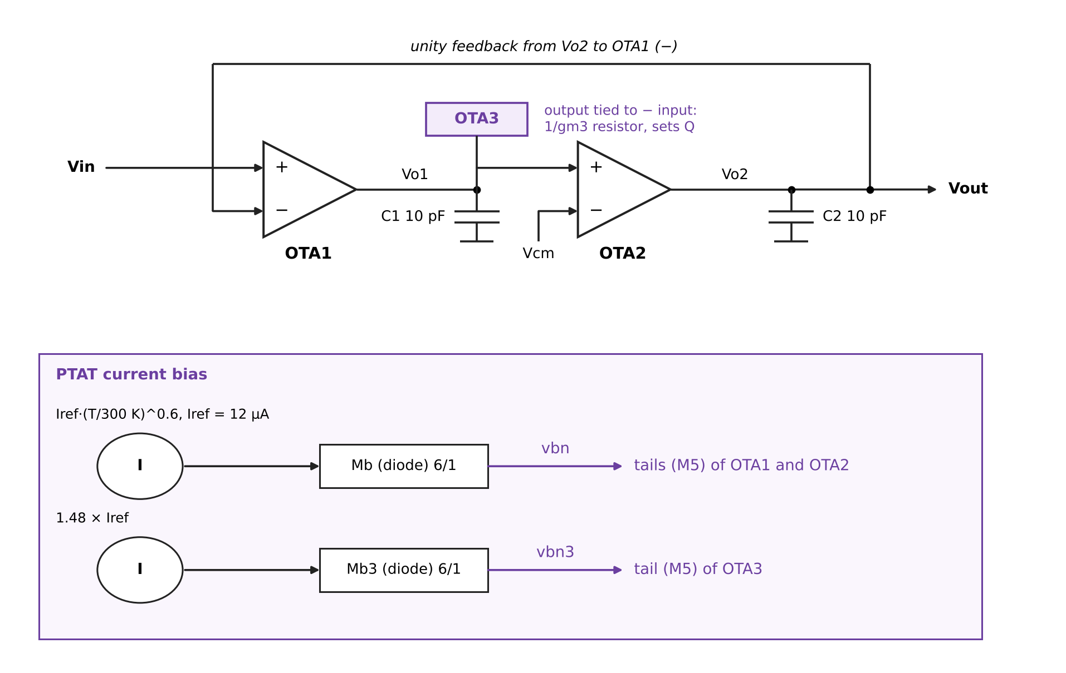
Figure 3.1: Block diagram of the three-OTA G_{m}-C biquad with its PTAT-referenced bias (OTA1 and OTA2 share one bias node, OTA3 has its own).
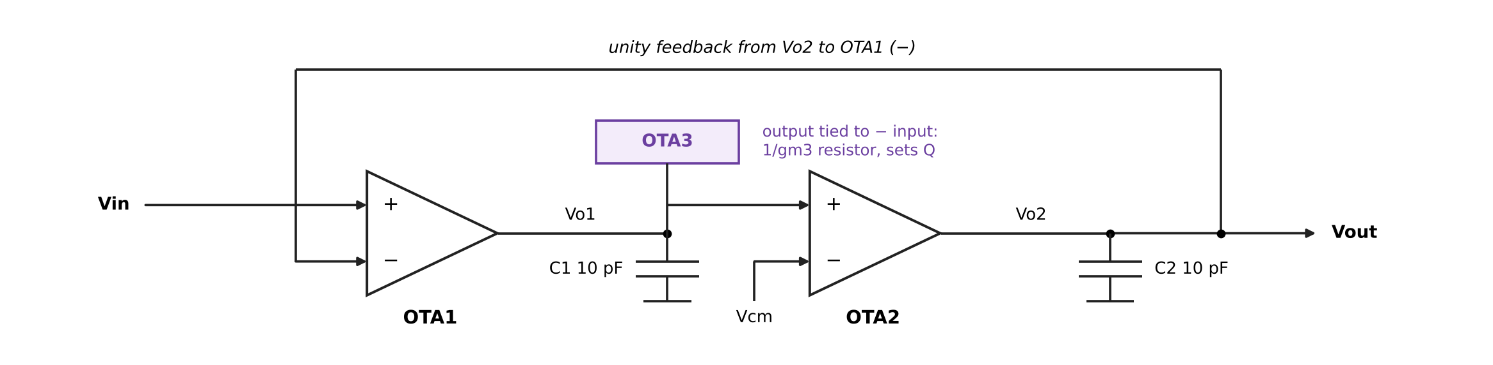
Figure 3.2: Signal flow: Vin enters OTA1, integrates onto V_{o1} and V_{o2}, exits at V_{o2}; OTA3 damps V_{o1}.
With all three OTAs having transconductance gm1 = gm2 = g_{m} and g_{m3}, and capacitors C₁ = C₂ = C, the transfer function from the input to the output is the standard second-order low-pass form
H(s) = ω₀² / ( s² + (ω₀/Q) s + ω₀² ) (3.1)
ω₀ = g_{m} / C , Q = g_{m} / g_{m3} (3.2)
Equal capacitors and equal OTA sizes fix the natural frequency f₀ = g_{m} / (2πC) and make the quality factor the ratio of two transconductances. A Butterworth response needs Q = 0.707, so g_{m3} should be about 1.41 times smaller than g_{m}. Because the OTAs are identical in size, this ratio is set by bias current: OTA3 is biased with a current 1.48 times that of OTA1 and OTA2, which was chosen in simulation to give a design Q of about 0.72 (slightly above Butterworth, still inside the 0.6 to 0.8 window). For a Butterworth response, the -3 dB frequency f₃ equals f₀; with Q slightly above 0.707 the -3 dB frequency lies marginally above f₀.
For a target f₃ of 1.6 MHz with C = 10 pF, the required transconductance per OTA is
g_{m} = 2π f₀ C = 2π × 1.6 MHz × 10 pF ≈ 100 µS (3.3)
The final device sizes and bias currents were tuned in simulation until the measured f₃ at the typical condition was close to 1.6 MHz. At a tail current of 12 µA (6 µA in each input transistor) the input pair of W/L = 4 µm/0.5 µm runs at a small overdrive of roughly 0.1 V by a square-law estimate, which gives a transconductance of the same order as the 100 µS required. The square-law estimate is only a sanity check; the simulated response is the reference.
3.1.2 The OTA Cell
Each OTA is a five-transistor differential amplifier: an NMOS input pair M1 and M2, a PMOS current-mirror load M3 and M4, and an NMOS tail current source M5 (Figure 3.3). The tail current, set by the bias voltage at the gate of M5, is the only tuning knob of the transconductance. The differential current produced by M1 and M2 flows into the output node, where it charges the capacitor; the mirror load converts the differential current to a single-ended output current without extra devices.
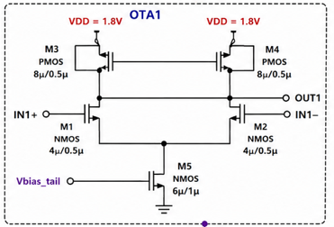
Figure 3.3: Schematic of OTA1 with device sizes (OTA2 and OTA3 are identical): M1, M2 NMOS 4/0.5; M3, M4 PMOS 8/0.5; M5 NMOS tail 6/1.
Table 3.1: OTA device sizes (all devices SKY130A, 1.8 V)
Device | Type (model) | W (um) | L (um) | Role
M1, M2 | NMOS sky130_fd_pr__nfet_01v8 | 4 | 0.5 | Differential input pair; voltage-to-current conversion
M3, M4 | PMOS sky130_fd_pr__pfet_01v8 | 8 | 0.5 | Current-mirror active load; M3 diode-connected, M4 mirrors to the output
M5 | NMOS sky130_fd_pr__nfet_01v8 | 6 | 1 | Tail current source; its gate voltage sets the OTA current and therefore g_{m}
Mb (XMr) | NMOS, diode-connected | 6 | 1 | Reference transistor that mirrors the bias current to the M5 gates of OTA1 and OTA2
Mb3 (XMr3) | NMOS, diode-connected | 6 | 1 | Reference transistor for OTA3 (1.48 times the current)

The choices behind these sizes follow common practice. The input pair is wide (4 µm) to obtain the required transconductance at a modest current, and short (0.5 µm) to keep the capacitance at the output small; the PMOS load is twice as wide so that its overdrive is comparable and the output common-mode level sits near the middle of the supply; the tail transistor is longer (1 µm) so that its output resistance, and therefore the tail current, depends less on the common-mode voltage. Longer, wider devices would reduce mismatch (Section 4.7) but cost area and capacitance. Because the structure is symmetric and no common-mode feedback loop is used, the output common-mode level is set only by the ratio of the PMOS and NMOS currents, which is an acknowledged simplification of this pre-layout study.
3.2 Bias Schemes Compared
The study compares three ways of generating the tail bias, listed from simplest to most realistic.
3.2.1 Fixed Voltage Bias (baseline)
The baseline applies a fixed DC voltage to the gate of each tail transistor (0.70 V for OTA1 and OTA2 and 0.73 V for OTA3 in the nominal design). The tail current then follows the transistor's own characteristics. Because mobility falls and threshold voltage changes with temperature, and because the process corner shifts both, the current, the transconductance and therefore f₃ all drift. This is the situation of a designer who simply biases the circuit with a voltage divider, and it provides the reference against which the compensation is judged.
3.2.2 Ideal PTAT Current Bias
A bias current that increases with absolute temperature compensates the loss of transconductance at high temperature. The ideal PTAT source used in the main campaign is a behavioural current source
I(T) = I_{ref} × ( T / 300.15 K )^{α} , I_{ref} = 12 µA, α = 0.6 (3.4)
pushing its current into a diode-connected NMOS (Mb, W/L = 6/1) whose gate voltage is mirrored to the tails of OTA1 and OTA2 (node v_{bn}); a second source of 1.48 × I_{ref} feeds a second diode (Mb3) for OTA3 (node v_{bn3}) (Figure 3.4). The exponent α = 0.6 was found by a scan of the nominal response: with a plain PTAT current (α = 1.0), f₃ drifts about -6 % at -20 °C and +6 % at 85 °C (1.504 and 1.694 MHz against 1.610 MHz at 27 °C at the tt corner), whereas α = 0.6 holds it within +/-1.5 %. All five process corners behave alike in this respect. The ideal source supplies an upper bound for what a perfect reference can achieve, since it has no supply dependence, no mismatch and no start-up issue.
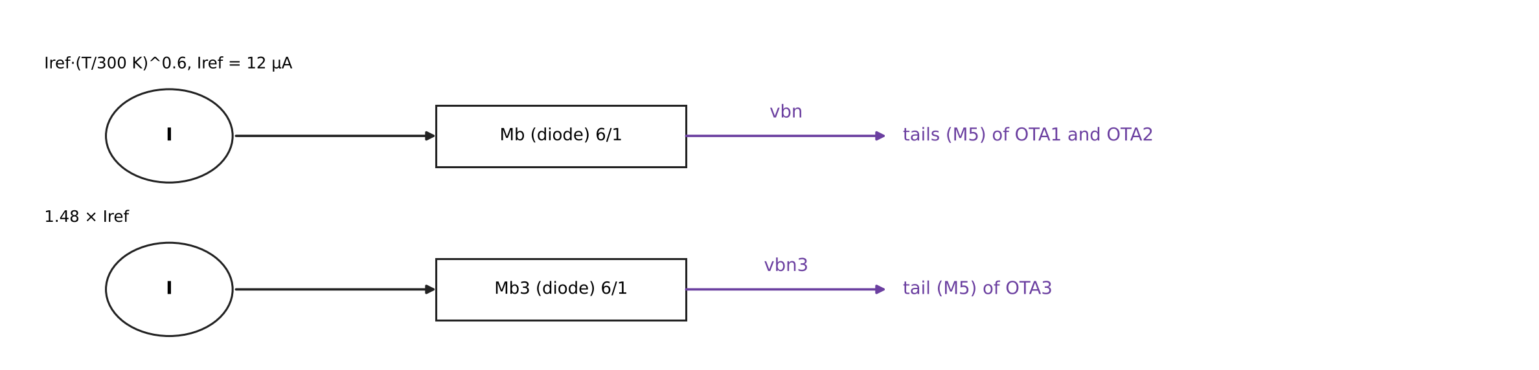
Figure 3.4: Ideal PTAT bias: two reference legs feed diode-connected NMOS transistors, whose gate voltages bias the OTA tails.
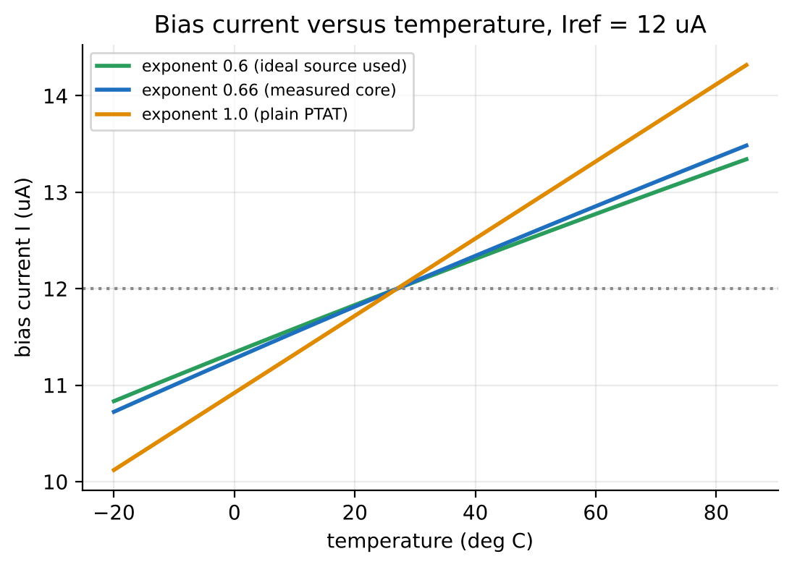
Figure 3.5: Bias current of the PTAT law for three exponents with I_{ref} = 12 µA (the transistor-level core of Section 3.2.3 has a measured exponent near 0.66).
3.2.3 Transistor-Level PTAT Core (beta multiplier)
The ideal source hides several real-world problems: a real reference has its own supply sensitivity, its own mismatch, and its temperature law is not freely selectable. To remove this optimism, the ideal source was replaced by a transistor-level beta-multiplier current reference (Figure 3.6). A PMOS mirror (XMP1, XMP2, W/L = 8/2) forces equal currents into two NMOS branches: XMc1 (W/L = 2/2) is diode-connected, and XMc2 (W/L = 8/2) has a polysilicon source resistor XRc (res_high_po_1p41, W = 1.41 µm, about 51.5 µm long, roughly 51.5 kΩ). The 4:1 ratio of the NMOS aspect ratios and the resistor fix the current to
I ≈ ( 2 / ( µ_{n}C_{ox} (W/L)₁ R² ) ) × ( 1 − 1/√K )² , K = (W/L)₂ / (W/L)₁ = 4 (3.5)
a classical result whose current depends on resistance and mobility but not, to first order, on the supply. Two further PMOS mirrors copy the current: XMP3 (W/L = 8/2, 1:1) feeds the reference transistor of OTA1 and OTA2 (v_{bn}, 12 µA) and XMP4 (W/L = 11.84/2, 1.48:1) feeds the reference transistor of OTA3 (v_{bn3}). A 5 MΩ start-up resistor from V_{DD} to the XMc1 drain removes the zero-current state, a 1 Ω resistor Rpg ties the PMOS gate node to the XMc2 drain, and initial nodesets guide the operating-point solver. The resistor length (about 51.47 µm) was calibrated in four iterations so that the core delivers 12.0 µA at tt, 1.8 V and 27 °C.
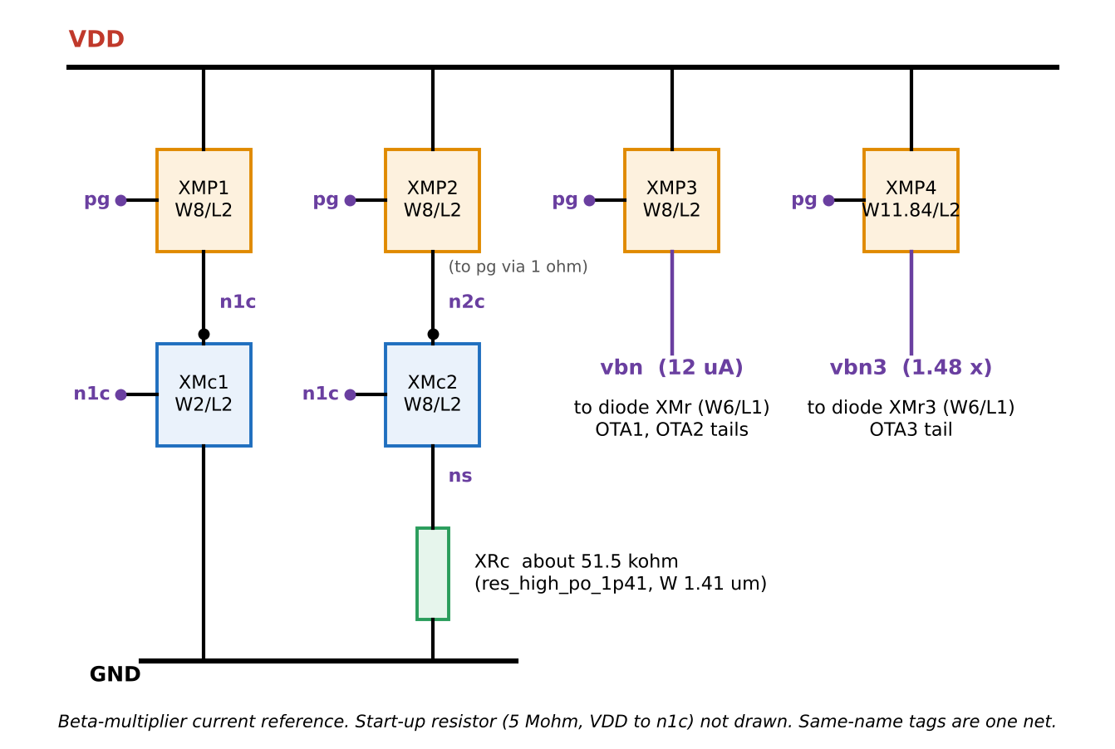
Figure 3.6: Transistor-level beta-multiplier PTAT core: PMOS mirror, NMOS pair with source resistor XRc, and 1:1 and 1.48:1 output mirrors to the two bias nodes.
The temperature dependence of this core is not chosen: it was measured. A probe sweep from -40 °C to 125 °C at the tt, ss and ff corners and at 1.62, 1.8 and 1.98 V gives a power-law exponent of 0.64 to 0.67 in every case, close to the 0.6 that the filter was tuned for. The core's current also depends on the supply: at tt and 27 °C it is 11.3, 12.0 and 12.3 µA at 1.62, 1.8 and 1.98 V, i.e. about 0.5 % per 1 % of supply (Section 4.8). Longer core devices (L = 4 µm and 8 µm, widths scaled to keep W/L) did not improve the nominal results (40 and 36 of 45 conditions inside the spec window, against 40 for L = 2 µm) so L = 2 µm was kept.
3.3 Process, Voltage and Temperature Grid
The PVT grid combines the five process corners provided by the PDK (tt, ss, ff, sf, fs; the first letter refers to NMOS and the second to PMOS), three supply voltages (1.62 V, 1.80 V and 1.98 V, i.e. nominal +/-10 %) and three temperatures (-20 °C, 27 °C and 85 °C). That gives 5 × 3 × 3 = 45 conditions (Figure 3.7). The same 45 conditions are used for every design so that the designs can be compared one condition at a time.
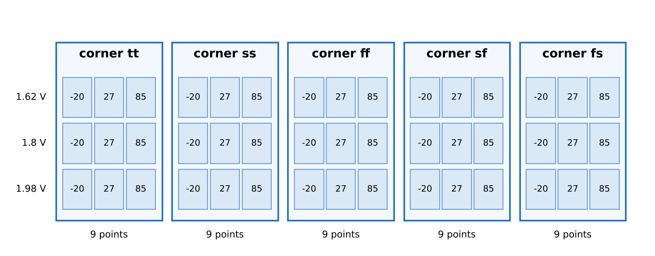
Figure 3.7: The 45-condition PVT grid: five process corners, each with three supply voltages (rows) and three temperatures (columns).
3.4 Monte Carlo Mismatch Analysis
3.4.1 Mismatch in the SKY130 PDK
Two nominally identical transistors never behave identically: random doping and geometry variations shift their threshold voltage and current factor by amounts that shrink as the gate area grows, the well-known Pelgrom area law, σ(ΔV_{T}) = A_{VT} / √(W L). The SKY130 PDK models this with mismatch parameters in its transistor model files; selecting a corner variant with the suffix _mm (tt_mm, ss_mm, and so on) activates a global switch that adds a Gaussian random perturbation to every transistor in the netlist, on top of the corner's process parameters. The PDK has no per-device switch, and the mismatch coefficients are embedded in the model files without independently published silicon validation, which is a documented limitation of the open process [5], [7], [11].
3.4.2 Monte Carlo Procedure
Each Monte Carlo condition is one ngspice run with a control loop. The run seeds the random generator once (setseed), then repeats N times: reset (which makes the simulator draw a fresh mismatch for every device), compute the DC operating point, run an AC analysis from 100 kHz to 10 MHz, and measure three quantities (Figure 3.8). The -3 dB frequency f₃ is the frequency where the gain has fallen by 3 dB from its DC value; f₉₀ is the frequency where the phase reaches -90°; and the peak of the gain above its passband value (gain peaking, the passband ripple). The quality factor is derived from the ratio of the two frequencies. For a second-order low-pass with u = (f₃/f₉₀)²,
Q = 1 / √( ( 2 − (1 − u)² ) / u ) (3.6)
which follows from solving |H(jω)|² = 1/2 for ω₃/ω₀ and using ω₉₀ = ω₀. Power is the supply current at the operating point times the supply voltage. Each condition uses its own seed (12345 plus the condition index) so that every run can be reproduced exactly.
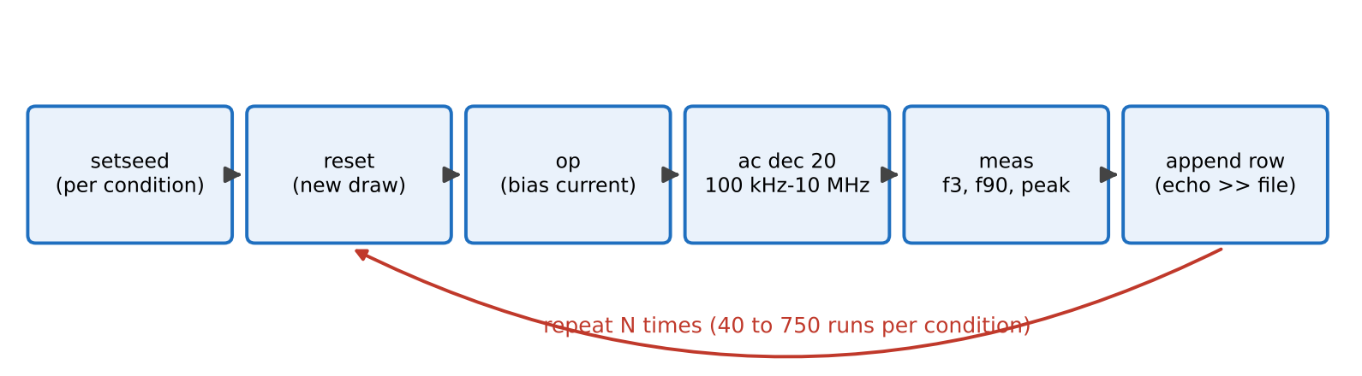
Figure 3.8: The Monte Carlo loop run inside ngspice for one PVT condition.
3.4.3 Specification and Yield
A run passes when both conditions hold at once: |f₃ − 1.6 MHz| ≤ 0.16 MHz (±10 %) and 0.6 ≤ Q ≤ 0.8. The yield of a condition is the fraction of its runs that pass. The overall yield of a design is the mean of the 45 condition yields. With N independent runs, the standard error of a yield p is √(p(1−p)/N): for 750 runs the 95 % confidence interval of a single condition is at most about ±3.6 points at p = 50 % (about ±0.4 points for the mean of 45 conditions), and for 40 runs per condition it is about ±15 points per condition (about ±2 points for the mean of 45 conditions). Passband ripple is reported separately and is not part of the pass criterion because it is tiny when Q is near 0.707 (Section 4.6).
3.5 Simulation Flow and Tools
• ngspice 47 runs every Monte Carlo and AC analysis; Xyce 7.10 is used as an independent second simulator for the cross-check. Both run in the hpretl/iic-osic-tools container image with the SKY130A PDK.
• A Python driver (Appendix 3) writes one netlist per PVT condition, launches the conditions in parallel (one process per CPU core, 8 cores), collects the per-run values and writes the summary tables. The transistor-level core campaign took about 16 s per run per core.
• Python (NumPy, pandas, Matplotlib) produces the statistics and plots, and a Streamlit and Plotly web application, described in Section 4.11, lets a reader repeat any condition live.
• Netlists were drawn in Xschem and exported to SPICE; the top-level netlist and the OTA cell are listed in Appendix 1.

3.6 Cross-Validation Plan
Because the SKY130 mismatch coefficients cannot be checked against silicon, the project guards its conclusions with five independent checks, whose results are reported in Section 4.9:
• AC against transient: a small-signal transient simulation of the same circuit must reproduce the AC gain and phase.
• Solver tolerance: the same 300 mismatch draws rerun with tighter tolerances and a denser frequency grid must give the same f₃ and Q.
• Sensitivity (Pelgrom-style) check: the per-device standard deviations of the gate voltage, taken from the PDK mismatch slopes, are propagated through simulated sensitivities to predict the f₃ and Q spread independently of the Monte Carlo loop.
• Seed reproducibility: repeating a condition with a second seed and 1,500 runs must agree with the 750-run result within the statistical error.
• Second simulator: the same netlist in Xyce must match ngspice at the nominal point, and the same injected random gate offsets must give the same per-run results in both simulators.

3.7 Testbench and Measurement Definitions
Every simulation in the study uses the same testbench so that the designs differ only in the bias. The settings are collected in Table 3.2 and follow directly from the netlist of Appendix 1 and the driver of Appendix 3.
Table 3.2: Testbench settings and measurement definitions
Item | Setting
Input | Vinp: DC 0.9 V with a 1 V AC magnitude (so the AC output is the transfer function); Vinn and the common-mode reference at 0.9 V (half of the nominal supply)
Supply | 1.62, 1.80 or 1.98 V (set per condition); the second reference leg of the ideal source is fed from an auxiliary 1.8 V source and excluded from the power
Loads | C₁ = C₂ = 10 pF; no other load; the output (V_{o2}) is unbuffered
Corner and temperature | .lib sky130.lib.spice with tt_mm, ss_mm, ff_mm, sf_mm or fs_mm (Monte Carlo) or tt to fs (nominal); .temp -20, 27 or 85
AC analysis | 100 kHz to 10 MHz; 20 points per decade in the Monte Carlo loop, 200 points per decade for nominal and cross-check runs
f₃ | Frequency at which vdb(vo2) falls through -3 dB (the DC gain is 0 dB), by interpolation between grid points (meas ac f₃ when vdb(vo2) = -3 fall = 1)
f₉₀ | Frequency at which vp(vo2) falls through -90 degrees (-1.5708 rad)
Gain peaking (ripple) | Maximum of vdb(vo2) over the band, in dB above the 0 dB passband gain
Q | Derived from f₃ and f₉₀ with the relation of Equation 3.6
Power | Supply current from the operating point multiplied by the supply voltage
Seed | 12345 plus the condition index, set once per condition with setseed

The 20-point-per-decade grid of the Monte Carlo loop is coarse. Its effect was measured in the tolerance check of Section 4.9: with 200 points per decade, the per-run f₃ changes by 0.12 % on average (0.18 % at most), which is small compared with the 5 to 6 % spread being measured.
3.8 Statistical Estimators
For a set of N runs of one condition the report uses the sample mean and the sample standard deviation of f₃ (quoted as a percentage of the mean) and of Q, and the yield estimator
p = k / N , SE(p) = √( p (1 − p) / N ) , 95 % interval = p ± 1.96 SE(p) (3.7)
where k is the number of runs that meet the specification. The overall yield is the mean of the 45 condition yields, with a standard error of √(Σ p_{i}(1−p_{i})/N)/45. For the two main designs (N = 750) the 95 % interval of the overall yield is about ±0.4 points, while a single condition has an interval of up to ±3.6 points. For the transistor-level core (N = 40) the overall interval is about ±2 points and a single condition has an interval of up to ±15 points. The sensitivity calculation of Section 4.9 additionally uses the first-order propagation formula σ_{f3}² = Σ (∂f₃/∂V_{i})² σ_{Vi}², where V_{i} are the gate-voltage offsets of the individual transistors.
CHAPTER 4
Results and Discussion
4.1 Nominal Response of the Filter
At the typical condition (tt corner, 1.8 V, 27 °C) with no mismatch and the PTAT bias, the filter is a low-pass response with a -3 dB frequency of 1.610 MHz and a quality factor of 0.722 (Figure 4.1). The -90° phase point lies near 1.58 MHz, as expected for a second-order section whose Q is close to Butterworth (f₃ is about 2 % above f₀ at Q = 0.72). The same netlist in Xyce 7.10 reproduces the response to 0.001 % (Section 4.9), and a transient simulation of the same circuit reproduces the AC magnitude and phase within 0.03 dB and 0.14°. The nominal design therefore meets the 1.6 MHz target within 0.6 %.
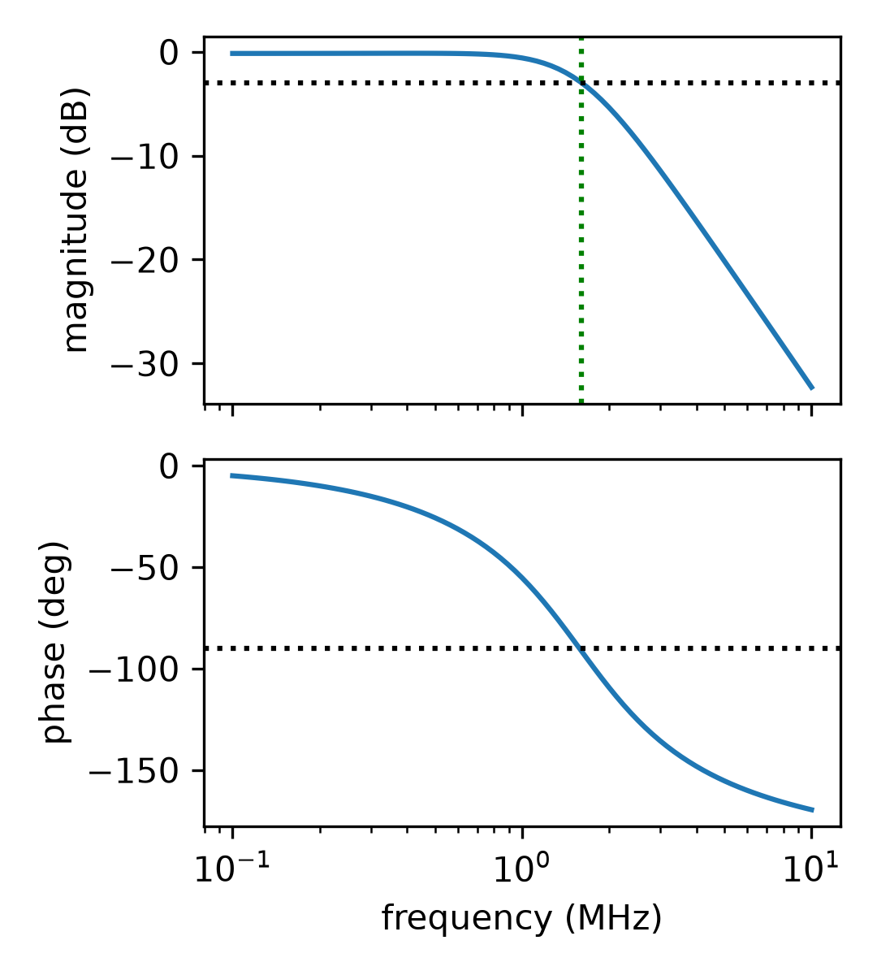
Figure 4.1: Nominal AC response (ngspice, PTAT bias, tt, 1.8 V, 27 °C): magnitude (top, with the -3 dB level and f₃) and phase (bottom, with -90°). f₃ = 1.610 MHz, Q = 0.722.
4.2 PVT Drift: Voltage Bias versus PTAT Bias
The first question the campaign answers is how far the mean cutoff moves when only the operating condition changes. With the fixed voltage bias, the mean f₃ of a condition ranges from 0.67 MHz to 2.54 MHz and its worst shift from the 1.6 MHz target is 0.944 MHz (59 %). Process corner, supply and temperature all contribute: at the typical corner and 1.8 V the cutoff rises from 1.20 MHz at -20 °C to 1.94 MHz at 85 °C (Table 4.2). With the PTAT bias the mean f₃ stays within 0.084 MHz of the target in every one of the 45 conditions (Figure 4.2, right panel).
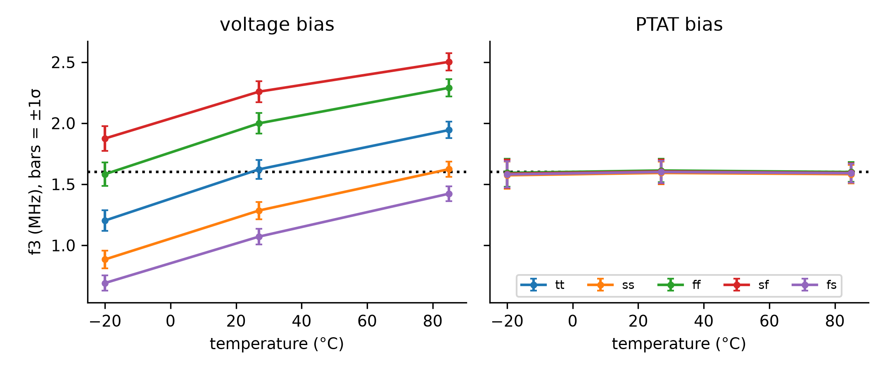
Figure 4.2: Mean f₃ versus temperature at 1.8 V for the five corners, voltage bias (left) and PTAT bias (right); bars are ±1σ of the Monte Carlo spread; the dotted line is the 1.6 MHz target.
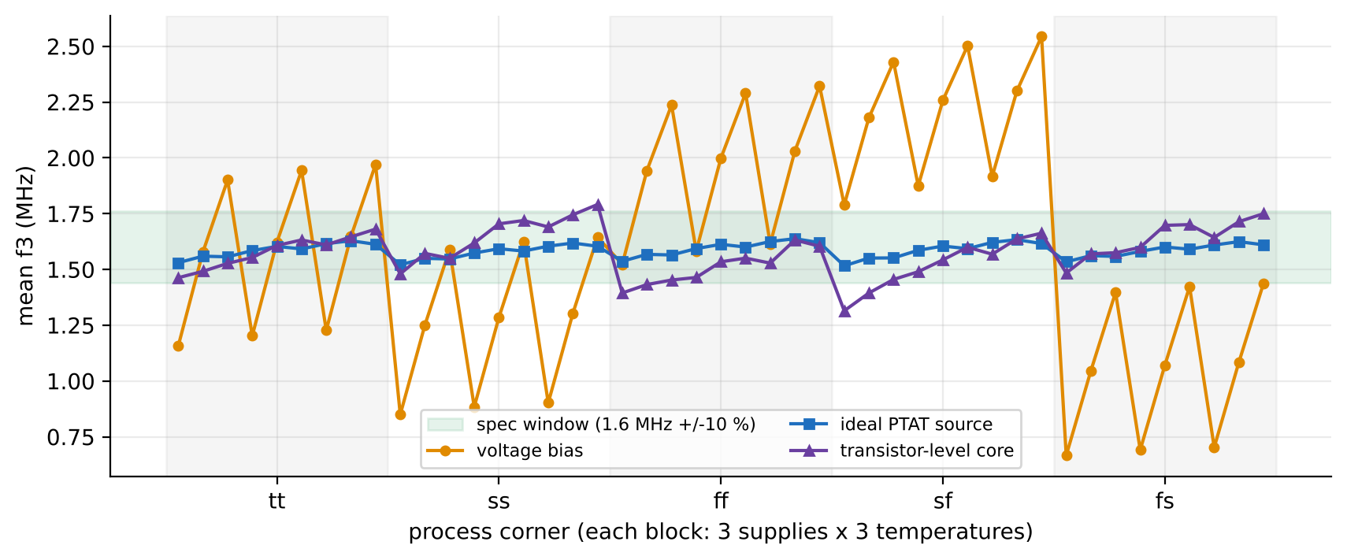
Figure 4.3: Mean f₃ in each of the 45 conditions for voltage bias, ideal PTAT source and transistor-level core; the shaded band is the ±10 % specification window.
The PTAT bias removes both the temperature trend and the corner dependence because the bias current rises exactly where the transistors lose transconductance, so g_{m} stays nearly constant. The voltage bias has no such mechanism: a fast corner raises the current and f₃, a slow corner lowers them, and the sf and fs corners, where NMOS and PMOS move in opposite directions, show the largest spread (Table 4.1).
Table 4.1: Results by process corner (mean over the 9 supply and temperature points of each corner)
Corner | Mean f₃, voltage (MHz) | Mean f₃, PTAT (MHz) | Yield, voltage | Yield, PTAT | f₃ sigma, voltage | f₃ sigma, PTAT
tt | 1.583 | 1.587 | 31.5 % | 88.8 % | 5.24 % | 6.08 %
ss | 1.259 | 1.577 | 32.7 % | 89.1 % | 6.00 % | 5.96 %
ff | 1.949 | 1.595 | 29.0 % | 88.3 % | 4.57 % | 6.18 %
sf | 2.200 | 1.586 | 6.5 % | 87.5 % | 4.16 % | 6.24 %
fs | 1.058 | 1.586 | 12.4 % | 89.9 % | 6.62 % | 5.90 %

Table 4.2: Typical corner at 1.8 V versus temperature (750 runs per row)
T (°C) | f₃ volt. (MHz) | f₃ PTAT (MHz) | Q volt. | Q PTAT | Power volt. (µW) | Power PTAT (µW) | Yield volt. | Yield PTAT
-20 | 1.202 | 1.584 | 0.659 | 0.714 | 51.0 | 81.6 | 0.1 % | 84.9 %
27 | 1.622 | 1.603 | 0.723 | 0.721 | 70.0 | 90.9 | 95.5 % | 92.3 %
85 | 1.944 | 1.592 | 0.772 | 0.725 | 90.2 | 101.4 | 0.1 % | 95.7 %

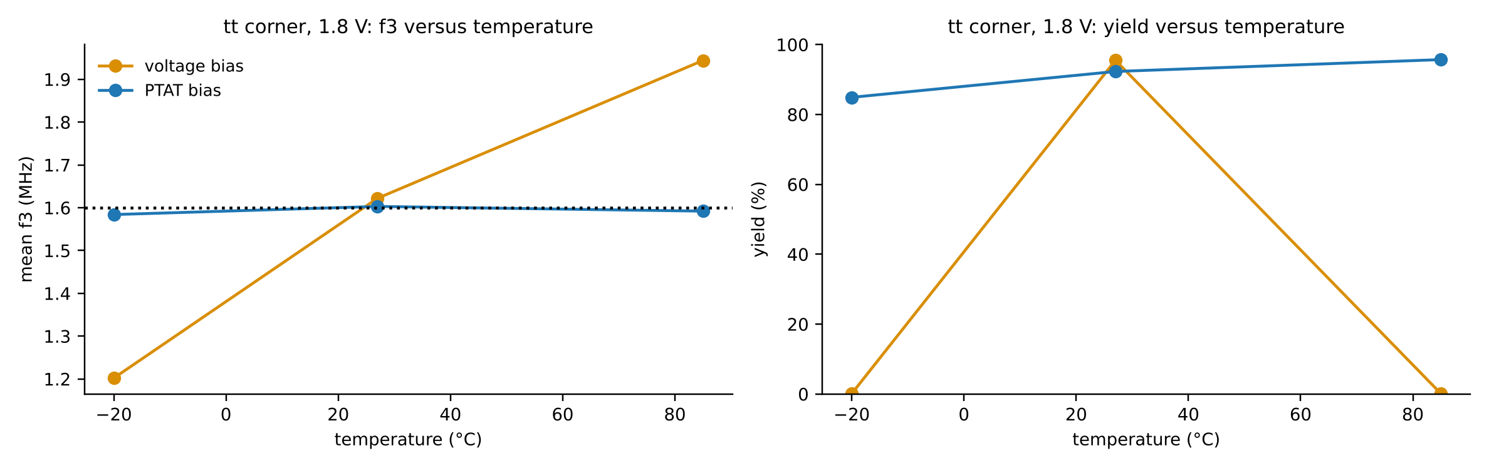
Figure 4.4: Typical corner, 1.8 V: mean f₃ (left) and yield (right) versus temperature for the two designs.
The voltage-bias design is, if anything, marginally better at exactly 27 °C typical (95.5 % yield against 92.3 %) because its bias was tuned there; away from that single point it collapses (0.1 % at -20 °C and 85 °C). The PTAT design is nearly flat: 84.9 %, 92.3 % and 95.7 % at -20, 27 and 85 °C.
4.3 Spec Yield over the 45 Conditions
Table 4.3: Summary of the two designs over all 45 conditions (33,750 runs each)
Metric | Voltage bias | Ideal PTAT bias
Mean yield, 45 conditions | 22.4 % | 88.7 %
Lowest condition yield | 0.0 % | 72.3 %
Worst mean-f₃ shift (MHz) | 0.944 | 0.084
Mean f₃ sigma over conditions | 5.32 % | 6.07 %
Worst f₃ sigma | 10.22 % | 8.28 %
Range of condition-mean Q | 0.598 – 0.806 | 0.697 – 0.737
Power range (µW) | 28.0 – 132.5 | 72.0 – 113.0

Over the full grid the fixed voltage bias passes only 22.4 % of the 33,750 trials and fails completely (0.0 %) at the worst condition, while the ideal PTAT bias passes 88.7 % and never falls below 72.3 %. The improvement comes from the condition means: the quality factor of the condition means moves between 0.598 and 0.806 for the voltage bias, a range that straddles the specification edges, against 0.697 to 0.737 for PTAT.
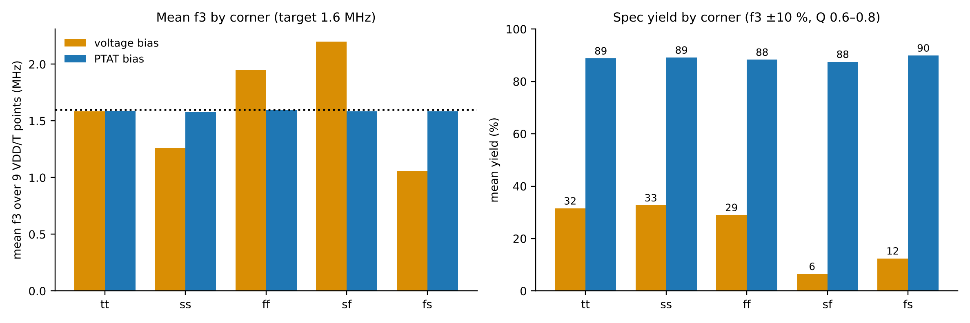
Figure 4.5: Left: mean f₃ by corner (mean over 9 supply and temperature points). Right: spec yield by corner. Dotted line: 1.6 MHz target.
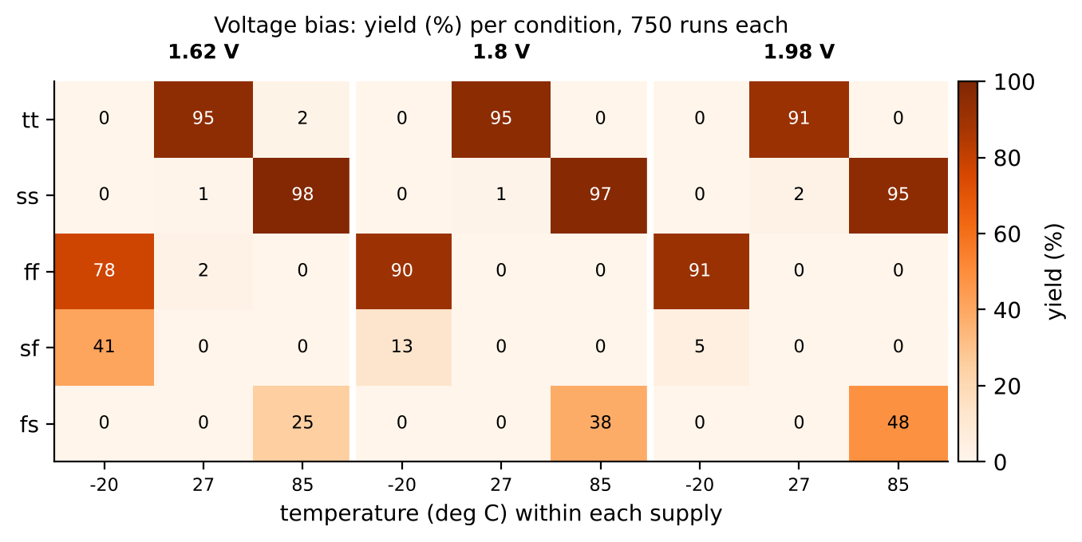
Figure 4.6: Voltage bias: yield (%) in each of the 45 conditions (750 runs each). Only the points at 27 °C in the tt corner (and the compensating ss/ff combinations) survive.
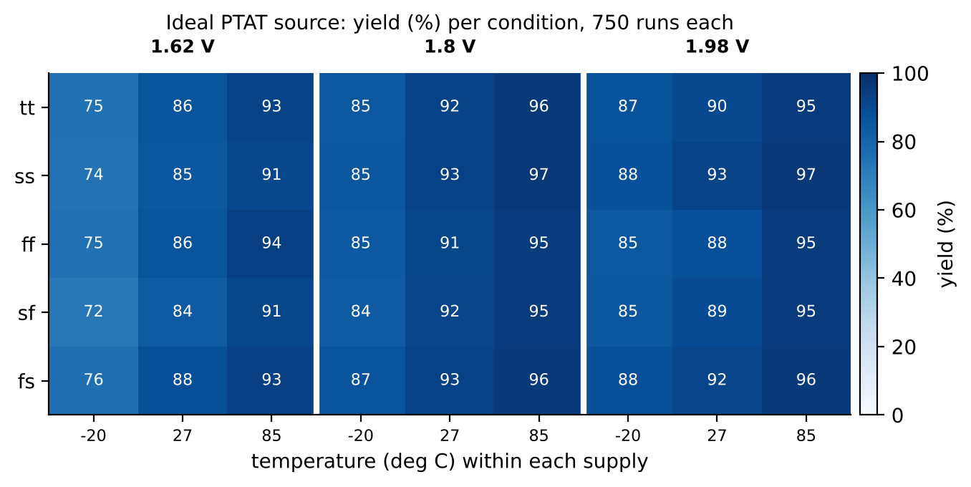
Figure 4.7: Ideal PTAT source: yield (%) in each of the 45 conditions (750 runs each). Low supply is the weakest column.
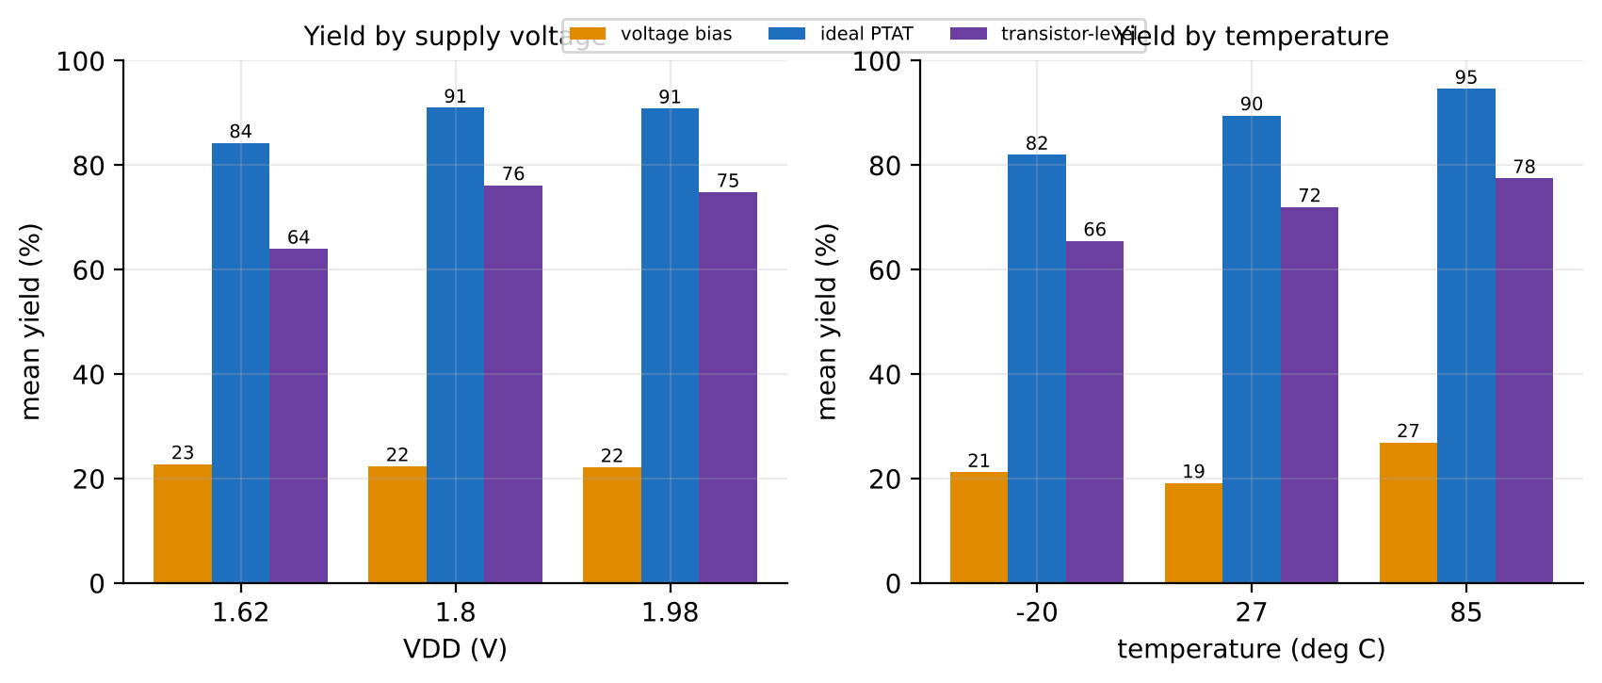
Figure 4.8: Mean yield by supply voltage (left) and by temperature (right) for the three designs.
Grouped by supply voltage (Figure 4.8, left), the voltage bias yields 22.8 / 22.3 / 22.2 % at 1.62, 1.80 and 1.98 V, so the supply has almost no effect on it; its loss comes from corner and temperature. The ideal PTAT source yields 84.3 / 91.0 / 90.9 %, with its weakest column at 1.62 V. The transistor-level core yields 64.0 / 76.2 / 74.8 %, with a clear loss at 1.62 V that is the core's supply sensitivity at work. Grouped by temperature (right), the voltage bias yields 21.2 / 19.2 / 26.9 % at -20, 27 and 85 °C, the ideal PTAT source 82.0 / 89.5 / 94.6 % and the transistor-level core 65.5 / 72.0 / 77.5 %; in both PTAT designs the yield rises with temperature and the cold end is the weakest.
The heat maps show where each design fails. The voltage bias passes at only a few cells where the corner and the temperature happen to cancel (for example ss at 85 °C, where the slow corner lowers f₃ and the high temperature raises it, and ff at -20 °C, where the opposite cancellation occurs) and fails everywhere else. The ideal PTAT bias is weakest at 1.62 V and -20 °C (72 to 76 % yield) and passes 84 to 97 % at every other condition.
4.4 Mismatch Statistics: Distributions of f₃ and Q
Mismatch is a separate effect from drift, and it is what the Monte Carlo runs measure. At the typical condition, 1,500 runs with the PTAT bias give a mean f₃ of 1.602 MHz with a standard deviation of 5.64 %, and a mean Q of 0.720 with a standard deviation of 0.026 (Figure 4.9). The distributions are close to Gaussian and the specification window (green band) captures 92.7 % of the runs at this condition. At the worst condition (sf, 1.62 V, -20 °C) the mean f₃ moves to 1.515 MHz and the standard deviation widens to 7.79 %, so the yield is 73.0 %.
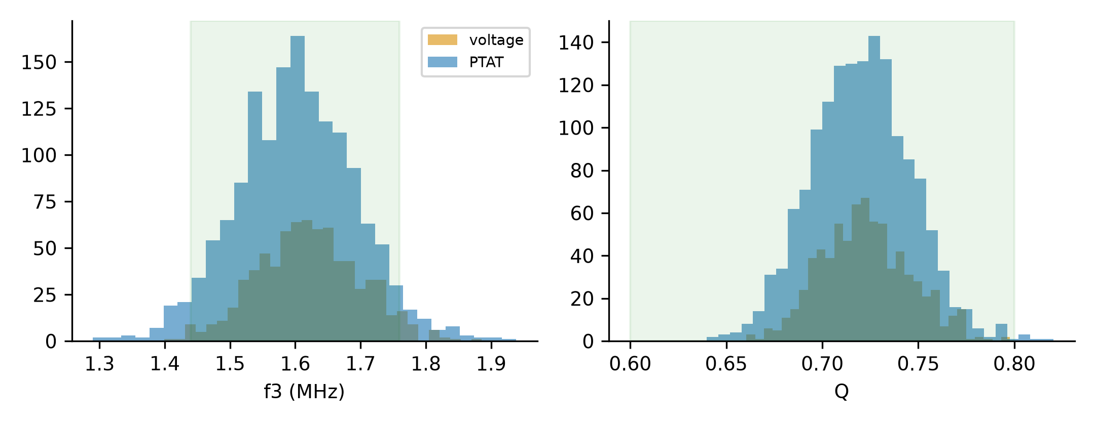
Figure 4.9: Monte Carlo histograms of f₃ (left) and Q (right) at tt, 1.8 V, 27 °C: PTAT bias 1,500 runs and voltage bias 750 runs; the green band is the specification window.
A comparison of the two designs at this single typical condition shows that PTAT bias does not reduce the mismatch spread: the f₃ standard deviation is 5.6 to 5.9 % for PTAT and 4.8 % for the voltage bias. The mean spread over the 45 conditions is 6.07 % for PTAT against 5.32 % for the voltage bias. This is expected, since the spread is set by transistor area and by the sensitivity of f₃ to each transistor, neither of which a bias reference changes. What PTAT bias changes is the centre of the distribution.
4.5 Correlation between f₃ and Q
The cutoff and the quality factor are not independent. A single mismatch draw that raises the OTA currents increases f₃ and, through the ratio of the transconductances, also changes Q, so the runs lie along a line in the f₃-Q plane (Figure 4.10). The specification window is a rectangle in this plane; the long diagonal of the cloud passes through the rectangle, so a run that misses on f₃ tends also to miss on Q. The two conditions plotted (tt at 27 °C and sf at 1.62 V and -20 °C) fall on the same line, which means the corner mainly moves the cloud along the line instead of changing its shape.
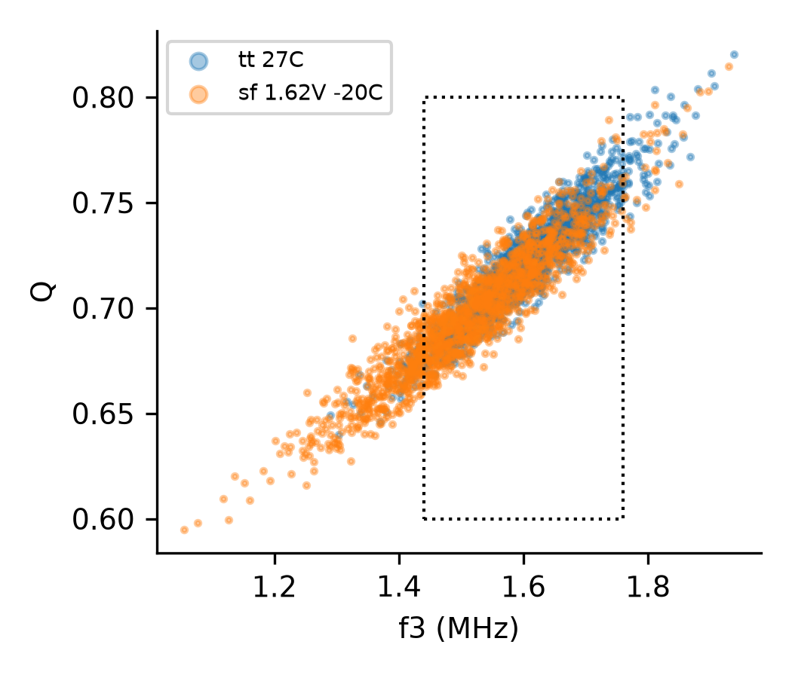
Figure 4.10: f₃ versus Q for 1,500 runs at tt, 27 °C and at sf, 1.62 V, -20 °C (PTAT bias); the dotted box is the specification window.
4.6 Passband Ripple and Summary Statistics (Table T-I)
The passband ripple is the gain peaking in dB above the passband gain. With Q near 0.72, the response is almost maximally flat and the ripple is tiny: at tt, 1.8 V and 27 °C its mean is 0.033 dB (standard deviation 0.043 dB) and the largest of 1,500 runs is 0.350 dB. Over the 45 conditions the mean ripple stays between 0.017 and 0.064 dB, with the largest values at the fs corner, 1.98 V and 85 °C (where Q is highest). Over all 33,750 PTAT runs the largest ripple is 0.350 dB. Because it is so small, the ripple is reported but not used in the pass criterion.
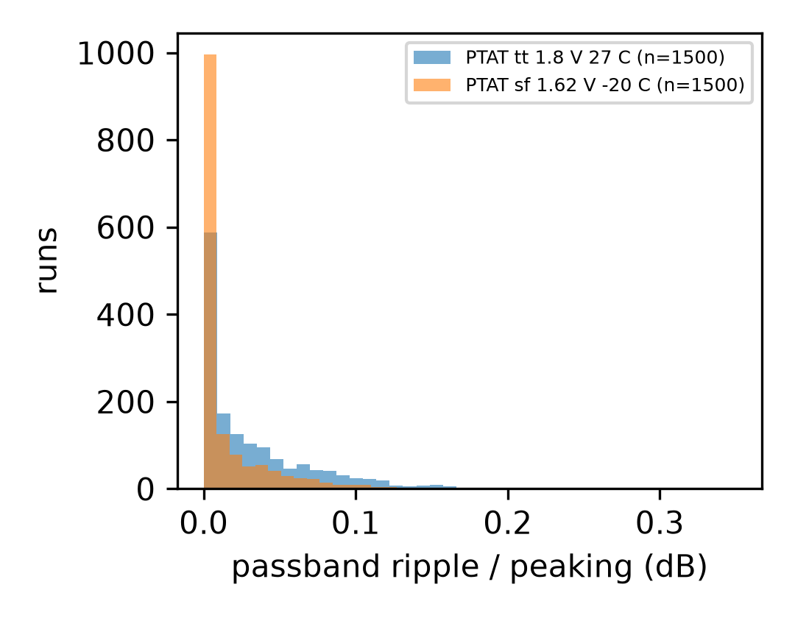
Figure 4.11: Passband ripple (gain peaking) over 1,500 runs at two conditions, PTAT bias.
Table 4.4: Summary statistics (Table T-I of the project), PTAT bias
Quantity | tt, 1.8 V, 27 °C (1,500 runs) | sf, 1.62 V, -20 °C (1,500 runs) | 45 condition means | All 33,750 runs (extremes)
f₃ mean (MHz) | 1.602 | 1.515 | 1.516 – 1.638 | 1.061 – 1.954
f₃ sigma | 5.64 % | 7.79 %
Q mean | 0.720 | 0.697 | 0.697 – 0.737 | 0.589 – 0.819
Q sigma | 0.026 | 0.031
Ripple mean (dB) | 0.033 | 0.016 | 0.017 – 0.064 | 0.000 – 0.350
Ripple sigma (dB) | 0.043 | 0.034

4.7 Reference-Mirror Sizing and Sources of Variance
Since the PTAT bias leaves mismatch untouched, the next question is how much of the remaining spread can be bought with area. The reference leg (the diode-connected bias transistor and the tail transistors that mirror it) was scaled by ×1, ×4 and ×16 in area, and 750 runs were made at two temperatures (Figure 4.12, Table 4.5).
Table 4.5: Extra Monte Carlo sets (PTAT bias): seeds, tolerance and reference-mirror sizing
Set | Runs | Mean f₃ (MHz) | f₃ sigma | Mean Q | Yield | Power (µW)
PTAT tt 1.8V 27C seed2 1500 | 1500 | 1.602 | 5.64 % | 0.720 | 92.7 % | 90.9
PTAT sf 1.62V -20C seed2 1500 | 1500 | 1.515 | 7.79 % | 0.697 | 73.0 % | 74.3
PTAT tight 300 | 300 | 1.606 | 5.99 % | 0.722 | 92.7 % | 91.0
mirror x1 27C | 750 | 1.603 | 5.91 % | 0.721 | 92.3 % | 90.9
mirror x4 27C | 750 | 1.607 | 4.81 % | 0.722 | 97.1 % | 155.7
mirror x16 27C | 750 | 1.598 | 4.80 % | 0.719 | 96.9 % | 414.9
mirror x1 -20C | 750 | 1.584 | 7.13 % | 0.714 | 84.9 % | 81.6
mirror x4 -20C | 750 | 1.590 | 5.81 % | 0.715 | 91.5 % | 140.1
mirror x16 -20C | 750 | 1.579 | 5.82 % | 0.712 | 90.3 % | 374.1

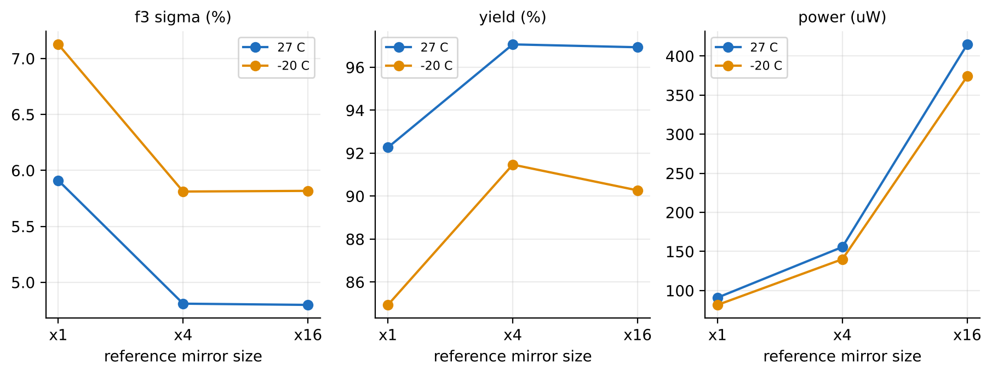
Figure 4.12: Effect of reference-mirror area (×1, ×4, ×16) at 27 °C and -20 °C on f₃ sigma, yield and power.
The ×4 mirror reduces the f₃ standard deviation from 5.91 % to 4.81 % and raises yield by about 5 points at 27 °C (92.3 % to 97.1 %) and by 6.6 points at -20 °C (84.9 % to 91.5 %), at the price of about 70 % more power (90.9 to 155.7 µW). The ×16 mirror adds nothing further and costs 4.6 times the power of the baseline. The baseline PTAT design (×1) is therefore the reported result and ×4 is an optional trade. The reason for the saturation is visible in the variance budget (Figure 4.13): at ×1 the OTA load transistors contribute 47 % of the f₃ variance, the reference 33 %, the tail transistors 19 % and the input pair about 1 %; at ×4 the reference share falls to 11 % and the load share rises to 62 %, so the load becomes the limit.
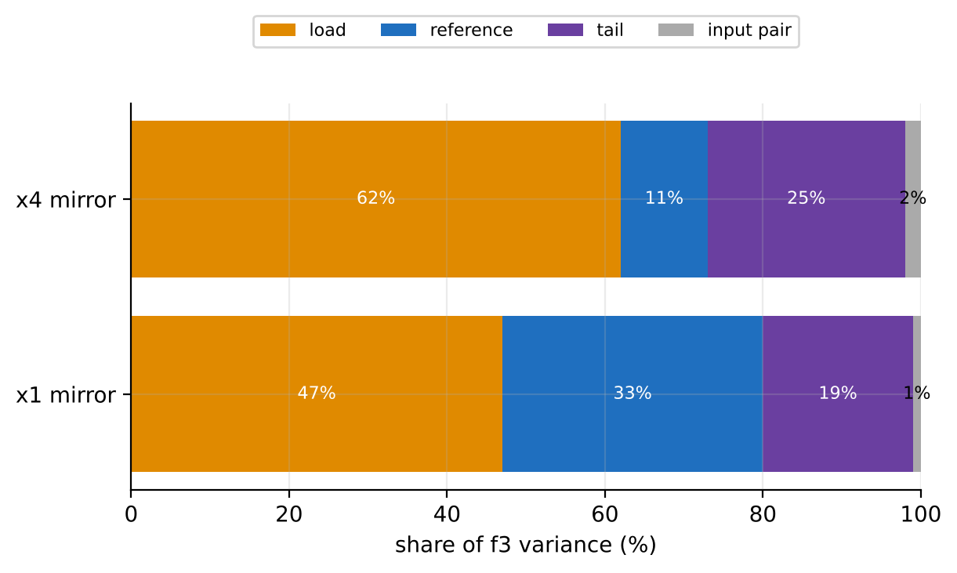
Figure 4.13: Share of the f₃ variance contributed by each transistor group, for the ×1 and ×4 reference mirror (sensitivity calculation, Section 4.9).
4.8 Transistor-Level Reference Core (1,800 runs)
The results above use an ideal PTAT source. The transistor-level beta-multiplier core of Section 3.2.3 was simulated in the same 45 conditions with mismatch applied to both the filter and the core, 40 runs per condition, 1,800 runs in total (about 16 seconds per run per core). Without mismatch, the 45 nominal conditions give f₃ between 1.362 and 1.803 MHz (-14.9 % to +12.7 % of 1.6 MHz) with 40 of 45 inside the specification window.
With mismatch, the mean yield is 71.7 % (about ±2 points, 95 % confidence), about 3.2 times the voltage bias and 17 points below the ideal source. The worst condition is sf at 1.62 V and -20 °C with 17.5 %, the best is 95 %, and the worst mean-f₃ shift is 0.285 MHz (-17.8 %). At the typical condition the yield is 85 % (40 runs, ±11 points). By process corner the mean yields are tt 80.0 %, fs 74.2 %, ss 70.6 %, ff 68.6 % and sf 65.0 %; by supply 64.0 %, 76.2 % and 74.8 % at 1.62, 1.80 and 1.98 V; by temperature 65.5 %, 72.0 % and 77.5 % at -20, 27 and 85 °C.
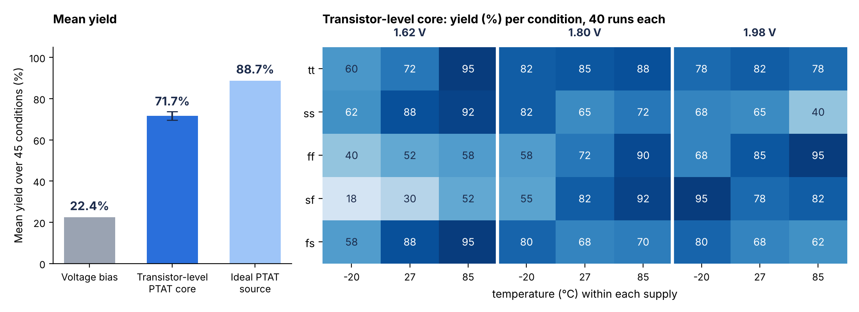
Figure 4.14: Left: mean yield of the three bias schemes (error bar ±2 points on the transistor-level core). Right: yield of the transistor-level core in each condition (40 runs each).
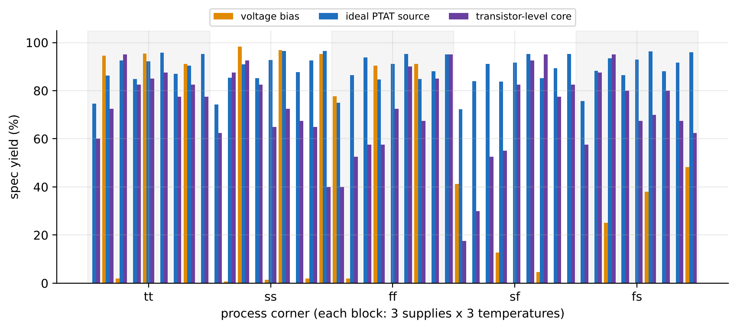
Figure 4.15: Yield in each of the 45 conditions for the voltage bias (750 runs), the ideal PTAT source (750 runs) and the transistor-level core (40 runs).
The loss against the ideal source is almost entirely a supply-sensitivity effect of the core, not a temperature effect. The core's current rises about 0.5 % for each 1 % of supply (11.3, 12.0 and 12.3 µA at 1.62, 1.8 and 1.98 V), which moves the mean f₃ from 1.49 MHz to 1.61 MHz to 1.65 MHz (Figure 4.16). At low supply and low temperature, where the supply effect and the (slightly too steep) exponent of 0.66 add up, the mean f₃ falls out of the window. The temperature drift of the core is small, as the by-temperature yields (65.5 to 77.5 %) show, and the loss comes mainly from the low-supply column. Longer core devices did not help (Section 3.2.3), so the obvious next step is a supply-insensitive core (cascoded or regulated).
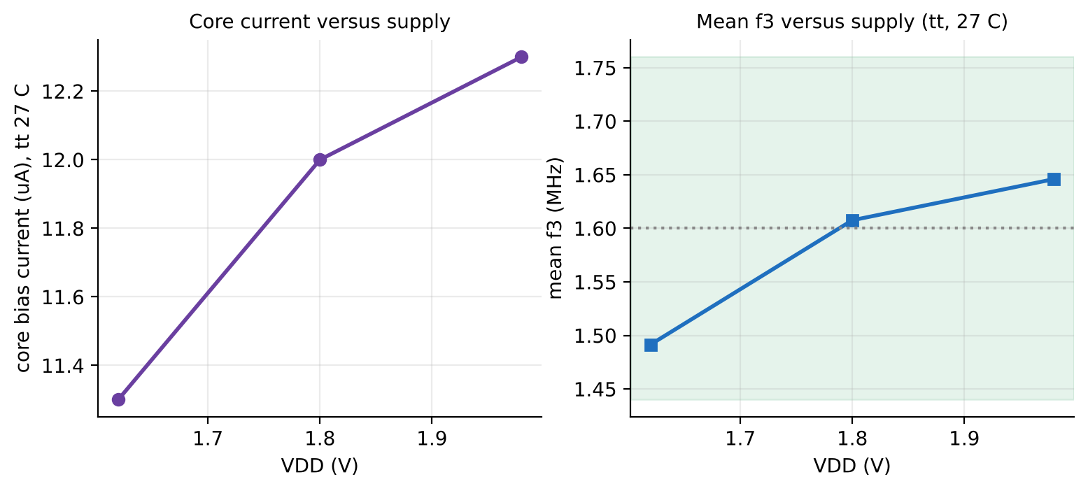
Figure 4.16: Left: core bias current versus supply at tt, 27 °C. Right: resulting mean f₃ versus supply.
Two statistical caveats apply. With 40 runs per condition the headline mean carries an uncertainty of about ±2 points, but a single condition about ±15 points, so the per-condition values (heat map, Appendix 4) are indicative. The full 750-run grid was not repeated for this core: at about 16 seconds per run per core it would take roughly 19 hours on the 8-core machine used.
Table 4.6: Three bias schemes compared
Quantity | Voltage bias | Ideal PTAT source | Transistor-level core
Mean yield, 45 conditions | 22.4 % | 88.7 % | 71.7 % (±2 points)
Lowest condition yield | 0.0 % | 72.3 % | 17.5 % (sf, 1.62 V, -20 °C)
Worst mean f₃ shift (MHz) | 0.944 | 0.084 | 0.285
Range of condition-mean Q | 0.598 – 0.806 | 0.697 – 0.737 | 0.690 – 0.752
Mean f₃ sigma over conditions | 5.32 % | 6.07 % | 6.75 %
Yield at tt, 1.8 V, 27 °C | 95.5 % | 92.3 % | 85.0 % (40 runs, ±11 points)
Runs per condition | 750 | 750 | 40

4.9 Cross-Validation Results
The five checks defined in Section 3.6 gave the following results.
Table 4.7: Cross-validation summary
Check | Result
Sensitivity (Pelgrom-style) check | Per-device sigma(V_{GS}) from the PDK mismatch slopes at fixed current: input pair 2.76 mV, tail and reference 1.45 mV, load 2.89 mV. Propagated through simulated sensitivities, the predicted f₃ sigma is 5.62 % against 5.91 % from Monte Carlo (×1 mirror) and 4.87 % against 4.81 % (×4); predicted Q sigma 3.61 % against 3.68 %.
AC versus transient (10 mV sine, 100 kHz to 6.4 MHz) | Gain differs by at most 0.028 dB and phase by at most 0.14°.
Solver tolerance (reltol 1e-6, 200 points per decade, same 300 draws, tt 27 °C) | Per-run f₃ changes by 0.12 % on average (maximum 0.18 %), Q by 0.22 % (maximum 0.41 %); yield unchanged at 92.7 %.
Seed reproducibility (95 % confidence) | tt 27 °C: 92.3 ±1.9 % (750 runs), 92.7 ±1.3 % (1,500 runs), pooled 92.6 ±1.1 %. sf 1.62 V -20 °C: 72.3 ±3.2 %, 73.0 ±2.2 %, pooled 72.8 ±1.8 %.
Nominal supply dependence (PTAT) | Nominal f₃ runs from 1.566 MHz at 1.62 V to 1.635 MHz at 1.98 V, about ±2.2 %.
Second simulator, nominal (Xyce 7.10) | DC operating point matches ngspice to about six digits (v_{bn} 0.6992 V, V_{o2} 0.8923 V). On a 200-point-per-decade AC grid f₃ and Q agree to 0.001 %.
Second simulator, injected mismatch (30 draws) | Xyce does not apply the PDK mismatch model (five different seeds all returned the nominal result), so the same random gate-voltage offsets were injected in both simulators on 17 devices. Per-run f₃ differs by at most 0.003 % and Q by at most 0.014 %; f₃ correlation 1.00000; f₃ sigma 5.23 % in both.

The Xyce check validates the simulator, not the PDK's mismatch statistics, which remain unverified against silicon. The sensitivity check is more informative: it recovers the Monte Carlo spread from the PDK's own mismatch slopes through an independent calculation, so the Monte Carlo loop and the mismatch infrastructure are used correctly.
4.10 Additional Studies
4.10.1 Tolerance of the Bias
A real reference will not deliver exactly 12 µA or exactly 1.48 times that. At tt and 27 °C the estimated yield (90.4 % at nominal) becomes 85.9 % for I_{ref} lower by 5 % and 78.9 % for I_{ref} higher by 5 %. A change of the ratio rt by -5 % gives 80.1 % and by +5 % gives 88.5 %. Matching of the two reference legs within about 5 % is therefore needed to keep the yield near the reported value.
4.10.2 Reference Exponent
The exponent 0.6 of the PTAT law is tuned. A plain PTAT current (exponent 1.0) drifts f₃ by about -6 % at -20 °C and +6 % at 85 °C (1.504 and 1.694 MHz against 1.610 MHz at 27 °C), whereas 0.6 holds f₃ within ±1.5 %. A rough estimate from the existing distributions puts the yield of a plain PTAT near 79 % rather than 88.7 %, with the worst condition near 48 %. The transistor-level core of Section 4.8 reaches an exponent of about 0.66 without any added constant-current leg, so the tuned exponent is realistic; its yield is limited by supply sensitivity instead.
4.10.3 Large-Signal Behaviour and Step Response
At 200 kHz and 100 mV peak input the total harmonic distortion is 0.33 %; at 1.6 MHz the 1 dB compression point is 65 mV peak. Over 200 mismatch runs the distortion at 200 kHz and 100 mV is 0.36 ±0.06 %. The step response over 200 runs shows an overshoot of 4.76 ±1.08 % (an ideal Butterworth second-order response overshoots by 4.3 %) and a 10 to 90 % rise time of 234 ±20 ns. These values confirm that the time-domain behaviour matches the frequency-domain design and that the filter is linear enough for inputs of tens of millivolts.
4.10.4 A Resistor-Based Alternative Bias
A resistor-referenced constant-g_{m} bias (R about 5.5 kΩ) was simulated as an alternative. At 1.8 V its f₃ varies by a max-to-min ratio of 1.086 over corners and temperature, against 1.023 for the ideal PTAT; a ±15 % error in the resistor moves f₃ by about -14 % to +19 %; and it draws 100 to 137 µW. It is a credible alternative but no better than the PTAT scheme in either power or spread.
4.10.5 Noise (nominal)
A nominal noise analysis (PTAT bias, tt, 1.8 V, 27 °C) gives an output noise of 240 µV rms from 1 kHz to 10 MHz (228 µV up to 1.6 MHz), a density of 1.86 µV/√Hz at 1 kHz falling to 115 nV/√Hz at 1 MHz, and a signal-to-noise ratio of about 50 dB for a 100 mV peak sine. The 1/f level is high, as the PDK documentation warns [3]; the figure has not been checked against silicon, and noise is not part of the Monte Carlo.
4.11 Live Laboratory Application and Demonstration
To let a reader repeat any condition without installing a simulator by hand, the project includes a web application built with Streamlit and Plotly that runs the same Monte Carlo netlists live in ngspice. It was used for the project demonstration. The sidebar sets the target frequency, the tolerance and the Q window; the main page offers eight tabs: live Monte Carlo, PVT grid, comparison of sets, Pelgrom check, transient, bias comparison, study results, and cross-checks and limits.
• Live Monte Carlo: choose the design (voltage bias, PTAT current bias, PTAT with ×4 mirror), the corner, supply, temperature, the number of runs and the seed, and press Run. A progress bar and running statistics follow the runs, and the histograms of f₃, Q and power, the f₃-Q scatter and the convergence of the running mean and sigma appear as the run completes (Figures 4.17 and 4.18).
• PVT grid and bias comparison: the stored 45-condition results are displayed as the heat maps and bar charts of this chapter, so the viewer can pick any condition without re-running.
• Cross-checks and limits: the cross-check table, the Xyce-versus-ngspice scatter, the nominal Bode plot, the summary statistics of Table T-I, the exponent scan, the noise result, the transistor-level heat map and the list of limitations (Figures 4.19 and 4.20).
• Output explanation: in the demonstration, each result was read off the screen as follows. The blue histogram of f₃ is centred on 1.60 MHz with a width of about 6 %; the shaded band marks the specification window; the yield tile is the share of runs inside the window; the convergence plot shows that the mean and sigma have settled, so the run count is adequate.

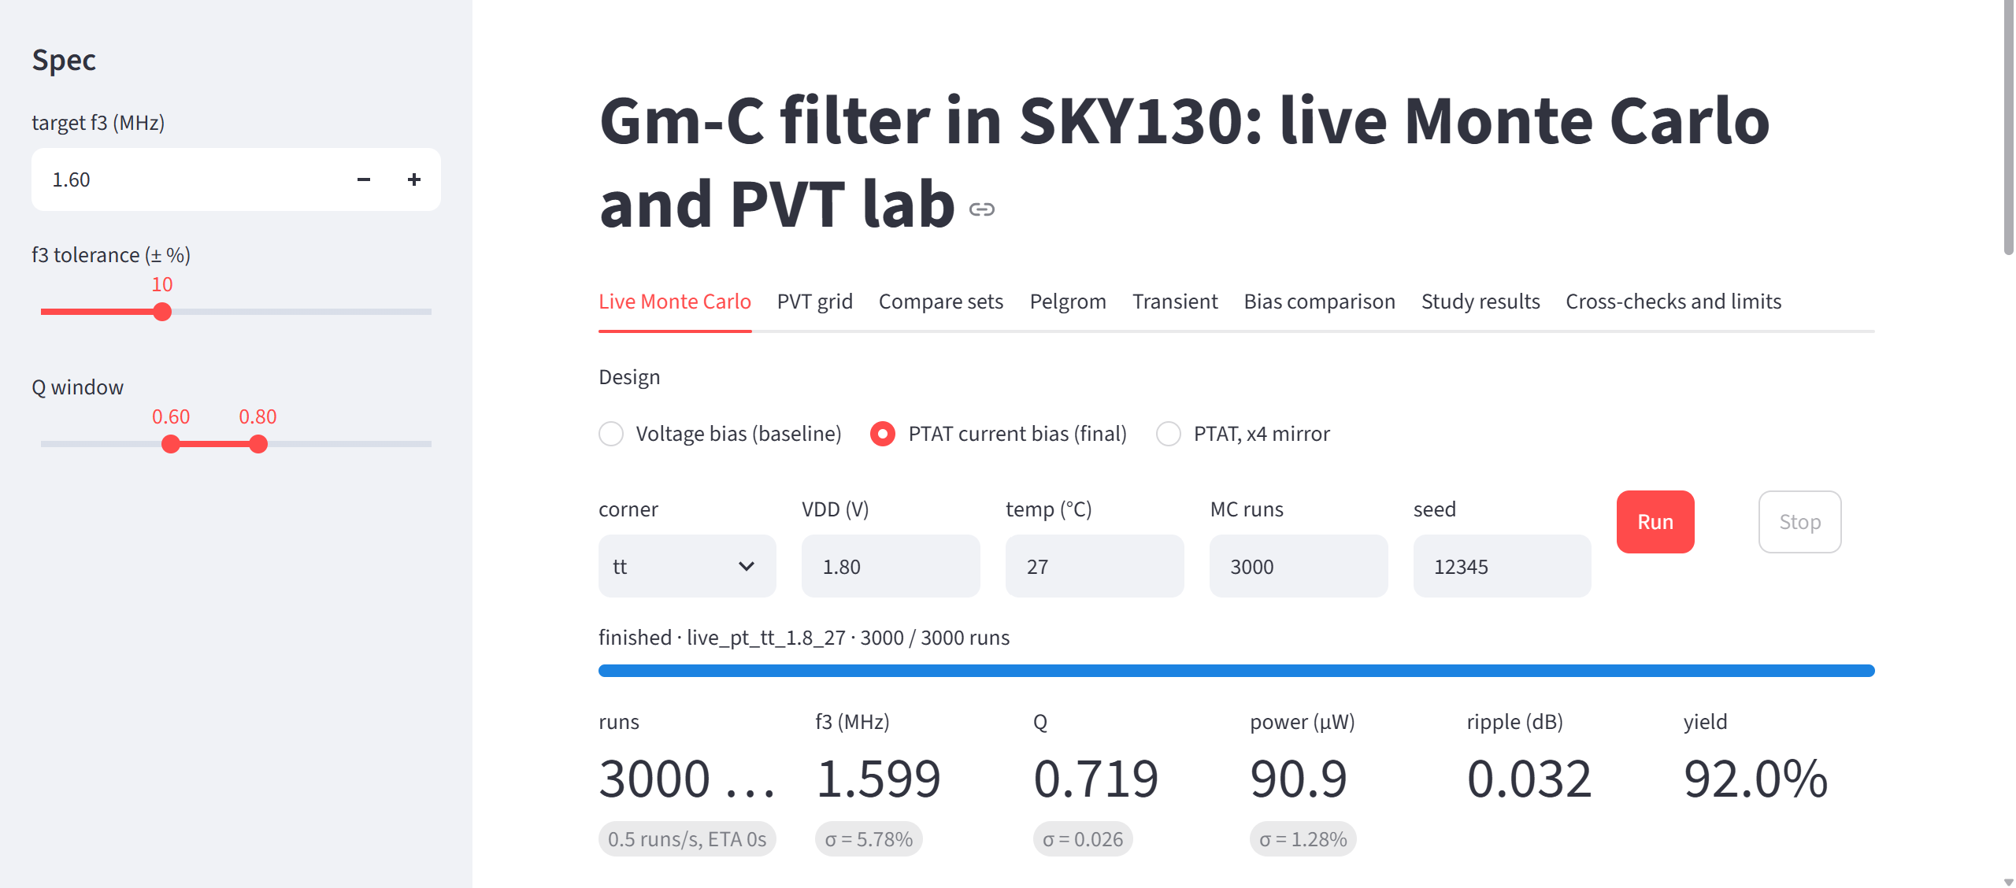
Figure 4.17: Live Monte Carlo tab: 3,000 runs at tt, 1.8 V, 27 °C with the PTAT bias. Mean f₃ 1.599 MHz (sigma 5.78 %), mean Q 0.719, power 90.9 µW, ripple 0.032 dB, yield 92.0 %.
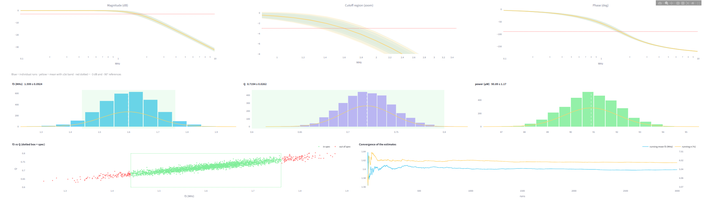
Figure 4.18: Live results of a run: AC response bundle (all runs), histograms of f₃, Q and power, f₃-Q scatter (green points are inside the specification box) and convergence of the running mean and sigma.
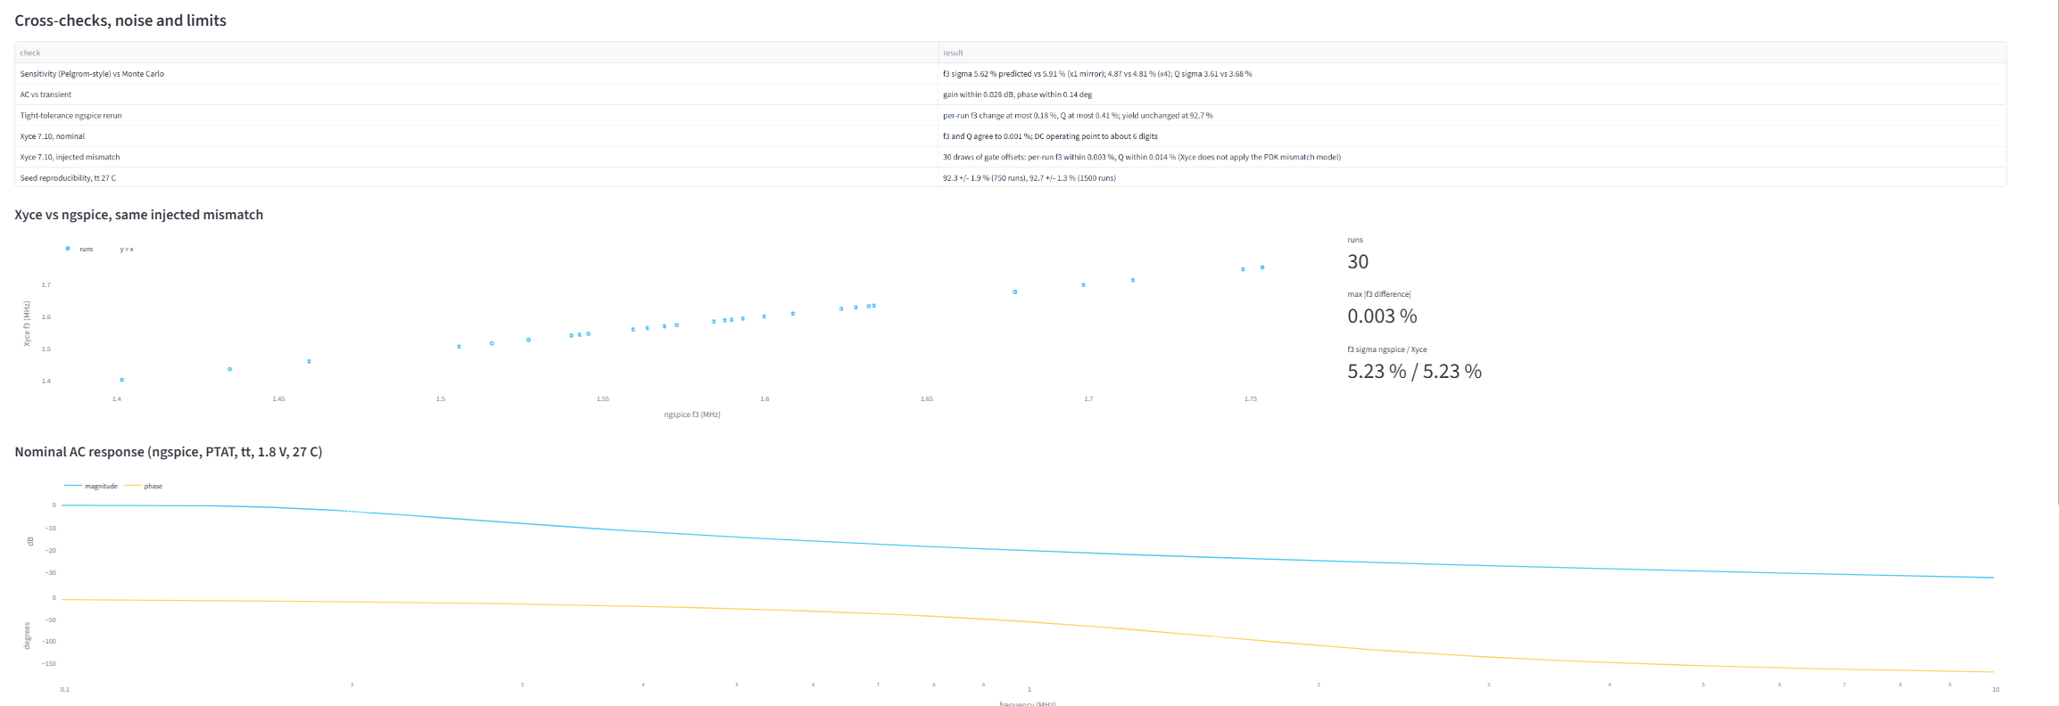
Figure 4.19: Cross-checks tab: cross-validation table, Xyce-versus-ngspice scatter for the 30 injected-mismatch draws, and the nominal AC response.
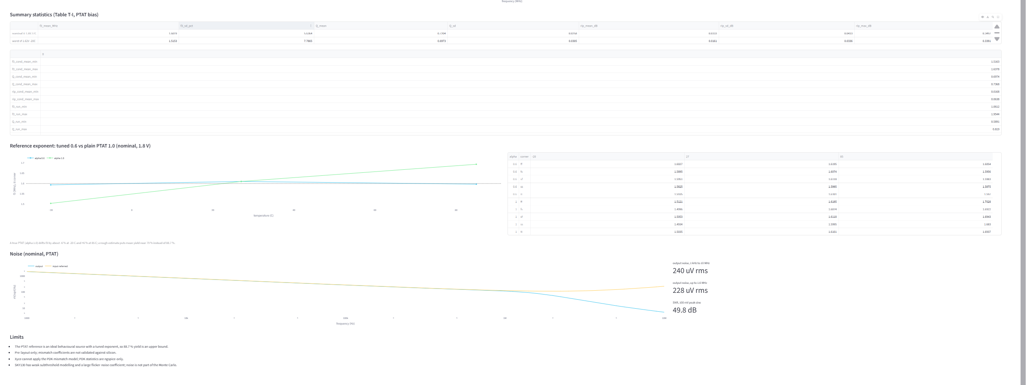
Figure 4.20: Lower sections of the application: summary statistics (Table T-I), reference-exponent scan, nominal noise result and the list of limits.
4.12 Output Explanation: How to Read the Results
This section explains each quantity and plot of the study so that the results can be read without the simulator. It is the basis of the explanation given during the demonstration.
Table 4.8: Reading guide for the outputs
Output | What it is | How to read it
f₃ (MHz) | The -3 dB cutoff frequency of one simulated filter | Target 1.6 MHz. A value above the target means the filter passes more bandwidth than intended; below means less. The pass window is 1.44 to 1.76 MHz.
Q | Quality factor, the sharpness of the response near the cutoff | 0.707 is the maximally flat (Butterworth) value; below 0.6 the cutoff is too soft, above 0.8 the response starts to peak. The pass window is 0.6 to 0.8.
Passband ripple (dB) | Gain peaking above the passband gain | Almost zero for Q near 0.7; grows quickly when Q exceeds 0.8. Reported only, not part of the pass test.
Power (µW) | Supply current times supply voltage at the operating point | About 91 µW at the typical condition with PTAT bias; it rises with temperature because the PTAT current rises.
Yield (%) | Share of Monte Carlo runs with f₃ and Q both inside the window | The single number that summarizes a design at one condition. 100 % means every random sample passes.
Histogram | Distribution of f₃ (or Q) over the runs | Its centre shows the systematic error (drift), its width shows the random mismatch. The green band is the pass window; the part of the histogram outside it is the loss.
f₃-Q scatter | One dot per run | A tilted cloud means f₃ and Q move together; yield is the share of dots inside the dotted box.
Convergence plot | Running mean and standard deviation versus the number of runs | When both lines are flat, the run count is adequate; the early swings are statistical noise.
Heat map | Yield for every corner, supply and temperature | Dark is good, light is bad; the map shows where in the PVT space a design fails.

Three observations follow from this reading and were the explanation given with the demonstration. First, the position of a histogram relative to the green band tells the story of the bias: the voltage-bias histogram slides left and right with corner and temperature, while the PTAT histogram stays centred. Second, the width of the histogram does not change with the bias, because it is set by mismatch and therefore by transistor area. Third, the yield is the overlap of the histogram with the window, so a design can raise its yield either by centring the distribution (PTAT bias) or by narrowing it (larger devices, a larger reference mirror).
4.13 Design Guidelines Derived from the Results
• Centre first, narrow second. The systematic shift of the voltage-bias design (up to 59 % of the target) is ten times larger than the random spread (5 to 6 %). Compensating the bias recovers most of the yield; spending area on matching recovers a few more points.
• Use a bias current with a positive temperature exponent of about 0.6 for this OTA, and check the exponent of the real reference: a plain PTAT (1.0) overshoots and gives only about 79 % estimated yield.
• Control the supply sensitivity of the reference. The beta-multiplier core moves its current by 0.5 % per 1 % of supply, which is enough to lose 17 points of yield against the ideal source; a cascoded or regulated reference is the first improvement to try.
• Match the two reference legs. A 5 % error in the 1.48 ratio costs 8 to 10 points of yield; a 5 % error in the reference current costs 5 to 12 points.
• Choose the reference mirror size by yield per microwatt: the ×4 mirror adds about 5 to 7 yield points for 70 % more power, the ×16 mirror adds nothing.
• Quote yields with their error bar: 750 runs give ±0.4 points for the overall yield but up to ±3.6 points for a single condition; 40 runs give ±15 points for a single condition.

4.14 Discussion and Limitations
Three findings stand out. First, the dominant source of failure in a G_{m}-C filter on this process is systematic, not random: the fixed voltage bias loses almost 78 % of its trials to process, supply and temperature, whereas the random mismatch alone (the 5 to 6 % f₃ spread) would, by itself, pass about 92 % of runs at the typical condition. Second, a temperature-proportional bias current is an effective and inexpensive fix: yield rises from 22.4 % to 88.7 % with an ideal source. Third, the realistic yield depends on the reference circuit: the transistor-level core reaches 71.7 %, because its own supply sensitivity moves f₃ at the supply extremes. An honest summary is therefore that a PTAT-biased G_{m}-C filter can reach roughly 70 to 90 % yield in this specification window, depending on the quality of the reference, whereas a fixed voltage bias cannot be used without on-chip tuning.
The limitations that apply to every number in this chapter are:
• The study is a pre-layout simulation: there are no layout parasitics, no package or supply noise and no process skew beyond the PDK corner models.
• SKY130 mismatch and flicker-noise coefficients come from the PDK model files and have not been validated against silicon; the PDK also has documented weak subthreshold modelling [4]. The cross-checks verify the simulator and the method, not the model files.
• The main 88.7 % result uses an ideal reference source and is an upper bound. The transistor-level core (71.7 %) is pre-layout, has no supply regulation, and its yield per condition rests on 40 runs.
• PTAT bias lowers corner and temperature drift but not mismatch: its mean f₃ sigma (6.07 %) is slightly above that of the voltage-bias design (5.32 %).
• Power counts the first reference leg; the second, ratioed leg of the ideal source is fed from an auxiliary supply and excluded. The power of the transistor-level core was not tabulated.
• Yield depends on the chosen specification window (f₃ ±10 %, Q 0.6 to 0.8) and on the number of runs: 750 runs per condition give about ±0.4 points for the mean over 45 conditions (up to ±3.6 points for one condition), 40 runs per condition give about ±2 points for the mean and ±15 points for a single condition.
• No common-mode feedback loop and no output buffer are used; the output common-mode level is not regulated.

CHAPTER 5
Conclusion and Future Scope
5.1 Conclusion
This project designed a second-order G_{m}-C low-pass filter from three identical OTAs in the open SKY130A process and characterized it statistically over 45 process, voltage and temperature conditions with up to 750 Monte Carlo mismatch trials per condition, 33,750 trials per design. The headline results are:
• The nominal design meets the target: f₃ = 1.610 MHz and Q = 0.722 at tt, 1.8 V and 27 °C, with a flat passband (ripple 0.033 dB on average).
• A fixed voltage bias is not viable in this specification window: it passes only 22.4 % of trials, and fails completely at the worst condition, because its mean f₃ moves by up to 0.94 MHz (59 %) across process, supply and temperature.
• A PTAT bias current whose exponent matches the transistors' temperature behaviour raises the yield to 88.7 % with an ideal reference source (worst condition 72.3 %) and cuts the worst mean f₃ shift to 0.08 MHz (5 %).
• With a transistor-level beta-multiplier reference core, with mismatch on both the core and the filter, the yield is 71.7 % (about three times the voltage bias), limited by the core's supply sensitivity; the worst condition is sf, 1.62 V, -20 °C at 17.5 %.
• PTAT bias does not reduce the random mismatch spread: the mean f₃ sigma stays near 6 % (5.3 % for the voltage bias). A larger reference mirror (×4) cuts it to 4.8 % and adds about 5 to 7 yield points at about 70 % more power.
• The results are validated by an AC-versus-transient check (0.03 dB), a tolerance rerun (0.2 %), an independent sensitivity calculation (5.6 % predicted against 5.9 % simulated f₃ sigma), seed reproducibility, and a second simulator (Xyce, 0.001 % nominal and 0.003 % per-run with injected mismatch).

Against the six objectives set at the first review, every objective was met or exceeded except the public release, which is prepared (archive with checksums) and awaits publication. The more general conclusion is that a G_{m}-C filter in this process needs either a temperature-compensating bias with a supply-insensitive reference or on-chip tuning, and that the yield obtainable can now be quoted with a number and an error bar rather than by guesswork.
5.2 Limitations
The results are simulation-only and pre-layout. The SKY130 mismatch and noise coefficients are taken from the PDK files and have not been compared with silicon, and the ideal-source result (88.7 %) is an upper bound. The transistor-level result rests on 40 runs per condition, so single-condition values are indicative (±15 points) while the mean is good to about ±2 points. No layout parasitics, supply noise, common-mode feedback or output buffer are included. These limits are detailed in Section 4.14.
5.3 Future Scope
• Supply-insensitive reference core: replace the beta-multiplier by a cascoded or regulated version, or add a start-up-free supply regulator, to close the 17-point gap to the ideal source.
• Full 750-run grid for the transistor-level core (about 19 hours on the 8-core machine used) to reduce the per-condition uncertainty from ±15 points to about ±3.6 points.
• Layout and post-layout simulation of the OTA, the capacitors and the bias core, including parasitics and the matching improvements of common-centroid layout.
• Add a common-mode feedback loop and an output buffer and extend the Monte Carlo with supply noise and flicker noise.
• Silicon validation through a multi-project wafer (for example the Tiny Tapeout shuttle) to check the PDK's mismatch statistics against measurement.
• A tuning loop (master-slave or frequency-locked) as an alternative to the open-loop PTAT bias, compared on yield and power.
• Open release of the repository on GitHub with continuous-integration regeneration of the figures.

CHAPTER 6
Appendix
Appendices are numbered Appendix 1 to Appendix 5. The code listings are the actual files used for the results in this report.
Appendix 1: Top-Level Netlist and OTA Cell (gmc_top.spice)
** sch_path: /foss/designs/gmc-filter/gmc_top.sch
**.subckt gmc_top
Vinp vin 0 0.9 ac 1
V1 VDD 0 1.8
Vinn vcm 0 0.9
Vbias_tail_v vb 0 0.7
C1 vo1 0 10p
x1 vo1 vin vo2 vb ota_core
x2 vo2 vo1 vcm vb ota_core
x3 vo1 vcm vo1 vb3 ota_core
C2 vo2 0 10p
Vb3 vb3 0 0.73
**** begin user architecture code

.lib /foss/pdks/sky130A/libs.tech/combined/sky130.lib.spice tt_mm

.include /foss/designs/gmc-filter/mc_nom.cir

**** end user architecture code
**.ends

* expanding symbol: ota_core.sym # of pins=4
** sym_path: /foss/designs/gmc-filter/ota_core.sym
** sch_path: /foss/designs/gmc-filter/ota_core.sch
.subckt ota_core OUT1 IN1+ IN1- Vbias_tail
*.ipin IN1+
*.ipin IN1-
*.opin OUT1
*.ipin Vbias_tail
XM1 net2 IN1+ net1 0 sky130_fd_pr__nfet_01v8 L=0.5 W=4 nf=1 ad=1.16 as=1.16 pd=8.58 ps=8.58 nrd=0.0725 nrs=0.0725 sa=0 sb=0 sd=0
+ mult=1
XM2 OUT1 IN1- net1 0 sky130_fd_pr__nfet_01v8 L=0.5 W=4 nf=1 ad=1.16 as=1.16 pd=8.58 ps=8.58 nrd=0.0725 nrs=0.0725 sa=0 sb=0 sd=0
+ mult=1
XM3 net2 net2 VDD VDD sky130_fd_pr__pfet_01v8 L=0.5 W=8 nf=1 ad=2.32 as=2.32 pd=16.58 ps=16.58 nrd=0.03625 nrs=0.03625 sa=0 sb=0
+ sd=0 mult=1
XM4 OUT1 net2 VDD VDD sky130_fd_pr__pfet_01v8 L=0.5 W=8 nf=1 ad=2.32 as=2.32 pd=16.58 ps=16.58 nrd=0.03625 nrs=0.03625 sa=0 sb=0
+ sd=0 mult=1
XM5 net1 Vbias_tail 0 0 sky130_fd_pr__nfet_01v8 L=1 W=6 nf=1 ad=1.74 as=1.74 pd=12.58 ps=12.58 nrd=0.0483333333333333
+ nrs=0.0483333333333333 sa=0 sb=0 sd=0 mult=1
.ends

.GLOBAL VDD
.end

Appendix 2: Transistor-Level Bias Core (netlist excerpt)
The lines below are generated by core() in the driver of Appendix 3 for the calibrated resistor length RL = 51.47 µm (W/L of the mirror devices scale with CL; CL = 2 µm is the reported design).
Vsns nr 0 DC 0
XMP1 n1c pg VDD VDD sky130_fd_pr__pfet_01v8 w=8 l=2
XMP2 n2c pg VDD VDD sky130_fd_pr__pfet_01v8 w=8 l=2
XMc1 n1c n1c 0 0 sky130_fd_pr__nfet_01v8 w=2 l=2
XMc2 n2c n1c ns 0 sky130_fd_pr__nfet_01v8 w=8 l=2
XRc ns nr 0 sky130_fd_pr__res_high_po_1p41 w=1.41 l=51.470
Rst VDD n1c 5Meg
Rpg n2c pg 1
XMP3 vbn pg VDD VDD sky130_fd_pr__pfet_01v8 w=8 l=2
XMP4 vbn3 pg VDD VDD sky130_fd_pr__pfet_01v8 w=11.84 l=2
.nodeset v(n1c)=0.8 v(n2c)=0.9 v(pg)=0.9 v(vbn)=0.6 v(vbn3)=0.6
* the two reference transistors of the filter (diode-connected NMOS, W6/L1)
XMr vbn vbn 0 0 sky130_fd_pr__nfet_01v8 L=1 W=6 nf=1
XMr3 vbn3 vbn3 0 0 sky130_fd_pr__nfet_01v8 L=1 W=6 nf=1

Appendix 3: Monte Carlo Driver (ptat_mc.py)
The driver writes one netlist per PVT condition, runs the 45 conditions in parallel with one ngspice process per core, parses the per-run results, computes Q from f₃ and f₉₀ and writes the summary table. The listing is the file used for the 1,800-run transistor-level campaign.
import os, subprocess, numpy as np, sys
D='/foss/designs/gmc-filter'; os.chdir(D)
LIB='/foss/pdks/sky130A/libs.tech/combined/sky130.lib.spice'
SIG=dict(pair=2.76e-3, tail=1.45e-3, load=2.89e-3)
NP='sky130_fd_pr__nfet_01v8'; PP='sky130_fd_pr__pfet_01v8'
def ota(k,out,inp,inn,vb,dv):
n1,n2='n1_%d'%k,'n2_%d'%k
a="ad=1.16 as=1.16 pd=8.58 ps=8.58 nrd=0.0725 nrs=0.0725 sa=0 sb=0 sd=0 mult=1"
b="ad=2.32 as=2.32 pd=16.58 ps=16.58 nrd=0.03625 nrs=0.03625 sa=0 sb=0 sd=0 mult=1"
c="ad=1.74 as=1.74 pd=12.58 ps=12.58 nrd=0.0483333333333333 nrs=0.0483333333333333 sa=0 sb=0 sd=0 mult=1"
return [
'XM1_%d %s g1_%d %s 0 %s L=0.5 W=4 nf=1 %s'%(k,n2,k,n1,NP,a), 'Vo1_%d g1_%d %s DC %.6e'%(k,k,inp,dv['m1']),
'XM2_%d %s g2_%d %s 0 %s L=0.5 W=4 nf=1 %s'%(k,out,k,n1,NP,a), 'Vo2_%d g2_%d %s DC %.6e'%(k,k,inn,dv['m2']),
'XM3_%d %s g3_%d VDD VDD %s L=0.5 W=8 nf=1 %s'%(k,n2,k,PP,b), 'Vo3_%d g3_%d %s DC %.6e'%(k,k,n2,dv['m3']),
'XM4_%d %s g4_%d VDD VDD %s L=0.5 W=8 nf=1 %s'%(k,out,k,PP,b), 'Vo4_%d g4_%d %s DC %.6e'%(k,k,n2,dv['m4']),
'XM5_%d %s g5_%d 0 0 %s L=1 W=6 nf=1 %s'%(k,n1,k,NP,c), 'Vo5_%d g5_%d %s DC %.6e'%(k,k,vb,dv['m5'])]
def draw(rng):
d=[]
for k in range(3):
d.append(dict(m1=rng.normal(0,SIG['pair']),m2=rng.normal(0,SIG['pair']),m3=rng.normal(0,SIG['load']),m4=rng.normal(0,SIG['load']),m5=rng.normal(0,SIG['tail'])))
return d, rng.normal(0,SIG['tail']), rng.normal(0,SIG['tail'])
def netlist(dr,sim,outfile):
d,r1,r2=dr
L=['inj '+sim]
if sim=='x': L.append('.options parser scale=1.0u')
L+=['Vinp vin 0 DC 0.9 AC 1','V1 VDD 0 DC 1.8','Vinn vcm 0 DC 0.9','Vaux vaux 0 DC 1.8','Iref VDD vbn DC 12u','Iref3 vaux vbn3 DC 17.76u',
'Vor1 gr1 vbn DC %.6e'%r1,'XMr vbn gr1 0 0 %s L=1 W=6 nf=1 ad=1.74 as=1.74 pd=12.58 ps=12.58 nrd=0.0483333333333333 nrs=0.0483333333333333 sa=0 sb=0 sd=0 mult=1'%NP,
'Vor2 gr2 vbn3 DC %.6e'%r2,'XMr3 vbn3 gr2 0 0 %s L=1 W=6 nf=1 ad=1.74 as=1.74 pd=12.58 ps=12.58 nrd=0.0483333333333333 nrs=0.0483333333333333 sa=0 sb=0 sd=0 mult=1'%NP,
'C1 vo1 0 10p','C2 vo2 0 10p']
L+=ota(1,'vo1','vin','vo2','vbn',d[0])+ota(2,'vo2','vo1','vcm','vbn',d[1])+ota(3,'vo1','vcm','vo1','vbn3',d[2])
L+=['.lib %s tt'%LIB,'.temp 27']
if sim=='n': L+=['.control','op','ac dec 200 100k 10Meg','wrdata %s vdb(vo2) vp(vo2)'%outfile,'quit','.endc','.end']
else: L+=['.ac dec 200 100k 10Meg','.print ac format=noindex vdb(vo2) vp(vo2)','.end']
return '\n'.join(L)+'\n'
def cross(x,y,lvl):
for i in range(len(y)-1):
if (y[i]-lvl)*(y[i+1]-lvl)<=0 and y[i]!=y[i+1]: return x[i]+(lvl-y[i])/(y[i+1]-y[i])*(x[i+1]-x[i])
def fq(f,m,ph):
if abs(ph).max()<7: ph=np.degrees(ph)
lf=np.log10(f); f3=10**cross(lf,m,-3)/1e6; f90=10**cross(lf,ph,-90)/1e6
u=(f3/f90)**2; return f3, 1/np.sqrt((2-(1-u)**2)/u)
def run_n(dr,i):
out='inj_n_%d.txt'%i; open('inj_n.cir','w').write(netlist(dr,'n',out))
if os.path.exists(out): os.remove(out)
subprocess.run(['ngspice','-b','inj_n.cir'],capture_output=True,text=True)
a=np.loadtxt(out); return fq(a[:,0],a[:,1],a[:,3])
def run_x(dr,i):
open('inj_x.cir','w').write(netlist(dr,'x',None))
if os.path.exists('inj_x.cir.FD.prn'): os.remove('inj_x.cir.FD.prn')
subprocess.run(['Xyce','inj_x.cir'],capture_output=True,text=True)
r=[[float(x) for x in l.split()] for l in open('inj_x.cir.FD.prn') if len(l.split())==3 and l.split()[0][0].isdigit()]
a=np.array(r); return fq(a[:,0],a[:,1],a[:,2])

CL=float(os.environ.get('CL','2')); K=CL/2.0
def core(RL):
return ['Vsns nr 0 DC 0',
'XMP1 n1c pg VDD VDD %s w=%g l=%g'%(PP,8*K,CL),'XMP2 n2c pg VDD VDD %s w=%g l=%g'%(PP,8*K,CL),
'XMc1 n1c n1c 0 0 %s w=%g l=%g'%(NP,2*K,CL),'XMc2 n2c n1c ns 0 %s w=%g l=%g'%(NP,8*K,CL),
'XRc ns nr 0 sky130_fd_pr__res_high_po_1p41 w=1.41 l=%.3f'%RL,
'Rst VDD n1c 5Meg','Rpg n2c pg 1',
'XMP3 vbn pg VDD VDD %s w=%g l=%g'%(PP,8*K,CL),'XMP4 vbn3 pg VDD VDD %s w=%g l=%g'%(PP,11.84*K,CL),
'.nodeset v(n1c)=0.8 v(n2c)=0.9 v(pg)=0.9 v(vbn)=0.6 v(vbn3)=0.6']
def netlist2_unused(RL,corner,vdd,temp,out):
d=[dict(m1=0,m2=0,m3=0,m4=0,m5=0)]*3
L=['full ptat']
L+=['Vinp vin 0 DC 0.9 AC 1','V1 VDD 0 DC %s'%vdd,'Vinn vcm 0 DC 0.9',
'XMr vbn vbn 0 0 %s L=1 W=6 nf=1 ad=1.74 as=1.74 pd=12.58 ps=12.58 nrd=0.0483333333333333 nrs=0.0483333333333333 sa=0 sb=0 sd=0 mult=1'%NP,
'XMr3 vbn3 vbn3 0 0 %s L=1 W=6 nf=1 ad=1.74 as=1.74 pd=12.58 ps=12.58 nrd=0.0483333333333333 nrs=0.0483333333333333 sa=0 sb=0 sd=0 mult=1'%NP,
'C1 vo1 0 10p','C2 vo2 0 10p']
L+=core(RL)
L+=ota(1,'vo1','vin','vo2','vbn',d[0])+ota(2,'vo2','vo1','vcm','vbn',d[1])+ota(3,'vo1','vcm','vo1','vbn3',d[2])
L+=['.lib %s %s'%(LIB,corner),'.temp %s'%temp,'.control','op','let ib = -i(Vsns)','echo IB $&ib','ac dec 200 100k 10Meg','wrdata %s vdb(vo2) vp(vo2)'%out,'quit','.endc','.end']
return '\n'.join(L)+'\n'
import time

import multiprocessing as mp
def netlist3(RL,corner,vdd,temp,N,seed,out):
d=[dict(m1=0,m2=0,m3=0,m4=0,m5=0)]*3
nm=NP
L=['mc ptat','Vinp vin 0 DC 0.9 AC 1','V1 VDD 0 DC %s'%vdd,'Vinn vcm 0 DC 0.9',
'XMr vbn vbn 0 0 %s L=1 W=6 nf=1 ad=1.74 as=1.74 pd=12.58 ps=12.58 nrd=0.0483333333333333 nrs=0.0483333333333333 sa=0 sb=0 sd=0 mult=1'%NP,
'XMr3 vbn3 vbn3 0 0 %s L=1 W=6 nf=1 ad=1.74 as=1.74 pd=12.58 ps=12.58 nrd=0.0483333333333333 nrs=0.0483333333333333 sa=0 sb=0 sd=0 mult=1'%NP,
'C1 vo1 0 10p','C2 vo2 0 10p']
L+=core(RL)
L+=ota(1,'vo1','vin','vo2','vbn',d[0])+ota(2,'vo2','vo1','vcm','vbn',d[1])+ota(3,'vo1','vcm','vo1','vbn3',d[2])
L+=['.lib %s %s_mm'%(LIB,corner),'.temp %s'%temp,'.control','setseed %d'%seed,'let n = %d'%N,'let k = 0','while k < n','reset','op',
'let ibx = -i(Vsns)','set ibs = $&ibx','ac dec 20 100k 10Meg','meas ac f3 when vdb(vo2)=-3 fall=1','meas ac f90 when vp(vo2)=-1.5708 fall=1',
'meas ac pk max vdb(vo2)','echo RES $ibs $&f3 $&f90 $&pk >> %s'%out,'let k = k + 1','end','quit','.endc','.end']
return '\n'.join(L)+'\n'
def job(a):
idx,corner,vdd,temp,N,RL=a
base='mcw_%d'%idx; out=base+'.out'
if os.path.exists(out): os.remove(out)
open(base+'.cir','w').write(netlist3(RL,corner,vdd,temp,N,12345+idx,out))
subprocess.run(['ngspice','-b',base+'.cir'],capture_output=True,text=True)
rows=[]
for l in open(out) if os.path.exists(out) else []:
p=l.split()
try:
ib,f3,f90,pk=[float(x) for x in p[1:5]]
if f3>0 and f90>0:
u=(f3/f90)**2; q=1/np.sqrt((2-(1-u)**2)/u); rows.append((abs(ib)*1e6,f3/1e6,q,pk))
except Exception: pass
return (corner,vdd,temp,rows)
if __name__=='__main__':
N=int(sys.argv[1]) if len(sys.argv)>1 else 100
RL=float(sys.argv[2]) if len(sys.argv)>2 else 51.47
conds=[(i,c,v,t,N,RL) for i,(c,v,t) in enumerate([(c,v,t) for c in ['tt','ss','ff','sf','fs'] for v in ['1.62','1.8','1.98'] for t in [-20,27,85]])]
nc=os.cpu_count() or 4; print('cores',nc,'conditions',len(conds),'runs/cond',N,flush=True)
t0=time.time(); res=[]
import time as _t
with mp.Pool(nc) as p:
for r in p.imap_unordered(job,conds):
res.append(r); print('done %s %s %s n=%d (%.0fs)'%(r[0],r[1],r[2],len(r[3]),time.time()-t0),flush=True)
res.sort(key=lambda r:(r[0],float(r[1]),r[2]))
import csv
with open('ptat_mc_runs.csv','w') as fh:
w=csv.writer(fh); w.writerow(['corner','vdd','T','I_uA','f3_MHz','Q','pk_dB'])
for c,v,t,rows in res:
for r in rows: w.writerow([c,v,t]+['%.5g'%x for x in r])
ys=[];tab=[]
for c,v,t,rows in res:
a=np.array(rows)
if len(a)==0: continue
ok=(abs(a[:,1]/1.6-1)<=0.1)&(a[:,2]>=0.6)&(a[:,2]<=0.8)
ys.append(ok.mean()); tab.append((c,v,t,len(a),a[:,1].mean(),100*a[:,1].std()/a[:,1].mean(),a[:,2].mean(),100*ok.mean()))
open('ptat_mc_summary.txt','w').write('corner vdd T n f3_mean f3_sd_pct Q_mean yield_pct\n'+'\n'.join('%s %s %d %d %.4f %.2f %.4f %.1f'%r for r in tab)+'\n')
print('TOTAL runs',sum(r[3] for r in tab),' MEAN yield %.1f%% WORST yield %.1f%% (%s) BEST %.1f%%'%(100*np.mean(ys),100*min(ys),[r[:3] for r in tab if abs(r[7]-100*min(ys))<1e-9][0],100*max(ys)))
nom=[r for r in tab if r[:3]==('tt','1.8',27)]
print('nominal tt 1.8V 27C:',nom)
mm=[r[4] for r in tab]; print('per-condition mean f3 min/max %.4f / %.4f'%(min(mm),max(mm)))

Appendix 4: Results for all 45 Conditions
Mean f₃, yield and Q per condition for the three designs. Voltage bias and ideal PTAT: 750 runs per condition; transistor-level core: 40 runs per condition.
Table 6.1: All 45 PVT conditions
Corner | V_{DD} (V) | T (°C) | f₃ volt. (MHz) | Yield volt. (%) | f₃ PTAT (MHz) | Yield PTAT (%) | Q PTAT | f₃ core (MHz) | Yield core (%)
tt | 1.62 | -20 | 1.157 | 0.1 | 1.530 | 74.7 | 0.705 | 1.463 | 60.0
tt | 1.62 | 27 | 1.578 | 94.5 | 1.559 | 86.3 | 0.714 | 1.492 | 72.5
tt | 1.62 | 85 | 1.901 | 1.9 | 1.556 | 92.5 | 0.719 | 1.527 | 95.0
tt | 1.8 | -20 | 1.202 | 0.1 | 1.584 | 84.9 | 0.714 | 1.554 | 82.5
tt | 1.8 | 27 | 1.622 | 95.5 | 1.603 | 92.3 | 0.721 | 1.607 | 85.0
tt | 1.8 | 85 | 1.944 | 0.1 | 1.592 | 95.7 | 0.725 | 1.632 | 87.5
tt | 1.98 | -20 | 1.227 | 0.1 | 1.615 | 86.9 | 0.718 | 1.610 | 77.5
tt | 1.98 | 27 | 1.647 | 91.2 | 1.629 | 90.4 | 0.724 | 1.646 | 82.5
tt | 1.98 | 85 | 1.971 | 0.0 | 1.613 | 95.3 | 0.728 | 1.681 | 77.5
ss | 1.62 | -20 | 0.850 | 0.0 | 1.521 | 74.3 | 0.712 | 1.480 | 62.5
ss | 1.62 | 27 | 1.251 | 0.7 | 1.550 | 85.5 | 0.720 | 1.572 | 87.5
ss | 1.62 | 85 | 1.590 | 98.3 | 1.547 | 90.9 | 0.726 | 1.550 | 92.5
ss | 1.8 | -20 | 0.884 | 0.0 | 1.574 | 85.2 | 0.720 | 1.619 | 82.5
ss | 1.8 | 27 | 1.285 | 1.3 | 1.593 | 92.7 | 0.727 | 1.704 | 65.0
ss | 1.8 | 85 | 1.624 | 96.9 | 1.582 | 96.5 | 0.732 | 1.719 | 72.5
ss | 1.98 | -20 | 0.902 | 0.0 | 1.604 | 87.7 | 0.724 | 1.690 | 67.5
ss | 1.98 | 27 | 1.304 | 2.0 | 1.618 | 92.5 | 0.731 | 1.745 | 65.0
ss | 1.98 | 85 | 1.645 | 95.2 | 1.604 | 96.5 | 0.736 | 1.791 | 40.0
ff | 1.62 | -20 | 1.523 | 77.6 | 1.537 | 75.1 | 0.700 | 1.394 | 40.0
ff | 1.62 | 27 | 1.943 | 2.0 | 1.567 | 86.4 | 0.708 | 1.432 | 52.5
ff | 1.62 | 85 | 2.237 | 0.0 | 1.565 | 93.9 | 0.713 | 1.452 | 57.5
ff | 1.8 | -20 | 1.582 | 90.4 | 1.593 | 84.7 | 0.708 | 1.464 | 57.5
ff | 1.8 | 27 | 1.999 | 0.1 | 1.613 | 91.2 | 0.715 | 1.534 | 72.5
ff | 1.8 | 85 | 2.290 | 0.0 | 1.600 | 95.2 | 0.718 | 1.551 | 90.0
ff | 1.98 | -20 | 1.615 | 91.1 | 1.625 | 84.9 | 0.712 | 1.528 | 67.5
ff | 1.98 | 27 | 2.031 | 0.0 | 1.638 | 88.1 | 0.718 | 1.632 | 85.0
ff | 1.98 | 85 | 2.322 | 0.0 | 1.620 | 95.1 | 0.721 | 1.604 | 95.0
sf | 1.62 | -20 | 1.789 | 41.2 | 1.516 | 72.3 | 0.697 | 1.315 | 17.5
sf | 1.62 | 27 | 2.180 | 0.0 | 1.551 | 83.9 | 0.707 | 1.394 | 30.0
sf | 1.62 | 85 | 2.430 | 0.0 | 1.552 | 91.1 | 0.713 | 1.455 | 52.5
sf | 1.8 | -20 | 1.875 | 12.7 | 1.586 | 83.7 | 0.709 | 1.490 | 55.0
sf | 1.8 | 27 | 2.258 | 0.0 | 1.605 | 91.6 | 0.716 | 1.543 | 82.5
sf | 1.8 | 85 | 2.502 | 0.0 | 1.593 | 95.3 | 0.720 | 1.599 | 92.5
sf | 1.98 | -20 | 1.917 | 4.7 | 1.621 | 85.2 | 0.714 | 1.568 | 95.0
sf | 1.98 | 27 | 2.300 | 0.0 | 1.633 | 89.3 | 0.720 | 1.637 | 77.5
sf | 1.98 | 85 | 2.544 | 0.0 | 1.616 | 95.3 | 0.723 | 1.662 | 82.5
fs | 1.62 | -20 | 0.666 | 0.0 | 1.534 | 75.7 | 0.715 | 1.484 | 57.5
fs | 1.62 | 27 | 1.046 | 0.0 | 1.562 | 88.3 | 0.723 | 1.570 | 87.5
fs | 1.62 | 85 | 1.397 | 25.1 | 1.558 | 93.5 | 0.728 | 1.575 | 95.0
fs | 1.8 | -20 | 0.691 | 0.0 | 1.581 | 86.5 | 0.722 | 1.599 | 80.0
fs | 1.8 | 27 | 1.071 | 0.0 | 1.601 | 92.9 | 0.729 | 1.698 | 67.5
fs | 1.8 | 85 | 1.423 | 38.0 | 1.591 | 96.4 | 0.734 | 1.701 | 70.0
fs | 1.98 | -20 | 0.703 | 0.0 | 1.609 | 88.0 | 0.726 | 1.643 | 80.0
fs | 1.98 | 27 | 1.084 | 0.0 | 1.625 | 91.6 | 0.732 | 1.714 | 67.5
fs | 1.98 | 85 | 1.438 | 48.3 | 1.610 | 96.0 | 0.737 | 1.750 | 62.5

Appendix 5: Reproduction and Release
All results can be regenerated from the release archive (gmc-filter-release.tgz, 981 files, 22 MB, with a SHA256SUMS file) in the hpretl/iic-osic-tools container (ngspice 47, Xyce 7.10, SKY130A). The main commands, run from the project directory, are:
sha256sum -c SHA256SUMS --quiet && echo CHECKSUMS OK # verify the archive
./dk.sh "bash ptat_probe.sh" # exponent probe of the core
./dk.sh "python3 ptat_full.py" # calibration and nominal 45 conditions, transistor-level core
./dk.sh "python3 ptat_mc.py 40 51.47" # 45 conditions x 40 runs, mismatch on filter and core
streamlit run gmc_app.py # live laboratory application

The release contains the netlists, testbenches, Monte Carlo seeds, analysis scripts, the result tables of Chapter 4, the live application and a README that describes each step. Publication of the repository on GitHub is the remaining release task.
Bibliography

[1] M. Kumngern, K. Aupithak, F. Khateb, and T. Kulej, “0.5 V fifth-order Butterworth low-pass filter using multiple-input OTA for ECG applications,” Sensors, vol. 20, no. 24, p. 7343, 2020.
[2] F. Aiello et al., “Design of a linear transconductance OTA using the open Sky130 process design kit,” ResearchGate preprint / SForum, 2023.
[3] michaelk99, “SKY130_CT-DSM,” GitHub repository, accessed 2026.
[4] Z. Li et al., “AnalogGym: An open and practical testing suite for analog circuit synthesis,” in Proc. IEEE/ACM Int. Conf. Computer-Aided Design (ICCAD), 2024, arXiv:2409.08534.
[5] SkyWater Technology and Google, “SKY130 open source PDK documentation: Simulation,” skywater-pdk.readthedocs.io/en/main/sim.html, accessed 2026.
[6] M. J. M. Pelgrom, A. C. J. Duinmaijer, and A. P. G. Welbers, “Matching properties of MOS transistors,” IEEE J. Solid-State Circuits, vol. 24, no. 5, pp. 1433–1439, Oct. 1989.
[7] VLSI Design Automation (UC Santa Cruz), “SKY130 PDK: device models, binning, and Monte Carlo mismatch,” chip tutorials, GitHub, accessed 2026.
[8] B. Razavi, Design of Analog CMOS Integrated Circuits, 2nd ed. New York, NY, USA: McGraw-Hill, 2017.
[9] A. G. Leynes et al., “A simple on-chip automatic tuning circuit for continuous-time filter,” TSMC 0.35 µm CMOS (reports about 30 % RC time-constant drift from PVT, up to 50 % at extremes).
[10] Y. Chen et al., “A high-accuracy RC time-constant auto-tuning scheme for integrated continuous-time filters,” Micromachines, vol. 15, no. 1, p. 166, 2024 (55 nm CMOS, 2.21 % average and 3.67 % maximum tuning error).
[11] open_pdks project (R. T. Edwards), community threads on mc_mm_switch, seed randomization and mismatch coefficient structure, open-source-silicon.dev, 2021–2022.
[12] lhrodovalho, “AICSP2022RAIL testbench example (tb_ol_ac_df_mc.spice),” GitHub, reference ngspice mismatch testbench.
[13] open-source-silicon.dev community thread on ngspice parameter and device-name collisions in SKY130 mismatch simulation.
[14] Beall et al., “DC cryogenic modeling of open-source SkyWater 130 nm MOSFETs at 77 K using BSIM4,” arXiv:2604.21625.
[15] F. Di Pasquale, “tt_um_psei_ota_qboost,” second-order regenerative OTA-C filter, GitHub repository (github.com/FedericoDiPasquale/tt_um_psei_ota_qboost), accessed October 2026.
Biodata

Name: Jaidev K (25BEC1392)
Mobile No.:
E-mail: jaidev.karthikeyan@gmail.com
Permanent Address:

Name: S Jai Akaash (25BECxxxx)
Mobile No.:
E-mail:
Permanent Address:

Name: Mohanakrishnan S (25BECxxxx)
Mobile No.:
E-mail:
Permanent Address:

Name: Jeswant P M (25BECxxxx)
Mobile No.:
E-mail:
Permanent Address:

