SIMULATION-ONLY RESEARCH PROPOSAL — SKY130 / ngspice
Statistical Characterization of a Gm-C Continuous-Time Filter in the Open-Source SKY130 PDK: A Monte Carlo and PVT-Corner Study
Zero-hardware, zero-cost pure-analog simulation study in the open-source SKY130 PDK

Abstract
Continuous-time Gm-C (operational-transconductance-amplifier–capacitor) filters are a foundational analog building block, prized for their tunability and suitability for high-frequency, low-power implementations, yet their statistical behavior under real device mismatch and process/voltage/temperature variation is rarely characterized in open-source silicon design kits. This paper presents a Monte Carlo and PVT-corner statistical characterization of a second-order Gm-C low-pass filter built entirely from open-source transconductor cells in the SkyWater SKY130 process, using only the free Xschem/ngspice toolchain. The study quantifies the distribution of cutoff frequency, quality factor, and passband ripple across 500 or more Monte Carlo mismatch runs and across standard process/voltage/temperature corners, addressing a gap identified in the literature: while individual open-circuit SKY130 transconductor designs exist, and while Gm-C filter statistical studies exist in proprietary commercial processes, no published open-SKY130 filter-level statistical characterization was found. All netlists, simulation scripts, and analysis code are released openly, providing both a quantitative statistical baseline for Gm-C filter design in this increasingly widely used open process and a reproducible methodology reference for statistical continuous-time filter characterization more broadly.
Index Terms — Gm-C filter, OTA-C, transconductor, SKY130, open-source PDK, Monte Carlo, PVT corners, continuous-time filter, statistical characterization

Deadline reality | Primary target: IEEE INDICON 2026 — paper submission deadline 31 August 2026 (opens 22 June 2026), notification 2 November 2026, camera-ready 16 November 2026
Secondary target | IEEE iSES 2026 (2025 pattern: submission closed 30 Aug, notification 10 Sept — verify 2026 dates) · IEEE INDISCON 2026 (Sept 11–13, 2026, MNIT Jaipur, has a Graduate Research Forum)
Hardware required | None — fully simulation-based. See Section 8.
Total cost | ₹0 — SKY130 PDK, Xschem, ngspice, and Python are all free and open source

Contents
1. Executive summary · 2. Background and motivation · 3. Circuit architecture: the Gm-C filter under test · 4. Novelty position and honest limitations · 5. Methodology: Monte Carlo and PVT corners · 6. Planned results and figure list · 7. Resources and cost · 8. Week-by-week timeline (6–7 weeks) · 9. Risks and mitigations · 10. Target venues · 11. Action checklist · 12. Key references

1. Executive summary
A Gm-C filter builds its frequency response purely from transconductance amplifiers (OTAs) driving capacitors — no resistors at all — which makes it naturally suited to high frequencies and to electronic tuning, since a transconductor's gain can be adjusted by its bias current. This makes Gm-C filters a workhorse of continuous-time analog signal processing. What is rarely published, and what a literature search for this proposal specifically confirmed is missing for the open-source SKY130 process, is a statistical characterization of how such a filter's actual cutoff frequency, quality factor, and passband ripple spread under realistic device mismatch and across process/voltage/temperature corners — as opposed to a single nominal-case simulation, which is what nearly all published open-PDK OTA and filter work reports.
This paper builds a second-order Gm-C low-pass filter entirely from SKY130 transconductor cells in Xschem, and runs it through 500 or more Monte Carlo mismatch simulations plus a standard PVT corner sweep in ngspice, reporting the resulting distributions of cutoff frequency, Q, and ripple as the paper's central result. The contribution is not a new filter topology or a new transconductor design — both are textbook — but a rigorous, statistically grounded, fully open-source characterization that fills a documented, verified gap in the open-silicon literature, releasing all netlists and scripts so the result is fully reproducible.
This is a zero-hardware, zero-cost, laptop-only study, achievable within the tight six-to-seven-week window imposed by INDICON 2026's confirmed 31 August 2026 deadline.

2. Background and motivation
Continuous-time filters built from transconductors and capacitors (Gm-C, or OTA-C, filters) avoid the resistors of active-RC filters entirely, which matters because on-chip resistors are large, imprecise, and hard to tune, whereas a transconductor's gain — and hence the filter's cutoff frequency — can be adjusted electronically simply by changing its bias current. This tunability, combined with suitability for higher frequencies than switched-capacitor alternatives, makes Gm-C filters a staple of RF front-ends, biomedical signal-conditioning chains, and any application needing a compact, tunable continuous-time filter.
The open-source SKY130 process has, in the last few years, become a popular platform for exactly this kind of analog design exercise, and individual open transconductor (OTA) designs in SKY130 are documented in the literature. However, a targeted search found that Gm-C filter statistical characterization — Monte Carlo mismatch and PVT corner analysis at the filter (not just single-transconductor) level — exists only in proprietary commercial processes, most directly in a Sensors 2020 paper on a fifth-order Butterworth low-pass filter for ECG applications built in TSMC 0.18 µm, which reports Monte Carlo statistics such as a cutoff-frequency standard deviation of 4.9 Hz around a 251.7 Hz mean. No equivalent open-SKY130 study was found.
The research question, stated plainly: how much do device mismatch and PVT corner variation spread the key transfer-function parameters — cutoff frequency, quality factor, and passband ripple — of a Gm-C filter built entirely in the open-source SKY130 process, and how reproducible is that characterization across the fully open-source ngspice/Xschem toolchain?

3. Circuit architecture: the Gm-C filter under test
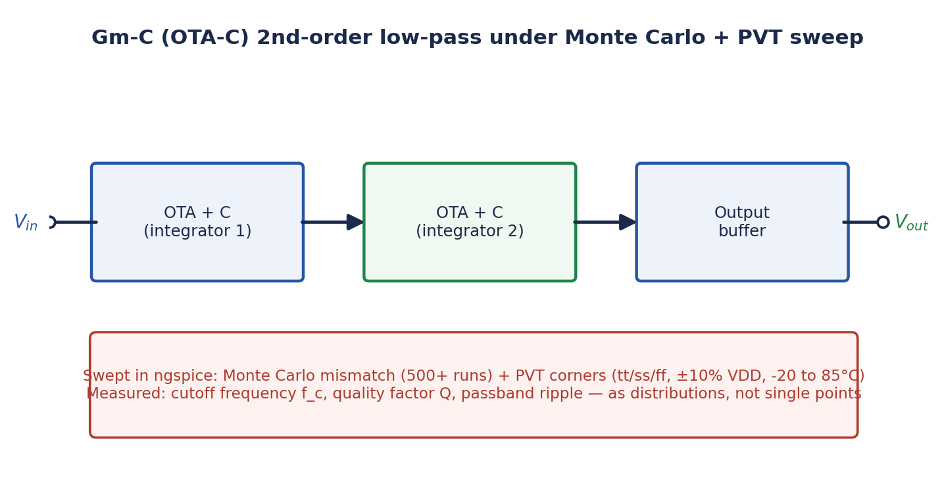
Figure 1 — The second-order Gm-C low-pass filter under test: two transconductor-capacitor integrator stages plus an output buffer, all built from SKY130 devices in Xschem.
The filter is built from two cascaded transconductor-capacitor integrator stages implementing a standard second-order low-pass response, plus an output buffer stage to isolate the filter's internal nodes from whatever measurement load is applied. Each transconductor is a straightforward differential-pair-based OTA cell, sized using standard hand-calculation and verified in simulation before being placed into the filter — deliberately the simplest correct topology, since the paper's contribution is the statistical characterization methodology, not topological novelty.

4. Novelty position and honest limitations
A literature and open-source-community search found related but non-overlapping work. "Design of a Linear Transconductance OTA using the Open Sky130 PDK" (Aiello et al.) documents a single open-SKY130 OTA cell, but not a filter and without Monte Carlo statistics. Kumngern, Aupithak, Khateb and Kulej, "0.5 V Fifth-Order Butterworth Low-Pass Filter Using Multiple-Input OTA for ECG Applications," Sensors 2020, 20(24):7343, runs 200 Monte Carlo simulations of a Gm-C-style filter and reports concrete statistics (cutoff frequency 251.7 Hz ± 4.9 Hz standard deviation; gain −6.23 dB ± 0.14 dB), but in a proprietary TSMC 0.18 µm process, not an open PDK. The SKY130_CT-DSM open-source project uses a Gm-cell in SKY130, but as the front end of a continuous-time delta-sigma modulator, not as a characterized standalone filter, and without Monte Carlo/PVT statistics.
The specific gap this paper targets — a Monte Carlo and PVT-corner statistical characterization of a complete Gm-C filter, built and simulated entirely in the open-source SKY130 PDK with the free ngspice/Xschem toolchain, with all netlists and scripts released openly — was not found published anywhere in the search conducted. This is the paper's defensible novelty position.
Honest limitations, stated upfront: this is a pre-layout, schematic-level study, so layout parasitics that would affect a fabricated implementation are not captured. Additionally, the SKY130 PDK has documented modeling limitations for precision analog work — the AnalogGym testing-suite paper (ICCAD 2024) notes that open PDKs like SKY130 often lack "precise subthreshold modeling," and the SKY130_CT-DSM project separately flags "the large flicker noise coefficient of the SKY130 PDK." These limitations are stated explicitly as boundaries on what the simulation results can claim, rather than discovered by a reviewer.
Standing caveat: this novelty assessment reflects a search conducted prior to submission and is not a guarantee, particularly given how quickly open-SKY130 analog work is proliferating. The action checklist (Section 11) includes a direct IEEE Xplore proceedings search, plus a fresh Google Scholar/arXiv/GitHub sweep, as the load-bearing verification step before deep investment begins.

5. Methodology: Monte Carlo and PVT corners
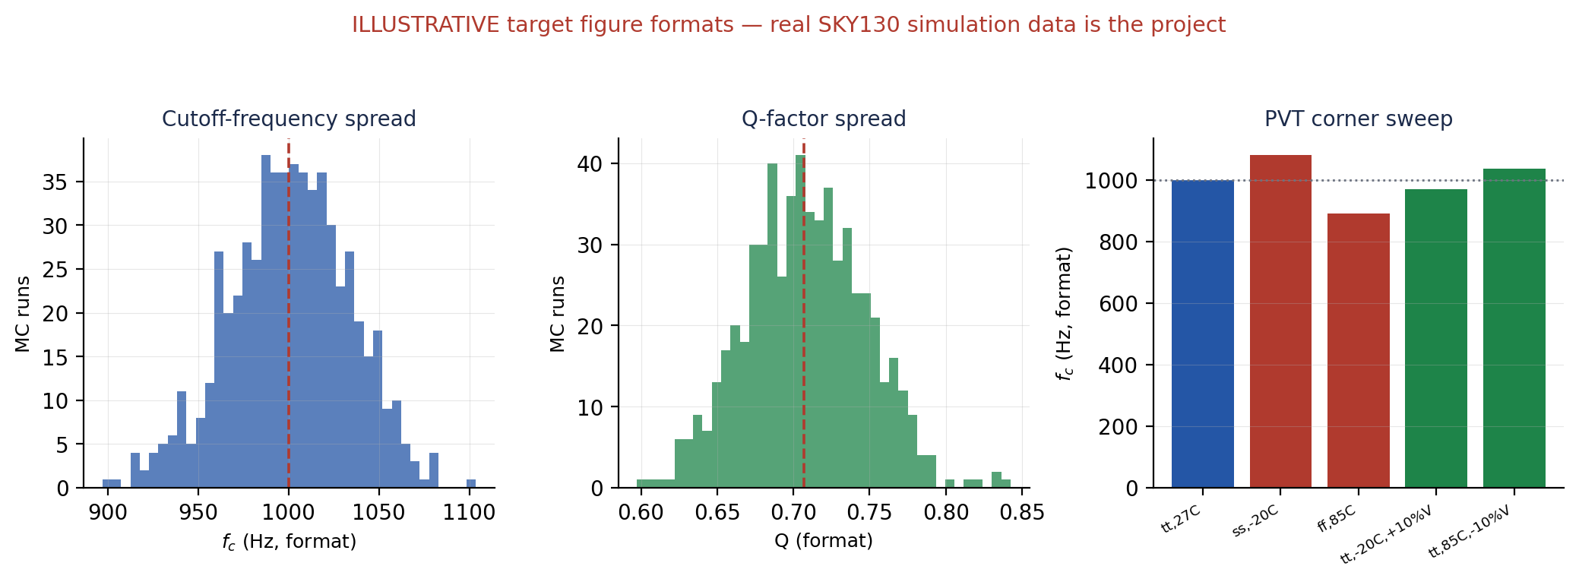
Figure 2 — Target result formats: Monte Carlo histograms of cutoff frequency (left) and Q-factor (center), and a PVT corner sweep (right). Illustrative; the real SKY130 simulation data is the paper's core deliverable.
Campaign | Method | Output
Monte Carlo mismatch | 500+ transient/AC simulation runs using SKY130's mismatch (AGAUSS-based) statistical device models, sweeping input signal to extract the transfer function each run | Distributions of cutoff frequency, Q, and passband ripple
PVT corners | Standard process corners (tt/ss/ff), supply-voltage variation (±10%), and temperature range (−20°C to 85°C) applied to the nominal design | Cutoff frequency and Q shift per corner, relative to the nominal design point
Cross-validation | Where feasible, key AC-domain results (e.g., cutoff frequency) cross-checked via an independent transient-domain measurement | Confidence that the reported statistics are not an artifact of one specific simulation method

Methodological safeguards: every Monte Carlo campaign records its random seed so any histogram in the eventual paper is exactly reproducible; every netlist, testbench, and analysis script is released on GitHub as part of the contribution; and the known SKY130 modeling limitations (flicker noise, subthreshold precision) are explicitly acknowledged wherever they could plausibly affect a reported number, rather than silently assumed away.

6. Planned results and figure list
# | Figure | Purpose
1 | Gm-C filter block diagram and transconductor schematic | Defines exactly what is built and characterized
2 | Nominal-case AC response (magnitude and phase) | Establishes the baseline design point before statistics are introduced
3 | Monte Carlo histogram of cutoff frequency (500+ runs) | The paper's headline statistical result
4 | Monte Carlo histogram of Q-factor | Completes the statistical characterization of the transfer function
5 | PVT corner sweep: cutoff frequency and Q shift per corner | Quantifies process/voltage/temperature robustness
6 | Passband ripple distribution across Monte Carlo runs | Rounds out the full transfer-function statistical picture
T-I | Summary statistics table: mean, σ, and corner-extremes for fc, Q, and ripple | The designer-facing takeaway

7. Resources and cost
This is a fully simulation-based study. No laboratory hardware, no components, no bench instruments.
Item | Role | Cost
SkyWater SKY130 PDK | The open-source process: device models, mismatch statistics | ₹0
Xschem | Schematic capture of the transconductor cells and the filter | ₹0
ngspice | AC, transient, Monte Carlo, and corner simulation engine | ₹0
Python 3 + numpy/pandas/matplotlib | Batch-driving Monte Carlo campaigns, statistical analysis, figure generation | ₹0
Git + GitHub | Version control and the open netlist/script release that is part of the contribution | ₹0
A laptop (4-core/8GB minimum, 8-core/16GB comfortable) or a free cloud VM | Running the simulation campaigns | ₹0 (existing hardware)

8. Week-by-week timeline (6–7 weeks)
Week | Milestone
1 | Direct IEEE Xplore proceedings search completed; INDICON 2026 deadline confirmed; SKY130 + Xschem + ngspice environment running; a single transconductor cell functional and verified against hand calculations
2 | Second transconductor stage added; full two-stage Gm-C filter assembled and producing a correct nominal-case AC response
3 | Monte Carlo mismatch pipeline scripted and producing a first batch (e.g., 100 runs) of results
4 | Full 500+ run Monte Carlo campaign completed; cutoff-frequency and Q histograms produced
5 | PVT corner sweep completed; passband ripple statistics extracted; cross-validation of key results performed
6 | All figures frozen; summary statistics table populated; GitHub repository finalized
7 | Full draft written; mentor review; submission to INDICON 2026

Note on schedule tightness: if the Monte Carlo campaign proves slower to converge than expected (a documented open question for SKY130's statistical models), the fallback is reducing the run count from 500+ to 200 (matching the sample size used in the closest proprietary-process precedent) — still statistically meaningful and explicitly noted as a scope reduction rather than hidden.

9. Risks and mitigations
Risk | Likelihood / impact | Mitigation
SKY130's Monte Carlo mismatch models behave unexpectedly or converge slowly | Medium / Medium | This is a documented open question in the SKY130 community; reduce run count to 200 if needed, and document whatever behavior is encountered either way — itself a useful methodological note
Transconductor cell design takes longer than planned to get right | Medium / Medium-High | Start from the simplest possible differential-pair OTA rather than a more elaborate cell; complexity can be added later if time permits
INDICON 2026's 31 August deadline is tighter than a full study needs | Confirmed / Medium | Timeline in Section 8 is front-loaded; the PVT-corner sweep (Section 5) can be trimmed to fewer corners if week 5 slips
A closely matching open-SKY130 Gm-C statistical study is found in the week-1 search | Low-Medium / High | Narrow to a specific sub-angle (e.g., a tuning-scheme robustness comparison, or a cross-simulator validation) while keeping the core Monte Carlo infrastructure
Known SKY130 modeling limitations (flicker noise, subthreshold precision) undermine a specific claimed result | Medium / Medium | State the limitation explicitly wherever it applies rather than have a reviewer discover it; this honesty is itself part of the paper's rigor

10. Target venues
Venue | Key dates (as verified) | Fit
IEEE INDICON 2026 | Submission opens 22 Jun 2026; deadline 31 Aug 2026; notification 2 Nov 2026; camera-ready 16 Nov 2026. Track: Electronic Devices, Circuits, VLSI, and Embedded Systems | Primary target
IEEE iSES 2026 | 2025 pattern: submission closed 30 Aug, notification 10 Sept (2026 dates not yet posted — verify) | Secondary target
IEEE INDISCON 2026 | Sept 11–13, 2026, MNIT Jaipur; has a Graduate Research Forum | Additional option

11. Action checklist
# | Action | Done when
1 | Run a direct IEEE Xplore proceedings search plus a fresh Google Scholar/arXiv/GitHub sweep for open-SKY130 Gm-C filter statistical characterization papers | Novelty position confirmed or a specific pivot identified
2 | Confirm INDICON 2026's exact submission portal and any track-specific requirements | Submission checklist ready
3 | Install/verify SKY130 + Xschem + ngspice environment; reproduce a known-good OTA or amplifier simulation | First waveform exported
4 | Build the first transconductor cell and get one clean AC response | First real (non-illustrative) transconductance plot exists
5 | Pitch faculty mentors using a one-page summary distilled from Sections 1 and 4 | At least one meeting scheduled

12. Key references
Verified via web search during proposal preparation; full citation details should be confirmed against the original source before submission.
[1] M. Kumngern, K. Aupithak, F. Khateb and T. Kulej, "0.5 V Fifth-Order Butterworth Low-Pass Filter Using Multiple-Input OTA for ECG Applications," Sensors, vol. 20, no. 24, p. 7343, 2020, doi:10.3390/s20247343 — closest related Monte Carlo statistical filter study, but in proprietary TSMC 0.18 µm.
[2] Aiello et al., "Design of a Linear Transconductance OTA using the Open Sky130 PDK" (ResearchGate) — a single open-SKY130 OTA cell, without filter-level or Monte Carlo characterization.
[3] michaelk99, SKY130_CT-DSM (GitHub repository) — uses a Gm-cell in SKY130 as a delta-sigma modulator front end; flags "the large flicker noise coefficient of the SKY130 PDK."
[4] Z. Li et al., "AnalogGym: An Open and Practical Testing Suite for Analog Circuit Synthesis," ICCAD 2024, arXiv:2409.08534 — documents open-PDK modeling limitations for precision analog work.
[5] SkyWater SKY130 PDK documentation (skywater-pdk.readthedocs.io) — device models, Monte Carlo/mismatch parameter structure.
[6] IEEE India Council, INDICON 2026 official Call for Papers — venue deadlines and track scope.

Prepared as the working proposal for a simulation-only, open-source SKY130 Gm-C filter statistical characterization study. Companion artifact to produce next: a one-page faculty pitch distilled from this document.

