CS 148 – Database for the Web

Kenny Alderman

Final Project

Karen’s Kloset

Version <1.0>

Table Of Contents

Time Log 3

Introduction 4

Purpose 4

Definitions, acronyms, and abbreviations 4

Overall Description 4

Story Board 6

Specific requirements 6

|  |  |  |  |
| --- | --- | --- | --- |
| Time Log | | | |
| Estimated time to complete assignment => | | | 50 Hours |
| Date | Time Spent  (in hours) | Description | Author |
| 08/19/14 | 2 | Transfer website contents TWICE | Kenny Alderman |
|  | 2 | Re transfer website content | KA |
|  | 1 | Figuring out git | KA |
|  | 3 | Major css changes | KA |
|  | 3.5 | Building the form outline | KA |
|  | 1 | Changing paragraphs and h1 colors | KA |
|  | 1.5 | Formatting nav | KA |
|  | 2 | Building tables in phpmyadmin | KA |
|  | 1 | Making Products page | KA |
|  | 2 | Page spacing | KA |
|  | 3 | Form editing | KA |
|  | 4 | Rebuild new form | KA |
|  | 7 | Still working on the form | KA |
|  | 2 | ERD in access | KA |
|  | 4 | SQL statements on myphpadmin | KA |
|  |  |  |  |
|  |  |  |  |
|  |  |  |  |
|  |  |  |  |
|  |  |  |  |
|  |  |  |  |
|  | 39 | <=Total Time Spent |  |
|  |  |  |  |

# Introduction

### Purpose

The purpose of this document is to describe the requirement specification for the web site Karens Kloset.

The intended audience for this document is Karol and Bob.

*First it is the contract between you and the client. Second it is for the developer of the site. Two primary goals are:*

1. *Client gets a very good understanding of what you will be delivering.*
2. *Developer has a very good understanding of what they are going to create.*

It will provide the client with proper database information, market research, and her own website instead of a cluttered google site. Trying to expand she needs a way to contact her customer besides fb which does not allow the client to have a list/emails for her “likers”.

### Definitions, acronyms, and abbreviations

(NO EDIT NEEDED)

*Sample for the client:*

GIT*-* I Will be making multiple syncs with github to receive credit for that aspect of work

HTML – Hypertext markup language – used to define your content.

PHP – Personal Home Page – language that helps to customize html.

CSS – Cascading Style Sheets – used to define the look of a web site.

W3 Validation – refers to both Html and CSS validation tool provided by the W3c.org. the html validator is located at:

<http://validator.w3.org/>

with the CSS validator located at:

<http://jigsaw.w3.org/css-validator/>

# Overall Description

The website will provide her customers navigation with ease following her specific stores colors. Because her target market is selling to an older crowd (30-60 y/o) a major aspect will be usability. Providing direct information to keep the customers satisfied. With the new website launce, we hope to be at the top of google, and use google analytics to use the website for daily promotions. Once linked with the promotions we will also promotion throughout all of our social media. The database will allow edits for the admin to keep things running smoothly. Using Karen’s Kloset butterfly and personable theme, the content needs to be easy to understand and browse.

# Story Board

-Draft 1

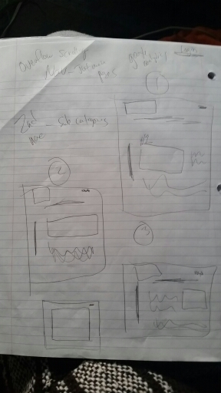

Draft 2 Below

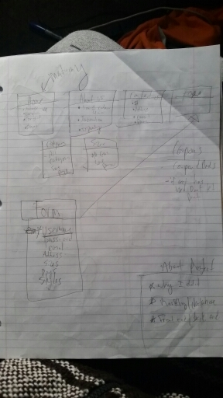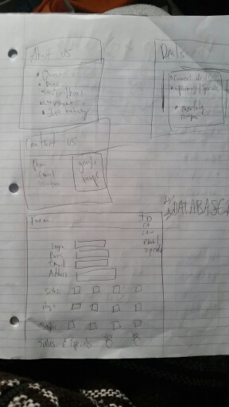

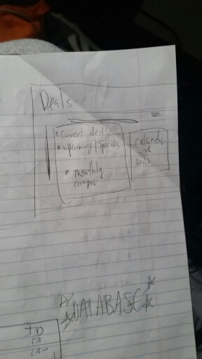

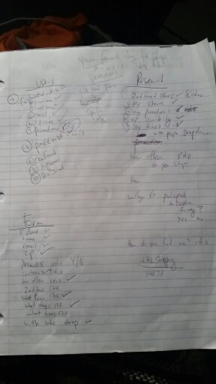

Draft 1 for my ERD

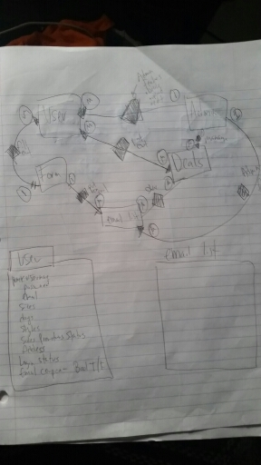

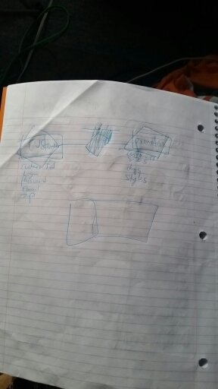

Draft 2 for my ERD

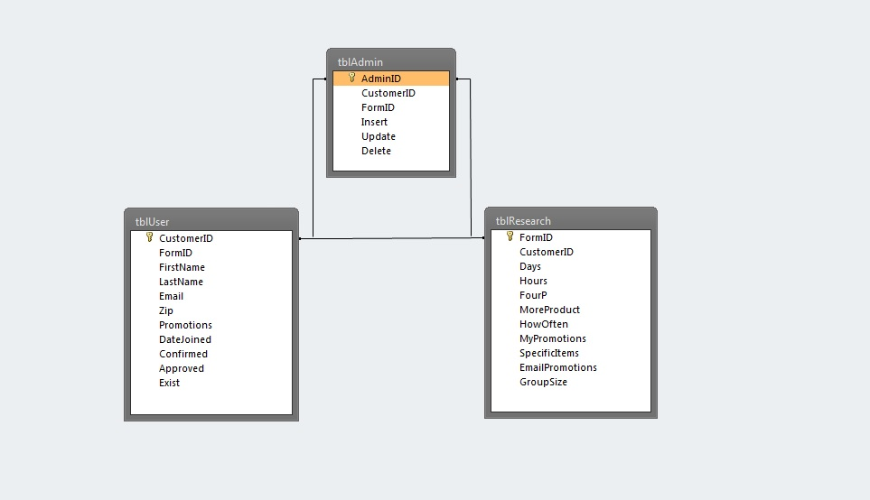

# Specific requirements

1. *You fill out* – This is where you would put the exact detail of what you want for the project. For example:
2. *Title for main page*: *Karens Kloset*
3. *Meta Description*: *Karen's Kloset - Klassy, Klassic, and Komfy. One on one customer service to get you what you need! Look for Anna the mannequinne.*
4. *Meta Character set*: UTF - 8
5. *Logo*: *Butterfly*
6. *Main page photo*: *Picture of Karens Kloset.*
7. *Header:* Business card
8. *Footer:* phone number and social media links
9. *Home Page*: List the sizes, hours, her tagline, sizes listed, under their own headings list the hours and location.
10. *Product Page*: Inserted statement about the product (pre written), followed by a list of products
11. *Deals, Events & info page*: Deals heading – content about current deals, events heading followed by the current events and an information heading with current information in bulleted form. Under important information include the consignment rules
12. *About us*: Two-3 paragraphs about karens kloset and Karen herself followed by a centered PDF written abour her.
13. *Contact us*: Forms of contact heading with phone number, fb, twitter, Instagram, and emal all clickable links, Heading for store hours with current store hours and a location heading once again followed by an embedded google map location.
14. *Store feedback*: We have a form design for you to follow. The first part will be based on customer information and placed into that specific table, the second half will be put into a market research table. Make sure they cannot validate with blank options.