Sonoma State University
Computer Science Department
CS 360 – Fall 2012 – Watts Version P2α

Project 2 User Guide

To start the program:
To start a Project 2 session, enter java –jar Project2.jar at the prompt. The Project 2 GUI will be displayed:

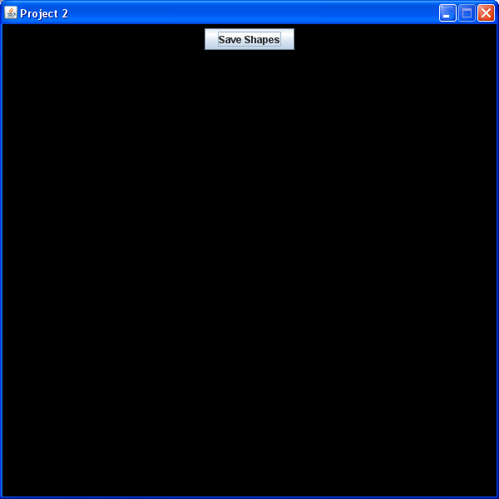

To add a shape:
Right click on the background to display the New Shape Dialog. Use the check box to select the type of shape and click the OK button. A shape modification Dialog will be displayed so that you can enter the shape specifications; each share requires different information. For example, the Modify Scalene Dialog requests the color, the lengths of the three sides, and the angle of rotation.
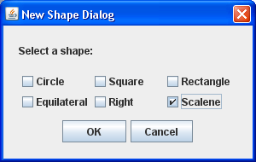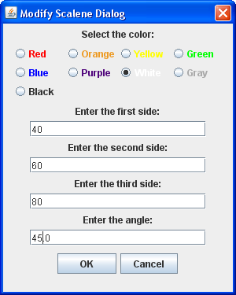

Fill in the requested information and click OK. The new shape will be displayed:

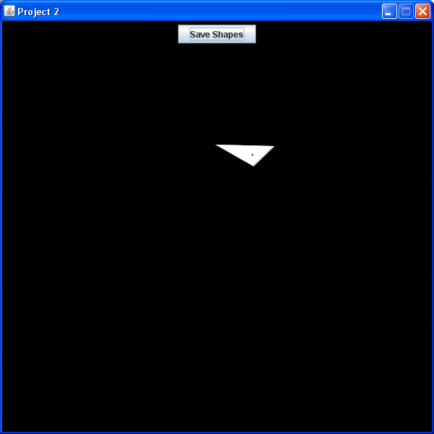

To move a shape:
Using the mouse, left click and drag the shape to the desire location.

To modify a shape:
Using the mouse, right click on the shape. The Modify Dialog for the shape will be displayed.

To save the shapes:
Click the Save Shapes button at the top of the screen. The shapes will be saved in a file called SavedShapes.sio – you must rename the file to avoid overwriting it.

To load existing shapes:
When you start a Project 2 session, you can load the shapes created in a previous session by entering java –jar Project2.jar <file name(s)> Multiple files can be loaded.

To end the program:
Click on the X or the red button in the GUI header.

