README for running ColocP2C, the Matlab implementation of the 2-way and 3-way punctate-to-continuum colocalization method described in the paper “Ligand-induced growth and compaction of CD36 nanoclusters enriched in Fyn induces Fyn signaling” by Githaka et al., Journal of Cell Science 2016 129: 4175-4189.

Overview of ColocP2C

ColocP2C is designed to measure the colocalization between two imaged molecules when one displays a punctate appearance (referred to hereafter as the **punctate** channel), and the other displays a more continuum appearance (referred to hereafter as the **continuum** channel). As described in the publication, the method relies on particle detection in the punctate channel and then measuring the enrichment of the continuum channel intensity at the locations of the detected particles.

In addition, ColocP2C can measure the colocalization between the punctate and continuum channels in the context of a third channel, also of a continuum nature (referred to hereafter as the **context** channel).

Installation

The software has been tested on **Matlab R2015b** and **R2016b** on **Windows 64-bit** and **Linux 64-bit**. It has not been tested on any MAC OS X.

The software requires the following **Matlab toolboxes**:

- Optimization Toolbox v. 7.3

- Image Processing Toolbox v. 9.3

- Statistics and Machine Learning Toolbox v. 10.1

- Curve Fitting Toolbox v. 3.5.2

The download package contains all necessary code to run ColocP2C once added to your MATLAB search path. Additionally, the package contains an image named **test_0001.tif** to test the analysis.

Running the General Colocalization Code

Once the package has been downloaded, unzipped, and added to your MATLAB search path, the script **scriptGeneralColocalization.m** can be used to run the 2-way colocalization process.

The script can be run all at once or you can evaluate individual processes for optimization of parameters described within the script.

Input: The first section of the script requires a single string input of the location of the image you wish to analyze (ex. ‘C:\Users\Joe\Data\image.tif’). See next section for further information on image format. The subsequent sections require various parameters that may require adjustment as described in the script.

Output: In addition to the MovieData object “MD”, all output from the various processes will be saved in a new folder in the directory where your image is located, with the name of your image. The folder contents and nature of these contents are further described in the core function of each process; the names of these functions are cited in **scriptGeneralColocalization.m.** MD can be used for subsequent visualization or analysis as discussed below.

Input Image Format

Images should be in multi-channel tiff format. If analyzing an image stack (i.e group of multi-channel images stacked together), an error will occur if stack is read as multiple **z-slices** rather than **frames**. To verify that your image stack is correctly formatted, you can check using an image processing program such as ImageJ as shown below:

1. Open image in ImageJ and under the tab “Image”, click on properties

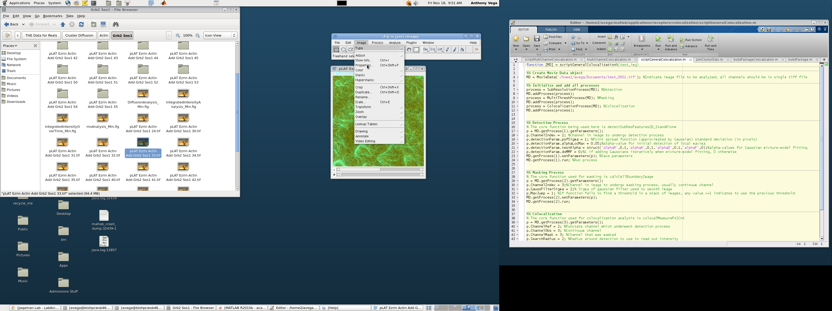

1. In the pop-up window, verify that your image stack has a single **slice** and multiple **frames.** Switch these properties if necessary and save these changes.

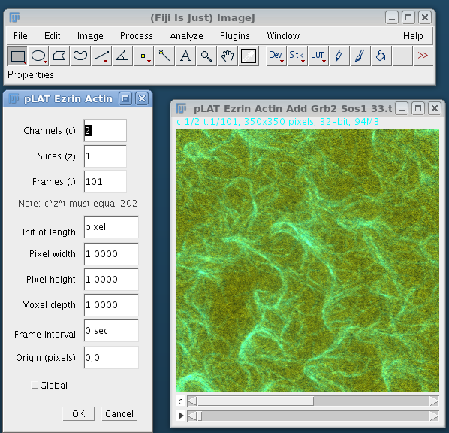

Visualizing the Output

Outputs from the first two processes (Detection, Masking) can be visualized as follows:

1. If not already in your MATLAB workspace, load the MovieData object “MD” by typing the command *MD = MovieData.load(****location of MD object****)* in the MATLAB command window and press enter as shown below:

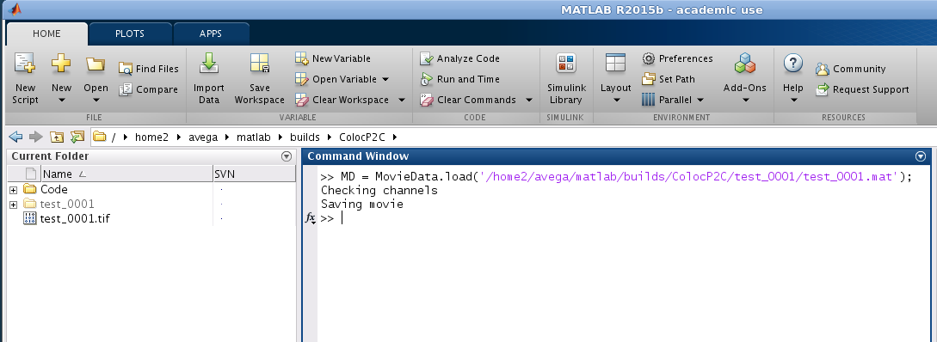

1. In MATLAB command window, type: *movieViewer(MD)* and press enter.
2. Three windows will appear a) Viewer, b) Movie Options, and c) Movie, as shown below.

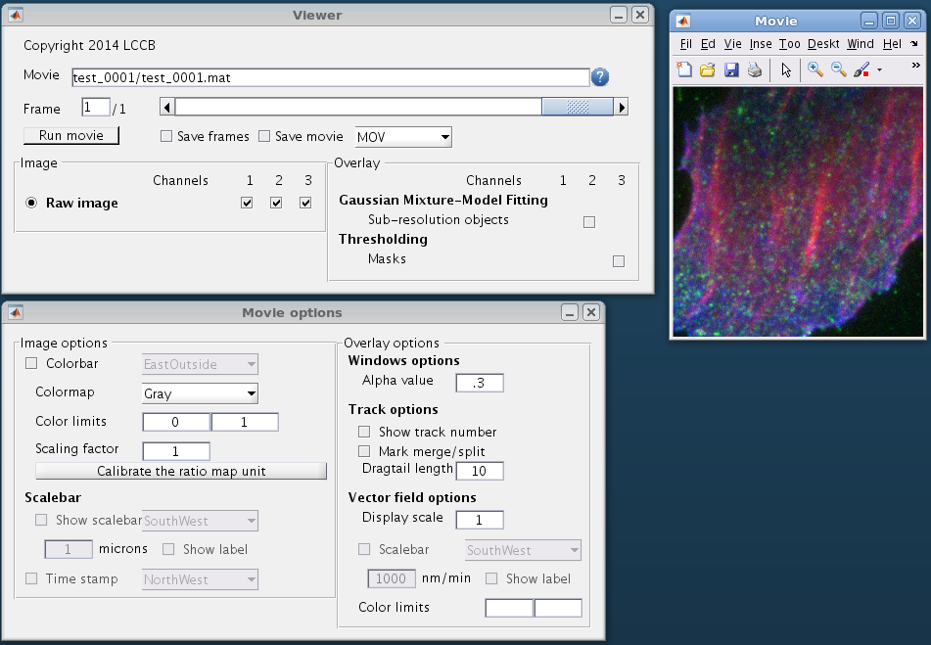

* 1. Viewer is the most relevant for this package. You can toggle on/off the visibility of each channel in the Movie window by checking the channel boxes, as illustrated below:

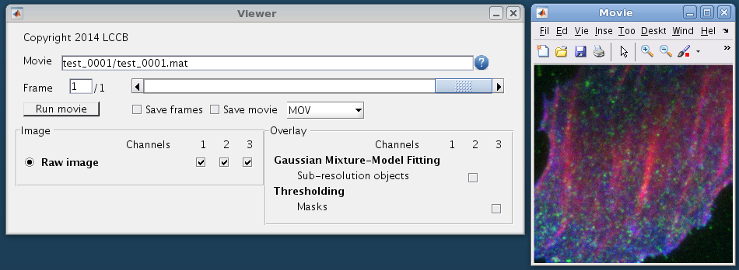

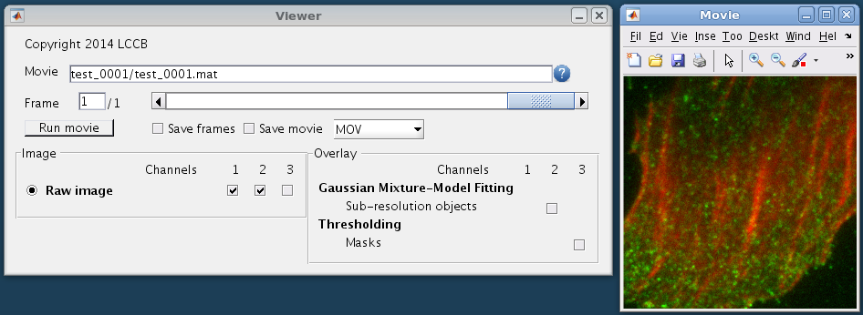

* 1. Additionally, you can toggle on/off the visibility of the Detection and Masking results in the Movie window by checking the boxes shown below:

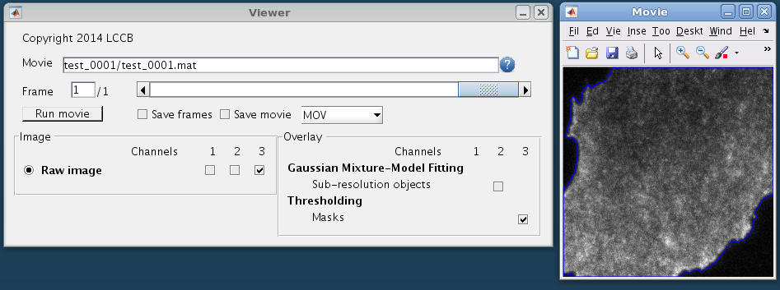

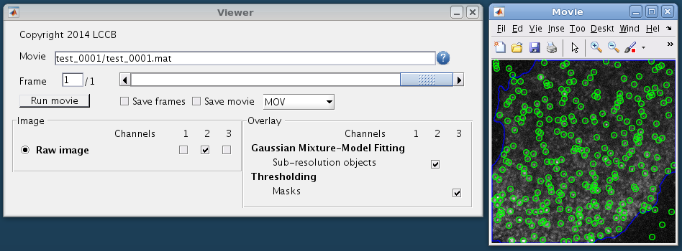

* 1. In the Movie Options window, almost all options are not relevant for colocalization analysis. However, color limits may be changed under Image Options to vary the image intensity range shown in the Movie Window display.

Running the Multi-channel Colocalization Code

To assess the punctate channel-to-continuum channel colocalization in the context of a third context channel, multi-channel analysis can be performed following the steps below:

1. *Initial Colocalization:* Run **scriptGeneralColocalization**, as described above, for the **punctate** and **continuum** channels.
2. *Separate colocalization results using enrichment information from the context channel:* Run **scriptMultiChannelColocalization**. The script will first analyze the enrichment of the **context** channel at the **punctate** channel objects, as done previously for the continuum channel. Then it will divide the punctate objects into two groups, those highly enriched in the context channel and those not enriched. Finally it will re-evaluate the punctate channel-to-continuum channel colocalization for the two groups separately.

Input: The first section of the script requires a single string input of the location of the output “MD” from step 1 (ex. ‘C:\Users\Joe\image\image.mat’). The subsequent sections require various parameters that may require adjustment as described in the script.

Output: All results from these processes will be saved in a new folder in the directory where your image is located, with the name of your image. The folder contents and nature of these contents are further described in the core function, **multiChannelColocalization**.