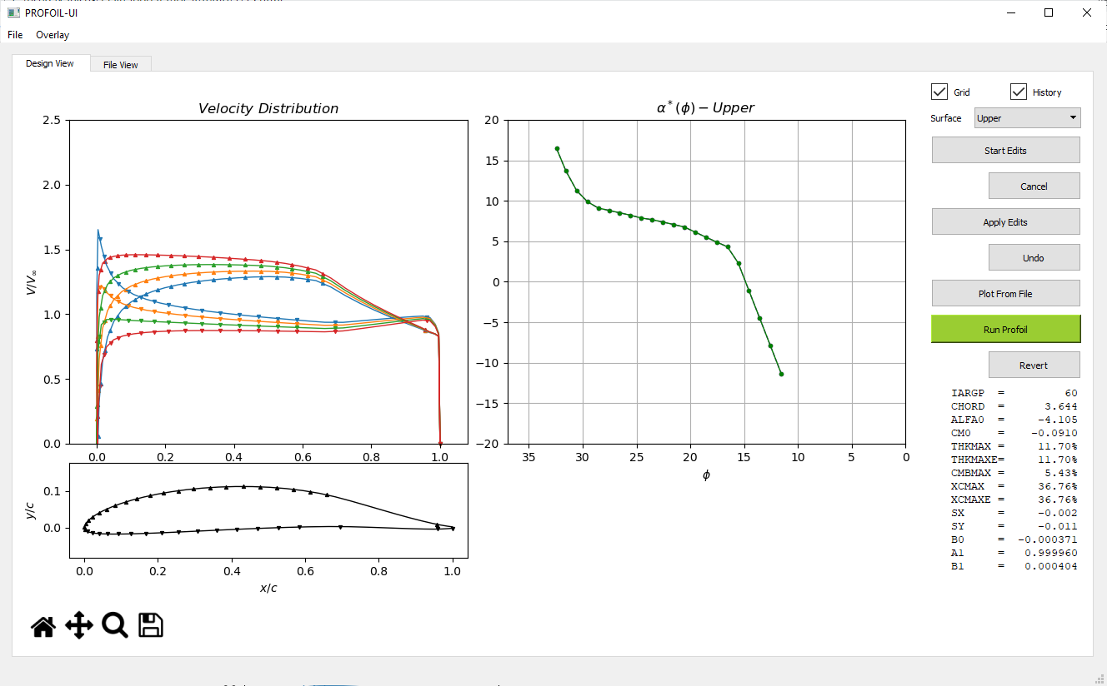

**Menu**

**Surface Selector**

**α*(ϕ) Distribution**

**Velocity Distribution**

**Airfoil Shape**

**Airfoil Summary Statistics**

**Graph Toolbar**