Karan Bhargava

Final Project Report

Machine Learning

**Project Outline and Purpose:**

This project is meant to analyze the performance of a CNN trained on Google Streetview Digits and tested on a classical MNIST dataset to see how robust a CNN model trained on images with a high level of noise is able to distinguish numbers in a much “cleaner” MNIST dataset. This is meant to be a training exercise to see how I can work with training models to be versatile enough on data that is similar in concept, but different in presentation.

One of the challenges that the model will face when training on Streetview digits is that the model will train on “perfectly drawn” numbers: numbers that are “perfect” in shape but imperfect due to the noise present in each of the images. Whether it be inconsistent lighting, the presence of distracting digits, or poorly angled images, the numbers will vary in how they will be read. This may effect the portions of the CNN that specialize and filter the images to reduce “noise” since the MNIST dataset will not have the same type of noise that the streetview images will have.

Ideally, I would like to use the experience from this project to then start creating models that train and read human handwriting on letters and words and synthesizing it with pictures of “perfect letters” to make a model that can read words accurately. In the long run, the goal is to then apply this to education so that AI can “grade” homework, tests, etc.

**Work**:

The dataset was taken from [www.ufldl.stanford.edu/housenumbers/](http://www.ufldl.stanford.edu/housenumbers/) . I talked with Tovio to give me an idea on how to scope the project to make it doable within the time-frame of when the project was assigned and when it was due. The basic model structure was based in the Practice 4 class notes that were found in blackboard. I tweaked the model to handle the Streetview images, though. I also took the data as a .mat file, saved each individual image to a folder, and then processed the images into the model since the .mat file had a bizarre 4d implementation on how the data was stored. I also changed the images to grayscale to match the types of images that the model will train on in MNIST. Model evaluation code was pulled directly from the blackboard code. I also increased the size of the MNIST images to match the size of the Streetview images (32x32).

*PreProcessing:*

**Libraries:**

Keras, Sklearn, tensorflow, cv2, numpy, pandas, matplotlib, warnings, os, skimage, scipy

All of these are standard libraries for deep learning and image/computer vision data processing.

**ML/DL algorithms and reasoning for selection:**

**Parameter settings/analysis of performance change with different hyperparameters:**

**Results:**

Performance of the trained CNN on the streetview image test set

Performance of the Base CNN on the Base MNIST Dataset

Performance of the CNN with mean subtraction and normalization on SV training dataset

Training results with Mean subtraction and normalization (blue = acc, orange = training loss)

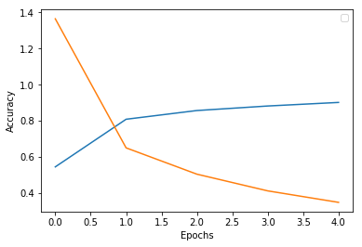

Performance of the CNN with mean subtraction and normalization on MNIST test dataset

**Why is this meaningful?**

As stated earlier, I would ultimately like to work in applying Artificial Intelligence to education. I want to work on creating an AI based tutor. In order for this to become a reality, I want to begin by learning how models read human handwriting and human language. This would then lead to a development in learning NLP. The project would also help me further understand how to analyze and preprocess data for computer vision. Other things that this project will help with is in understanding the limitations or advantages of processing data in grayscale as opposed to the classic RGB. Furthermore, this would also help understand more into CNN’s strengths and weaknesses when comparing it with images that are not in the same style of its training dataset.