BA 64060 Assignment 5
Kyle Breeden
2025-11-23
#rm(list = ls())
library(readr)
## Warning: package 'readr' was built under R version 4.5.1
assign5_dataset <- read_csv("C:/Users/kylej/OneDrive/Documents/BA 64060/Assignment 5/Cereals.csv")
## Rows: 77 Columns: 16
## ── Column specification ────────────────────────────────────────────────────────
## Delimiter: ","
## chr (3): name, mfr, type
## dbl (13): calories, protein, fat, sodium, fiber, carbo, sugars, potass, vita...
##
## ℹ Use `spec()` to retrieve the full column specification for this data.
## ℹ Specify the column types or set `show_col_types = FALSE` to quiet this message.
summary(assign5_dataset)
## name mfr type calories
## Length:77 Length:77 Length:77 Min. : 50.0
## Class :character Class :character Class :character 1st Qu.:100.0
## Mode :character Mode :character Mode :character Median :110.0
## Mean :106.9
## 3rd Qu.:110.0
## Max. :160.0
##
## protein fat sodium fiber
## Min. :1.000 Min. :0.000 Min. : 0.0 Min. : 0.000
## 1st Qu.:2.000 1st Qu.:0.000 1st Qu.:130.0 1st Qu.: 1.000
## Median :3.000 Median :1.000 Median :180.0 Median : 2.000
## Mean :2.545 Mean :1.013 Mean :159.7 Mean : 2.152
## 3rd Qu.:3.000 3rd Qu.:2.000 3rd Qu.:210.0 3rd Qu.: 3.000
## Max. :6.000 Max. :5.000 Max. :320.0 Max. :14.000
##
## carbo sugars potass vitamins
## Min. : 5.0 Min. : 0.000 Min. : 15.00 Min. : 0.00
## 1st Qu.:12.0 1st Qu.: 3.000 1st Qu.: 42.50 1st Qu.: 25.00
## Median :14.5 Median : 7.000 Median : 90.00 Median : 25.00
## Mean :14.8 Mean : 7.026 Mean : 98.67 Mean : 28.25
## 3rd Qu.:17.0 3rd Qu.:11.000 3rd Qu.:120.00 3rd Qu.: 25.00
## Max. :23.0 Max. :15.000 Max. :330.00 Max. :100.00
## NA's :1 NA's :1 NA's :2
## shelf weight cups rating
## Min. :1.000 Min. :0.50 Min. :0.250 Min. :18.04
## 1st Qu.:1.000 1st Qu.:1.00 1st Qu.:0.670 1st Qu.:33.17
## Median :2.000 Median :1.00 Median :0.750 Median :40.40
## Mean :2.208 Mean :1.03 Mean :0.821 Mean :42.67
## 3rd Qu.:3.000 3rd Qu.:1.00 3rd Qu.:1.000 3rd Qu.:50.83
## Max. :3.000 Max. :1.50 Max. :1.500 Max. :93.70
##
#The directions say to remove all cereals with missing values
#See which columns have missing values and how may cereals will be lost when removing those with empty values
colSums(is.na(assign5_dataset))
## name mfr type calories protein fat sodium fiber
## 0 0 0 0 0 0 0 0
## carbo sugars potass vitamins shelf weight cups rating
## 1 1 2 0 0 0 0 0
sum(is.na(assign5_dataset))
## [1] 4
#You can also look in the summary statistics above
#See which cereas will be lost
rows_with_na <- which(!complete.cases(assign5_dataset))
unique(assign5_dataset$name[rows_with_na])
## [1] "Almond_Delight" "Cream_of_Wheat_(Quick)" "Quaker_Oatmeal"
#remove all cereals with missing values & then check for NAs
assign5_clean <- na.omit(assign5_dataset)
summary(assign5_clean)
## name mfr type calories
## Length:74 Length:74 Length:74 Min. : 50
## Class :character Class :character Class :character 1st Qu.:100
## Mode :character Mode :character Mode :character Median :110
## Mean :107
## 3rd Qu.:110
## Max. :160
## protein fat sodium fiber carbo
## Min. :1.000 Min. :0 Min. : 0.0 Min. : 0.000 Min. : 5.00
## 1st Qu.:2.000 1st Qu.:0 1st Qu.:135.0 1st Qu.: 0.250 1st Qu.:12.00
## Median :2.500 Median :1 Median :180.0 Median : 2.000 Median :14.50
## Mean :2.514 Mean :1 Mean :162.4 Mean : 2.176 Mean :14.73
## 3rd Qu.:3.000 3rd Qu.:1 3rd Qu.:217.5 3rd Qu.: 3.000 3rd Qu.:17.00
## Max. :6.000 Max. :5 Max. :320.0 Max. :14.000 Max. :23.00
## sugars potass vitamins shelf
## Min. : 0.000 Min. : 15.00 Min. : 0.00 Min. :1.000
## 1st Qu.: 3.000 1st Qu.: 41.25 1st Qu.: 25.00 1st Qu.:1.250
## Median : 7.000 Median : 90.00 Median : 25.00 Median :2.000
## Mean : 7.108 Mean : 98.51 Mean : 29.05 Mean :2.216
## 3rd Qu.:11.000 3rd Qu.:120.00 3rd Qu.: 25.00 3rd Qu.:3.000
## Max. :15.000 Max. :330.00 Max. :100.00 Max. :3.000
## weight cups rating
## Min. :0.500 Min. :0.2500 Min. :18.04
## 1st Qu.:1.000 1st Qu.:0.6700 1st Qu.:32.45
## Median :1.000 Median :0.7500 Median :40.25
## Mean :1.031 Mean :0.8216 Mean :42.37
## 3rd Qu.:1.000 3rd Qu.:1.0000 3rd Qu.:50.52
## Max. :1.500 Max. :1.5000 Max. :93.70
colSums(is.na(assign5_clean))
## name mfr type calories protein fat sodium fiber
## 0 0 0 0 0 0 0 0
## carbo sugars potass vitamins shelf weight cups rating
## 0 0 0 0 0 0 0 0
sum(is.na(assign5_clean))
## [1] 0
#Need to normalize numeric variables
#Separate numeric and non-numeric variables
assign5_non_numeric <- assign5_clean[ , !sapply(assign5_clean, is.numeric)]
assign5_numeric <- assign5_clean[ , sapply(assign5_clean, is.numeric)]
#Normalize only numeric variables
assign5_norm <- sapply(assign5_numeric, scale)
#Add cereal names as row labels
row.names(assign5_norm) <- assign5_clean$name
#Apply hierarchical clustering to the data using Euclidean distance to the normalized measurements.
#compute distance
d_norm <- dist(assign5_norm, method = "euclidean")
#Apply hierarchical clustering
hc_single <- hclust(d_norm, method = "single")
plot(hc_single, hang = -1, cex = 0.4, ann = FALSE)
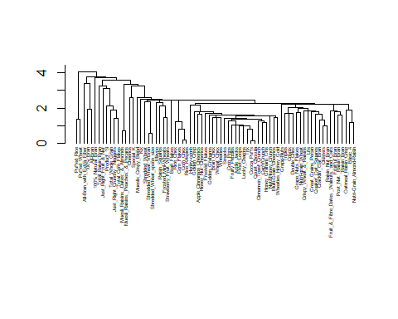
hc_complete <- hclust(d_norm, method = "complete")
plot(hc_complete, hang = -1, cex = 0.4, ann = FALSE)
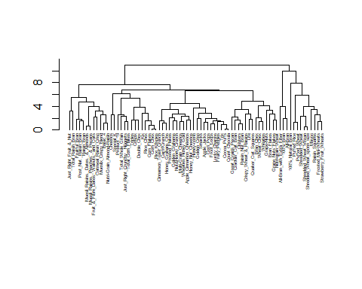
hc_average <- hclust(d_norm, method = "average")
plot(hc_average, hang = -1, cex = 0.4, ann = FALSE)
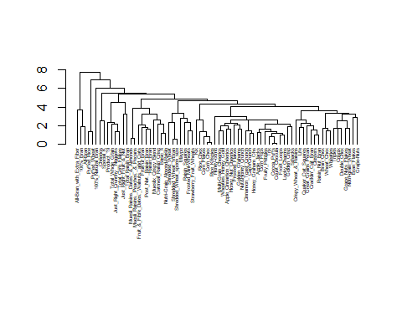
hc_ward <- hclust(d_norm, method = "ward.D2")
plot(hc_ward, hang = -1, cex = 0.4, ann = FALSE)
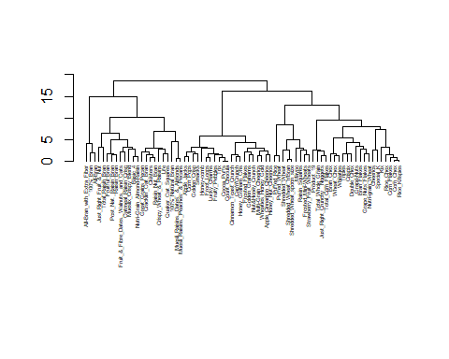
#Use Agnes to compare the clustering from single linkage, complete linkage, average linkage, and Ward.
library(cluster)
Agnes_single <- agnes(assign5_norm, method = "single")
pltree(Agnes_single, hang = -1, cex = 0.4, main = "Agnes Single")
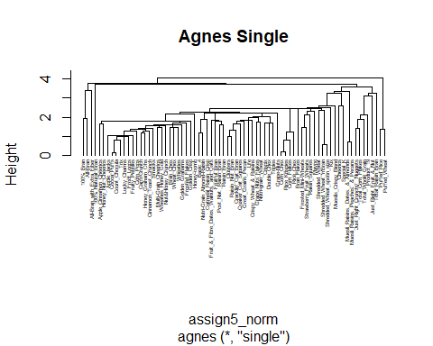
Agnes_complete <- agnes(assign5_norm, method = "complete")
pltree(Agnes_complete, hang = -1, cex = 0.4, main = "Agnes Complete")
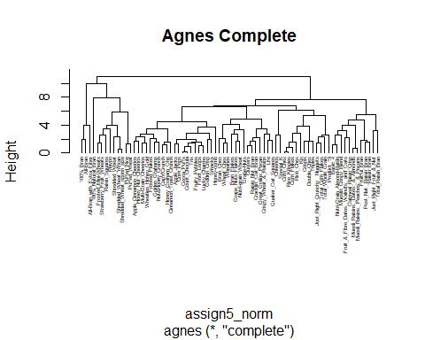
Agnes_average <- agnes(assign5_norm, method = "average")
pltree(Agnes_average, hang = -1, cex = 0.4, main = "Agnes Average")
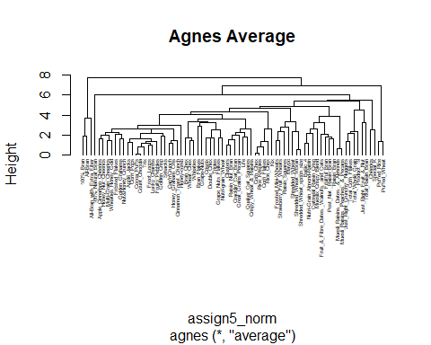
Agnes_ward <- agnes(assign5_norm, method = "ward")
pltree(Agnes_ward, hang = -1, cex = 0.4, main = "Agnes Ward")
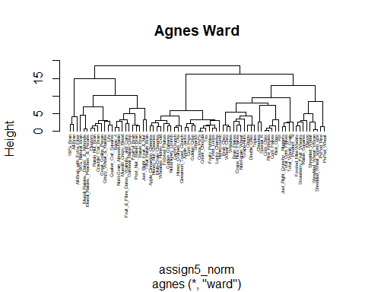
#Choose the best method.
#Use agglomerative coefficients (AC)
Agnes_single$ac
## [1] 0.6067859
Agnes_complete$ac
## [1] 0.8353712
Agnes_average$ac
## [1] 0.7766075
Agnes_ward$ac
## [1] 0.9046042
#Ward is the best method becasue it has the highest AC. #I choose 4 clsuters based on increases in merge height at 10, 14, and 22.
#Comment on cluster stability
#Split into partitions A & B
set.seed(123)
n <- nrow(assign5_norm)
idx <- sample(1:n, size = n/2)
Partition_A <- assign5_norm[idx, ]
Partition_B <- assign5_norm[-idx, ]
#Cluster Partition A
#library(cluster)
A_ward <- agnes(Partition_A, method = "ward")
A_clusters <- cutree(as.hclust(A_ward), k = 4)
#Find cluster centroids
A_centroids <- aggregate(Partition_A, by = list(A_clusters), FUN = mean)
#crucial step (missed at first) remove group column
A_centroids <- A_centroids[ , -1]
#Assign each record in partition B to the cluster with the closest centroid
assign_cluster_B <- apply(Partition_B, 1, function(x) {
dists <- apply(A_centroids, 1, function(c) dist(rbind(x, c)))
which.min(dists)})
#Use Agnes to cluster all data, This is to use for comparison per the directions.
full_ward <- agnes(assign5_norm, method = "ward")
full_clusters <- cutree(as.hclust(full_ward), k = 4)
#Compare clusters predicted for B using A’s centroids vs. true clusters from the full data
full_B <- full_clusters[-idx]
#produce a stability table
table(Predicted_B = assign_cluster_B, FullData_B = full_B)
## FullData_B
## Predicted_B 1 2 3 4
## 1 3 1 0 9
## 2 0 6 0 0
## 3 0 1 10 0
## 4 0 0 0 7
#Diagonal values are stable assignments, so 3, 6, 10, 7 #Sum of diagonal values = 26 #So 26 cereals out of partions B were assigned to the same cluster in both methods #Partition B contains 37 cereals, so 70% (26/37) are stable
#comment on cluster structure
#find cluster centroids for all cereals
cluster_centroids <- aggregate(assign5_numeric,
by = list(Cluster = full_clusters),
FUN = mean)
cluster_centroids
## Cluster calories protein fat sodium fiber carbo sugars
## 1 1 63.33333 4.000000 0.6666667 176.6667 11.0000000 6.666667 3.666667
## 2 2 124.00000 3.150000 1.9500000 155.0000 3.1000000 13.950000 9.350000
## 3 3 110.95238 1.523810 1.0000000 172.3810 0.5714286 12.619048 11.285714
## 4 4 97.33333 2.633333 0.4000000 158.8333 1.8000000 17.533333 3.033333
## potass vitamins shelf weight cups rating
## 1 310.00000 25.00000 3.000000 1.0000 0.3866667 73.84446
## 2 151.50000 31.25000 2.900000 1.1725 0.6925000 38.26161
## 3 45.95238 25.00000 1.666667 1.0000 0.8871429 28.84825
## 4 78.83333 30.83333 2.066667 0.9610 0.9053333 51.43111
#Cluster 1 is lowest calorie, highest protein, and highest fiber, so the healthiest among the clusters #Cluster 2 has highest calories and fat with a good amount of protein #Cluster 3 has high calories with the lowest protein and fiber so the least healthy cluster #Cluster 4 is a middle range with moderate calaries, protein, and fiber
#Elementary School Question
#Get a list of the healthy cereals (cluster 1)
#Add the cluster membership to your data
assign5_clean$cluster <- full_clusters
#Filter to only Cluster 1 (healthy cereals)
healthy_cereals <- assign5_clean[assign5_clean$cluster == 1, ]
healthy_cereals$name
## [1] "100%_Bran" "All-Bran"
## [3] "All-Bran_with_Extra_Fiber"
#After identifying that the healthy cluster contains only 3 of the 74 cereals remaining after removing those with missing values, I would consider re-running the clustering with 3 clusters to give the schools a larger set of healthy options.
#Normilization is necessary because the variables are measured on very different scales. Normalizing ensures that variables with larger ranges (such as sodium) do not dominate the Euclidean distance calculation and that each nutritional attribute contributes proportionally to the clustering.

