WEEK 6-7 DELIVERABLES
- For our prototype using Figma, please see link here
- ERD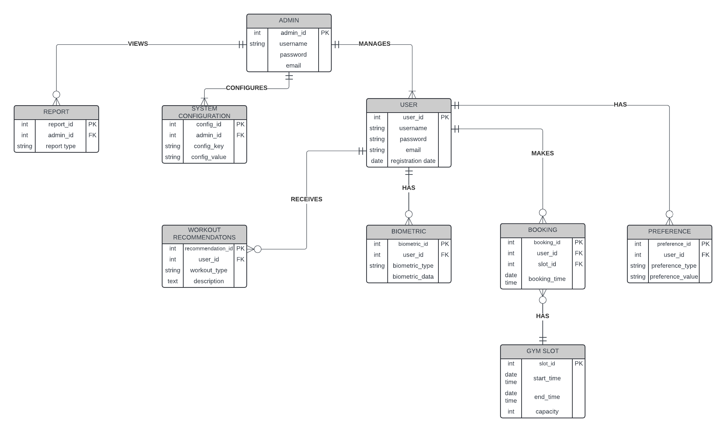

- ACCEPTANCE CRITERIA
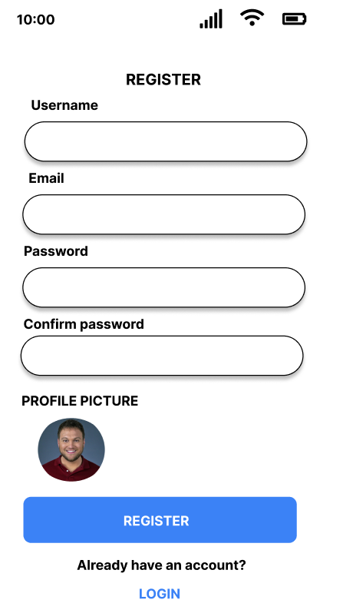
REGISTRATION PAGE
- Design form with fields: username, email, password, confirm password
- Add profile picture upload option
- Include terms and conditions checkbox
- Create submit button with clear call-to-action text
- Design error states for invalid inputs
- Add link to login page for existing users
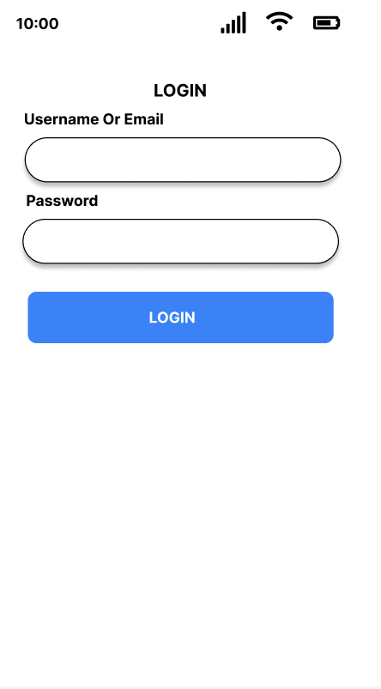
LOGIN PAGE
- Create input fields for username/email and password
- Design "Forgot Password" link
- Include "Remember Me" checkbox
- Add prominent login button
- Design link to registration page for new users
- Consider adding social media login options
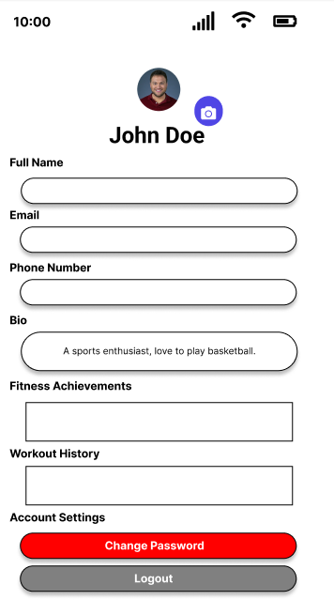
PROFILE PAGE
- Display user's profile picture, name, and basic info
- Create editable fields for personal information
- Design section to showcase fitness achievements
- Include tab or section for viewing workout history
- Add option to change password
- Create logout button

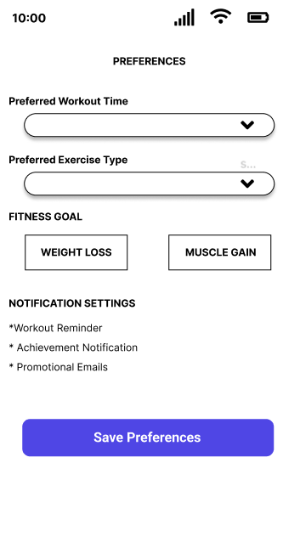
PREFERENCE PAGE
- Design toggles or dropdown menus for various preferences
- Create sliders for setting fitness goals
- Include options for notification settings
- Add save button to confirm preference changes

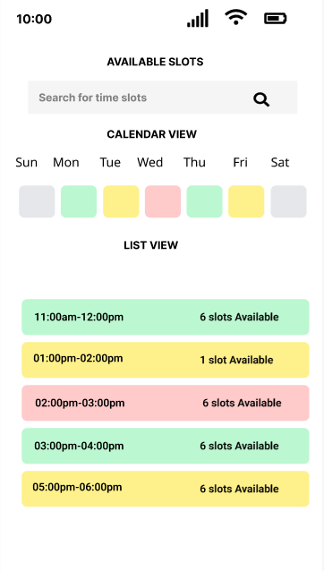
SLOT VIEWING PAGE
- Design calendar view showing available slots
- Create list view alternative for slot availability
- Include filters for date, time, and type of equipment
- Show occupancy levels for each slot (color-coded or percentage)
- Add search function to find specific time slots
- Design refresh button to update slot availability in real-time

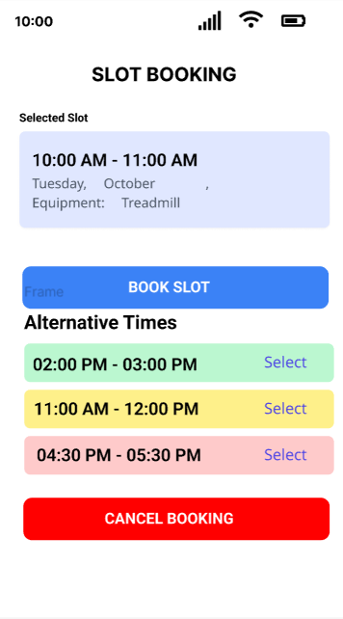
SLOT BOOKING PAGE
- Create detailed view of the selected slot
- Design confirmation modal for booking a slot
- Include feature to add booking to device's calendar
- Show related slots or alternative times if chosen slot is unavailable
- Add cancellation option for existing bookings

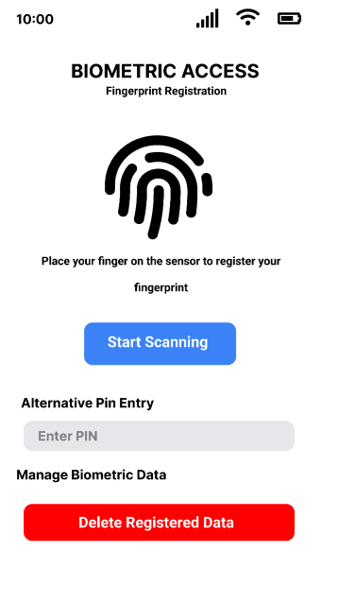
BIOMETRIC ACCESS PAGE
- Design interface for fingerprint registration
- Create visual guide for proper fingerprint scanning
- Include alternative PIN entry option
- Design feedback animations for successful/unsuccessful scans
- Add option to manage registered biometric data

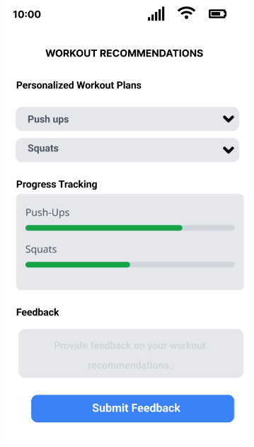
WORKOUT RECOMMENDATION PAGE
- Create dashboard showcasing personalized workout plans
- Design expandable sections for each recommended exercise
- Include visual aids or animations for exercise demonstrations
- Add feature to mark exercises as completed
- Create progress tracking visualization
- Design way to provide feedback on recommendations

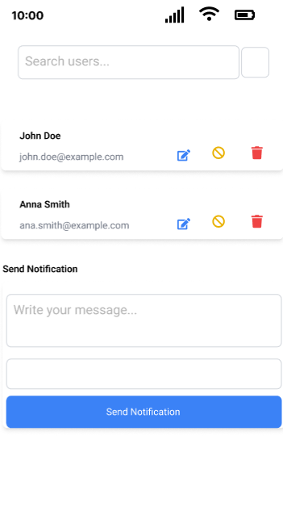
USER MANAGEMENT
- Design searchable and sortable user list
- Create user profile cards with key information
- Include options to edit, suspend, or delete user accounts
- Add feature to send notifications to specific users or groups
- Design user analytics dashboard

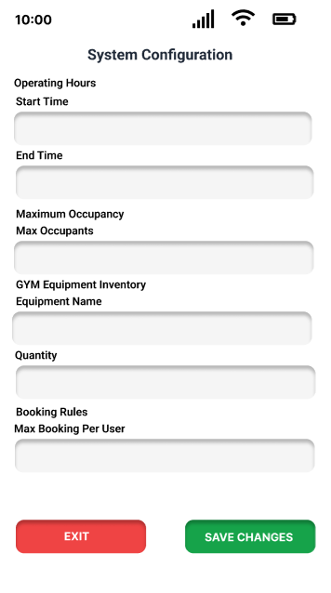
SYSTEM CONFIGURATION
- Create sections for different system settings
- Design input fields for updating gym equipment inventory
- Include options for setting booking rules
- Add controls for adjusting the recommendation algorithm
- Create save/revert changes mechanism

