{Do you need validation plots?}

**Disc Areas**

This is the design structure we obtained.

**Initial design Point**:  
Disc Outer Radius: 164mm

Disc Inner Radius: 49.2mm

Disc Spacing: 0.2mm

I think R0: 200mm

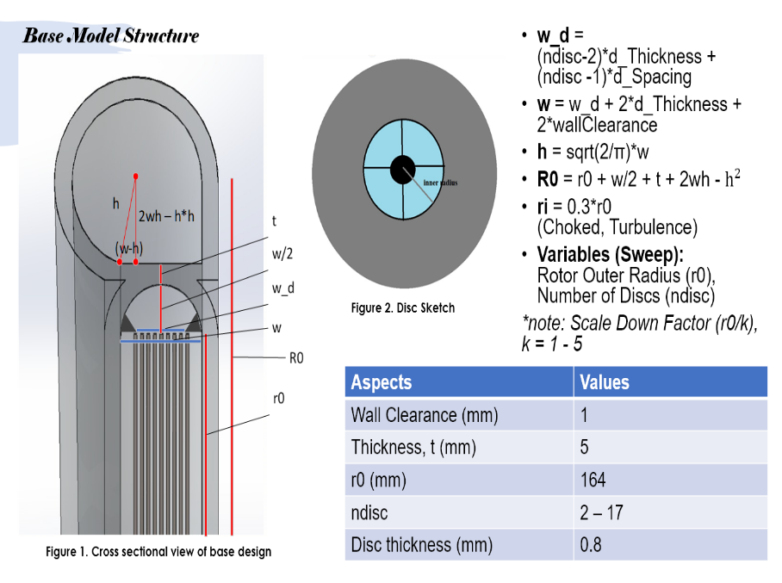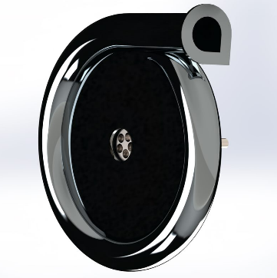

With the basic design outlines, we then proceed on with developing a simplified analytical model for analysing and optimising turbine performance under different settings and configurations.

{ show volute casing and disc dimensions (some of it) }

As can be seen from the contour plots, with a fixed mass flow rate of 1kg/s (tap water), we have selected a design point that accounts for aspects such as maximum power output, efficiency as well as containing it within manufacturing limitations. This was done with careful scaling approach so as to retain the initial design integrity.

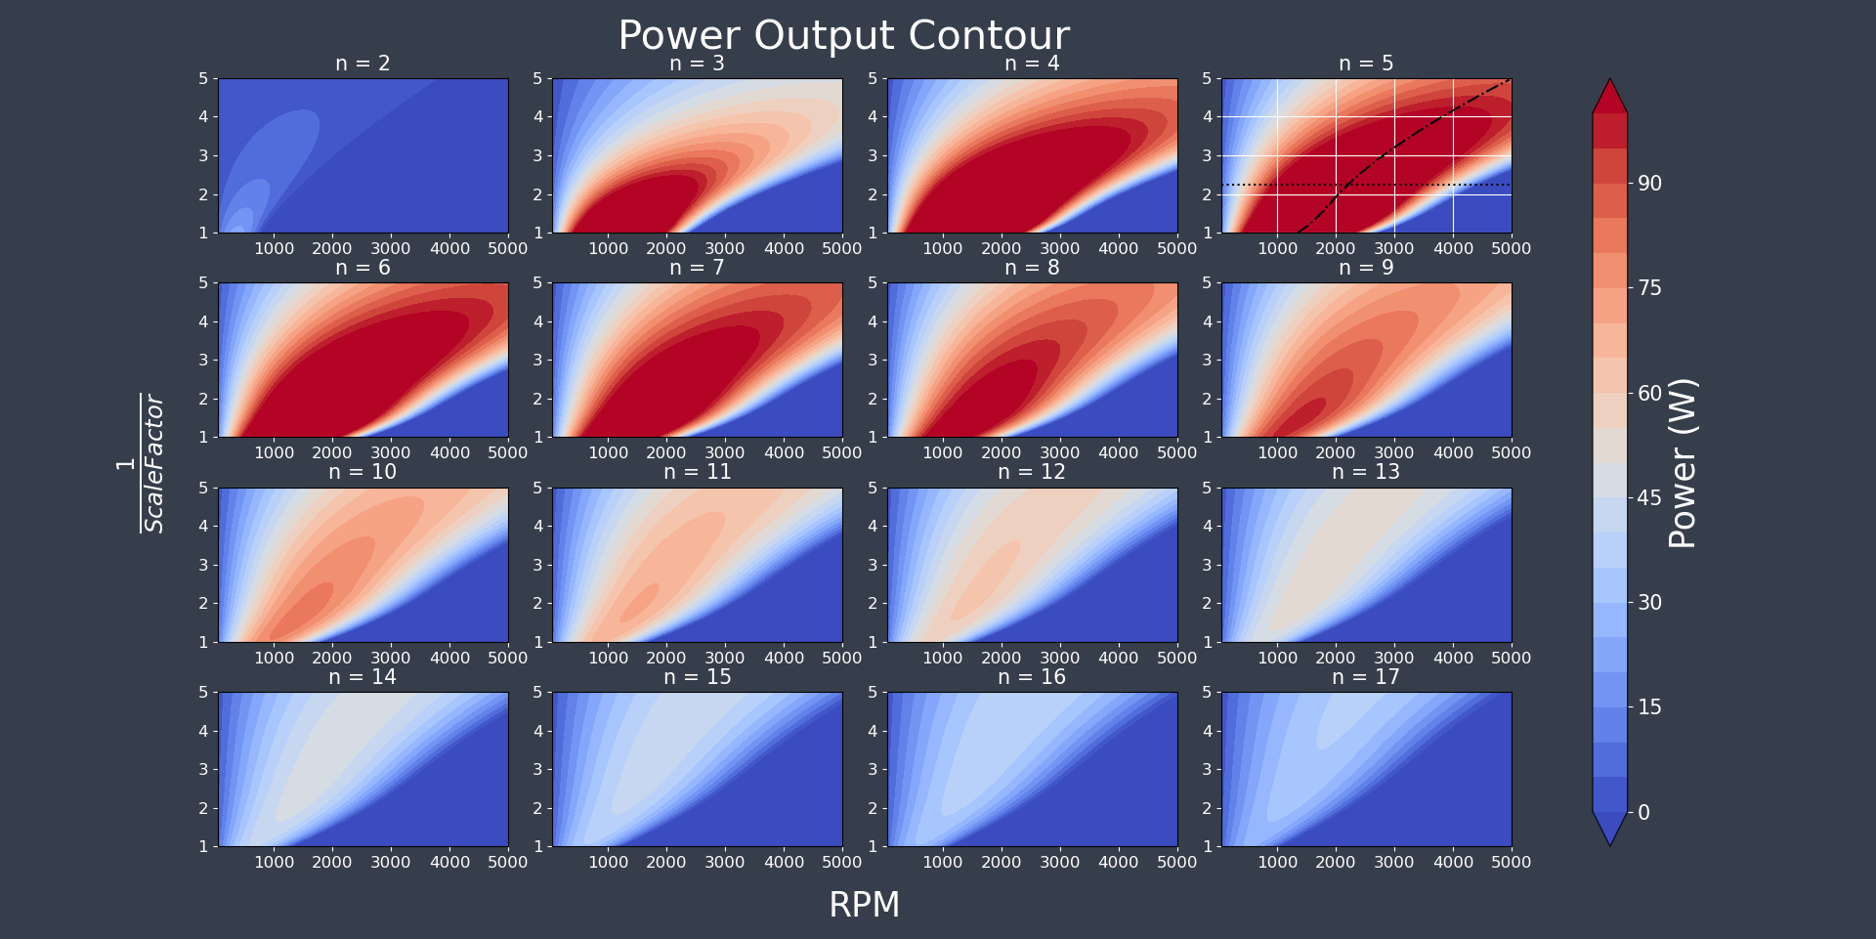

**Figure 1 Power Output under varying scale factors, disc numbers and working RPM. (Emphasize)**

From this, we finalised our design dimensions such as that shown in this video.

Moving on, we continue looking into the flow characteristics in between each pair of discs to further investigate relevant design alterations and conditions that bring about performance changes.

{Following 4 plots on the screen}

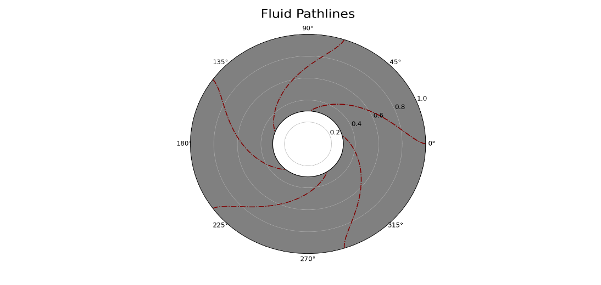

**Figure 5 Flow angle and path-lines.**

This analysis is also followed by manipulating the disc spacing using the following formula,

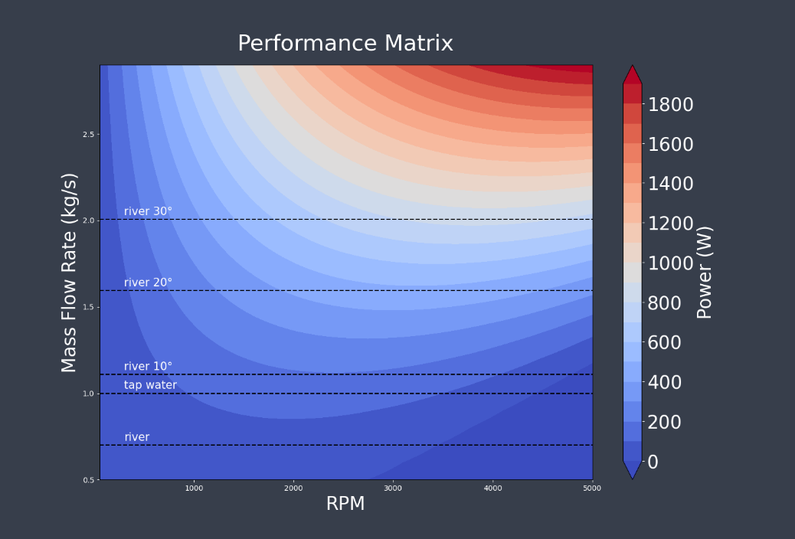

**Figure 7 Performance matrix at differnet mass flow rate and RPM settings.**

1. ***Pre intro: optimisation of design point***
2. ***Disc and Flow field analysis for power extraction***
3. ***Performance matrix and its applicable grounds***