Addendum from Ken Cottrell – using Eclipse for OrderIT training class

1. Create Eclipse workspace for GGtraining-Lab3 project, for example:

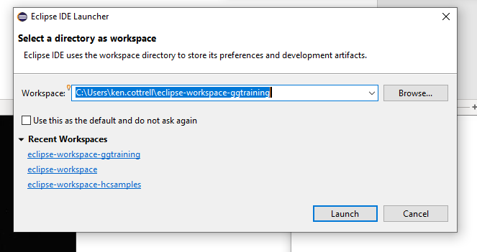

1. Import existing Maven project, for example:

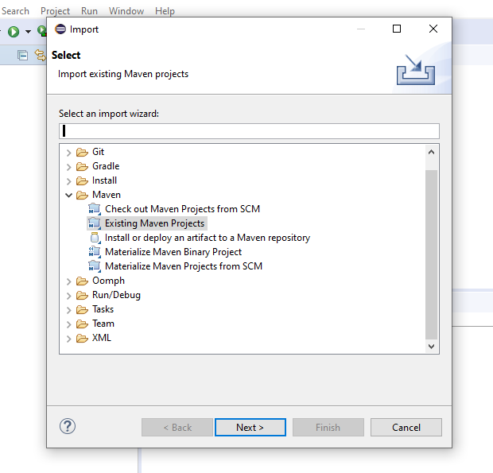

1. Select Lab 3 \ Orderit directory which has the pom.xml file:

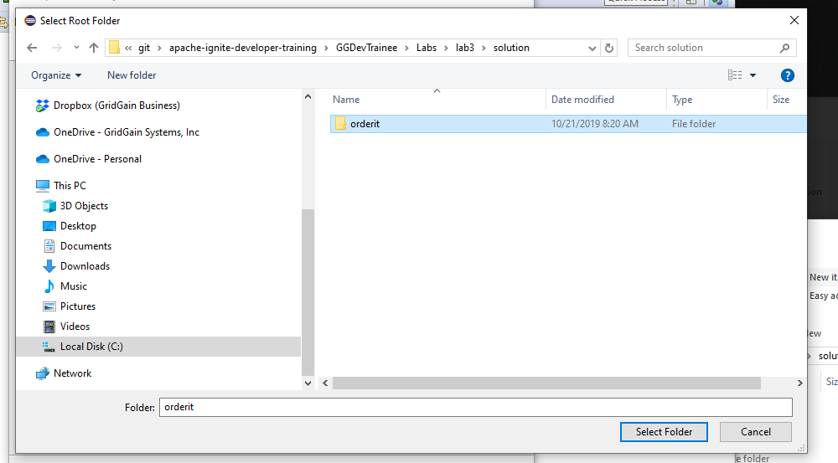

1. Select the application and model file in the directory with the pom.xml file:

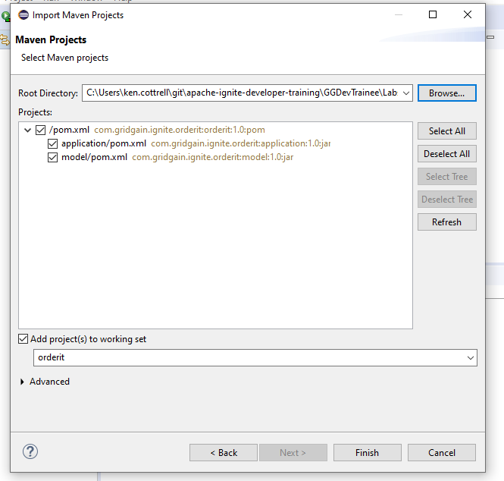

1. Fix the pom.xml file specification. Note that this file is missing from the dependencies: the ..\target\model.1.0.jar file needed for this pom.xml file:

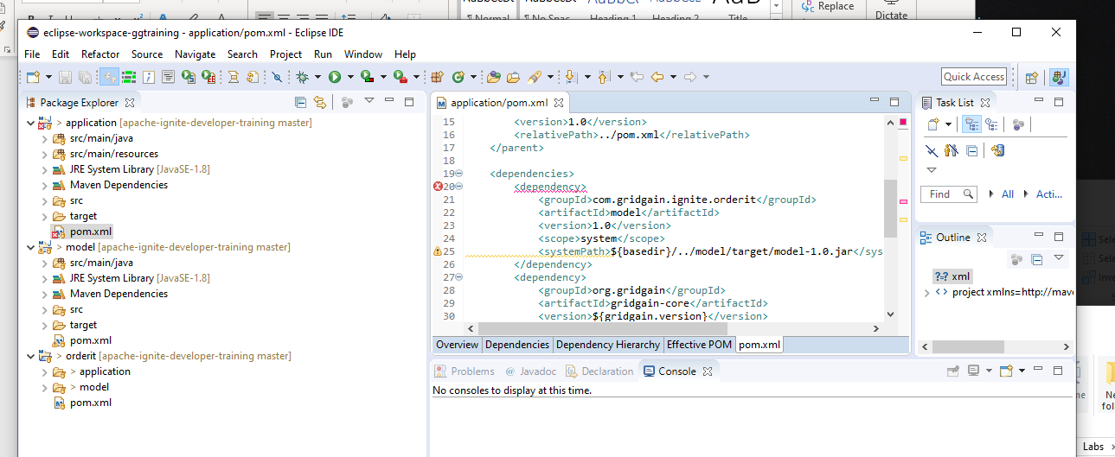

1. Do Maven clean install for each of the 3 configurations: orderit

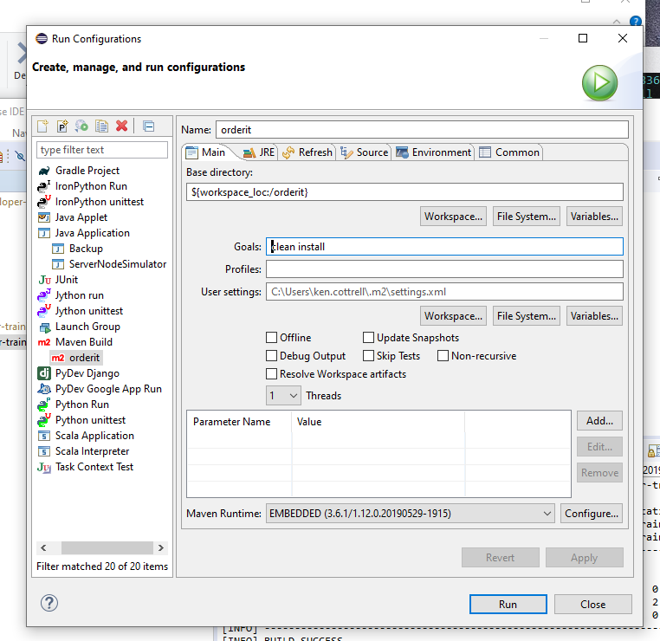

1. Generate the model .jar file (note the base directory setting pom.xml in application base directory.

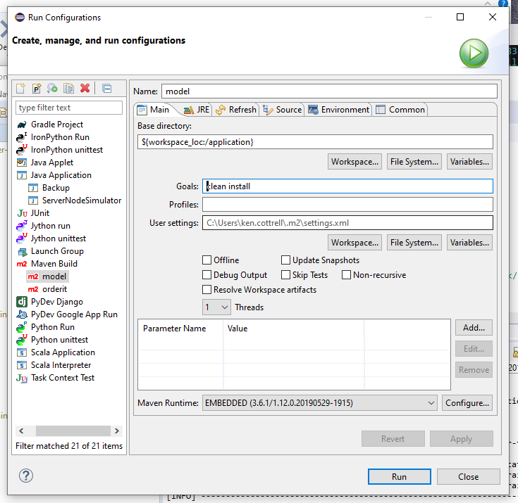

1. Update the pom.xml project in application directory

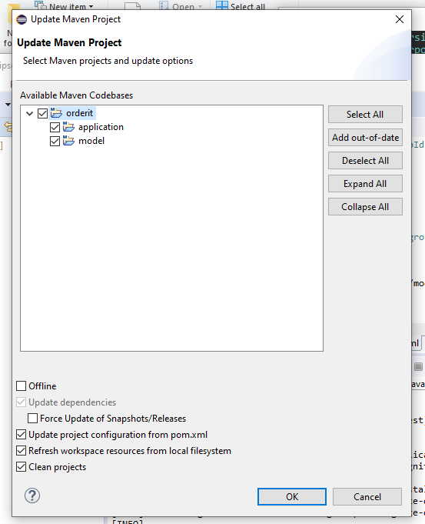

1. Note - No more dependency errors:

