1. To test the lab 3 orderit code, set up run configurations for MassCustomerFeeder and MassCustomerReader as follows:

* Create new Java application configuration, rename to MassCustomerFeeder, then set project to application, and set the main class as shown below:

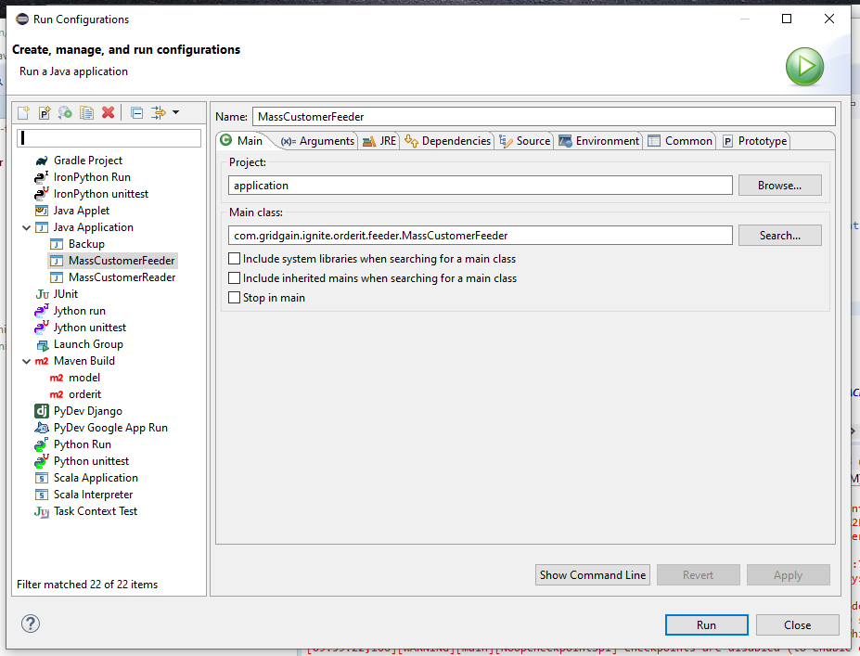

1. Same with MAssCustomerReader:

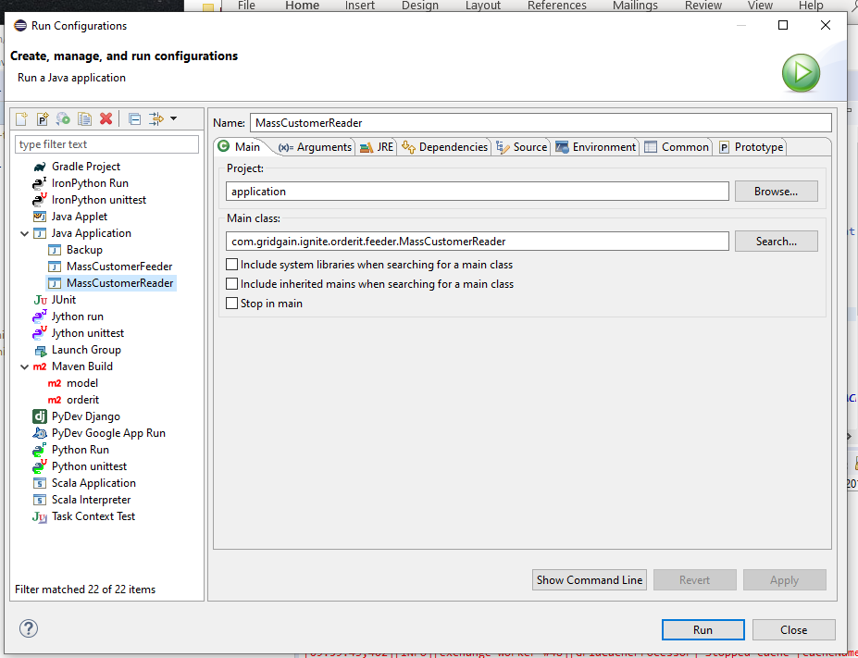

1. You should see output similar to this:

