1. Create new Eclipse workspace

* eclipse-workspace-ggtraining-lab5

1. Import from lab 5 folder:

* {C:\Users\ken.cottrell\git\}apache-ignite-developer-training\GGDevTrainee\Labs\lab5\solution\orderit

1. Fix the application folder pom.xml file (compile the ${basedir}/../model/target/model-1.0.jar needed)

* Maven build configuration:

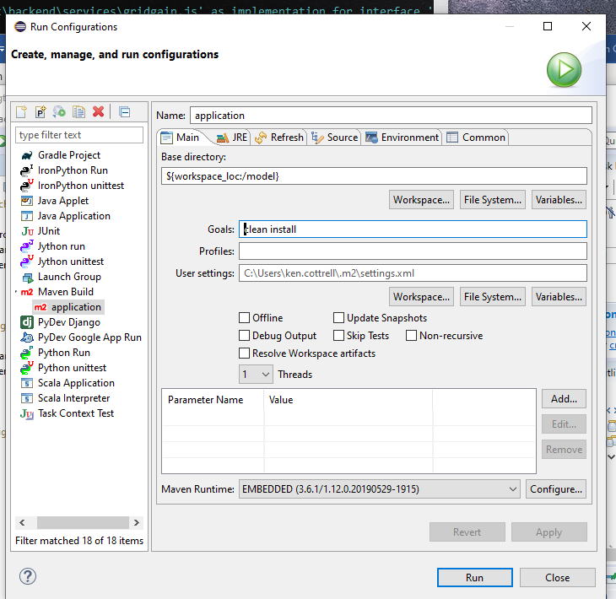

1. If needed, add Java Run configuration for SingleCustomerFeeder

